SERBIS Admin Panel — User Manual
  - MDRRMO Echague Disaster Communication & Service Coordination System
September 2026

Introduction
The SERBIS admin panel is where MDRRMO Echague staff handle resident requests, ambulance bookings, equipment loans, vehicles, responders, resident accounts and SMS blasts. Open it in a desktop browser and sign in with your staff email and password.
The sidebar groups every page under Overview, Requests, Resources, Community, Configuration and System. You only see the pages your account has access to. A super admin decides which pages each account gets. Pages marked (Super admin only) are hidden from everyone else.

Signing in
Signs you in to the panel.
- Enter your staff email and password.
- Tick Keep me signed in on this device only on your own computer.
- Click Sign in. If you forgot your password, ask another admin to reset it.
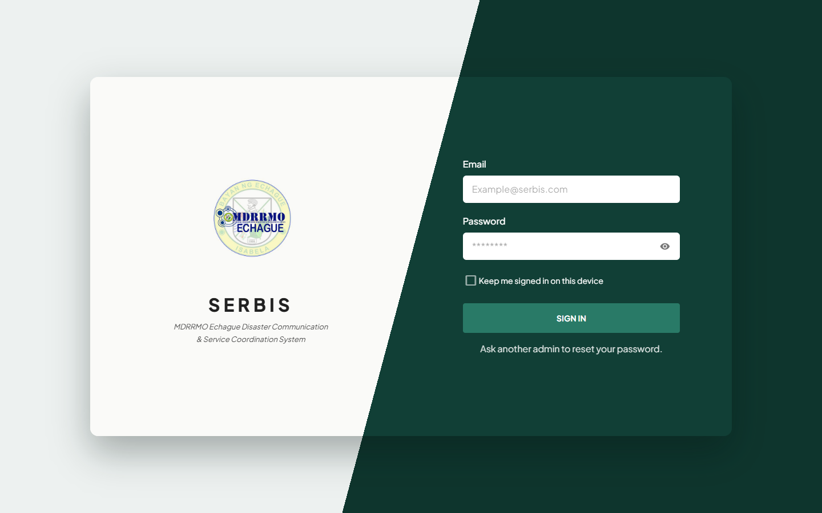
Sign-in page
To sign out, click your name at the bottom of the sidebar, then click Logout.
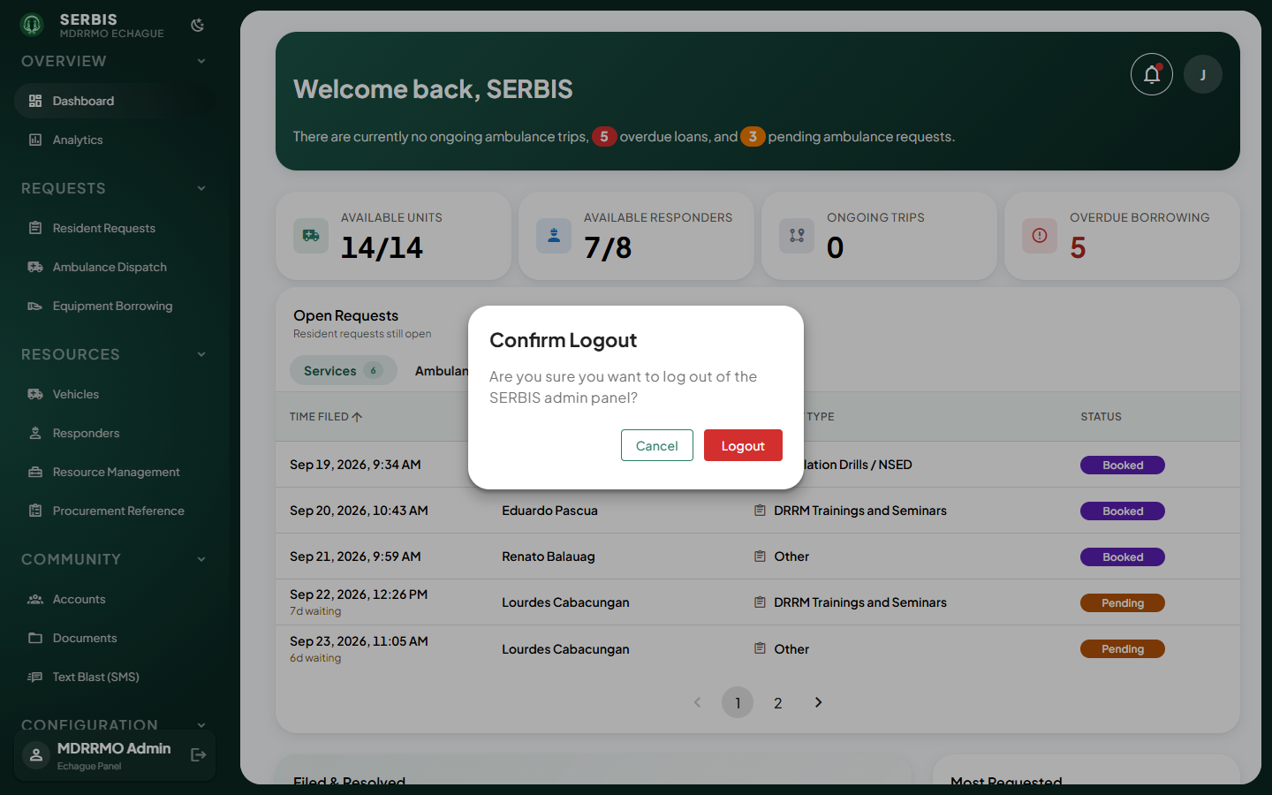
Sign-out confirmation

Overview

Dashboard
Today’s picture: available units and responders, ongoing trips, overdue loans and open requests.
- Read the summary cards at the top.
- Switch between the Services and Ambulance tabs under Open Requests.
- Click a row to open that request.
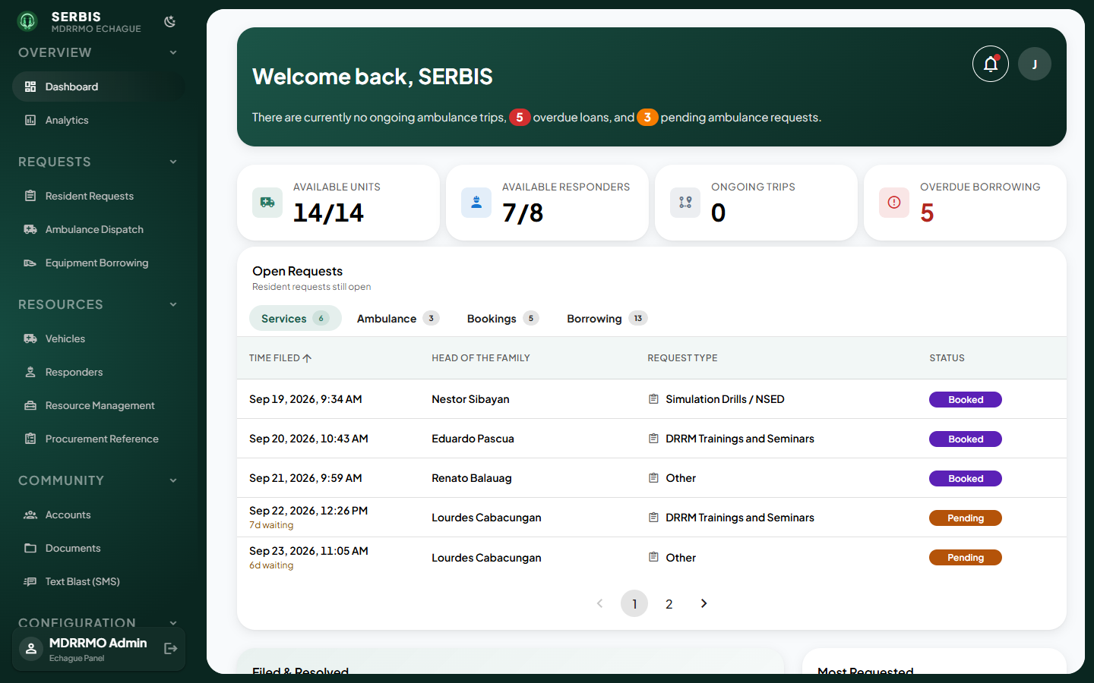
Dashboard

Analytics
Request and service trends over a chosen period.
- Set the date range (From / To) and filters in the bar at the top.
- Scroll through the sections; the filter bar stays in view.
- Switch a section between chart and table view to read exact numbers.
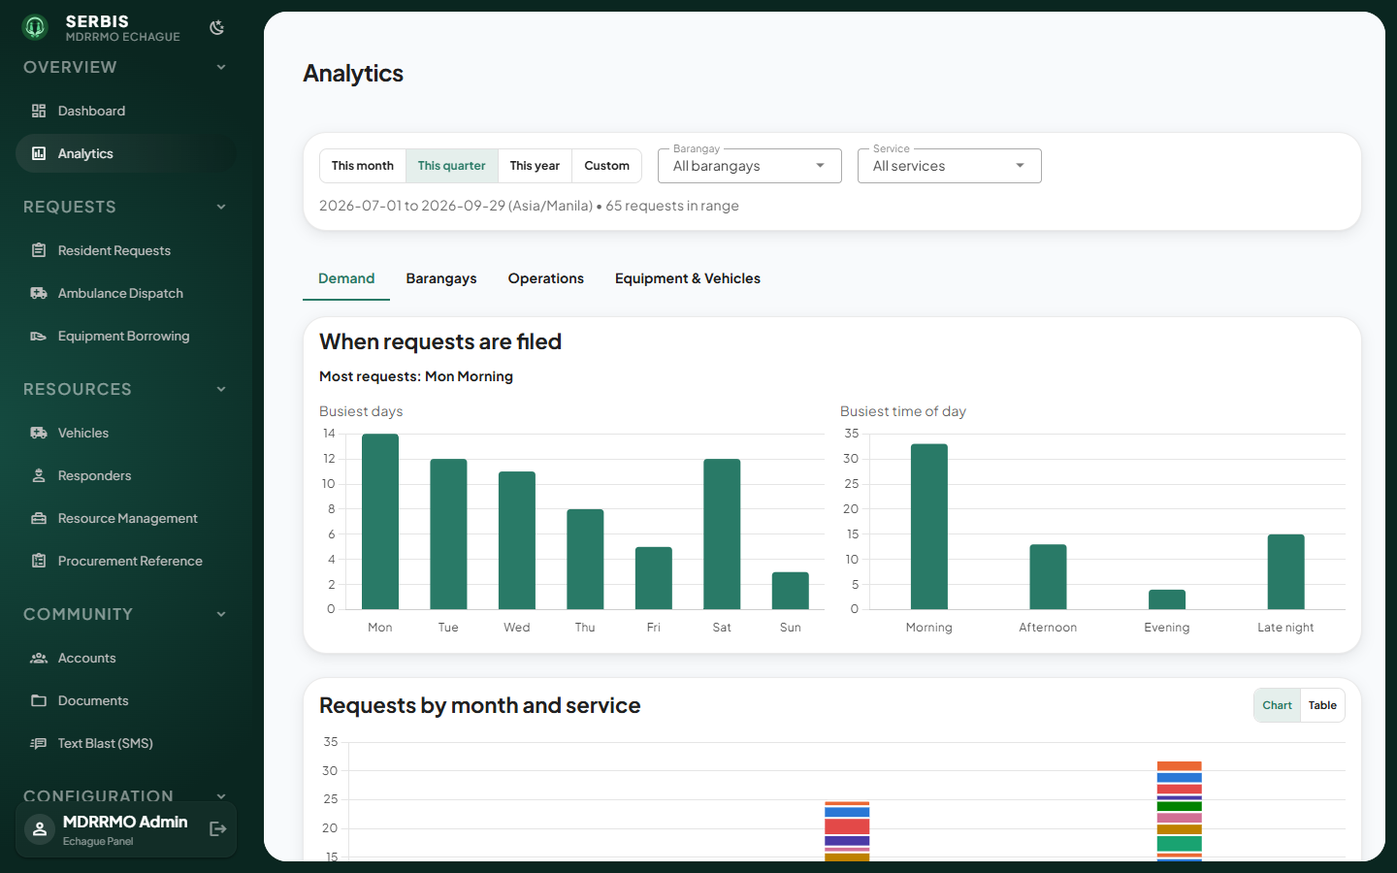
Analytics

Requests

Resident Requests
Service requests filed by residents, from Pending to Resolved.
- Pick a status tab or search to find a request.
- Click the row to open it.
- Assign a unit or click Select Responders, then Approve (or Disapprove with a reason).
- Once the work is done, mark it resolved.
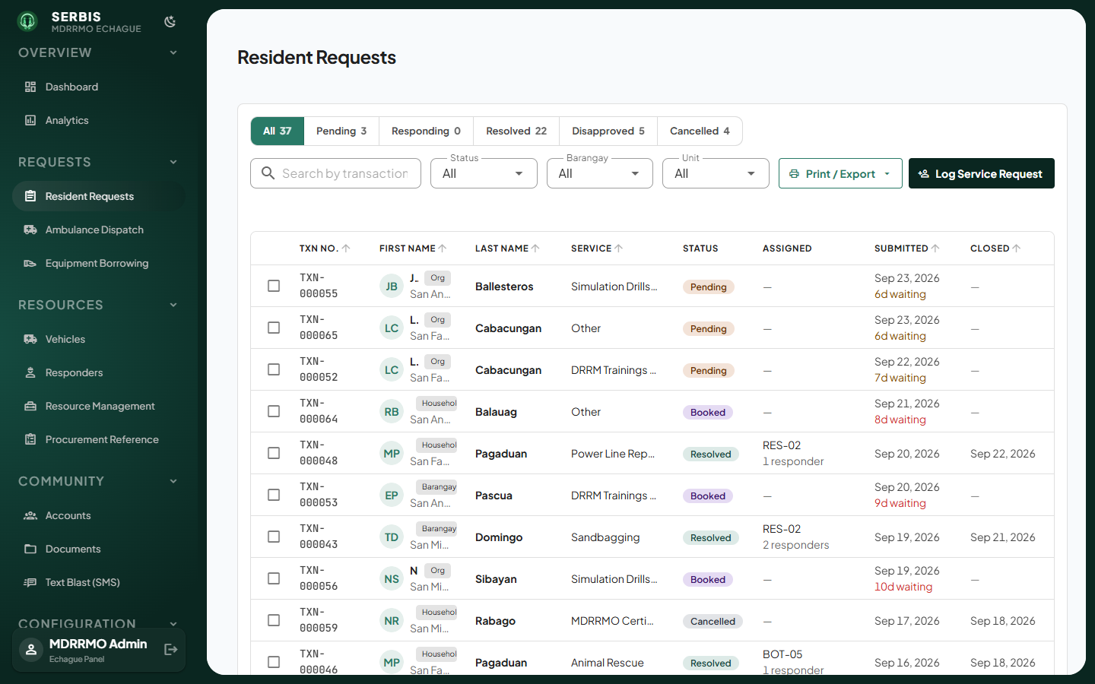
Resident Requests
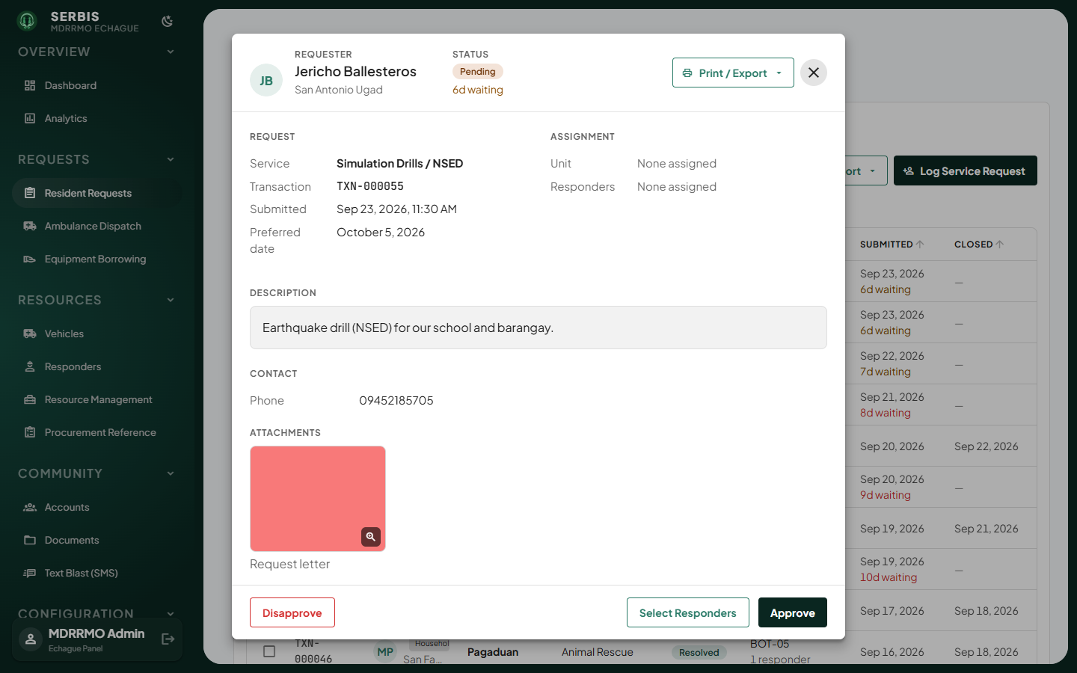
Request detail
To record a request that came in by phone or walk-in, click Log Service Request and fill in the form.
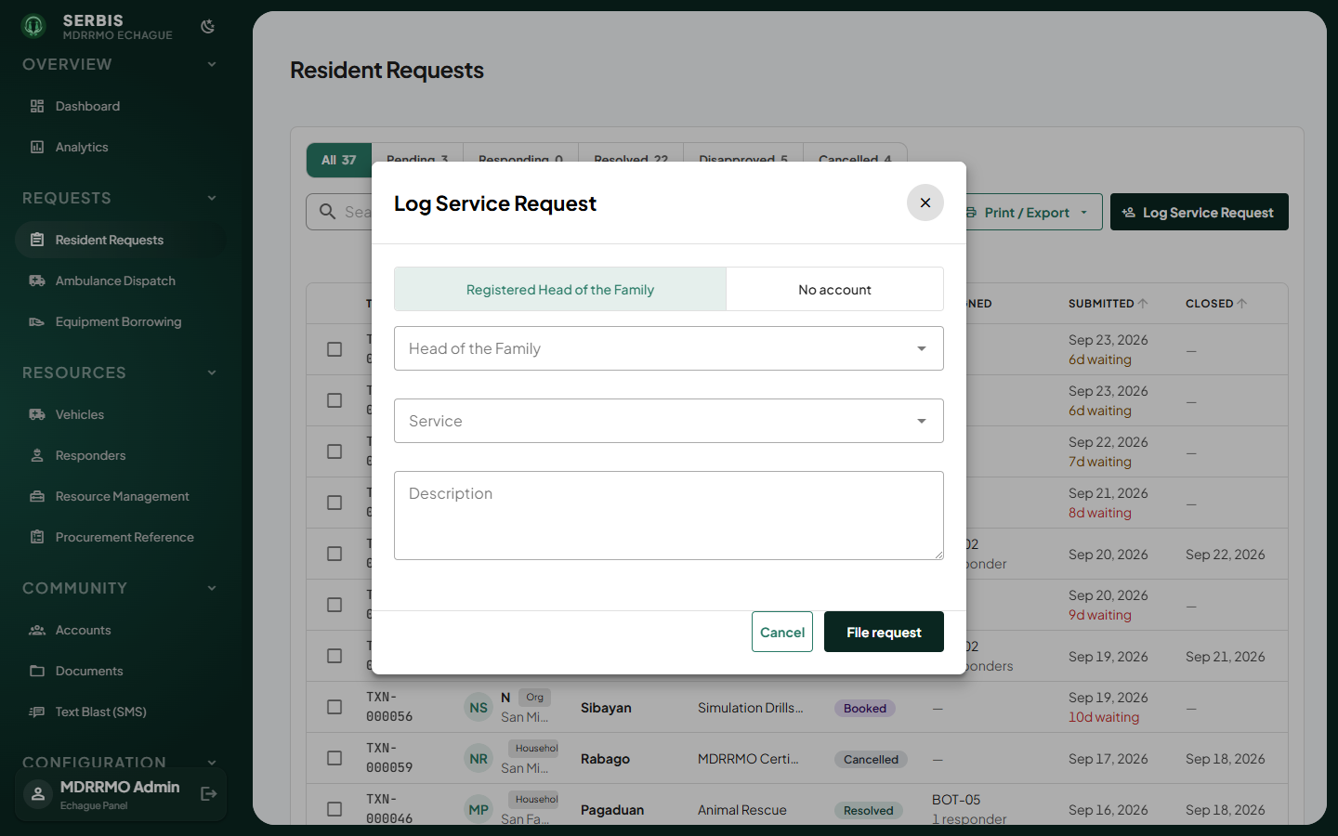
Log Service Request

Ambulance Dispatch
Ambulance bookings (Bookings tab) and the trip record of each run (Trip Logs tab).
- On Bookings, click a pending request to open it.
- Click Select next to Unit and choose an ambulance.
- Click Approve & Dispatch. A trip record is created automatically.
- Use Reschedule or Disapprove when the booking cannot go ahead as filed.
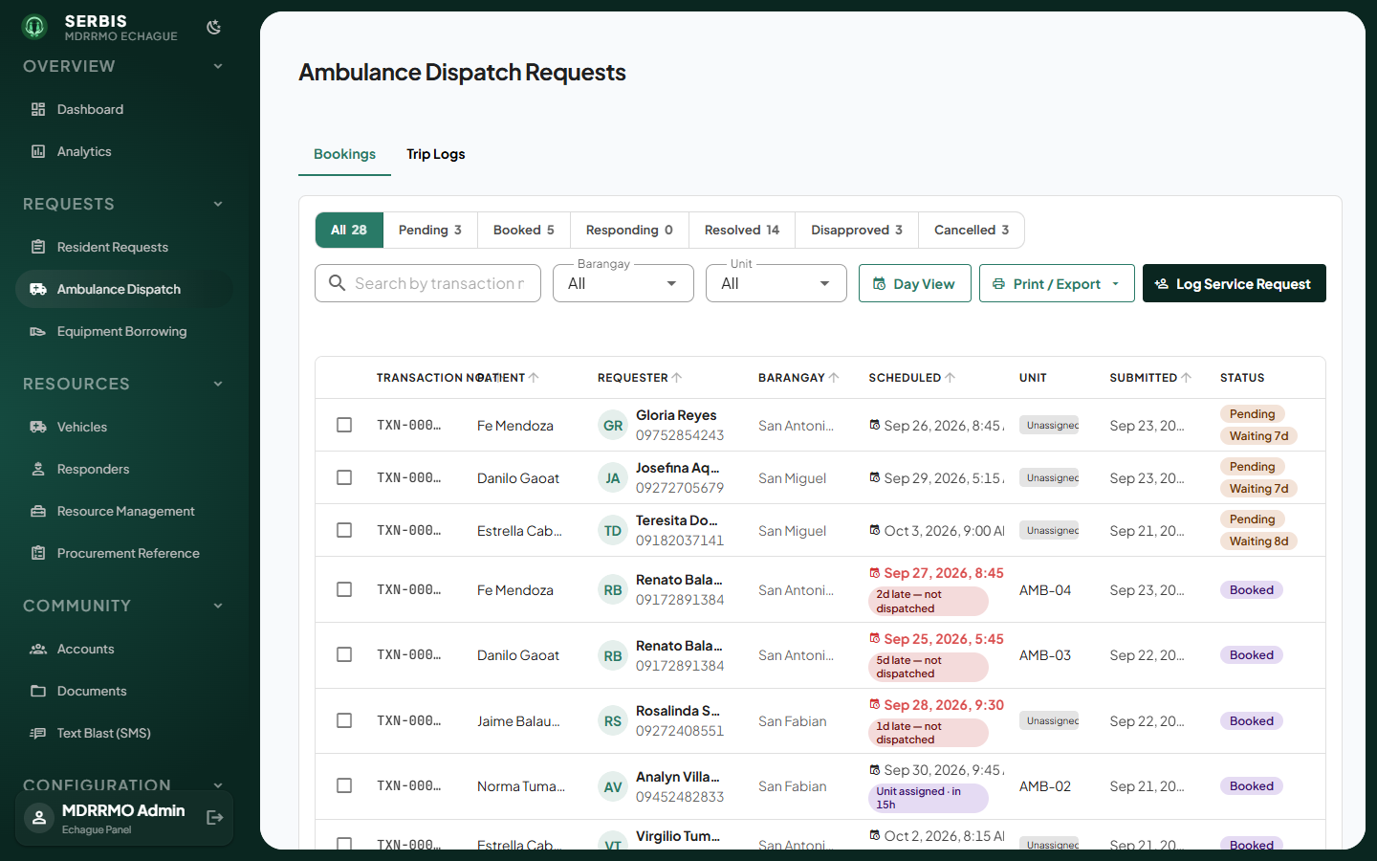
Ambulance Dispatch
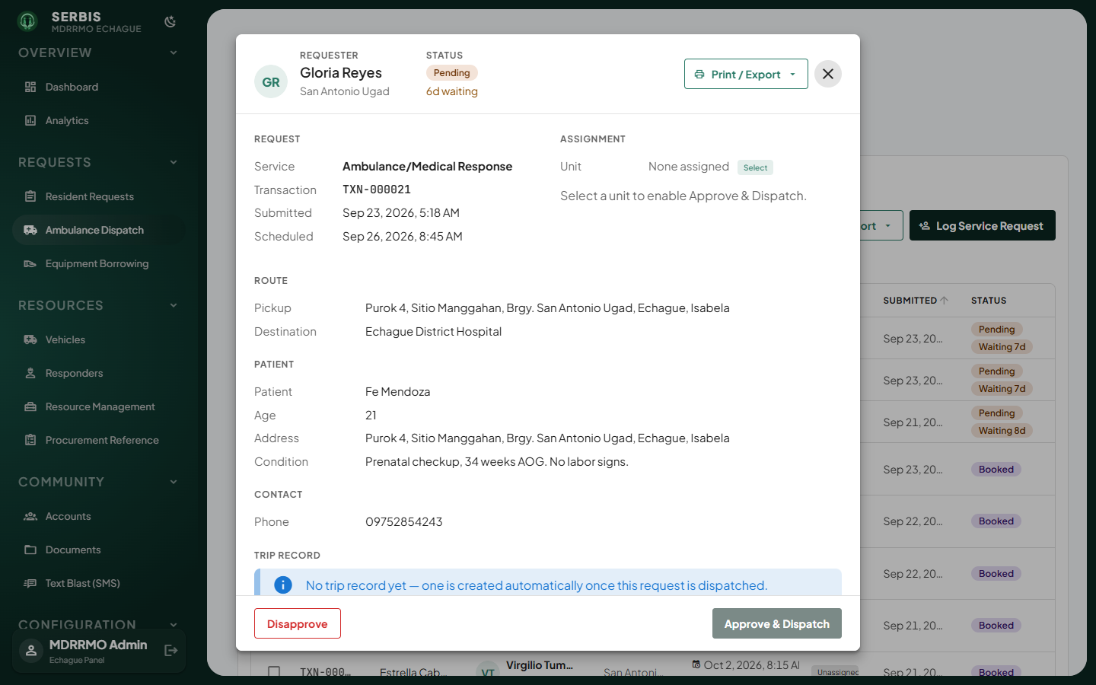
Ambulance request detail
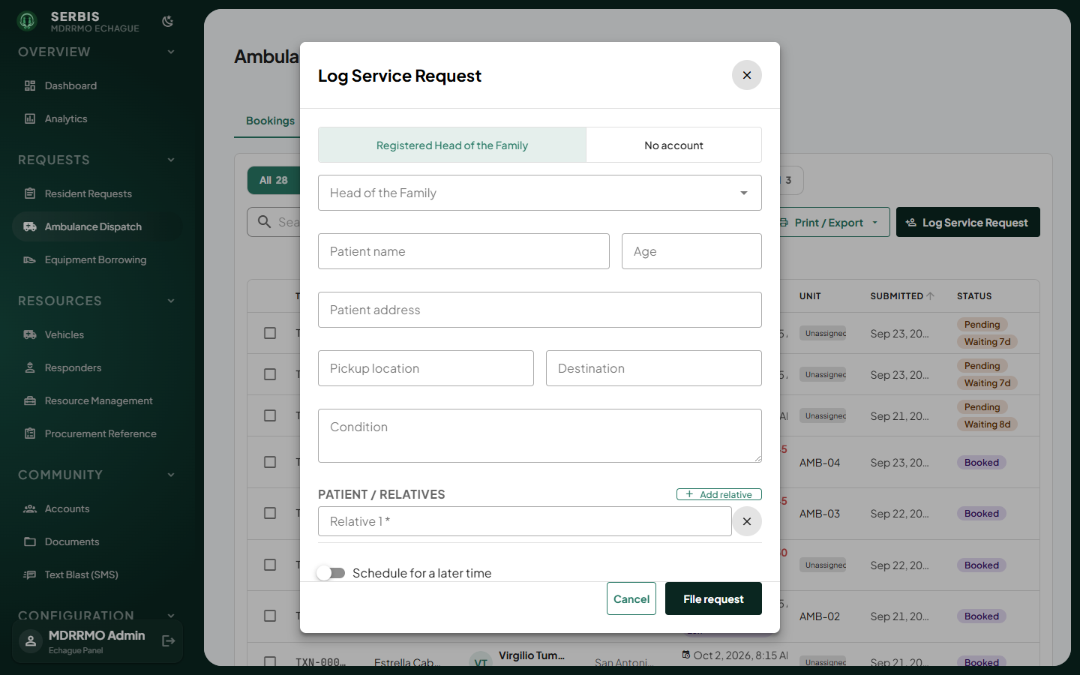
Log an ambulance request
On Trip Logs, filter by status, date or vehicle. Click Ambulance Trip Record to add a trip by hand.
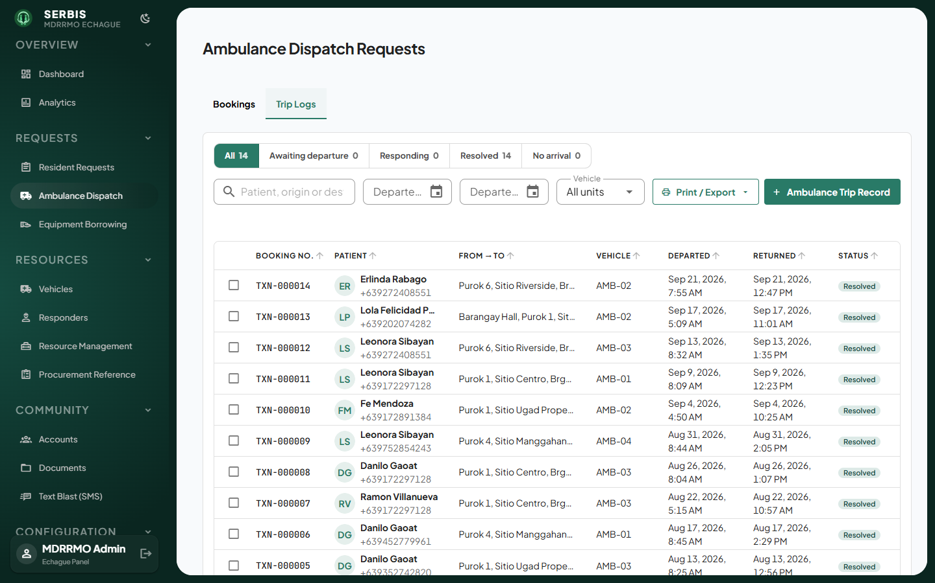
Trip Logs

Equipment Borrowing
Equipment loans from request to return, with overdue ones flagged.
- Click a request to see the items, purpose and due date.
- Click Mark as Released to Resident when the items leave the office.
- Click Confirm return in the list when they come back.
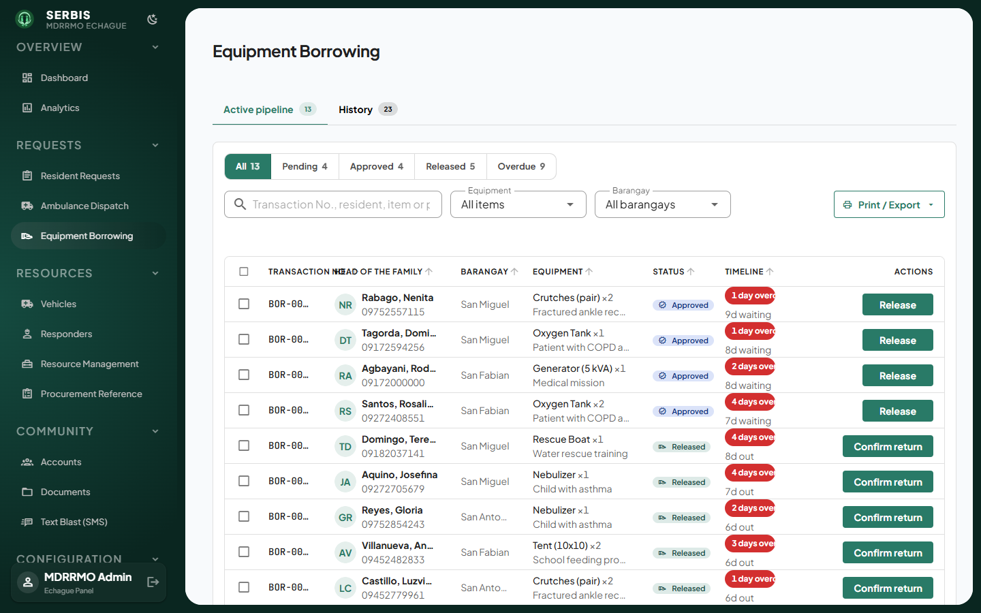
Equipment Borrowing
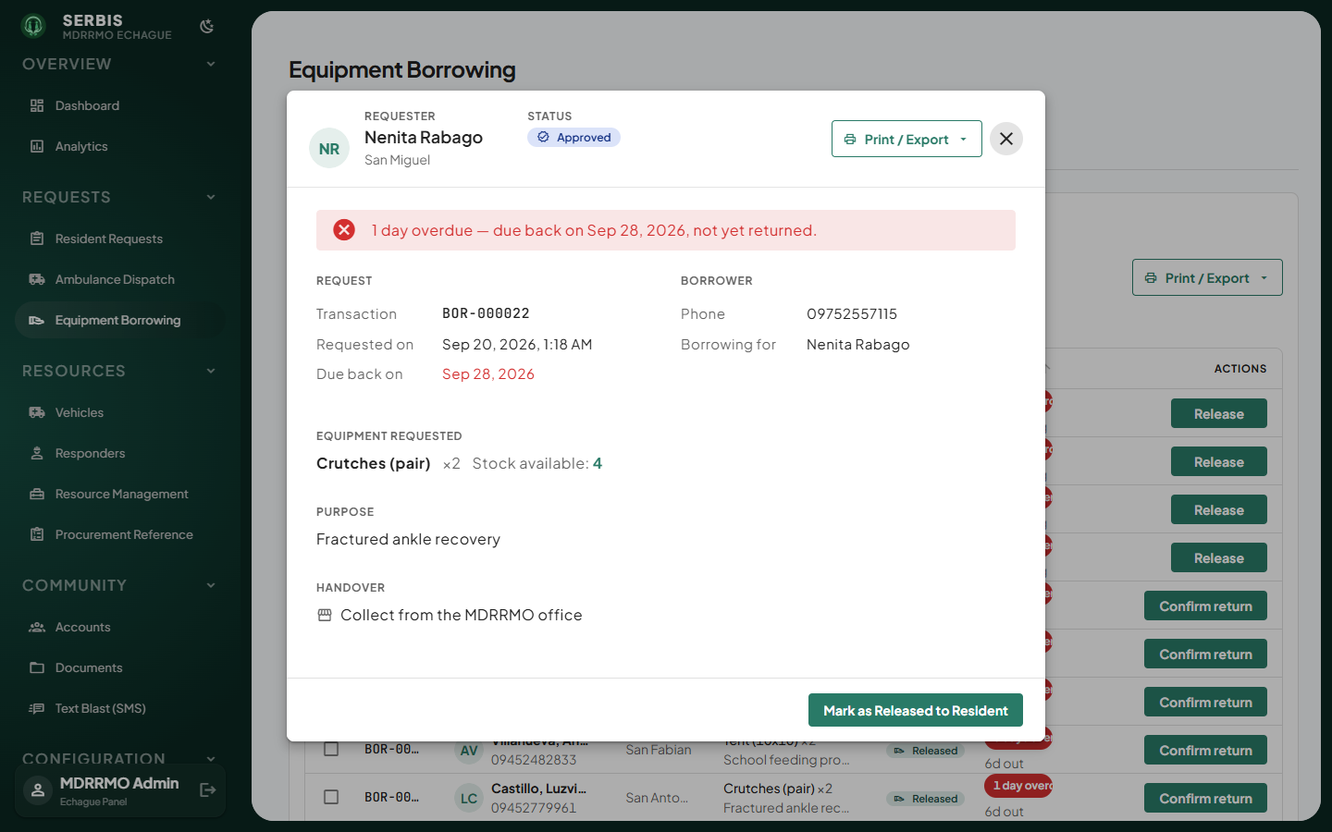
Borrowing detail

Resources

Vehicles
The fleet: ambulances, rescue vehicles, fire trucks and boats, with their status.
- Click Add Unit.
- Enter the unit details and save.
- Click a row to edit a unit or change its status.
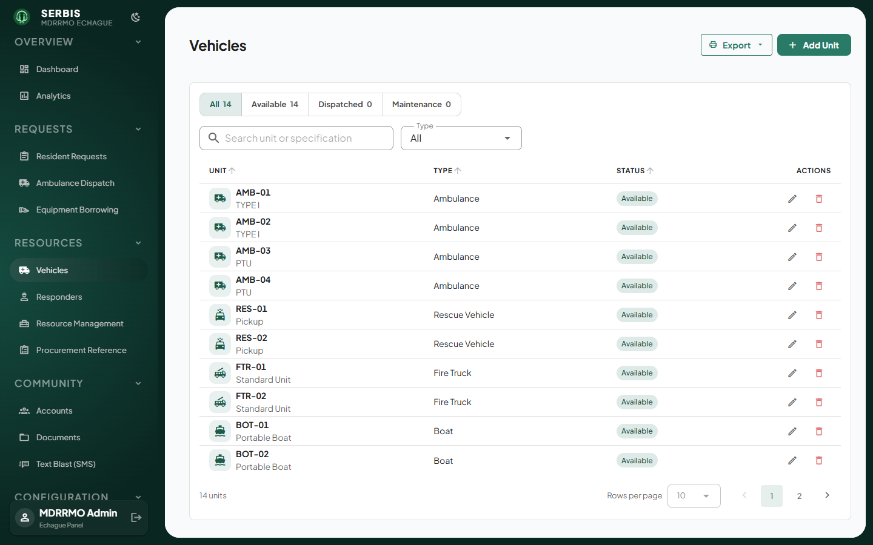
Vehicles
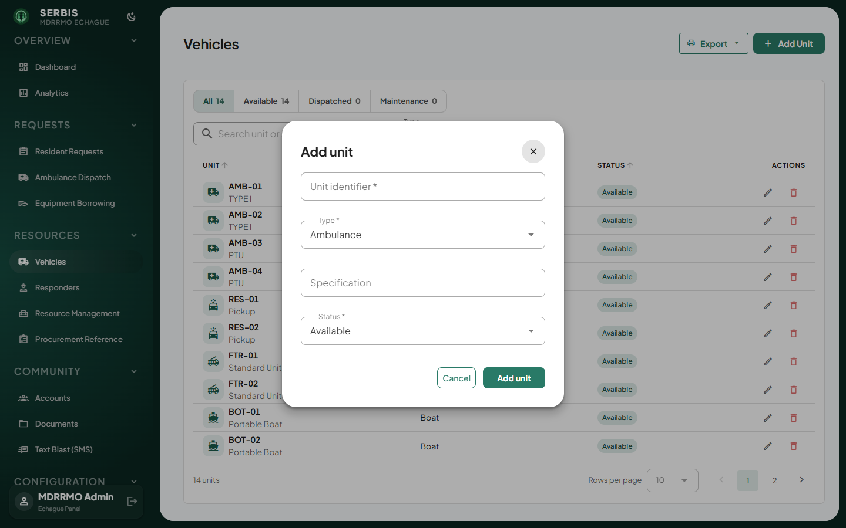
Add a unit

Responders
Staff who can be assigned to requests.
- Click Add Responder.
- Enter their details and save.
- Click a row to edit a responder or change their availability.
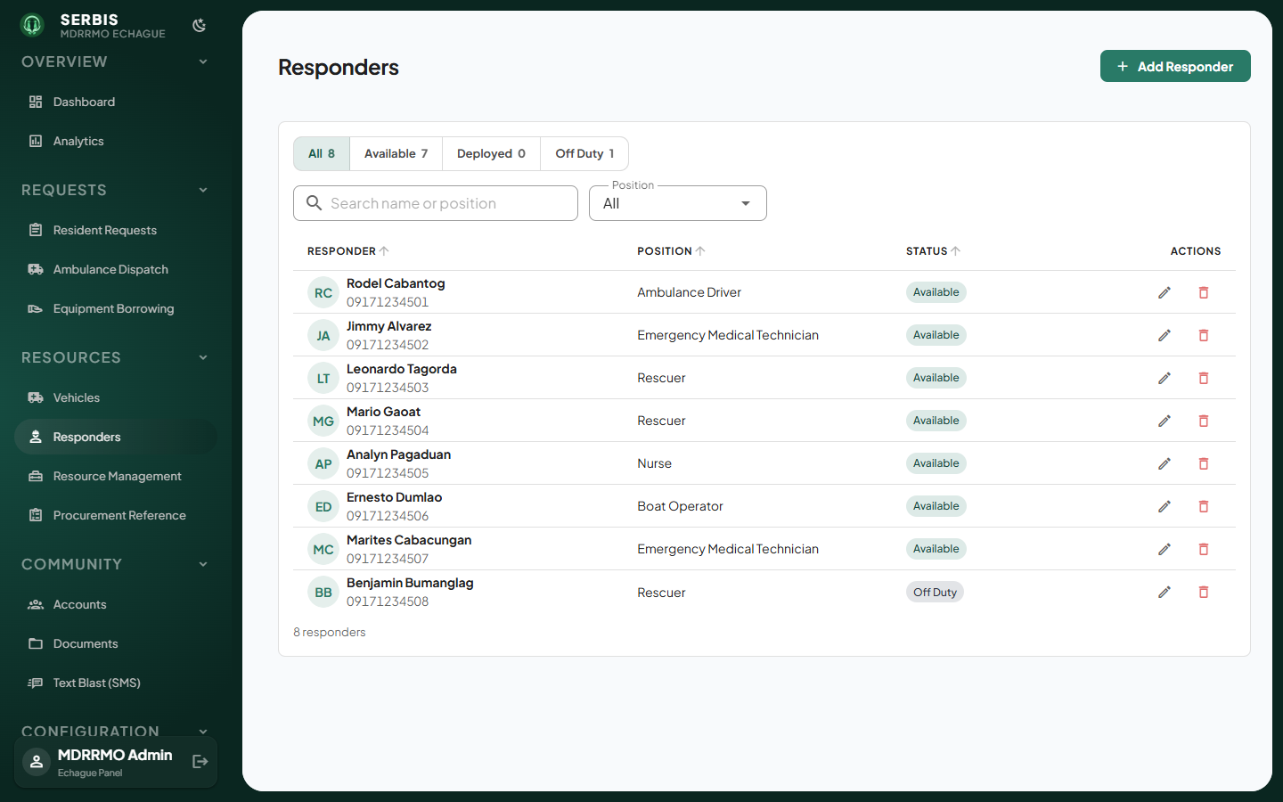
Responders
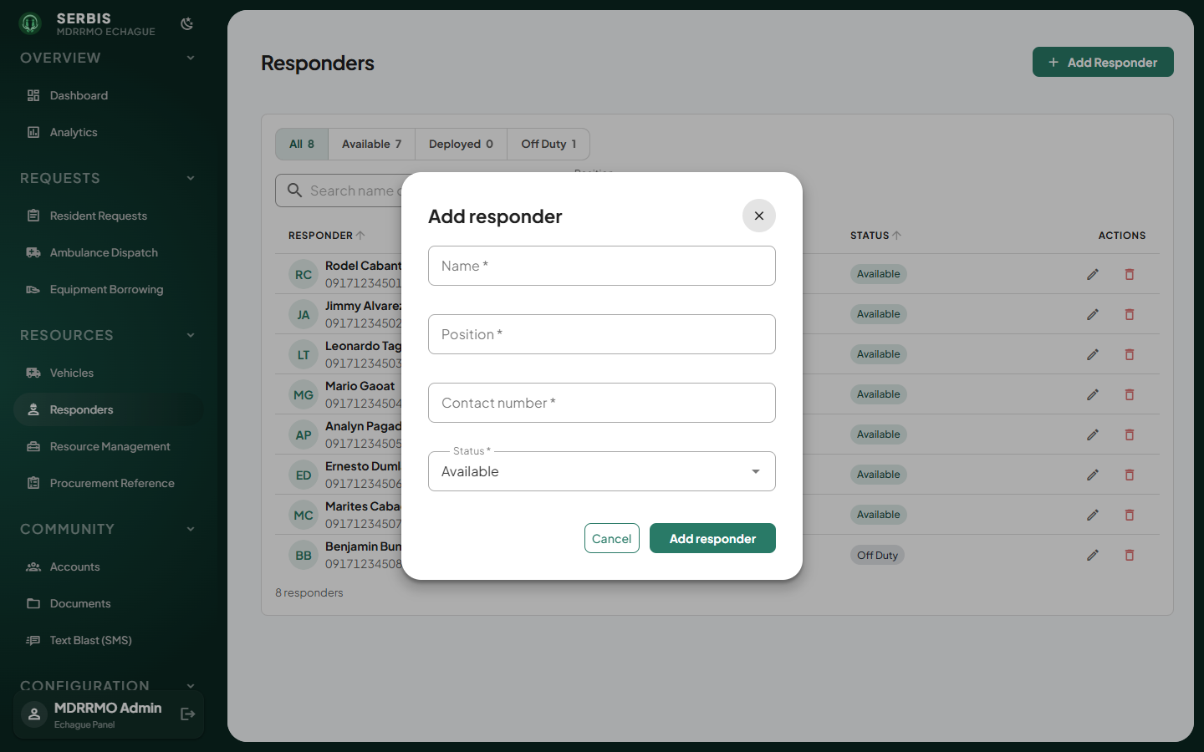
Add a responder

Resource Management
The equipment catalogue and stock that residents can borrow.
- Click Add Equipment.
- Enter the name and quantity, then save.
- Click a row to edit an item’s stock.
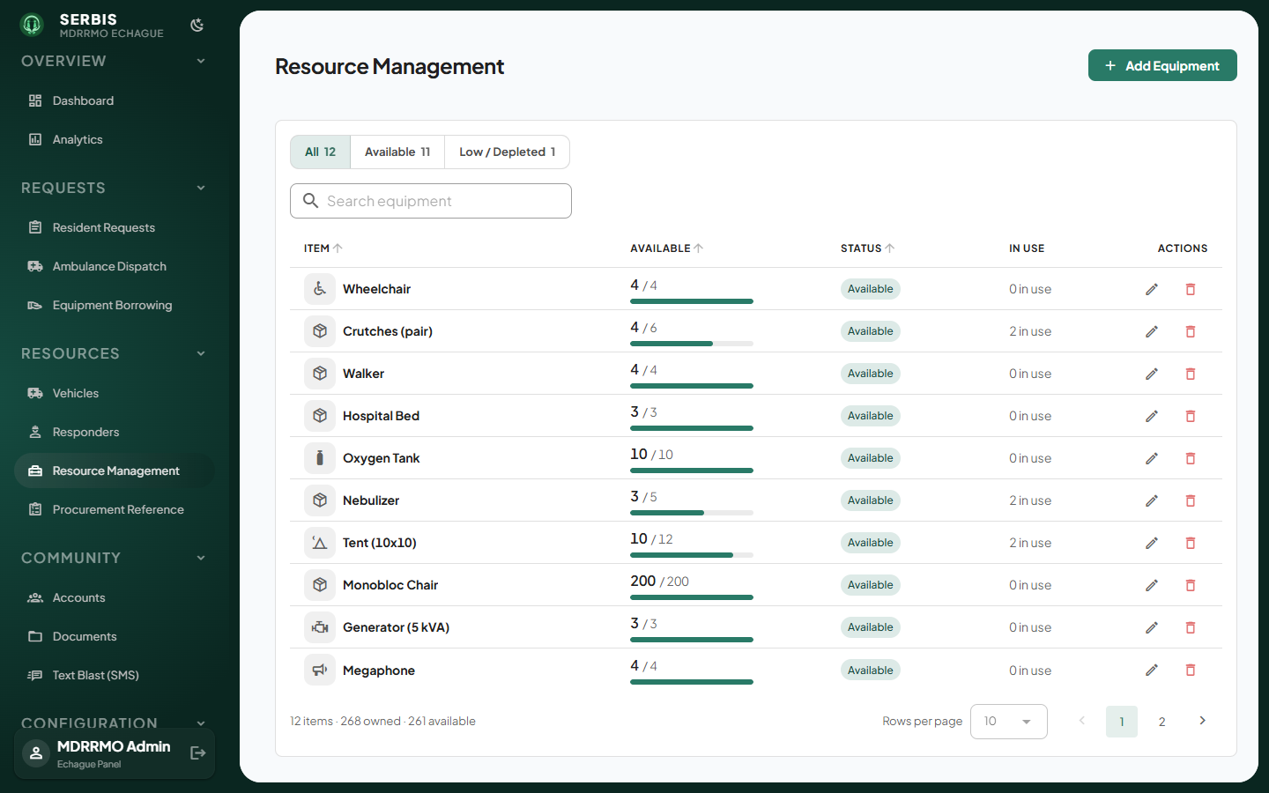
Resource Management
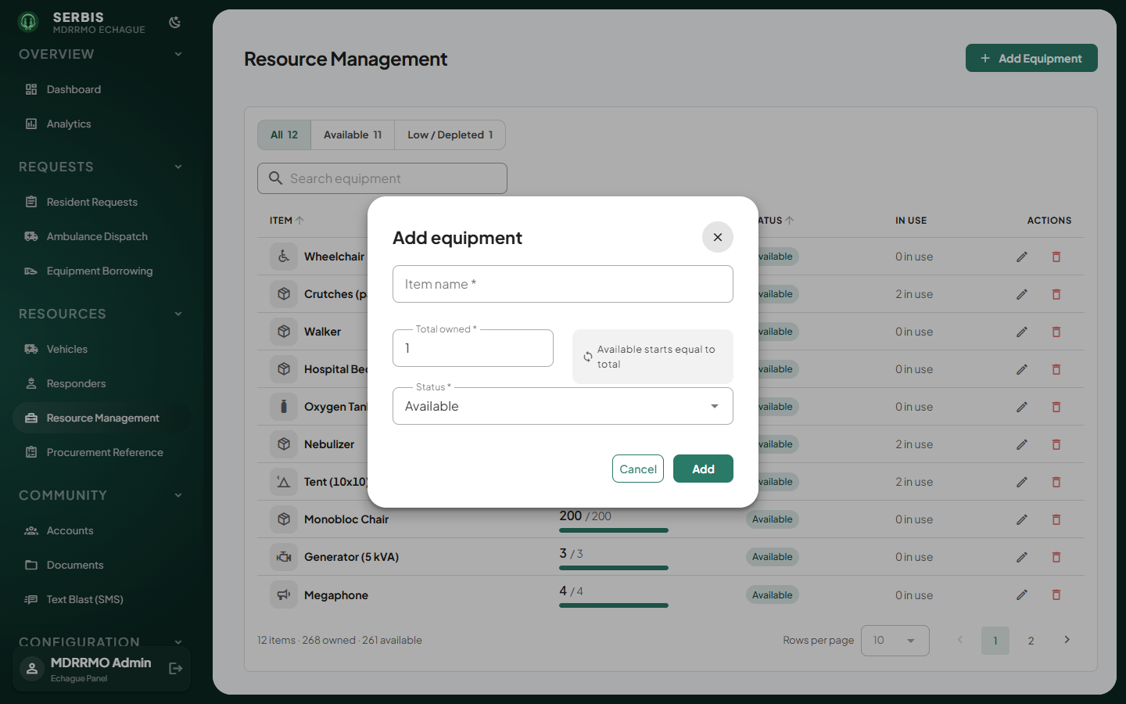
Add equipment

Procurement Reference
Borrow requests for items the catalogue does not carry. Read-only: use it to decide what to buy.
- Review the list of uncatalogued requests.
- Add any item you acquire in Resource Management. Only then can the request be released.
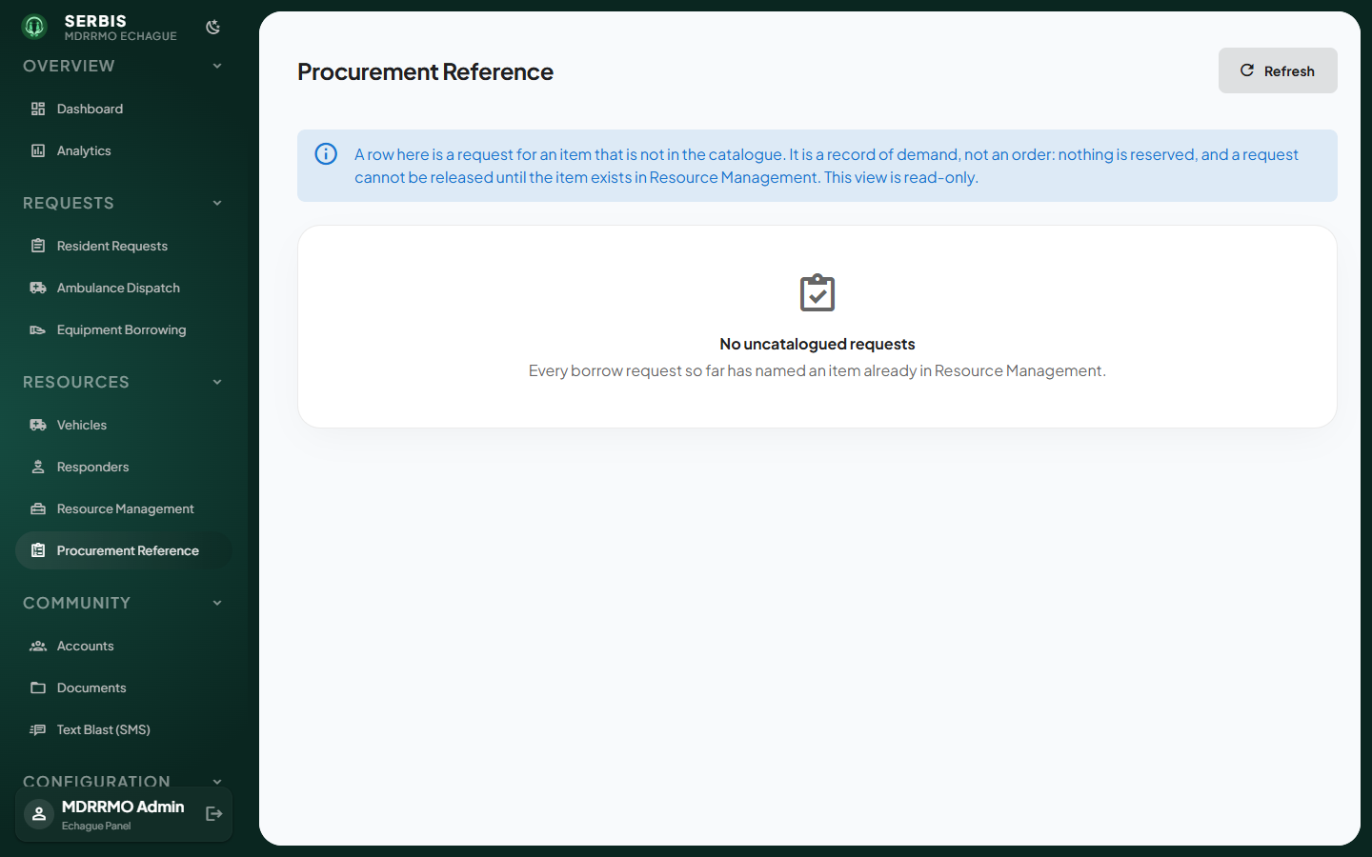
Procurement Reference

Community

Accounts
Resident accounts: heads of the family, barangays and organizations.
- Filter by account type, status or barangay, or search by name.
- Click a row to open the account.
- From the account, click Edit profile, Deactivate account or Delete account.
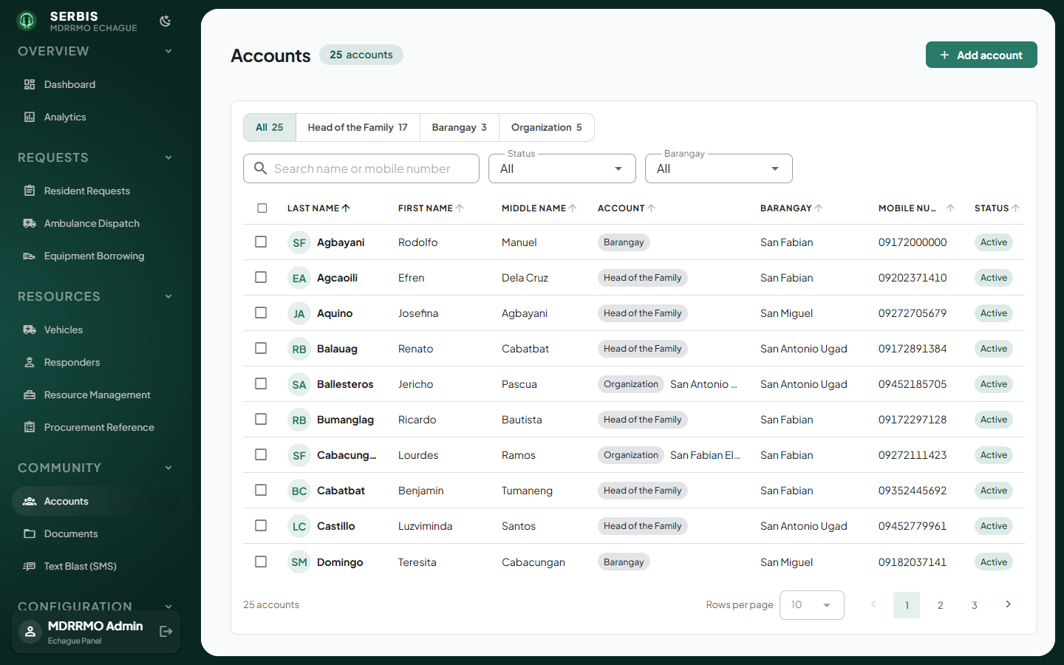
Accounts
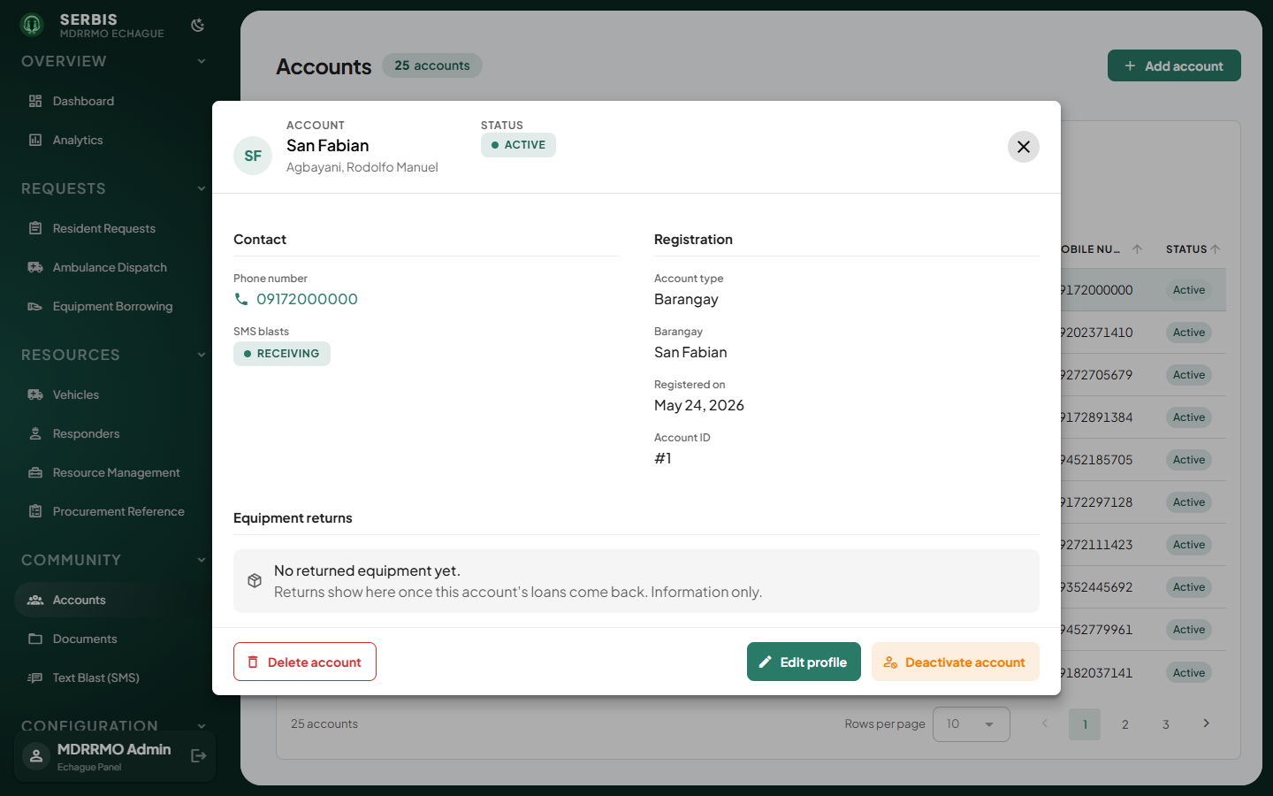
Account detail
To create an account for a resident, click Add account and fill in the form.
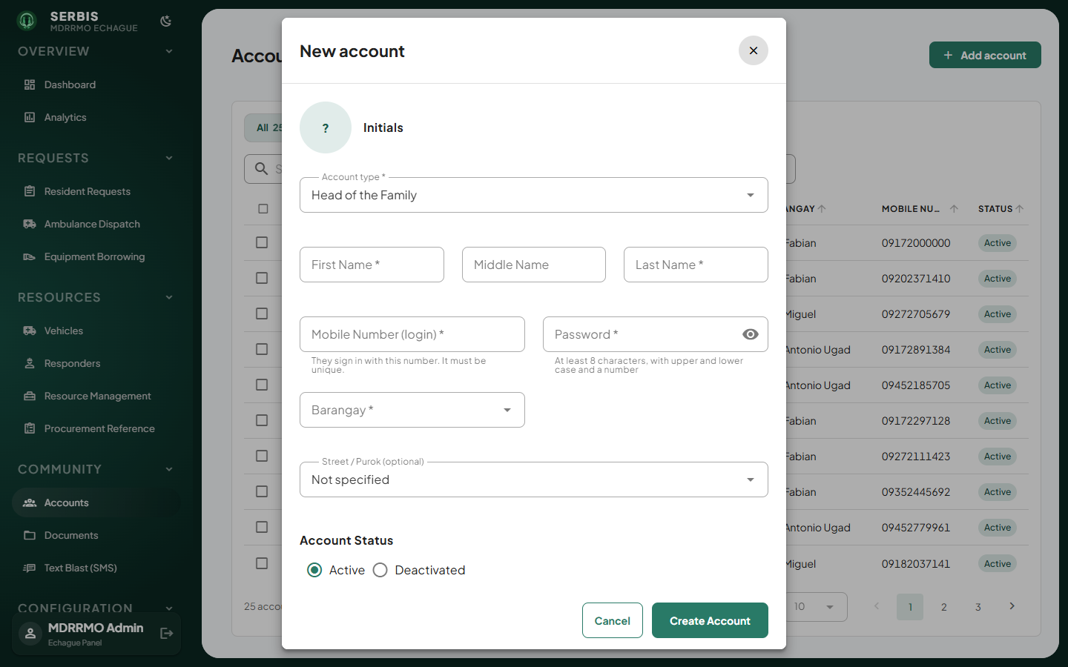
Add account

Documents
Files published for residents to download: PDFs and images up to 10 MB.
- Drop a file onto the upload box, or click it to browse.
- Click Mark verified once the file is checked.
- Use the actions column to open or delete a file.
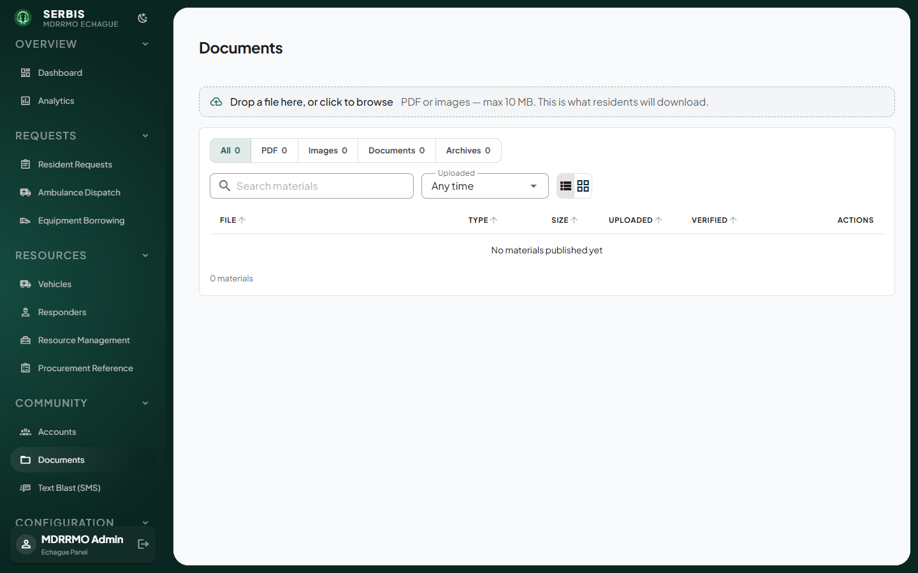
Documents

Text Blast (SMS)
Sends an SMS to every resident in the chosen barangays.
- Pick one or more barangays under Target audience.
- Choose a template or type the message. The segment count shows the cost.
- Click Send Blast, enter the 6-digit text blast code, and confirm.
- Check Recent blasts. A message is delivered only when it shows Sent.
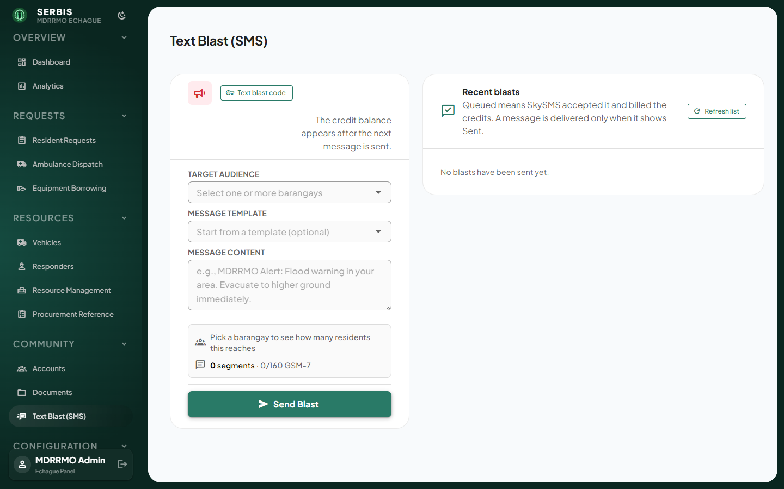
Text Blast
Click Text blast code to change the code that confirms each send.
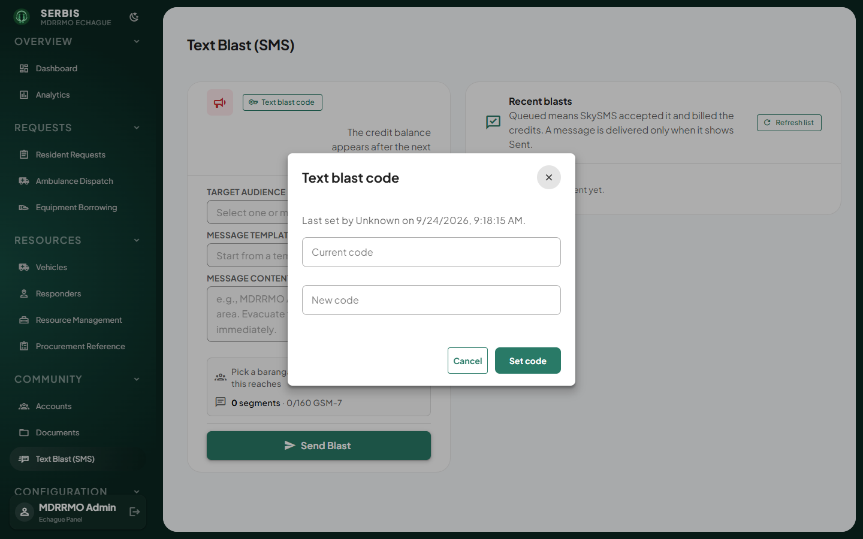
Text blast code

Configuration

Manage Services
The list of services residents can request. Service names and categories are fixed.
- Filter by status or category.
- Click a row to edit its description, then click Save changes.
- Use the eye icon to disable or re-enable a service.
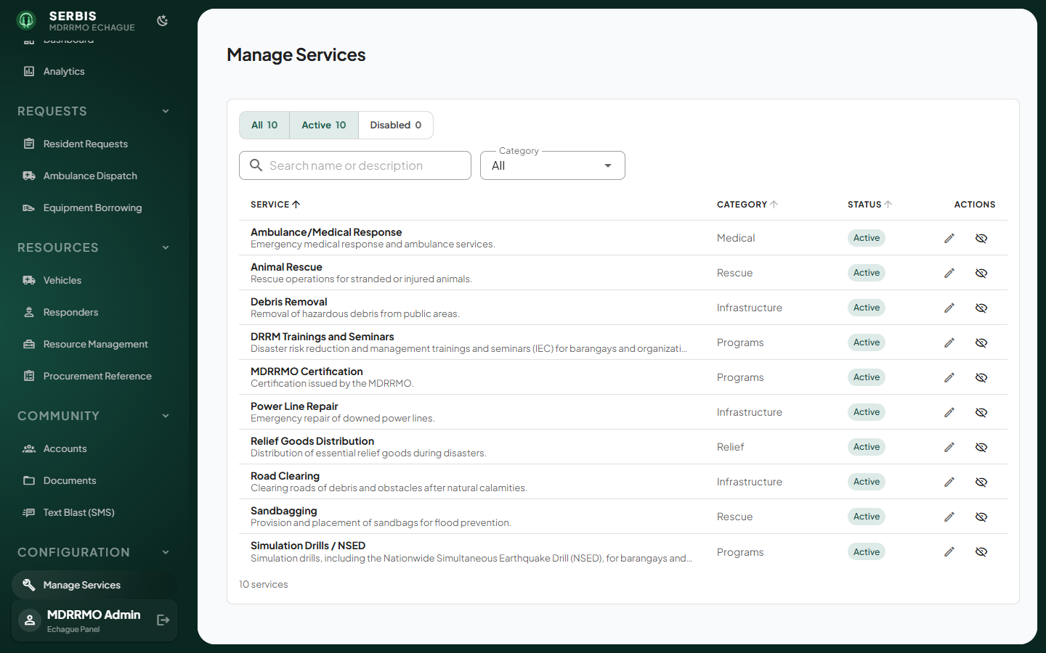
Manage Services
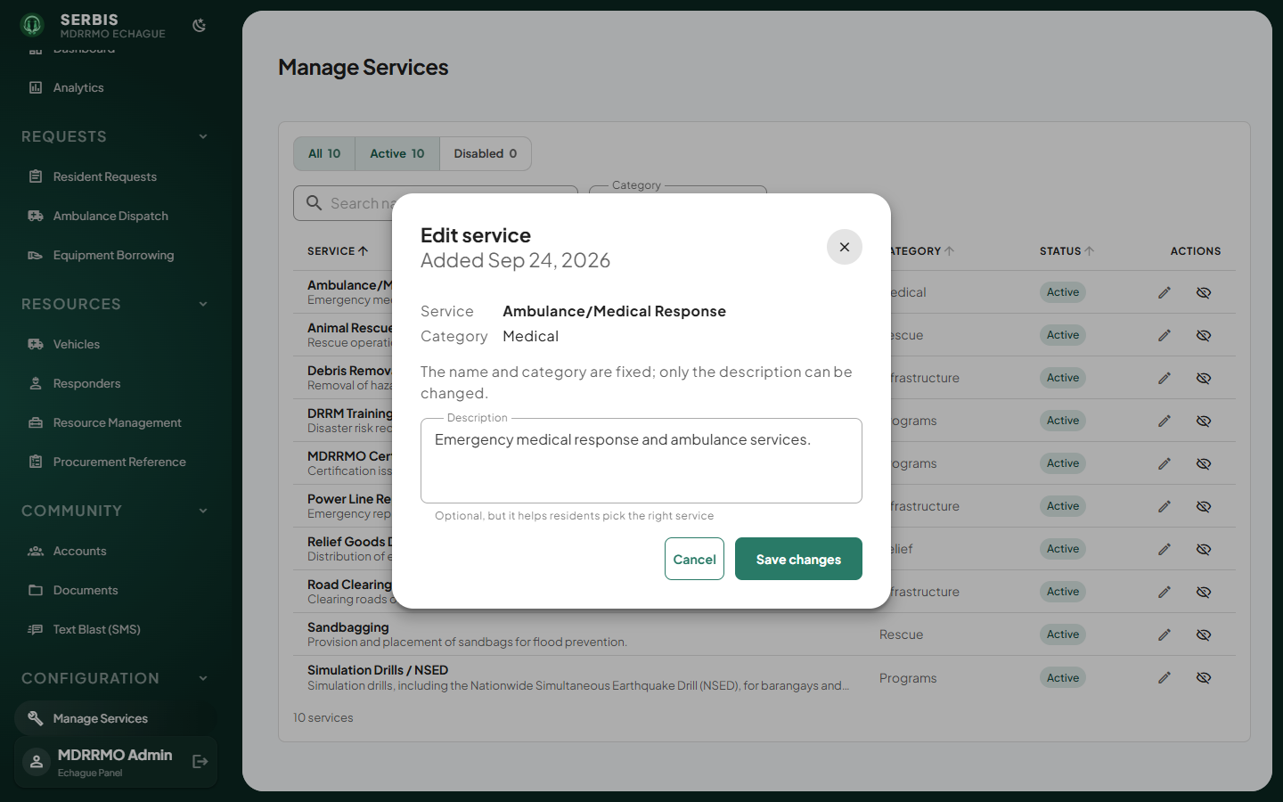
Edit service

Service Audience
Which account types can request each service.
- Tick or untick a box for each service and account type.
- An unticked service is hidden from that account type in the mobile app.
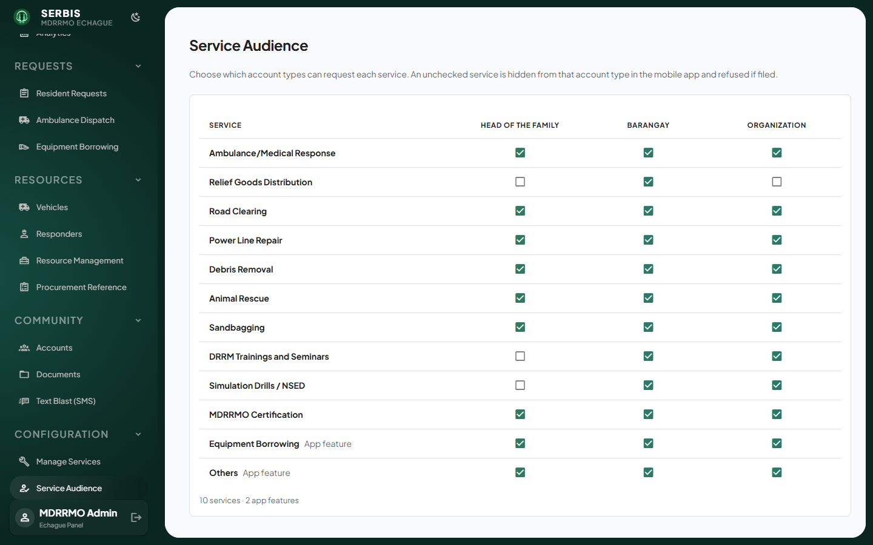
Service Audience

Service Vehicles
Which vehicle types can be sent on each service.
- Tick the vehicle types allowed for each service.
- Leave a row unticked to allow any available non-ambulance unit.
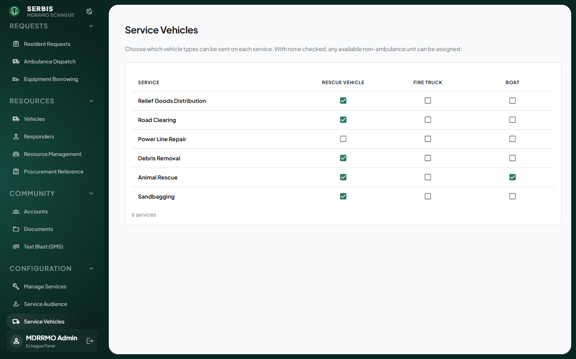
Service Vehicles

System

Staff Accounts (Super admin only)
Admin panel accounts and the pages each one can open.
- Click Add staff account, fill in the details and save. Pass the temporary password to the person; they must change it at first sign-in.
- Click Access on a row to choose which pages that account can open, then click Save access.
- Use Reset password if someone forgets theirs, and Close account when someone leaves.
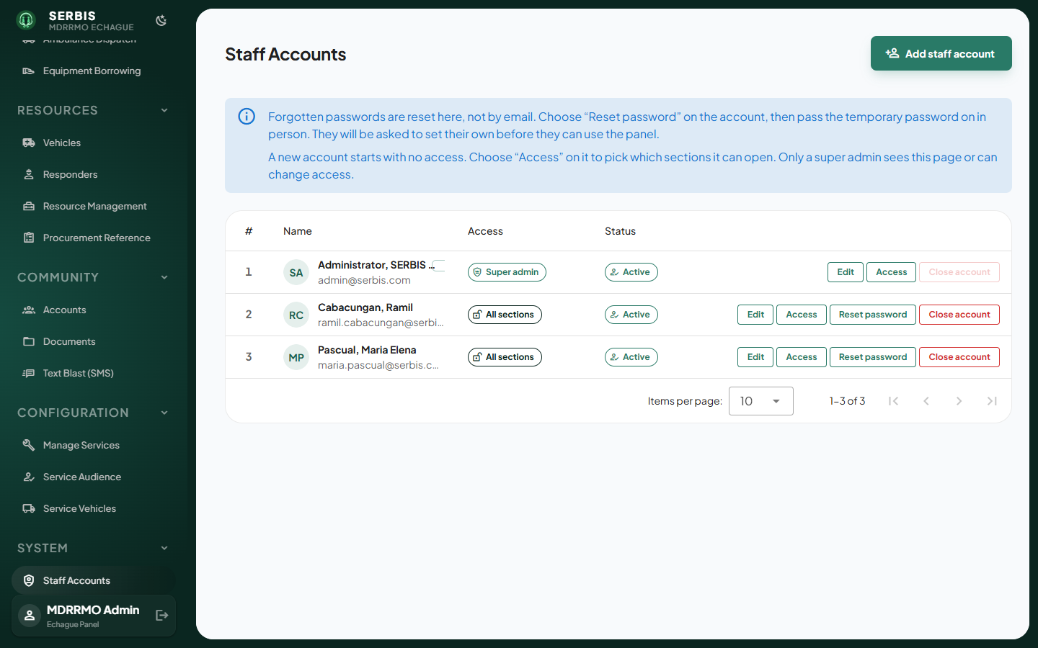
Staff Accounts
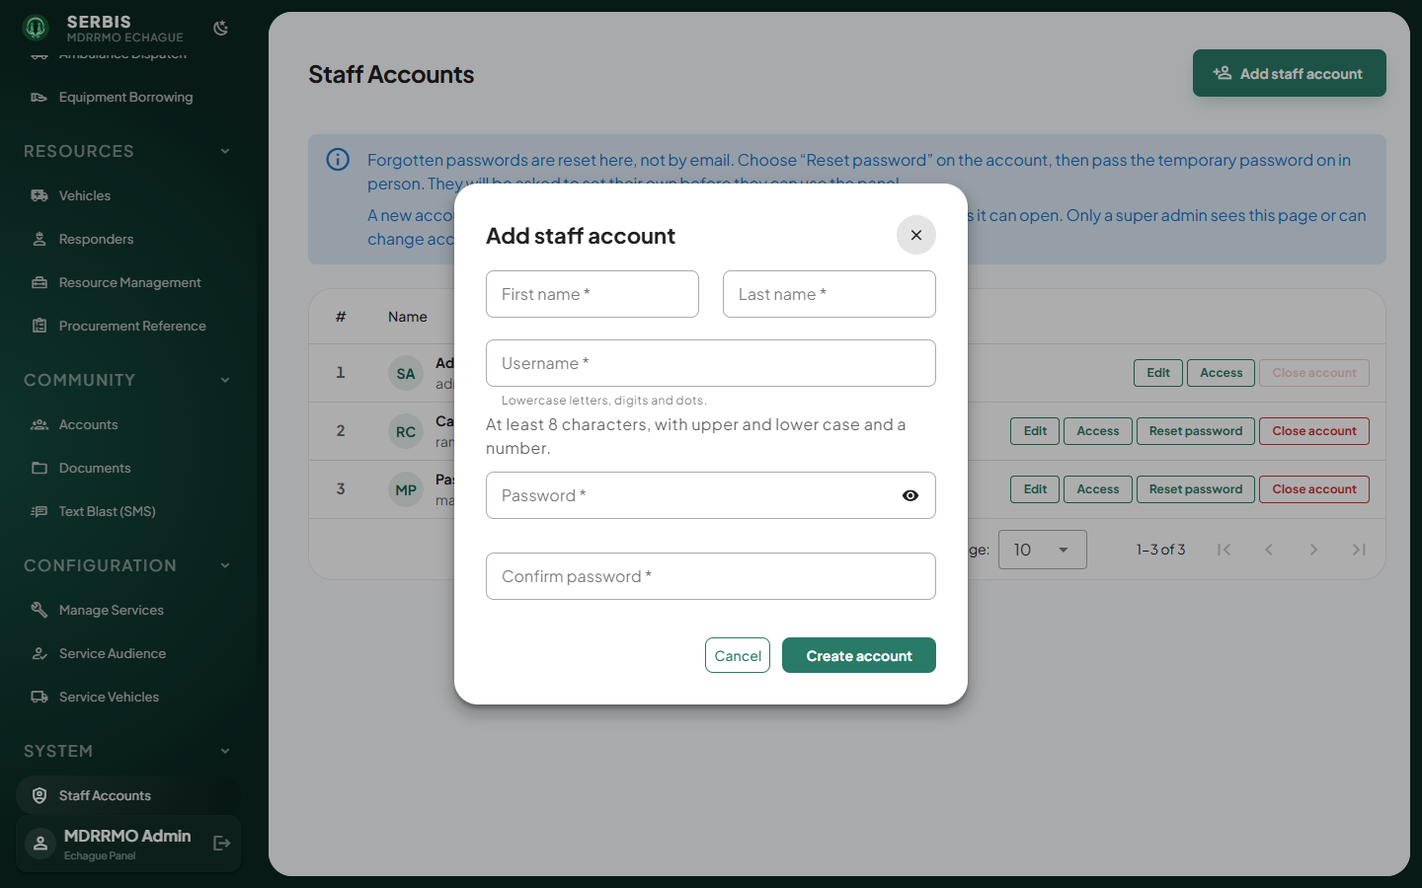
Add staff account
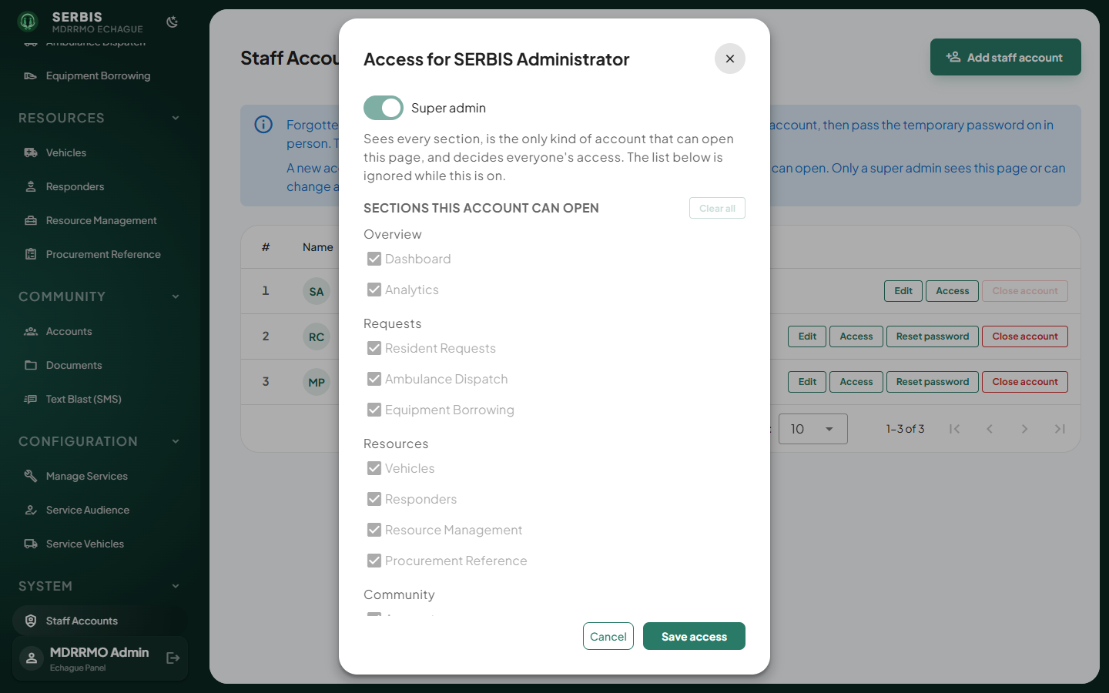
Access dialog

Activity Logs
A record of who did what, plus every SMS sent.
- Open System Activity for panel and app actions, or SMS History for sent messages.
- Type in Search logs… to find a name or record.
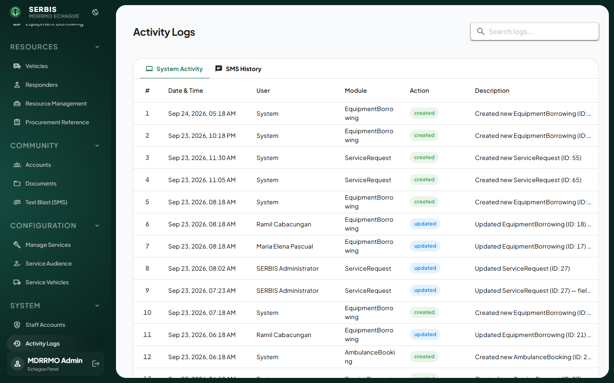
Activity Logs

