SERBIS: Development of a Record Management and Data Analytics System for MDRRMO to Enhance Service Request Monitoring and Decision-Making

A Capstone Project
Presented to the Faculty Members of the

ISABELA STATE UNIVERSITY
Echague Campus

In Partial Fulfillment of the
Requirements for the
Degree Bachelor of Science in Information Technology (BSIT)
With Specialization Track in Web and Mobile Application Development

By:
DE BELEN, EDUARD JOSEPH B.
FERRER, JILMAR CAESAR
VILLARTA, JAMBY

September 2026
CHAPTER I
INTRODUCTION
  - Project Context
Municipal Disaster Risk Reduction and Management Offices (MDRRMOs) operate continuously on a 24/7 basis, tasked not only with immediate disaster response but also with facilitating essential community services, including non-emergency medical transport and the deployment of medical equipment. In Echague, Isabela, the MDRRMO handles a steady volume of requests from various barangays for patient transfers and equipment lending
The Echague MDRRMO maintained an active deployment inventory comprising a 23-vehicle fleet, including 2 Type I ambulances, 11 Patient Transport Vehicles (PTVs), 2 rescue pickups, 2 fire trucks, and 6 specialized watercrafts, alongside extensive medical and rescue equipment such as oxygen tanks, stretchers, wheelchairs, and first aid kits. Despite managing an average of 20 service requests, previous coordination practices relied entirely on manual logging and unstructured communication. Equipment borrowing mandated a formal letter and a manual logbook entry, while transport requests were processed through phone calls and social media platforms like Facebook Messenger.
This manual approach created significant gaps in service delivery, particularly during peak days when regular transport runs overlapped with unexpected incidents. According to Chavula and Kayusi (2025), service systems in rural communities are frequently hindered by poor data accessibility and fragmented communication. In the context of the Echague MDRRMO, relying on manual processes for logistics resulted in specific operational bottlenecks:
- Fragmented Request Tracking: Processing medical transport and equipment requests across disparate channels (e.g., paper logs, social media) increased the risk of overlooked or delayed services, as there was no standardized logging method.
- Communication Inefficiencies: Relying on internet-dependent platforms left remote barangays vulnerable to communication delays when internet connectivity was unstable, complicating the coordination of vehicle dispatches.
- Inefficient Resource Management: Without digitized records, the office struggled to monitor the real-time availability and location of deployed medical equipment. Furthermore, the inability to analyze historical data prevented the MDRRMO from identifying recurring demand patterns or planning resource allocation from its own records.
To address these operational challenges, the researchers developed SERBIS, a Service Coordination System. The platform focuses specifically on streamlining non-emergency medical transport and medical equipment requests through a centralized web administrative dashboard and mobile application. By digitizing records and integrating SMS support to ensure residents have a reliable communication channel regardless of internet status, the proposed system aims to transition the MDRRMO from a fragmented manual process toward an organized, data-driven service management framework.
1.1.1 Purpose and Description
The primary purpose of this project was to enhance communication, service coordination, and data-driven decision-making between the Municipal Disaster Risk Reduction and Management Office (MDRRMO) and the residents of Echague. By providing a centralized system for information dissemination and service management, the project aims to improve the efficiency, accessibility, and organization of non-life-threatening disaster-related services.
The developed system, SERBIS, was designed as a cross-platform application composed of a web-based administrative panel and a mobile application for residents. The web-based admin panel enables MDRRMO personnel to manage and monitor service requests, generate reports, and send targeted SMS alerts to specific barangays. The SMS text blast feature allowed the dissemination of early warnings and important announcements even without internet connectivity, ensuring that critical information reaches residents in a timely manner.
On the user side, the mobile application allows residents to request non-life-threatening services from the MDRRMO's service catalogue, such as ambulance or medical transport, road clearing, debris removal, relief goods, sandbagging, power line repair, DRRM trainings, simulation drills, and MDRRMO certification; to book an ambulance; and to borrow equipment such as wheelchairs and oxygen tanks. The system provides a structured and centralized method of submitting and tracking requests, replacing informal channels such as phone calls, walk-ins, and social media messaging.
Furthermore, the system includes a data analytics feature that processes service request data to identify the most frequently requested services, determine which barangays have the highest number of requests, and analyze trends and frequency of service demand over time. These insights assist MDRRMO personnel in generating accurate reports, improving resource allocation, and supporting evidence-based decision-making.
Overall, SERBIS was developed to replace manual, disjointed, and unstructured processes with an integrated system that enhances communication efficiency, improves service monitoring, strengthens disaster response coordination, and supports data-driven governance within the MDRRMO.
1.1.2 Statement of the Problem
The Echague Municipal Disaster Risk Reduction and Management Office (MDRRMO) historically relied on manual, paper-based records and fragmented communication channels to manage an average of 20 service requests. This decentralized approach results in significant delays in service processing, lack of data security for sensitive resident information, and an inability to analyze service trends for better resource allocation. There was a critical need for a centralized digital system that could streamline coordination, secure data, and provide actionable insights through analytics.
This study aimed to develop, implement, and evaluate SERBIS, a Disaster Communication and Service Coordination System, to address these operational bottlenecks.
Specifically, this study seeks to answer the following questions:
- How does the system improve the efficiency of processing of the citizens requests for emergency equipment (e.g., ambulance, wheelchairs, oxygen tanks) particularly for non-life-threatening cases, compared to manual methods in terms of processing time, response time, and task completion rate?
- How does the implementation of data analytics provide an accurate categorization of availed services by barangay and type of case to support MDRRMO decision-making?
- In what way does the integration of multi-factor authentication (MFA) address the security gap in protecting sensitive resident data and preventing unauthorized access to the system?
- How accurate is the SMS notification delivery of the system in terms of successful transmission, correct recipient targeting, and timeliness?
- What is the level of information quality of the offline safety information materials provided in the mobile application in terms of accuracy, relevance, completeness, and clarity?
- What is the extent of end-users’ and technical experts’ acceptance of the system based on ISO/IEC 25010 standards in terms of:
  - functional suitability
  - compatibility
  - interaction capability
  - security
  - flexibility
1.2 Objectives of the Project
The primary objective of this project is to design, develop, and implement SERBIS, a web and mobile-based disaster communication and service coordination system for the MDRRMO of Echague, Isabela.
- To design and develop a centralized system architecture that integrates a web-based dashboard and a mobile application to improve service request processing by:
- reducing average processing time by at least 30%, and
- achieving at least 90% task completion rate within the expected time frame.
- To implement an SMS Gateway integration as a redundant communication framework for low-connectivity areas, aiming for:
· at least 95% successful delivery rate,
· 98% correct recipient targeting rate, and
· 90% on-time delivery rate.
- To implement multi-factor authentication (MFA) to enhance system security by protecting sensitive resident data and preventing unauthorized access.
- To develop a Data Analytics and Reporting module that converts raw request data into structured insights, targeting at least 95% data accuracy across categories when compared to the records stored in the system database.
- To assess the information quality of offline safety materials in the mobile application in terms of accuracy, relevance, completeness, and clarity.
- To determine functional performance and acceptability of the developed system based on ISO/IEC 25010 quality characteristics, aiming for an overall mean rating of at least 4.0 out of 5 across:
- functional suitability
- compatibility
- interaction capability
- security
- flexibility
1.3 Scope and Limitations
The scope of this study focuses on the design, development, and implementation of a web- and mobile-based system for the Municipal Disaster Risk Reduction and Management Office (MDRRMO) of Echague. The developed system includes a web-based administrative panel for MDRRMO personnel to manage service requests, generate reports, and send targeted SMS announcements to residents in specific barangays.
For the public, the system provides a mobile application for Android devices that allows registered accounts to submit non-life-threatening service requests from the MDRRMO's service catalogue (such as medical transport, road clearing, and relief goods), book an ambulance, borrow equipment, track and cancel their requests, read offline safety guides and emergency hotlines, and receive advisories. Three account types are supported: Head of the Family, Barangay, and Organization. Organization accounts can file requests only after the MDRRMO activates them, and the office sets which services each account type may request. The system also includes a data analytics module that generates summaries and reports on service request frequency, types of services requested, and barangay-based request distribution to support MDRRMO decision-making and service monitoring. The analytics are descriptive: they summarize past records and do not forecast demand.
To address the security gaps of the previous manual system, the platform applies Role-Based Access Control (RBAC): a super administrator grants each MDRRMO staff account access only to specific sections of the administrative panel. Passwords are stored as bcrypt hashes, never in plain text. Data in transit between the mobile application, the web panel, and the server is protected by HTTPS (TLS). Multi-Factor Authentication (MFA) adds a second step after the password: residents enter a one-time code sent by SMS when they register and every time they log in, and MDRRMO staff enter a one-time code sent by SMS to their registered phone after entering their username and password.
This study had specific technical boundaries and limitations. First, the system’s ability to send text messages is entirely dependent on third-party SMS gateway providers; if the provider’s service is interrupted, the alert module will be affected. Second, the system faces network reliability issues during disasters, as cellular signals may weaken or fail during extreme weather events, which could delay message delivery. Third, the mobile application needs an internet connection to register, log in, file, book, borrow, or cancel; without a connection it shows only the cached records, the hotline list, the built-in safety guides, and downloaded materials. The mobile application is built for Android only. Fourth, the analytics module is descriptive and does not forecast future demand. Finally, while the platform includes data privacy and security measures through login authentication and basic encryption, it does not include advanced biometric security or enterprise-level threat detection systems.
As part of the future work for this system, the researchers recommend adding a feature for Evacuation Center Mapping. This would allow the mobile app to show residents the location of the nearest evacuation centers based on their current area, helping people find safe zones more quickly without needing to call an emergency hotline.
1.4 Significance of the Project
This study contributes to the advancement of local government digital services through the application of E-Governance and Community Informatics. By implementing a research-based communication platform, the results of this project offer the following practical and academic benefits:
E-Governance Systems. This project serves as a model for local e-governance by demonstrating how municipal offices can transition from traditional, non-integrated workflows to a centralized digital ecosystem. It highlights the role of "G2C" (Government-to-Citizen) interaction in improving public trust through transparency in service tracking. By digitizing record management and reporting, the system promotes administrative accountability and provides a scalable framework for other local government units (LGUs) aiming to modernize their public service delivery.
ICT Innovation in Disaster Management. The study introduces a technical innovation by addressing the "digital divide" in disaster communication. While most modern systems rely heavily on high-speed internet, this project integrates hybrid communication channels combining web-based data analytics with SMS gateway services. This ensures that ICT remains functional even in "last-mile" areas with limited connectivity. Furthermore, the integration of a Data Analytics module represents an innovation in municipal disaster management, moving the MDRRMO from undocumented, case-by-case handling to decisions based on its own recorded service data.
Municipal Disaster Risk Reduction and Management Office (MDRRMO). The project supports administrative efficiency by transitioning manual record-keeping into a structured digital tracking system. It provides the office with a specialized communication tool designed to meet target metrics, such as reducing alert transmission time and increasing the reliability of information delivery to residents in areas with limited internet connectivity.
Local Residents. Citizens are provided with a dedicated and structured channel for requesting non-life-threatening services such as medical transport, road clearing, and relief assistance. The system also ensures that residents receive timely updates and important information through SMS notifications, especially in situations where internet connectivity is limited.
Emergency Responders and ICT Administrators. For responders, the system allows organized coordination and prioritization of service requests, improving response efficiency. For ICT administrators, the study provides a technical reference for integrating SMS gateway services with a web and mobile platform to support continuous communication during network disruptions.
Policy Makers and Local Government Units. This study serves as a reference for improving transparency and efficiency in local governance. It demonstrates how digital systems can support structured service delivery, communication, and reporting, which may be adapted by other municipalities to enhance disaster management operations.
Barangay Officials. The system assists barangay officials by ensuring that accurate and timely information from the MDRRMO is directly communicated to their respective areas, reducing reliance on manual coordination and improving response organization at the local level.
Future Researchers. This study contributes to the literature on Disaster Information Systems by providing a framework for integrating service request management, SMS-based communication, and data analytics. It also identifies specific areas for further study, such as the use of automated alert prioritization and the integration of Geographic Information Systems (GIS) for evacuation mapping.

CHAPTER III
METHODOLOGY
This chapter outlines the methodology utilized in the development of the system SERBIS: Development of a Record Management and Data Analytics System for MDRRMO to Enhance Service Request Monitoring and Decision-Making for the Municipal Disaster Risk Reduction and Management Office (MDRRMO) of Echague. This covers the research design, system development methodology, tools, participants, data gathering instruments, procedures, and data analysis techniques that were used by the researchers.
3.1 Research Design
This study utilized a developmental research design, which focused on the systematic study of design, development, and evaluation processes to create effective solutions for real-world problems (Richey & Klein, 2014). This approach was selected because the study aimed to develop SERBIS, a Record Management and Data Analytics System designed to enhance service request monitoring and operational efficiency for the Municipal Disaster Risk Reduction and Management Office (MDRRMO) of Echague, Isabela. The current workflows are often manual and uncoordinated, which hinders the MDRRMO’s ability to analyze service request trends and generate the data-driven insights necessary for effective decision-making.
The proposed system was designed to incorporate a web administrative dashboard for MDRRMO personnel and a mobile application for residents. Through these digital platforms, the system was configured to support targeted SMS broadcasting, resident profile management, and automated service request tracking. A core feature of this architectural framework was the Data Analytics module, which processes digital records to visualize service frequency and barangay-based distribution. This allows the MDRRMO to manage citizen concerns in a highly organized manner while utilizing real-time analytics to improve resource allocation and ensure that municipal responses are prioritized based on actual demand and evidence-based insights.
To execute this systematically, the methodology adopts the Input-Process-Output (IPO) model (as shown in Figure 1), which is structured as follows:
Figure 1
The Input-Process-Output (IPO) model
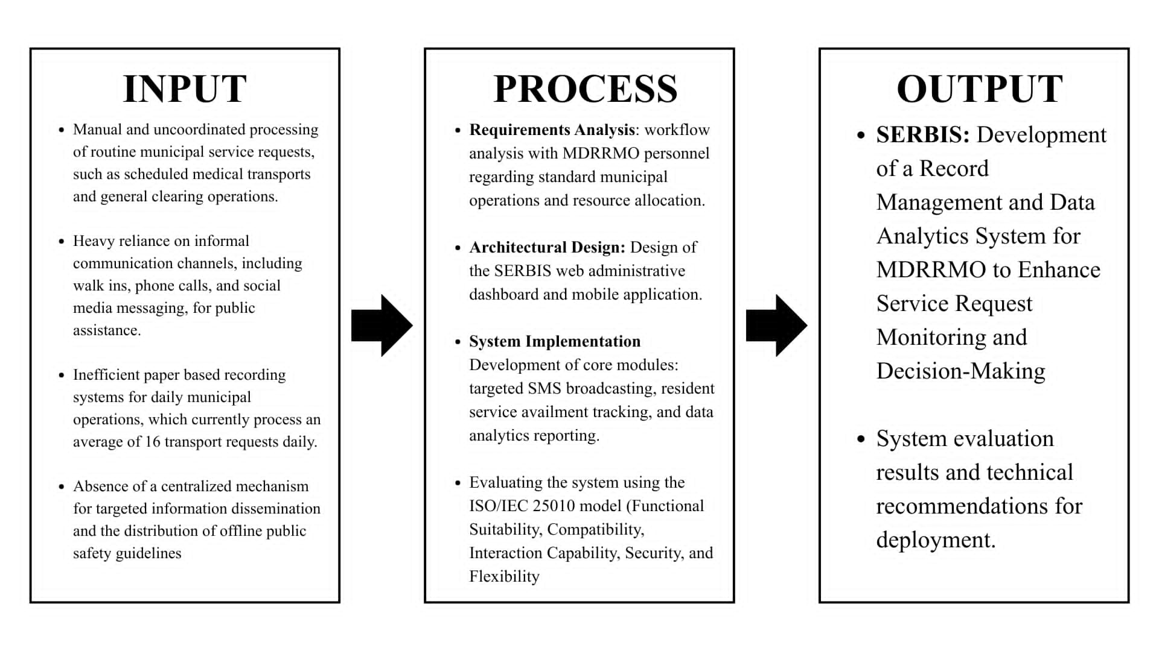
- Input: This phase identified foundational requirements based on the current manual and uncoordinated processing of municipal service requests and the heavy reliance on informal communication channels. It accounted for the inefficient paper-based recording system, which handles an average of 16 transport requests daily, and integrated the hardware and software tools (Laravel, Vue 3, Flutter, MySQL) required to build a centralized solution.
- Process: The study adopted the Rapid Application Development (RAD) model. This involved conducting a workflow analysis with MDRRMO personnel, designing the architectural framework, and implementing core modules including targeted SMS broadcasting, service request tracking, and data analytics reporting. Finally, the system undergoes an evaluation phase using the ISO/IEC 25010 model to test functional suitability, compatibility, interaction capability, security, and flexibility.
- Output: The output phase resulted in the functional prototype of SERBIS: Development of a Record Management and Data Analytics System for MDRRMO to Enhance Service Request Monitoring and Decision-Making. This web and mobile platform included the system evaluation framework and technical recommendations for its deployment in the municipality of Echague.
At the end of the development process, the system was designed to undergo technical testing and user evaluation to determine whether it performed its intended functions and whether it is suitable for actual use in a municipal disaster response setting. The study established framework to evaluate the system based on selected quality characteristics under the ISO/IEC 25010 software quality model, specifically functional suitability, compatibility, interaction capability, security, and flexibility.
3.2 System Development Model
The proponents adopted the Rapid Application Development (RAD) model in developing SERBIS This model is selected for its emphasis on iterative prototyping and continuous user feedback (Nalendra, 2021), which is essential for aligning the system with the operational workflows of the Echague MDRRMO.

Figure 2
The Rapid Application Development (RAD) Diagram
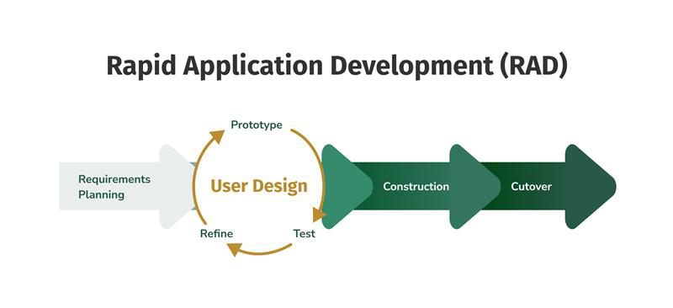
Figure 2 illustrates the RAD framework applied to this study. The process is structured into four sequential phases, emphasizing a cycle of design, build, and refine.
3.2.1 Requirements Planning
In this phase, the researchers conducted structured interviews and workflow analysis with MDRRMO personnel. The objective was to map current communication bottlenecks and define the functional requirements for the SERBIS platform. This consultation ensures that the development of core modules—such as targeted SMS dissemination and offline safety access—was grounded in the actual operational needs of the municipality.
3.2.2 User Design
The researchers translated the gathered requirements into interactive wireframes and prototypes using Figma. This phase involved an iterative feedback loop where MDRRMO personnel reviewed the layout of the dashboard and mobile interfaces. By planning the web layout around Vuetify's Material Design components at this stage, the researchers ensured the system’s navigation aligns with user workflows before the coding phase begins.
3.2.3 Rapid Construction
During this phase, the researchers executed the technical development of the system using Laravel for the backend, Vue 3 with Vuetify for the web administrative panel and Flutter for the mobile application. This involves:
- Software Architecture: The system adopted a Client-Server Architecture. The backend was built using Laravel (PHP) as a RESTful API provider, while the frontends consisted of a Vue 3 and Vuetify web dashboard and a Flutter-based mobile application. This structure enabled both platforms to consume the same data sources simultaneously.
- Database Design: A relational database schema was developed using MySQL. The design utilized Eloquent ORM for database abstraction, maintaining data integrity through foreign key constraints and structured relationships between resident profiles, service requests, and SMS logs.
- API Integration and Communication: Frontend-backend communication was facilitated through JSON (JavaScript Object Notation) over HTTPS. The mobile app and web panel interact with the backend via a series of protected REST API endpoints, utilizing Bearer Token authentication issued by Laravel Sanctum to secure data transmission.
- Module Integration: The SMS Gateway was integrated using an external API service, allowing the system to send one-time verification codes, ambulance booking reminders, and targeted text blasts through SkySMS, while Firebase Cloud Messaging delivers in-app push notifications when a request or borrowing changes status. Simultaneously, the Data Analytics engine was programmed to execute aggregate queries on the MySQL records, converting raw data into formatted arrays for visualization.
- Synchronization and Deployment: Unit and integration testing were performed to verify that data submitted via the Flutter mobile app reflected accurately on the Laravel web dashboard. Automated backend and mobile test suites ran on every push through GitHub Actions. Development was done in a local environment (XAMPP) before deployment, where the API runs as a Docker container on Railway and the web panel is hosted on Vercel.
3.2.4 Cutover
The final phase was designed to focus on the formal transition and evaluation of the system. The established procedures for this phase were structured as follows:
- Operational Validation: A validation protocol was designed for MDRRMO personnel to perform hands-on tasks, using the administrative dashboard and mobile application, ensuring system readiness for live data handling.
- System Evaluation: An evaluation instrument based on the ISO/IEC 25010 quality model was established to collect quantitative data on the system’s functional suitability, compatibility, interaction capability, security and flexibility via a Likert-scale questionnaire.
- Refinement: A post-evaluation refinement procedure was outlined to incorporate technical optimizations, performance tuning, and final interface polish based on user feedback prior to full deployment.
3.2.5 Rationale for Selecting RAD over other SDLC Models
While several models were considered, RAD was selected for its balance of speed and user-centricity:
- Comparison with Waterfall: The Waterfall model was rejected because its linear and non-iterative structure makes it difficult to accommodate technical adjustments once development commences. Within the context of municipal service coordination, where specific user requirements often emerge during the evaluation phase, the inability to backtrack in a Waterfall framework poses a significant risk to the project utility.
- Comparison with Agile: While Agile also supports iterative growth, RAD is preferred here due to its specific focus on prototyping as the primary means of communication between developers and the MDRRMO.
3.2.6 Risks and Limitations of the RAD Model
Despite its advantages, the proponents acknowledged and have planned for the following limitations:
- Dependency on User Availability: The success of the RAD model relied heavily on the frequent availability of MDRRMO personnel for feedback. To mitigate this, a clear consultation schedule was established during the Requirements Planning phase.
- Scope Creep: Due to the iterative nature of feedback, there is a risk of adding too many features. The proponents strictly adhered to the "Core Features" defined in the Scope and Limitations to ensure timely delivery.
To maintain the development process organized, the researchers followed a structured sequence of requirements gathering, prototype design, module construction, testing, and final system deployment. The phases of RAD guided the development of the system from initial planning until the final release.

Table 1
RAD Phases and Outputs
RAD Phase | Main Activities | Tools & Technologies | Expected Output
Requirements Planning | Conducted interviews, consultations, and workflow analysis | MS Word, Flowcharts | Documented system requirements and feature specifications
User Design | Created wireframes, planned interfaces, and reviewed prototype layouts | Figma, Vuetify | Approved interface prototypes and system layout.
Rapid Construction | Executed code implementation, database modeling, module integration, and verification testing | Laravel, Vue 3, Flutter, MySQL, SkySMS API | Working system modules and integrated application prototype.
Cutover | Established the system evaluation framework, outlined testing procedures, and structured deployment recommendations | Git/GitHub, ISO 25010 Instrument | Functional SERBIS prototype and evaluation protocol

The outcome of this development phase was a functional SERBIS prototype designed to support centralized record management, data-driven decision-making, and streamlined service request monitoring for the municipality of Echague.
3.3 Participants/Respondents
The participants of this study consisted of MDRRMO personnel and selected residents of Echague, Isabela. MDRRMO personnel were designated to serve as the primary evaluators of the web administrative dashboard, while residents were selected to evaluate the mobile application in terms of usability, accessibility, and utility in municipal service coordination. Because the system was intended for both administrative management and community level use, the respondents were structured to represent both operational and end user perspectives.
3.3.1 Population and Sampling Justification
The study utilized a total sample of 63 participants. To ensure the SERBIS system was tested against the diverse geographical and connectivity conditions of Echague, the 50 resident respondents are purposefully selected from three distinct regions:
- San Miguel (Forest Region): 17 participants
- San Antonio Ugad (Southern Region): 17 participants
- San Fabian (Highway Region): 16 participants
The selection of 50 residents across the designated zones is established through a purposive sampling approach to ensure the formal evaluation reaches statistical saturation for a localized municipal study. While earlier models like Nielsen and Landauer (1993) are primarily used for identifying usability defects in small groups, this study utilizes a larger sample of 50 to provide a clearer methodological basis for the quantitative assessment of interaction capability. According to Roscoe’s Rule of Thumb (Sekaran & Bougie, 2016), sample sizes between 30 and 500 are considered sufficient for most research utilizing descriptive statistics, ensuring that the calculated weighted means are stable and representative of the community's perception. This participant count is further supported by the research of Hwang and Salvendy (2021), who emphasize that a larger pool is necessary to ensure the reliability of results when evaluating software quality characteristics in community-based platforms. Furthermore, Al-Zahrani et al. (2022) established that 50 respondents provided an adequate data snapshot to judge the effectiveness and information quality of emergency applications within a local town, ensuring that the feedback collected was comprehensive enough to represent the diverse technical proficiencies of the residents of Echague.
Purposive sampling was applied because the study required respondents with specific roles: IT experts for technical validation, MDRRMO staff for emergency management, and family heads from the selected barangays. Family heads are chosen as they act as the primary representatives for household-level communication. Their feedback determined if the mobile application was accessible and useful for the community, regardless of their location within the municipality.
3.3.2 Inclusion and Exclusion Criteria
To maintain the integrity of the evaluation, the following criteria were established:
- Inclusion Criteria
  - MDRRMO Personnel must be full-time employees involved in operations or administration.
  - Residents must be permanent residents of the selected barangays, recognized heads of the family, and active mobile phone users.
  - IT Validators must hold an IT-related degree with at least one year of technical experience.
- Exclusion Criteria: Non-residents of Echague.
  - Individuals with no experience using mobile applications or smartphones.
Table 2
Participant Type | Role in Study | Sampling Method | Number
MDRRMO Personnel | Admin system evaluation | Purposive sampling | 11
Residents (Family Heads) | Mobile application testing | Purposive sampling | 50
IT Validators | Evaluate technical functionality and system correctness | Purposive sampling | 2
Total |  |  | 63
Role of Respondents

3.3.3 Role of the Respondents
MDRRMO Personnel: The head and staff of the Municipal Disaster Risk Reduction and Management Office (MDRRMO) will participate in evaluating the administrative functions of the web administrative dashboard. A total of eleven (11) MDRRMO personnel were selected utilizing purposive sampling, as they are directly involved in targeted information dissemination, process of resident service requests, and public service monitoring. They will rate the administrative panel on all five ISO/IEC 25010 characteristics and the information quality of the analytics reports, and will comment on its alignment with existing administrative workflows. Their participation is important to ensure that the platform effectively supports the actual operational procedures of the municipality.
Residents: The primary users of the mobile application consisted of family heads residing in the municipality of Echague. Each family head represents their household, and will rate the mobile application on the five ISO/IEC 25010 characteristics and the information quality of the offline safety materials, covering service requests, equipment borrowing, ambulance booking, service request tracking, and access to offline disaster information. For the system evaluation, a total of fifty (50) resident participants were selected from three representative barangays: San Miguel (Forest Region), San Antonio Ugad (Southern Region), and San Fabian (Highway Region).
This geographical distribution, comprising 17 participants from San Miguel, 17 from San Antonio Ugad, and 16 from San Fabian— allows the researchers to gather feedback from diverse users operating in different environmental conditions and network signal strengths. This target approach ensures that the evaluation captures the system’s performance in both urbanized and remote settings while remaining manageable within the study’s logistical constraints.
IT Validators - Two (2) IT validators will be invited to assess the technical aspects of the system, including functional correctness, data exchange between the web panel and the mobile application, security controls, and flexibility. Their evaluation will help ensure that the system operates correctly and that the implemented features meet technical standards and system requirements.
3.3.4 Ethical Considerations and Data Privacy
The proponents will strictly adhere to the Data Privacy Act of 2012 (RA 10173) to protect participant information:
- Informed Consent: All participants will be briefed on the study's objectives and will sign a consent form acknowledging their voluntary participation.
- Confidentiality: Personal identifiers will be coded or anonymized, and data will be reported in aggregate form only.
- Data Security: All collected survey data and system logs will be stored in a password-protected repository and destroyed after the study's completion.
All participants are expected to contribute feedback throughout the development phase, and also in the formal evaluation system based on the ISO/IEC 25010 quality standards upon the completion of the project.
3.4 Data Gathering Instruments
The main instrument for data gathering will be a structured questionnaire based on the ISO/IEC 25010 software quality model. This questionnaire will be used to evaluate the SERBIS system in terms of functional suitability, compatibility, interaction capability, security, and flexibility. The use of this standard ensures that the system will be assessed using recognized software quality characteristics that reflect its overall performance, usability in interaction, and technical reliability. The questionnaire format was adapted from a prior capstone study under the same adviser [cite the study]. Each respondent group receives its own version: the statements describe only the parts of the system that group uses, while all three versions share the same five characteristics and sub-characteristics, so the means are compared at the characteristic level. A separate part rates information quality in terms of accuracy, relevance, completeness, and clarity. Each copy carries a respondent code in place of the respondent's name: R-01 to R-50 for residents, M-01 to M-11 for MDRRMO personnel, and I-01 to I-02 for IT validators.
3.4.1 Operationalization of ISO/IEC 25010 Criteria
The questionnaire will be given to MDRRMO personnel, residents, and IT validators after they have used the system, including features such as SMS alerts, service request management, and access to system functionalities across web and mobile platforms.

Table 3
Sample Questionnaire Items and Operationalization
Category | Operational Definition | Sample Survey Item
Functional Suitability | The degree to which the system provides functions that meet the specified needs of the MDRRMO and residents. | “Text blasts are sent only to the barangays selected." (MDRRMO personnel)
Compatibility |  | "A request submitted in the app reaches the MDRRMO without delay." (Residents)
  The ability of the web portal and mobile app to exchange data and operate in a shared environment.
Interaction Capability | The ease with which diverse users can recognize, learn, and operate the system's interface. | "I can tell right away where to file a request or view an announcement." (Residents)
Security | The system's ability to protect information and ensure data is traceable to authorized users. | "Staff can only access the functions allowed for their role." (MDRRMO personnel)
Flexibility | The system's ability to adapt to different devices and handle an increasing volume of data. | “New services and categories can be added without changing the code." (MDRRMO personnel)

Figure 3
ISO/IEC 25010 Evaluation Framework for SERBIS
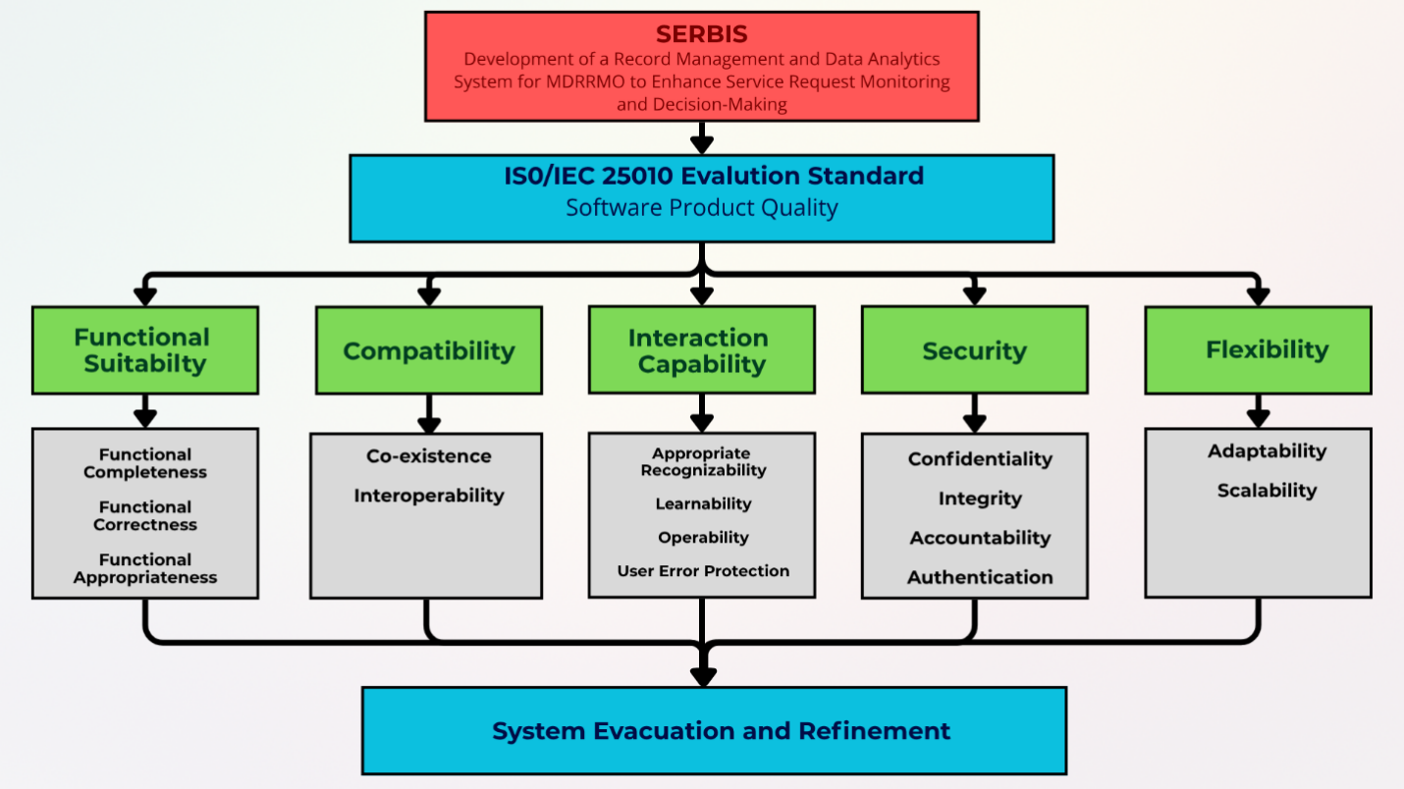
Figure 3 illustrates that the SERBIS system will be evaluated using the ISO/IEC 25010 software quality model. The evaluation will focus five primary quality characteristics that are directly relevant to the proposed system: Functional Suitability, Compatibility, Interaction Capability, Security, and Flexibility. These characteristics were selected because they reflect the most critical operational requirements of a municipal disaster communication and service coordination platform. They ensure that the system can deliver accurate information, support cross-platform accessibility, provide effective user interaction, protect sensitive data, and operate in different environments used by MDRRMO personnel and residents.
- Functional Suitability:
Functional Suitability ensures the system provides the tools necessary for disaster coordination.
- Functional Completeness - Confirms all required features (SMS, reporting, requests) are present.
- Functional Correctness – Validates that the system provides accurate data outputs (e.g., correct barangay counts).
- Functional Appropriateness – Evaluates how well the functions facilitate the specific emergency tasks of the MDRRMO.
- Compatibility:
Compatibility assesses how well the platform integrates across different interfaces.
- Interoperability – Measures how seamlessly the web portal and mobile app exchange data.
- Co-existence –Verifies the app operates efficiently alongside other applications on a user's smartphone.
- Interaction Capability:
Interaction Capability focuses on the user experience for both residents and staff.
- Appropriate Recognizability - Determines if users can immediately identify how to file a service request or view an advisory.
- Learnability – Assesses the ease with which staff can master administrative tools like report generation.
- Operability - Ensures the interface is easy to navigate for users of all ages and technical levels.
- User Error Protection - Evaluates the system's ability to prevent accidental actions, such as sending a text blast to the wrong barangays or sending it twice. The panel shows the recipient count before sending, requires a blast authorization code, and rejects duplicate submissions.
- Security:
Security ensures the protection of sensitive resident data and administrative records from unauthorized access or modification. It is essential for maintaining the trust of the community and the integrity of the information. Key sub-characteristics include:
- Confidentiality and Authenticity (Multi-Factor Authentication) – Multi-factor authentication adds a one-time code sent by SMS after the password: at resident registration, at every resident login, and at every staff login to the administrative panel.
- Testing Method: The researchers will perform Authentication Testing by attempting to access an administrative account and a resident account using valid credentials without completing the second verification factor. The system should deny access until the factor is satisfied.
- Integrity – Protection of data-in-transit using SSL/TLS encryption protocols to prevent unauthorized interception of service requests between the mobile app and the server.
  - Testing Method: A Vulnerability Assessment will be conducted by inspecting the database records after transmission. The researchers will verify that user credentials remain bcrypt-hashed and that service request data remains consistent from the point of mobile submission to the database storage.
- Accountability – Utilizes system audit logs to trace and verify which administrative account performed specific actions within the portal.
- Testing Method: A Traceability Test will be performed by sending a text blast and changing a request's status, then verifying that the SMS history records the sending administrator and time, and that the activity log records the administrator, the time, and the old and new values of the changed request. This ensures that every high-level action in the portal is tied to a specific authorized account.
- Flexibility:
Flexibility examines the system's long-term viability as the municipality grows.
- Adaptability Evaluates the system’s capability to function across various Android versions and web browsers.
- Scalability – Assesses the system's potential to handle a growing database of residents and incident logs without loss of performance.
3.4.2 Scoring System and Interpretation
The data gathered through the instrument will be quantified using a five-point Likert scale. Each response corresponds to a numerical weight, allowing the researchers to calculate a mean score for every software quality characteristic.
The interpretation of these scores is based on a standardized statistical range. To ensure clarity and avoid redundancy, the specific numerical ranges, verbal interpretations, and corresponding action benchmarks are shown in Table 6 under the Data Analysis Techniques (Section 3.6). This scale serves as the primary basis for determining if the SERBIS system meets the minimum Grand Mean of 4.00 required for deployment.
Table 4
Likert Scale Interpretation
Scale | Rating | Qualitative Rating
5 | 4.21 – 5.00 | Strongly Agree
4 | 3.41 – 4.20 | Agree
3 | 2.61 – 3.40 | Neutral
2 | 1.81 – 2.60 | Disagree
1 | 1.00 – 1.80 | Strongly Disagree

Table 4 shows that the weighted mean within the range of 4.21–5.00 will indicate that respondents strongly agree that the system performs excellently in the evaluated aspect, while 3.41–4.20 will indicate general agreement and satisfactory performance. A score of 2.61–3.40 will reflect a neutral or moderate perception, suggesting that improvements may be needed. Meanwhile, scores between 1.81–2.60 and 1.00–1.80 will indicate disagreement and strong dissatisfaction, respectively, showing that the system does not meet user expectations in those areas.
3.5 Evaluation Procedure
The evaluation process specifically measures two distinct areas: System Quality, which assesses the technical performance of the software, and Information Quality (IQ), which evaluates the accuracy, relevance, completeness and clarity of the offline public safety materials (rated by the residents) and of the analytics reports (rated by the MDRRMO Personnel). This procedure ensures a structured assessment of the system's ability to address the gaps in centralized communication and manual data management.
To ensure a structured and objective assessment, the researchers will follow a systematic process organized into specific phases and a defined timeline.
3.5.1 System Testing and Validation
Before the final user evaluation, the SERBIS system will undergo rigorous technical testing to ensure software reliability, data integrity, and complete requirement coverage. The researchers will conduct both functional and non-functional testing through the following structured test cases:
1. Levels of Testing
- Unit Testing: Individual software components will be tested in isolation to verify their logic.
  - Test cases: Input validation for the resident registration form.
  - Criteria: The system must reject non-numeric characters in phone number fields and null values in required fields.
- Integration and Data Integrity Testing: This level verifies that different modules communicate correctly.
  - Test cases: SMS Trigger synchronization and backend communication.
  - Criteria: A text blast or ambulance booking reminder triggered in the Laravel backend must be accepted by the SkySMS API and recorded in the SMS logs, and a request status change must send a push notification through Firebase Cloud Messaging. For SMS, the system must achieve at least a 95% successful delivery rate (the delivery status returned by SkySMS), a 98% correct recipient targeting rate (the recipients logged in tbl_recipients compared with the active, opted-in Heads of the Family of the selected barangays), and a 90% on-time delivery rate (messages delivered within [state the time window] of sending).
- System Testing: An end-to-end test of the fully compiled platform.
  - Test cases: Full workflow from administrator SMS broadcast to resident service request submission.
  - Criteria: Data submitted via the mobile app must synchronize with the MySQL database and reflect on the web dashboard with 100% accuracy and zero data loss.
2. Functional and Non-Functional Testing
- Functional Testing: Aligned with the ISO/IEC 25010 Functional Suitability criteria, test cases will strictly verify if the core features (SMS broadcasting, request tracking, offline access) operate exactly as required by the MDRRMO.
Data Integrity and Report Accuracy
  - Test cases: will verify that the Data Analytics module correctly reflects the information from service requests (e.g., matching the barangay counts and service types) to ensure the information quality of the reports generated for decision-making.
  - Criteria: The system must achieve at least 95% data accuracy in report generation, where the visual dashboard summaries match the records stored in the MySQL database.
- Non-Functional Testing: Aligned with Interaction Capability, Security, Compatibility, and Flexibility criteria, test cases will measure system load times, database response speeds under multiple concurrent users, the success rate of user authentication, and overall interface accessibility.
  - Performance Benchmark: The system must maintain a response time of under 3 seconds for data retrieval under standard network conditions.
  - Security Benchmark: The system must verify that Role-Based Access Control (RBAC) blocks 100% of unauthorized attempts to access administrative sections not granted to the account, including the activity logs.
  - Authentication Benchmark: The system must verify that multi-factor authentication (MFA) correctly requires a second verification factor before granting access to administrative accounts.
3. Test Documentation and Traceability
To ensure a transparent and methodical testing process, the researchers will utilize the following documentation tools:
- Requirements Traceability Matrix (RTM): A matrix will be developed to map the initial system requirements directly to specific test cases. This ensures 100% test coverage and guarantees that no requested feature is left untested.
- Test Evidence: All executed test cases will be documented. The researchers will compile test evidence in the form of system error logs, database transaction records, screen recordings, and screenshots of successful SMS deliveries. This evidence will be appended to the final manuscript to prove system readiness prior to deployment.
4. Bug Tracking and Remediation Procedures
To ensure technical rigor, any failure in the test cases follows a structure d process:
- Identification: Any feature that fails to meet the criteria is logged as a bug and categorized by severity.
- Remediation and Regression: The researchers will fix the code in the development environment and re-test the module. A bug is only considered "Closed" once the test case passes successfully in three consecutive trials.
- Documentation: All identified bugs and their corresponding fixes will be recorded to ensure the system is stable before the final user evaluation.
3.5.2 Phase-Based Evaluation Framework
Following the technical testing, the user evaluation will be conducted within a two-week period to ensure that all data is collected and verified according to the study's objectives.
Table 5
Evaluation Timeline and Success Indicators
Step | Activity | Duration | Success Indicator / Benchmark
1 | Orientation & Consent | Day 1-2 | 100% of participants sign informed consent.
2 | Hands-on System Testing | Day 3-7 | At least 90% of assigned tasks completed within the expected time (Objective 1).
3 | Survey Distribution | Day 8-10 | Attain a Grand Mean score of ≥ 4.00 on the ISO/IEC 25010 scale.
4 | Data Collation & Analysis | Day 11-14 | Identification of recurring themes via Thematic Analysis.

3.5.3 Step-by-Step Procedure
Step 1: Orientation and Ethical Clearance
The evaluation will begin with the securing of permission from the MDRRMO office and the informed consent of the participants. After permission is granted, the researchers will orient the respondents on the purpose of the study and demonstrate how to use the system. This orientation is important because it allows the participants to become familiar with the features of both the web-based and mobile-based platforms before they begin testing. During this session, the researchers will also explain the data privacy protections in accordance with RA 10173.
Step 2: Hands-on System Testing
After the orientation, the respondents will be given the opportunity to utilize the platform according to their designated roles. MDRRMO personnel will evaluate the web administrative dashboard, particularly focusing on targeted SMS broadcasting, the processing of resident service requests, equipment borrowing, ambulance dispatch, and account management. Conversely, residents will test the mobile application functionalities, which include submitting service requests, booking an ambulance, borrowing equipment, tracking requests, receiving advisories, and accessing offline public safety materials. During this procedure, the researchers will observe the participant interactions with the platform and document any operational challenges encountered. The researchers also record whether each assigned task is completed and how long it takes, and compare the processing times with baseline times of the manual process recorded before the system was used, to measure the 30% reduction and the 90% task completion rate in Objective 1.

Step 3: Survey Distribution and Administration
Once the hands-on testing is completed, the respondents will accomplish the evaluation questionnaire based on the ISO/IEC 25010 model. Their answers will serve as the main basis for determining the quality of the system. The researchers will be present to assist respondents with any technical terminology in the questionnaire to ensure the accuracy of the data collected.
  - Technical Evaluation (ISO/IEC 25010): Measures the software's functional suitability, compatibility, interaction capability, security and flexibility.
  - Information Quality (IQ) Evaluation: A dedicated criteria set focusing on the accuracy, relevance, completeness, and clarity of the offline public safety guides (rated by residents) and the analytics summaries provided to the MDRRMO (rated by MDRRMO personnel).
Step 4: Data Collection and Qualitative Analysis
After the questionnaires are collected, the researchers will review the responses for completeness and organize them for statistical analysis. Qualitative data from participant comments and researcher observations will be used to refine not only the system's interface but also the content of the safety guides, ensuring that the information provided is actionable and easy for residents to follow during emergencies.
3.5.4 Success Criteria
The system is considered to have successfully met its operational objectives if: (1) average processing time is at least 30% shorter than the manual baseline and at least 90% of tasks are completed within the expected time; (2) SMS delivery reaches at least 95% successful delivery, 98% correct recipient targeting, and 90% on-time delivery; (3) every login attempt that skips the SMS one-time code is denied; (4) the analytics outputs match the database records with at least 95% accuracy; (5) the information quality of the offline safety materials is reported for each of the four criteria; and (6) the ISO/IEC 25010 evaluation reaches a Grand Mean of at least 4.00, interpreted as "Agree", indicating that the target level of functional performance and usability has been achieved across all participant groups. The outcome of this phase will be a fully functional SERBIS platform that is tested, evaluated, and refined to effectively support targeted information dissemination of high-quality public safety information and processing of resident service requests for the municipality of Echague.
3.6 Data Analysis Techniques
3.6.1 System-Generated Data Analytics Logic
To address the operational gaps in the MDRRMO’s decision-making, the SERBIS platform implements an analytics engine that transforms raw records into actionable insights through the following:
1. Descriptive Analytics (Frequency Distribution):
The system utilizes SQL-based aggregation to calculate the volume of service requests. The engine executes COUNT and SUM functions on the MySQL tables, grouped by barangay_id (the barangay recorded at the time of filing) and service_id. The Analytics page shows the results as a ranked barangay table and a choropleth map of Echague's barangays shaded by request count, and both can be filtered by date range, barangay, and service.
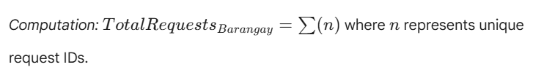
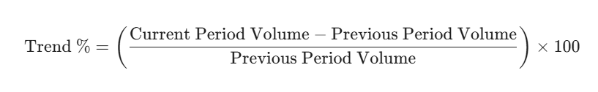
2. Temporal Trend Analytics (Descriptive Analytics):
The system summarizes request volumes over time: requests filed versus resolved per day for the last 30 days, requests by month and service, outcomes by month, the busiest days of the week, and the time of day requests are filed, to show fluctuations and recurring peak periods in past records, which the MDRRMO uses to plan staffing and resources. These summaries describe what has already happened; the system does not forecast future demand.

3. Operational Summaries (Descriptive Analytics):
The Analytics page also reports the median time to resolve a request, open and oldest open requests, request aging, the most used vehicles, equipment utilization, the share of late equipment returns, and app adoption by month. Results are cached and refreshed whenever a request or borrowing record changes.
3.6.2 Evaluative Statistical Analysis (Research Data)
To ensure technical rigor and reliability, the following statistical methods will be applied:
- Internal Consistency Reliability (Cronbach’s Alpha): Before analyzing the results, the researchers will use Cronbach’s Alpha to test the reliability of the evaluation instrument. A coefficient of 0.70 or higher will be required to ensure that the questionnaire items consistently measure the intended ISO/IEC 25010 characteristics.
- Weighted Mean and Ranking: The primary tool for interpreting user perception. Items will be ranked to identify which specific technical features (e.g., SMS speed vs. UI clarity) are the strongest or require refinement.
- System and Information Accuracy Metric: To mathematically validate the Analytics Module, the system must achieve an Accuracy Rate of at least 95%.

The formula is defined as:
- Number of Correct Outputs: Refers to the analytics reports that exactly match the records stored in the system database.
- Total Number of Outputs Tested: Refers to the total number of analytics outputs (counts, totals, and chart values) compared against the database during the system testing phase.
The weighted mean for each item and each quality characteristic will be computed separately. After computing the values, the results will be interpreted using the descriptive scale provided in the Likert table. This will help determine whether the system is strongly agreed upon, agreed upon, neutral, or needs improvement based on user feedback.

Table 6
Weighted Mean | Descriptive Interpretation | Action / Benchmark
4.21 – 5.00 | Strongly Agree | Target met: the system exceeds requirements.
3.41 – 4.20 | Agree | Satisfactory: target met only if the mean is 4.00 or higher.
2.61 – 3.40 | Neutral | Moderate performance; requires minor adjustment.
1.81 – 2.60 | Disagree | Failed indicator; requires significant revision.
1.00 – 1.80 | Strongly Disagree | Critical failure; immediate redesign needed.
Weighted Mean Descriptive Scale

3.6.3 Interpretation and Success Benchmarks
The general interpretation of the weighted mean will assist the researchers in determining whether the SERBIS system meets the expected quality standards for municipal information dissemination and the processing of resident service requests. High scores in Functional Suitability and Security will indicate that the platform accurately executes its intended modules and protects sensitive resident data. High scores in Compatibility and Flexibility will prove that the system can operate across different devices and adapt to changing municipal needs, while high scores in Interaction Capability will suggest that the application is highly intuitive and accessible for community use.
The researchers established a Target Grand Mean of 4.00 as the success threshold for the study. A mean of 4.00 lies inside the "Agree" range (3.41–4.20) and means that respondents, on average, agree that the system meets the quality statements across all five characteristics: Functional Suitability, Compatibility, Interaction Capability, Security, and Flexibility. The target does not require a perfect rating; it requires general agreement from MDRRMO personnel, residents, and IT validators. The Grand Mean measures user acceptance only. The measured objectives (processing time, SMS delivery, MFA, and analytics accuracy) are judged separately against their own benchmarks in Section 3.5.4.
In addition to the numerical results, the researchers will perform Thematic Analysis on the comments gathered from the participants. This involves:
- Coding: Breaking down raw feedback and suggestions into specific categories.
- Thematic Grouping: Identifying recurring requirements, common gaps, and notable suggestions from the participants.
These insights will serve as the basis for refining the SERBIS system to ensure that it effectively meets the needs of the MDRRMO and the residents. If significant discrepancies appear between the ratings of MDRRMO Personnel and Residents, the researchers will conduct a Comparative Analysis to ensure that the system fulfills its dual-purpose role effectively.

CHAPTER IV
TECHNICAL BACKGROUND
4.1 Introduction
This chapter presents the technical foundation of the SERBIS system. The discussion focuses on the technical choices and the practical reasons behind them that support the operations of the Municipal Disaster Risk Reduction Management Office (MDRRMO) of Echague. The following sections outline the system architecture, the selected technologies and tools, key design planning, and the visual diagrams modeling data flow and system interactions. These choices are implemented to ensure the system delivers reliable performance and security.
4.2 System Architecture
4.2.1 Overview of the System Architecture
The SERBIS system utilizes a Three Tier Architecture. In the third step of data flow, the Application Tier does not just store data but also aggregates service request records to generate real-time analytics. This allows the Data Tier to confirm transactions while the Application Tier computes frequency and distribution trends for the administrative dashboard.
To maintain system integrity, strict security measures are enforced within each specific layer. The Presentation Tier collects credentials and forwards them over HTTPS; it does not decide who may access the system. The Application Tier acts as the main security gateway: it verifies passwords, SMS one-time codes, and administrator authenticator codes, issues access tokens, and validates every input before it reaches the database. Finally, the Data Tier is reachable only from the Application Tier over the hosting provider's private network, and resident passwords are stored as bcrypt hashes rather than in readable form.
When a resident submits a request, the data flows systematically across all three tiers. First, the user enters the request details through the Presentation Tier using the Flutter mobile application. Second, this request travels via API to the Application Tier, where the Laravel backend validates the incoming data and processes the business rules. Third, the Application Tier forwards the validated information to the Data Tier for secure storage. Finally, the database confirms the transaction, allowing the Application Tier to send a success response back to the user screen while simultaneously updating the live monitoring feed on the web administrative dashboard.
4.2.2 System Components
User Interface Layer. This layer is the front-end component where residents and administrators interact with the platform.
- Mobile Application Interface
  - Function: Allows residents to register accounts, request non-life-threatening services from the MDRRMO, and access the Offline Access Module for persistent emergency information.
  - Input and Output: Inputs include resident credentials, service request details, and valid IDs. Outputs display visual status updates, confirmation messages, and rendered educational materials.
  - Technologies Used: Flutter, using the Dart language.

- Administrative Web Application
  - Function: Serves as a centralized control portal for MDRRMO personnel to perform real-time monitoring, data analytics visualization, user account management, and targeted SMS broadcasting.
  - Input and Output: Inputs include admin credentials, approval commands for service requests, and target barangay selections for text blasts. Outputs display analytical charts (Pie and Bar charts showing request frequency and barangay distribution), an interactive map of barangay request density, active request dashboards, and system logs.
  - Technologies Used: Vue 3, TypeScript, and Vuetify, with Chart.js for analytics visualization and d3-geo for geospatial mapping.
Application Logic Layer. This layer serves as the system's secure backend. It connects the user interfaces to the database, ensuring all requests are efficiently validated and executed. It primarily handles:
- Backend Server
  - Function: It primarily handles: authentication, request workflow routing, SMS triggers, and the data aggregation engine for generating municipal service analytics.
  - Input and Output: Inputs consist of raw HTTP requests containing user data or admin commands from the presentation tier. Outputs include validated JSON responses, error codes, and processed data payloads sent to the database.
  - Technologies Used: Laravel and PHP.
Data Storage Layer. This layer is responsible for securely storing and retrieving all system information in the database. It manages:
- Cloud Database
  - Function: Securely stores, indexes, and retrieves all system records, including user profiles, transactional logs, and the educational content repository.
  - Input and Output: Inputs include SQL insert and update queries from the Laravel backend. Outputs return queried datasets and verification records to the application tier.
  - Technologies Used: MySQL 8, managed via Railway.
External Services and APIs. The system integrates third-party services to extend its functionality without building from scratch:
- SMS Gateway API
  - Function: Handles the technical execution of targeted text blasts, bridging the web application to local cellular networks without requiring custom telecommunication hardware.
  - Input and Output: Inputs include formatted HTTP POST requests containing emergency message payloads and target phone numbers. Outputs return the gateway's acceptance status, which the backend logs for each blast and each recipient.
  - Technologies Used: SkySMS, a prepaid-credit SMS provider, called directly by the Laravel backend over HTTPS at the time of sending.
- Push Notification Service
  - Function: Delivers in-app notifications to residents who have the mobile application installed.
  - Input and Output: Inputs include the resident’s registered device token and a notification payload sent by the Laravel backend. Outputs are notifications displayed on the resident’s device.
  - Technologies Used: Firebase Cloud Messaging (HTTP v1 API), authenticated with a Google service account.
To ensure seamless operations, these components interact through a strict linear data flow based on REST API principles (IBM, 2024). When a user executes an action on the User Interface Layer, the application packages the input data and transmits it as an HTTP request to the Application Logic Layer. The Laravel backend intercepts this request, validates the data against defined business rules, and translates it into SQL queries. These queries are sent to the Data Storage Layer, where MySQL executes the requested storage or retrieval operation. Finally, the database returns the raw data back to the Application Logic Layer, which formats it into a secure JSON response and sends it up to the User Interface Layer to dynamically update the screen for the user or administrator.
4.2.3 System Architecture Diagram
This section provides the visual layout of SERBIS. Figure 4 shows the system architecture of the proposed system.

Figure 4
Three Tier Architecture Diagram of the proposed system
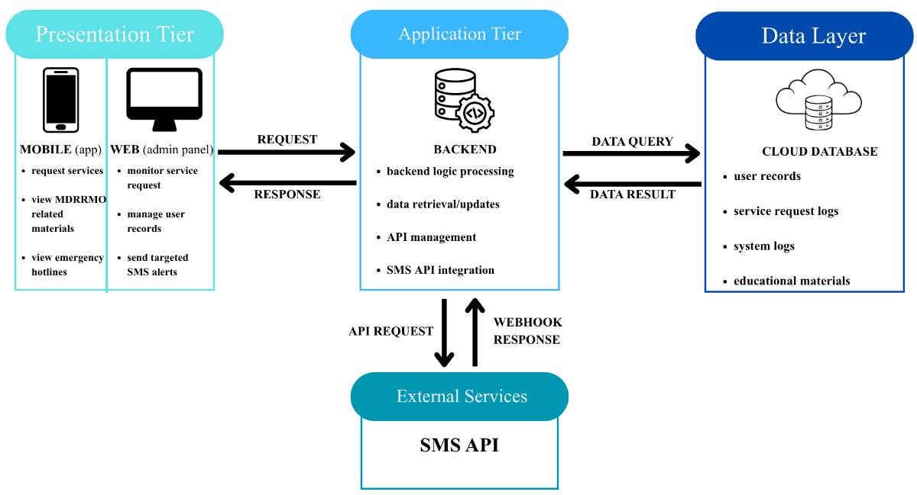
Figure 4 illustrates the Three Tier Architecture and maps the direction of data flow and third-party integrations.
Presentation Tier (Client Interfaces): This layer includes the Flutter mobile application and the Vue 3 web dashboard. The arrows pointing outward from this tier represent standard HTTP requests containing user inputs, such as login credentials or safety inspection requests. The arrows pointing back inward represent secure JSON responses from the server, which are used to dynamically update the user screens.
Application Tier (Backend Logic): Powered by Laravel, this central hub intercepts all incoming API requests from the Presentation Tier. The diagram highlights the internal routing where the backend validates incoming data before execution. Additionally, this tier features a direct outward data flow to the external SMS Gateway API. When an administrator triggers an emergency alert, the Laravel server sends an HTTP POST payload to this third-party service, which then bridges the text message to local cellular networks.
Data Tier (Cloud Database): This layer houses the MySQL 8 database. The bidirectional arrows between the Application Tier and the Data Tier indicate SQL queries. The Laravel backend sends insert and update commands to store records securely. In return, the database pushes the requested datasets, such as offline educational materials or transactional logs, back to the application logic for processing.
4.3 Technologies and Development Tools
The technology stack for SERBIS was specifically engineered. To support the core functions of the MDRRMO, including centralized record management and data analytics, the system relies on a precise combination of tools. Flutter provides cross platform mobile access, Laravel securely manage the core business logic, and MySQL ensures robust data storage. Together, these frameworks provide a lightweight but highly scalable foundation, guaranteeing that administrative personnel can efficiently manage operations and execute targeted SMS broadcasts without encountering system bottlenecks.
4.3.1 Programming Languages
The SERBIS platform uses a multi-language stack to meet the unique needs of the mobile, web, and server layers. Mobile rendering requires high-performance capabilities, whereas the backend focuses on secure business logic. Standardized communication protocols manage the integration complexity and ensure all components exchange data seamlessly.
Mobile
Dart - the primary language for the mobile application. It enables the development of a high-performance interface that works across multiple platforms from a single codebase. This ensures residents have a consistent experience regardless of their device hardware.
Frontend
Vue 3 with TypeScript and Vuetify - build the administrative dashboard. TypeScript adds static typing to component logic, Vuetify supplies Material Design components and layout structure, and Vue's reactivity system drives the interactive elements of the interface. This combination allows the dashboard to display real time status updates for service requests without requiring manual page refreshes.
Backend
PHP - serves as the core server-side language. It is highly optimized for the Laravel framework and provides built in security features. PHP manages critical background operations, including user authentication and the connection to the external SMS Gateway.
Data Layer
SQL - manages the communication between the backend and the database. It provides a structured way to store and retrieve sensitive information, such as resident records and emergency hotlines. This ensures data remains consistent across all layers.
The system manages the complexity of using multiple languages through Application Programming Interfaces. The mobile and web layers communicate with the PHP backend using HTTP requests. The backend then processes these requests and uses SQL to interact with the database. This structured flow ensures different languages work together without causing instability.
4.3.2 Frontend Frameworks
The frontend is divided into two components: the mobile application for users and the web dashboard for administrators.
- Mobile Application (Flutter): The Flutter framework was selected for the citizen facing application. It was chosen over alternatives like React Native because it compiles directly to native code, offering superior rendering performance and a more unified codebase. This architecture is vital for the Offline Resource Module. It allows for efficient local caching of educational materials, ensuring residents can access safety information without an active internet connection. A known limitation of Flutter is that it generally produces larger application file sizes compared to native development, but the benefit of rapid cross platform deployment outweighs this storage trade off.
- Administrative Dashboard (Vue 3 with Vuetify): The Vue 3 framework, paired with the Vuetify component library, was selected for the administrative panel over alternatives like Bootstrap for its reactive component model and native TypeScript support, which reduce runtime errors in a data-heavy interface. Vuetify's Material Design components provide accessible, pre-built UI elements data tables, dialogs, navigation drawers while Chart.js renders the request-frequency and barangay-distribution analytics, and d3-geo renders barangay request density as an interactive choropleth map using GeoJSON boundary data. This combination lets MDRRMO personnel read spatial and statistical trends on the same dashboard without a page reload.
4.3.3 Backend Frameworks
Laravel, a PHP framework, is utilized as the primary backend infrastructure. It was selected over alternatives like Node JS or Django because of its robust internal security features and expressive syntax tailored for rapid application development. Laravel functions as the central API provider. It facilitates secure communication between the MySQL database and the frontend interfaces using structured RESTful API routing.
The framework handles complex API management by acting as the bridge for the mobile application to retrieve data and for the seamless integration of third-party SMS Gateway APIs utilized in the text blast feature. Security is strictly enforced through Laravel middleware. The middleware validates user authentication tokens before granting access to sensitive routes, while built in protections automatically defend against common vulnerabilities like Cross Site Request Forgery and SQL injection.
4.3.4 Database Management System
To maintain the structural integrity of the system, the researchers utilized MySQL 8 for its highly reliable relational data management capabilities. The database design strictly follows data normalization principles up to the Third Normal Form. This eliminates data redundancy and ensures that resident records and emergency materials are stored efficiently.
Data integrity is enforced through strict primary and foreign key constraints. This architecture allows the researchers to precisely map resident profiles to specific service requests and accurately track administrative SMS logs without orphan records (Elmasri & Navathe, 2016). Furthermore, the implementation leverages database indexing to optimize query performance, ensuring the system remains responsive during high traffic periods, such as when multiple users synchronize the offline digital library simultaneously (Stauffer, 2019).
4.3.5 Development and Collaboration Tools
The development lifecycle of SERBIS is structured around a continuous integration workflow. This approach links each specialized tool to a specific phase of the development cycle, ensuring a seamless transition from coding to testing and final deployment. The collaboration process is actively managed using Trello, which tracks tasks and aligns the entire team with Rapid Application Development iterations.
Development Phase
The coding process begins in Visual Studio Code. This serves as the primary integrated development environment for writing the Laravel backend and the Vue 3 web interface. Simultaneously, Android Studio provides the necessary emulators and software development kits to build and debug the Flutter mobile application. During this phase, Figma and Canva are utilized to create system wireframes and develop visual assets for the user interface.

Version Control and Collaboration
As code is written, Git and GitHub manage version control. GitHub acts as the central collaboration platform. It allows the development team to safely track code revisions, merge new features, and prevent workflow conflicts when multiple group members edit the same file.
Testing Phase
Before any code is deployed, the workflow moves to testing. Postman is utilized specifically for API testing. It verifies the endpoints connecting the Laravel backend to the mobile application and the web dashboard, ensuring that data exchanges securely and correctly. XAMPP provides a local server environment to host the PHP application for the initial debugging. Beyond manual checks, automated test suites run through Github Actions on every push and pull request: a PHP Unit job runs the backend features tests (more than 1,380 tests) against a MySQL 8 service container, and a separate job runs the Flutter test suite for the mobile application. A change is not deployed unless both jobs pass.
Deployment Cycle
After successful testing and local validation, the final verified code merges into the main branch, which triggers deployment: Railway rebuilds the Laravel API container and Vercel rebuilds the administrative web panel.

4.3.6 Hosting and Deployment Platforms
To ensure public accessibility while controlling operating cost, the researchers adopted a three-provider cloud architecture, each provider responsible for a single concern. Railway hosts the Laravel API as a Dockerized service together with a managed MySQL 8 database; the API and database communicate over Railway's private network, so the database is not exposed to the public internet. Cloudflare R2 supplies S3-compatible object storage for uploaded files: government ID scans and resident photos are served only through authenticated API routes, while public advisories and evacuation guides can be opened by residents without a token. Vercel hosts the Vue 3 administrative web panel. Scheduled maintenance is automated through a Railway Cron service that runs once a day at 00:00 UTC (08:00 Philippine time). Each run sends reminder messages for borrowed equipment nearing its return date and prunes authentication tokens that expired more than 24 hours earlier.
4.4 Design Considerations
The architectural design of the SERBIS platform emphasizes stringent security measures and operational resilience to sustain the critical functions of the MDRRMO. To establish a secure technological foundation, the system strictly adheres to the fundamental principles of the CIA Triad: Confidentiality, Integrity, and Availability. By integrating the updated cybersecurity frameworks established by the National Institute of Standards and Technology (NIST, 2024), these design parameters ensure that sensitive resident data is safeguarded against unauthorized access, system records are preserved without unauthorized modification, and emergency communication modules maintain continuous operability during disaster scenarios.
4.4.1 Functional Suitability
To guarantee operational effectiveness, the system architecture is explicitly designed to execute the core requirements of municipal service coordination accurately and comprehensively. The integration of the SMS gateway allows the web administrative dashboard to broadcast targeted public service updates to specific barangays, reaching residents even when they have no internet connection or do not have the application open. Push notifications through Firebase Cloud Messaging complement this channel for app users, informing them of service request status changes, ambulance booking decisions, equipment borrowing updates and return reminders, and newly published materials.
Concurrently, the mobile application features a robust offline caching mechanism that ensures residents maintain continuous access to public safety materials, while the centralized database accurately tracks the lifecycle of every resident service request
4.4.2 Compatibility
The proposed platform is engineered for broad operational deployment without requiring complex external software dependencies. To ensure maximum reach within the community, the mobile application is exclusively compiled for Android operating systems, optimizing performance for the most widely utilized mobile devices in the municipality. Conversely, the web administrative dashboard is entirely browser agnostic, functioning seamlessly across any standard web browser. Furthermore, SERBIS operates as a completely standalone architectural framework, processing municipal service coordination independently without requiring integration with existing third-party local government software.
4.4.3 Interaction Capability
The platform prioritizes intuitive navigation to ensure seamless engagement for individuals with varying levels of technical proficiency. Within the Android application, the interface employs structured dropdown menus and predefined data fields for service requests, significantly minimizing manual text entry and reducing cognitive load for the end user. On the administrative end, the Vuetify-powered web panel organizes complex operational data into digestible visual metrics and straightforward navigation paths. This streamlined user experience allows MDRRMO personnel to easily format targeted SMS text blasts and monitor service request trends with minimal required training.
4.4.4 Security
Ensuring the confidentiality and integrity of resident data is a critical requirement. All traffic between the mobile application, the web administrative dashboard, and the API is encrypted with HTTPS (TLS), and the database is reachable only through the hosting provider's private network. For user authentication, the backend implements Laravel Sanctum to issue and validate API tokens, with administrator sessions expiring after eight hours and resident sessions after thirty days; a daily scheduled task prunes expired tokens to prevent indefinite accumulation. During registration and login, SkySMS delivers a one-time verification code by SMS to the resident's mobile number. There is no email fallback: if the SMS cannot be sent, the request fails and the resident is told to check the number and try again in a minute, or to visit the MDRRMO office. Administrator accounts are further protected by multi-factor authentication: after the password, a six-digit one-time code is sent by SMS to the staff member's registered mobile number, and signing in requires both. Furthermore, strict role-based authorization controls are programmed into the system routing, ensuring that only verified MDRRMO personnel can execute critical administrative commands, such as the targeted SMS broadcasting.
4.4.5 Flexibility
To accommodate fluctuating volumes of resident service requests, the system architecture is inherently adaptable. The backend utilizes a highly modular code structure, which permits administrators to seamlessly introduce new public assistance categories in the future without disrupting the core system logic. The API currently runs as a single service instance. Because it authenticates each request with a token rather than a server-side session, additional instances can be added on the hosting platform if request volume grows, without changes to the application code.
4.5 User Interface
The User Interface acts as the critical bridge between the SERBIS platform and its users. The interface design strictly follows core usability principles to ensure efficient operation during high stress emergency situations. The design prioritizes consistency, intuitive navigation, and accessibility across both the mobile and web environments.
4.5.1 Web Application Mock-ups
The following Figures illustrate the initial user interface of the SERBIS administrative panel. Rather than isolating the design logic, the reasoning behind the information hierarchy, user workflow, and navigation structure is explained as it applies to each specific interface. Furthermore, the administrative interface is designed to support data-driven decision-making by integrating graphical analytics that summarize service trends directly on the main dashboard.
Figure 5
SERBIS Admin Login Page
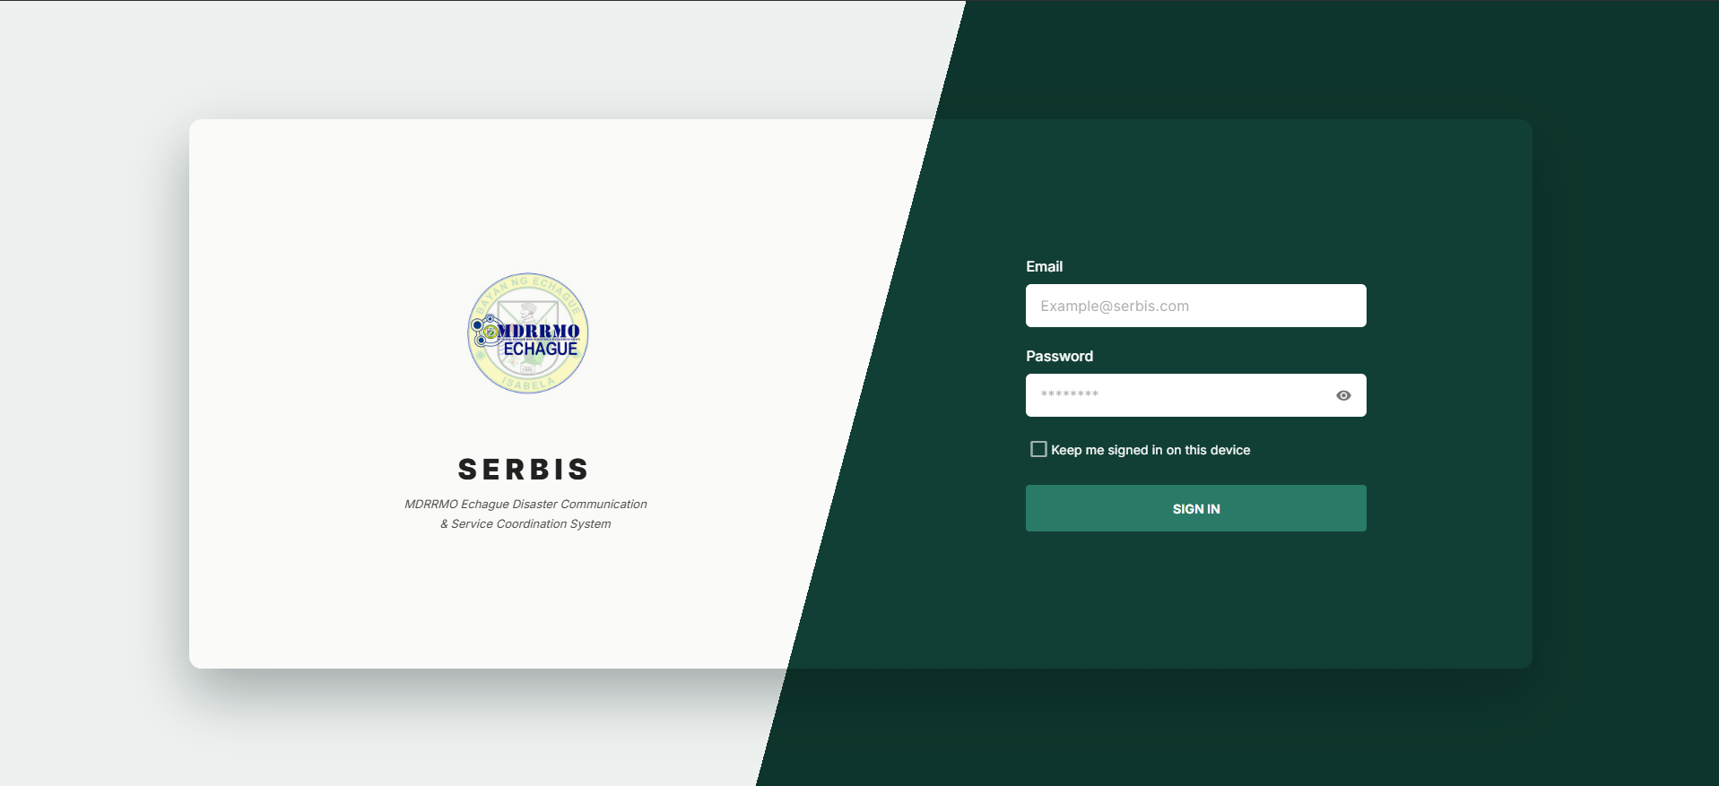
Figure 5 displays the Web Admin Login interface, which initiates the secure user workflow. Before accessing the system, MDRRMO personnel must verify their credentials here, acting as a strict security gateway to protect centralized resident data and prevent unauthorized system entry.
Figure 6
SERBIS Admin Dashboard
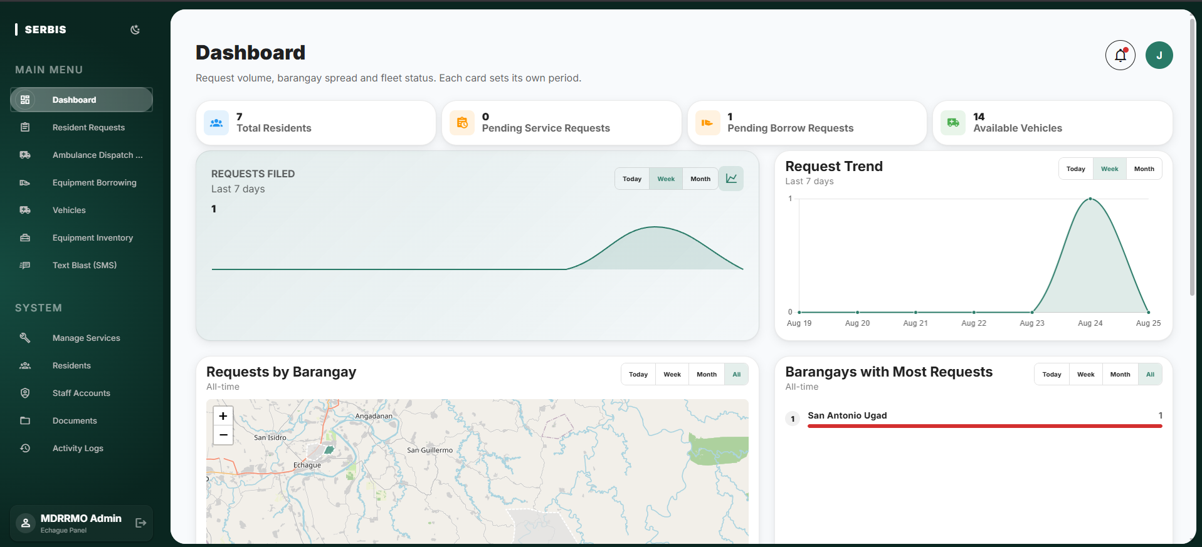
Figure 6 presents the Dashboard, which administrators are directed to upon authentication. This page establishes the primary information hierarchy by placing the operational summary cards for total residents, pending service requests, pending borrow requests, and available vehicles across the top, followed by the requests filed and request trend charts, an interactive choropleth map rendering request density across Echague's barangay boundaries, and a ranked list of the barangays filing the most requests. Each panel carries its own daily, weekly, monthly, and all-time filter, ensuring administrators can perform at-a-glance resource and fleet allocation based on real-time, geographically contextualized data.
Figure 7
SERBIS Resident Request Management
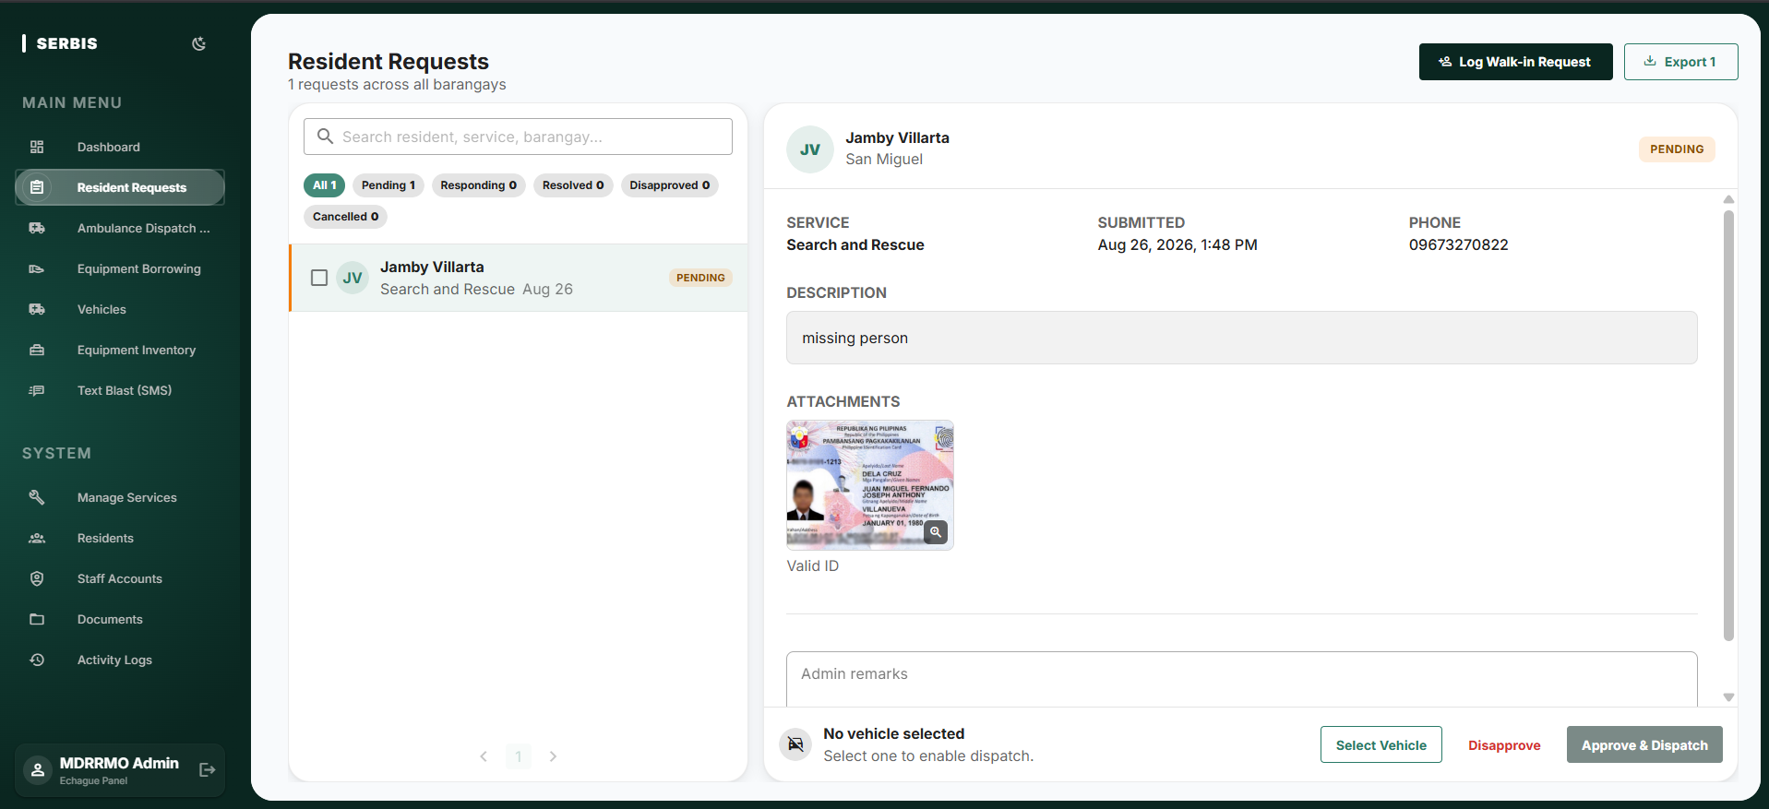
Figure 7 details the Manage Resident Request module. Following the logical workflow design, administrators utilize this interface to review, validate, and update the status of citizen submissions. The screen is divided into a filterable queue on the left, grouped by Pending, Responding, Resolved, Disapproved, and Cancelled, and a detail panel on the right showing the requested service, submission time, contact number, description, and the valid identification uploaded by the resident. From the same panel the administrator records remarks, assigns a vehicle, and approves or disapproves the request. Placing this critical response tool highly within the navigation hierarchy ensures timely disaster response and resource deployment during an active crisis.
Figure 8
SERBIS Ambulance Dispatch Requests
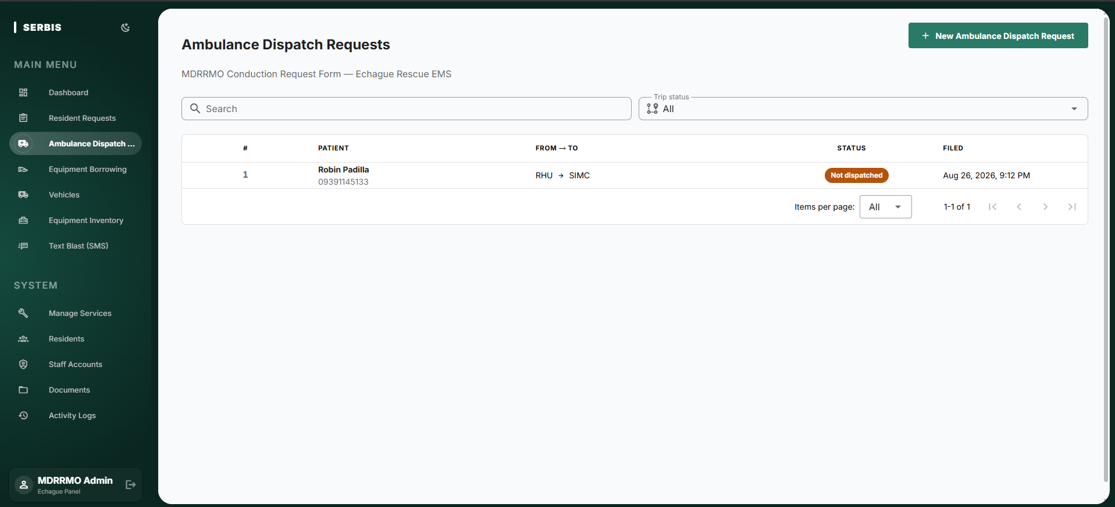
Figure 8 presents the Ambulance Dispatch Request interface, a digitized version of the MDRRMO's paper conduction request and trip log form, stored in the tbl_conduction_requests and tbl_conduction_request_people tables. Because the form is filed by office staff rather than by residents, the interface is separated from the resident request queue. Each entry records the patient, the origin and destination of the trip, the dispatch status, and the date filed, and the list can be searched or narrowed by trip status.
Figure 9
SERBIS Equipment Borrowing
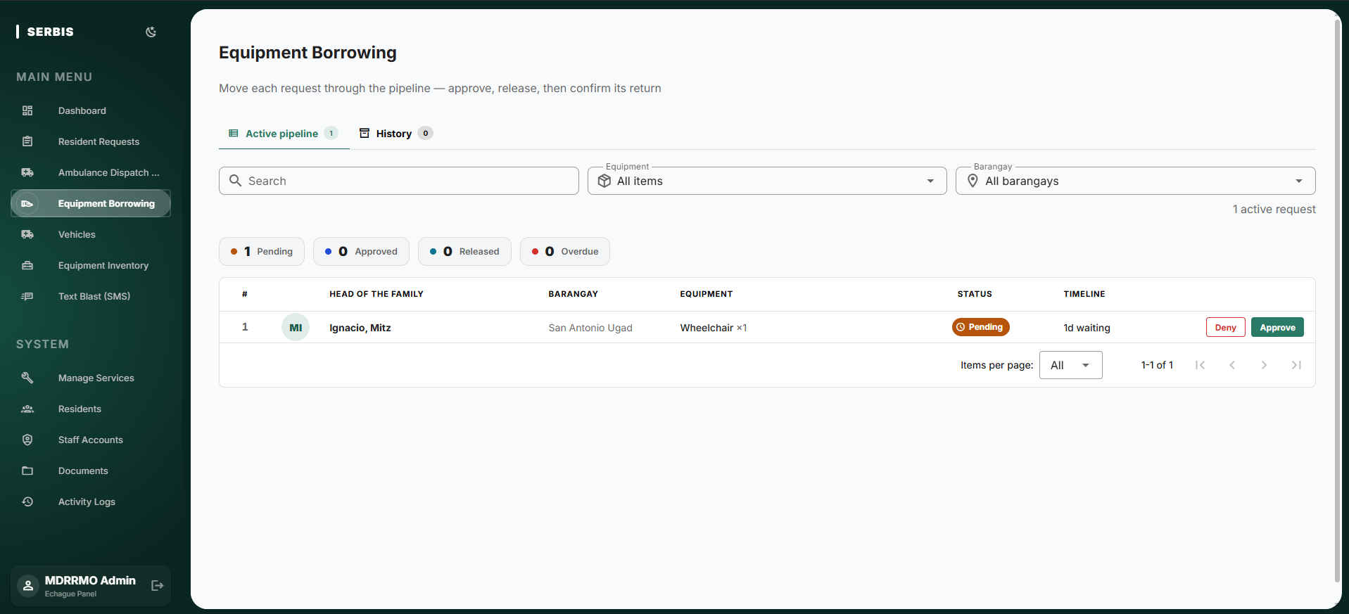
Figure 9 presents the Equipment Borrowing interface, which manages the request, approve, release, and return pipeline for resident borrowings recorded in tbl_equipment_borrowing. The active pipeline lists each request together with the head of the family, the originating barangay, the item requested, its current status, and the time it has been waiting, while counters above the table summarize pending, approved, released, and overdue items. Completed transactions are retained under the History tab, replacing what would otherwise be an untracked manual process.
Figure 10
SERBIS Vehicle Fleet Management
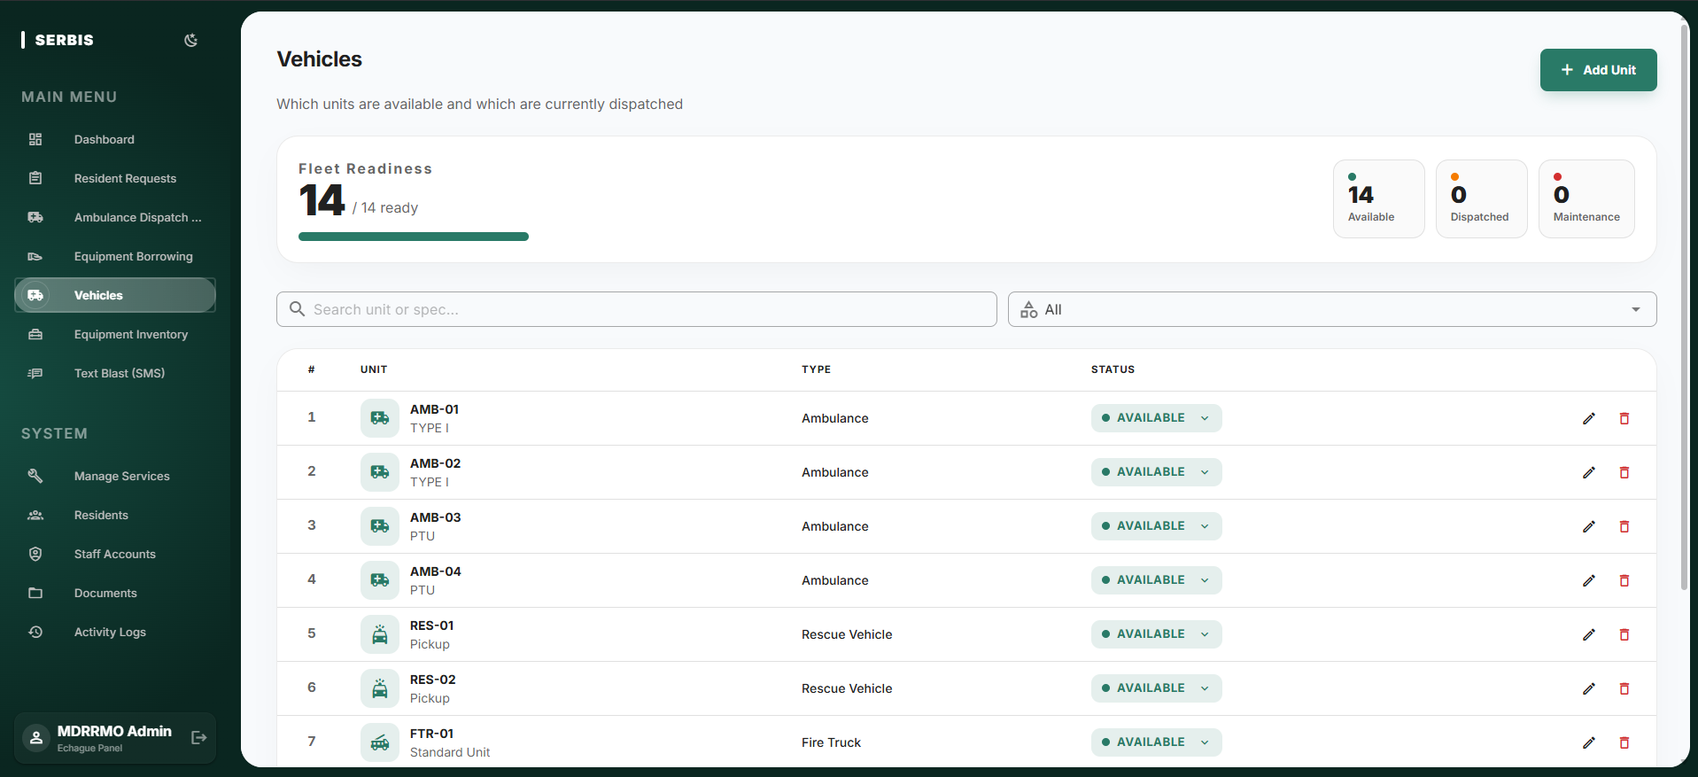
Figure 10 represents the Vehicles interface, which tracks ambulance and rescue unit availability in tbl_vehicles independently of any single service request. A fleet readiness summary reports how many units are Available, Dispatched, or under Maintenance, and the table below lists each unit by code, type, and current status. Maintaining fleet state separately from the request queue allows dispatchers to confirm that a vehicle is free before committing it to a response.
Figure 11
SERBIS Equipment Inventory
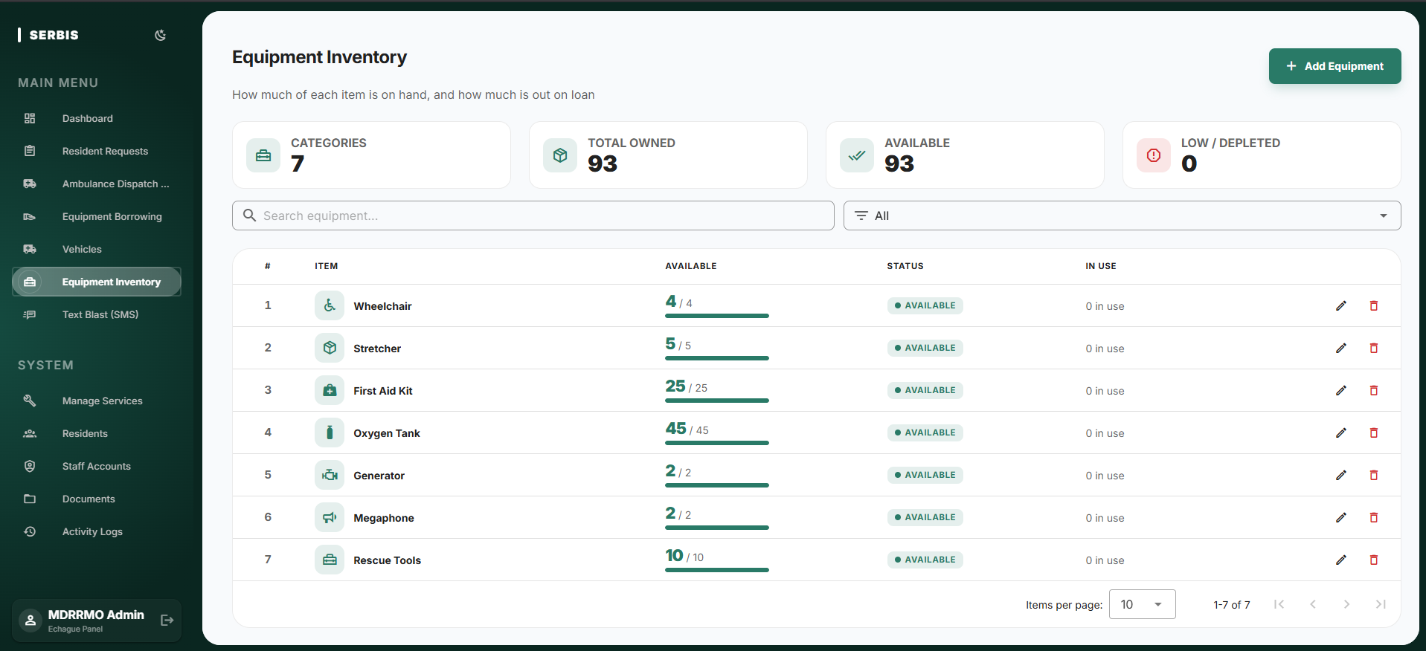
Figure 11 presents the Equipment Inventory interface, where administrators maintain the catalogue of rescue and relief items held by the office in tbl_equipments. Each record carries an item name, an operational status, the total quantity owned, and the quantity currently available, while the summary cards report the number of categories, the total items owned, the items available, and the items that are low or depleted. These figures update as items move through the borrowing workflow shown in Figure 9, keeping stock levels accurate without manual reconciliation.
Figure 12
SERBIS Targeted SMS Alert
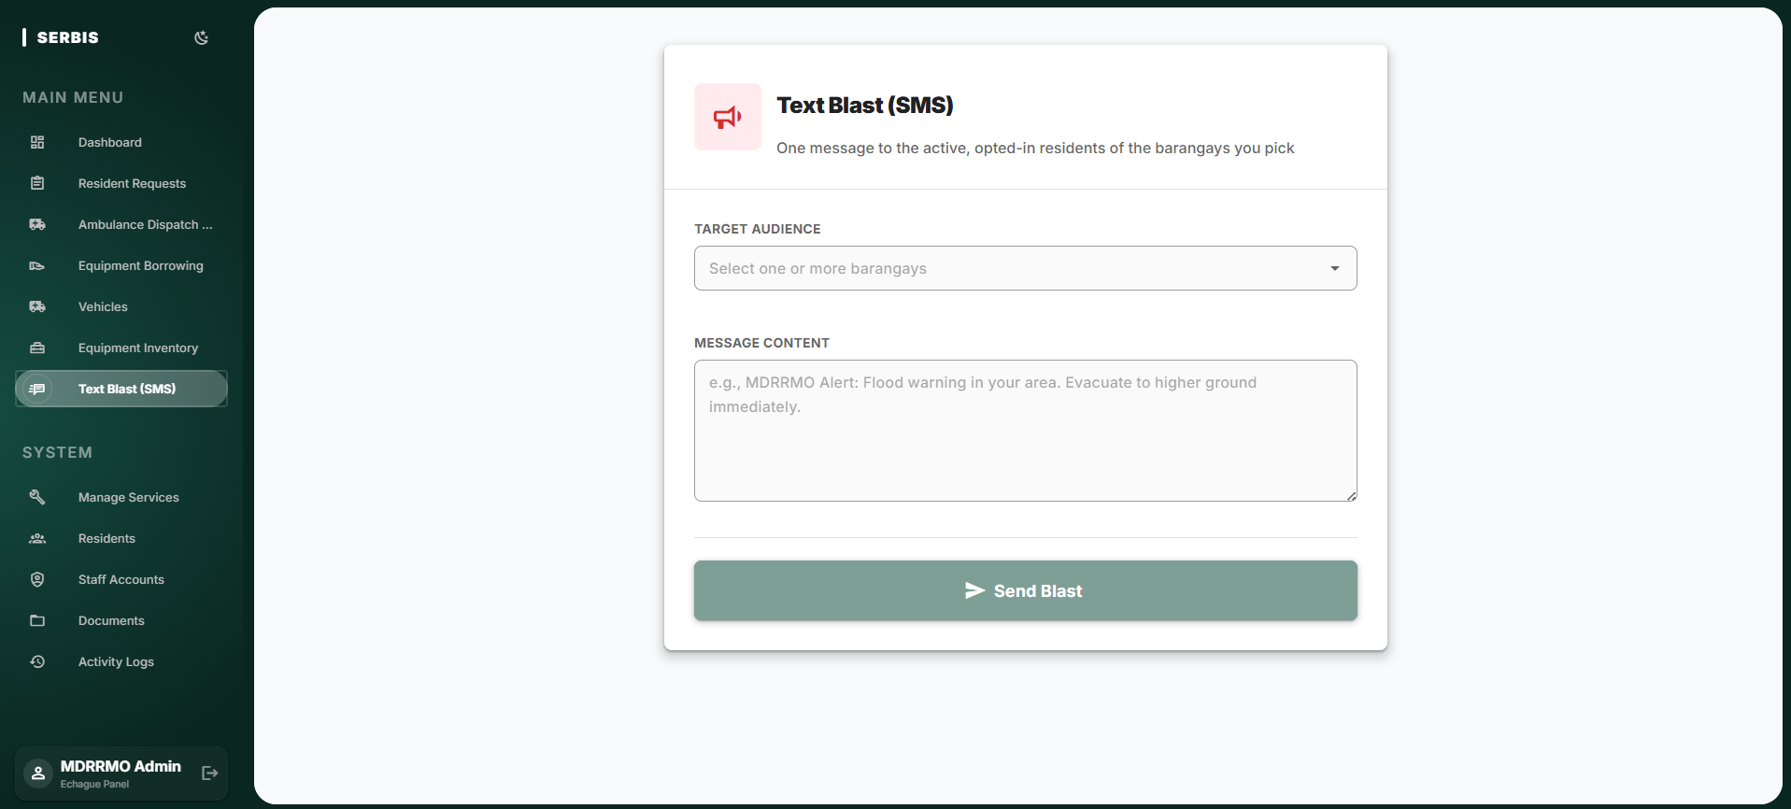
Figure 12 shows the Text Blast interface, representing a critical operational priority. Because emergency communication requires immediate action, this direct broadcasting tool is easily accessible via the fixed sidebar navigation. The administrator selects one or more target barangays and composes the message body in a single screen, and the system dispatches the alert only to the active, opted-in residents of those barangays. This structure allows administrators to rapidly compose and dispatch critical emergency notifications without navigating through complex submenus.
Figure 13
SERBIS Manage Services
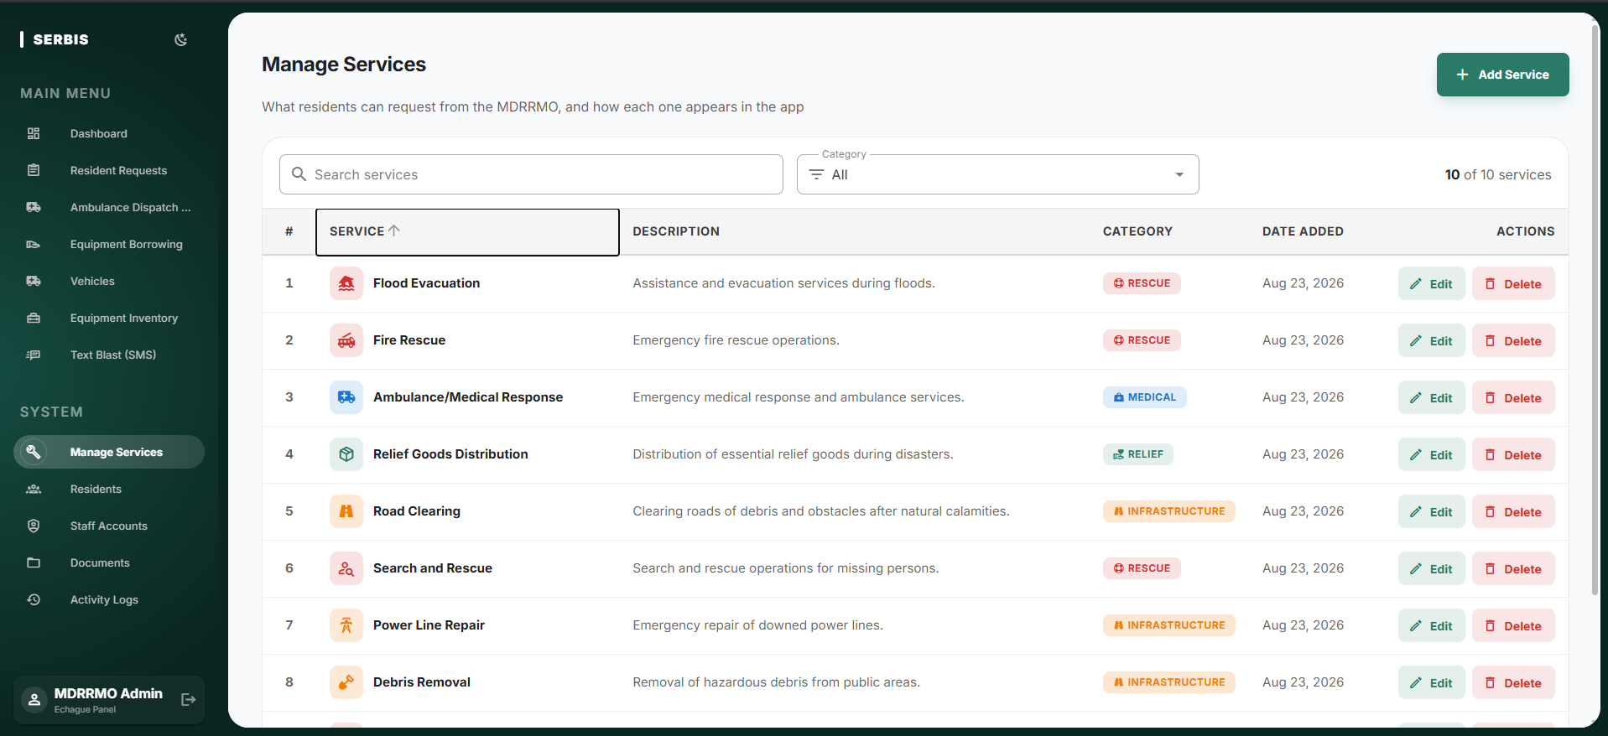
Figure 13 presents the Manage Services interface, which controls the catalogue of services residents can request from the mobile application. Each service carries a name, a description, and a category such as Rescue, Medical, Relief, or Infrastructure, and the searchable list allows MDRRMO personnel to add, revise, or withdraw an offering without any change to the application code.
Figure 14
SERBIS Resident Directory
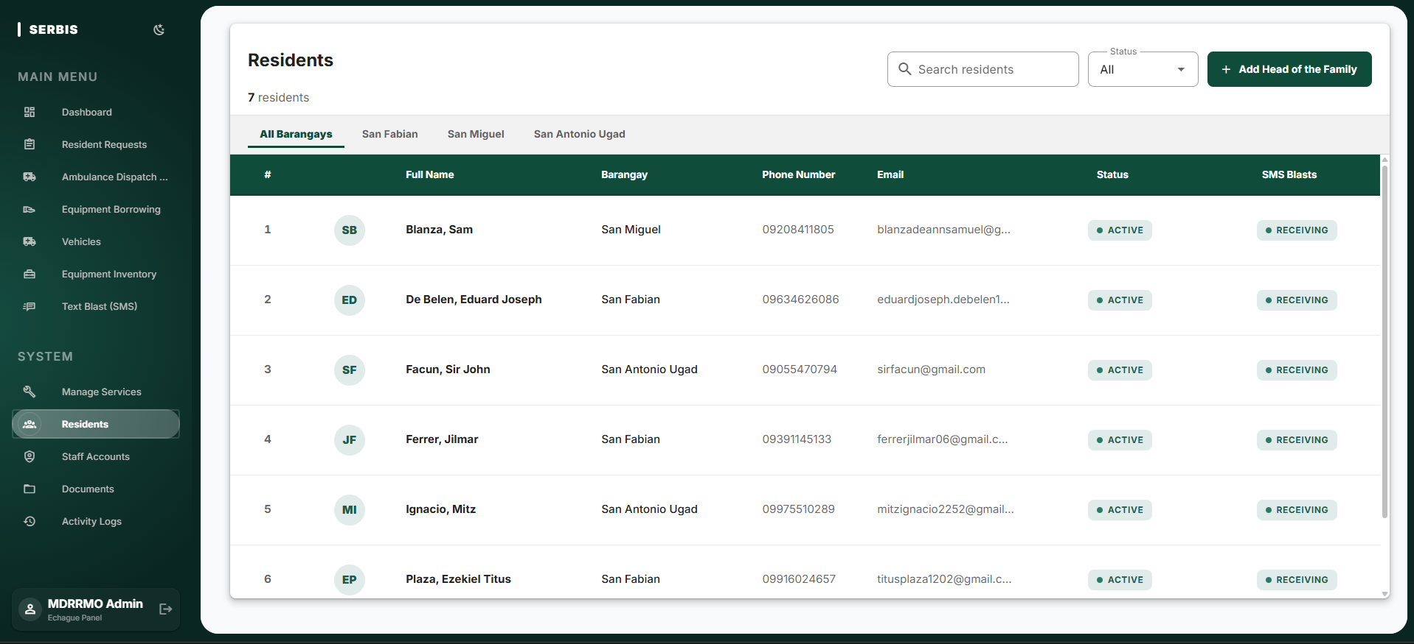
Figure 14 illustrates the Residents directory. Positioned as a secondary administrative task within the overall information hierarchy, this module allows personnel to oversee registered head of the family profiles and verify resident identities. The roster lists each resident's full name, barangay, phone number, account status, and text blast subscription state, and it can be filtered by barangay. Placing this lower in the hierarchy maintains the integrity of the registered user base without cluttering the more urgent emergency response screens.
Figure 15
SERBIS Staff Accounts
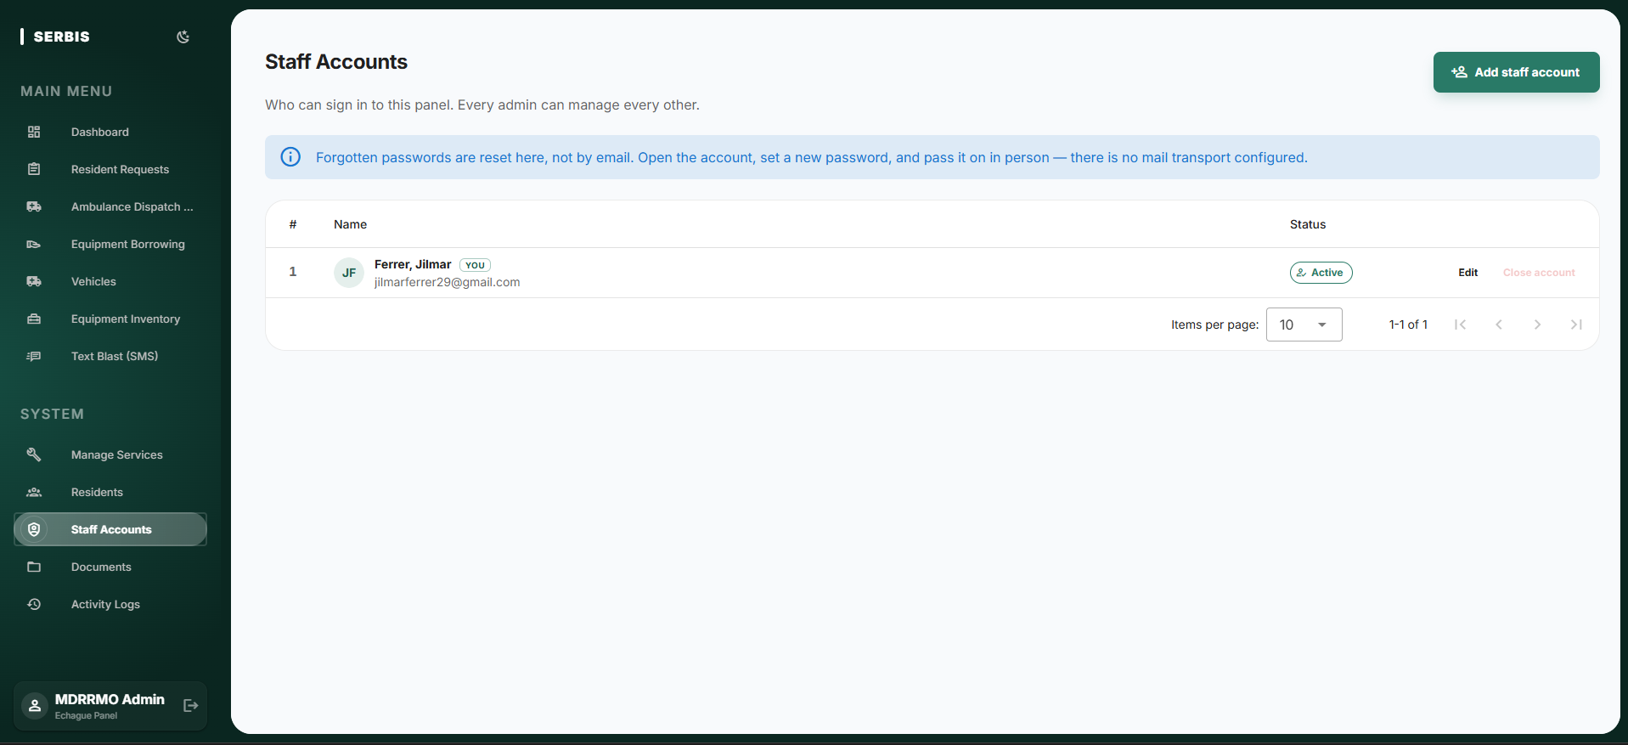
Figure 15 presents the Staff Accounts interface, which is distinct from the resident directory shown in Figure 14. Administrators register MDRRMO personnel accounts with a first name, last name, username, and mobile number (where the sign-in code is sent), edit those details, reset a forgotten password directly within the panel, and close or reactivate an account rather than deleting it, so that the activity log retains a complete attribution history for every administrative action.
Figure 16
SERBIS Educational Materials Management
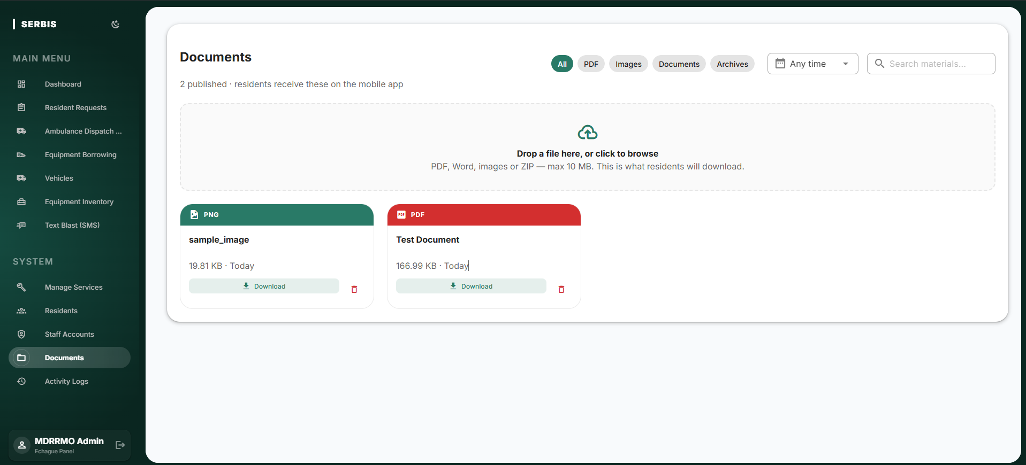
Figure 16 displays the Documents interface. As part of the ongoing system maintenance workflow, administrators use this repository to manage safety guides, uploading portable document format, word processing, image, or archive files up to ten megabytes and filtering the published set by type or date. Because uploading educational materials requires careful file management, separating this function into its own dedicated workspace prevents interference with real time emergency monitoring. Every item published here becomes available to residents through the mobile Safety Library shown in Figure 26.
Figure 17
SERBIS System Logs
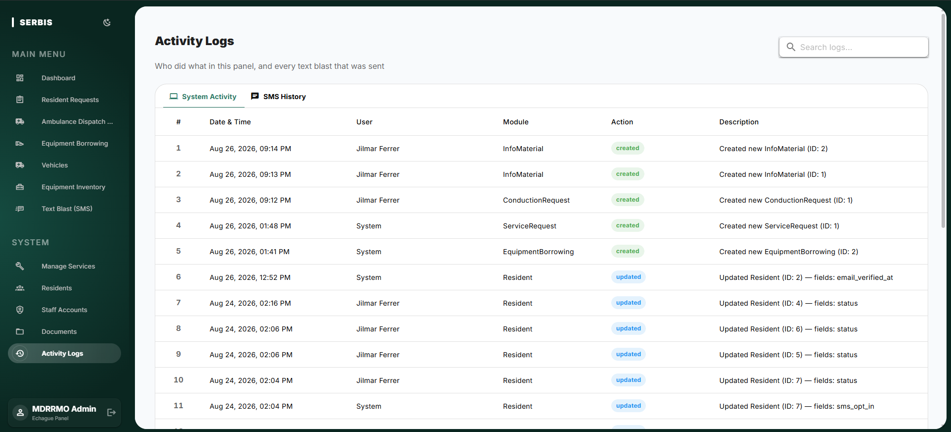
Figure 17 presents the Activity Logs module, which completes the system workflow loop. Every action taken across the platform is automatically recorded here with its date and time, the responsible user, the module affected, the type of action performed, and a description of the record changed, while a separate tab retains the history of every text blast dispatched. This centralized tracking design ensures transparency and provides administrators with a highly organized audit trail for post disaster review.
4.5.2 Mobile Application Mock-ups
The mobile application design prioritizes rapid accessibility and ease of use during high stress situations. To achieve this, the interaction design strictly follows mobile usability standards. The screen layout features large tap targets and clear text hierarchies to ensure readability, even in low light or outdoor environments during a disaster. For navigation, a persistent bottom bar is utilized, allowing residents to switch between critical modules using only one hand. Furthermore, the mobile interface adheres to the same Material Design principles as the web dashboard, ensuring visual and functional consistency across the entire SERBIS platform.
Figure 18
SERBIS User Login Page
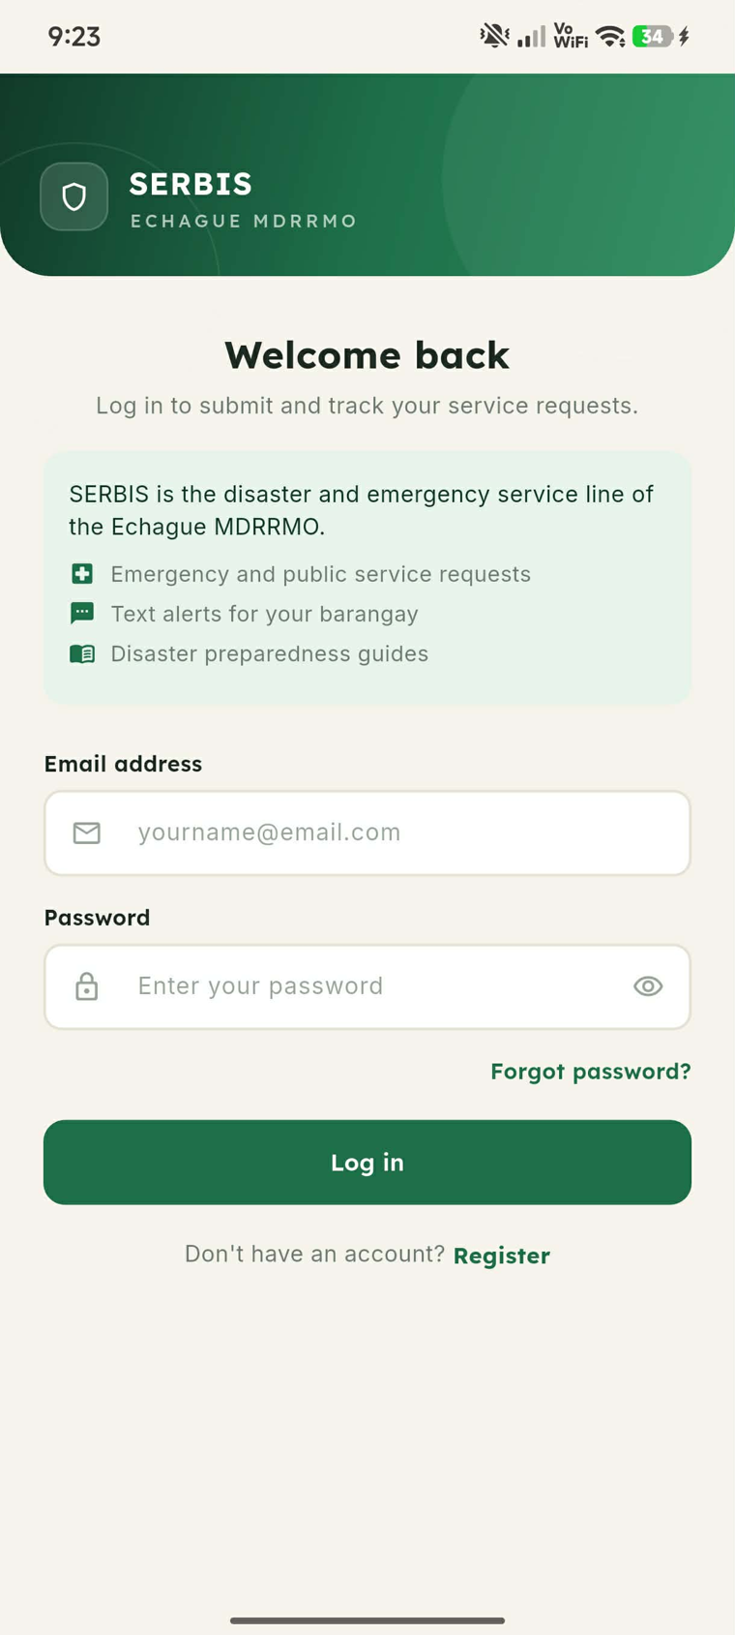
Figure 18 displays the User Login interface. This screen acts as the initial security gateway for existing residents. The layout is intentionally minimal, pairing credential verification with a short summary of what the service covers, so that users can access emergency services quickly without visual distractions. Password recovery and registration links are placed directly beneath the log in control for residents who have not yet enrolled.
Figure 19
SERBIS User Registration Page
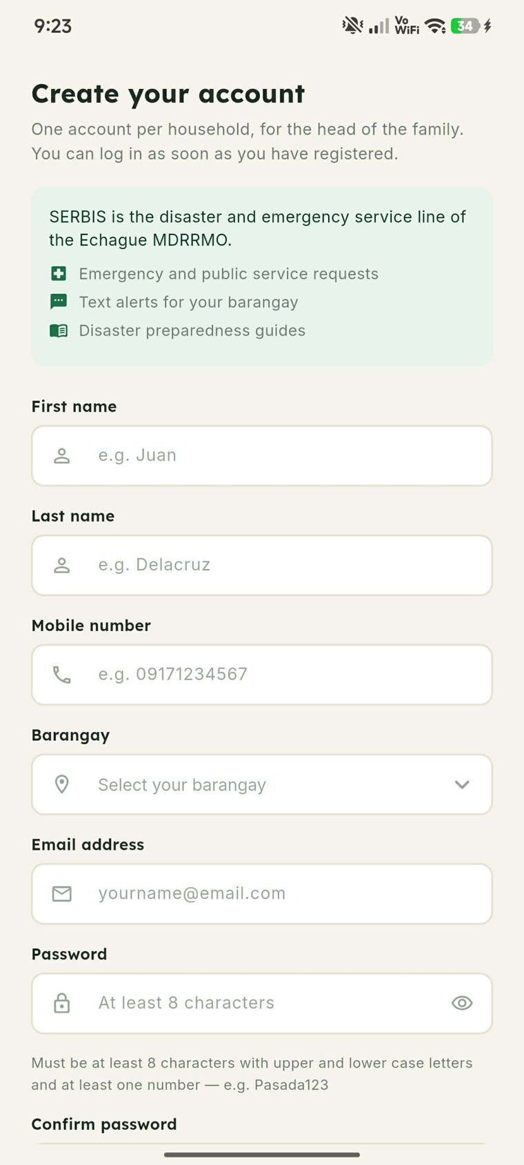
Figure 19 presents the User Registration interface, serving as the onboarding point for new residents. One account is issued per household to the head of the family. The layout guides the user through identity verification, requiring a first and last name, a mobile number, a barangay selection, and a password that satisfies the stated complexity rule. This structured data entry ensures the MDRRMO can accurately verify new accounts before granting system access.
Figure 20
SERBIS Home Page
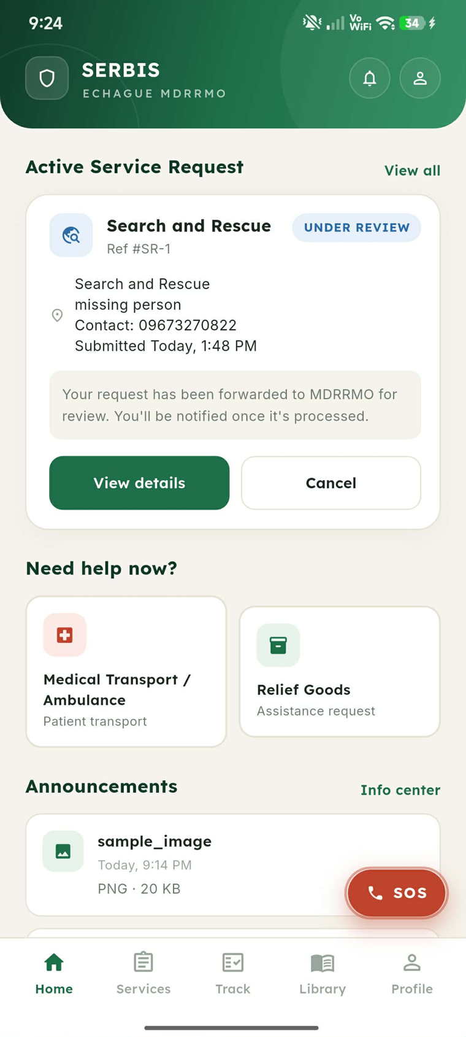
Figure 20 illustrates the primary Home dashboard, which residents see immediately upon logging in. The screen layout prominently displays real time tracking for the active service request, showing its reference number, transparent administrative status, and a plain language note on what happens next, followed by shortcuts for medical transport and relief goods and by announcements published by the office. This page also introduces the persistent bottom navigation design, which allows immediate thumb access to the Services, Track, Library, and Profile modules, together with the floating emergency call control.
Figure 21
SERBIS Service Request Page
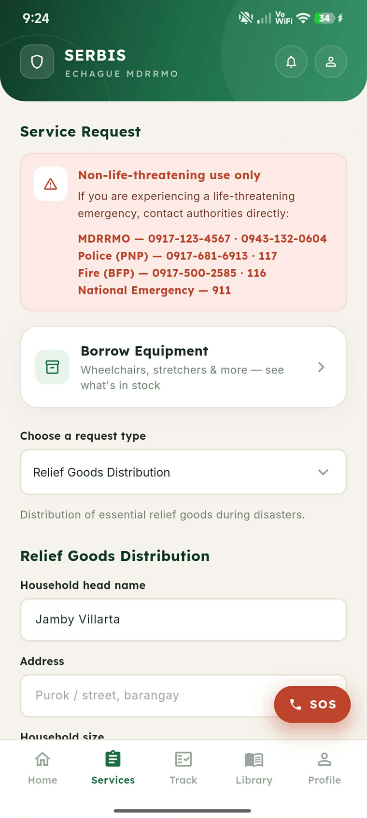
Figure 21 details the Service Request interface. Operating as the core emergency response tool, this screen allows verified residents to submit non-life-threatening requests only, and it therefore opens with a prominent advisory listing the MDRRMO, police, fire, and national emergency hotlines for situations that require direct contact with authorities. Beneath the advisory the resident may enter the equipment borrowing flow or choose a request type from a single dropdown, ensuring that users can identify the nature of their needs rapidly and accurately during a crisis.
Figure 22
SERBIS Service Request Form
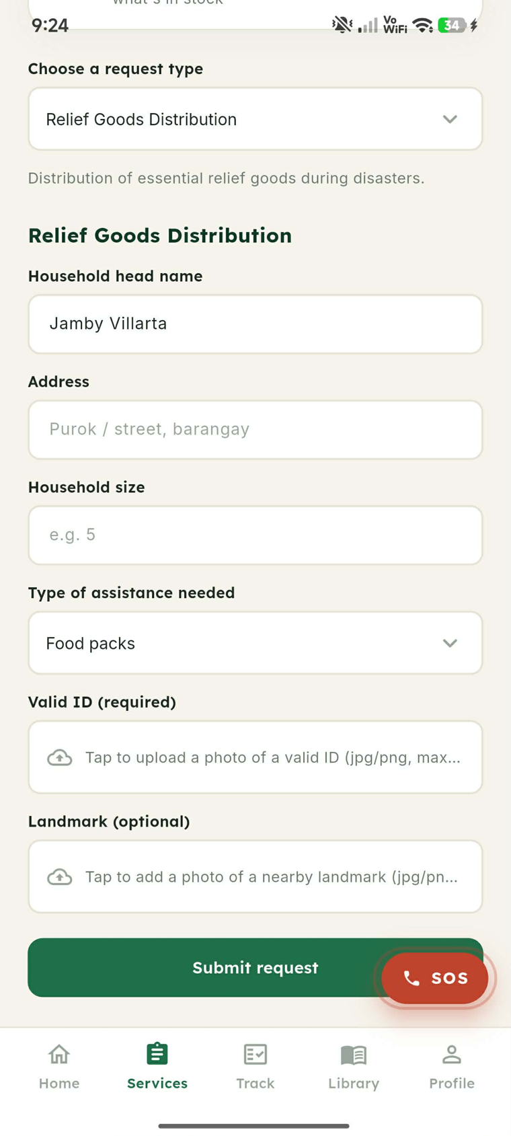
Figure 22 shows the lower portion of the Service Request screen, where the form fields change to match the request type selected in Figure 21. For a relief goods request the resident supplies the household head name, the address, the household size, and the type of assistance needed, then attaches a photograph of a valid identification document and, optionally, of a nearby landmark before submitting. Collecting the identification at the point of submission allows the administrator to verify the requester from the record itself, as shown in Figure 7.
Figure 23
SERBIS Equipment Borrowing Page
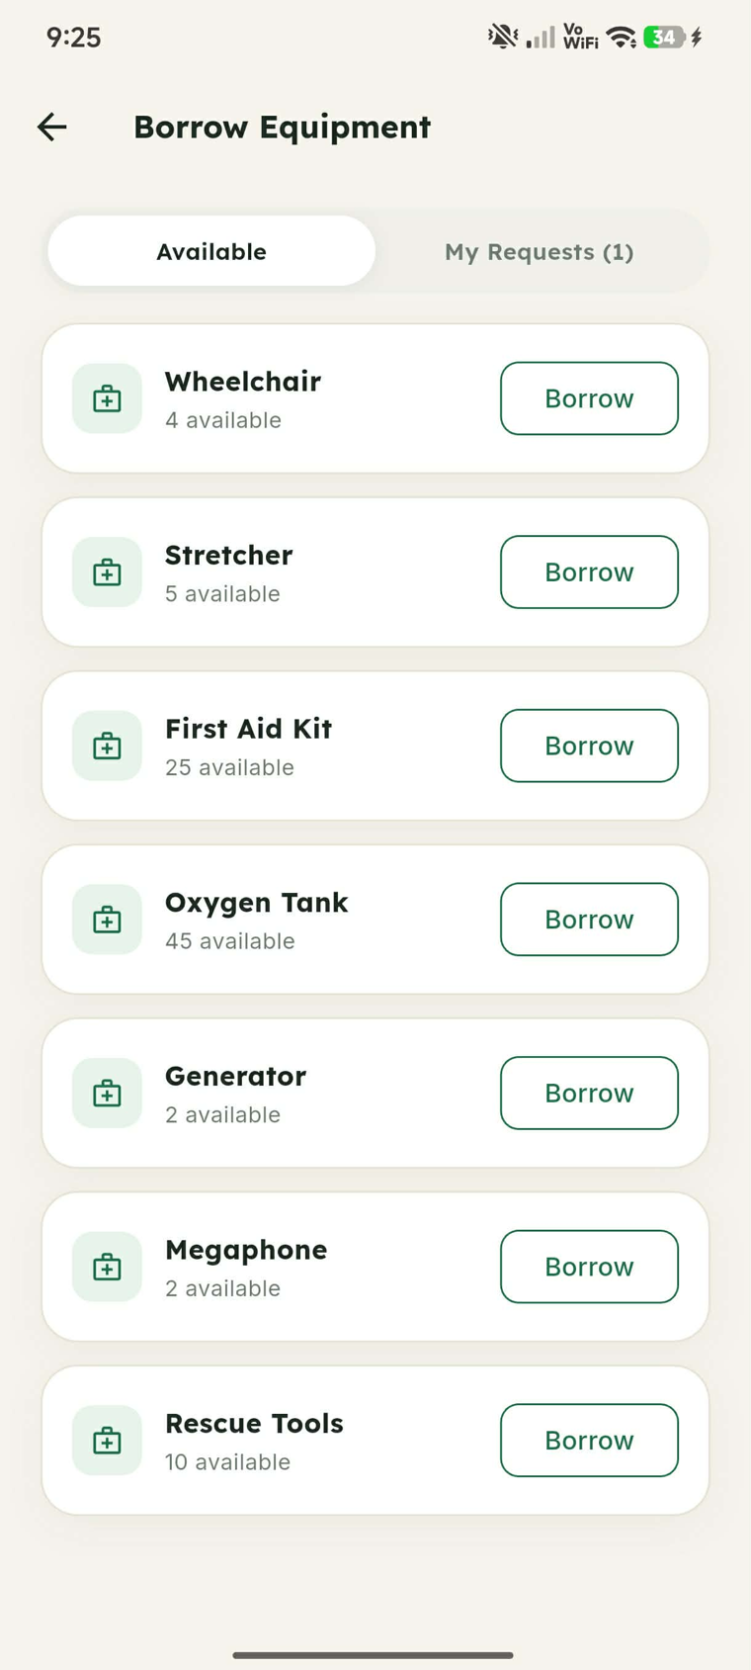
Figure 23 presents the Borrow Equipment interface, the resident facing counterpart of the administrative workflow in Figure 9. The Available tab lists each item held by the office together with the quantity remaining, drawn directly from the inventory records, so that residents request only stock that is genuinely on hand, while the My Requests tab reports the status of borrowings already filed.
Figure 24
SERBIS Request Tracking Page
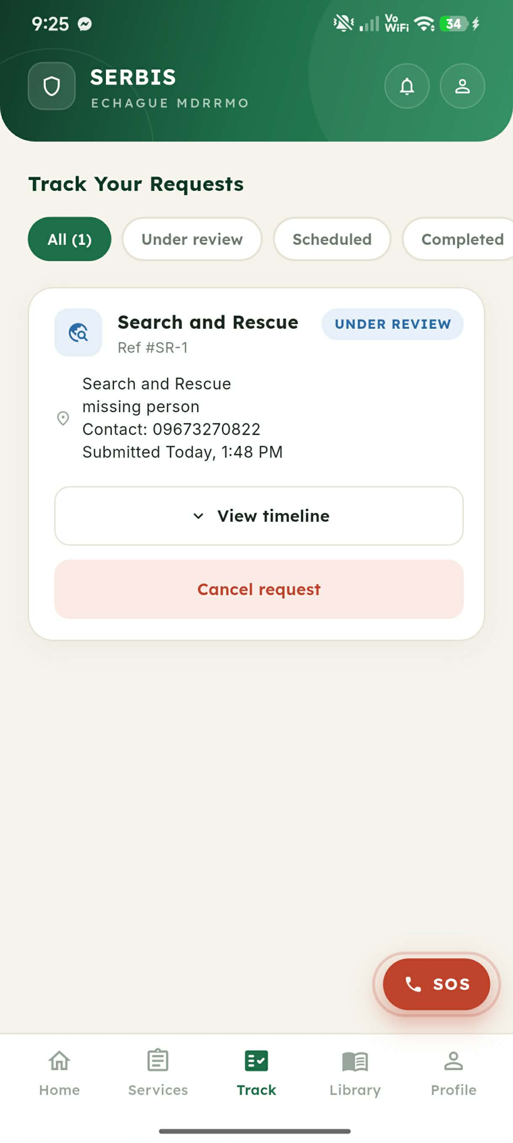
Figure 24 illustrates the Track Your Requests interface, which gives residents visibility over submissions after they are filed. Requests are grouped under All, Under review, Scheduled, and Completed tabs, and each card carries its reference number, service type, current status, contact number, and submission time. Expanding the timeline reveals each administrative action recorded against the request, and the resident may cancel a request that is no longer needed.
Figure 25
SERBIS Information and Education Materials Page
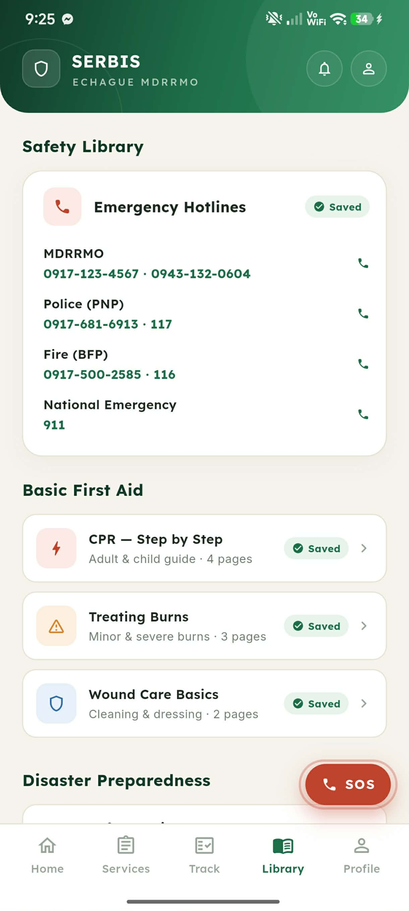
Figure 25 shows the Information Center, functioning as the digital resource library of the application. The screen opens with the emergency hotline directory, whose numbers can be dialed directly from the list, followed by the basic first aid collection. Each article is marked as saved, indicating that it has been cached on the device and remains readable without an active internet connection.
Figure 26
SERBIS Offline Preparedness Guides and MDRRMO Documents
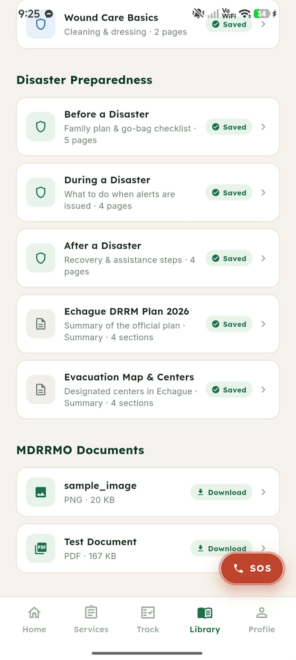
Figure 26 presents the lower portion of the Information Center, where the disaster preparedness collection covers the before, during, and after phases of an event alongside summaries of the Echague disaster risk reduction and management plan and the evacuation map. Beneath these cached articles, the MDRRMO Documents section lists the files published by administrators through the interface shown in Figure 16, which residents download on demand rather than receiving automatically.
Figure 27
SERBIS User Profile Management
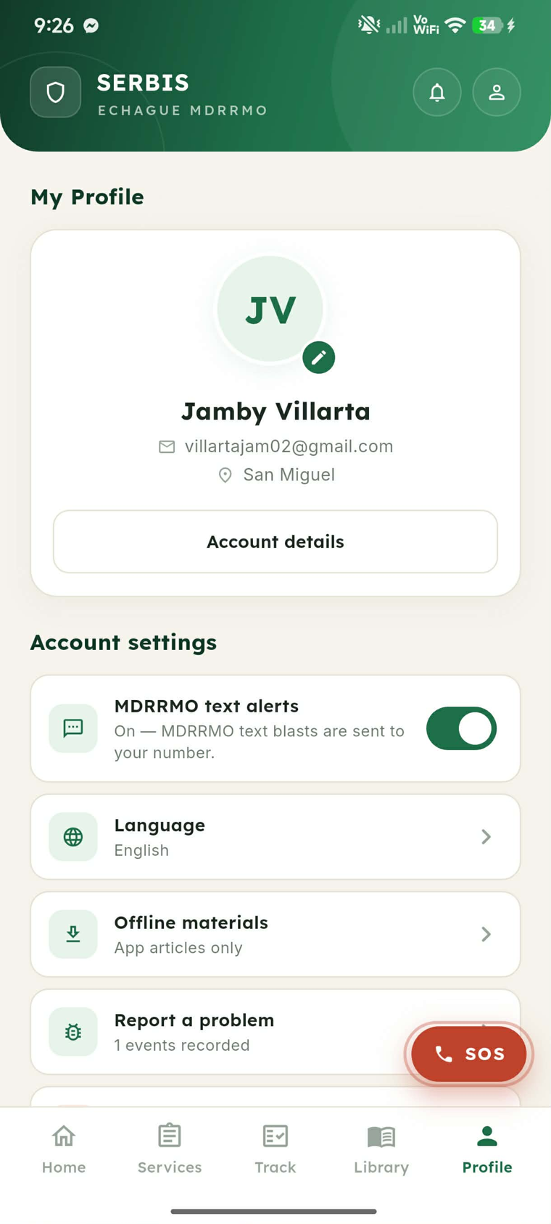
Figure 27 presents the My Profile interface. Acting as the centralized personal data hub, this screen allows users to view and update their contact information and barangay affiliation. The account settings on the same screen govern whether MDRRMO text blasts are delivered to the registered number, the interface language, the scope of materials retained for offline use, and problem reporting. Placing this feature directly in the main navigation ensures residents can easily keep their demographic records accurate without searching through complicated settings menus.
4.6 System Diagrams
This section presents the architectural and behavioral system diagrams developed for the SERBIS platform. Rather than serving solely as visual aids, these models provide a validated technical blueprint of the system structure, data routing, and relational database design.
To ensure operational correctness, every process modeled in the following subsections was strictly evaluated against the core requirements of the MDRRMO. This validation confirms that the theoretical data flows and user workflows accurately support automated record management, visualized data analytics, and emergency service management. Furthermore, standard modeling notations are utilized throughout this section.
4.6.1 Context Diagram
The Context Diagram serves as the high-level visual anchor for the SERBIS architecture. It establishes the system boundary by isolating these interactions, the diagram proves that the architectural design correctly handles the specific directional flow of disaster communication data and the generation of analytical reporting required for a coordinated municipal response.

Figure 28
Context Diagram of the proposed system
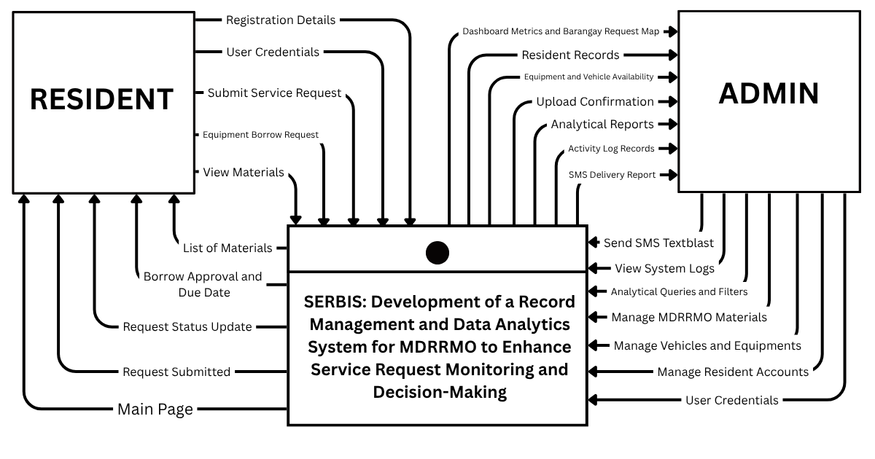
Figure 28 illustrates the Context Diagram for SERBIS, which establishes the system boundary between the central software process and its external actors. Following standard Data Flow Diagram notation, the central process box represents the entire platform logic, while the square terminators represent the external entities: Residents and MDRRMO Personnel. This model is validated against municipal requirements to ensure accurate data exchange, where input flows such as User Credentials and SMS Broadcast Commands are processed to generate output flows like Response Statuses and Service Logs and Analytical Trend Reports. By isolating these interactions, the diagram proves that the architectural design correctly handles the specific directional flow of disaster communication data required for a coordinated municipal response

4.6.2 Data Flow Diagram (DFD)
The Data Flow Diagram (DFD) provides a technical walkthrough of how information is transformed as it moves through the SERBIS system. This section utilizes standard notations where square boxes represent external entities, rounded rectangles represent functional processes, and open-ended rectangles represent data stores.
Figure 29
Data Flow Diagram of the proposed system for Residents
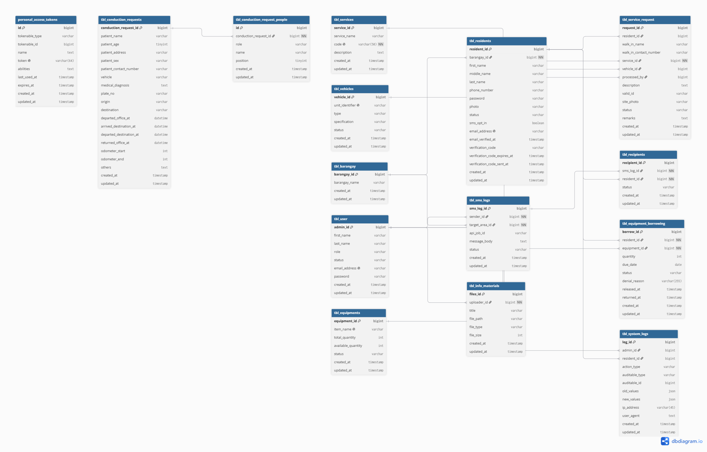
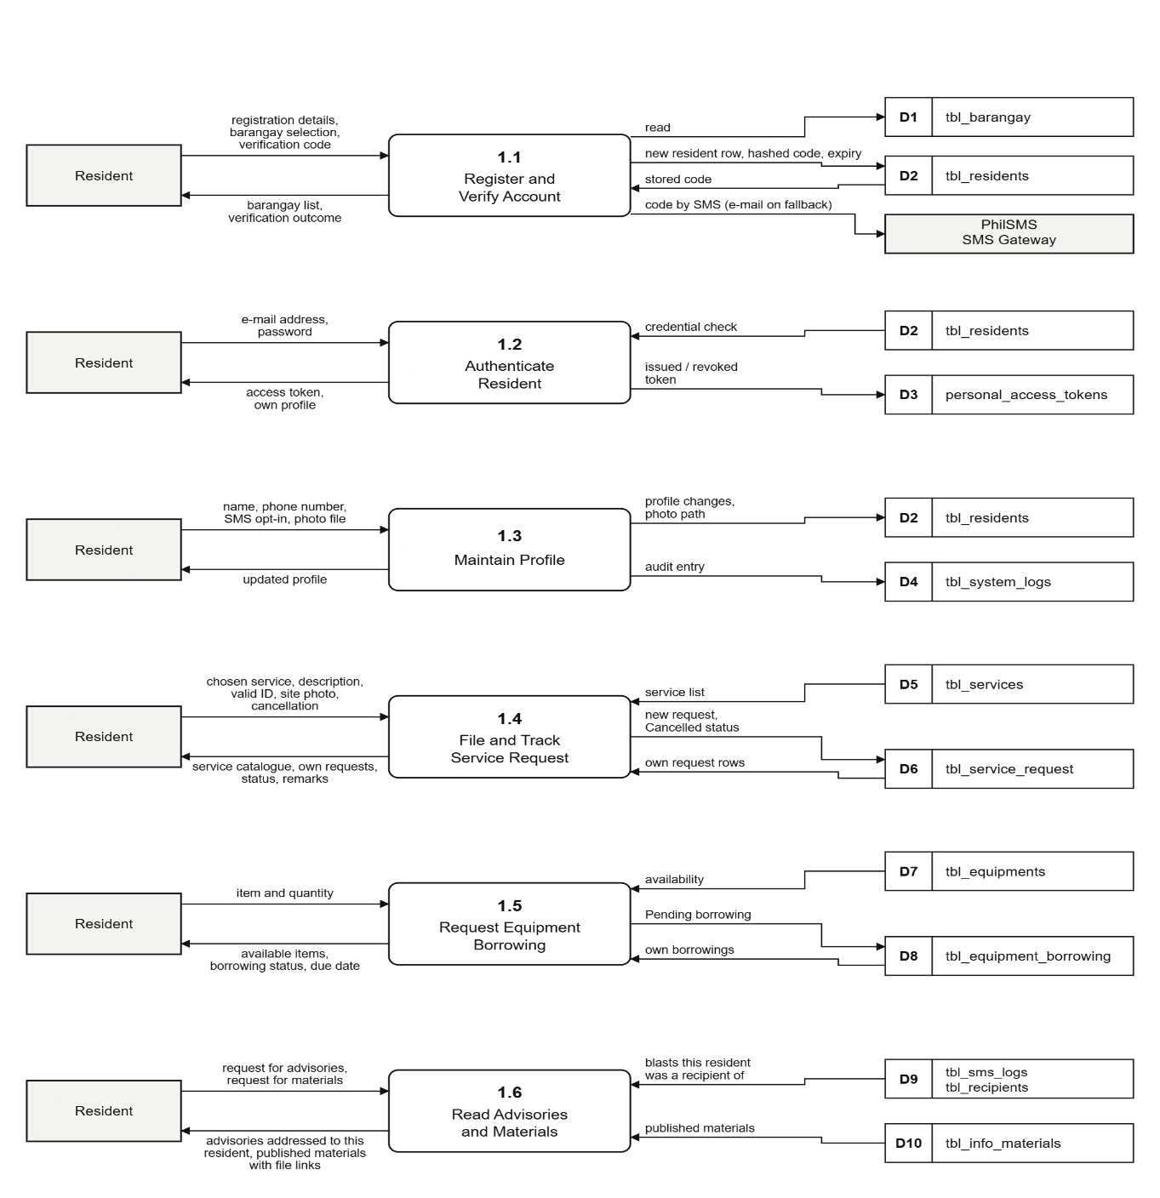
Figure 29 illustrates the Resident Level 1 DFD, detailing the process steps and data movement for the Resident entity.
Process 1.1 (Register and Verify Account) handles account creation by reading barangay data from tbl_barangay, writing registration details to tbl_residents, and interfacing with an external SMS Gateway for verification.
Process 1.2 (Authenticate Resident) validates login credentials against tbl_residents and manages access tokens in personal_access_tokens.
Process 1.3 (Maintain Profile) allows residents to update their information in tbl_residents, with changes recorded as audit entries in tbl_system_logs.
Process 1.4 (File and Track Service Request) retrieves available services from tbl_services and commits resident submissions to tbl_service_request.
Process 1.5 (Request Equipment Borrowing) checks item availability in tbl_equipments and logs borrowing transactions in tbl_equipment_borrowing.
Process 1.6 (Read Advisories and Materials) retrieves resident-specific SMS alerts from tbl_sms_logs and tbl_recipients, and pulls published safety guides from tbl_info_materials.

Figure 30
Data Flow Diagram of the proposed system for Administrator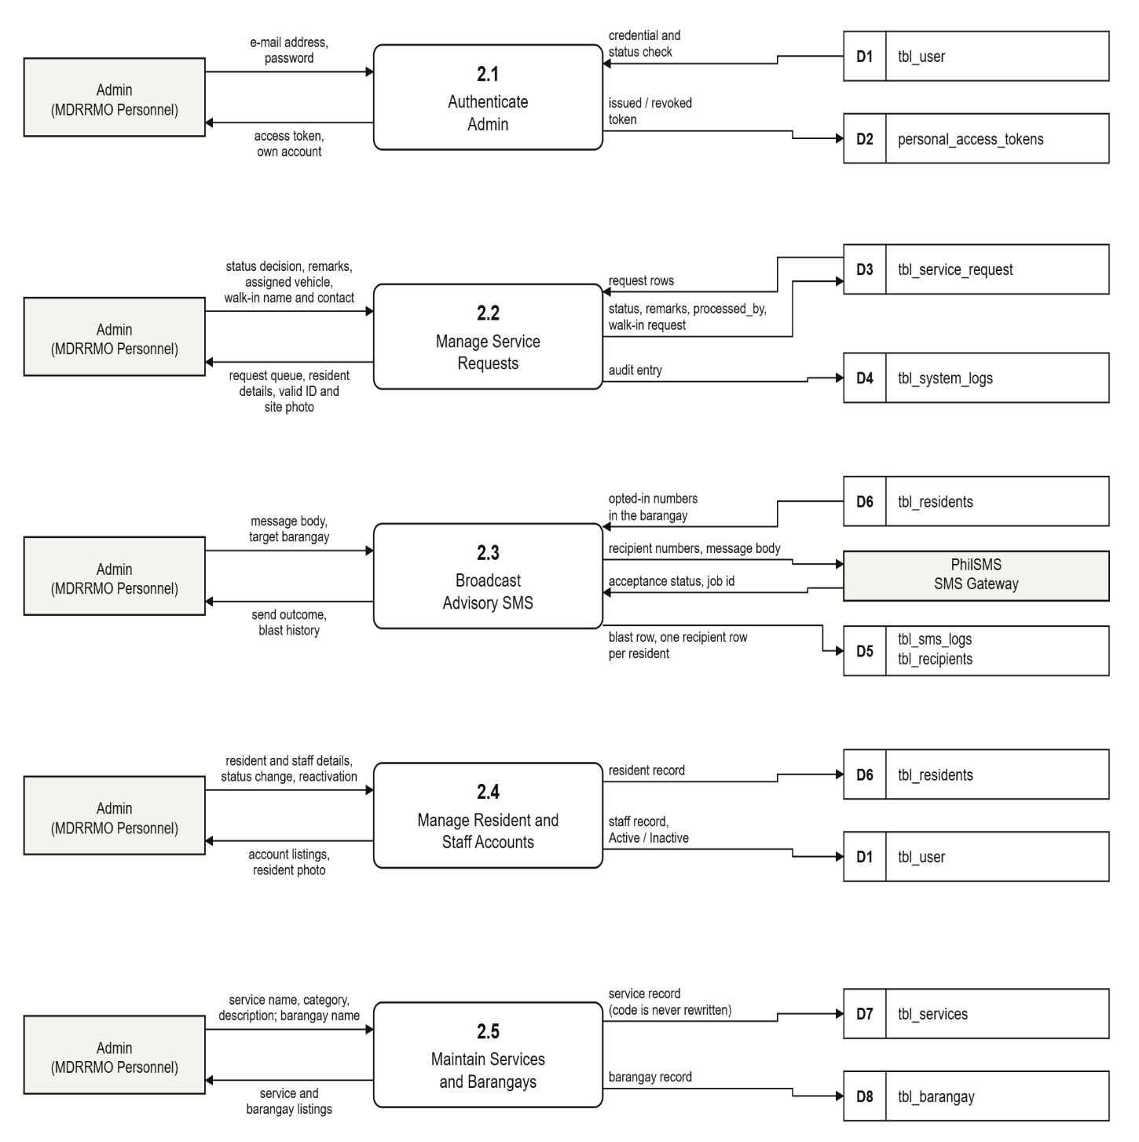
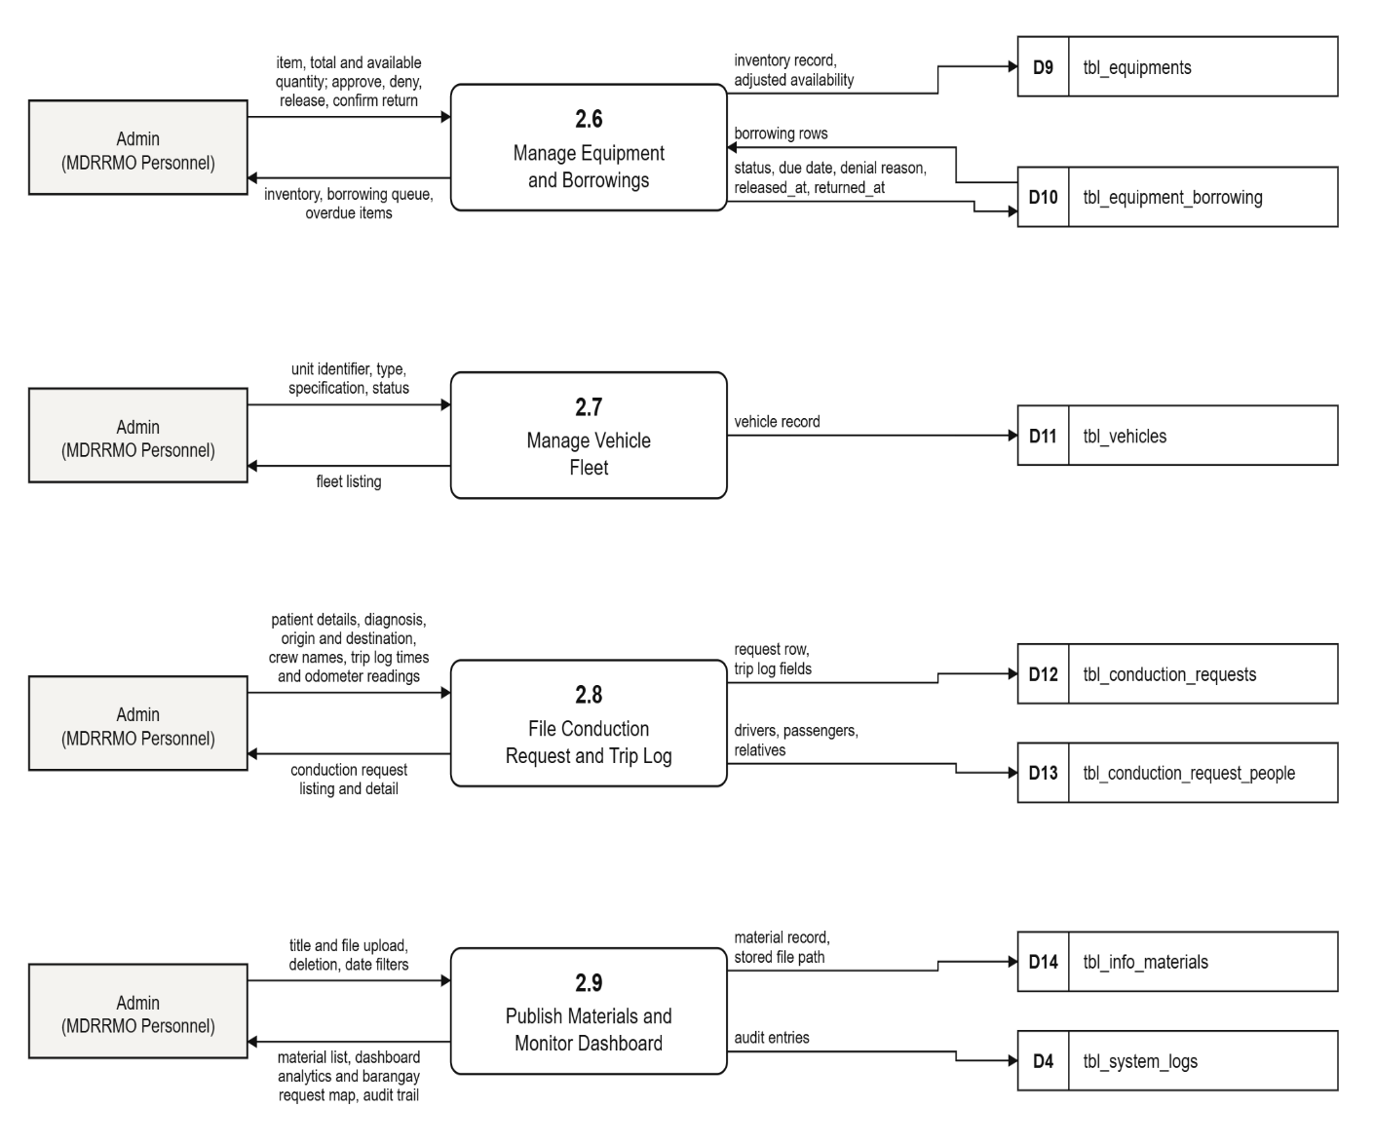
Figure 30 shows the Level 1 DFD for the Admin module, covering nine processes that support municipal oversight.
Process 2.1 (Authenticate Admin) validates login credentials against tbl_user and issues or revokes access tokens in personal_access_tokens.
Process 2.2 (Manage Service Requests) lets the admin review submitted requests from tbl_service_request, record status decisions and remarks, and log a walk-in request when a resident reports in person.
Process 2.3 (Broadcast Advisory SMS) sends an advisory to opted-in residents in a target barangay by pulling numbers from tbl_residents, routing the message through the SkySMS gateway, and logging the blast and per-recipient outcomes in tbl_sms_logs and tbl_recipients.
Process 2.4 (Manage Resident and Staff Accounts) handles account creation, status changes, and reactivation for both resident records (tbl_residents) and staff records (tbl_user).
Process 2.5 (Maintain Services and Barangays) lets the admin define service offerings (tbl_services) and manage the list of barangays (tbl_barangay).
Process 2.6 (Manage Equipment and Borrowings) covers inventory upkeep in tbl_equipments and the approval, release, and return of borrowed items in tbl_equipment_borrowing.
Process 2.7 (Manage Vehicle Fleet) records vehicle units, specifications, and status in tbl_vehicles.
Process 2.8 (File Conduction Request and Trip Log) captures patient conduction details and trip log data (crew, times, odometer readings) across tbl_conduction_requests and tbl_conduction_request_people.
Process 2.9 (Publish Materials and Monitor Dashboard) manages upload and deletion of informational materials in tbl_info_materials and surfaces dashboard analytics, while writing audit entries to tbl_system_logs.
Each process logs relevant actions back to the admin as confirmations, listings, or dashboards, giving MDRRMO personnel end-to-end control over resident services, resources, and communication.
4.6.3 Entity-Relationship Diagram (ERD)
The Entity Relationship Diagram (ERD) is a visual representation of the data and its relationship within the system
Figure 31
Entity-Relationship Diagram of the proposed system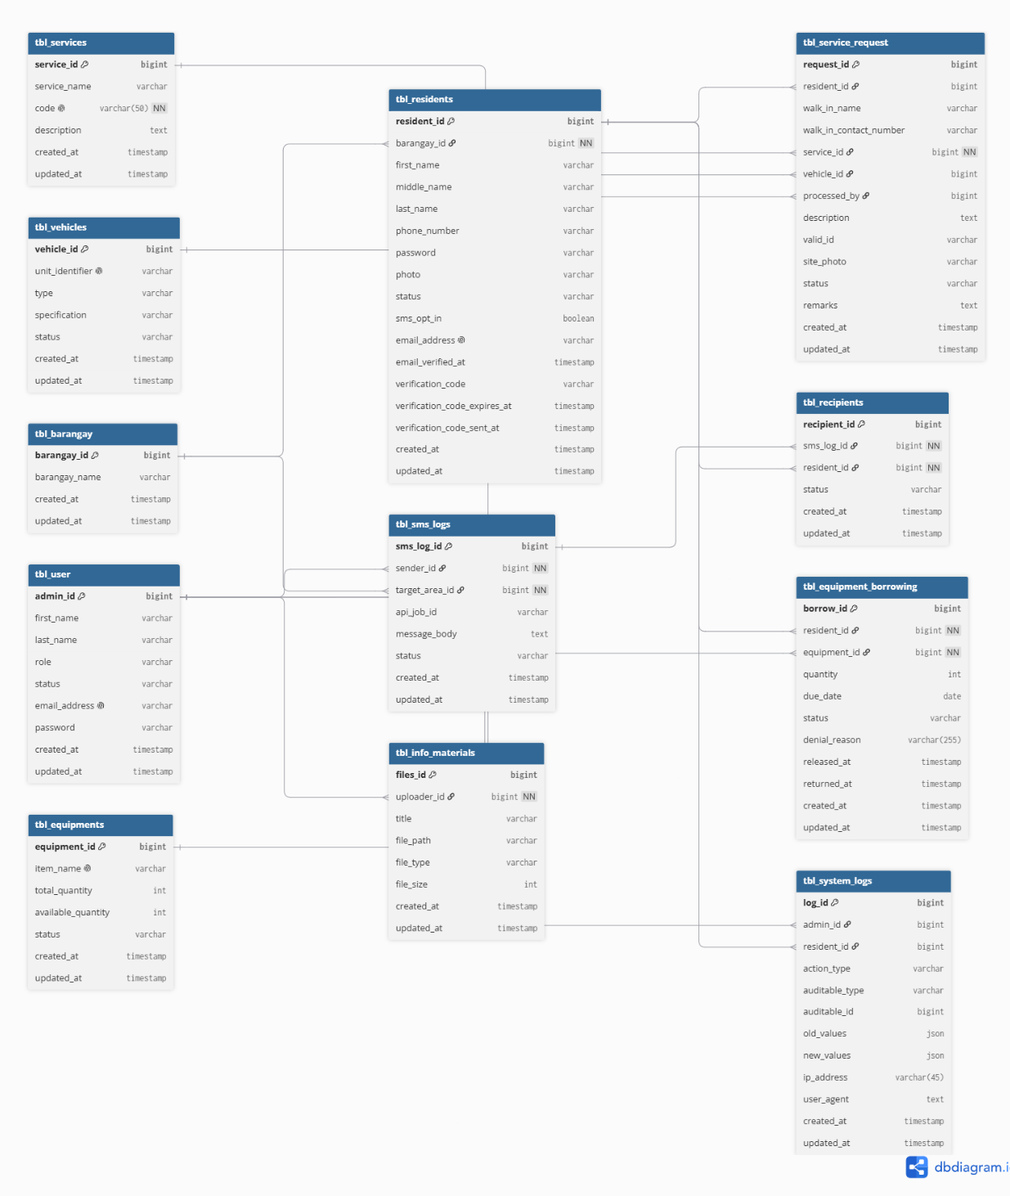
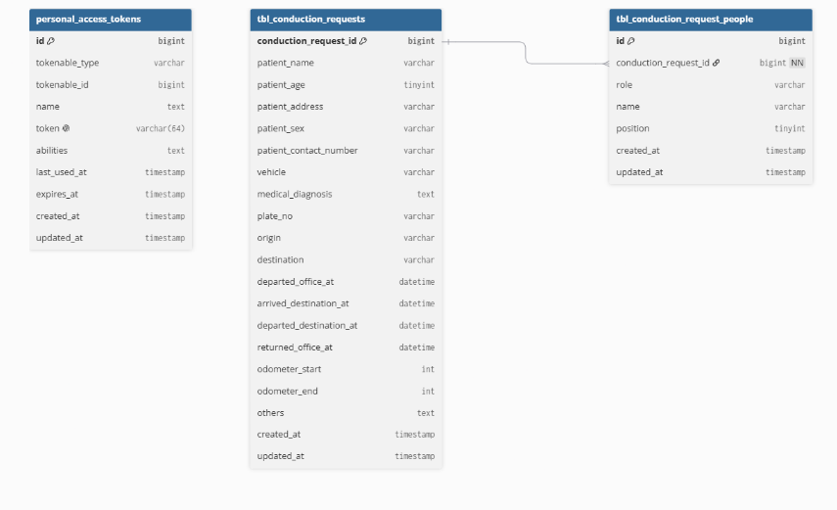
Figure 31 presents the Entity-Relationship Diagram (ERD) of SERBIS, illustrating the database structure of the system. The schema consists of twenty-five application tables, grouped below by module. A Disasters entity was planned in the original proposal but never populated with a taxonomy; the targeted-SMS module absorbed its intended role by addressing barangays directly, and the table was dropped. In its place, the schema grew a fleet and logistics layer that covers MDRRMO's non-SMS operations: vehicles, responders, equipment lending, ambulance bookings, and the office's paper-based ambulance dispatch and trip log. Framework-managed tables (such as personal_access_tokens for API tokens) are not part of the ERD.
User Profiles: tbl_residents is keyed by resident_id and links to tbl_barangay through barangay_id. Each account has an account_type of head of the family, barangay, or organization; organization accounts also store an organization_name. The system allows only one barangay account per barangay, enforced in the application. MDRRMO admin accounts are keyed by admin_id in tbl_user. tbl_device_tokens stores each resident's push notification tokens, and tbl_system_logs records audit entries linked to either an administrator or a resident.
Service Requests: tbl_service_request, keyed by request_id, is the primary source for the analytics engine. resident_id links each request to the account that filed it, and service_id links it to tbl_services; service_id is optional because ambulance bookings are filed without a catalogue service. processed_by links the request to the administrator who handled it, and vehicle_id to the assigned vehicle. tbl_ambulance_bookings extends a request one-to-one (sharing its request_id) with the patient, destination, and scheduled time, drawing destinations from tbl_ambulance_destinations. tbl_service_request_relatives records the relatives accompanying a request. tbl_responders lists MDRRMO responders, and tbl_request_responders assigns one or more responders to a request.
Service Configuration: tbl_service_audience defines which account types may request each service, and tbl_service_vehicle_types defines which vehicle types can serve each service. Both are keyed by service rather than by a foreign key to tbl_services. tbl_emergency_hotlines stores the emergency hotline directory that the mobile application lists in its Information Center.
SMS Module: tbl_sms_logs is keyed by sms_log_id, records the sending administrator and the target barangay, and connects to tbl_recipients to record exactly which residents received a given blast. tbl_sms_queue_ids stores the gateway's queue identifiers for each blast, and tbl_sms_blast_code stores a single hashed authorization code that an administrator must enter before a text blast is sent, together with the administrator who last changed it. Text blasts are addressed to barangays directly, consistent with the Disasters entity's removal from the schema. tbl_info_materials stores the published advisories and guides together with their uploader.
Fleet and Logistics Module: tbl_vehicles (vehicle_id) tracks unit status and can be assigned to service requests and conduction requests. tbl_equipments (equipment_id) manages lending inventory, linked through tbl_equipment_borrowing to tbl_residents by resident_id and to tbl_equipments by equipment_id, recording borrow, release, and return timestamps. Each borrowing has a borrower_type of resident or organization; for an organization borrower, the organization's name is recorded, while the borrowing remains filed under a resident account. tbl_conduction_requests (conduction_request_id) digitizes MDRRMO's ambulance dispatch form and is filed by staff rather than residents; it can link to the originating service request and the vehicle used. tbl_conduction_request_people links to it by conduction_request_id to record an arbitrary number of drivers, passengers, and relatives per trip.

References
Aisyah, D. N., Rahman, F. M., Diva, H., Putra, B. S., Rizki, M. H., Bisri, M. B. F., & Manikam, L. (2026). Mobile-enabled technologies in disaster management: A systematic literature review. Disaster Medicine and Public Health Preparedness, 20, e15. https://doi.org/10.1017/dmp.2025.40
Al-Zahrani, A., Al-Mutairi, M., & Smith, J. (2022). Evaluating the usability of mobile emergency alert systems: A community-based study. International Journal of Human-Computer Interaction Studies, 9(1), 45–62. https://doi.org/10.1016/j.ijhcis.2022.01.004
Chavula, J., & Kayusi, M. (2025). Bridging the digital divide in disaster-prone regions through offline-first mobile architectures. Journal of Community Informatics, 21(3), 88–104. https://doi.org/10.1539/jci.2025.1022
Conchas, C. A. J., & Salapa, A. C. (2025). Assessing digital governance implementation issues in local government units: A systematic literature review. International Journal of Engineering Technology Research & Management. https://ijetrm.com/issues/files/Dec-2025-10-1765366936-DEC25.pdf
Elejalde, E., Naushirvanov, T., Kalimeri, K., Omodei, E., Karsai, M., Bravo, L., & Ferres, L. (2025). Use of mobile phone data to measure behavioral response to SMS evacuation alerts. International Journal of Disaster Risk Reduction. https://doi.org/10.1016/j.ijdrr.2025.104235
EmergInsight. (2026). EmergInsight: A real-time dashboard for optimizing emergency care through data visualization and analytics. JAMIA Open, 9(1), ooag008. https://doi.org/10.1093/jamiaopen/ooag008
Escolano, D., Hernandez, P., & Cruz, F. (2023). Evaluating mobile applications for disaster preparedness: Fostering decision intelligence among disaster management personnel. Disaster Prevention and Management, 32(4), 567–582. https:// doi.org/10.1108/DPM-09-2022-0285
Fonseca, R., & Silva, T. (2025). Assessing the effectiveness of SMS disaster warnings: Analysis of 73,701 messages in Brazil. International Journal of Disaster Risk Science, 16(1), 45–61. https://doi.org/10.1007/s13753-024-00345-8
Gatchalian, C. B., Pascual, K. F. C., & Domingo, M. S. (2023). Enhancing community resilience through the Government Text Alert System: A case study in Barangay San Miguel, Bulacan. Journal of Disaster Management Studies. https://irjaes.com/wp-content/uploads/2023/08/IRJAES-V8N3P202Y23.pdf
Goh, L., Tan, R., & Lim, K. (2023). iAlerto: A web and mobile alert system for Pasig City DRRMO. Journal of Emergency Management Technology, 15(3), 120–136. https://doi.org/10.1016/j.jemt.2023.03.005
Gongora, J., et al. (2026). Computerized record management of resident and certificate issuance system for Barangay Dammang, Sanchez Mira, Cagayan [Capstone Project, Bachelor of Science in Information Technology]. College of Information and Computing Sciences. https://www.scribd.com/document/556710148/Updated-Capstone-Project-Gongora
Huang, D., Wang, S., & Liu, Z. (2021). A systematic review of prediction methods for emergency management. Journal of Emergency Management Research, 15(4), 221–240. https://doi.org/10.1016/j.jemr.2021.00373
Hwang, W., & Salvendy, G. (2021). Number of people required for usability evaluation: The 10±2 rule updated. Communications of the ACM, 64(5), 33–40. https://doi.org/10.1145/3430360
International Organization for Standardization. (2023). Systems and software engineering — Systems and software quality requirements and evaluation (SQuaRE) — Product quality model (ISO/IEC Standard No. 25010:2023). https://www.iso.org/standard/78174.html
Lidres, K. A., Sadava, D. J. G., & Soberano, K. T. (2024). RescueLink: SOS alert system for disaster response and management. International Journal of Computer Science and Mobile Computing, 13(5), 130–135. https://doi.org/10.47760/ijcsmc.2024.v13i05.013
Montefalcon, M., Reyes, C., & Santos, B. (2021). IRespondPH: Mobile and web application for post-disaster needs assessment in the Philippines. International Journal of Disaster Risk Reduction, 56, 102123. https://doi.org/10.1016/j.ijdrr.2021.102123
Nalendra, A. K. (2021). Rapid Application Development (RAD) model method for creating an agricultural irrigation system based on internet of things. IOP Conference Series: Materials Science and Engineering, 1098(2), 022103.
https://doi.org/10.1088/1757-899X/1098/2/022103doi.org
Nielsen, J., & Landauer, T. K. (1993). A mathematical model of the finding of usability problems. Proceedings of the INTERACT '93 and CHI '93 Conference on Human Factors in Computing Systems, 206–213.
https://doi.org/10.1145/169059.169166doi.org
Nurjannah, U., Hasymi, E., & Putera, R. E. (2025). Information technology-based public service innovation management strategy: A case study of mobile application usage in government agencies. Jurnal Ilmiah Ekotrans & Erudisi, 5(1), 33–49. https://doi.org/10.69989/fwfxnn22
Puspita, I., Kurniawan, A., & Marfai, M. A. (2025). Contribution of ICT development to disaster risk reduction from a spatial perspective: A preliminary literature review. Journal of Disaster Research, 20(1), 89–110. https://doi.org/10.20965/jdr.2025.p0089
Rafael-Vicente, L., & Mercado, K. (2024). Community perceptions of local disaster response coordination in the Philippines. Journal of Philippine Social Sciences and Development, 12(4), 150–168. https://www.pssd.org.ph/archives/2024/vol12-4-rafael-vicente
Rai, P. K., Singh, P., & Mishra, V. N. (2021). Recent technologies for disaster management and risk reduction. Springer Nature. https://doi.org/10.1007/978-3-030-76116-5
Republic Act No. 11315. (2019). An act establishing a Community-Based Monitoring System (CBMS) and appropriating funds therefor. Official Gazette of the Republic of the Philippines. (Updated review via PIDS 2024). https://www.officialgazette.gov.ph/2019/04/17/republic-act-no-11315/
Richey, R. C., & Klein, J. D. (2014). Design and development research: Methods, strategies, and issues. Routledge. https://www.perlego.com/book/1608666/design-and-development-research-methods-strategies-and-issues-pdfwww.perlego.com
Sekaran, U., & Bougie, R. (2016). Research Methods for Business: A Skill-Building Approach (7th ed.). John Wiley & Sons.
Syahputra, A., & Sembiring, F. (2021). Early flood detection prototype with Arduino microcontroller and SMS Gateway automation. Indonesian Journal of Disaster Science, 5(2), 77–88. https://doi.org/10.22146/ijds.2021.11342
Trogrlić, R. Š., van den Homberg, M., Budimir, M., McQuistan, C., Sneddon, A., & Golding, B. (2022). Early warning systems and their role in disaster risk reduction. International Journal of Disaster Risk Science, 13(1), 45–60. https://doi.org/10.1007/978-3-030-98989-7_2

