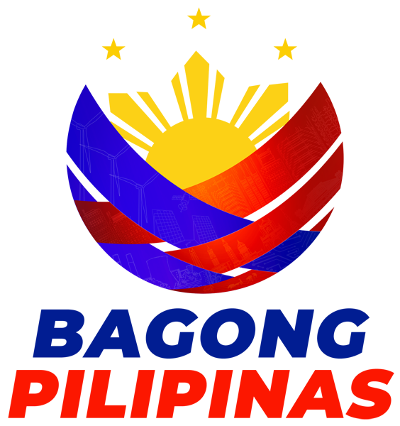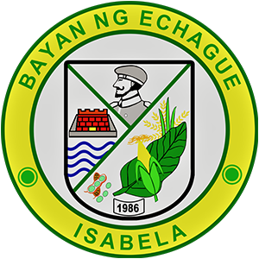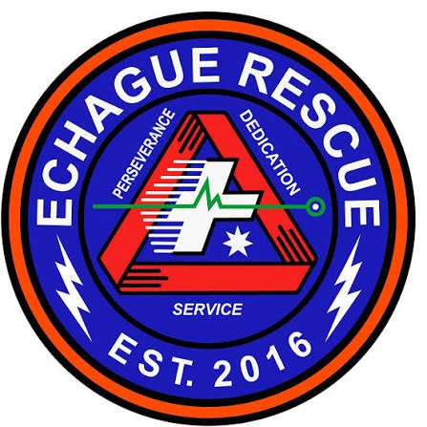
SERBIS Mobile App User Manual
v1.0, October 2026
Municipal Disaster Risk Reduction and Management Office
Municipality of Echague, Isabela

Contents
Contents are filled in when the PDF is made.

About this manual
This manual is for residents of Echague who use the SERBIS app to ask the MDRRMO for services, book patient transport, borrow equipment and read safety guides.
SERBIS is for non-emergency requests. In an emergency, call the hotline. The numbers are in the app's Safety library.
Each task has numbered steps. Red numbered boxes on a picture match the numbers in the legend under it.
Account types. What you can request depends on your account:
• Head of the Family: for a household.
• Barangay: for a barangay hall. MDRRMO creates these accounts.
• Organization: for a school, company or group. It can request services only after MDRRMO approves it. Some services are only for certain account types. For example, relief goods are for barangay accounts, and trainings and drills are for barangays and organizations.

Get started

Install the app
SERBIS is not on the Play Store. Organizations wait for MDRRMO to activate the account before filing requests.
1. Open https://serbis-landing-page.vercel.app/ on your Android phone.
2. Tap Download APK and wait for the file to finish.
3. Open the file from your notifications or Downloads.
4. If the phone asks, allow installs from this source.
5. Open SERBIS and create your account.

Create an account
1. Tap Register.
2. Under Registering as, choose Head of the Family or Organization.
3. Type your name and mobile number. An organization also types its name, and the name of its contact person.
4. Tap Next: Where you live.
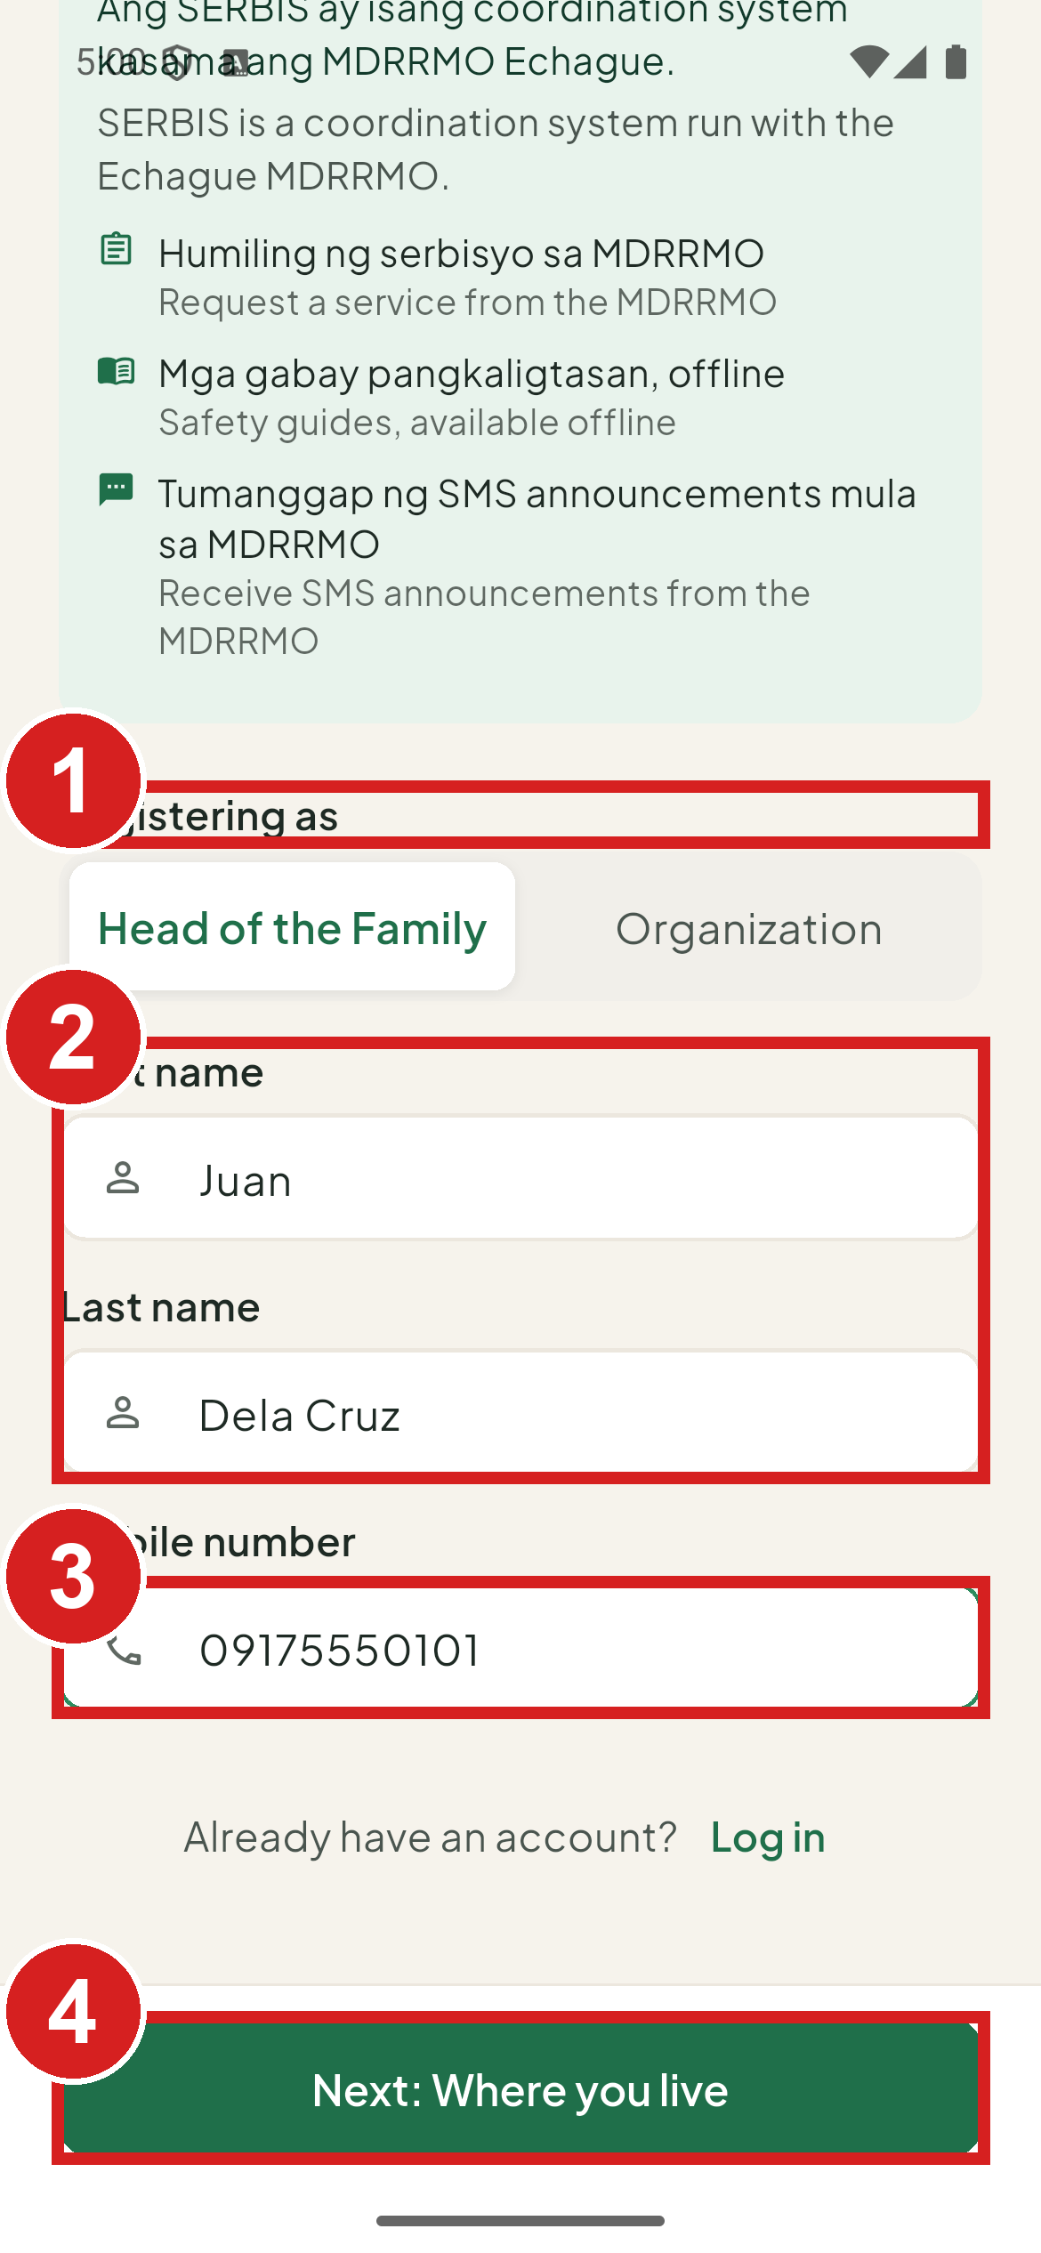 | 1 Head of the Family or Organization  2 Your name  3 Your mobile number  4 Go on

5. Choose your barangay and type your street or purok.
6. Tap Next: Password and review.
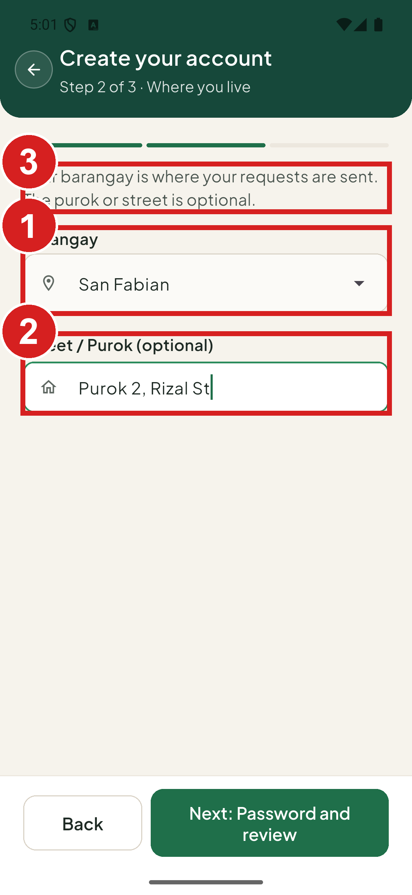 | 1 Where you live  2 Street or purok  3 Read this before you choose

7. Type a password twice. It needs at least 8 characters, with upper and lower case letters and a number, for example Pasada123.
8. Check your details.
9. Tap Create account.
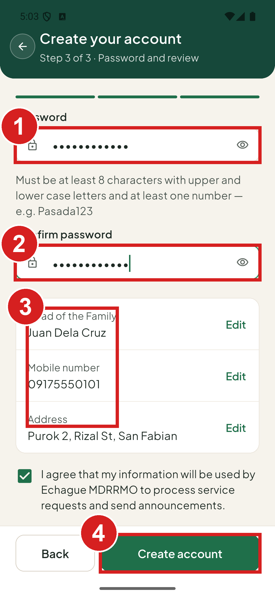 | 1 At least 8 characters  2 Type it again  3 Check your details  4 Finish

Confirm your mobile number
SERBIS texts a 6-digit code to your number. The screen is called Check your messages.
1. Type the code.
2. Tap Verify. If the text does not come, wait for Resend code in … to count down 60 seconds, then tap Send a new code. If you typed the wrong number, tap Back to log in and register again.
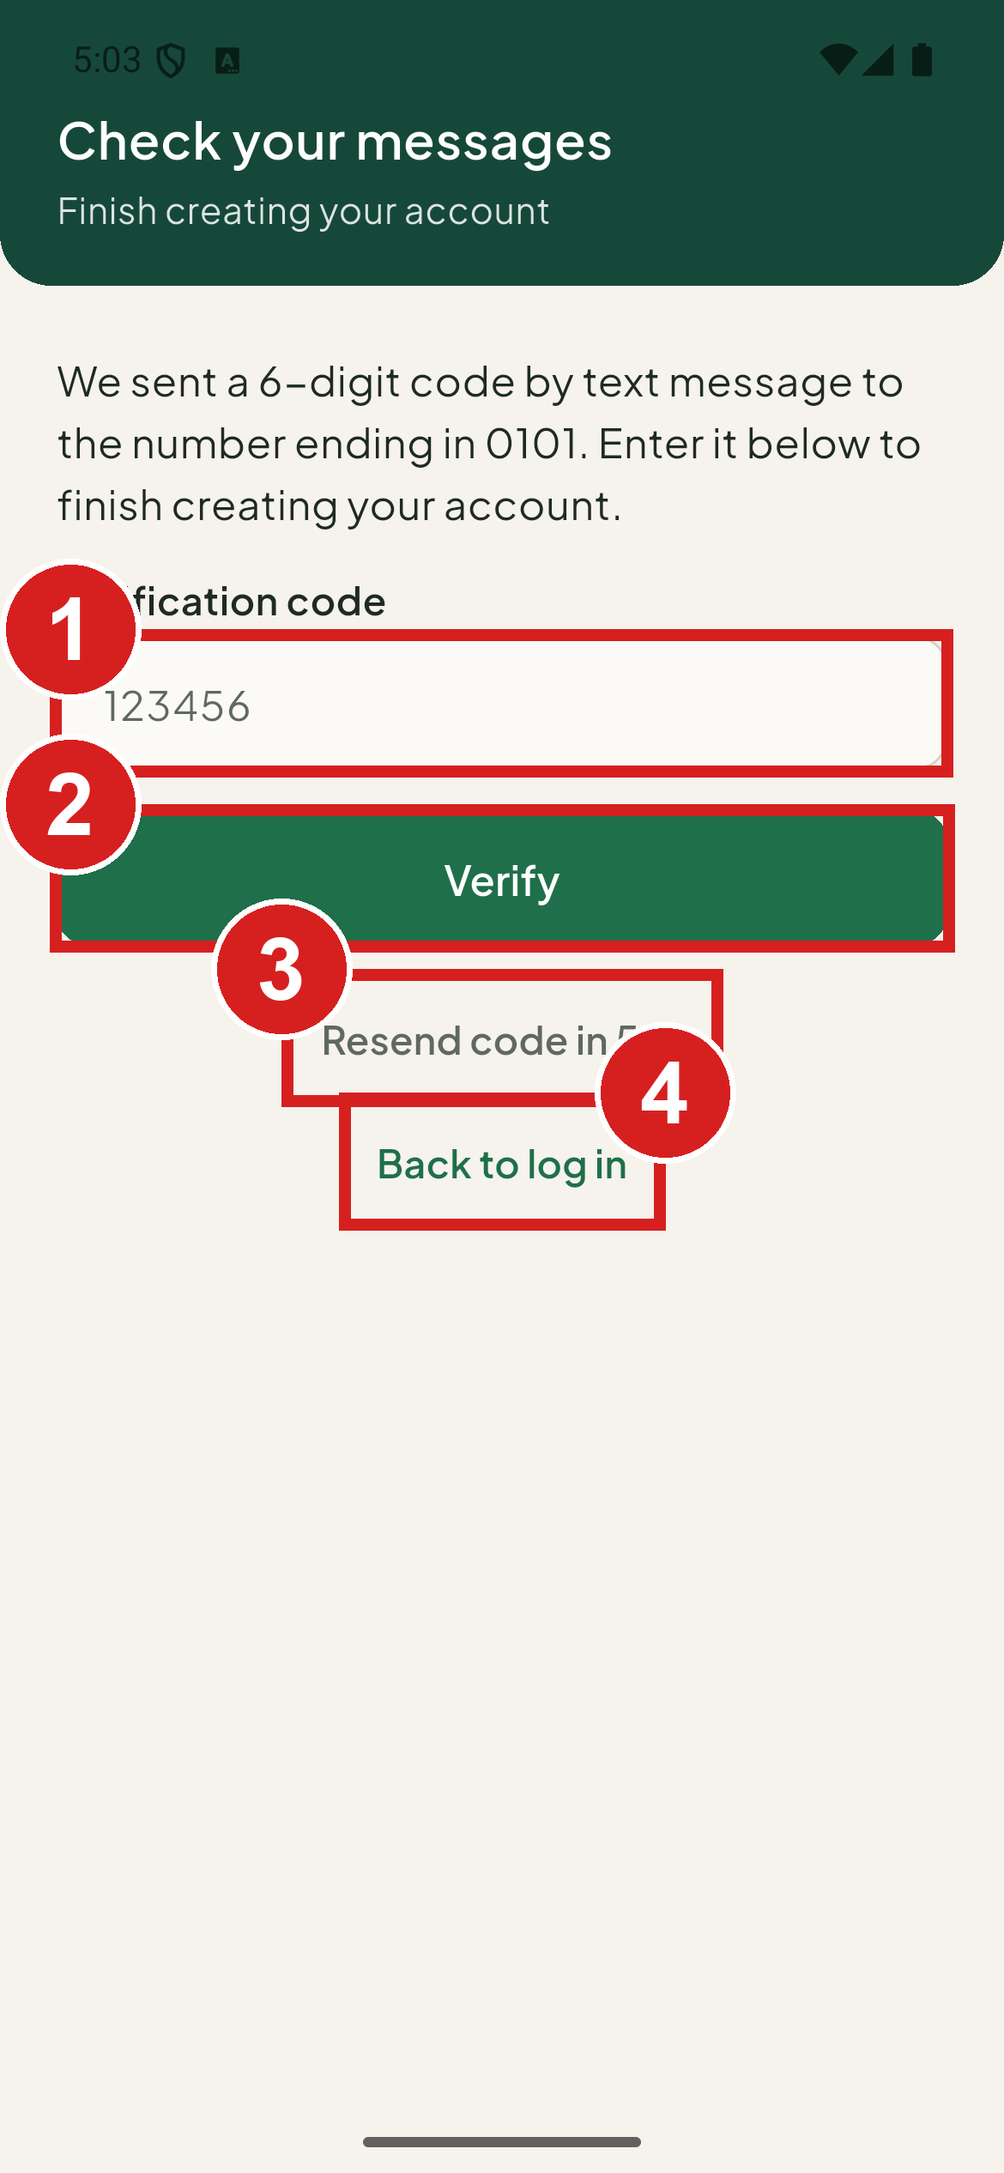 | 1 The 6-digit code  2 Confirm your number  3 Ask for a new code when it reaches 0  4 Wrong number? Start again

Log in
1. Type your mobile number and password.
2. Tap Log in.
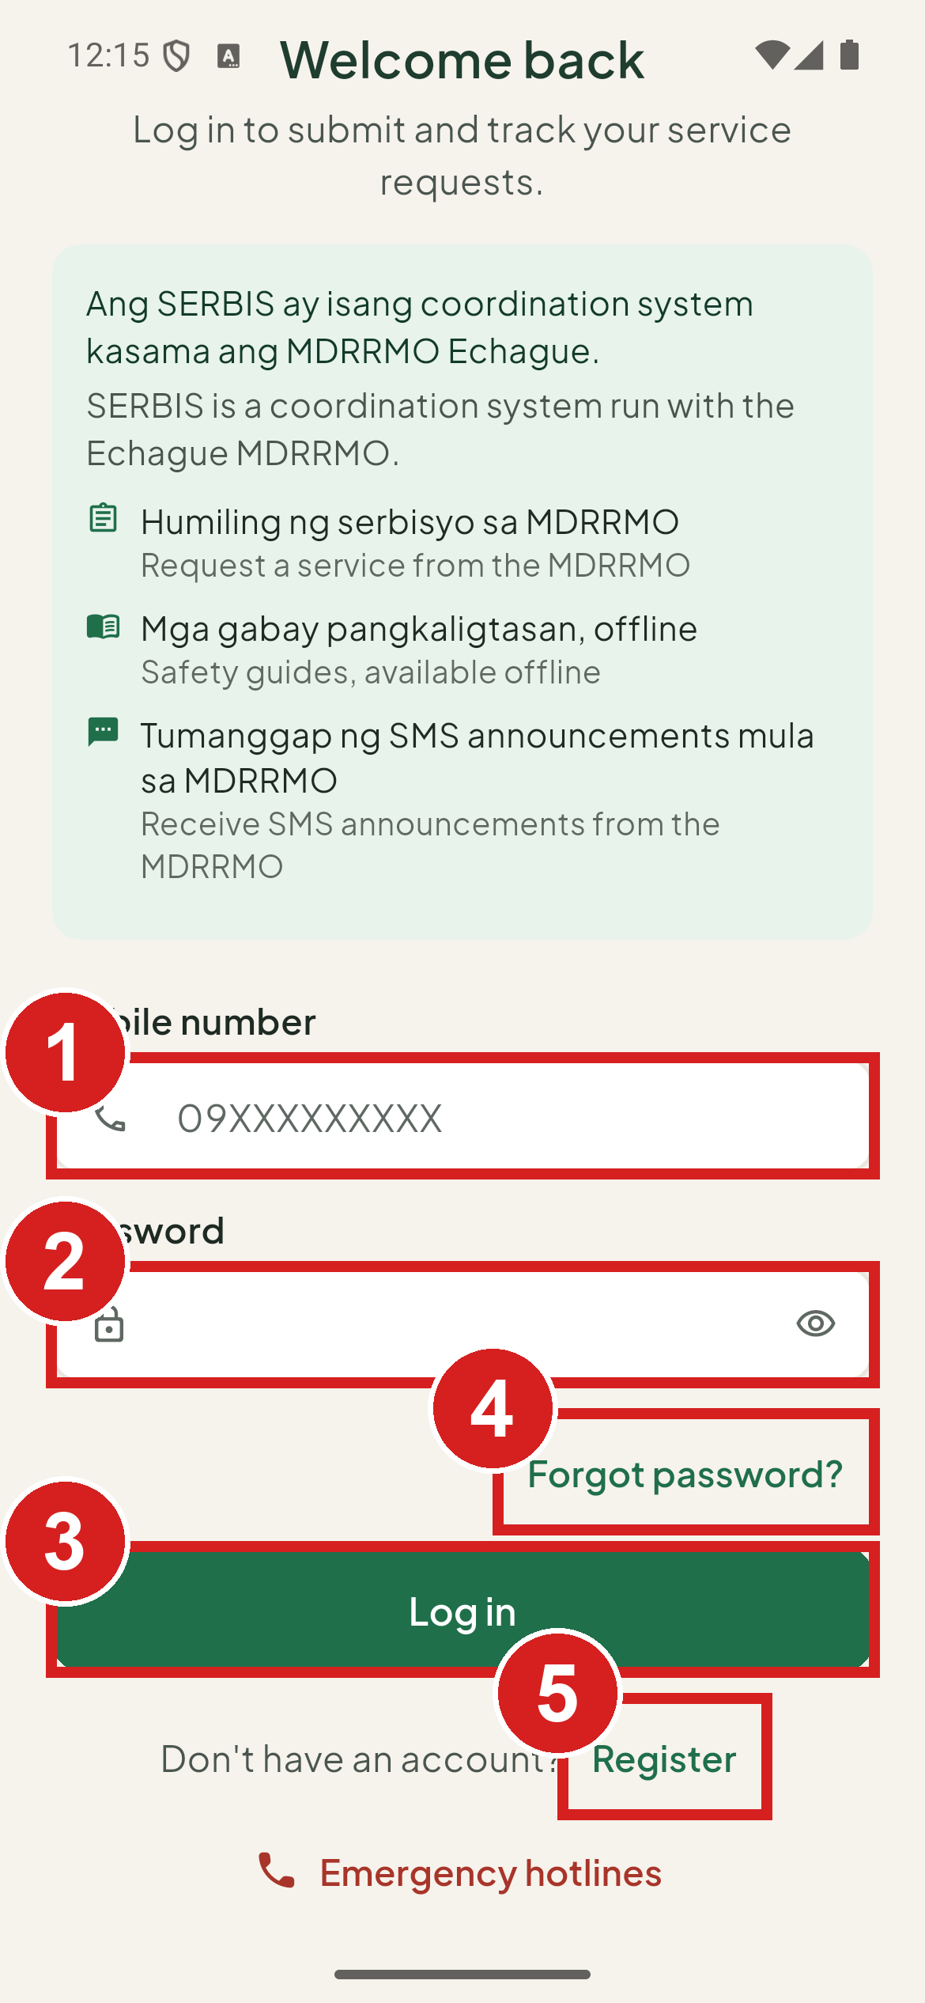 | 1 Your number  2 Your password  3 Log in  4 Reset your password  5 Make a new account

3. On Check your messages, type the code texted to you.
4. Tap Verify.
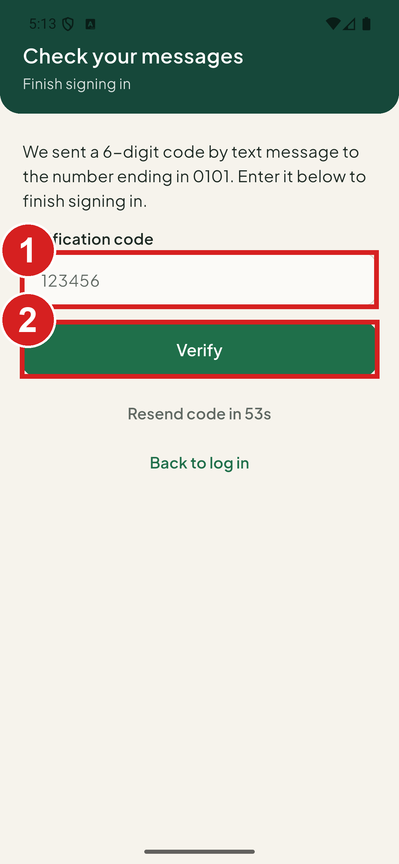 | 1 The code from the text message  2 Finish

Call a hotline before you log in
You can see the hotlines without an account.
1. On the log in screen, tap Emergency hotlines.
2. Tap a number to call it.
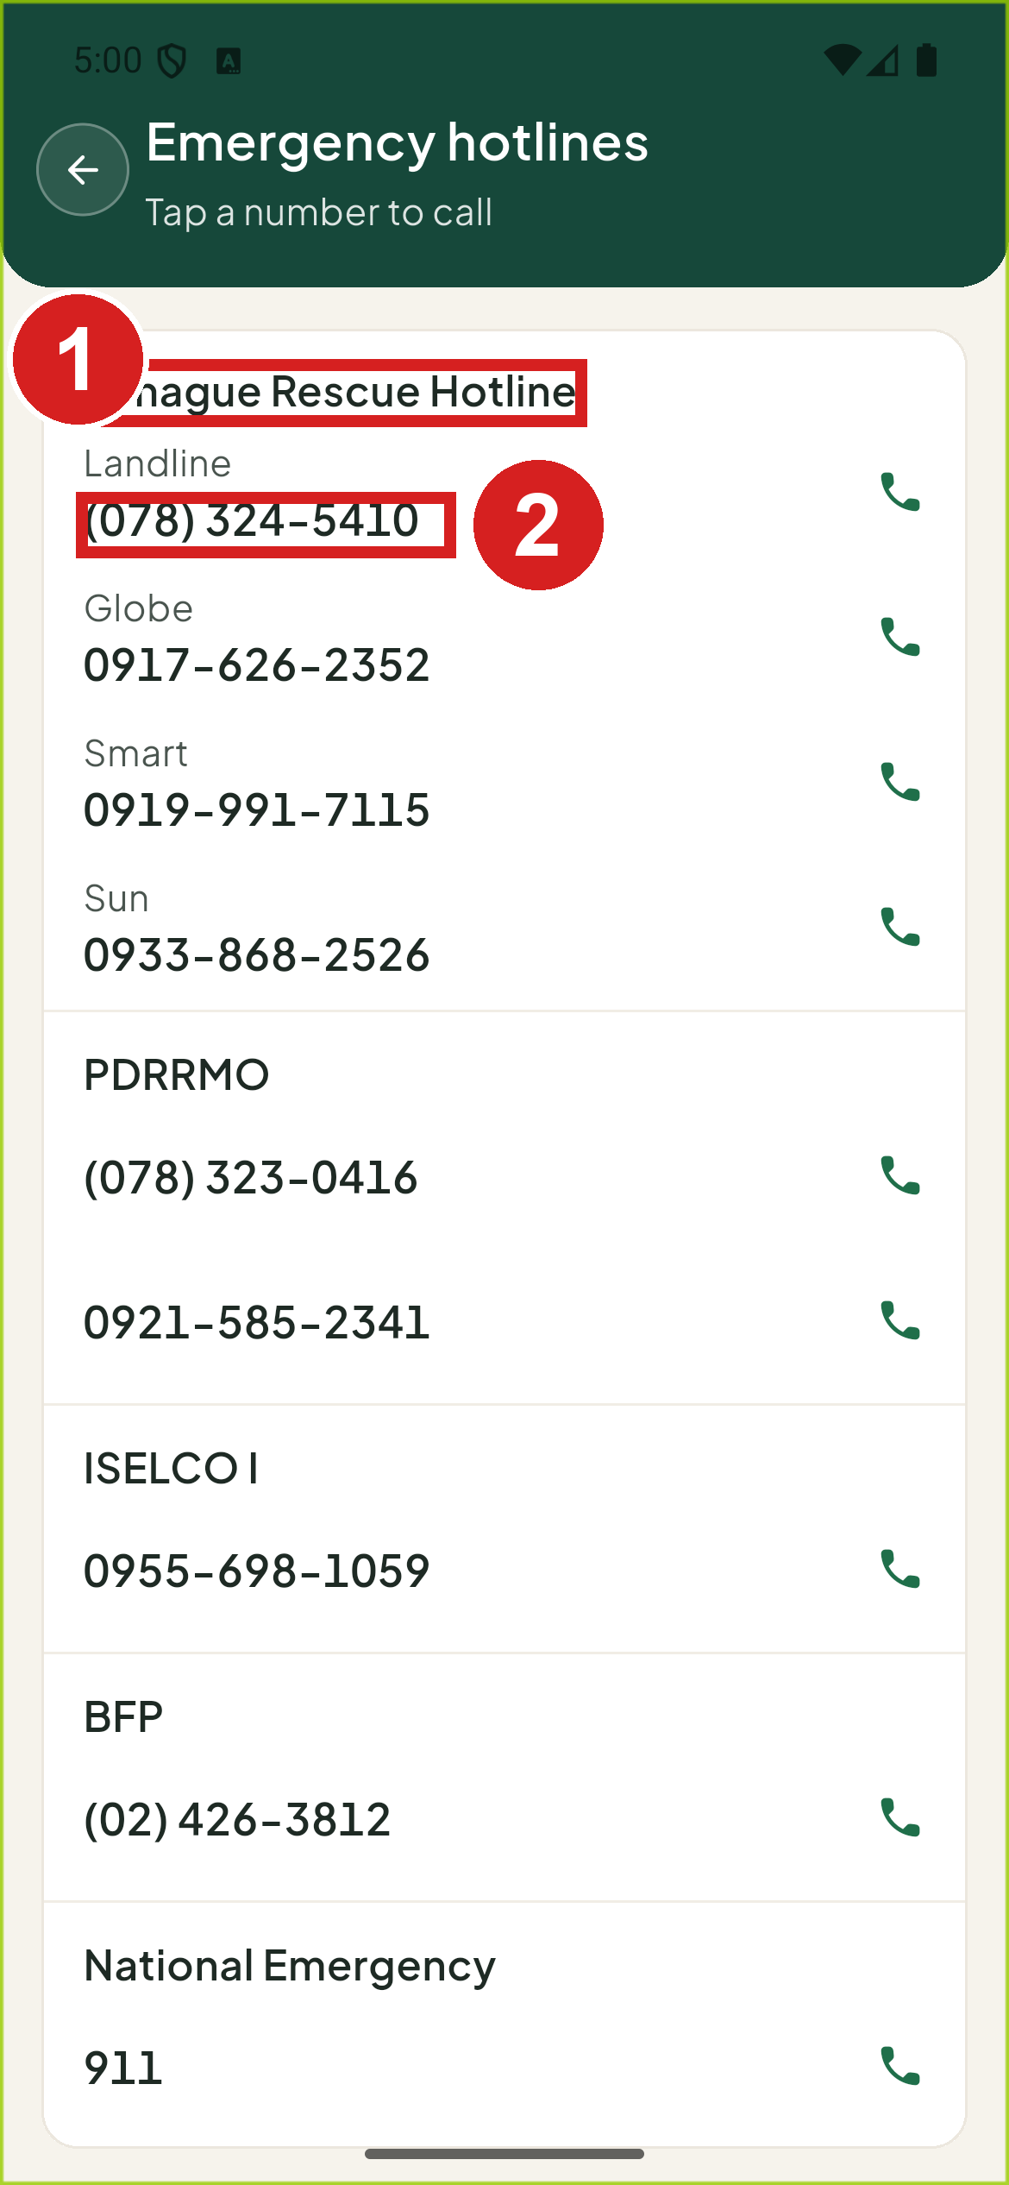 | 1 Who you are calling  2 Tap to call

Reset a forgotten password
1. Tap Forgot password? on the log in screen.
2. Type your mobile number and tap Send code.
3. On Check your messages, type the code and tap Verify.
4. On Choose a new password, type your new password twice.
5. Tap Change password.
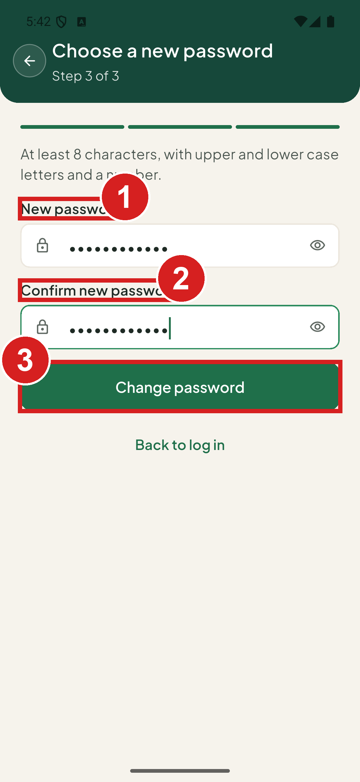 | 1 Your new password  2 Type it again  3 Save it

If your organization is waiting for approval
A new organization account shows Awaiting MDRRMO approval until the MDRRMO activates it.
1. Tap Check again to see if it has been approved.
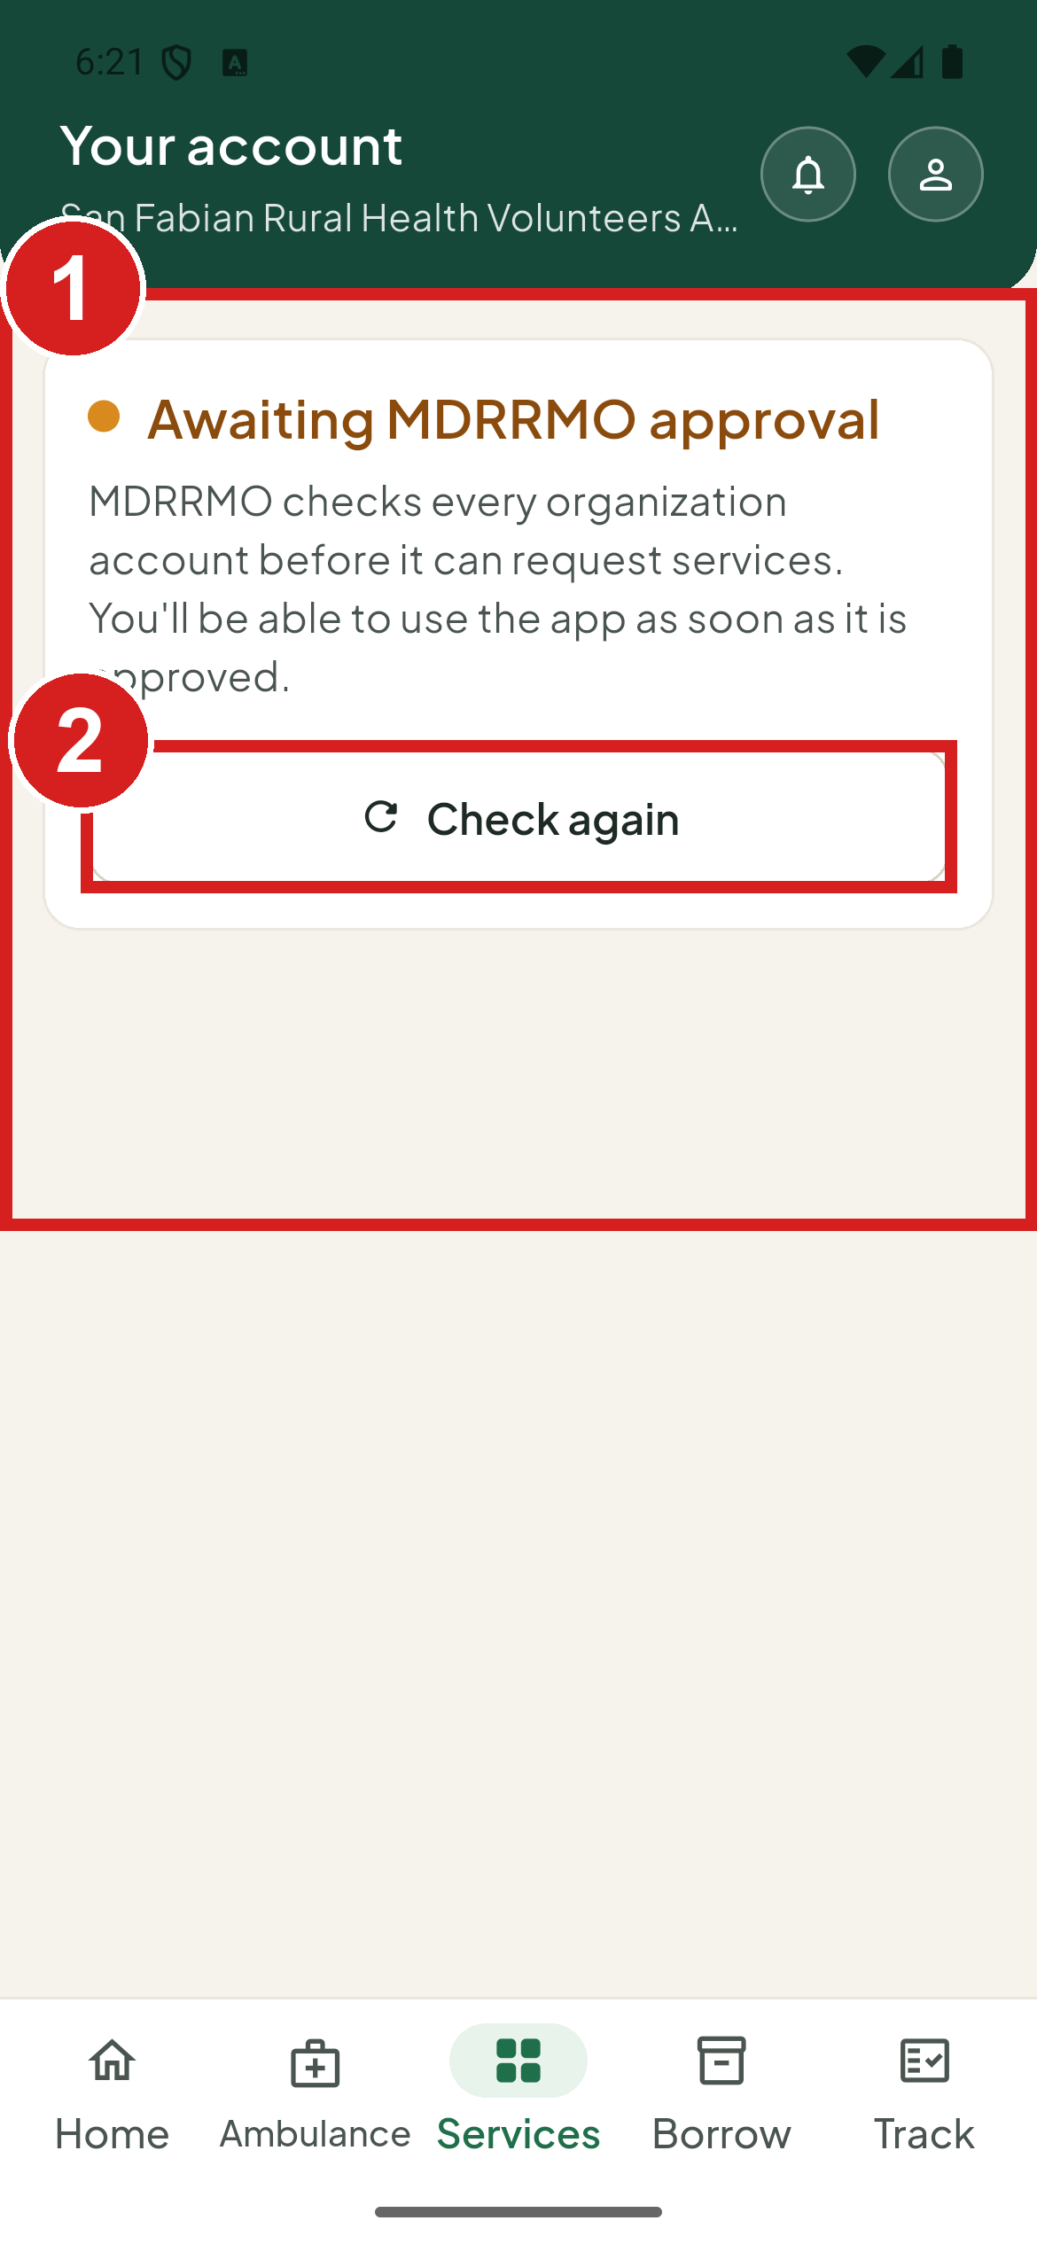 | 1 MDRRMO is checking your account  2 See if it is approved

Find your way around

The Home screen
Home shows your newest open request, shortcuts to common services, and announcements from the MDRRMO. The tabs at the bottom are Home, Ambulance, Services, Borrow and Track.
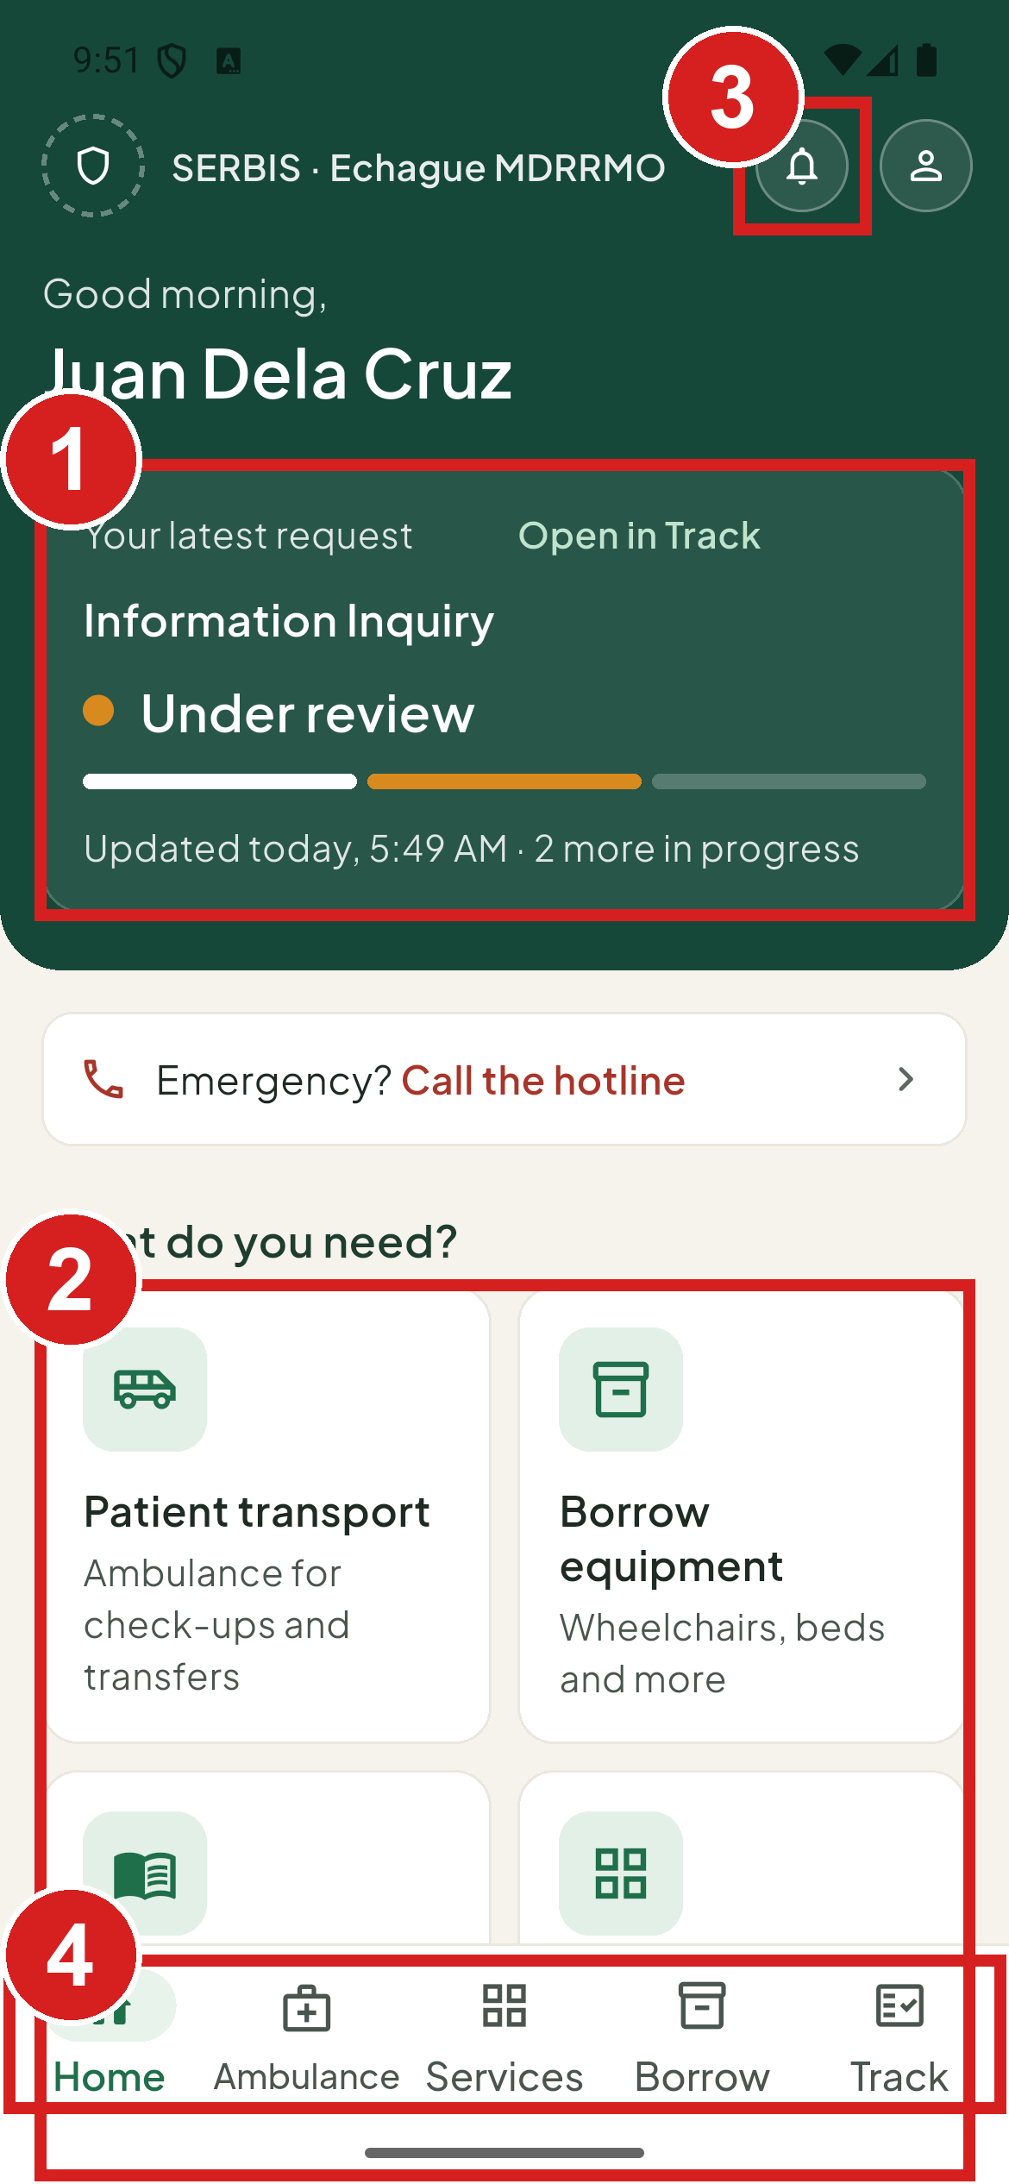 | 1 Your newest open request  2 Shortcuts  3 Notifications  4 Main parts of the app

The request panel is hidden when you have nothing open.

Call the MDRRMO from Home
1. Tap Emergency? Call the hotline at the top of Home. Your phone opens the MDRRMO number, ready to call.
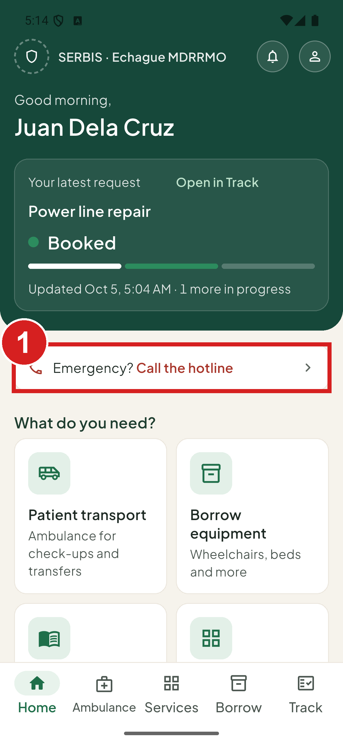 | 1 Call the MDRRMO

When a tab says Not available
A tab shows Not available and Not offered right now when the MDRRMO does not offer that part of the app to your account type. For example: Ambulance booking is not offered to this account type. The MDRRMO decides which account types may use each service. If you think your account should have it, contact the MDRRMO.
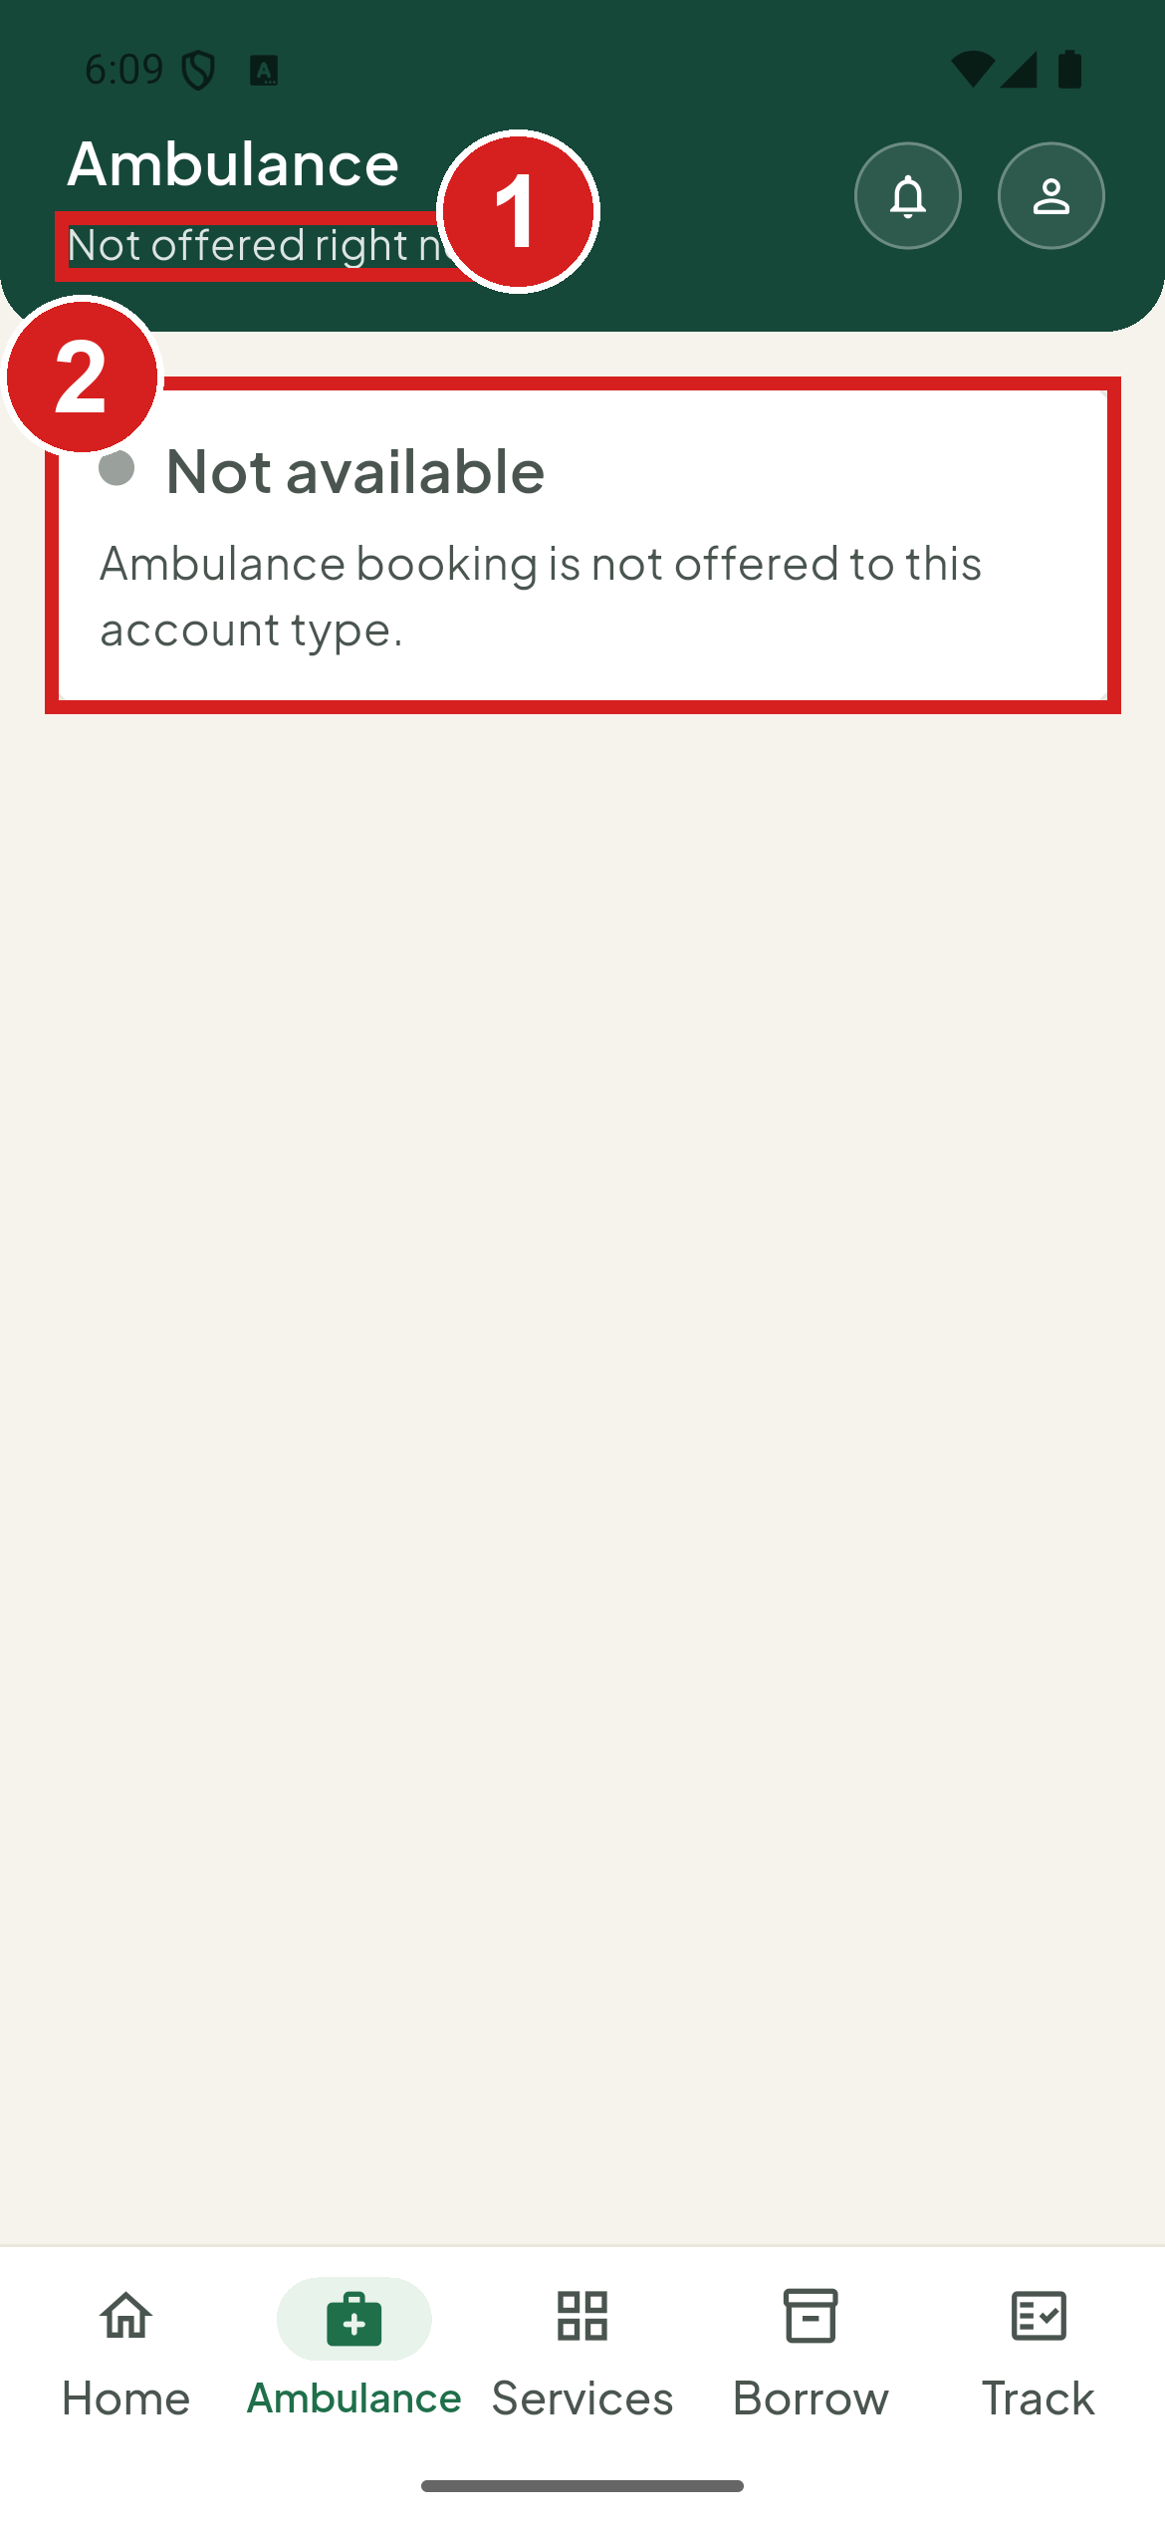 | 1 Not offered to your account type  2 Why

Notifications
1. Tap the bell at the top.
2. Read the updates. MDRRMO advisories come first, then updates on your requests from the last 30 days. New ones are marked New; older ones are under Earlier.
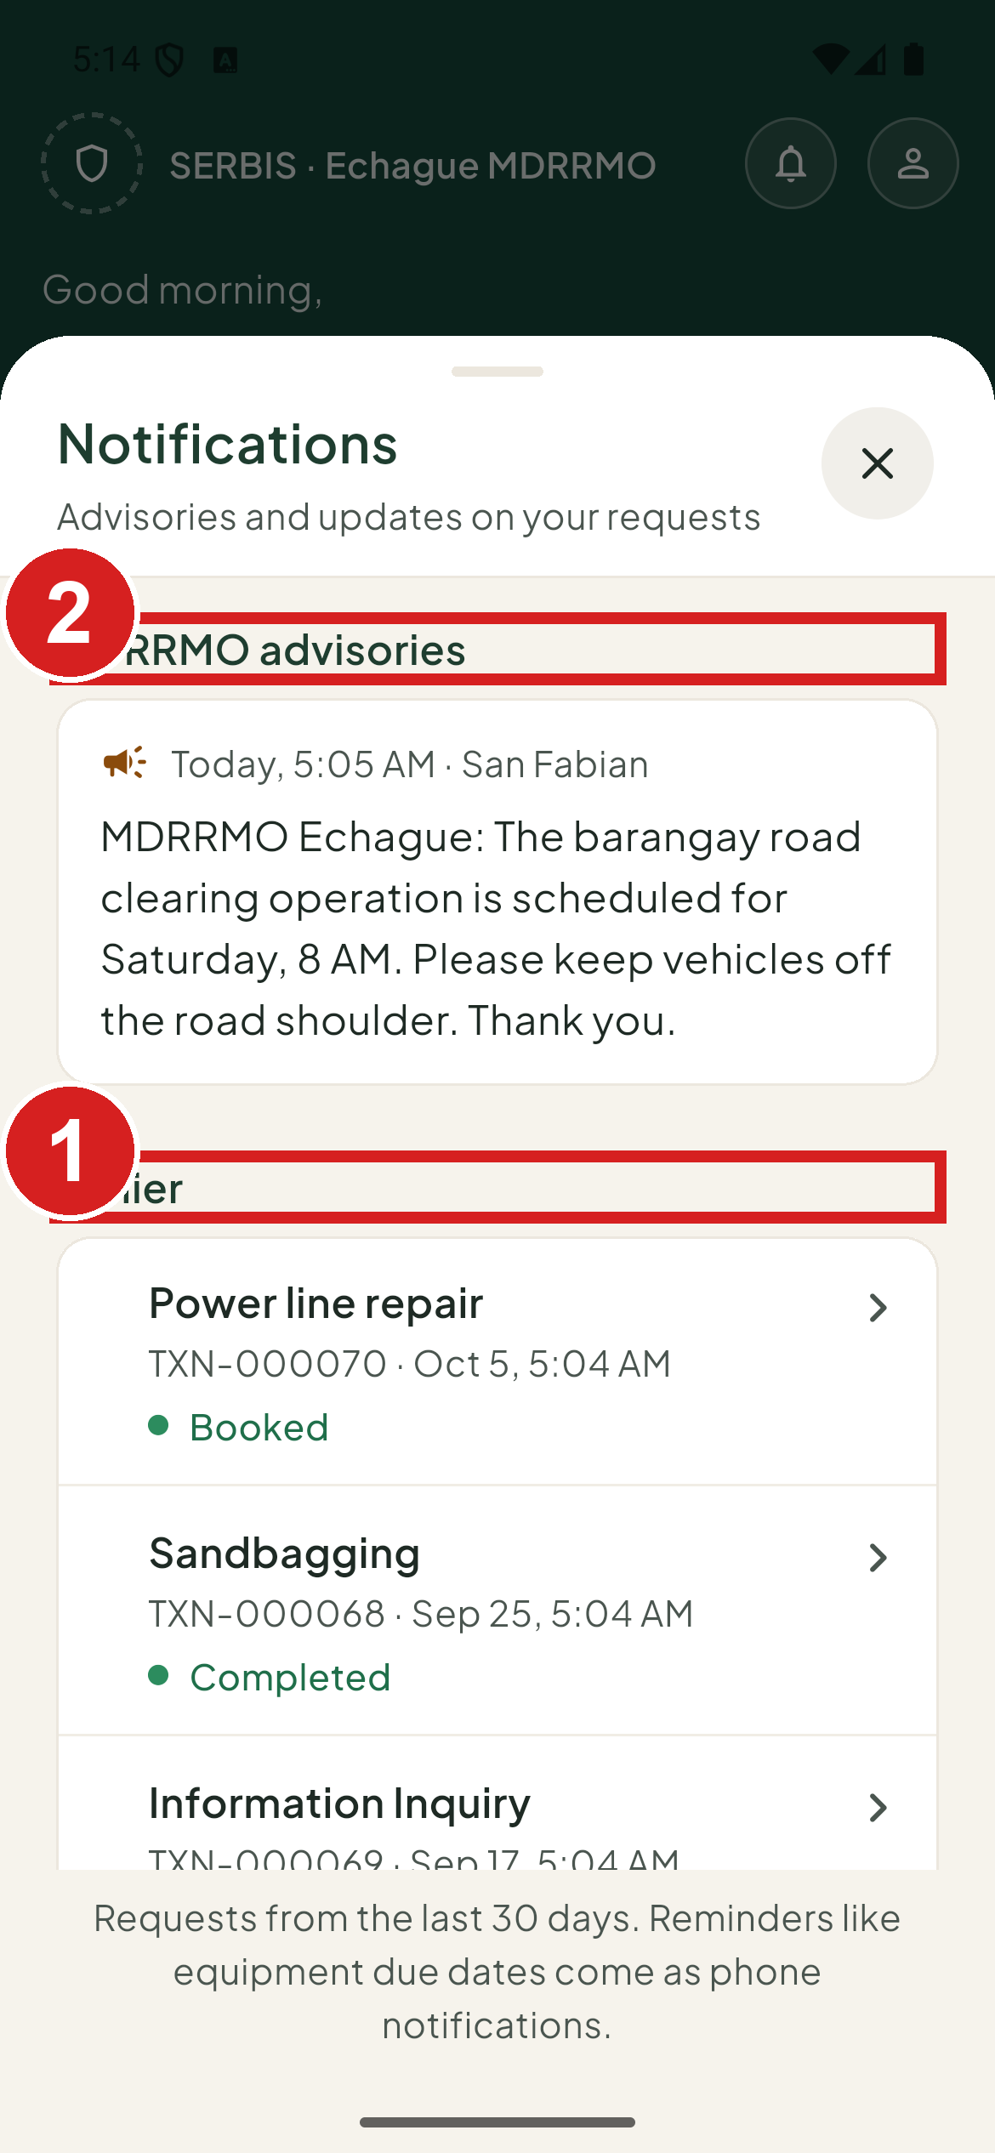 | 1 Older updates  2 A notice from MDRRMO

Ask for a service

Choose a service
1. Tap Services.
2. Tap the service you need.
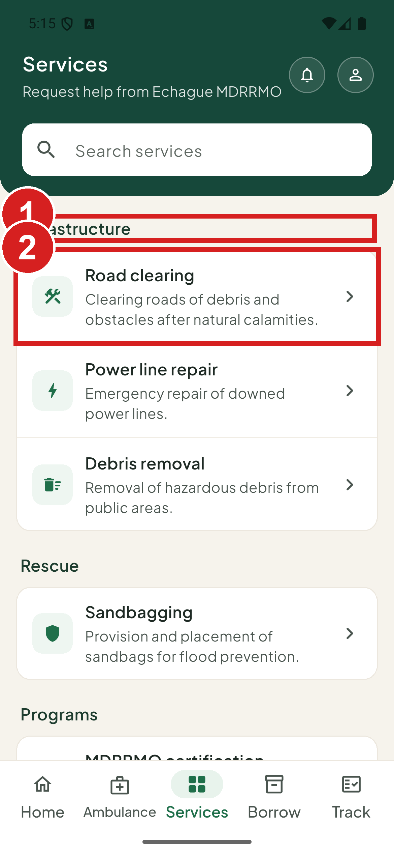 | 1 Services are grouped  2 Open a service

Fill in the form
1. Fill in every field marked with a red star.
2. Add a photo of the place if the form asks for one.
3. Tap Send request.
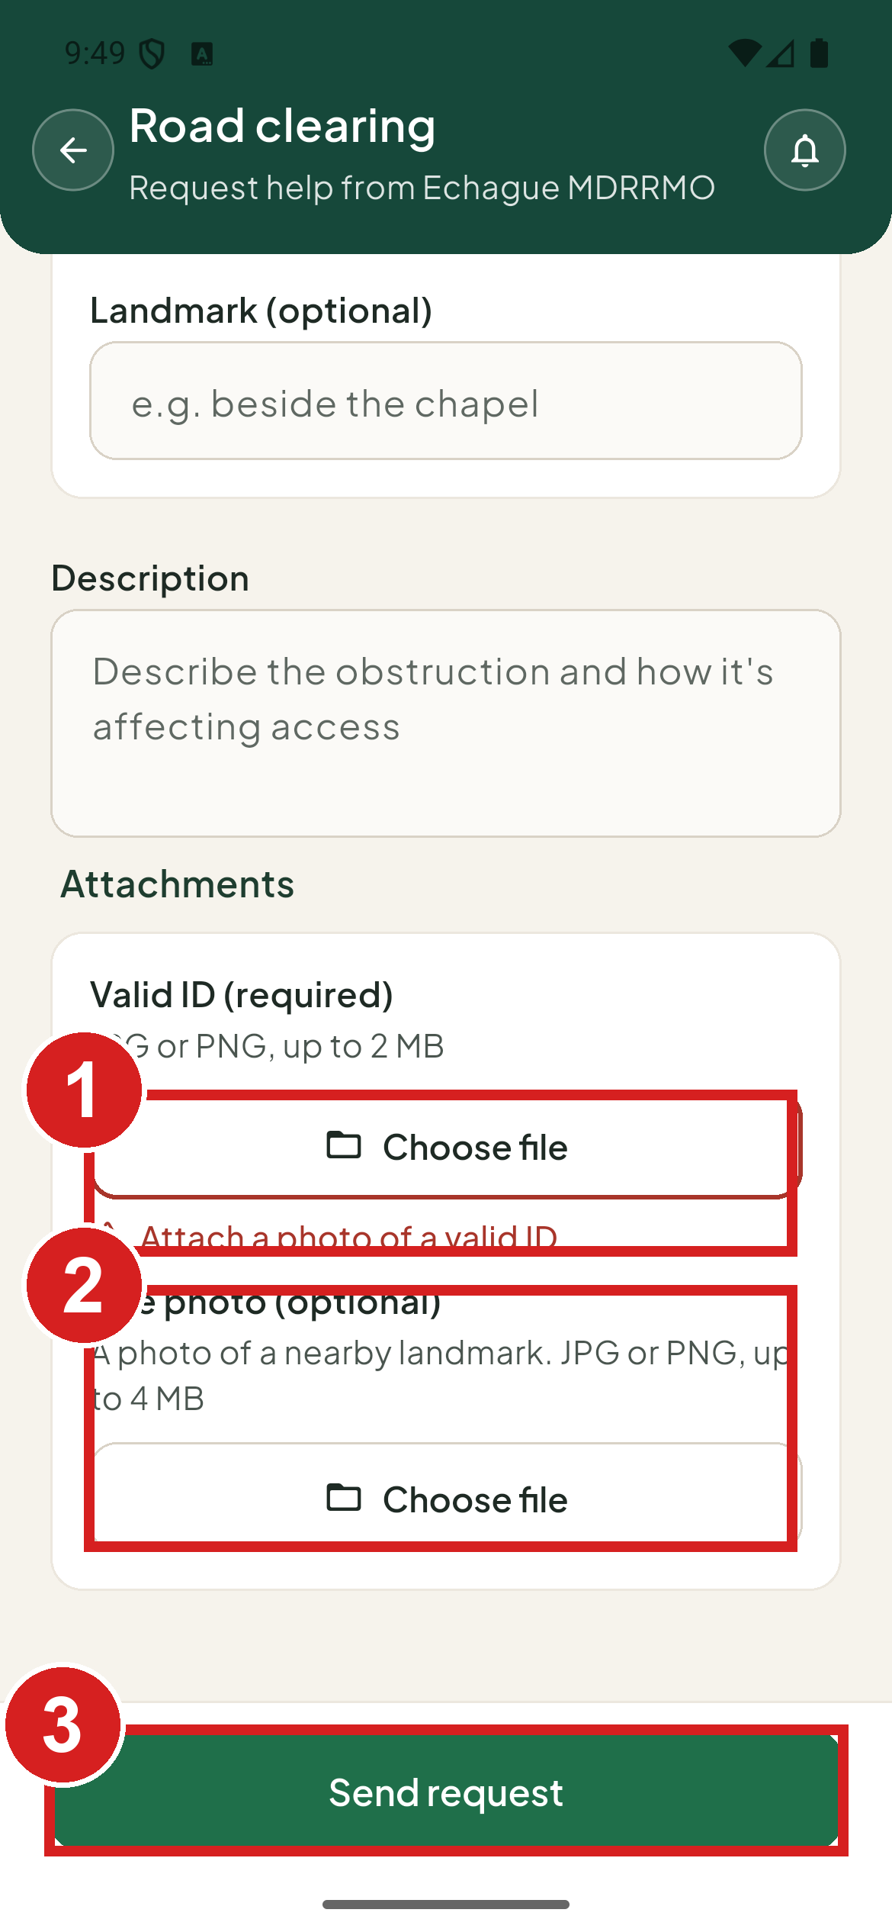 | 1 Photo of a valid ID (required)  2 Photo of the place (optional)  3 Send

If something is missing, the form lists how many fields need attention and marks each one in red.

Relief goods (three steps)
1. Fill in each step.
2. Tap Next: … to go on, or Back to change an earlier step. The steps are Household, Assistance and delivery, and ID and review.
3. Tap Send request on the last step.
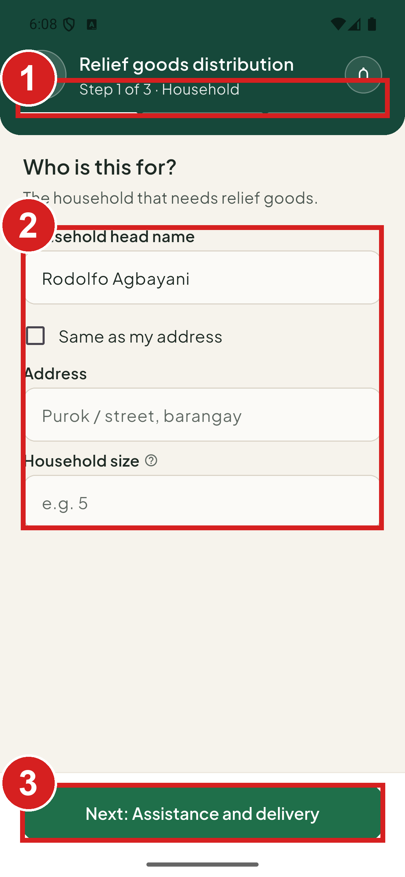 | 1 Where you are in the form  2 About your household  3 Go on

Trainings, seminars and drills
These are for barangay and organization accounts. The Simulation Drills / NSED form works the same way.
1. Choose the date you want.
2. Attach your request letter. It is required.
3. Tap Send request.
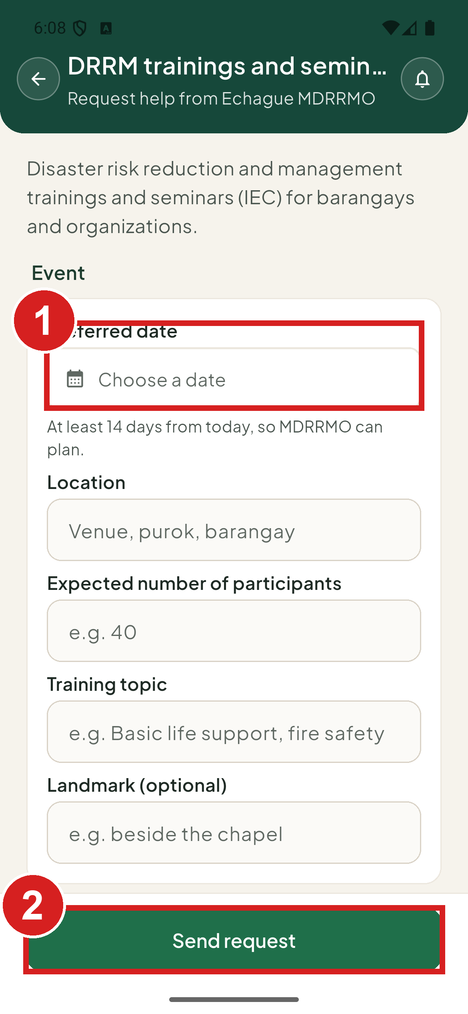 | 1 When you want it  2 Send

Certification
1. Say what the certification is for.
2. Attach a letter if you have one. It is optional.
3. Tap Send request.
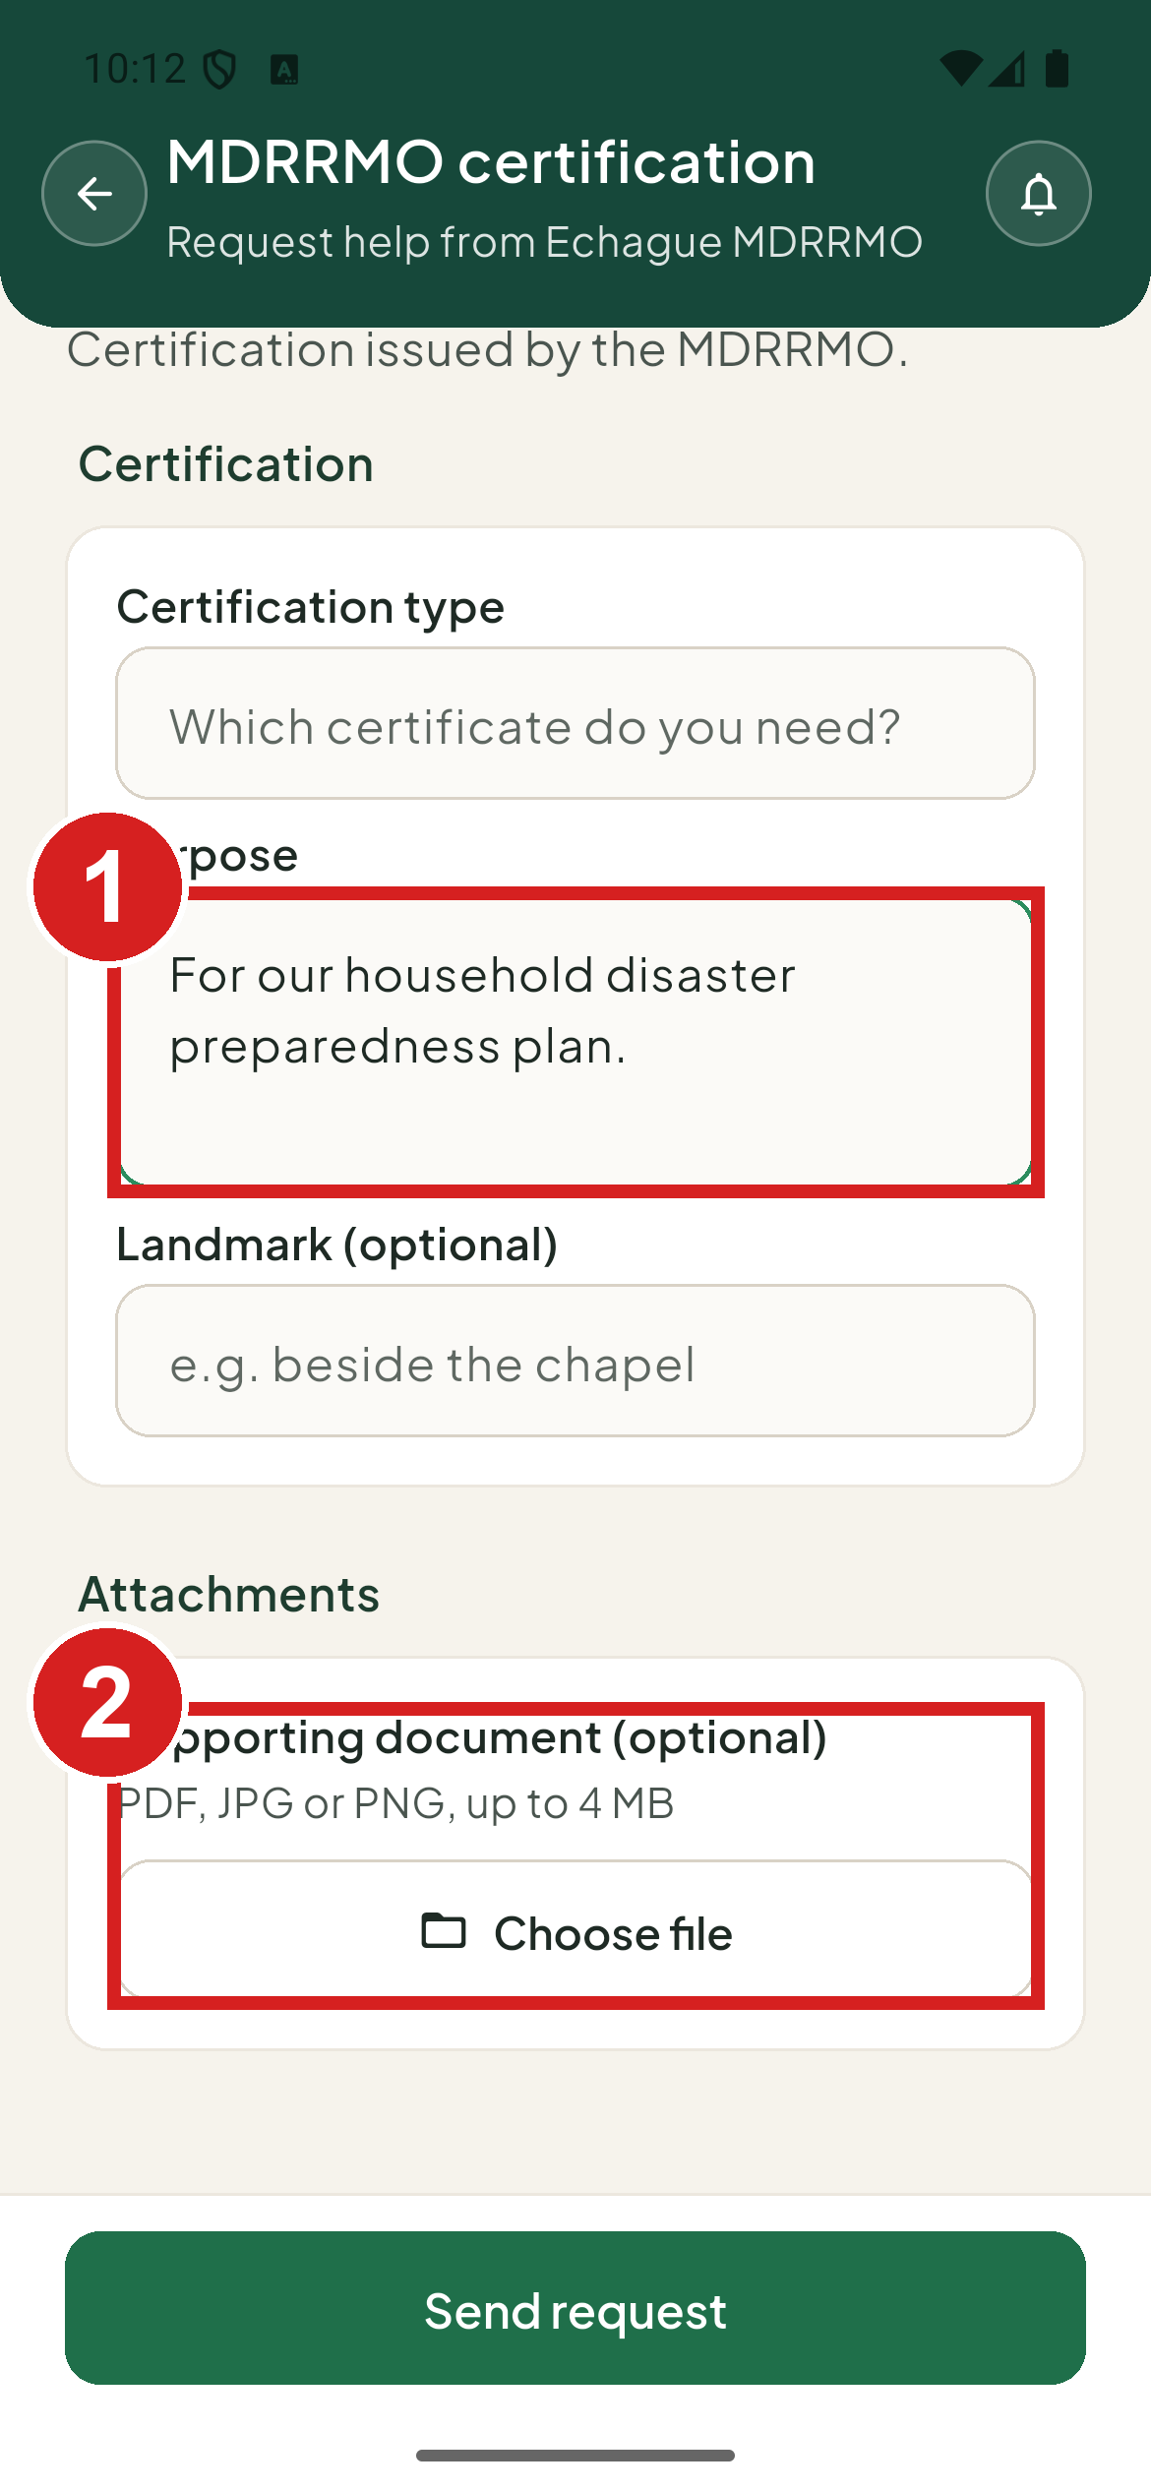 | 1 What the certification is for  2 Attach a letter if you have one

Other requests
Use Others when your need is not on the list.
1. Describe what you need.
2. Add a photo of a valid ID.
3. Tap Send request.
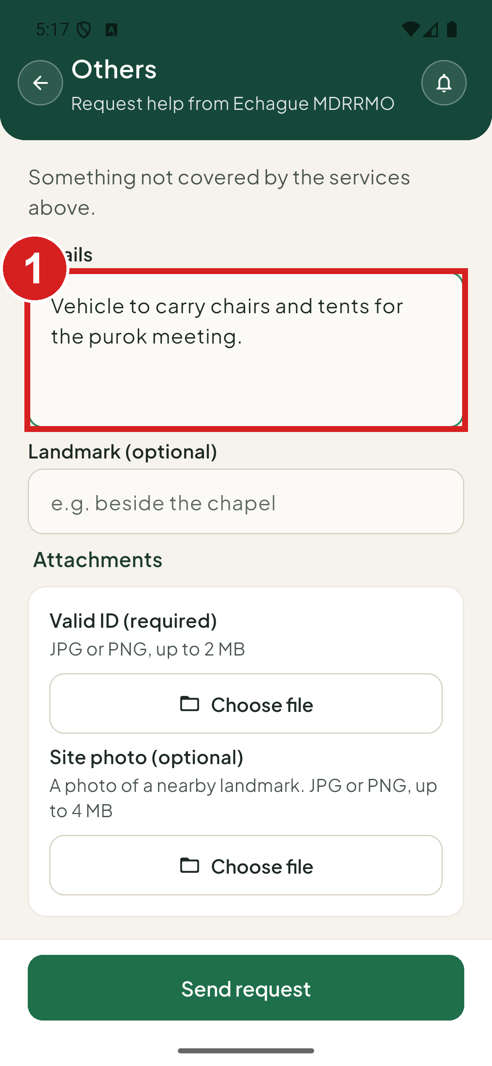 | 1 Say what you need

After you send
The app shows Request sent with your reference number.
1. Tap View in Track to follow it, or Done to close.
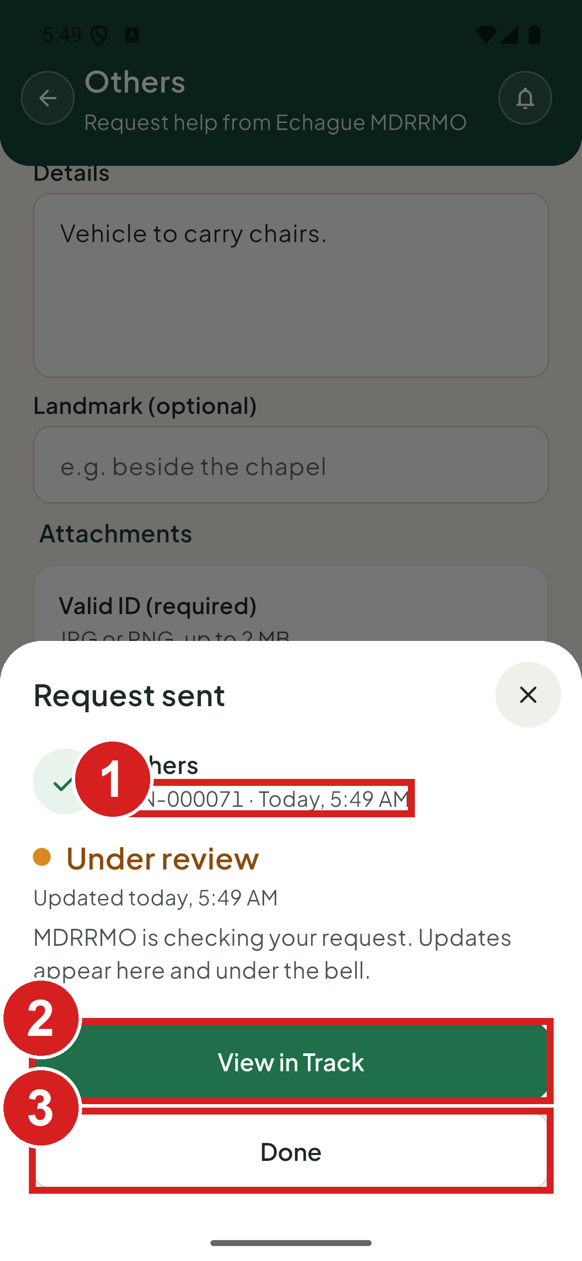 | 1 Keep this number  2 Follow the request  3 Close

Book an ambulance
Use the Ambulance tab to book patient transport, for example for a check-up, dialysis or a transfer between hospitals. The booking has five steps: Patient, Trip, Condition, Schedule and ID, and Review. This is not an emergency service. In an emergency, call the hotline.

Patient
1. Tap Ambulance.
2. Type the patient's name, age and other details.
3. Tap Next: Trip.
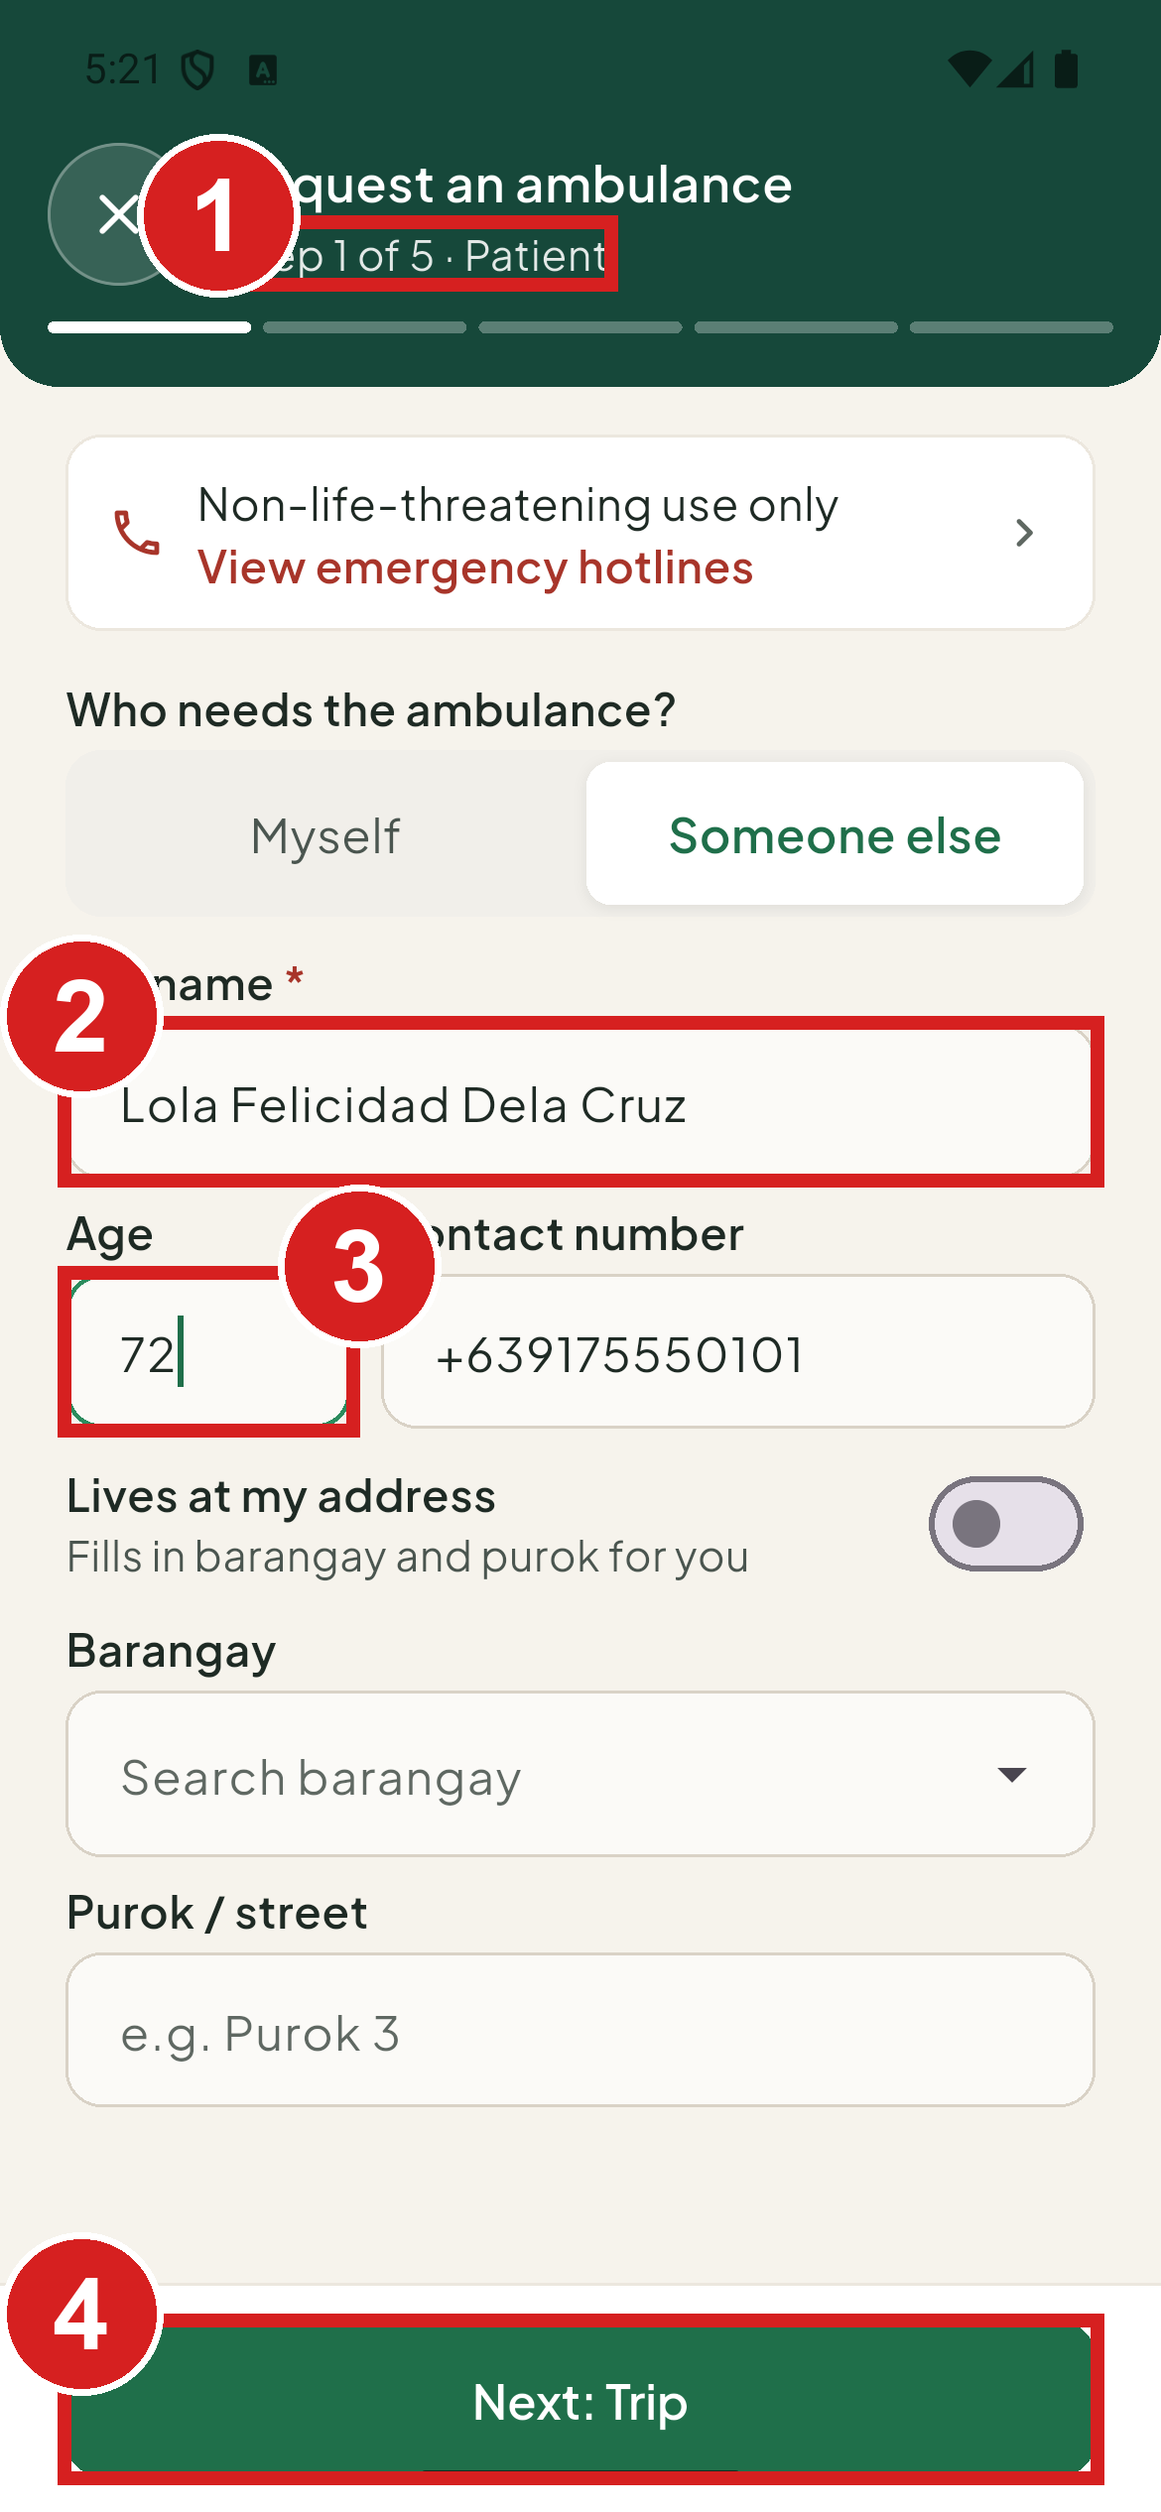 | 1 Step 1 of 5  2 Who will ride  3 Their age  4 Go on

Trip
1. Leave Pick up at my address on to use your saved address, or turn it off and type the pickup place.
2. Choose the destination from the list, or type it.
3. Tap Next: Condition.
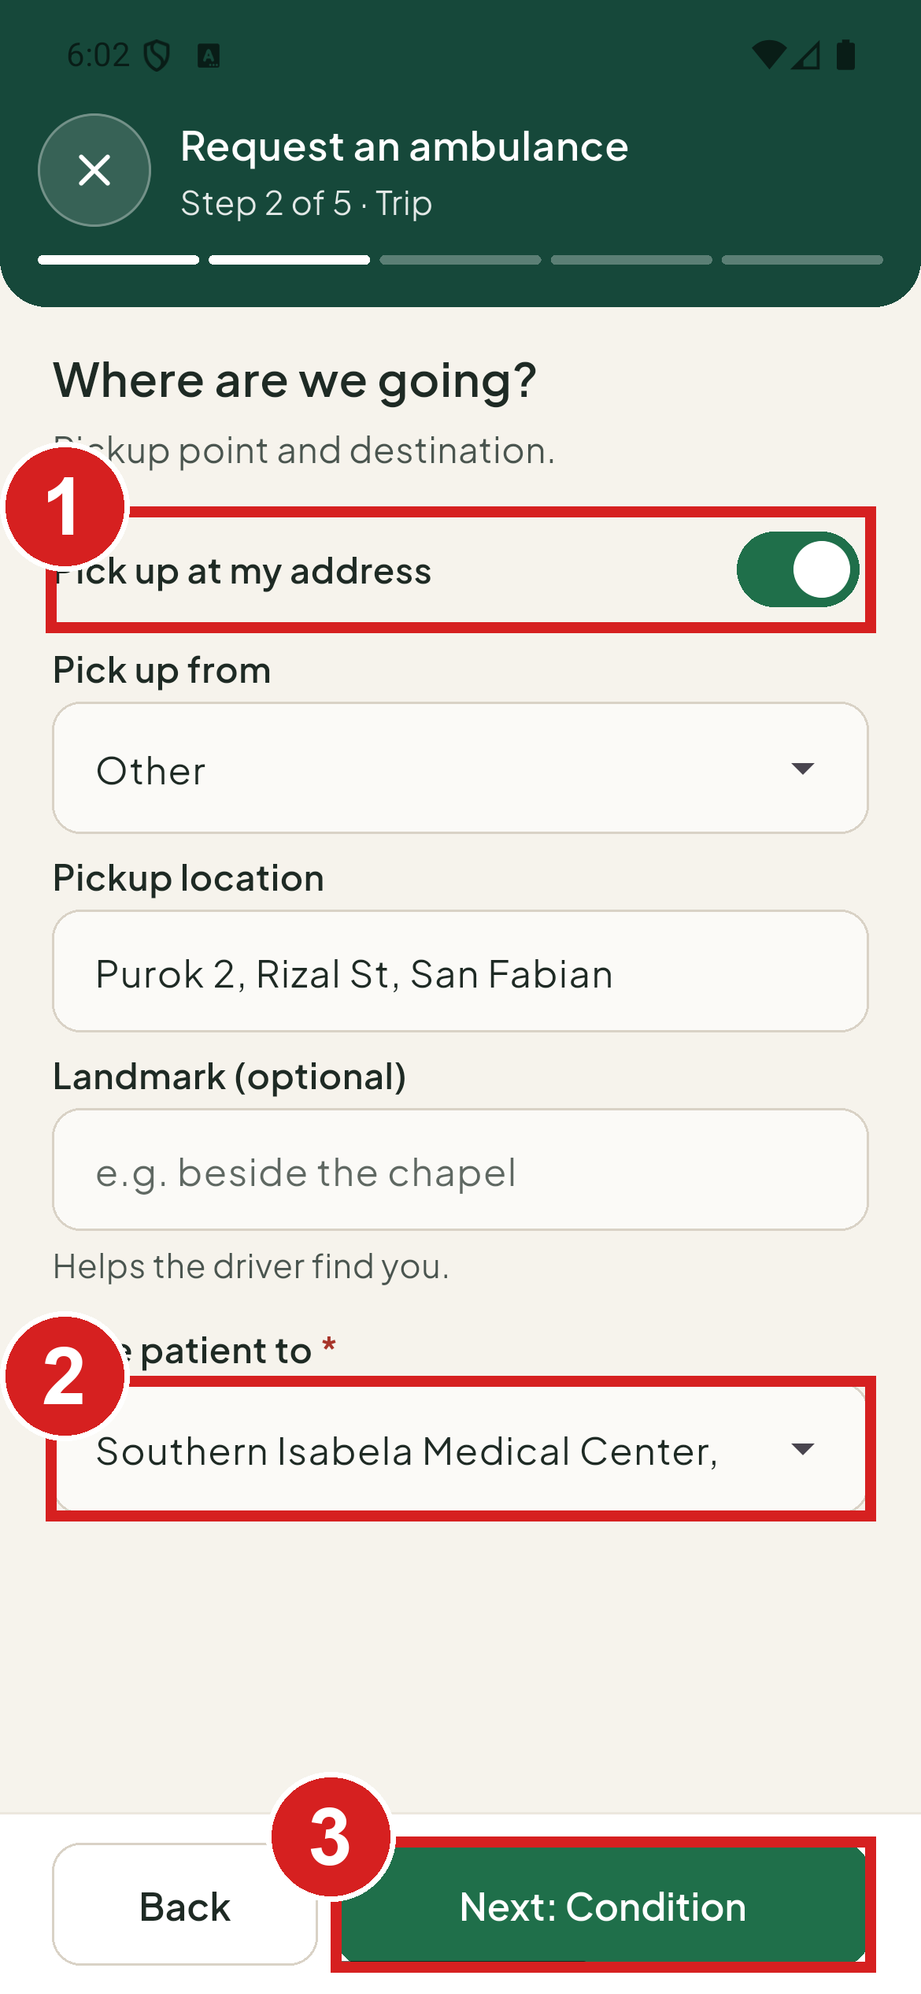 | 1 Pickup place  2 Destination  3 Go on

Condition
1. Say why the patient needs transport.
2. Add the relatives who will come along.
3. Tap Next: Schedule and ID.
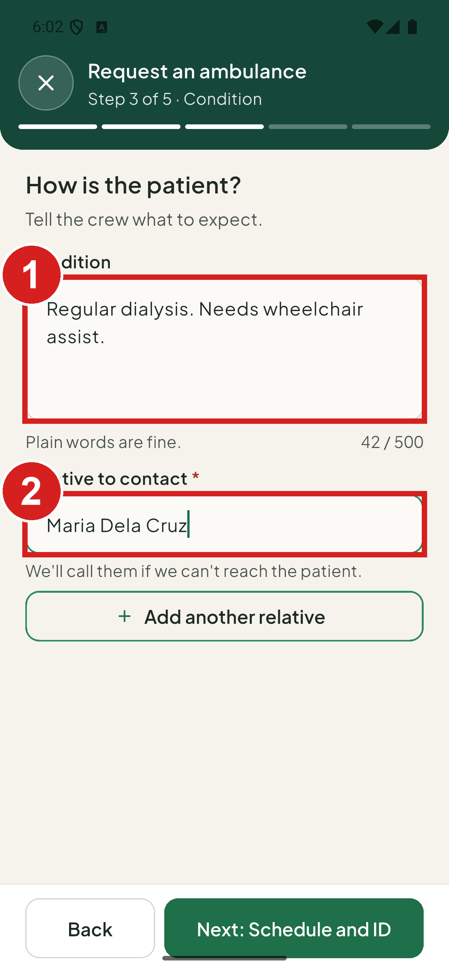 | 1 Why the patient needs transport  2 Who will come along

Schedule and ID
1. Choose Now, when available, or Scheduled and pick a date and time.
2. Check the note on whether a unit looks free. The MDRRMO confirms the unit and time.
3. Add a photo of a valid ID.
4. Tap Next: Review.
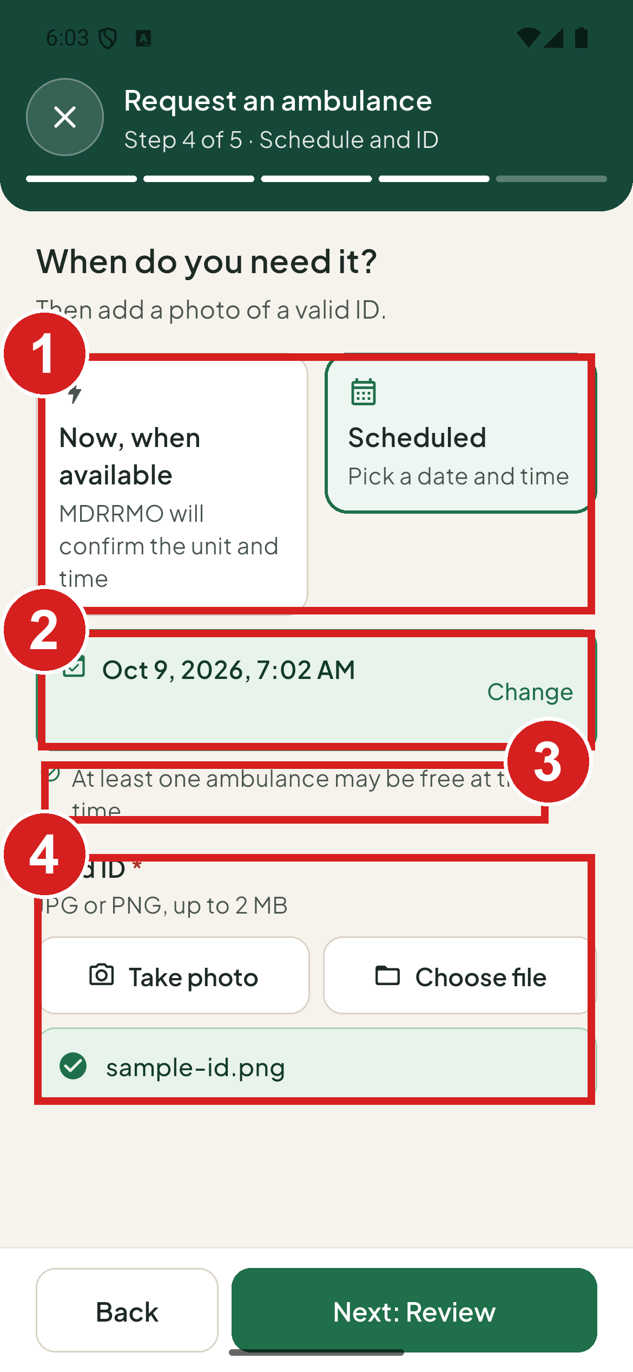 | 1 Now or a set time  2 When to pick up  3 Whether a unit looks free  4 Photo of a valid ID

Review and send
1. Check your answers. To change a part, tap its Edit link.
2. Tap Send request.
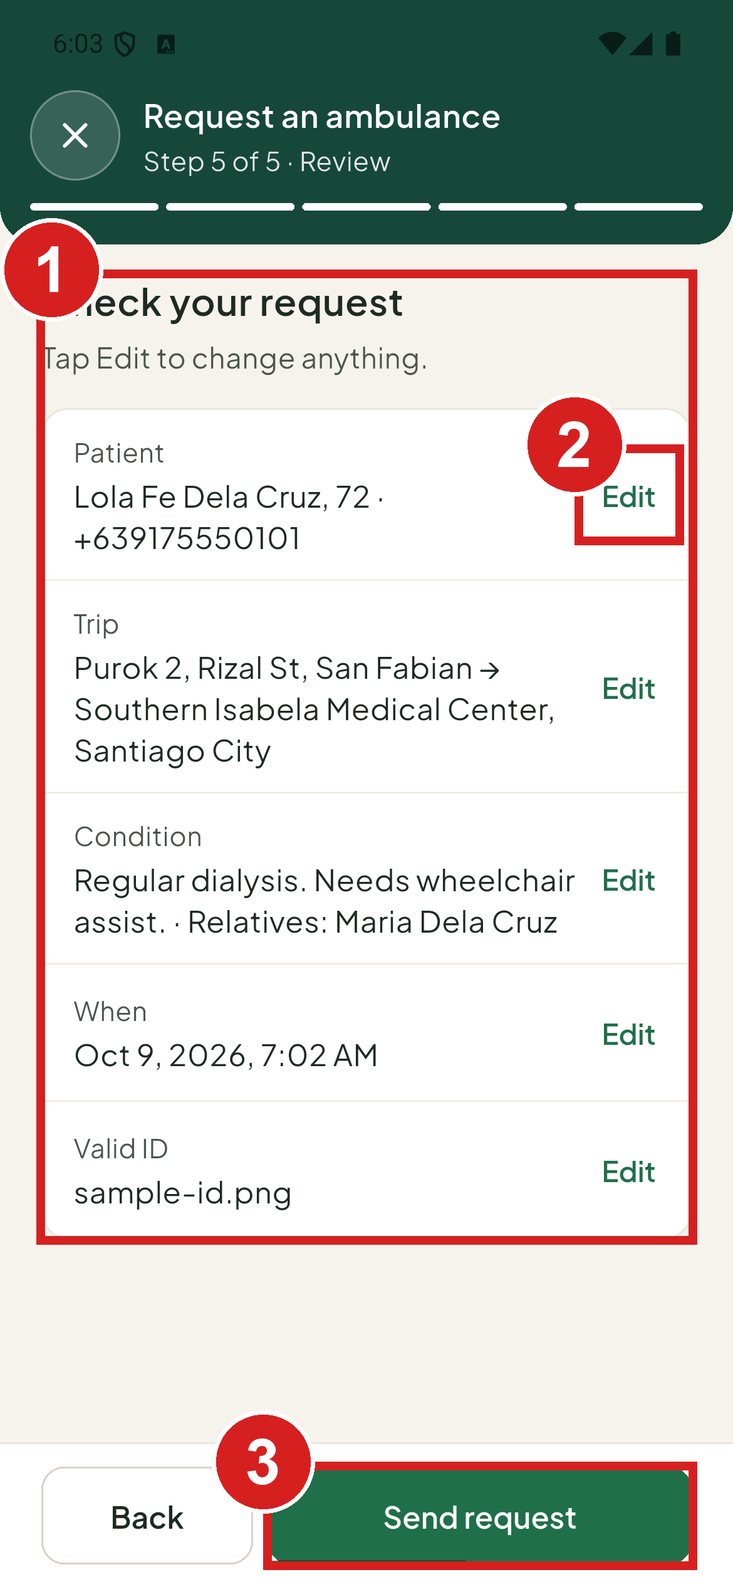 | 1 Check your answers  2 Change a step  3 Send

Leaving the form
If you close the form before sending, the app asks Discard this request? Tap Discard to leave and clear your answers, or Keep editing to stay.
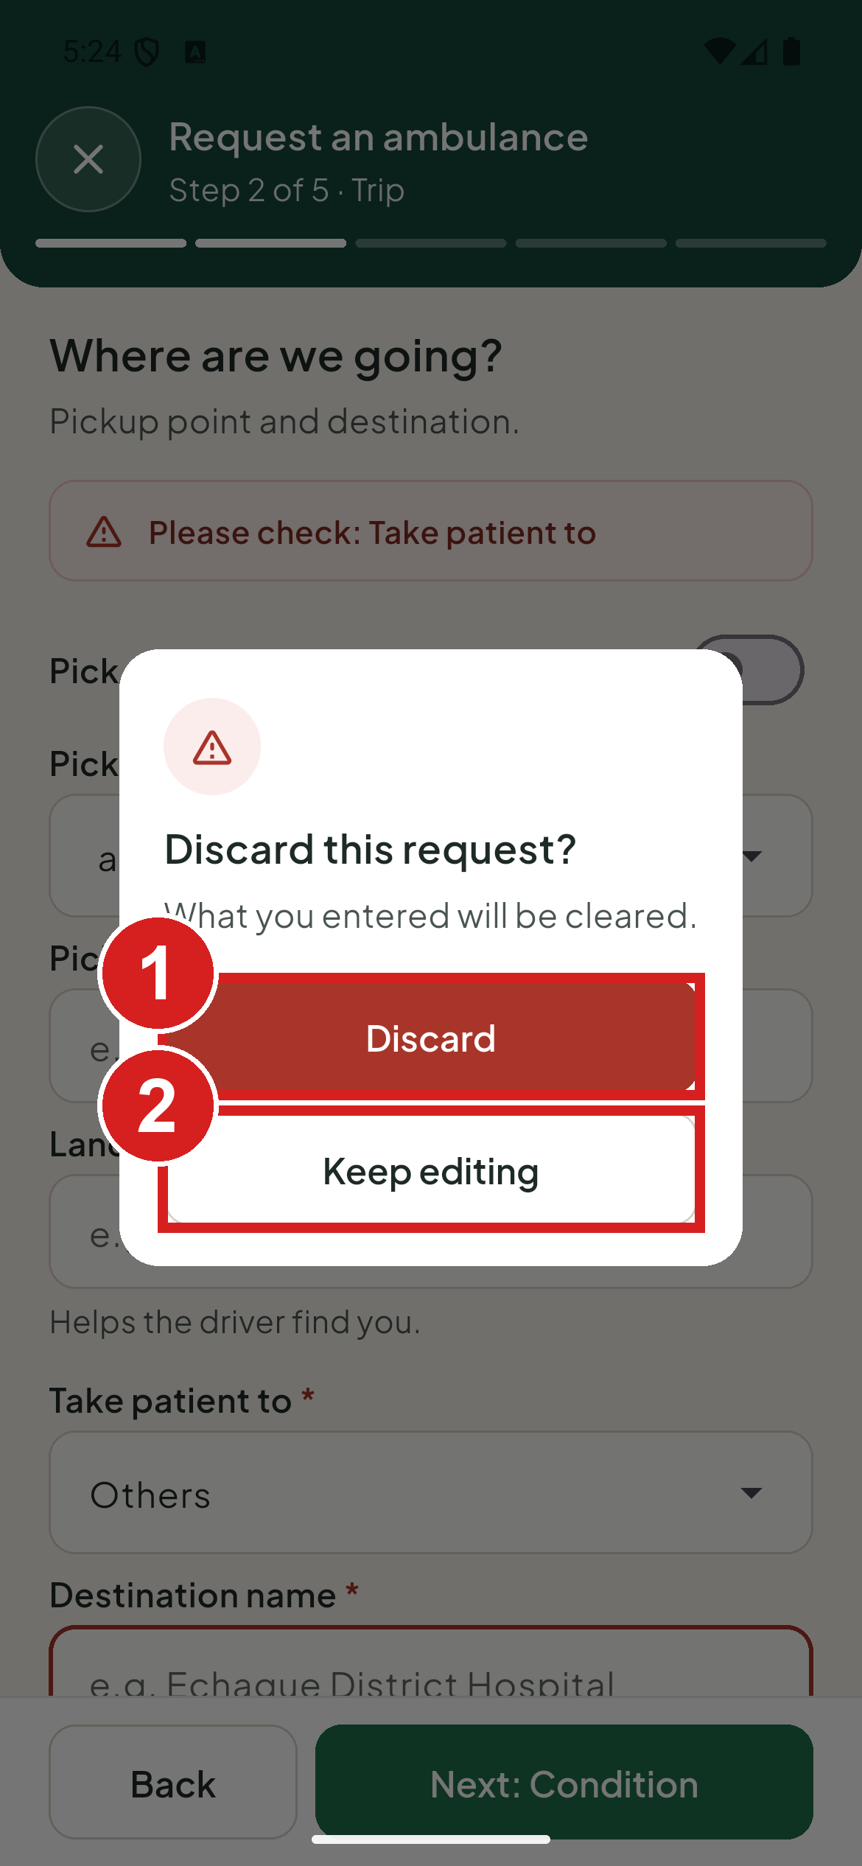 | 1 Leave and delete your answers  2 Stay on the form

Follow your requests

See all your requests
1. Tap Track.
2. Open requests are under In progress. Finished ones are under Past requests.
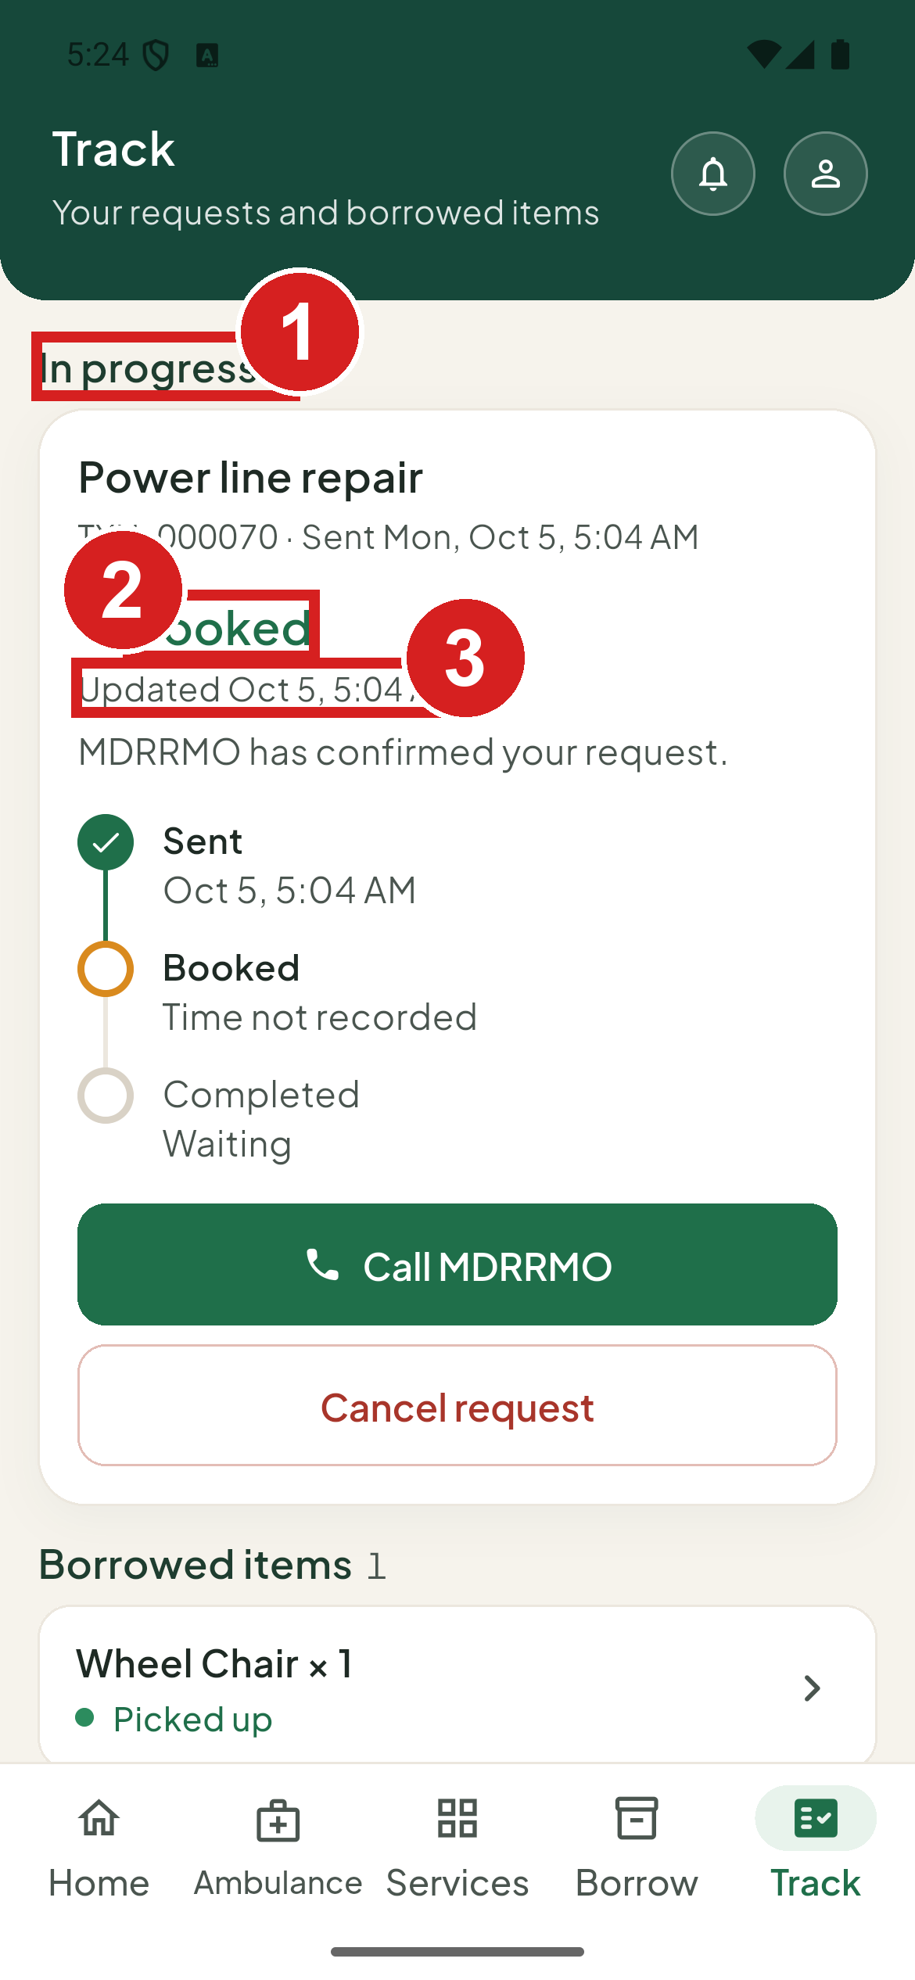 | 1 Requests still open  2 Where it stands  3 When it last changed

Each request shows one status:
• Under review: the MDRRMO is checking it.
• Booked: an ambulance booking holding its date and time. The MDRRMO assigns a unit before the trip.
• Responding: the team is working on it.
• Approved: for trainings, drills and certifications.
• Completed: done.
• Not transported: the ambulance trip did not carry the patient. The reason is shown.
• Not approved: the MDRRMO could not approve it. The reason is shown.
• Cancelled by you: you withdrew it.

Borrowed items in Track
Items you have borrowed and not yet returned are listed in Track under Borrowed items.
1. Tap Track.
2. Tap an item under Borrowed items. Borrow opens on My requests.
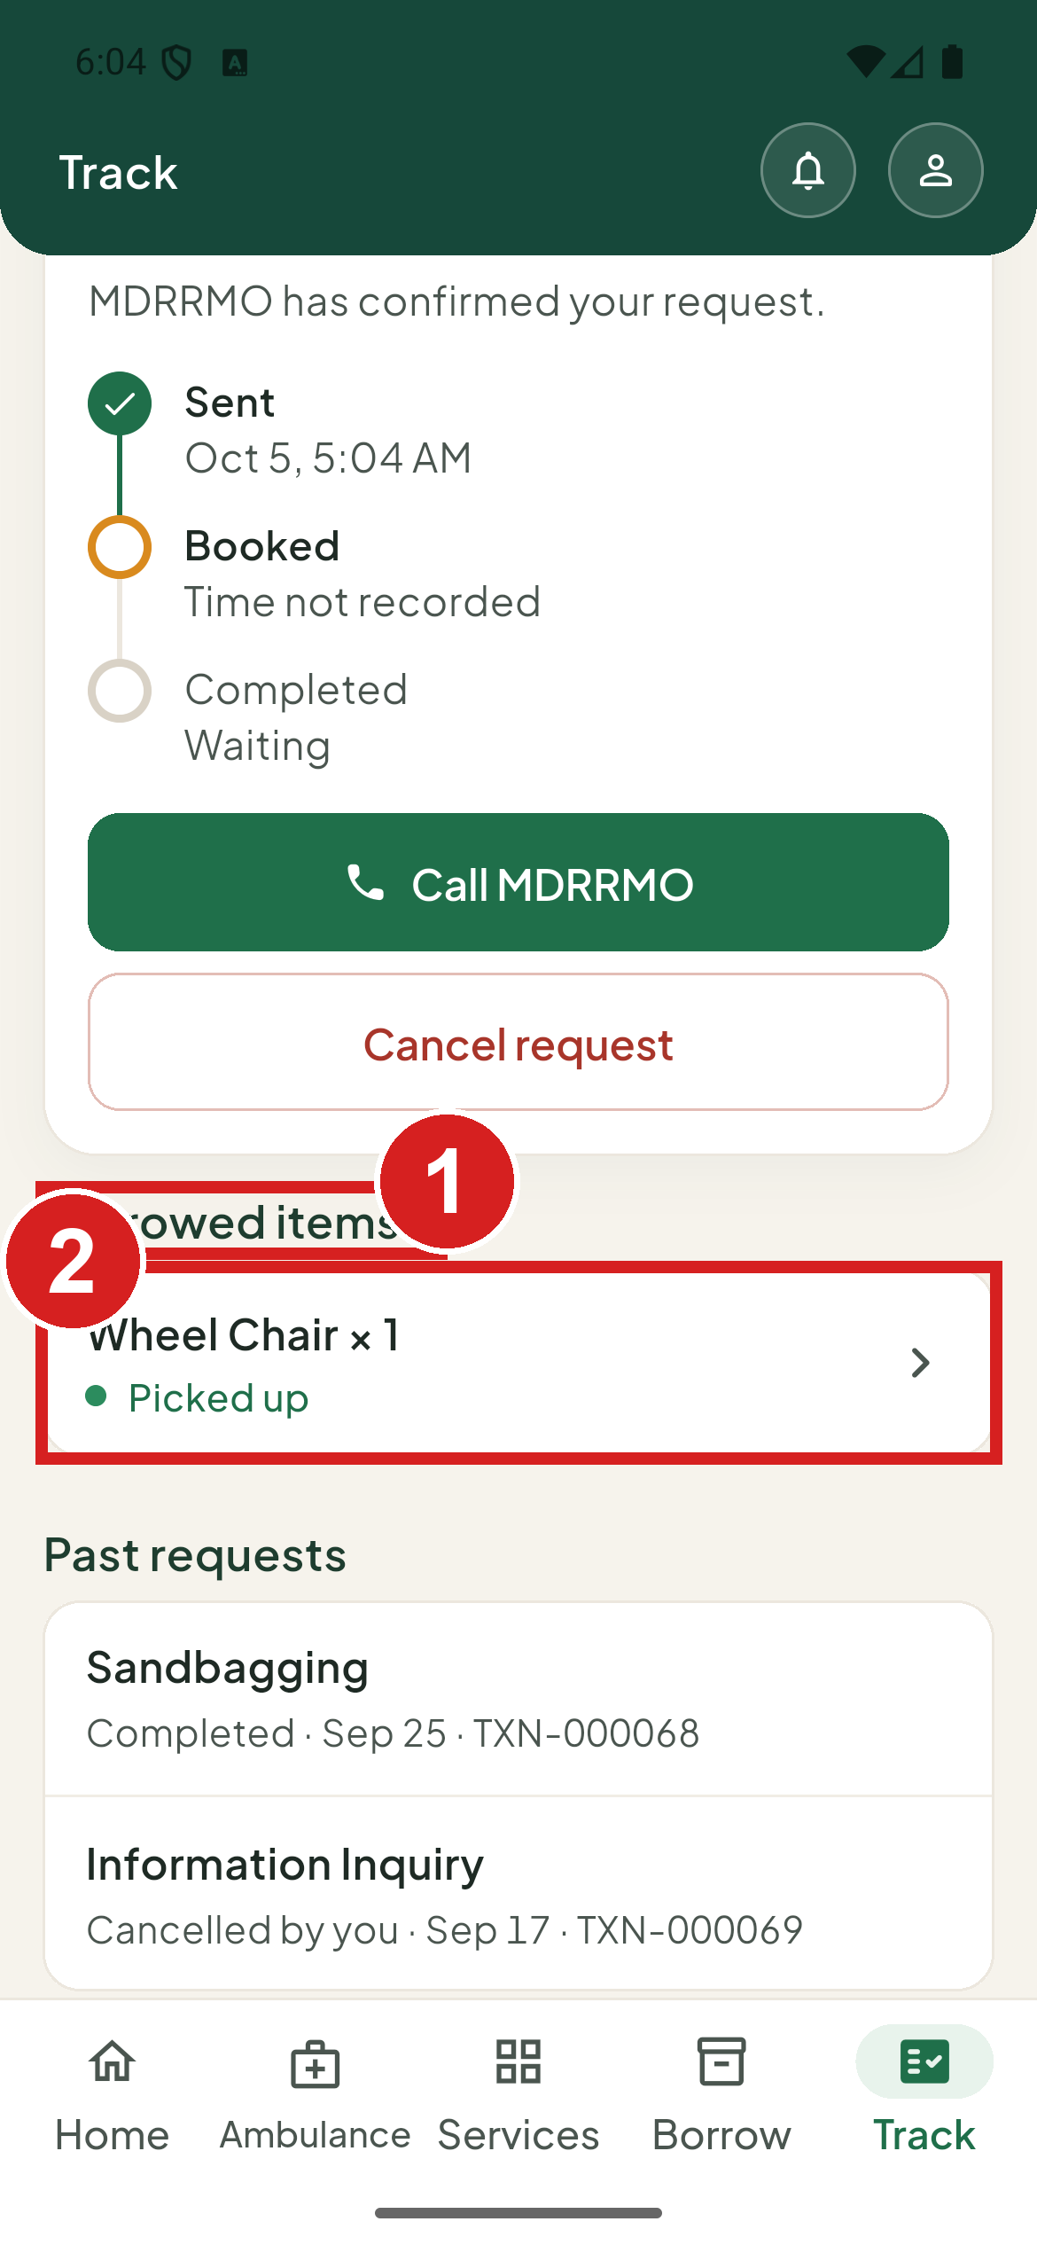 | 1 Items you have out  2 Open it in Borrow

Open a request
1. Tap the request.
2. Read the status, the steps and what happens next.
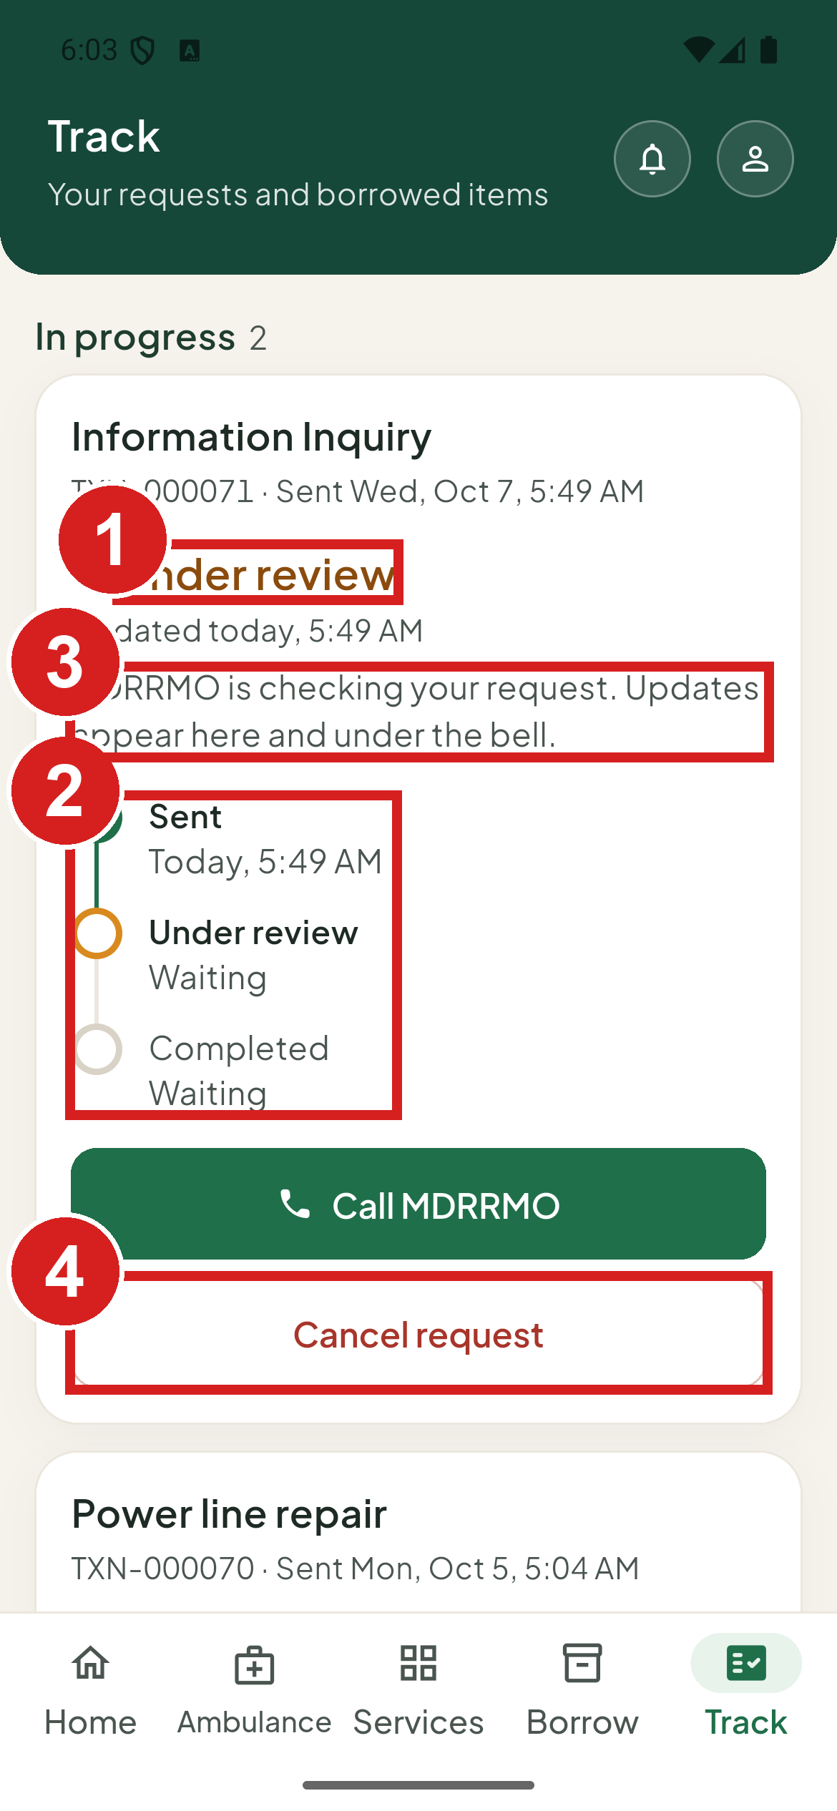 | 1 Where it stands  2 Steps done and to come  3 What MDRRMO does next  4 Withdraw it

Cancel a request
You can cancel a request while it is Under review or Booked. A booking cannot be cancelled in the last 2 hours before its time, or once the unit has left; call the office instead. If the button is not shown, it can no longer be cancelled.
1. Tap Cancel request.
2. The app asks Cancel request? Tap Cancel request to confirm, or Keep request to go back.
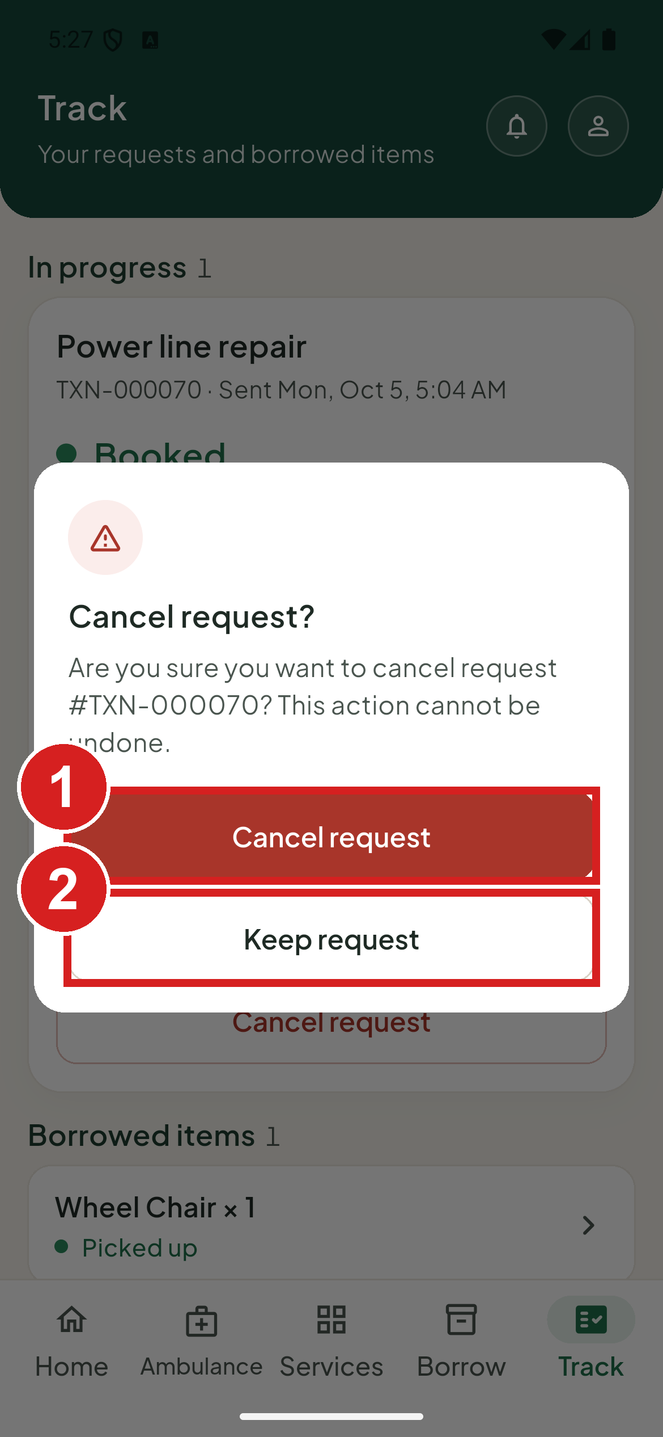 | 1 Withdraw it  2 Go back

Borrow equipment

Find an item
1. Tap Borrow.
2. Search for the item, or scroll the list. Each item shows how many are free.
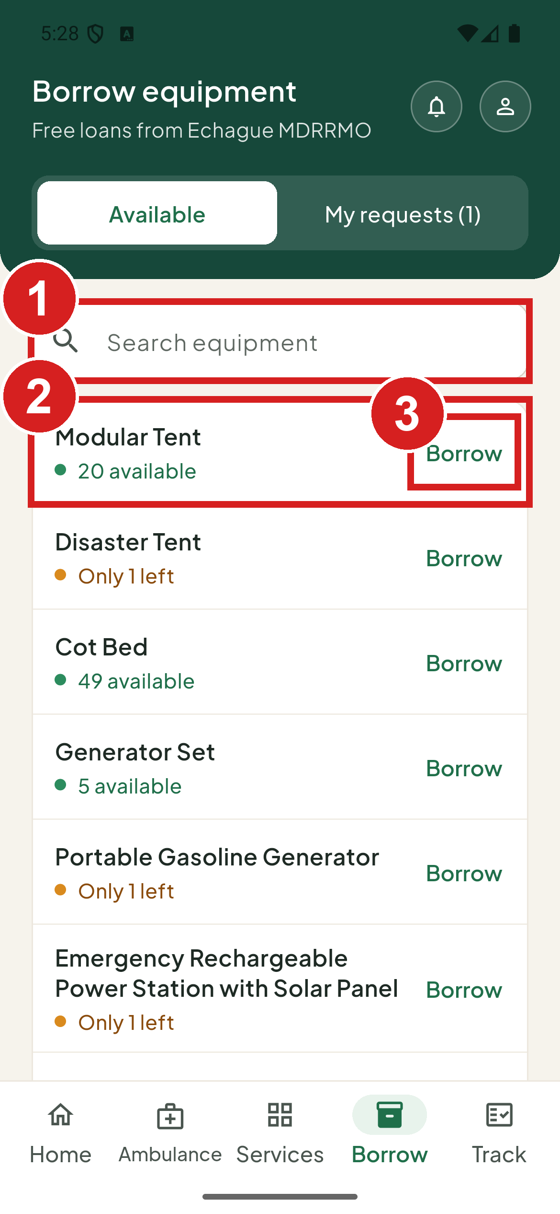 | 1 Find an item  2 How many are free  3 Ask to borrow it

Borrow an item
1. Tap Borrow next to the item.
2. Set how many you need. You can ask for up to the number available.
3. Say what it is for.
4. Choose Pickup at the MDRRMO office or Delivery to your address. For delivery, type the address.
5. Tap Send request.
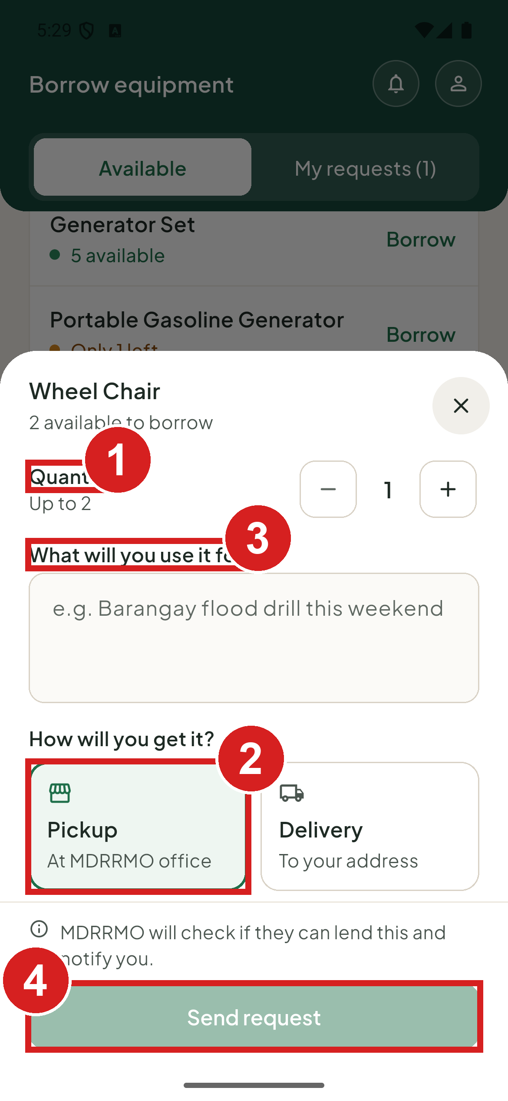 | 1 How many  2 How you get it  3 What it is for  4 Send

Ask for an item not on the list
1. Tap Need something else? at the end of the list. The Request another item sheet opens.
2. Type the item and how many, say what it is for, and choose pickup or delivery.
3. Tap Send request.
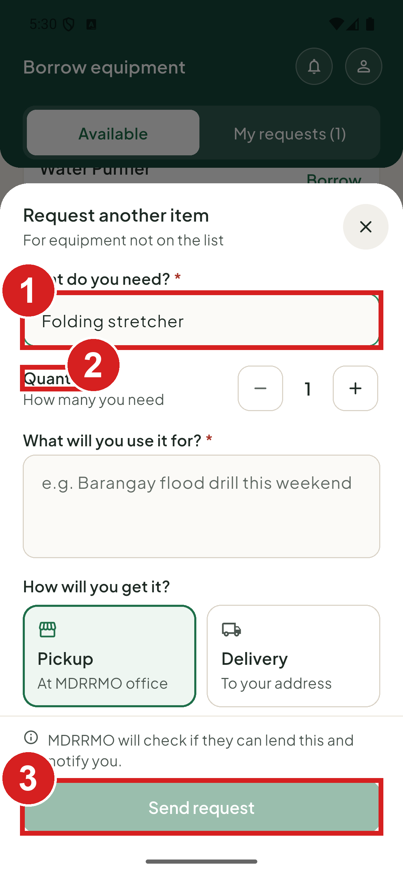 | 1 What you need  2 How many  3 Send

Follow your borrowing
1. Open My requests on the Borrow screen.
2. Check the status and the date to return the item.
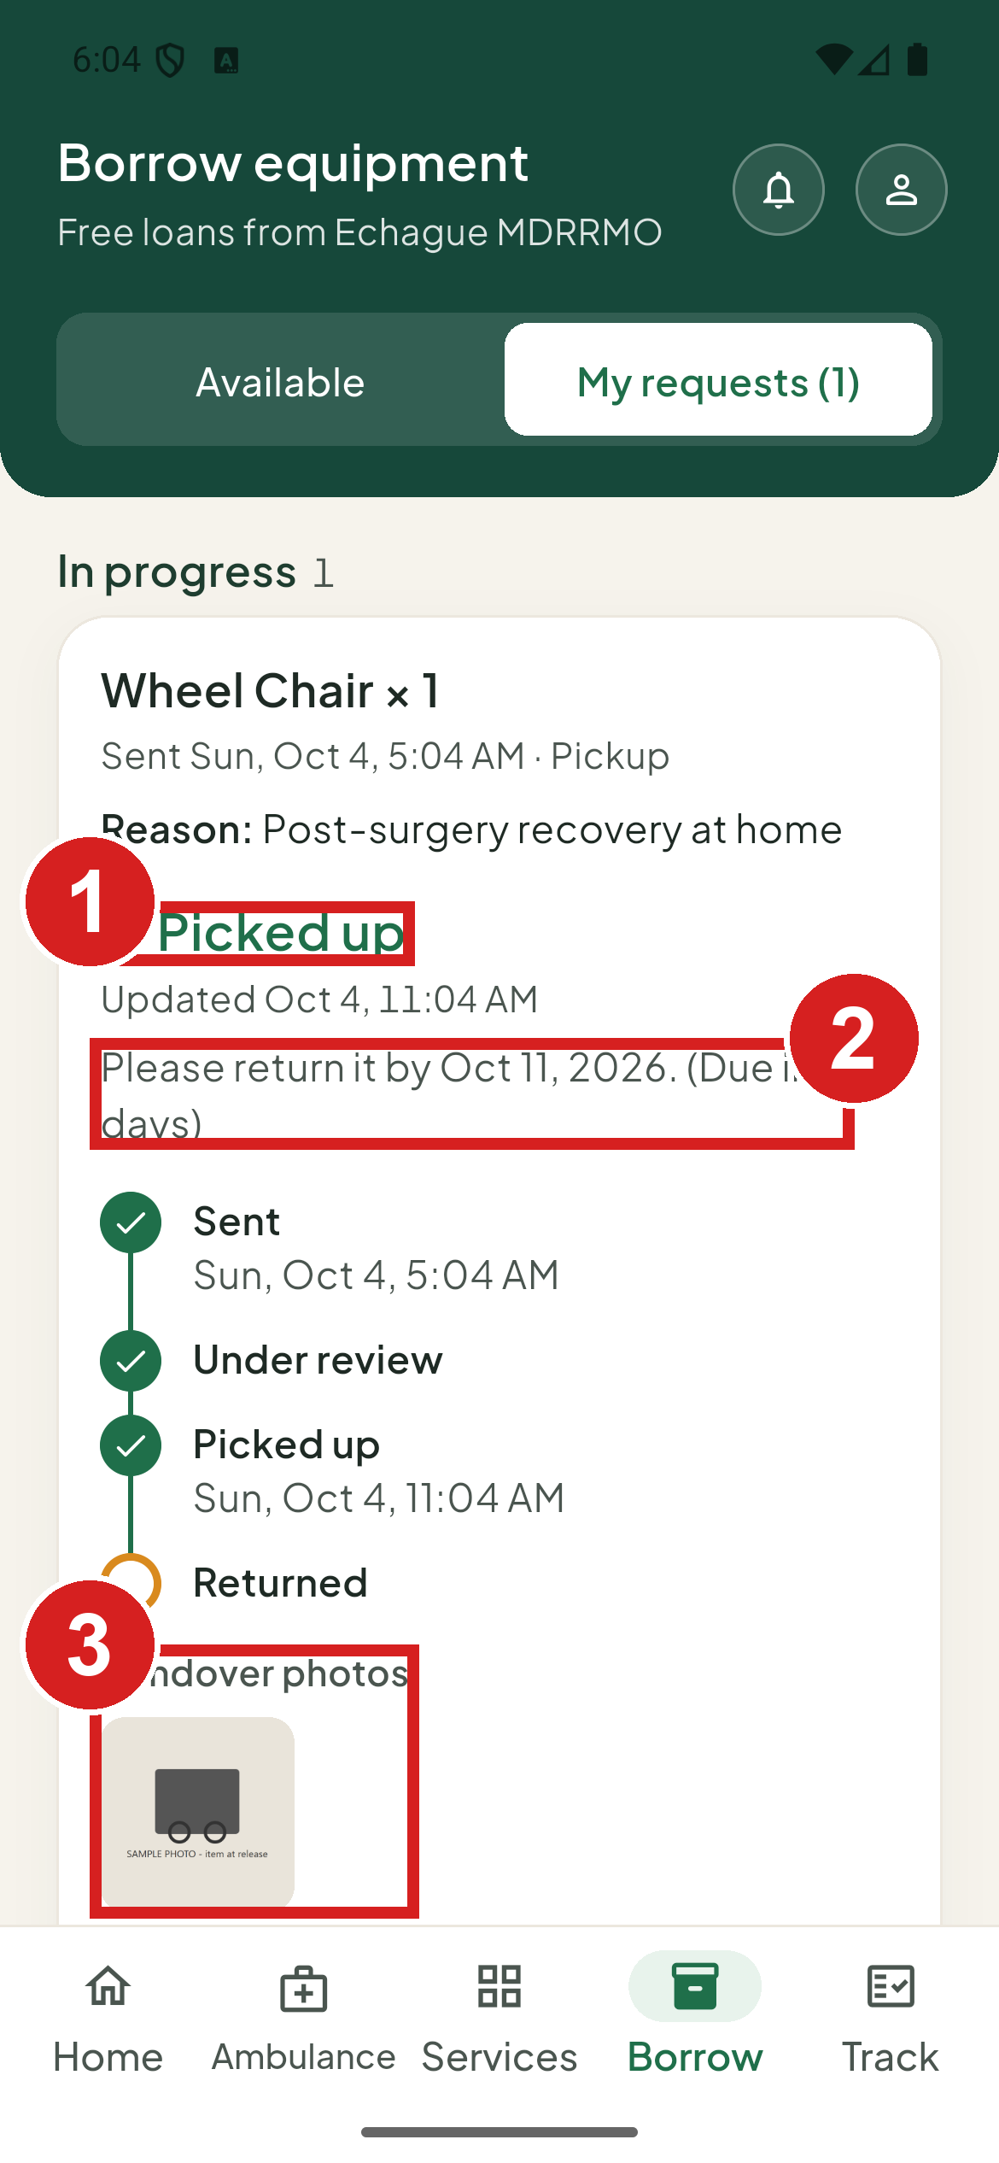 | 1 Where it stands  2 When to bring it back  3 Photos taken at the counter

A borrowing request goes Under review, then Ready to pick up or Out for delivery, then Picked up or Delivered, and ends Returned. If the MDRRMO cannot lend it, it shows Not approved with the reason. You can tap Cancel request until the item is released to you.

Safety guides and hotlines

Read a guide
1. On Home, tap Safety guides.
2. Tap a guide to read it.
3. Tap Download to keep it on your phone. It then shows Saved.
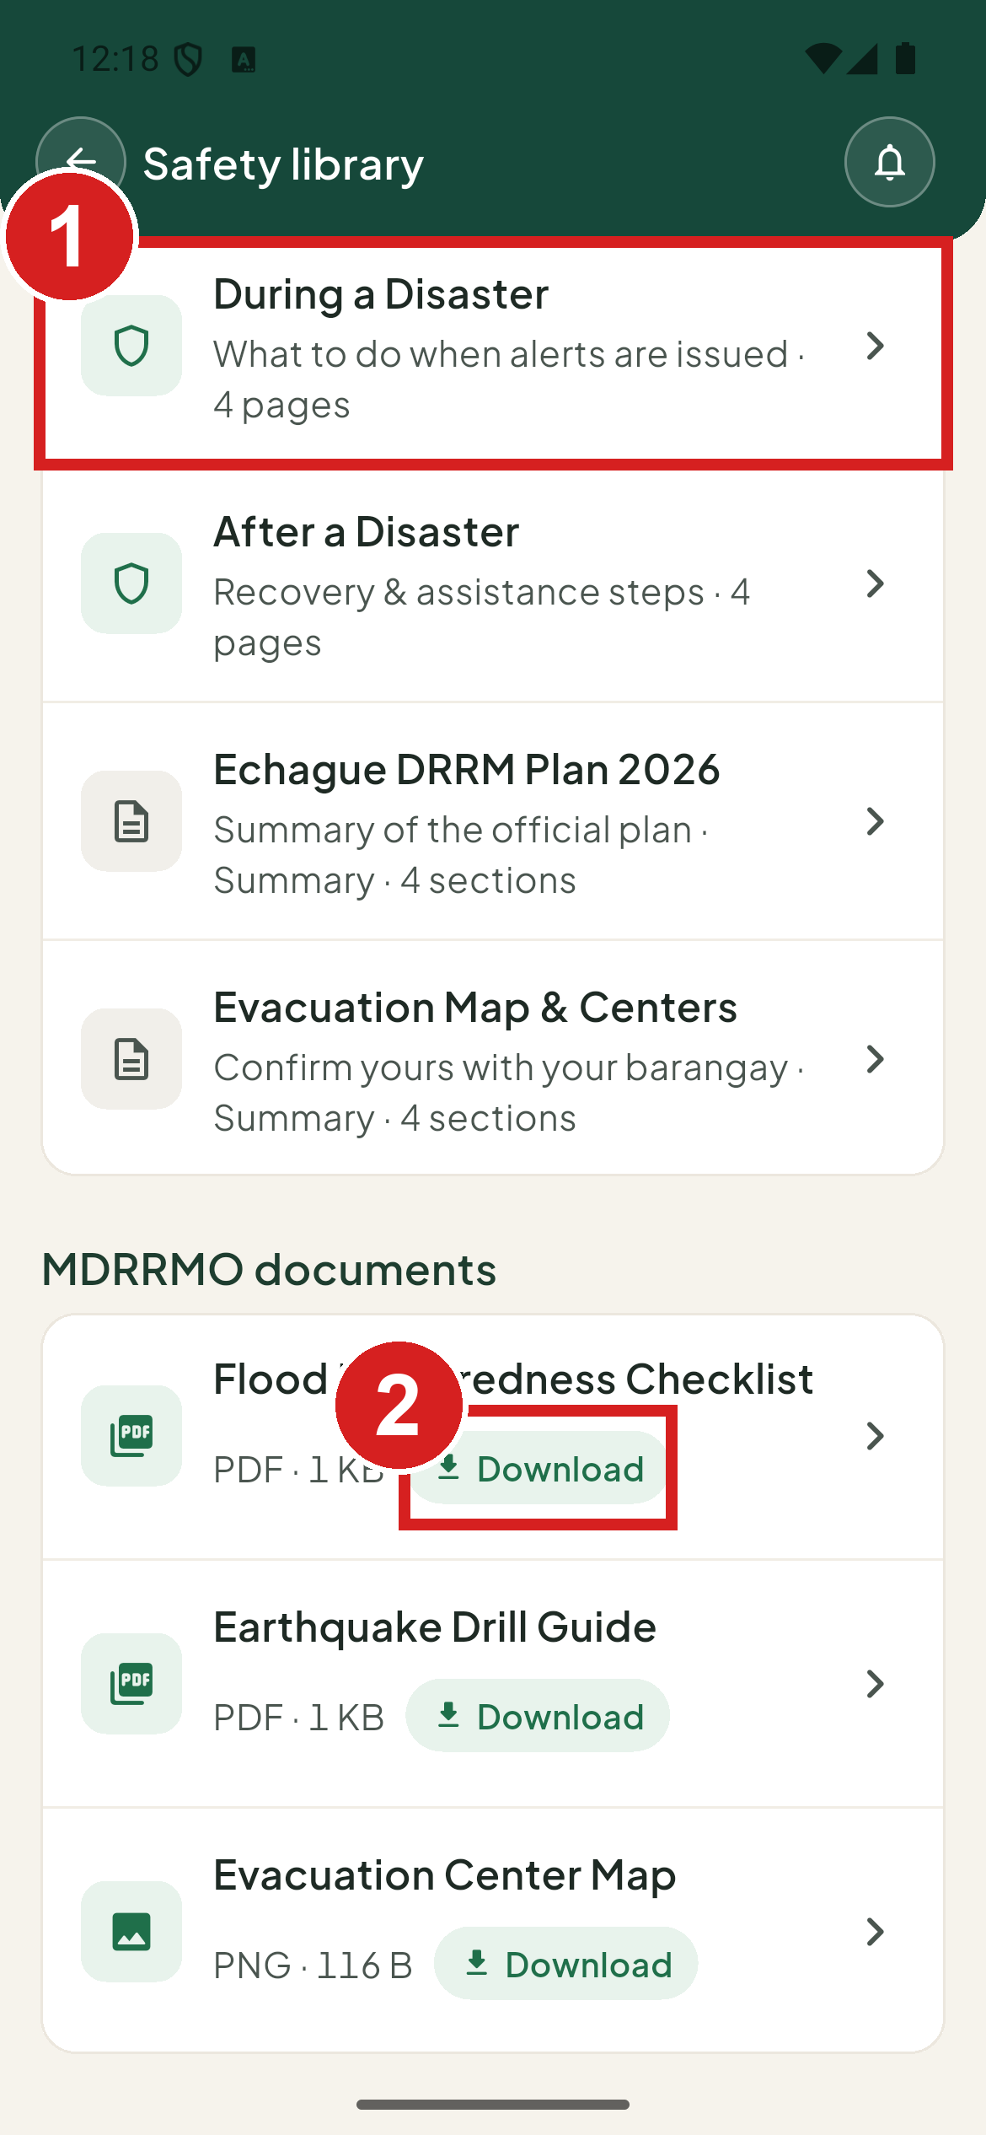 | 1 Open a guide  2 Keep it on your phone

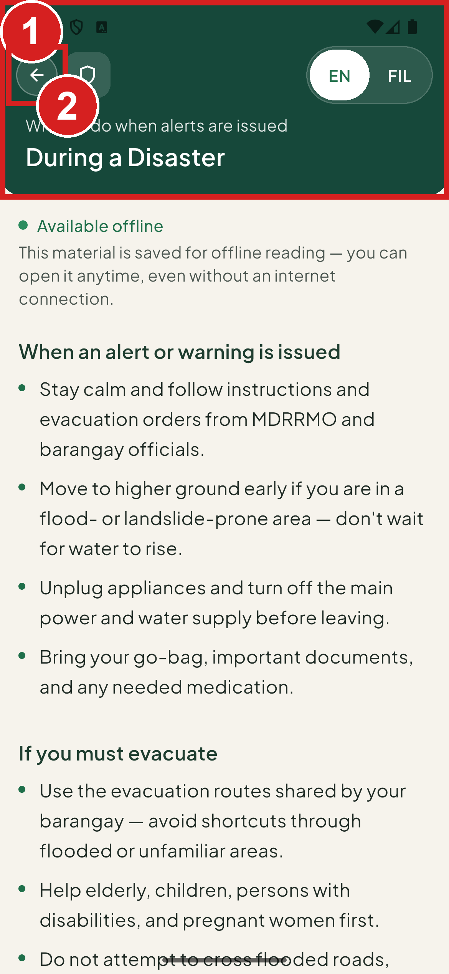 | 1 The guide  2 Return to the library

Read a guide without internet
1. In the Safety library, tap Download on a guide. It then shows Saved.
2. Later, even without internet, tap the profile button at the top.
3. Tap Offline materials.
4. Tap the guide to read it.
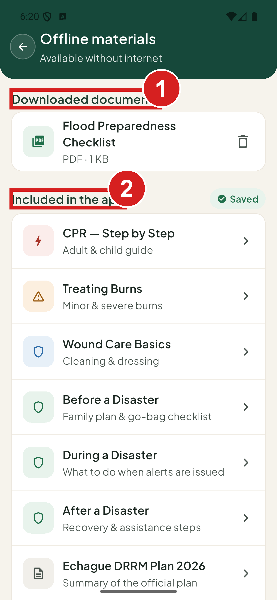 | 1 Guides you downloaded  2 Guides that come with the app

Call a hotline
1. Tap Emergency hotlines in the Safety library.
2. Tap a number to call it.
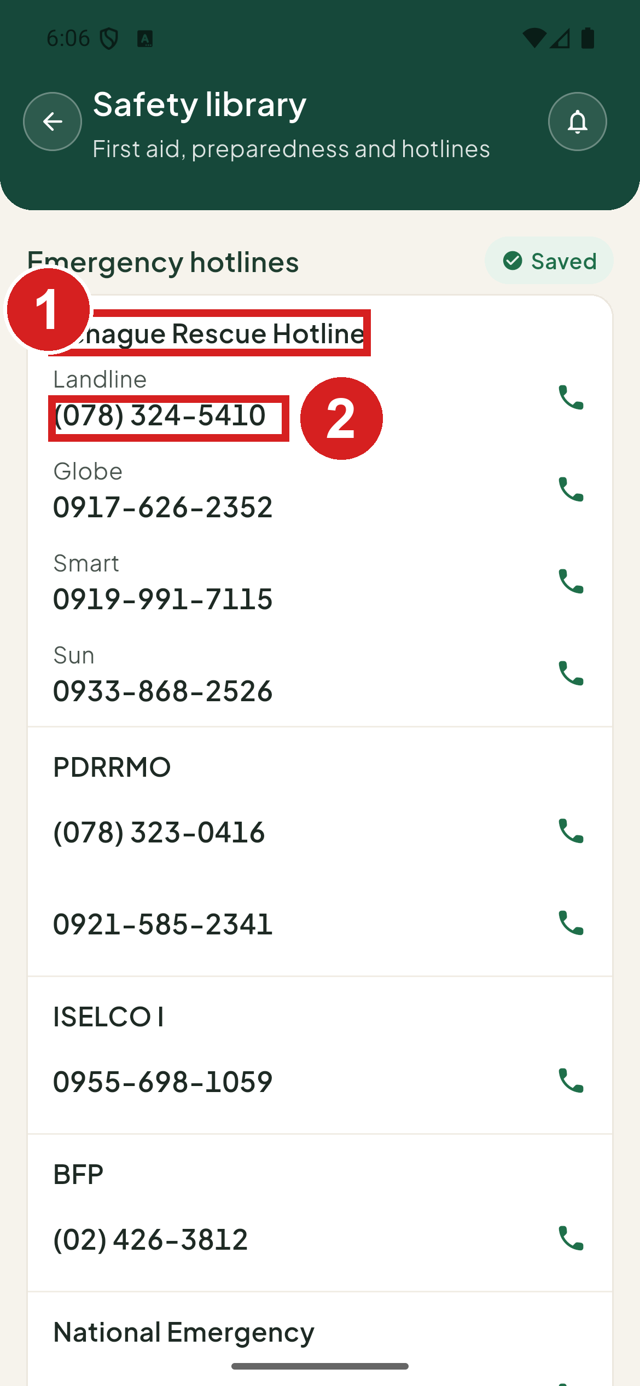 | 1 Who you are calling  2 Tap to call

Your profile

Open your profile
1. Tap the profile button at the top.
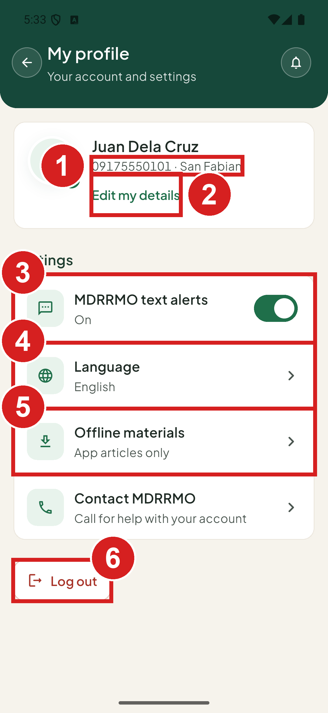 | 1 Your number and barangay  2 Name and address  3 Turn text alerts on or off  4 English or Filipino  5 Saved guides  6 Sign out

Keep MDRRMO text alerts on to receive flood and evacuation texts from the MDRRMO. While your account is pending, the profile shows Text alerts start once MDRRMO activates your account.

Edit your details
1. Tap Edit my details.
2. Change your name or address.
3. Tap Save changes. If you changed your barangay, the app asks Change your barangay? Tap Change barangay. Requests you already sent stay with the old barangay.
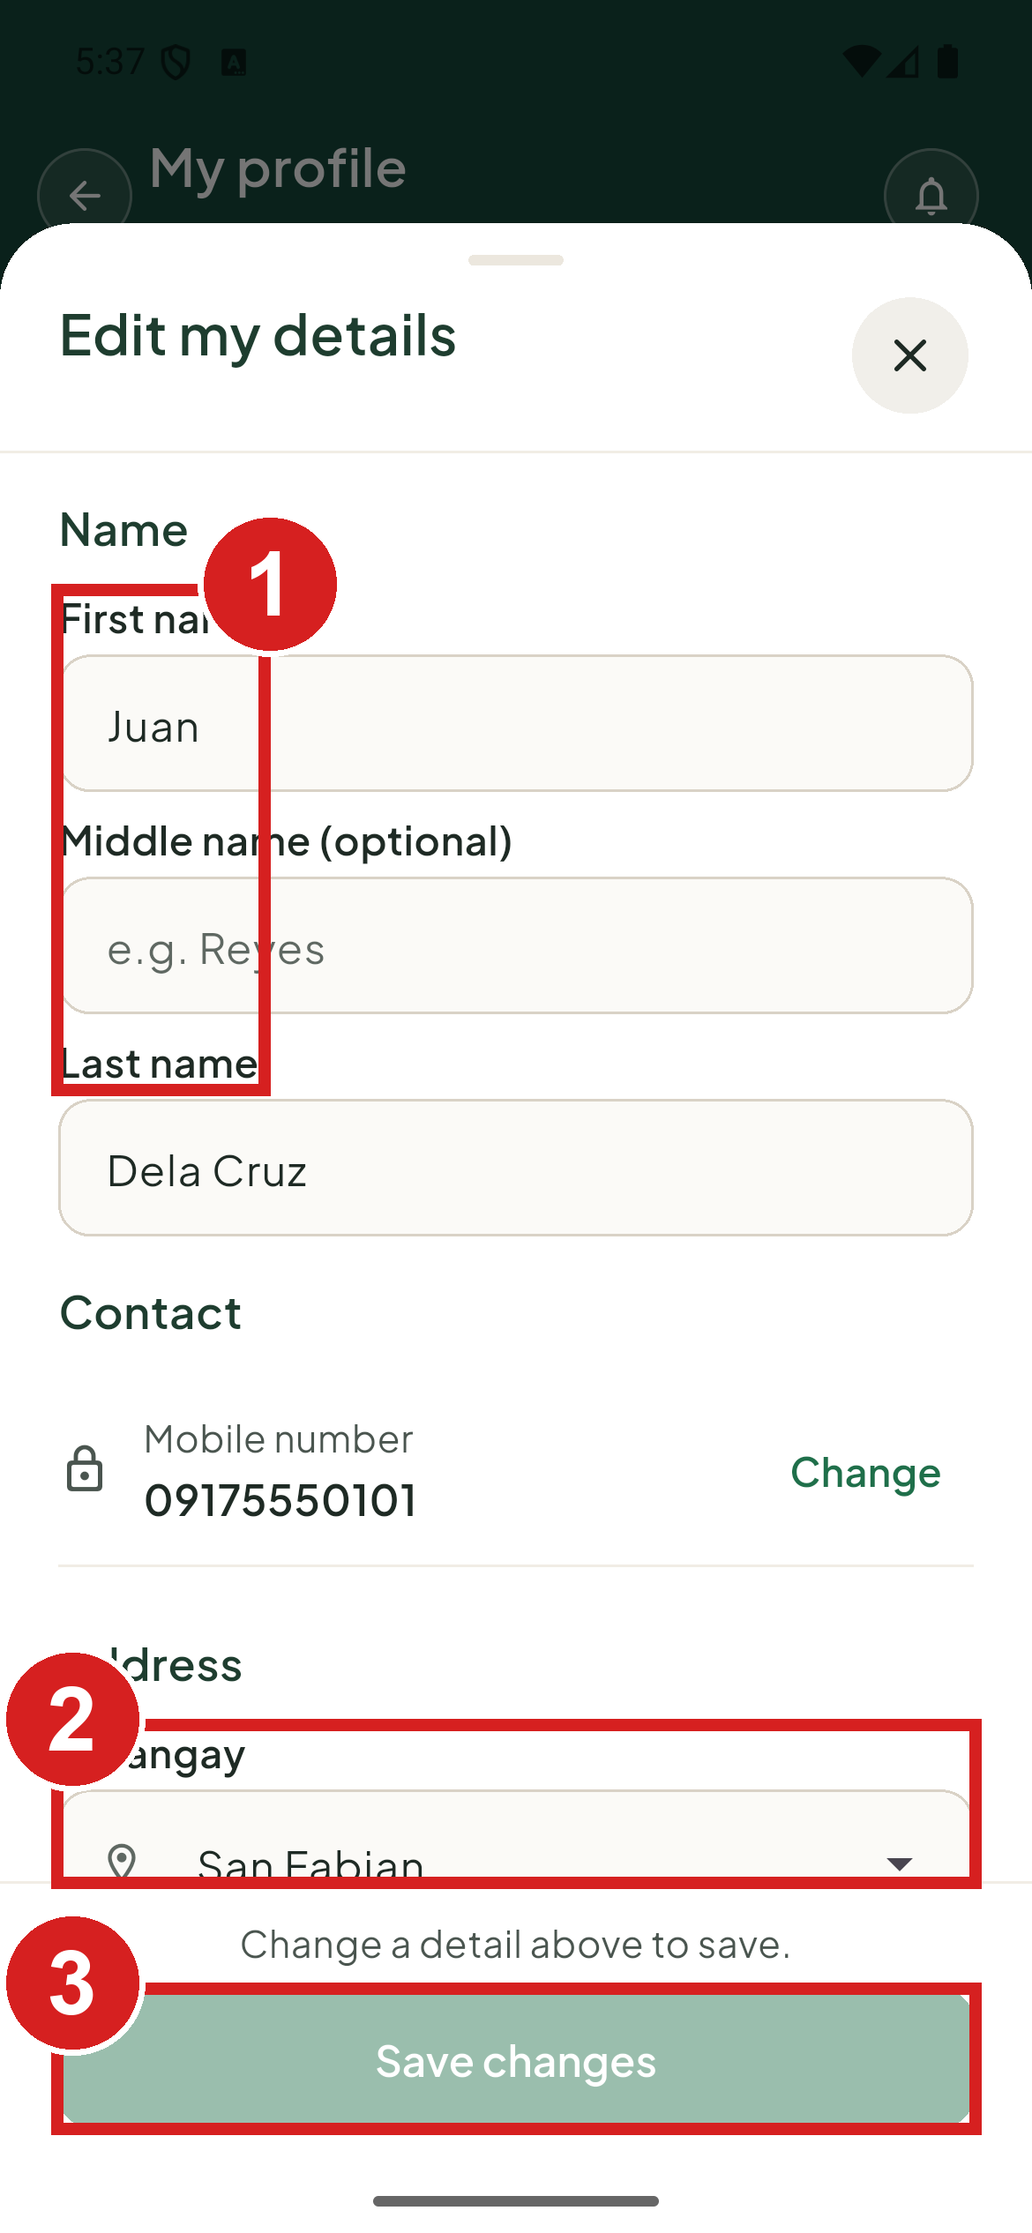 | 1 Your name  2 Where you live now  3 Save

A Head of the Family can change barangay here after moving. Barangay and organization accounts cannot. They must contact the MDRRMO.

Change your mobile number
1. Tap Edit my details, then Change next to your mobile number.
2. Type the new number and your current password.
3. Tap Send code.
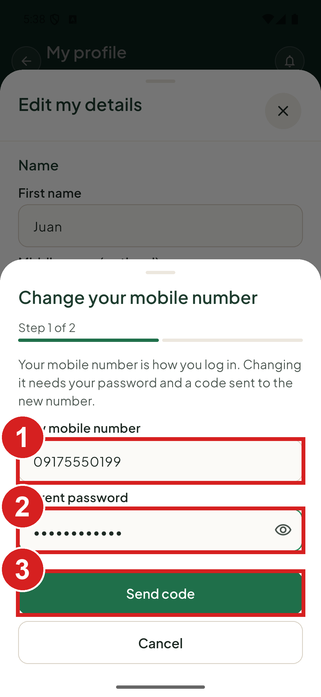 | 1 Your new number  2 To prove it is you  3 Get a code on the new number

4. On Enter the code, type the code sent to the new number.
5. Tap Confirm new number. You now log in with the new number.
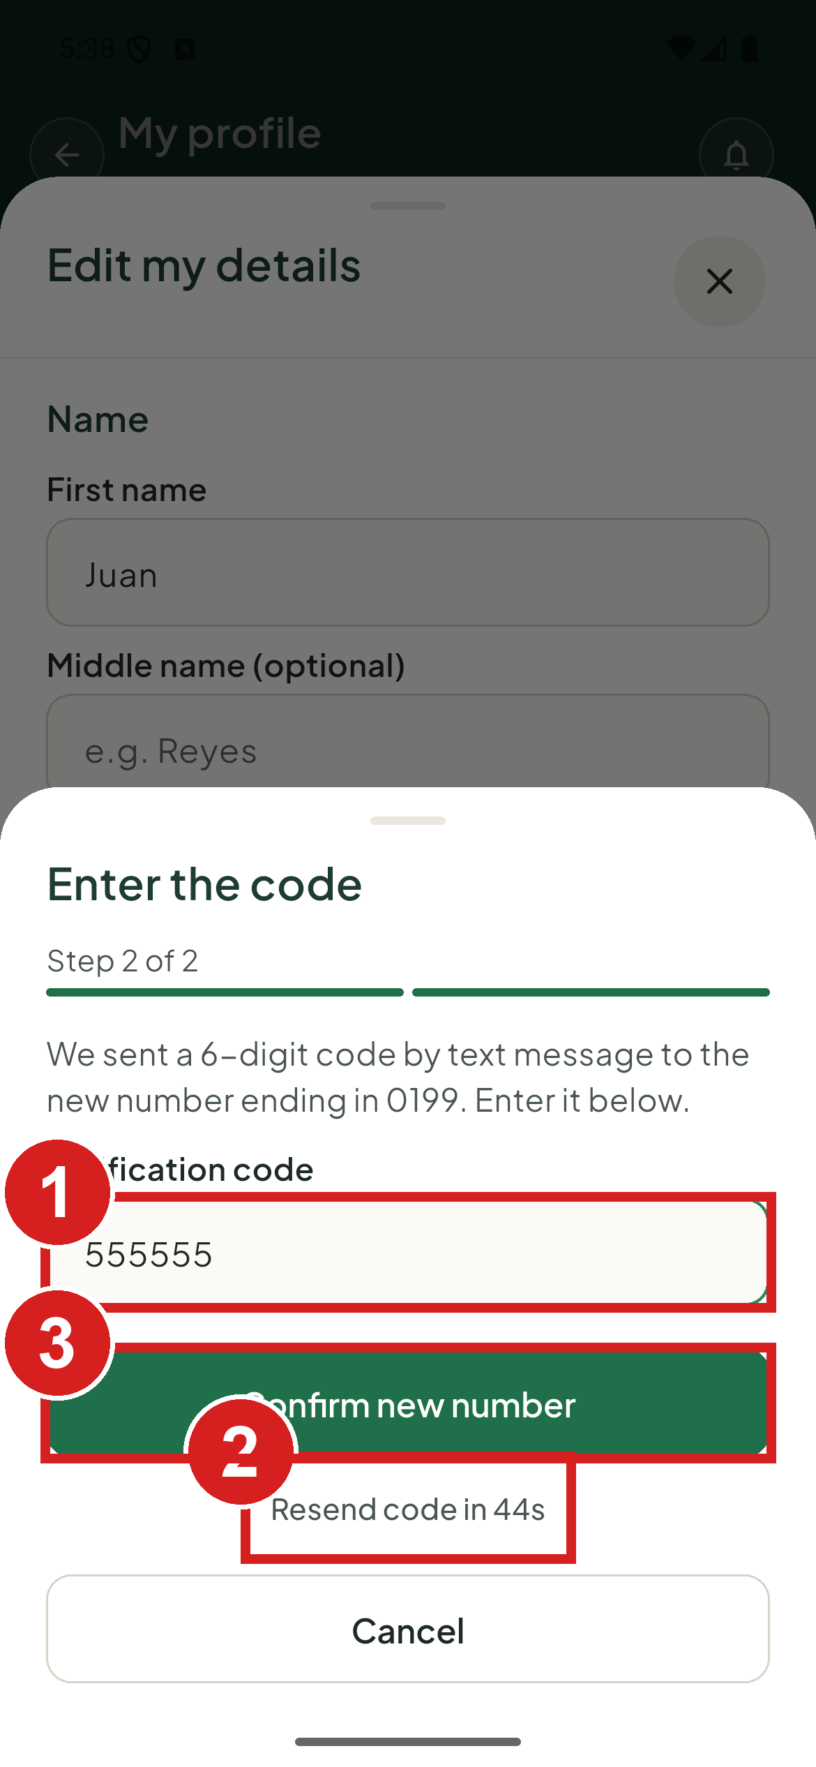 | 1 The code sent to the new number  2 Ask for a new code  3 Finish the change

Change the language
1. Tap Language.
2. Choose English or Filipino.
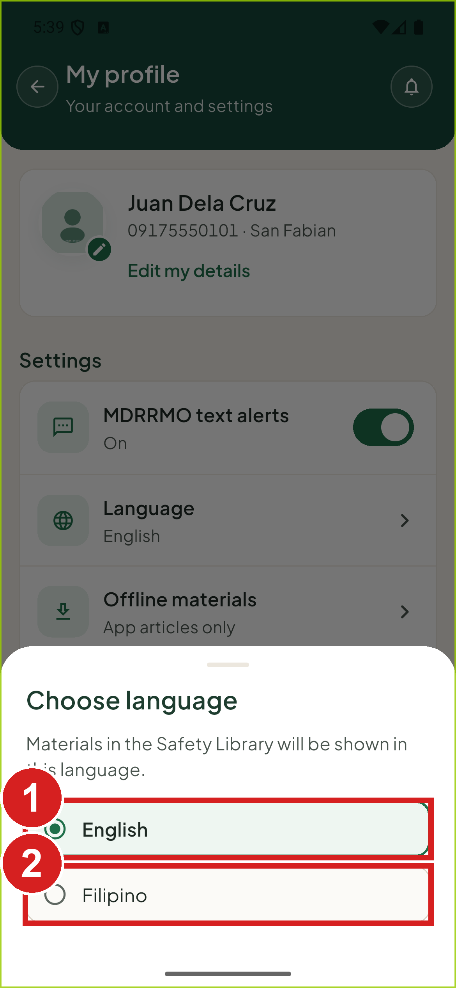 | 1 English  2 Filipino

Change your profile photo
1. Tap your photo or initials at the top of your profile.
2. Tap Choose a photo and pick a picture. To take it off, tap Remove photo.
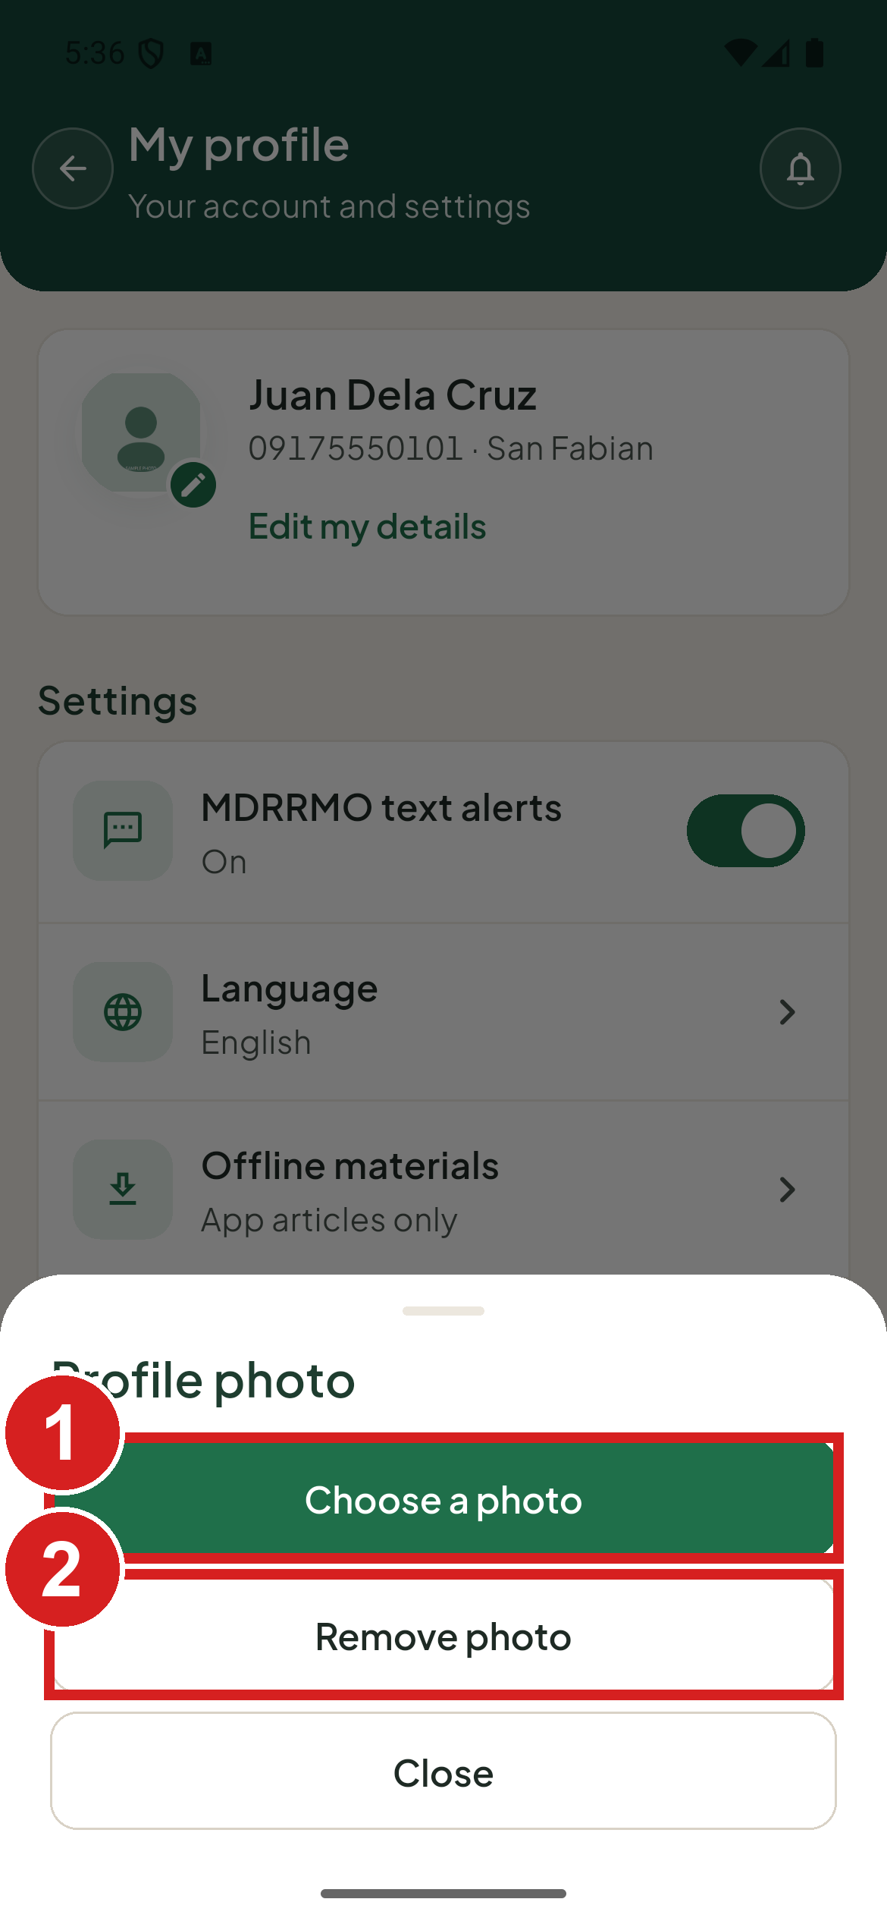 | 1 Pick a new picture  2 Take the photo off

Contact the MDRRMO
1. Tap Contact MDRRMO on your profile. Your phone opens the MDRRMO number, ready to call.
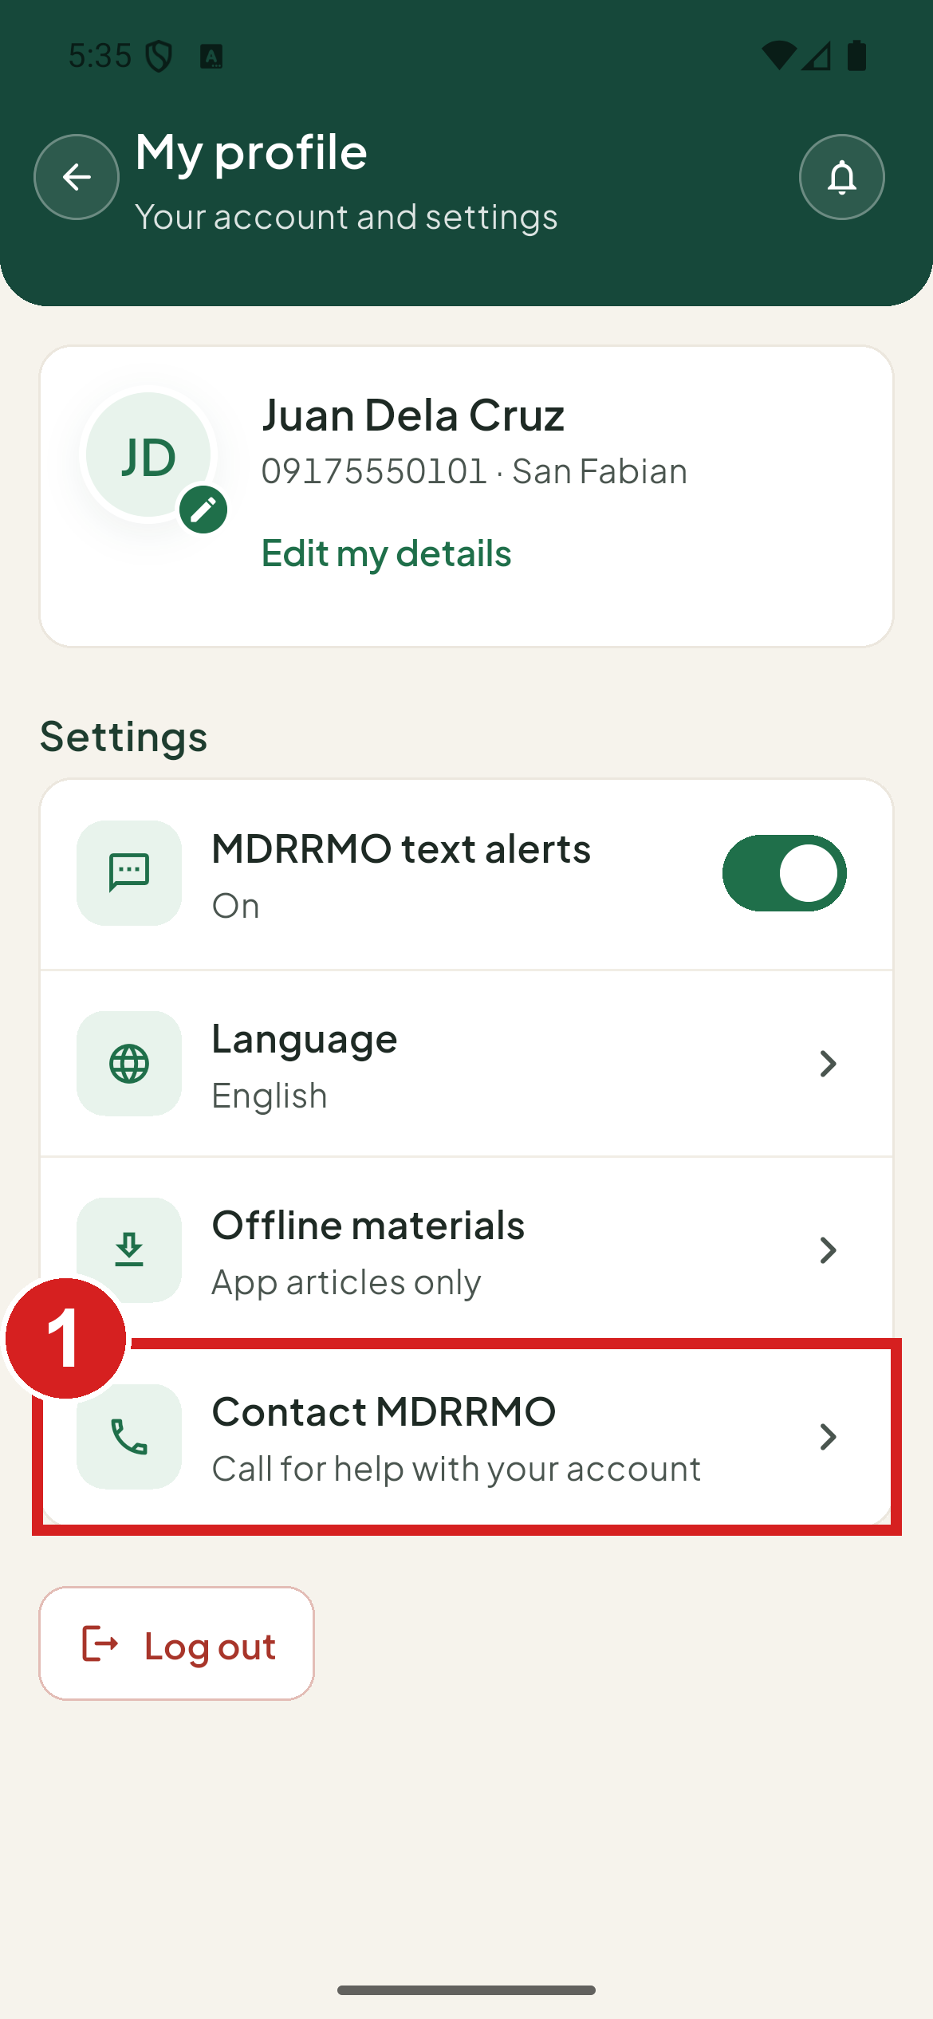 | 1 Call for help with your account

Log out
1. Tap Log out at the bottom of your profile.
2. The app asks Log out? Tap Log out to confirm.

Common problems
You are offline. A bar at the top says No connection to MDRRMO. Requests can't be sent. and shows when the data was last updated. You can read saved requests and guides, but you cannot send anything until you are back online.
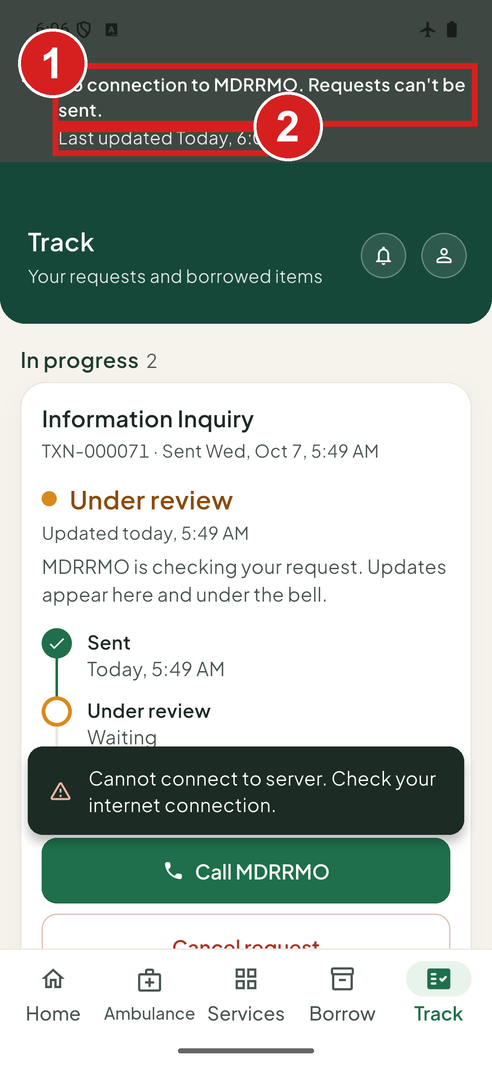 | 1 You are offline  2 How old the shown data is

A list could not load. Check your connection, then tap Try again.
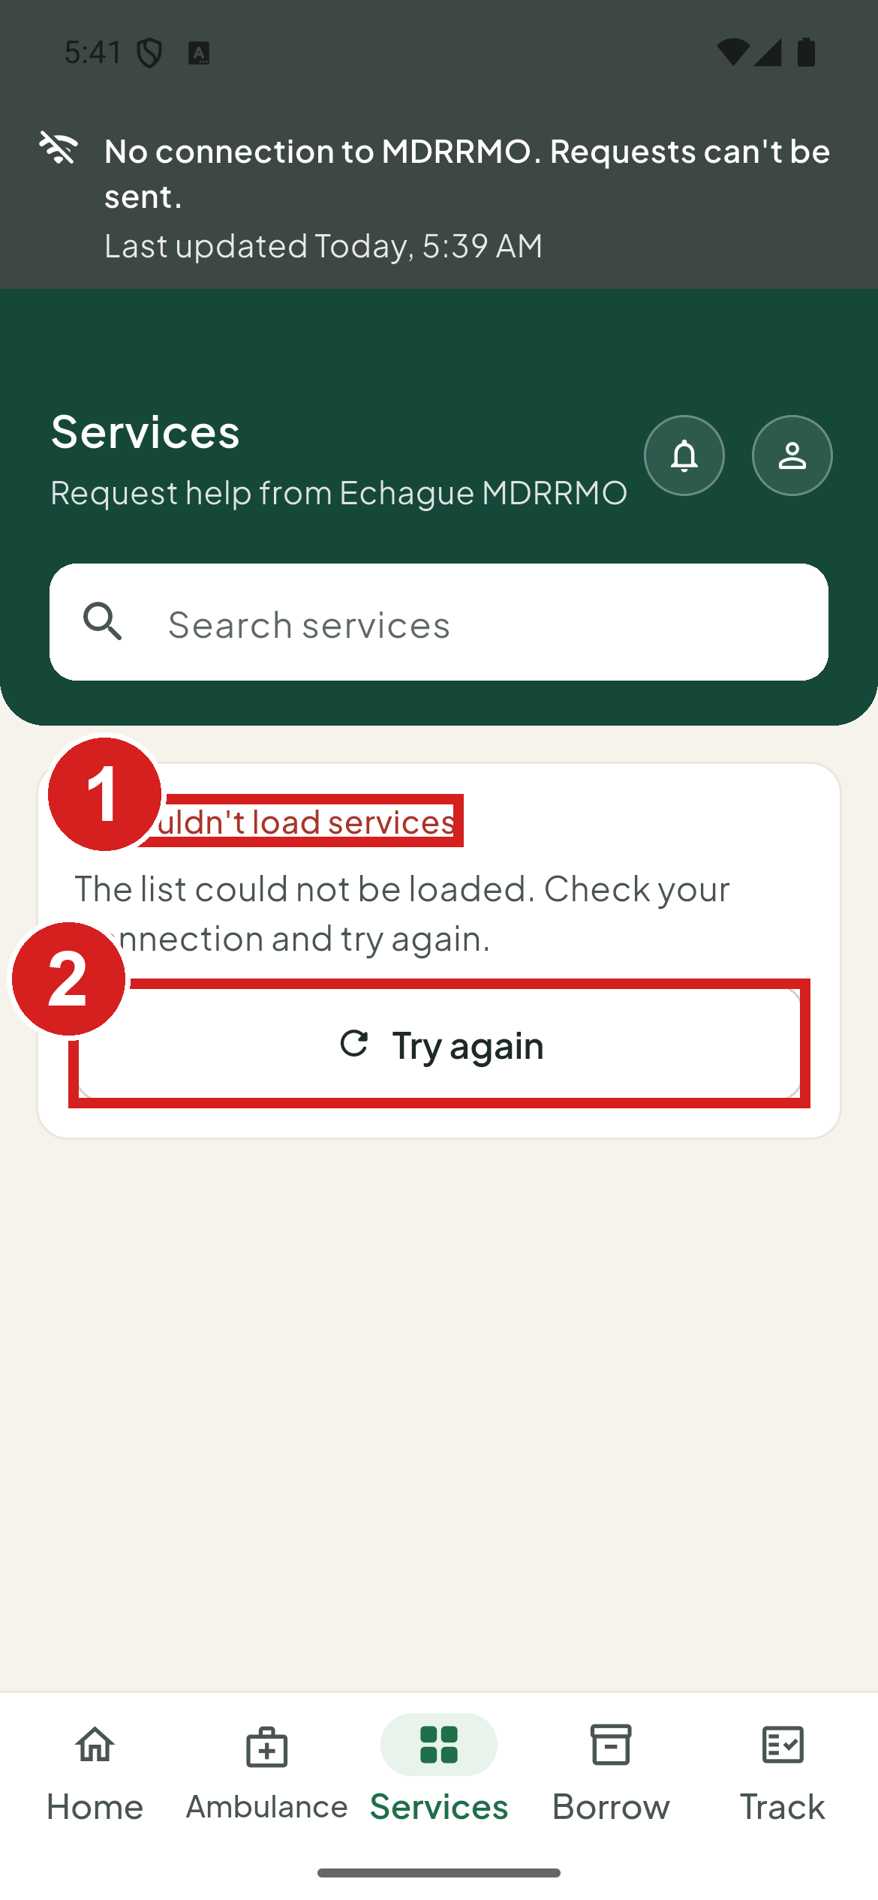 | 1 What went wrong  2 Load it again

The text-message code did not arrive. Wait for the countdown to reach 0, then tap Send a new code. Check that the number is right.
A service is not on the list. It is not offered for your account type, or the MDRRMO has turned it off.
"Your organization account is awaiting MDRRMO approval." You can request services after the MDRRMO activates your account.
"This account has been deactivated. Please visit the MDRRMO office." Visit or call the MDRRMO.
The app asks you to update. Install the newest version of the app, then open it again.

SERBIS
Municipal Disaster Risk Reduction and Management Office
Municipality of Echague, Isabela
Operations Center, Municipal Ground, San Fabian, Echague, Isabela, 3309
Hotline: 09176262352 / 09431320604
Email: mdrrmo.echague@gmail.com
Facebook: Mdrrmo Echague | Page: Echague Rescue
v1.0, October 2026

