

Vel Tech Rangarajan Dr. Sagunthala R&D Institute of Science and Technology (Deemed to be University Estd. u/s 3 of UGC Act, 1956)
School of Computing
B.Tech. – Computer Science and Engineering
VTR UGE2021- (CBCS)


Academic Year: 2025–2026 SUMMER SEMESTER - SS2526

Course Code : 10211CS207
Course Name : Database Management Systems Slot No : S4-L5

DBMS TASK - 11 REPORT

Submitted by:

VTUNO | REGISTER NUMBER | STUDENT NAME
VTU30252 | 24UECS1140 | BOYAPATI ANANDA SIVA KOTESWARA RAO

ABSTRACT

The objective of this task is to perform CRUD operations using graph databases such as Neo4j.
Graph databases use nodes and relationships to represent and query complex data relationships efficiently.

AIM:
To perform CRUD operations like creating, inserting, querying, finding, deleting operations on graph spaces.

Create Node with Properties
Properties are the key-value pairs using which a node stores data. You can create a node with properties using the CREATE clause. You need to specify these properties separated by commas within the flower braces “{ }”.

Syntax
Following is the syntax to create a node with properties. CREATE (node:label { key1: value, key2: value, })

Returning the Created Node
To verify the creation of the node, type and execute the following query in the dollar prompt.
MATCH (n) RETURN n

Creating Relationships

We can create a relationship using the CREATE clause. We will specify relationship within the square braces “[ ]” depending on the direction of the relationship it is placed between hyphen “ - ” and arrow “ → ” as shown in the following syntax.

Syntax
Following is the syntax to create a relationship using the CREATE clause. CREATE (node1)-[:RelationshipType]->(node2)

Creating a Relationship Between the Existing Nodes
You can also create a relationship between the existing nodes using the MATCH clause.

Syntax
Following is the syntax to create a relationship using the MATCH clause.
MATCH (a:LabeofNode1), (b:LabeofNode2)
WHERE a.name = "nameofnode1" AND b.name = " nameofnode2" CREATE (a)-[: Relation]->(b)
RETURN a,b

Deleting a Particular Node
To delete a particular node, you need to specify the details of the node in the place of “n” in the above query.

Syntax
Following is the syntax to delete a particular node from Neo4j using the DELETE clause.
MATCH (node:label {properties })
DETACH DELETE node

Create a graph database for student course registration, create student and dept node and insert values of properties.

create(n:student{Sid: "VTU14500", Sname:"John",
deptname:"CSE" }
)

OUTPUT
Added 1 label, created 1 node, set 3 properties, completed after 232 ms.

Create(n:student {Sid: "VTU14501", Sname:"Dharsana", deptname:"EEE"})

OUTPUT
Added 1 label, created 1 node, set 3 properties, completed after 16 ms.

Create(n:student { Sid: "VTU14502", Sname:"vijay",
deptname:"CSE"
})

OUTPUT
Added 1 label, created 1 node, set 3 properties, completed after 12 ms.

Create(n:dept{deptname:"cse",deptid:"d001"})

OUTPUT:
Added 1 label, created 1 node, set 2 properties, completed after 72 ms.

Select all the nodes in your database using match command

- match(n) return(n)

OUTPUT

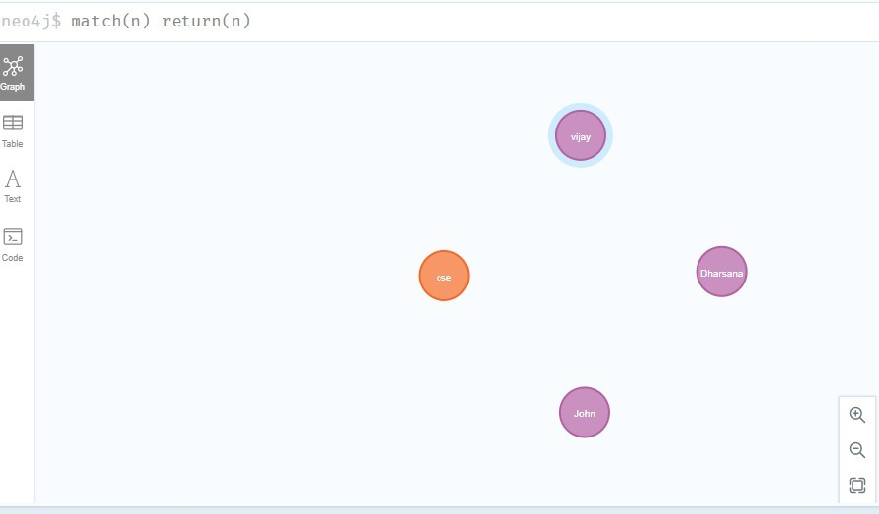
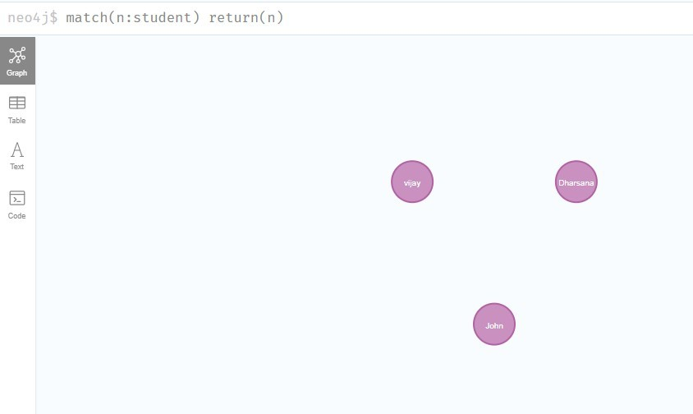

- match(n:student) return(n)

OUTPUT:

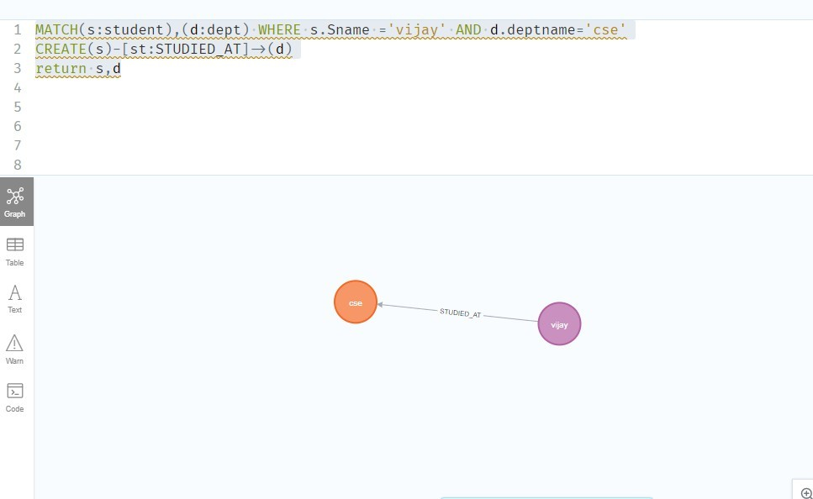

Create relationship between student and cse .

MATCH(s:student),(d:dept) WHERE s.Sname ='vijay' AND d.deptname=' cse'
CREATE(s)-[st:STUDIED_AT]->(d)
return s,d

OUTPUT:

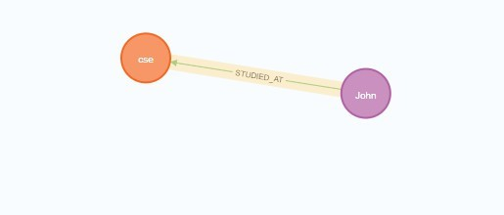
MATCH(s:student),(d:dept) WHERE s.Sname ='John' AND d.deptname=' cse'
CREATE(s)-[st:STUDIED_AT]->(d)
return s,d

OUTPUT:

match(n) return(n)

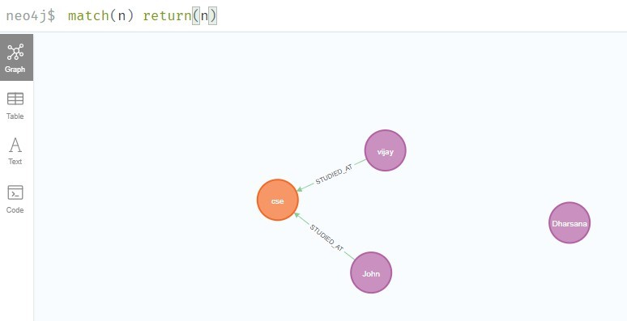

- Delete a node from student

match(n:student{Sname:'Dharsana'}) DELETE(n)

OUTPUT:
Deleted 1 node, complaeted after 10834 ms.

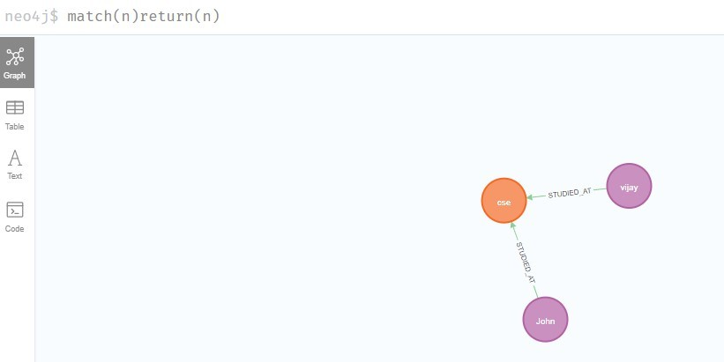

Result
The implementation of CRUD operations like creating, inserting, finding and removing operations using GraphDB is successfully executed.

