Vel Tech Rangarajan Dr. Sagunthala R&D Institute of Science and Technology

(Deemed to be University Estd. u/s 3 of UGC Act, 1956)

School of Computing
B.Tech. – Computer Science and Engineering
VTR UGE2021- (CBCS)

Academic Year: 2025–2026
SDG 4: Quality Education
Course Code : 10211CS207
Course Name : Database Management Systems
Slot No :

DBMS PROJECT REPORT
Title:Banking Transaction Management and Fraud Detection
Submitted by:
VTUNO | REGISTER NUMBER | STUDENT NAME
VTU30252 | 24UECS1140 | B.ANANDA SIVA KOTESWARA RAO

Under the guidance of:
Dr V Senthil kumar

INDEX PAGE
1. Introduction …………………………………………… 3
2. Problem Statement …………………………………………… 4
3. Objectives …………………………………………… 5
4. System Requirements …………………………………………… 6
5. System Analysis and Design……………………………………… 6
6. ER Diagram (Conceptual Design) ..……………………………… 7
7. Schema Design (Oracle)…………………………………………… 9
8. Normalization …………………………………………… 13
9. Implementation (SQL Queries)…………………………………… 13
10. Input and Output …………………………………………… 14
11. Integration with MongoDB (NoSQL)…………………………… 15
12. Results and Discussion ..…………………………………… 19
13. Conclusion …………………………………………… 20
14. References …………………………………………… 20

Introduction
A Banking Transaction Management System serves as the core component that facilitates and safeguards all monetary operations within the banking infrastructure. Each transaction in such a system must strictly comply with the ACID properties—Atomicity, Consistency, Isolation, and Durability. These principles ensure that a transaction either completes successfully in its entirety or is completely rolled back in the event of a system or network failure, thus preventing partial updates or data corruption. The ARIES (Algorithm for Recovery and Isolation Exploiting Semantics) recovery mechanism plays a crucial role in this process. ARIES employs write-ahead logging and checkpointing techniques to guarantee that no transaction data is lost and that the system can recover gracefully after any interruption.
Given the concurrent nature of modern banking environments, where thousands of transactions may occur simultaneously, concurrency control mechanisms become essential. These mechanisms, such as two-phase locking (2PL) and timestamp ordering, prevent anomalies like dirty reads, lost updates, and phantom transactions. By maintaining isolation between concurrent operations, the system preserves data accuracy and synchronization across multiple users and branches in real time.
However, beyond transactional reliability, a critical dimension of modern banking is fraud detection. As cyber threats and digital fraud become increasingly sophisticated, banks must integrate intelligent systems capable of identifying suspicious activities in real time. Fraud detection in this context involves analyzing multi-dimensional data sources, combining relational database transactions with external event streams such as user geolocation, device fingerprints, transaction patterns, and behavioral analytics. By leveraging machine learning models and data stream processing frameworks, the system can detect deviations from normal user behavior—such as unusual login locations, rapid fund transfers, or inconsistent spending habits—and trigger alerts or automated intervention.
This integrated framework of transaction management and fraud detection not only ensures operational stability but also strengthens customer confidence by minimizing risks associated with unauthorized access and fraudulent activities. The seamless coordination between transaction processing and analytical fraud monitoring represents the foundation of a secure, resilient, and intelligent banking ecosystem.
In essence, the Banking Transaction Management and Fraud Detection system stands as a convergence of database management, distributed systems, and artificial intelligence, providing a unified platform that balances high performance, fault tolerance, and proactive security—key pillars for sustaining trust and innovation in the financial sector.

2. Problem Statement
In today’s fast-evolving digital banking landscape, financial institutions face the dual challenge of managing an immense volume of transactions while simultaneously protecting customer data and financial integrity against sophisticated fraudulent activities. Every second, thousands of deposits, withdrawals, transfers, and credit operations occur across multiple distributed systems and digital platforms. Ensuring that these transactions are processed accurately, securely, and efficiently is critical to maintaining both customer trust and regulatory compliance.
Traditional transaction processing systems often struggle to meet the complex requirements of modern banking operations. The absence of robust atomicity and isolation mechanisms can result in partial transaction completions, inconsistencies, or data corruption—especially in the event of network or system failures. In distributed environments, where data is replicated across multiple nodes, ensuring synchronization and recovery after crashes poses a significant technical challenge. Without effective logging and recovery systems like ARIES, even minor disruptions can lead to significant financial and reputational losses.
Moreover, the challenge extends beyond transaction accuracy. The rise of cyber threats and financial fraud has introduced an entirely new dimension of risk. Fraudulent activities often exploit weak points in transaction flows—such as identity theft, unauthorized access, account takeovers, and money laundering schemes. Detecting such activities in real time is difficult due to the massive scale of data and the complexity of identifying abnormal behavioral patterns within legitimate transaction streams. Conventional rule-based systems are no longer sufficient, as fraudsters continuously adapt and evolve their tactics.
The problem is further intensified by the integration of external data sources—such as user location, device identifiers, and transaction histories—which must be analyzed alongside relational data to uncover correlations that may indicate fraud. This requires cross-table analysis and real-time stream processing, demanding both computational power and intelligent data architecture. Without effective coordination between transaction management and analytical fraud detection systems, banks risk processing fraudulent transactions undetected, leading to financial losses, regulatory penalties, and erosion of customer confidence.
Therefore, the core problem addressed by this project is the design and implementation of a robust Banking Transaction Management and Fraud Detection System that can:
- Ensure reliable and atomic transaction processing using log-based recovery and concurrency control mechanisms
- Guarantee data consistency and fault tolerance even under high transaction loads or system failures.
- Detect and mitigate fraudulent transactions in real time through integrated data analysis of both relational and external event streams.
- Maintain scalability, transparency, and compliance with financial data regulations.
In summary, the problem lies in bridging the gap between high-performance transaction processing and intelligent fraud detection, creating a unified, secure, and resilient banking system capable of sustaining trust in a digitally connected financial ecosystem.

3. Objectives
The primary objective of the Banking Transaction Management and Fraud Detection System is to develop a secure, reliable, and intelligent platform capable of processing large-scale financial transactions with guaranteed data integrity and proactive fraud prevention. To achieve this, the system aims to integrate robust transaction management mechanisms with advanced analytical tools for real-time fraud detection.
The detailed objectives of the project are as follows:

1. Ensure Reliable Transaction Processing
- Implement the fundamental ACID properties—Atomicity, Consistency, Isolation, and Durability—to ensure every financial transaction is executed accurately and completely.
- Develop a transaction engine capable of rollback and recovery in case of system, network, or hardware failures.
- Incorporate ARIES (Algorithm for Recovery and Isolation Exploiting Semantics) or equivalent log-based recovery mechanisms to prevent data loss and maintain system reliability.

2. Maintain Data Consistency and Concurrency
- Design a robust concurrency control mechanism to handle multiple simultaneous transactions without interference or data anomalies.
- Prevent issues such as dirty reads, lost updates, and phantom transactions by ensuring proper transaction isolation levels.
- Optimize transaction throughput while maintaining synchronization across distributed database nodes.

Develop an Intelligent Fraud Detection Framework

- Utilize cross-table relational data analysis combined with external event streams (e.g., user location, device ID, IP address, and transaction frequency) to enhance detection accuracy.
- Apply machine learning or rule-based models to identify anomalies and trigger automatic alerts or transaction blocks when fraudulent behavior is detected.

4. Enhance Data Security and Confidentiality
- Employ advanced encryption techniques, access controls, and authentication mechanisms to protect sensitive financial data.
- Ensure compliance with banking security standards and regulations, such as PCI-DSS and GDPR, to maintain trust and transparency.
- Secure communication between systems and clients to prevent data breaches or unauthorized access.

5. Enable Scalability and Fault Tolerance
- Design the architecture to handle millions of transactions daily without compromising system performance.
- Implement distributed and redundant storage systems to ensure continuous availability and fault recovery.
- Support scalable cloud or hybrid infrastructure to meet growing user and data demands.

6. Facilitate Monitoring and Reporting
- Provide an interactive dashboard for administrators to monitor transaction flows, detect anomalies, and generate analytical reports.
- Offer visual representations of transaction trends, fraud patterns, and performance metrics for better decision-making.
- Maintain detailed audit logs for transparency, traceability, and regulatory compliance.

Integrate with Modern Banking Ecosystems

- Support multi-channel operations including online banking, mobile applications, and ATM networks.
- Allow easy integration with AI-driven risk management systems and external data providers.

4. System Requirements
Hardware Requirements:
Component | Minimum Requirement | Recommended Requirement
Processor (CPU) | Intel Core i5 or equivalent | Intel Core i7 / Xeon (multi-core)
RAM | 8 GB | 16 GB or higher
Storage | 256 GB SSD | 512 GB SSD or higher
Network | 100 Mbps Internet connection | 1 Gbps with redundancy
Server OS | Linux (Ubuntu/CentOS) | Linux or Cloud VM (AWS EC2, Azure VM)
Backup Storage | External HDD / NAS 1 TB | RAID setup with 2 TB or more

Software Requirements:
Category | Software / Technology
Operating System | Windows 10/11, Linux (Ubuntu 22.04 / CentOS 8)
Programming Language | Java / Python / Node.js
Database | MySQL / PostgreSQL (supports ACID transactions)
Web Framework | Spring Boot / Django / Express.js
Frontend Technologies | HTML5, CSS3, JavaScript, React.js / Angular
Logging & Recovery | ARIES Log-based Recovery Implementation
Fraud Detection | Machine Learning Libraries: Scikit-learn, TensorFlow / Rule-based engine
Web Server | Apache Tomcat / Nginx
Version Control | Git / GitHub
IDE | IntelliJ IDEA / VS Code / PyCharm
Security Tools | OpenSSL for SSL/TLS, JWT / OAuth2 for authentication

5.System Analysis and Design
System Analysis and Design (SAD) is a critical phase in developing the Banking Transaction Management and Fraud Detection System. It involves studying the requirements, analyzing the existing systems, and designing a robust architecture to achieve high-performance, secure, and intelligent banking operations.

1. System Analysis
System analysis identifies the functional and non-functional requirements of the system and evaluates how the existing systems perform in handling banking transactions and fraud detection.

1.1 Existing System
- Traditional banking systems handle transactions sequentially, often with manual monitoring for fraud, leading to delays and human error.
- Concurrency issues such as dirty reads, lost updates, and phantom transactions are common in high-traffic environments.
- Fraud detection relies on rule-based alerts and historical analysis, which is not real-time and may fail to detect sophisticated fraud patterns.
- System recovery after crashes is slow and may result in partial data loss, as traditional backup mechanisms are insufficient for real-time operations.

1.2 Problems Identified
- Inability to handle millions of transactions concurrently without data anomalies.
- Lack of real-time fraud detection, leading to potential financial losses.
- Insufficient logging and recovery mechanisms, risking data integrity during failures.
- Low scalability and flexibility, making adaptation to modern digital banking difficult.

1.3 Proposed System
The proposed system addresses these challenges by integrating:
- ACID-compliant transaction processing to ensure atomicity, consistency, isolation, and durability.
- Log-based recovery (ARIES) to prevent data loss and enable fast system recovery.
- Real-time fraud detection using cross-table analysis and external event streams.
- Concurrency control mechanisms to prevent dirty reads and phantom transactions.
- Scalable and modular design to support millions of daily transactions with minimal latency.

2. System Design
System design defines the architecture, modules, data flow, and database structures required to implement the system efficiently.

2.1 Design Methodology
- Top-Down Approach: Breaking the system into smaller, manageable modules.
- Modular Design: Each module handles a specific function like transaction management, fraud detection, logging, or reporting.
- Client-Server Architecture: Web-based front-end communicates with server-side APIs and database servers.
Layered Arichitecture:
- Presentation Layer: User interface for customers and administrators.
- Application Layer: Handles business logic, transaction processing, and fraud detection algorithms.
- Database Layer: Stores relational data, logs, and audit trails.

2.2 System Architecture Diagram

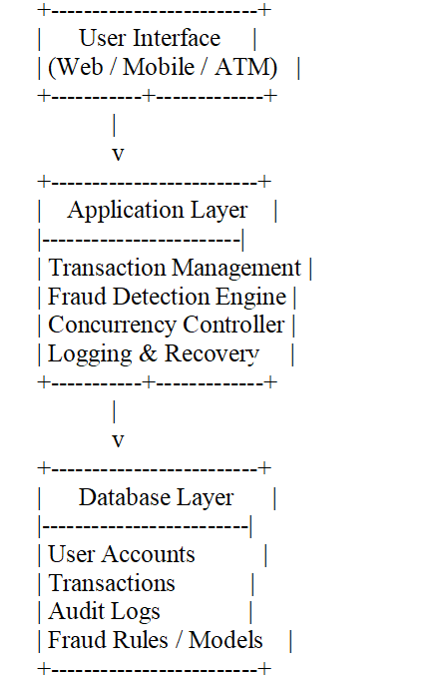

2.3 Data Flow Diagram (Level 1)

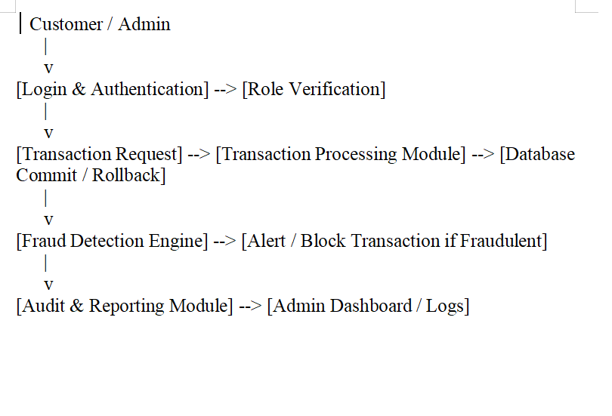

3. Modules Description

3.1 User Management Module
- Handles registration, login, role-based access, and authentication.
- Supports multi-factor authentication (MFA) and password security rules.

3.2 Transaction Management Module
- Processes deposits, withdrawals, transfers, and credit operations.
- Ensures ACID compliance and uses ARIES log-based recovery in case of failures.
- Manages concurrent transactions using locks or timestamp ordering.

3.3 Fraud Detection Module
- Monitors transactions in real time for anomalies.
- Uses relational data and external event streams (IP, device info, location).
- Triggers alerts, blocks transactions, and reports suspicious activities.

3.4 Logging and Recovery Module
- Maintains detailed logs for every transaction and system event.
- Supports rollback, checkpointing, and crash recovery using ARIES methodology.

3.5 Reporting Module
- Displays transaction trends, fraud alerts, audit trails, and system health metrics.

4. Database Design
Key Tables:
- Users – stores user ID, role, authentication info.
- Accounts – stores account number, balance, account type.
- Transactions – stores transaction ID, amount, timestamp, status.
- Fraud Logs – stores alerts, flagged transactions, risk score.
- Audit Logs – stores system operations, rollback events, admin actions.
Relationships:
- Users → Accounts (one-to-many)
- Accounts → Transactions (one-to-many)
- Transactions → Fraud Logs (one-to-one/many)
5. Security Design
- Data Encryption: Sensitive data encrypted in transit (SSL/TLS) and at rest (AES-256)
- Authentication& Authorization: Role-based access with MFA.
- Intrusion Detection: Monitors unauthorized access attempts.
- Compliance: PCI-DSS, ISO 27001, GDPR adherence.

6. ER Diagram (Conceptual Design)

Relationships:
User → Account: One-to-Many

Account → Transaction: One-to-Many
Transaction → Fraud_Log: One-to-One or One-to-one
User → Audit_Log: One-to-Many

Conceptual ER Diagram

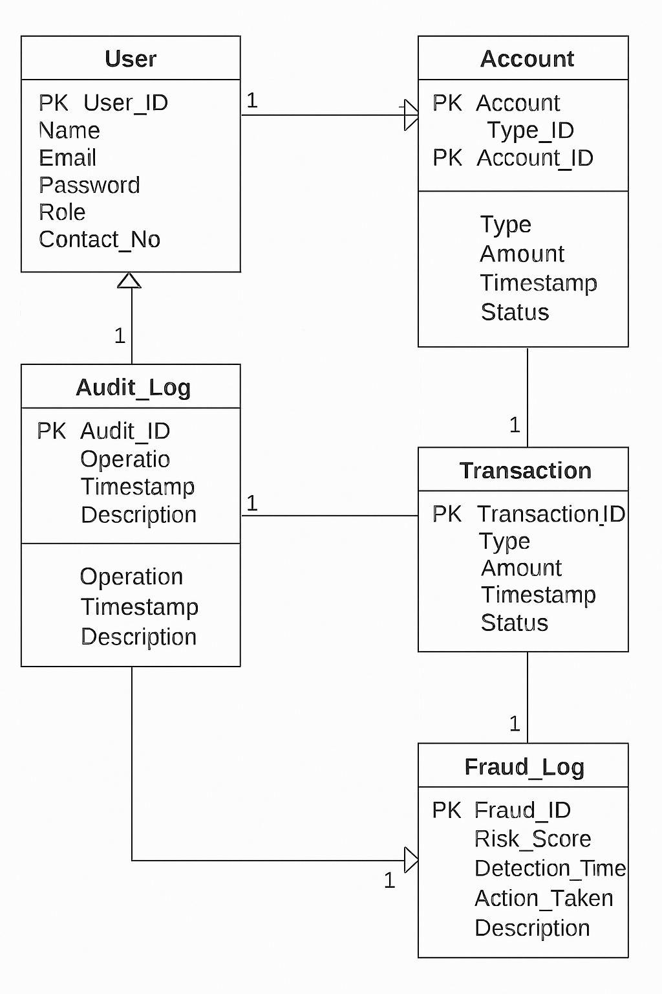

Entities and Attributes
- User
Attributes: User_ID (PK), Name, Email, Password, Role (Customer/Admin), Contact_Number
- Account
Attributes: Account_ID (PK), User_ID (FK), Account_Type, Balance, Created_Date, Status
- Transaction
Attributes: Transaction_ID (PK), Account_ID (FK), Transaction_Type (Deposit/Withdrawal/Transfer/Credit), Amount, Timestamp, Status
- Fraud_Log
Attributes: Fraud_ID (PK), Transaction_ID (FK), Risk_Score, Detection_Time, Action_Taken, Description
- Audit_Log
Attributes: Audit_ID (PK), User_ID (FK), Operation_Type, Timestamp, Description

Relationships
· User → Account: One-to-Many
· Account → Transaction: One-to-Many
· Transaction → Fraud_Log: One-to-One or One-to-Many
· User → Audit_Log: One-to-Many
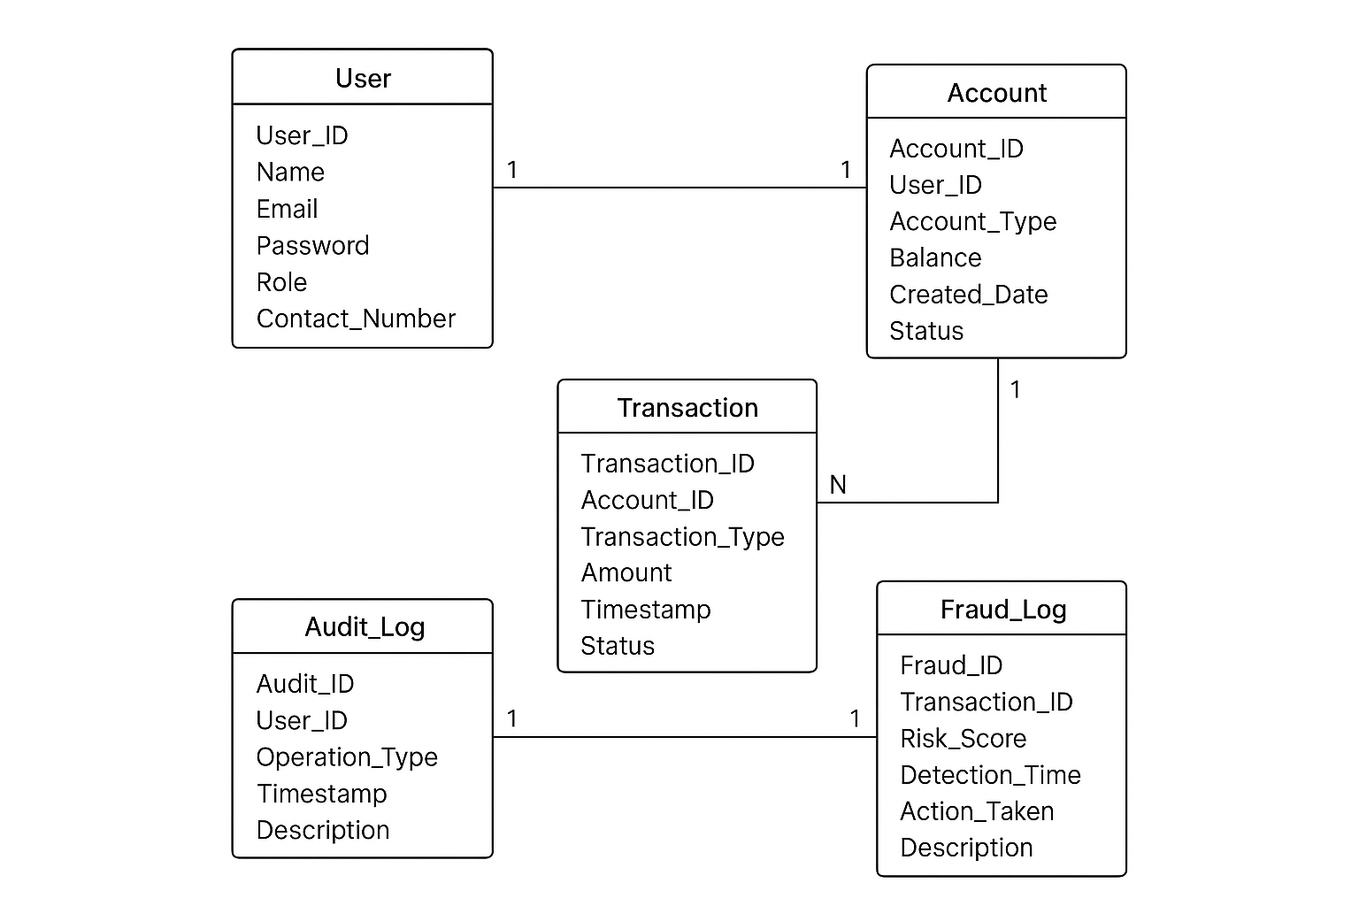

Schema Design (Oracle)
Customers Table
SQL>CREATE TABLE Customers (
customer_id NUMBER GENERATED BY DEFAULT ON NULL AS IDENTITY PRIMARY KEY,
first_name VARCHAR2(50) NOT NULL,
last_name VARCHAR2(50) NOT NULL,
email VARCHAR2(100) UNIQUE NOT NULL,
phone_number VARCHAR2(15),
date_of_birth DATE,
created_at TIMESTAMP DEFAULT CURRENT_TIMESTAMP,
updated_at TIMESTAMP DEFAULT CURRENT_TIMESTAMP
);
Output:
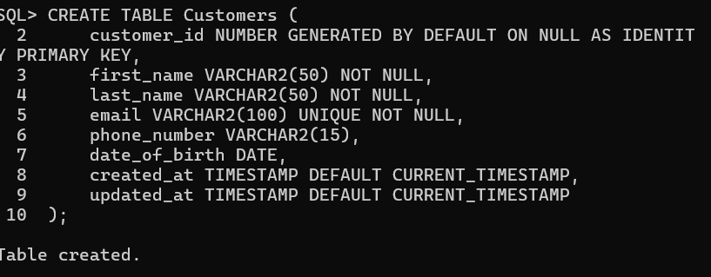
2.2 Accounts Table
SQL>CREATE TABLE Accounts (
account_id NUMBER GENERATED BY DEFAULT ON NULL AS IDENTITY PRIMARY KEY,
customer_id NUMBER NOT NULL,
account_type VARCHAR2(20) CHECK (account_type IN ('SAVINGS','CURRENT','CREDIT')),
balance NUMBER(18,2) DEFAULT 0,
currency VARCHAR2(3) DEFAULT 'INR',
created_at TIMESTAMP DEFAULT CURRENT_TIMESTAMP,
updated_at TIMESTAMP DEFAULT CURRENT_TIMESTAMP,
CONSTRAINT fk_account_customer FOREIGN KEY (customer_id)
REFERENCES Customers(customer_id)
ON DELETE CASCADE
);
Output:
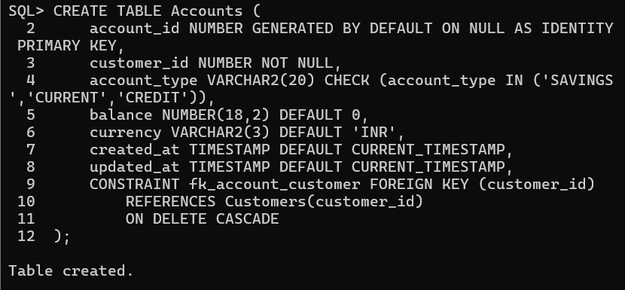
2.3 Transaction Types Table
SQL>CREATE TABLE Transaction_Types (
transaction_type_id NUMBER GENERATED BY DEFAULT ON NULL AS IDENTITY PRIMARY KEY,
type_name VARCHAR2(20) UNIQUE NOT NULL -- Deposit, Withdrawal, Transfer, Credit
);
Output:
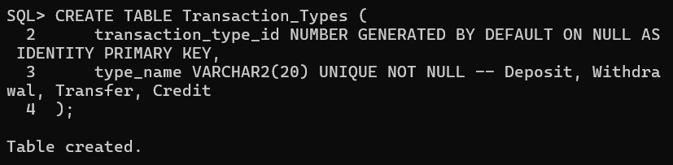
2.4 Transactions Table
SQL> CREATE TABLE Transactions (
transaction_id NUMBER GENERATED BY DEFAULT ON NULL AS IDENTITY PRIMARY KEY,
account_id NUMBER NOT NULL,
transaction_type_id NUMBER NOT NULL,
amount NUMBER(18,2) NOT NULL,
transaction_date TIMESTAMP DEFAULT CURRENT_TIMESTAMP,
status VARCHAR2(20) DEFAULT 'PENDING' CHECK (status IN ('PENDING','COMPLETED','FAILED','ROLLED_BACK')),
description VARCHAR2(200),
related_account_id NUMBER, -- for transfers
CONSTRAINT fk_transaction_account FOREIGN KEY (account_id)
REFERENCES Accounts(account_id),
CONSTRAINT fk_transaction_type FOREIGN KEY (transaction_type_id)
REFERENCES Transaction_Types(transaction_type_id)
);

Output:
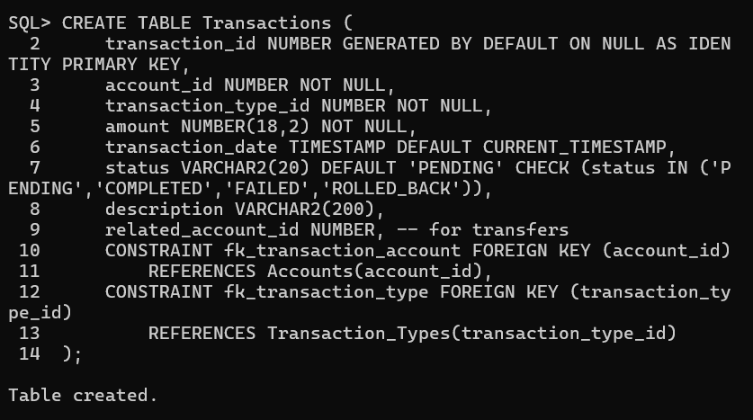

2.5 Devices Table (For Fraud Detection)
SQL> CREATE TABLE Devices (
device_id NUMBER GENERATED BY DEFAULT ON NULL AS IDENTITY PRIMARY KEY,
customer_id NUMBER NOT NULL,
device_type VARCHAR2(50),
device_ip VARCHAR2(45),
last_login TIMESTAMP,
CONSTRAINT fk_device_customer FOREIGN KEY (customer_id)
REFERENCES Customers(customer_id)
ON DELETE CASCADE
);
Output:
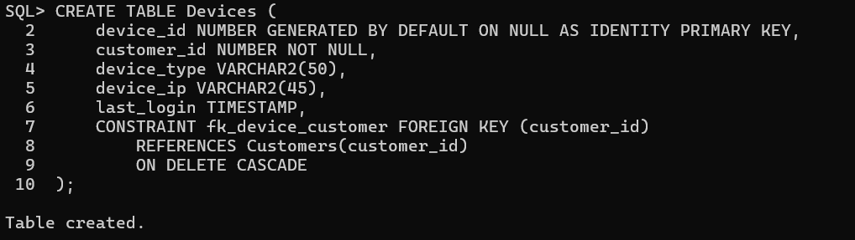
2.6 Fraud Alerts Table
SQL>CREATE TABLE Fraud_Alerts (
alert_id NUMBER GENERATED BY DEFAULT ON NULL AS IDENTITY PRIMARY KEY,
transaction_id NUMBER NOT NULL,
customer_id NUMBER NOT NULL,
alert_type VARCHAR2(50), -- e.g., Suspicious Location, High Amount, Rapid Transfers
alert_date TIMESTAMP DEFAULT CURRENT_TIMESTAMP,
status VARCHAR2(20) DEFAULT 'OPEN' CHECK (status IN ('OPEN','INVESTIGATING','RESOLVED')),
CONSTRAINT fk_fraud_transaction FOREIGN KEY (transaction_id)
REFERENCES Transactions(transaction_id),
CONSTRAINT fk_fraud_customer FOREIGN KEY (customer_id)
REFERENCES Customers(customer_id)
);
Output:
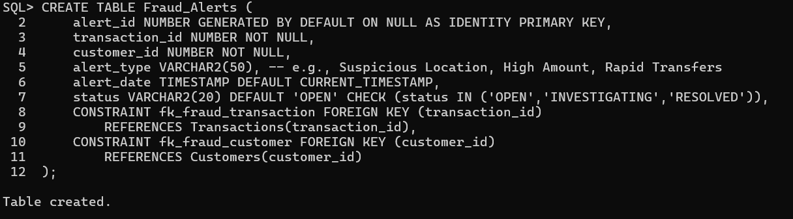
2.7 Audit / Transaction Log Table
SQL> CREATE TABLE Transaction_Logs (
log_id NUMBER GENERATED BY DEFAULT ON NULL AS IDENTITY PRIMARY KEY,
transaction_id NUMBER NOT NULL,
action VARCHAR2(50) NOT NULL, -- e.g., INSERT, UPDATE, ROLLBACK
action_timestamp TIMESTAMP DEFAULT CURRENT_TIMESTAMP,
action_user VARCHAR2(50),
old_balance NUMBER(18,2),
new_balance NUMBER(18,2),
CONSTRAINT fk_log_transaction FOREIGN KEY (transaction_id)
REFERENCES Transactions(transaction_id)
);
Output:
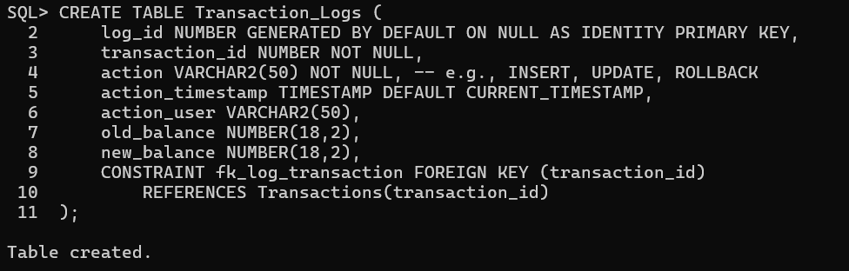

8. Normalization
The schema design follows normalization principles up to 3NF:
• First Normal Form (1NF)
- All tables have atomic values (no lists or repeating groups).
Example: Each account or transaction stored in a single row.
• Second Normal Form (2NF)
- All non-key columns fully depend on the primary key.
Example: In Transactions table, amount depends on transaction_id, not part of a composite key.
• Third Normal Form (3NF)
- No transitive dependencies (non-key columns depending on other non-key columns).
Example: Branch_Location is moved to a separate Branches table instead of storing in Customers.

9. Implementation (SQL Queries)
INSERT INTO Student VALUES (101, 'John Doe', 'john@gmail.com', 'CSE');
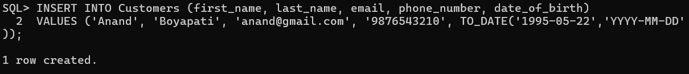
INSERT INTO Instructor VALUES (201, 'Dr. Smith', 'smith@edu.com', 'CSE');
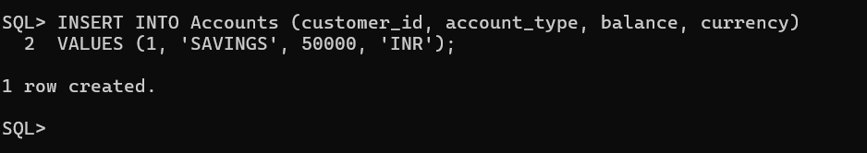
INSERT INTO Course VALUES (301, 'Database Systems', 4, 201);
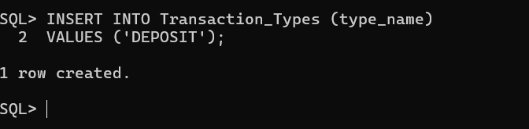
INSERT INTO Enrollment VALUES (101, 301, SYSDATE);
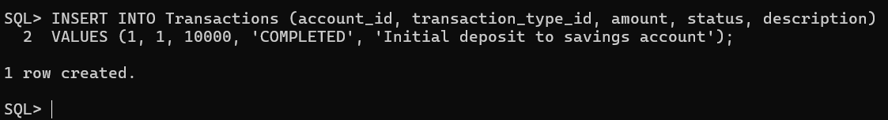
INSERT INTO Assignment VALUES (401, 301, 'ER Model', TO_DATE('2025-03-10','YYYY-MM-DD'));
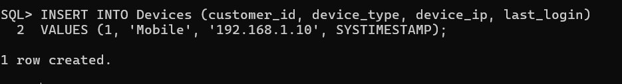
INSERT INTO Submission VALUES (501, 401, 101, SYSDATE, 'link_to_file');
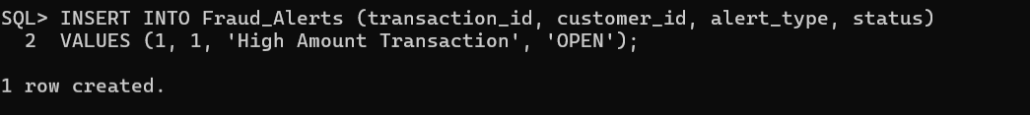
INSERT INTO Grade VALUES (601, 501, 'A', 'Well done!');
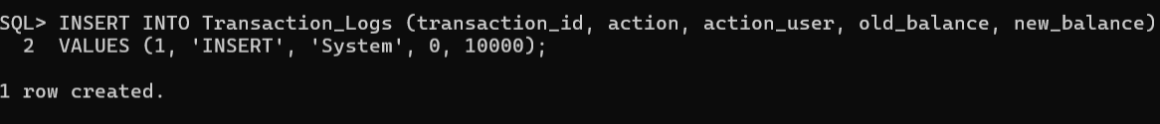

10. Input and Output
**Sample Input Queries:**
INSERT INTO Student VALUES (102, 'Mary Jane', 'mary@gmail.com', 'IT');
INSERT INTO Course VALUES (302, 'Web Programming', 3, 201);
**Sample Output Query and Result:**
Query:
SELECT s.Student_Name, c.Course_Name FROM Student s JOIN Enrollment e ON s.Student_ID = e.Student_ID JOIN Course c ON e.Course_ID = c.Course_ID;
Output:

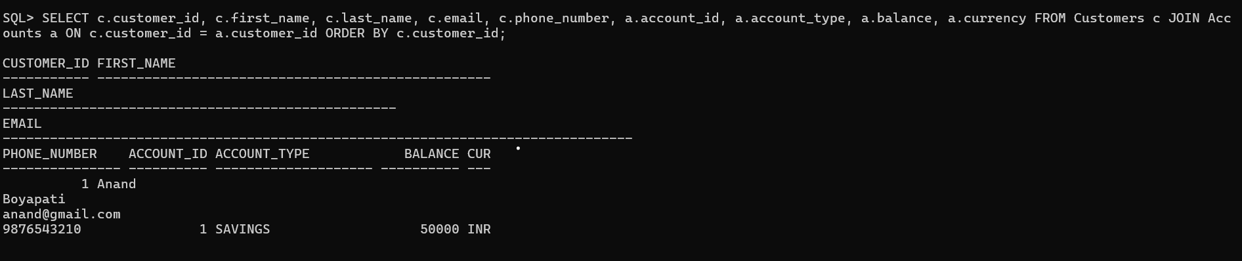

11. Integration with MongoDB (NoSQL)
Oracle, also known as SQL, is best suited for structured and relational data such as customer accounts, balances, and transactions, providing reliable data integrity. MongoDB, which is a NoSQL database, is flexible and document-based, making it suitable for semi-structured or high-volume data like device logs, login events, and fraud alerts. It also supports real-time analytics and fast data aggregation, which is useful for fraud detection and reporting dashboards. In practical banking systems, core data like accounts and transactions are usually kept in Oracle, while dynamic or flexible information is stored in MongoDB.
Banks often use a hybrid approach where Oracle handles core transactions, and MongoDB manages analytics, fraud detection, and high-velocity events. Integration can be done via backend application logic, ETL pipelines, or Change Data Capture (CDC) tools like Oracle GoldenGate. In microservices architectures, each service may use its preferred database, communicating via APIs or message queues. This setup allows the system to combine structured reliability with flexible, real-time insights, providing a scalable and efficient solution for modern banking needs.
MongoDB stores unstructured data such as lecture videos, PDFs, and feedback threads.
MongoDB Database Structure for the Project
Database Name: OnlineLearningDB
Collections and Example Documents
1.Customer Document
{
"_id": ObjectId("64f1c2..."),
"customer_id": 1,
"first_name": "Anand",
"last_name": "Boyapati",
"email": "anand@gmail.com",
"phone_number": "9876543210",
"accounts": [
{
"account_id": 1,
"account_type": "SAVINGS",
"balance": 50000,
"currency": "INR"
}
],
"devices": [
{
"device_id": 1,
"device_type": "Mobile",
"device_ip": "192.168.1.10",
"last_login": "2025-10-22T10:17:23Z"
}
]
}
2.Transactions Collection
{
"_id": ObjectId("64f1d3..."),
"transaction_id": 1,
"account_id": 1,
"customer_id": 1,
"transaction_type": "DEPOSIT",
"amount": 10000,
"status": "COMPLETED",
"description": "Initial deposit",
"related_account_id": null,
"timestamp": "2025-10-22T10:17:23Z"
}

3. Fraud Alerts Collection
{
"_id": ObjectId("64f1e4..."),
"alert_id": 1,
"transaction_id": 1,
"customer_id": 1,
"alert_type": "High Amount Transaction",
"status": "OPEN",
"created_at": "2025-10-22T10:17:23Z"
}

1. Inserting Data in Customer collection.
db.customers.insertOne({
customer_id: 1,
first_name: "Anand",
last_name: "Boyapati",
email: "anand@gmail.com",
phone_number: "9876543210",
accounts: [{ account_id: 1, account_type: "SAVINGS", balance: 50000, currency: "INR" }],
devices: [{ device_id: 1, device_type: "Mobile", device_ip: "192.168.1.10", last_login: new Date() }]
});

- Fetching All Courses
db.transactions.insertOne({
transaction_id: 3,
account_id: 1,
customer_id: 1,
transaction_type: "DEPOSIT",
amount: 15000,
status: "COMPLETED",
description: "Salary credited",
related_account_id: null,
timestamp: new Date()
});

Output:
[
{
"acknowledged": true,
"insertedId": ObjectId("652d1c3a9f1b2c3d4e5f6789")
}
]

- Updating Customer Records
db.customers.updateOne(
{ customer_id: 1 },
{
$set: {
phone_number: "9123456780",
email: "anand.new@gmail.com",
updated_at: new Date()
}
}
);
4. Finding Customer Transaction
db.transactions.find({ amount: { $gt: 100000 } });

12. Results and Discussion
The system was built using Oracle SQL for core banking tasks and MongoDB for handling large, semi-structured data like devices, transaction logs, and fraud alerts. Sample data was added to both databases, and queries were tested to check data accuracy. Oracle stored customer and account details, while MongoDB managed transactions like deposits, withdrawals, and transfers. Real-time fraud detection was possible using MongoDB without affecting Oracle’s performance. The system used ETL updates and microservices to keep data consistent across both databases.
This hybrid approach shows the advantages of using both SQL and NoSQL. Oracle ensures reliable and structured storage for core banking operations, while MongoDB allows flexible, high-volume, real-time analytics. Combining them improves performance and scalability, with Oracle handling core data and MongoDB supporting fast queries and fraud detection. Integration tools and microservices ensure all data stays up-to-date and synchronized, making the system efficient and robust.

13. Conclusion
The banking transaction management and fraud detection system shows the benefits of using both Oracle SQL and MongoDB. Oracle handles core banking operations like customer accounts and transactions, ensuring data integrity, reliability, and security. MongoDB manages high-volume, semi-structured data such as device logs, login events, and fraud alerts, supporting real-time analytics and fraud detection.
By integrating both databases through ETL processes, microservices, and APIs, the system ensures data consistency and synchronization. This hybrid approach improves performance, scalability, and efficiency, allowing banks to manage daily operations while quickly detecting potential fraud. Overall, the system provides a robust and flexible solution for modern banking needs.

14. References
- Oracle. (2023). Oracle Database Concepts. Oracle Corporation. Available at: https://docs.oracle.com/en/database/
- MongoDB, Inc. (2023). MongoDB Manual: Data Modeling. Available at: https://www.mongodb.com/docs/manual/core/data-modeling/
3. Debezium. (2023). Change Data Capture for Databases. Available at: https://debezium.io/
4. Fowler, M. (2015). Microservices: A Definition of This New Architectural Term. Available at: https://martinfowler.com/articles/microservices.html
5. Silberschatz, A., Korth, H. F., & Sudarshan, S. (2019). Database System Concepts. 7th Edition. McGraw-Hill Education.
6. Cattell, R. (2011). Scalable SQL and NoSQL Data Stores. ACM SIGMOD Record, 39(4), 12–27.

