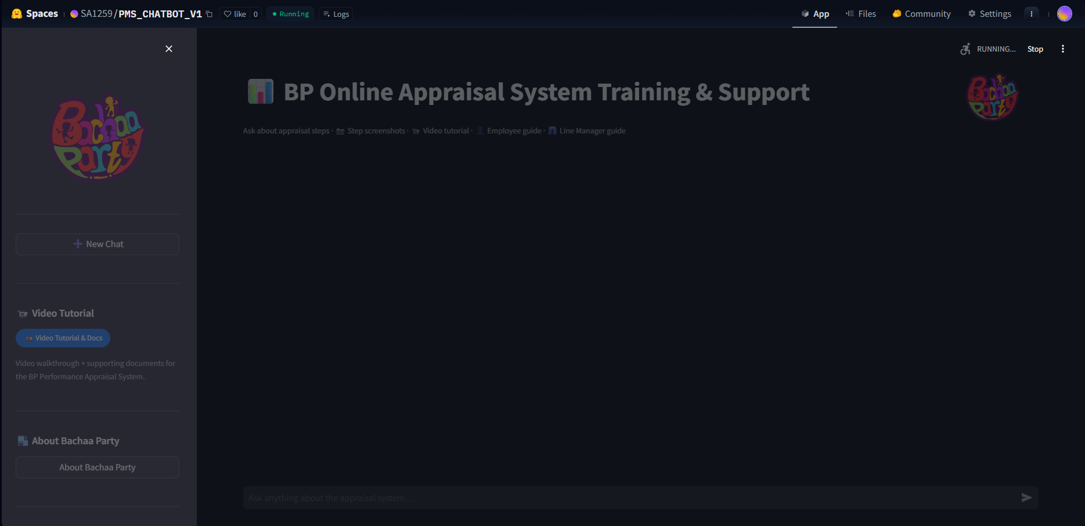

Streamlit is currently, connecting non stop even after 1 hr, due to this chatbot is reloading ,
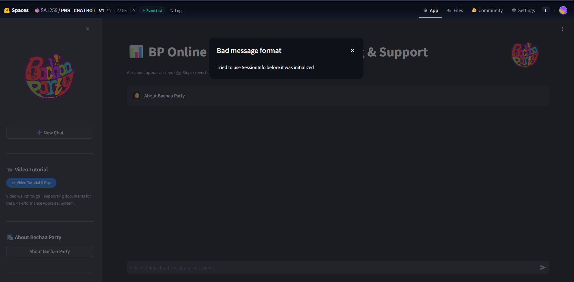
Giving prompt during connecting results in this error,
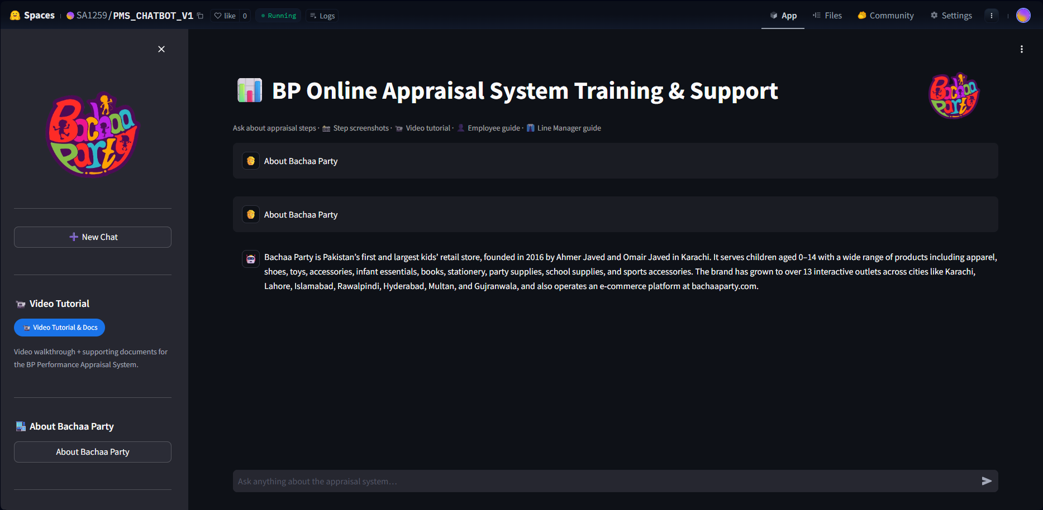

After that the chatbot works fine and perfectly till the next space reload/build.

