BP Performance Appraisal System
Employee Guideline & Tutorial
Goals Input & Self Evaluation | HRMS

Contents
1. Purpose & Scope 3
2. System Overview 3
3. How to Log In 4
4. Entering Your Goals 4
Step 1: Navigate to Performance 4
Step 2: Open Objective-KPI Request 5
Step 3: Add a New KPI 5
Step 4: Record Your Individual Goal 6
Step 5: Add Remaining Goals 6
Step 6: Edit Goals Before Submission 7
Step 7: Send Request for Approval 7
Step 8: Confirm Submission 8
5. Submitting Goals for Approval 8
Step 9: Notification of Approval 8
6. Completing Your Self Evaluation 9
Step 10: Open Your Evaluation 9
Step 11: Rate Yourself on Each Goal 9
Step 12: Rate Yourself on Company Core Values 10
Step 13: Submit Performance Evaluation 10
7. Do's and Don'ts 11

1. Purpose & Scope
This SOP guides employees through using the BP Performance Appraisal System — from entering goals to completing their self evaluation. Following these steps ensures your appraisal is submitted accurately and on time.

Scope:
- All permanent employees subject to the annual appraisal cycle.
- Covers: Login → Goals Input & Submission → Self Evaluation & Form Submission.

2. System Overview
The BP Performance Appraisal System is a seven-step cycle. As an employee, you are responsible for Steps 2 and 4.

Step | Stage | Description
1 | Login | Access the system using your company credentials.
2 | Goals Input & Submission | Enter your goals and submit for approval.
3 | Goals Approval | HR reviews and approves submitted goals (Phase 1).
4 | Self Evaluation & Form Submission | Rate yourself on each goal and company values, add comments, and submit.
5 | Line Manager Appraisal & Rating | Line Manager / HOD conduct appraisal meeting, reviews self-evaluation, adds their own rating and comments.
6 | Reviews Auto Submitted to HR | Completed appraisals are automatically submitted to HR.
7 | Reports Available | Reports are accessible to employees and their line manager/HOD.

📝 Each step is time-bound. HR will communicate deadlines for each phase. Missing a deadline may delay your appraisal or increment review.

SECTION 1 — LOGIN

3. How to Log In
- Open the system. Go to the HRMS URL: https://bachaaparty.flowhcm.com. Use a desktop browser for best experience (Chrome or Edge recommended).

- Enter your credentials. Type your Employee ID and password provided by HR.

- Click 'Login' or press Enter. You will be taken to your personal dashboard.

- Verify your profile. Check that your name, department, and line manager are correctly displayed under "My Info" on the dashboard.

📝 If you cannot log in or your profile details are incorrect, contact HR immediately before proceeding.

SECTION 2 — GOALS INPUT & SUBMISSION

4. Entering Your Goals
Goals are the specific targets, objectives, or KPIs you will be evaluated against during this appraisal cycle. You must enter all goals in the system before the deadline communicated by HR.

Step 1: Navigate to Performance
- From your dashboard, click Others in the top navigation bar, then select Performance from the dropdown menu.
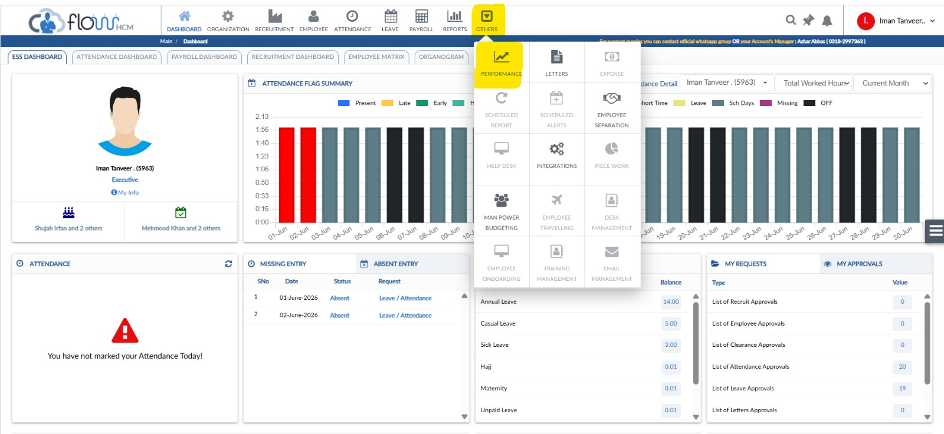
Step 1: Click ‘Others’ then ‘Performance’ from the dashboard

Step 2: Open Objective-KPI Request
- Click on Evaluations in the left sidebar. In the Action column of your evaluation record, click the dropdown arrow and select Objective-KPI Request.
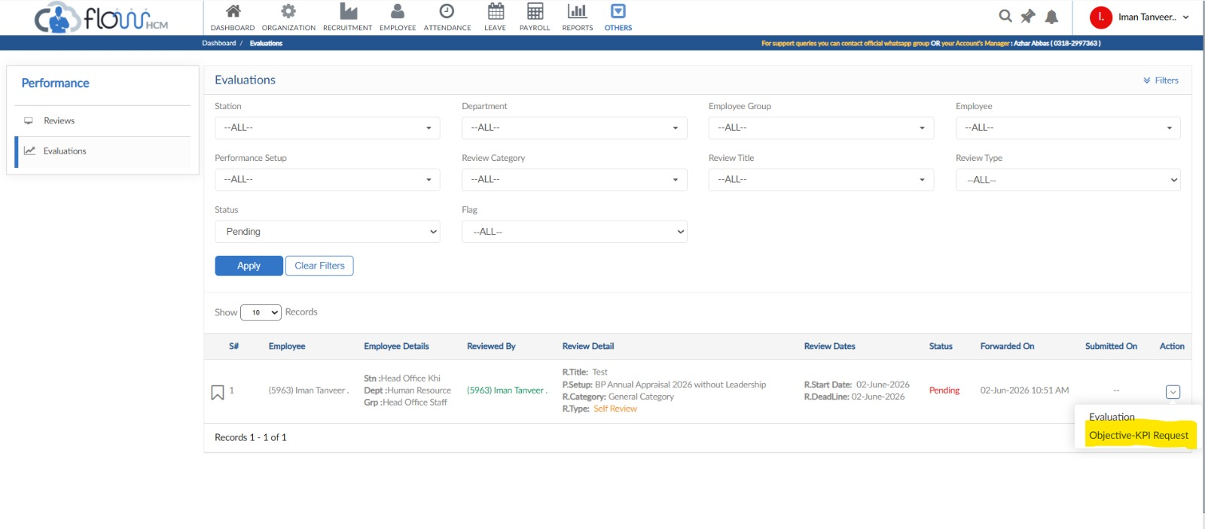
Step 2: Go to Evaluations and select ‘Objective-KPI Request’ from the Action dropdown

Step 3: Add a New KPI
- The Performance Request screen will open, showing Objective: Goals (80%). Click the +New KPI button to begin adding your first goal.
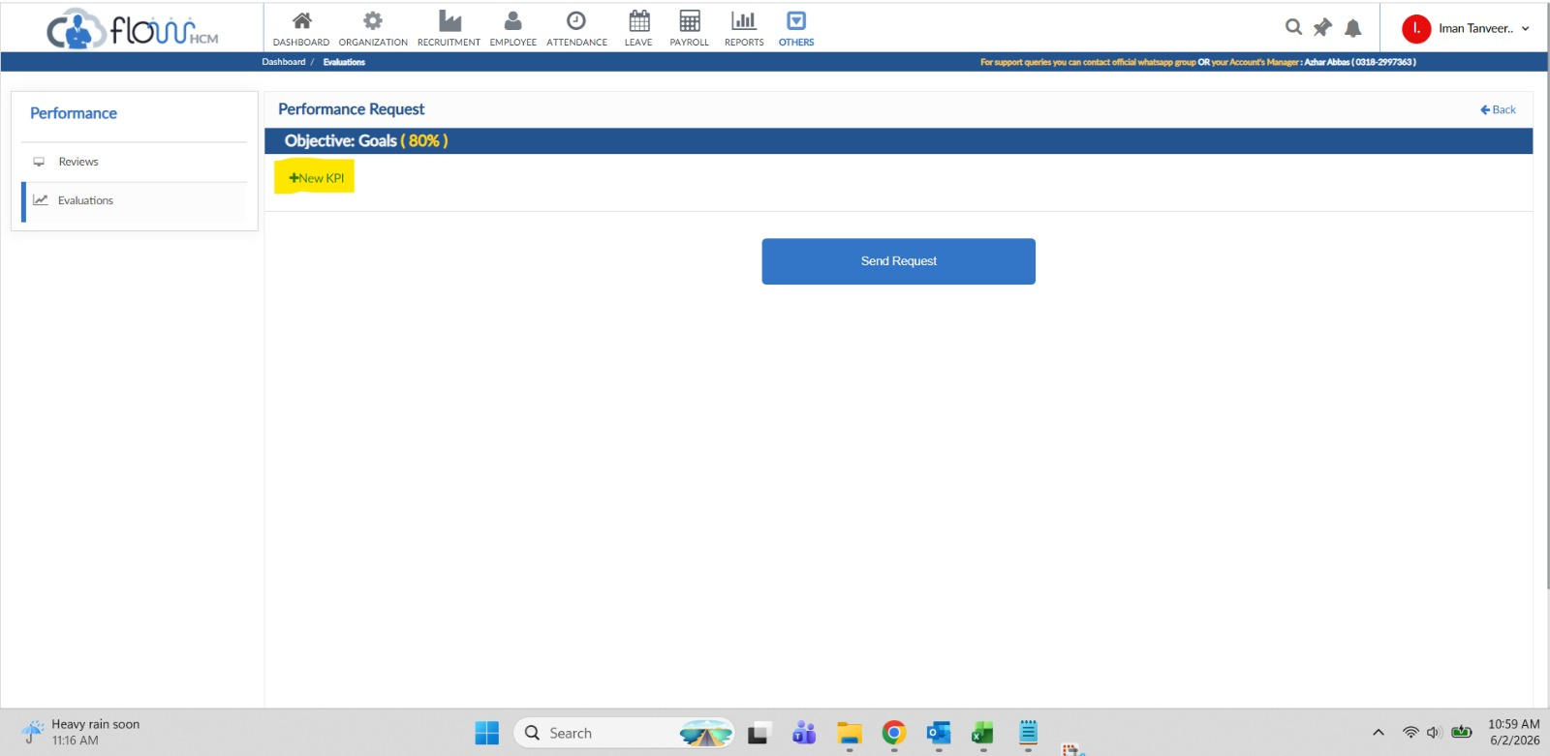
Step 3: Click ‘+New KPI’ to add a goal

Step 4: Record Your Individual Goal
- The form will expand. Fill in the KPI Type, KPI Title (a clear, concise goal title), KPI Details (brief explanation of the goal and how it will be measured), and Weightage (%) for this KPI.
- Once filled, click Add KPI to save the entry.
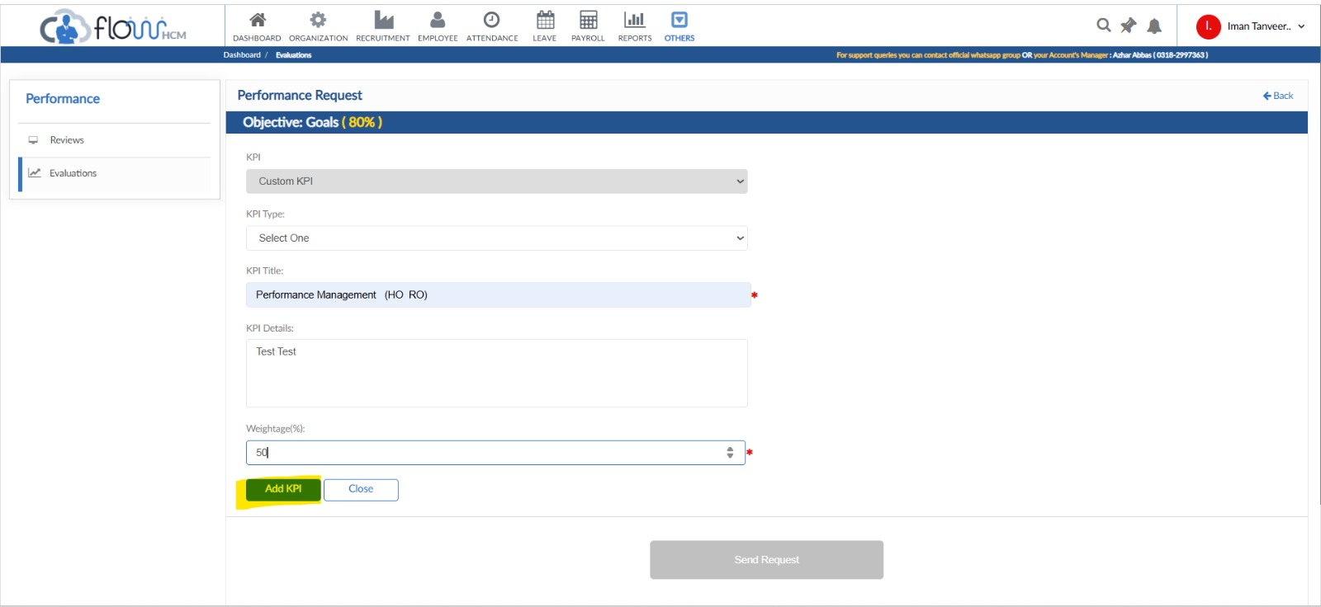
Step 4: Fill in KPI details and click ‘Add KPI’

Step 5: Add Remaining Goals
- Repeat the same process — click +New KPI, fill in the details, and click Add KPI — for each remaining goal until all your goals for the appraisal cycle are entered. Ensure all weightages add up to 100%.
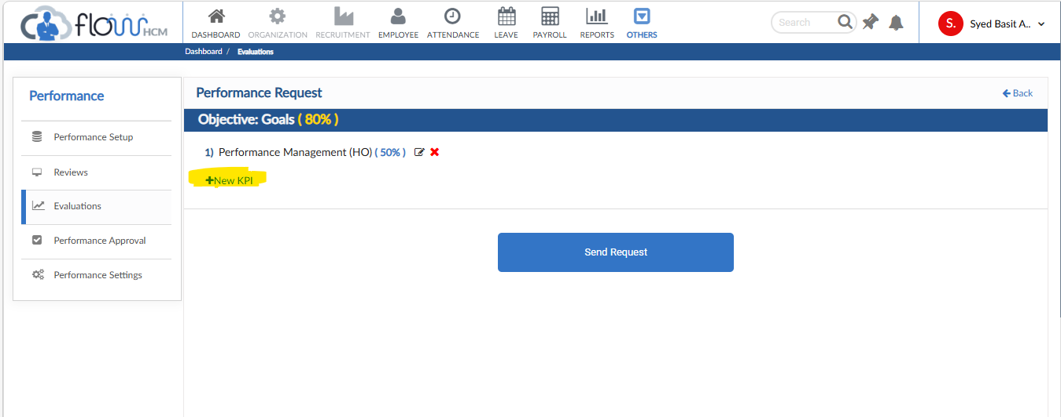
Step 5: Continue adding goals until all KPIs are recorded

Step 6: Edit Goals Before Submission
- Before submitting, employees can review their recorded goals. Click the Edit icon (yellow) next to any goal to make changes, or the red × to remove it. Once satisfied, click "Send Request" to submit.
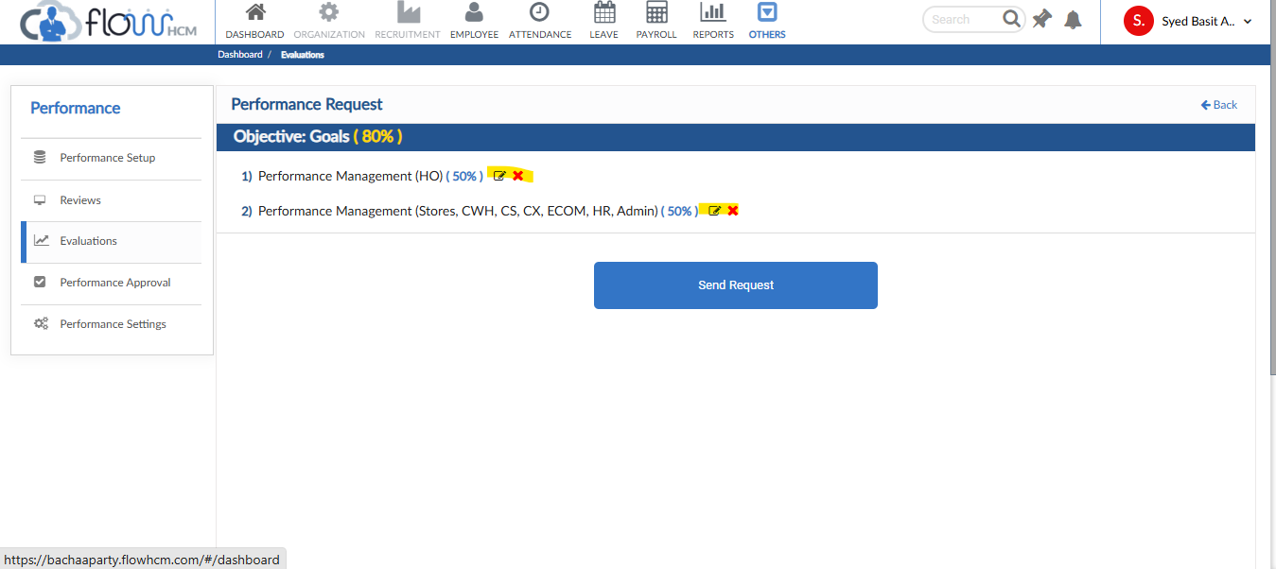
Step 6: Edit Goals

Step 7: Send Request for Approval
- Once all goals are entered and reviewed, click Send Request at the bottom of the page to submit your goals for Line Manager / HR approval.
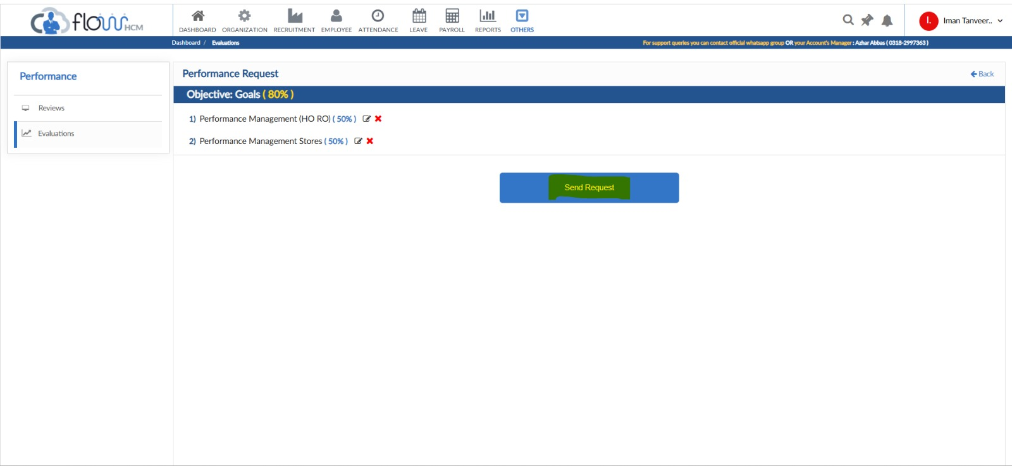
Step 7: Click ‘Send Request’ after recording all goals

Step 8: Confirm Submission
- Your request will be generated and the status will change to Pending Approval. The KPI request will be sent to your Line Manager for review.
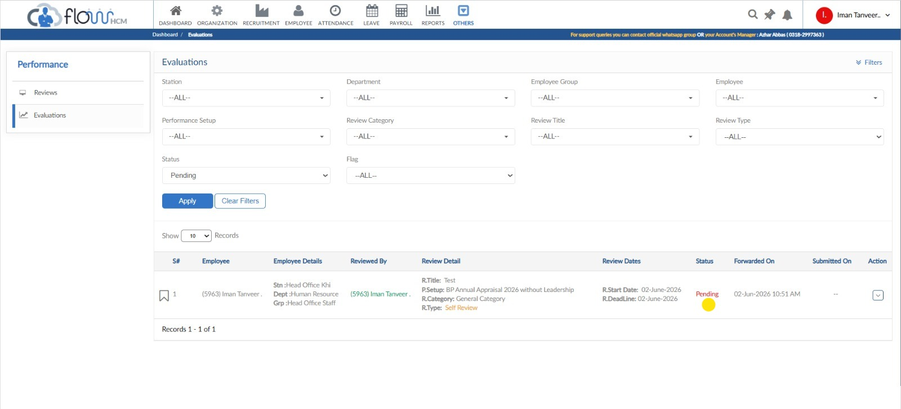
Step 8: Request generated and awaiting Line Manager approval

5. Submitting Goals for Approval
Once all goals are entered and reviewed, you must submit them for approval. Evaluations are not active until approved.

⚠ ⚠ Important: Once submitted, you cannot edit your goals unless HR or your Line Manager sends them back for revision. Do not submit until you are satisfied with all entries.
📝 Phase 1 (this year): Goals will be reviewed and approved by HR.
Phase 2 (next year onwards): Line Managers will approve goals directly.

Step 9: Notification of Approval
- After your Line Manager approves your KPI request, you will receive a notification on the Bell icon in the top navigation bar. Click it to view the approval message.
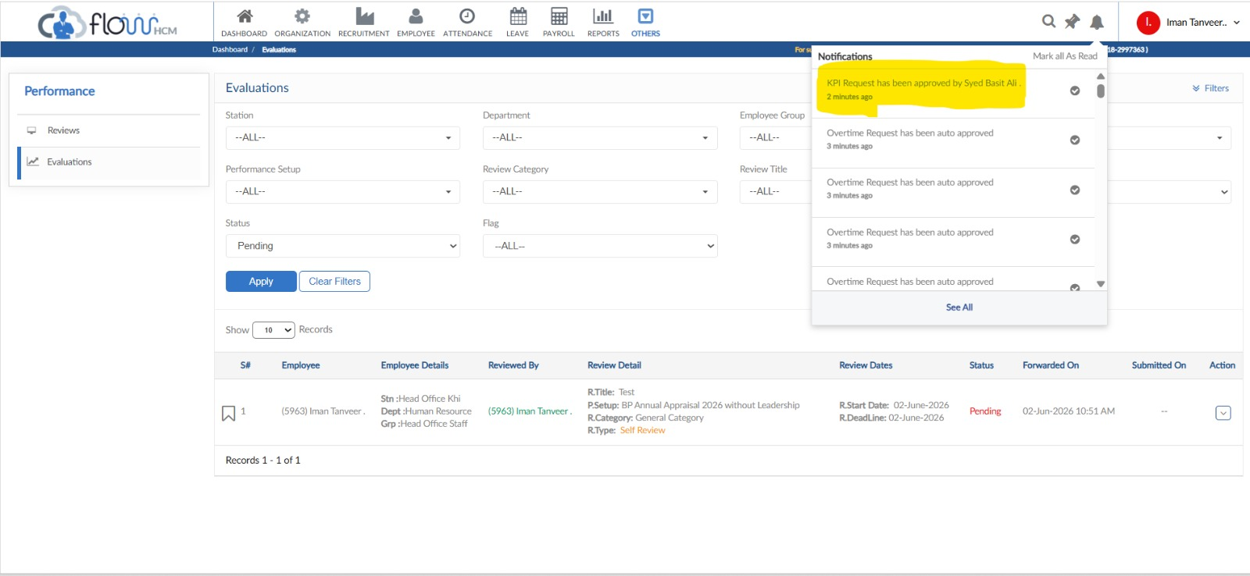
Step 9: Bell icon notification confirms KPI approval by Line Manager

SECTION 3 — SELF EVALUATION & FORM SUBMISSION

6. Completing Your Self Evaluation
After goals are approved and the self-evaluation window opens (HRMS will notify you), you must evaluate your own performance against each goal and against the company values. This is your opportunity to reflect on your achievements and provide supporting comments.

Step 10: Open Your Evaluation
- Go to Others → Performance → Evaluations. In the Action column for your evaluation record, click the dropdown and select Evaluation.
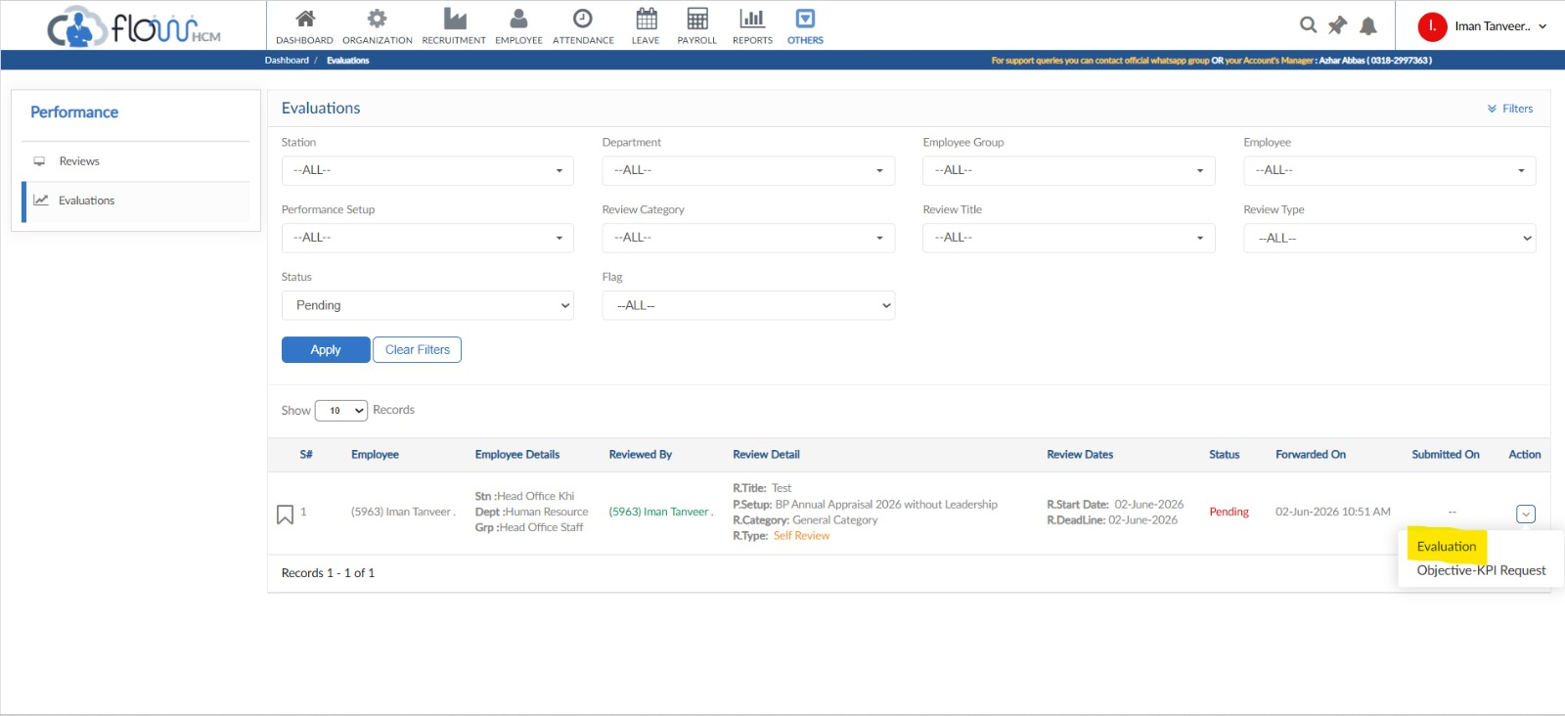
Step 10: Select ‘Evaluation’ from the Action dropdown

Step 11: Rate Yourself on Each Goal
- The evaluation form will open showing your approved goals. For each KPI under Objective #1: Goals (Weightage: 80%), enter your self-assessment percentage in the input field and add a comment explaining your performance.
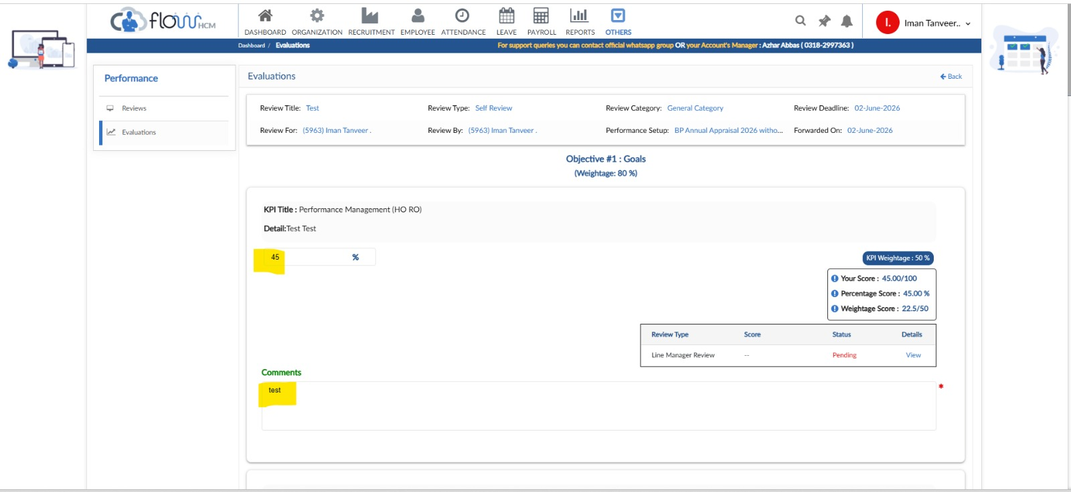
Step 11: Enter percentage score against each goal and add supporting comments

Step 12: Rate Yourself on Company Core Values
- Scroll down to Objective #2: Company Core Values (Weightage: 20%). Enter your rating percentage, and if applicable, add a grace percentage. Add comments to support your rating on each value.
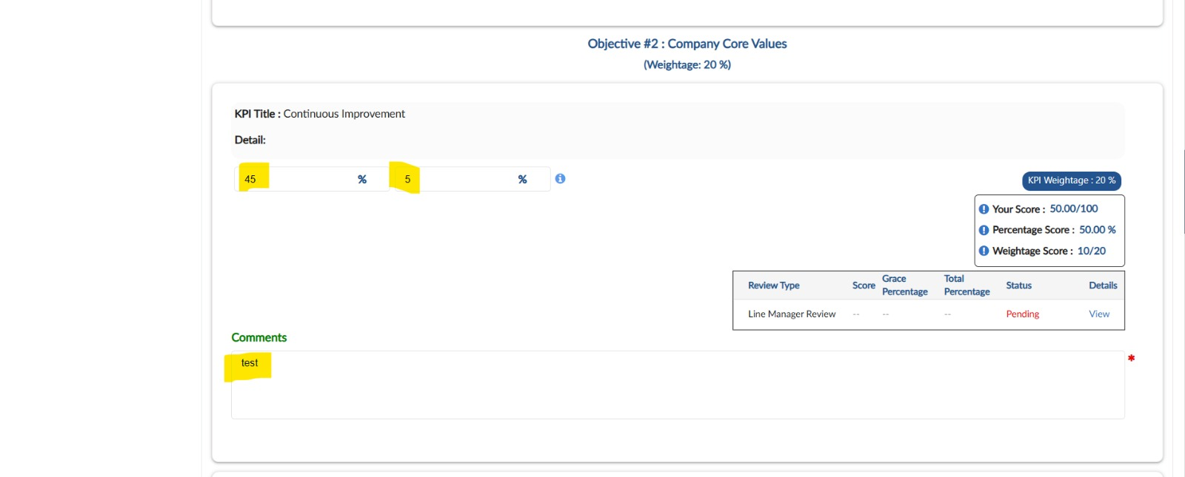
Step 12: Rate yourself on Company Core Values and optionally add grace percentage

Step 13: Submit Performance Evaluation
- Scroll to the bottom of the form. Review your self-weightage scores for both Goals and Company Core Values. Add any feedback for your manager in the Feedback to Manager text box, then click Submit Performance Evaluation.
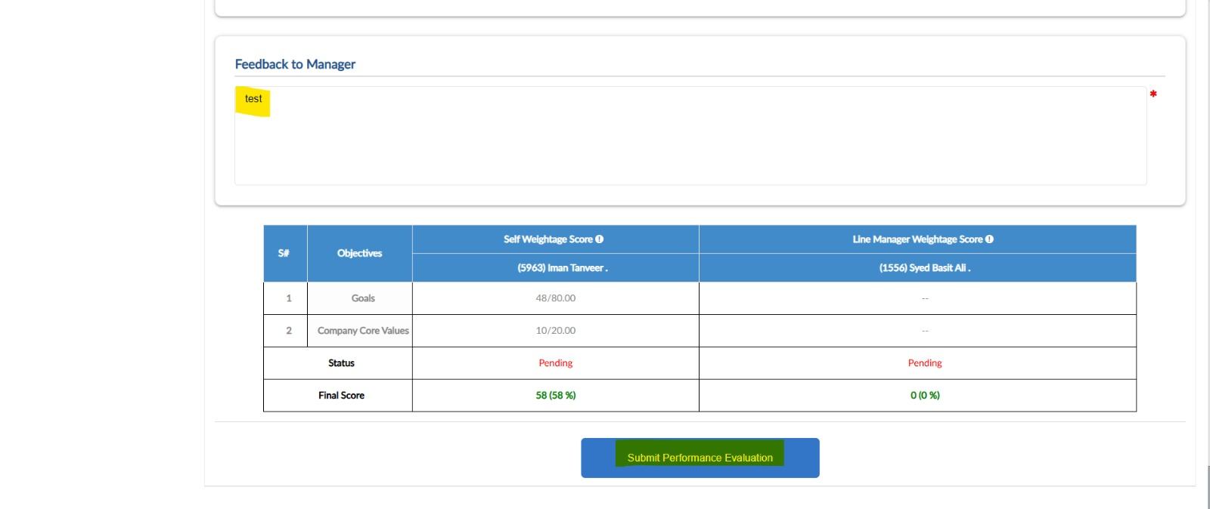
Step 13: Review scores, add feedback, and click ‘Submit Performance Evaluation’

7. Do's and Don'ts

✔ Do | ✘ Don't
Submit goals before the deadline. | Don't wait until the last day.
Be honest and objective in your self-evaluation. | Don't inflate ratings without supporting comments.
Add meaningful comments to support your ratings. | Don't leave comment boxes empty.
Verify all goals and ratings before submitting. | Don't submit the form without reviewing all entries.
Contact HR if you face any system issues. | Don't ignore system errors — report them promptly.

