BP Online Appraisal System
Line Manager Guideline & Tutorial
Rating Subordinate Appraisals | HRMS

Document | BP Online Appraisal System — Line Manager SOP
Audience | Line Managers / Heads of Department (HODs)
System | FlowHCM — bachaaparty.flowhcm.com
Prepared by | HR Department

Table of Contents
1. Purpose & Scope 3
2. System Overview 3
3. How to Log In 4
4. Rating Pending Subordinate Appraisals 5
Step 1: Navigate to Performance 5
Step 2: Open Evaluations & Identify Pending Records 6
Step 3: Open the Action Menu & Select Evaluation 7
Step 4: Review Form Header & Employee Details 8
Step 5: Enter Your Rating for Each Goal 9
Step 6: Add a Comment for Each Goal 10
Step 7: Rate Company Core Values (Objective #2) 11
Step 8: Review Summary & Submit 12
5. Editing a Completed Appraisal 13
Step 9: Go to Evaluations & Filter by Completed 13
Step 10: Select 'Edit' from the Action Dropdown 14
Step 11: Update Rating or Comment 15
Step 12: Save Changes with 'Update Performance Evaluation' 16

1. Purpose & Scope
This guideline walks Line Managers through their responsibilities in the BP Performance Appraisal System. It covers how to rate your subordinates' appraisal forms and, if needed, how to edit a rating or comment after a form has already been submitted.

Scope:
- All Line Managers / HODs responsible for conducting subordinate performance reviews.
- Covers: Login → Accessing Pending Evaluations → Entering Ratings & Comments → Submitting → (Optional) Editing Completed Forms.

2. System Overview
The BP Performance Appraisal System is a seven-step cycle. As a Line Manager, you are responsible for Step 5.

Step | Stage | Description
1 | Login | Access the system using your company credentials.
2 | Goals Input & Submission | Employee enters goals and submits for approval.
3 | Goals Approval | HR reviews and approves submitted goals (Phase 1).
4 | Self Evaluation & Submission | Employee rates themselves on goals and company values, adds comments, and submits.
5 | Line Manager Appraisal & Rating | YOU review the employee's self-evaluation, enter your own rating and comments, and submit. (Your responsibility)
6 | Auto Submitted to HR | Completed appraisals are automatically forwarded to HR.
7 | Reports Available | Reports accessible to employees and their line manager/HOD.

📝 Each step is time bound. HR will communicate deadlines for each phase. Missing a deadline may delay your team's appraisal processing.

SECTION 1 — LOGIN

3. How to Log In
- Open the system. Go to: https://bachaaparty.flowhcm.com. Use a desktop browser for best experience (Chrome or Edge recommended).
- Enter your credentials. Type your Employee ID and password provided by HR.
- Click 'Log In'. You will be taken to your personal dashboard.

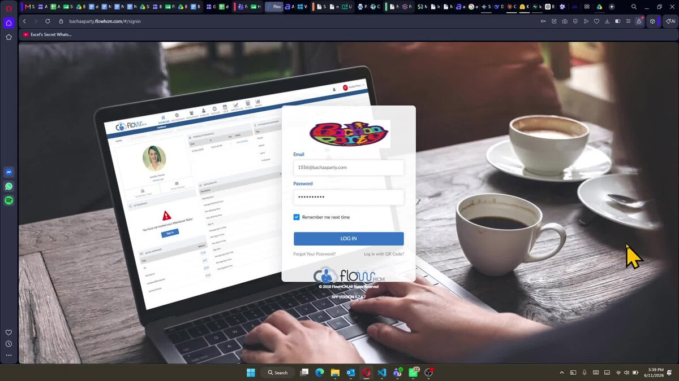
Step 1: Log in with your Employee ID and password at bachaaparty.flowhcm.com

📝 If you cannot log in or your profile details are incorrect, contact HR immediately before proceeding.

SECTION 2 — RATING PENDING SUBORDINATE APPRAISALS

4. Rating Pending Subordinate Appraisals
Once an employee has submitted their self-evaluation form, it will appear in your Evaluations list as a Pending record: Line Manager Review. You must enter your own rating and comments for each KPI before the HR deadline.

Step 1: Navigate to Performance
- From your dashboard, click Others in the top navigation bar, then select Performance from the dropdown menu.

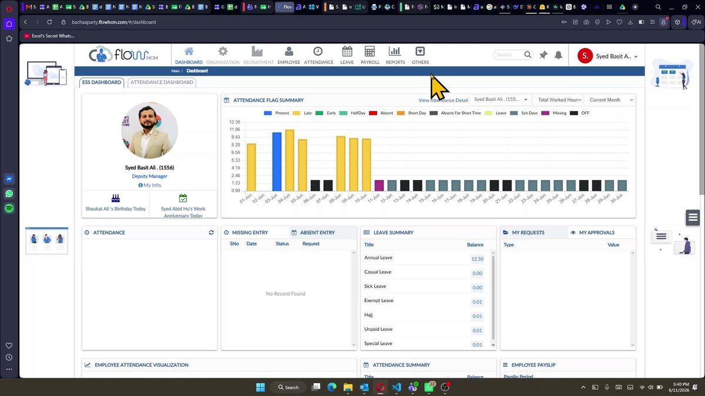
Step 1: Your dashboard after login — click 'Others' in the top navigation bar

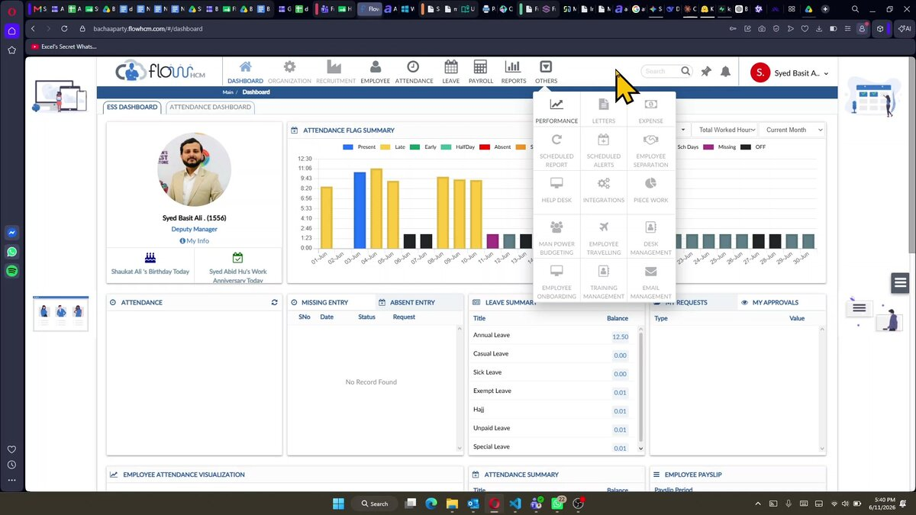
Step 1: Click 'Others' → select 'Performance' from the dropdown menu

Step 2: Open Evaluations & Identify Pending Records
- Click on Evaluations in the left sidebar under Performance. The system will show your evaluations list with Status defaulting to Pending.
- Each row shows the employee’s name, department, review title, review dates, and status.

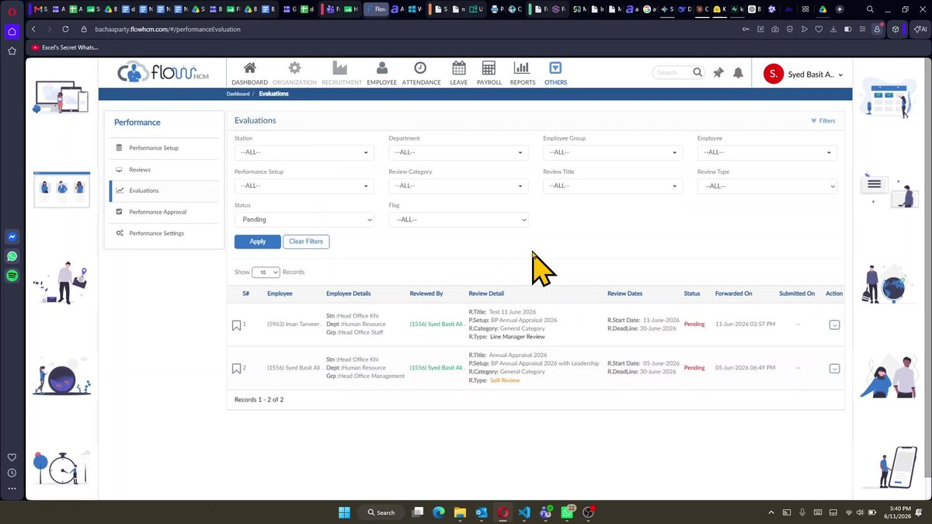

Step 2: Evaluations list — Status: Pending, identify records with Status: Line Manager Review

📝 If no records appear, check that the Status filter is set to 'Pending'. Only forms submitted by the employee will appear here.

Step 3: Open the Action Menu & Select Evaluation
- In the Action column on the right side of the record, click the small dropdown arrow (▼) next to the subordinate's pending evaluation.
- A menu will appear. Select Evaluation to open the appraisal form for rating.

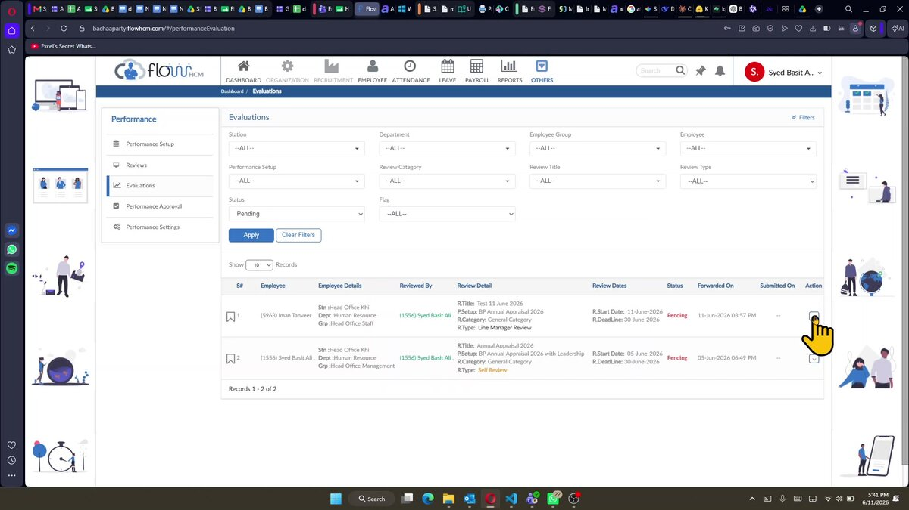
Step 3: Click the Action dropdown (▼) on the Line Manager Review record to open the evaluation form

Step 4: Review Form Header & Employee Details
- The evaluation form opens. The header area shows: Review Title, Review Type (Line Manager Review), Employee name (Review For), Reviewer name (Review By), Performance Setup, Deadline, and Forwarded On date.
- Below the header, the form begins with Objective #1: Goals (Weightage: 80%).

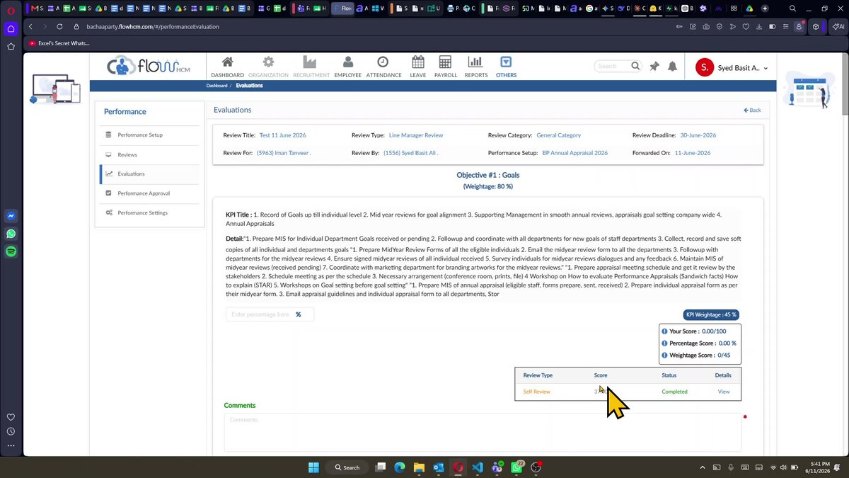
Step 4: Evaluation form header — review employee and review details before entering ratings

Step 5: Enter Your Rating for Each Goal
- For each KPI under Objective #1: Goals, you will see the KPI Title and Detail. The employee's self-rating is shown in the Review Type table below the KPI.
- Enter your own rating percentage in the 'Enter percentage here' field. The score summary panel on the right updates in real time: Your Score, Percentage Score, and Weightage Score.
- Repeat for all KPIs listed under Objective #1. Each KPI has its own percentage field and score panel.
- If applicable, enter a Grace Percentage in the second field. The score panel will reflect the total including grace.

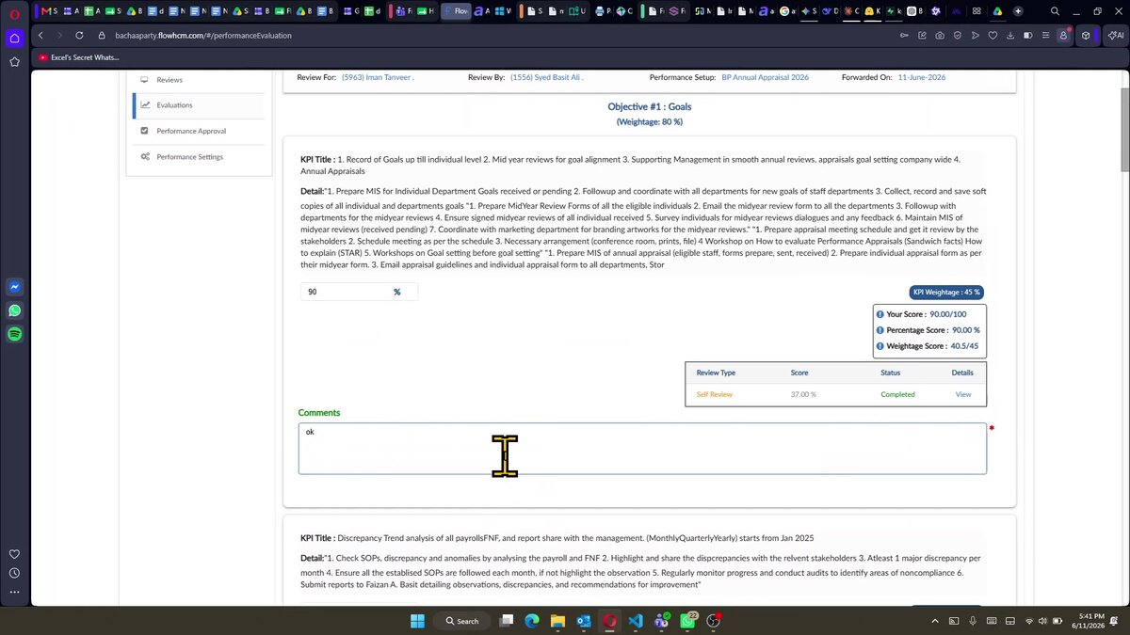
Step 5: Enter your rating percentage for each KPI — score panel updates in real time

Step 6: Add a Comment for Each Goal
- Below each KPI's score entry, there is a mandatory Comments field (marked with a red *). Type a meaningful comment explaining your rating.
- Comments are required — the form cannot be submitted if any comment box is left empty.


Step 6: The Comments field below each KPI is mandatory (marked *) — enter your justification

Step 7: Rate Company Core Values (Objective #2)
- Scroll down to Objective #2: Company Core Values (Weightage: 20%). For each core value, enter your rating percentage in the first field.
- If applicable, enter a Grace Percentage in the second field. The score panel will reflect the total including grace.
- Add a comment in the Comments field for each core value.

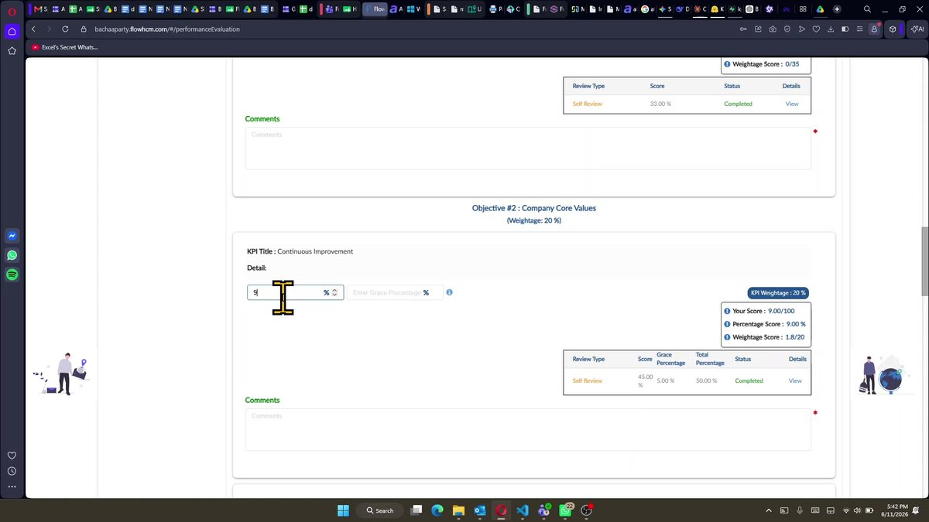
Step 7: Rate Company Core Values — enter percentage and optional grace percentage, then add a comment

Step 8: Review Summary & Submit
- Scroll to the bottom of the form. A summary table shows Self Weightage Score (employee's score) and Line Manager Weightage Score (your score) for both Goals and Company Core Values objectives.
- Review the final scores. Once satisfied with all entries, click Submit Performance Evaluation to complete and submit your appraisal rating for this employee.

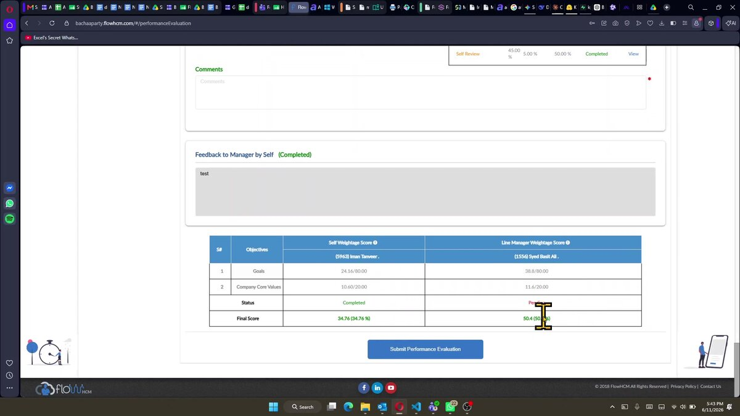
Step 8: Summary table — review both scores side by side, then click 'Submit Performance Evaluation'

💡 After submission, the status changes to Completed and the form is automatically forwarded to HR. You can still edit it after submission — see Section 5.

SECTION 3 — EDITING A COMPLETED APPRAISAL (ADDITIONAL STEPS)

5. Editing a Completed Appraisal
If you need to revise a rating or comment after a form has already been submitted, you can access completed evaluations and make changes using the Edit action. This applies to forms with Status: Completed.

Step 9: Go to Evaluations & Filter by Completed
- Go to Others → Performance → Evaluations from the left sidebar.
- In the Status filter (currently showing 'Pending'), click the dropdown and select Completed, then click Apply. The list will now show only submitted evaluations.

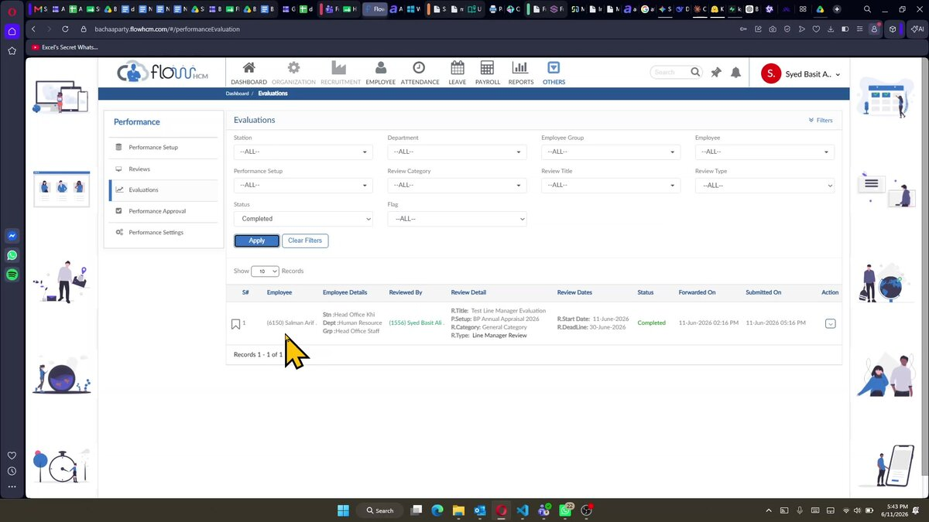

Step 9: Change the Status filter to 'Completed' and click Apply to find submitted evaluations

Step 10: Select 'Edit' from the Action Dropdown
- Locate the completed evaluation record you want to edit. In the Action column on the right, click the dropdown arrow (▼).
- Select Edit from the menu. The form will re-open in editable mode.

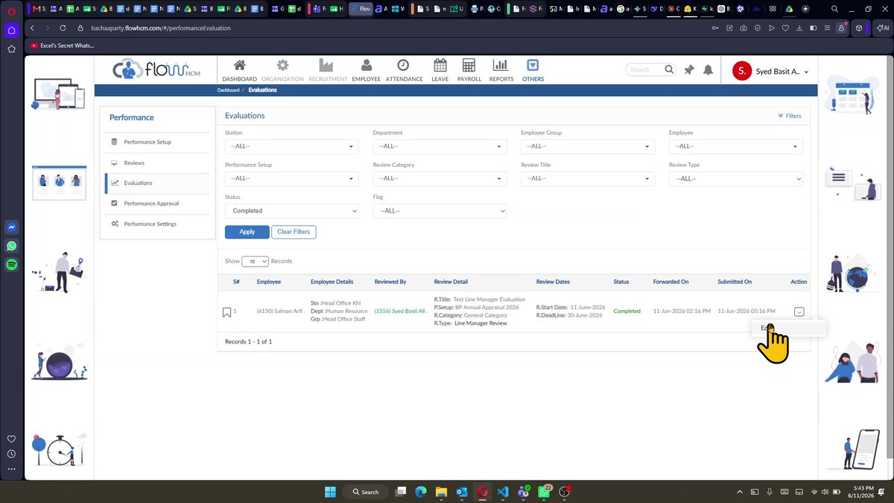
Step 10: Click the Action dropdown (▼) on the completed record and select 'Edit'

Step 11: Update Rating or Comment
- The evaluation form re-opens with all previously entered data. Navigate to the KPI or Core Value you wish to update.
- Change the percentage rating and/or update the comment in the relevant fields. The score panel will update in real time.

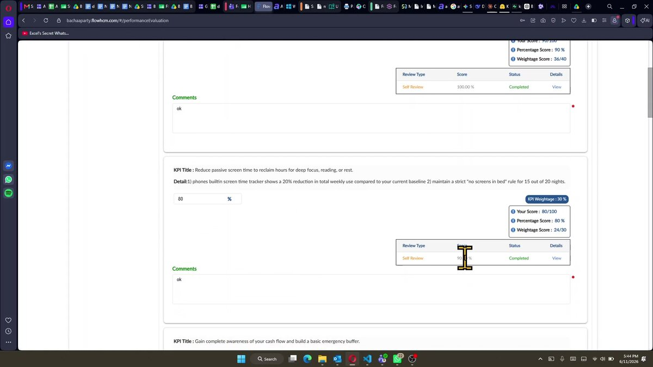
Step 11: Form opens in edit mode — navigate to the KPI and update the rating or comment

Step 12: Save Changes with 'Update Performance Evaluation'
- Scroll to the bottom of the form. Review the updated summary table showing revised final scores.
- Click Update Performance Evaluation to save your changes. The form will remain in Completed status with the updated values.

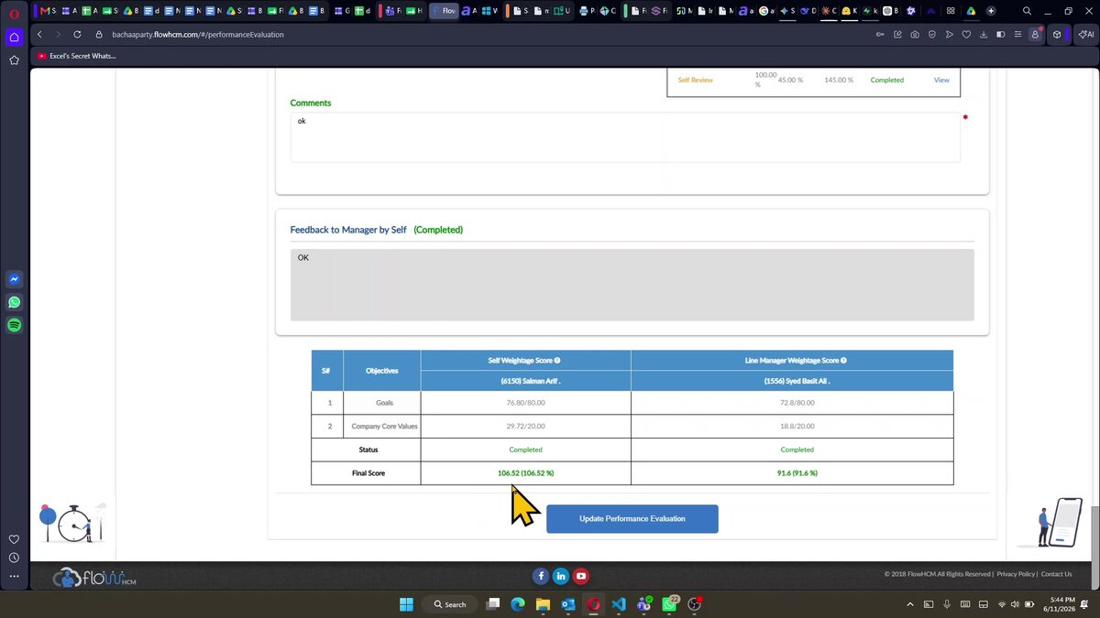
Step 12: Review updated summary scores, then click 'Update Performance Evaluation' to save changes

📝 The 'Update Performance Evaluation' button replaces the 'Submit' button when editing a completed form. The summary table shows both Self and Line Manager final scores.

