**Procedure For Test Plan** **1**

Test Shell Script 1

Test Latency Color Change On Value 1

Test Piece Drop on Key Press 4

Test GUI Update 5

Test Puzzle Timer 6

# Procedure For Test Plan

## Test Shell Script

1. Clone the repository from forked project
   1. <https://github.com/BP4rker/puzzle-massive.git>
2. Follow development steps on your linux machine until you get to "Create the .env and .htpasswd files" section
   1. <https://github.com/jkenlooper/puzzle-massive/blob/develop/docs/development.md>
3. Once you get there, run '**./bin/create_dot_env.sh**'
4. You will be prompted with a few questions
5. If you see a prompt for your favorite muppet character and doesn't throw an unbound variable error, the test is successful.

Note: You are allowed to enter any characters and this will be created as your unique developer key. Changes you make to puzzles will be held under this name.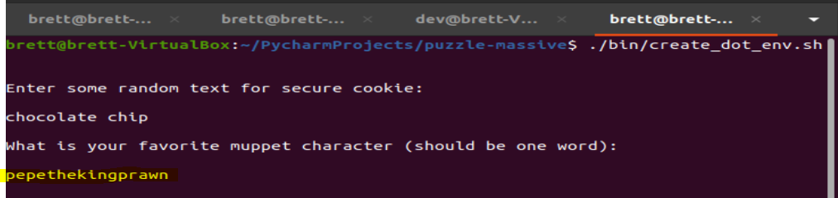

## Test Latency Color Change On Value

1. Clone the repository from forked project
   1. <https://github.com/BP4rker/puzzle-massive.git>
2. Follow development steps on your linux machine and run the project on your local machine.
3. After loading your local instance of the project, load an incomplete puzzle.
4. If your internet connection is secure (300 ms or below latency), the latency amount should be the color green as shown below:

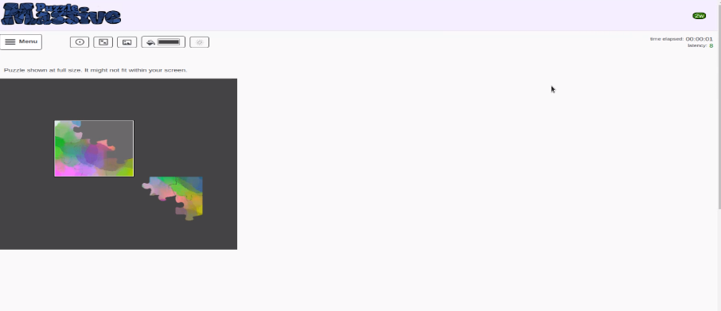

1. If your internet connection is moderate (between 301 ms and 999 ms latency inclusive), then the latency value should be orange as displayed below:

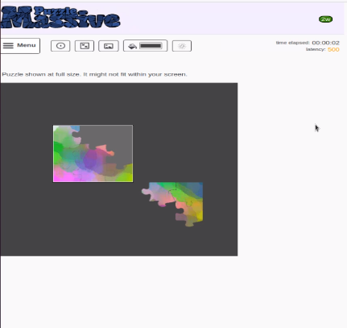

1. If your internet connection is poor (above 1000 ms latency), then the latency value should be red as displayed below:

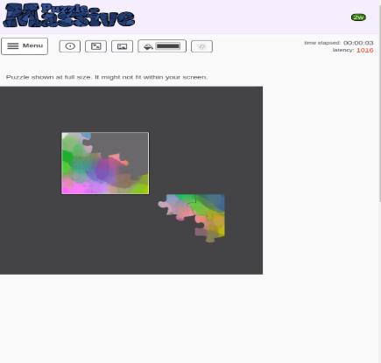

## Test Piece Drop on Key Press

1. Once the website is hosted, you may open up an active puzzle
2. At this point, select a piece
3. Press enter and you will see the piece drop

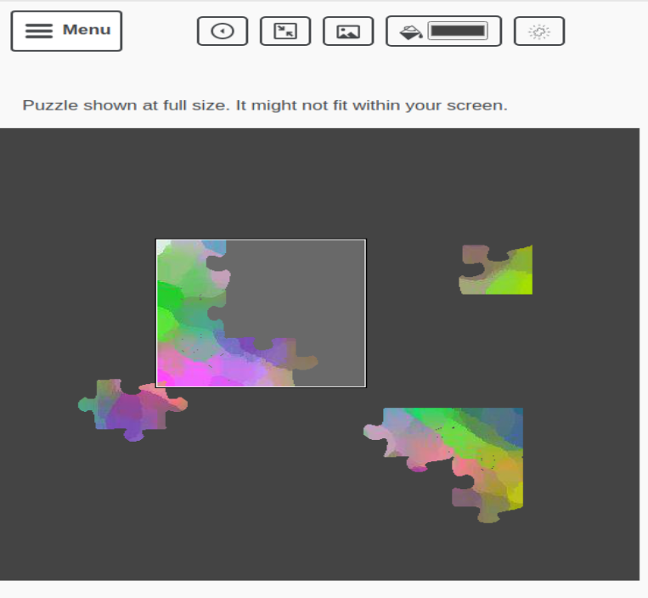

1. Press enter again when selecting a piece and do not let go until new piece is selected
2. Karma will not be updated and new piece will be selected
3. To get Karma to show up on the screen, spam click a piece until you see it at the bottom right of the screen

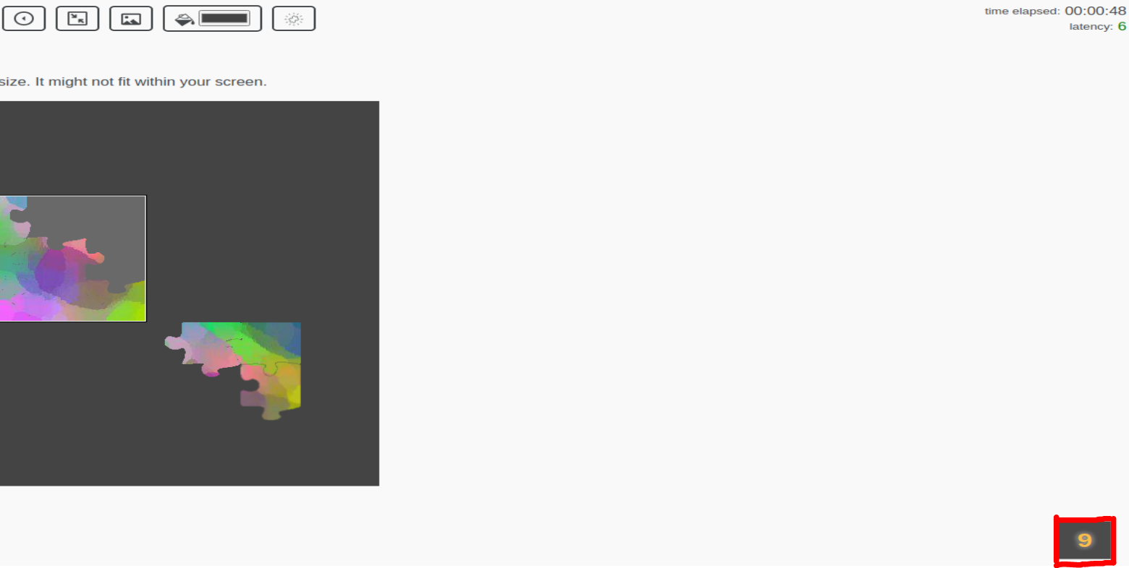

NOTE: This is not always perfect and needs more debugging to work 100% of the time. Occasionally there will be colliding cases and this will prevent the proper actions from taking place

## Test GUI Update

1. If the project is hosted using the 'friendly name' local-puzzle-massive, navigate to:
   1. local-puzzle-massive/chill/site/new-puzzle/submit/

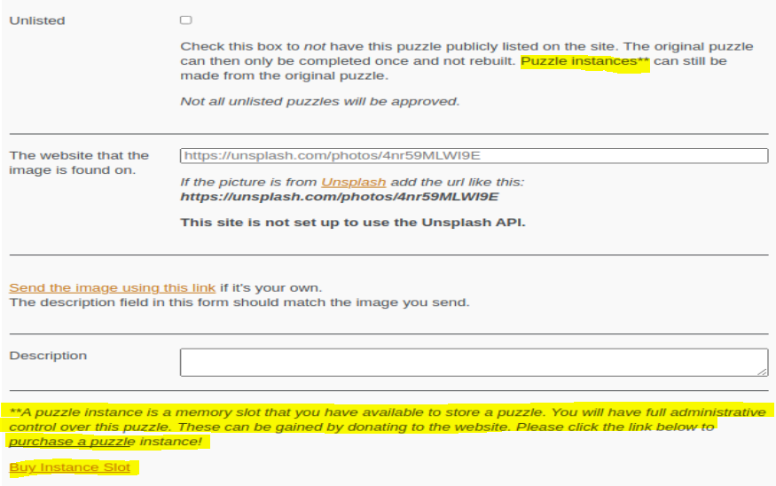

1. The highlighted bits were added to clarify what a puzzle instance is
2. Click the hyperlink 'Buy Instance Slot'

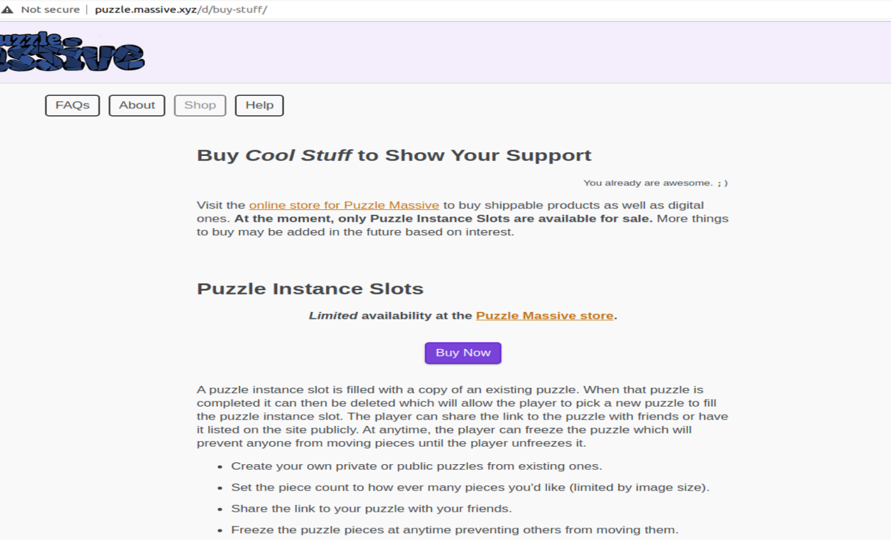

1. You will be rerouted to a buy page for the main website that will show another explanation as well as a place to purchase the instance slot

## Test Puzzle Timer

1. Clone the repository from forked project:

* <https://github.com/BP4rker/puzzle-massive.git>

1. Follow the development instructions to set up the project on your machine.
2. Host the website and use a supported web browser to access the homepage.
3. Choose a puzzle.
4. At the top right of the screen above the latency indicator and below the header, a label should be seen, reading “time elapsed”.
5. This label should be followed by a series of numbers in the format “HH:mm:ss”, where the first set of numbers represents hours, the second set represents minutes, the third representing seconds.

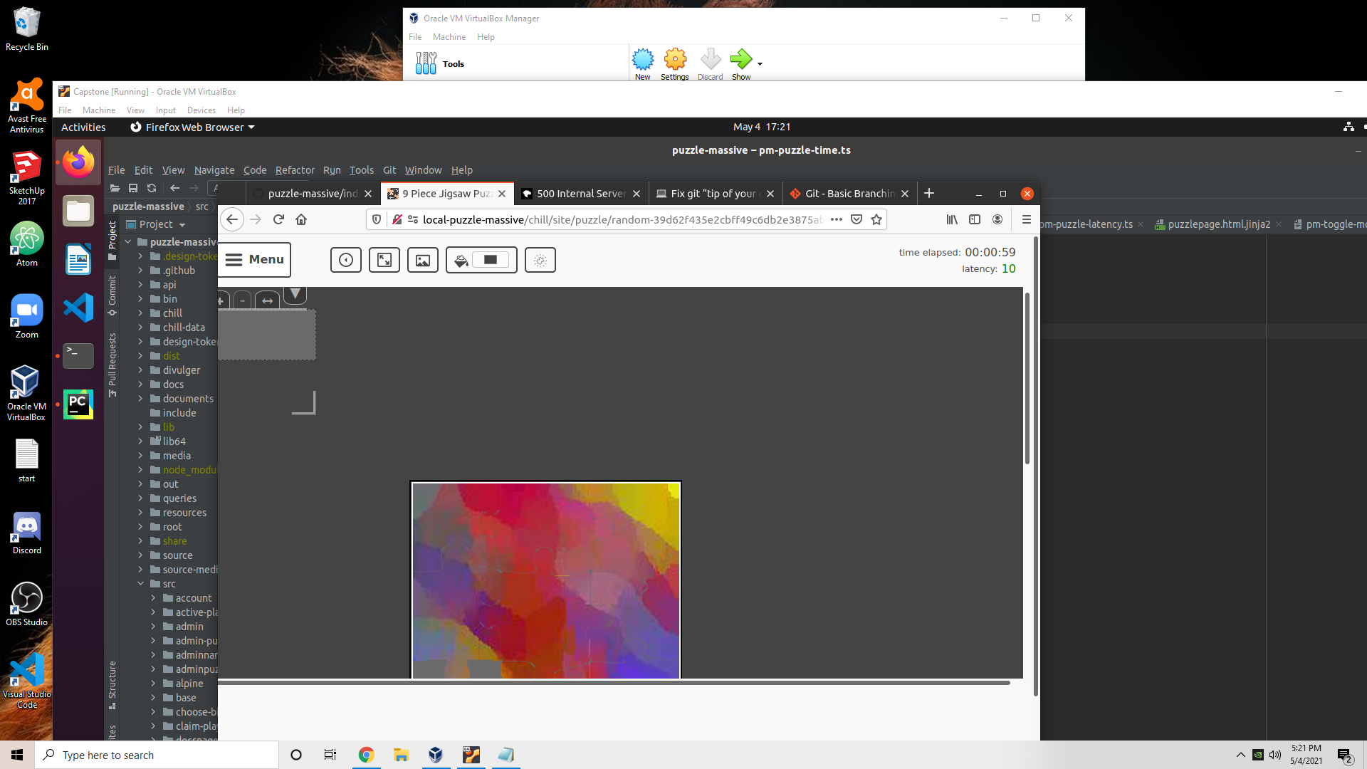

1. These numbers should continue to go up, acting as a timer recording the time elapsed from when the puzzle was first loaded. Once 59 seconds is reached, the seconds portion should become zero again, and the minutes section should have a 1. If this is the case, the timer is working appropriately.

