**eShoppe**

**An online shopping portal**

**Ponnam BalaKrishna**

**Sirisha Valluri**

**Kommineni Shiva Shankar**

**Ramesh Kuthala**

**Objective:**

“eShoppe” is an online web and mobile application developed for the customer for the shopping of products through internet. It makes the consumer to shop from the home without travelling for the product and can also save the time. With this application the customer can also find the details of the nearest store like route map from home and also indicating how much time it takes to reach the store. This application can also be accessed by guest users. The guest user can search all the available products, but to buy the product he need to be registered. If the customer has logged in multiple times from next time we recommend the products based on the previous products he purchased. This application also sends the message to customer mobile phone if he orders for any product.

**Framework Specification:**

The Framework consists of four stages namely GUI editor, API, parsing and database. Database handles the storage of data regarding the items and also the customer data. GUI editor is developed as mobile and web application. The both mobile and web application are accessed by connecting through the same database, the GUI connects to the API and gets the required data from the API, then the data is parsed by the parser and display in the user interface. The purchase details of the customer can be stored in the database.

**System Architecture:**



The Architecture diagram shows the basic representation of flow of the application. The developed all features are represented in nice GUI. The user access those developed features where they request by giving some input. On giving the input it gets connected to the database or the web services based on the feature the user has requested. Then he returns the required response data after the operations. Those returned data will be displayed to the GUI where the user can access.

**Application Specifications:**

Tools: Visual Studio, Android Development Kit

Languages: Java, C#, ASP.Net, ADO.Net

Operating System: Android

Development Operating System: Windows 8

Database: SQL Server 2008

**Class Diagram:**

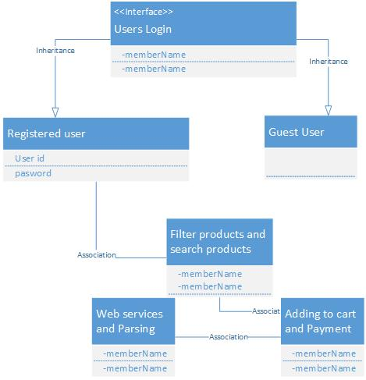

The class diagram shows the important features in the project where divided into the classes. It also describes the relation between two classes. And in the classes it shows the features using and shown as the blueprint of an application for the developers.

**Activity Diagram:**

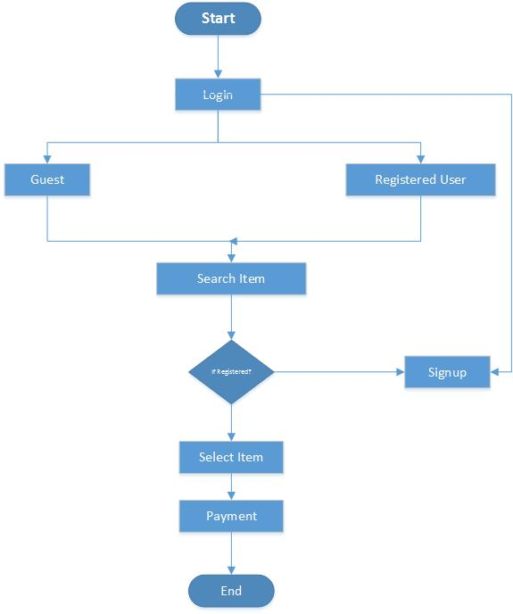

After entering into the login page customer will be having two options as like guest and registered user, customer can view the item even as guest but he needs to get registered for purchasing a product and finally payment will be done after goods selection.

**Sequence Diagram:**



**API Collection:**

 Walmart API: <https://developer.walmartlabs.com/io-docs>

Supermarket API: www.supermarketapi.com

eBay API - <http://developer.ebay.com/DevZne/Shopping/docs/CallRef/index.html>

Amazon API - <https://developer.amazonservices.com/>

**Implementation:**

**Current Implementation:**

Current Implementation includes login page creation, registration page creation, customer authentication, guest user page, storing of the customer data in database and also API collection.

The following are the screen shots of the application:

The below screen is the login pages where the user gets logged in by giving his username and password which checks the authentication in database. If it is correct then it allows the user to enter into the site.

The Guest user is the user can enter into app where he can search but he don’t have right access to buy the product in order to buy any product he need to get registered.

The below screen shot shows the login screen

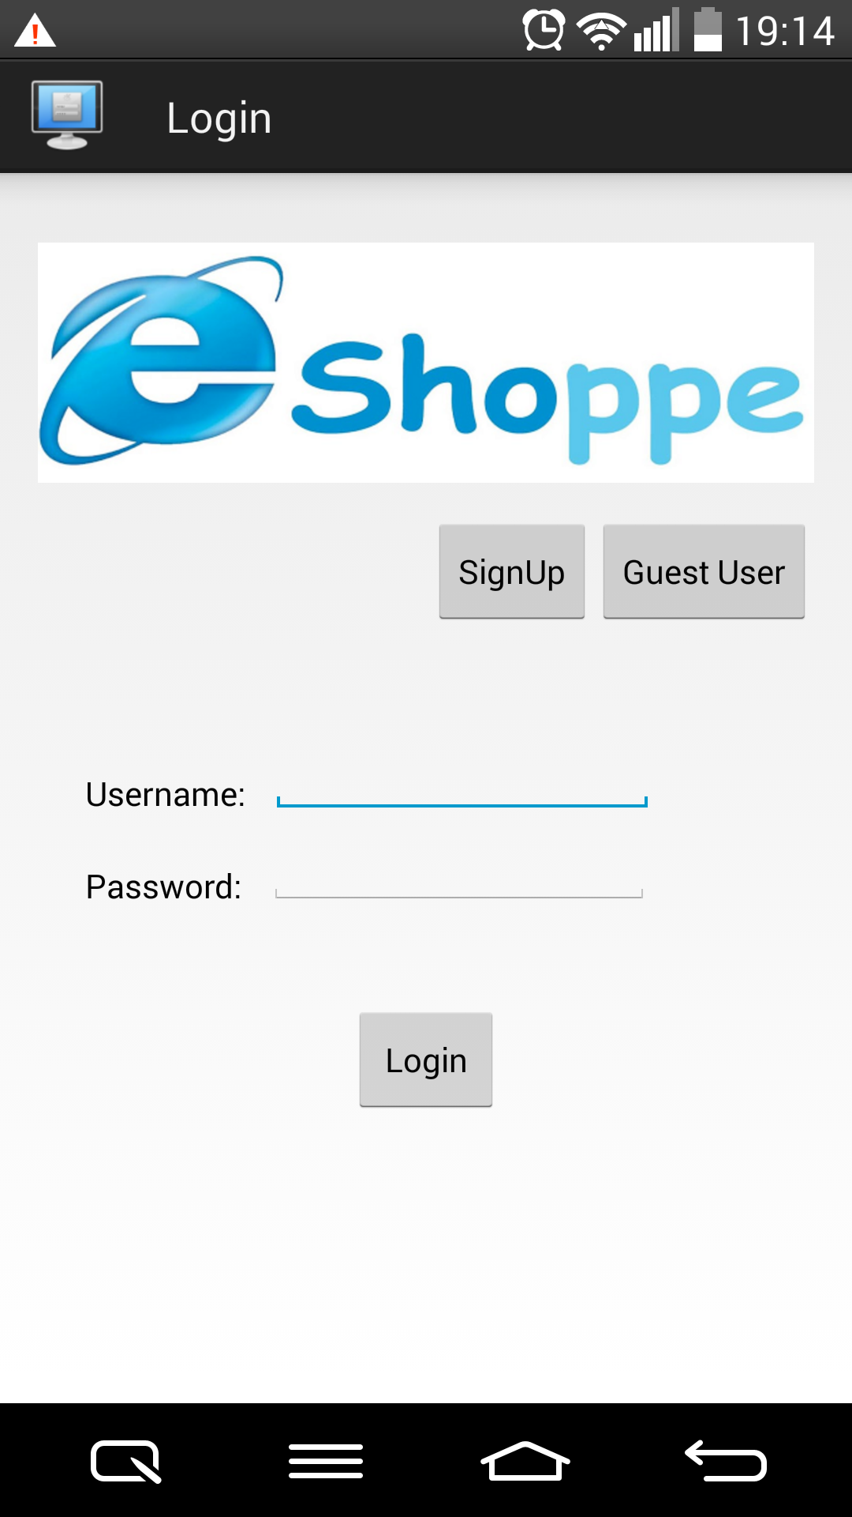

The below screen is the Registration screen where the user to get SignUp to get login details and to buy the product from this app.

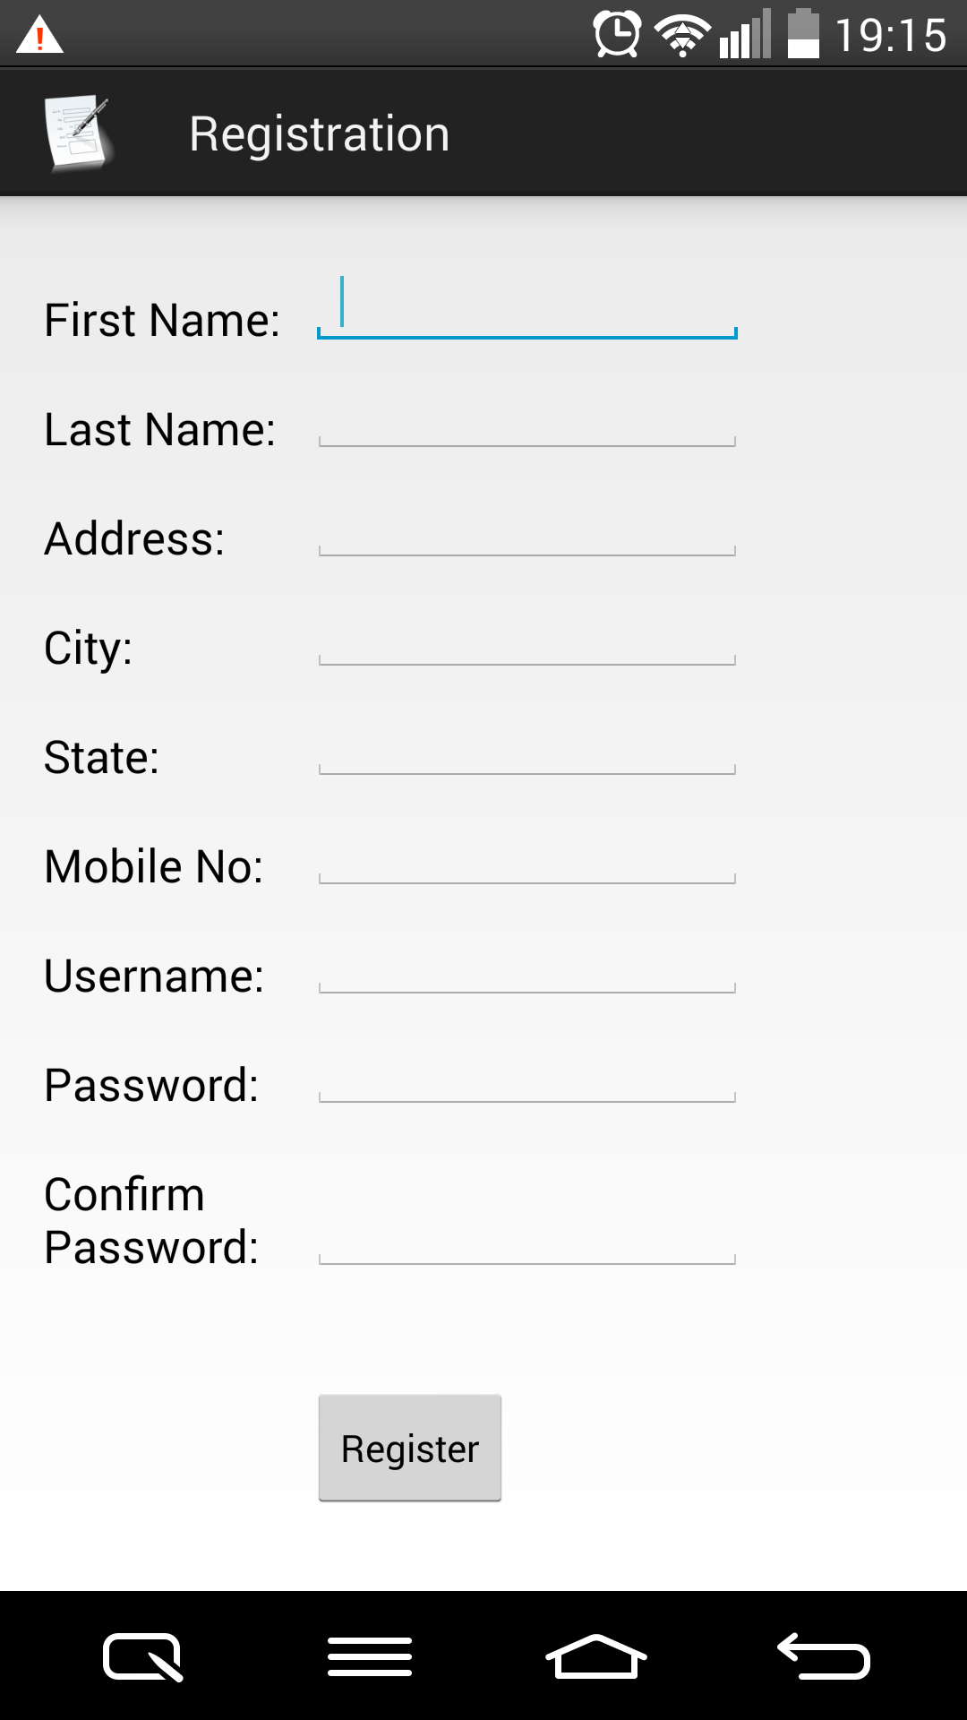

**The below screen is the screen which gets when the login user or the guest user gets logged.**

**This page displays and can search the all available products.**



**The below screen is the creation of database table for the user details.**

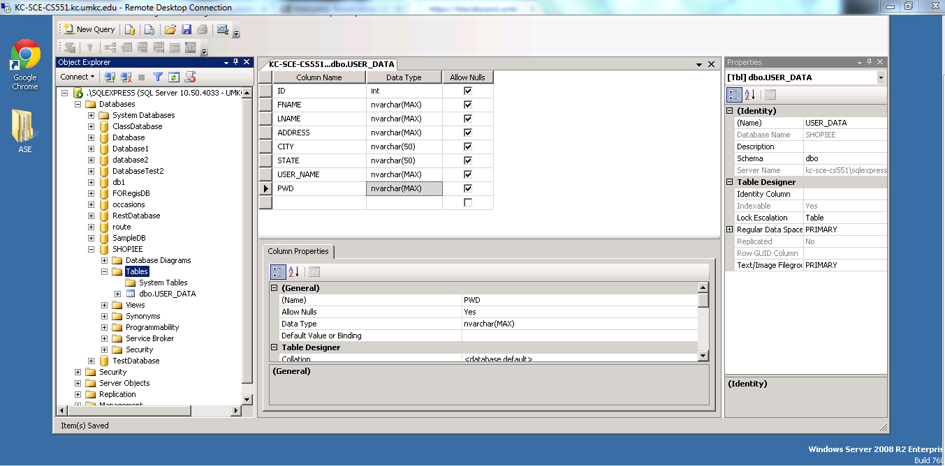

**Project Management:**

All the tasks and their day today increments are being updated in the scrumdo.

<https://www.scrumdo.com/account/login/?next=/projects/project/ehopiee-web-and-mobile-application-for-e-shop/iteration/111956/board>

The work has been equally distributed between the four members of the data with two members dealing with API Collection, Parser Implementation and two members dealing with GUI design and Database Connection.

GUI Design and Database Connection: Ponnam BalaKrishna, Kommineni Shiva Shankar

API Collection and Parser Implementation: Ramesh Kuthala, Sirisha Valluri

**Second Increment:**

* Parsing Data from the APIs based on the required product- Ramesh Kuthala
* Listing the items into the main page – Kommineni Shiva Shankar
* Map services to the store – Sirisha Valluri
* Product Search by filters –Ponnam BalaKrishna
* Maintaining the users log in Database- Ponnam BalaKrishna
* Web application development with login and registrations – Sirisha Valluri
* Payment mode implementation – Ramesh Kuthala and Kommineni Shiva Shankar

All the stories with time allocations will be updated in the scrum do for the second phase increment also.