**Project Deployment**

**Summary:**

The entire code of implementation has been completed and deployed in the GitHub. The GitHub link is provided below:

* <https://github.com/BP8G6/ASE---Project>

The project description and methodologies are described briefly and pictured as a video. This video has been uploaded to the YouTube which can be viewed using the following link:

* <https://www.youtube.com/watch?v=hHllem3NIFA&feature=youtu.be>

**User Manual**

**System Requirements:**

Operating System: Android

Android Version Support: Froy to JellyBean

Memory required: 256MB

Internet Connection: Yes

**Devices: Android devices**

* Bluetooth 4.0 compatible android device
* Android 4.3 or above OS
* GPS

**Devices/Sensors:**

## Sensors: TI Sensor Tag - CC2541DK-SENSOR

**Goal:**

To provide a sensor based motion game control to the open source projects and provide better experience for the android users.

Till now we played games with less physical contact. Now we are developing a game that can be easily controlled by the sensor motions and directions of alignment.

**Guide Lines:**

1. Please download the Tetris.apk file and install it onto your mobile device.
2. Once you have installed the application, Launch the application by clicking or tapping Tetris icon which will be displayed on your screen.
3. Now you can see the buttons on the screen as play, charts.
4. Click on the play button to start playing the game.
5. You notice that it takes time to train the sequence files generated for the game.
6. Wait for a minute and start moving the sensor in the required direction.
7. The game is mostly played by all of us in our child hood days
8. Different objects are falling from the top of the screen to the bottom. We can now change this objects movement using the sensor tag.
9. Once we complete a row of objects with no spacing we can say that the entire row gets deleted.
10. If we don’t align these objects in the order all these form as a heap and settle down till the top of the screen and then the game gets completed.
11. Once the game is completed there will be an option for saving the data for the game we played in the date using the save data button.
12. This functionality comes under the charts button present in the main menu screen.
13. When we click on the save data button automatically data gets saved in the DB and generates different statistical charts.
14. Later when we click on the charts button in the main menu we can notice the charts generated based on the dates for various data collected.

**Sample Execution:**

On running the game with sensor devices we get the Play and chart button.

On Punch the play button gets activated and the game will be running by generating the objects. Those objects can be moved towards Right, Left and can also rotate the object using the sensor.

The below screen shot shows the beginning of the game with the play and Chart button:

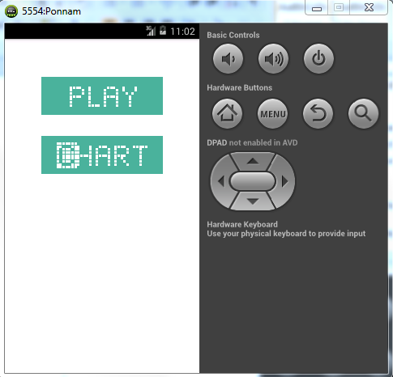

The below screen shows the objects falling down and which are moved towards left, right and rotated by using the Sensor device:

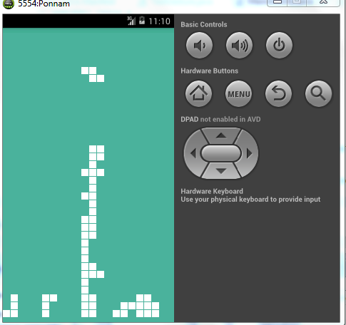

**Generating Charts for the Gestures:**

The game is played by using the sensor tag where generating five different Gestures.

We have collected a report of how many times the particular gesture is being performed. We collected five gestures Rotate, Right, Left, down and Punch. We took the count of each gesture performed while playing the game. The individual Gesture count is sent to the database with the date.

Thus we generate a pie chart for all gestures based on the date by retrieving those data from the database.

The below screen shows the main screen with play and chart button:



We have a chart button, on pressing the chart button we get the drop down which has all the dates in which we played the game. On selecting the date and pressing the submit button we get the pie chart with gestures we have used.

The below screen shows the selection of Date with drop down and submit button:

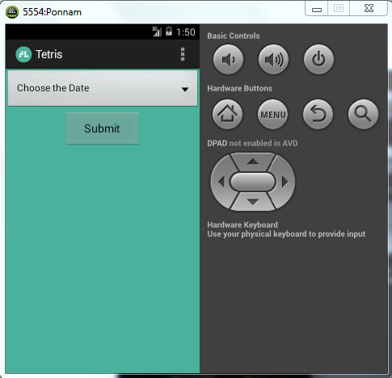

The below screen shot shows the selection of date from the dropdown:

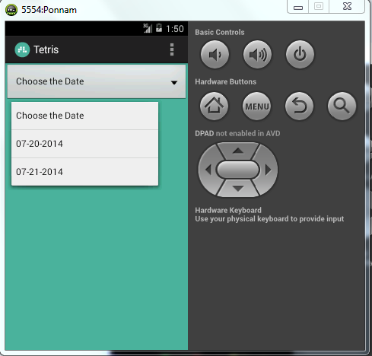

On selecting the date and pressing the Submit button we get the Pie Chart with the gestures we have used.

Here the Date is from the database which selects all the dates with the gesture. It removes the Duplicates and shows the available dates in the drop down box.

On selecting the particular day it fetches all the gestures used and its count and draws the pie chart based on the count of the particular gesture.

The below screen shows the Pie Chart of the Gestures we have used:

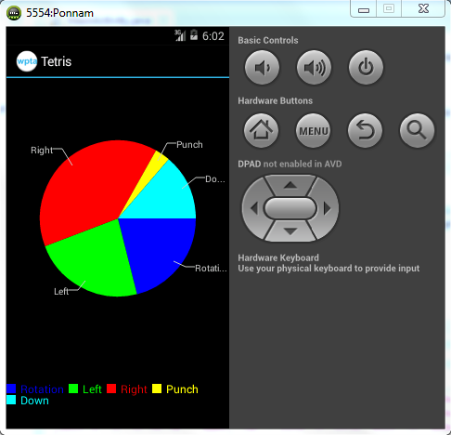

**Troubleshooting:**

* If you have any issues while installing, please remove the apk and reload it.
* If it takes lot of time for training the data after the application gets loaded.
* Make sure the directions of the motions and alignments of the sensors are same as that in the testing and training phase

**Note:**

We have got the open source game reference from the following web site.

1. Application code for reference

<https://github.com/semenoh/Tetris>