**Project Management**

**Summary:**

Agile process is the software development method we have used. We have divided the project plan into four increments where each increment included improvements in both back end and front end implementation from increment to increment. We have used ScrumDo for our project management and for maintaining the project artifacts. Our team consists of four members’ and the project development has been shared equally between all of us. In each phase two members used to work on back end and two members used to work on front end. And these will be swapped in successive increments.

The below are the tasks that have been scheduled in each of the increments:

If there are any pending backlogs we all worked together to nullify them.

**First Increment:**

1. Design and architecture specifications – Ramesh

2. Web services and Back end – BalaKrishna

3. Google places services and parsers - Sirisha

4. Front end and API services. - Siva

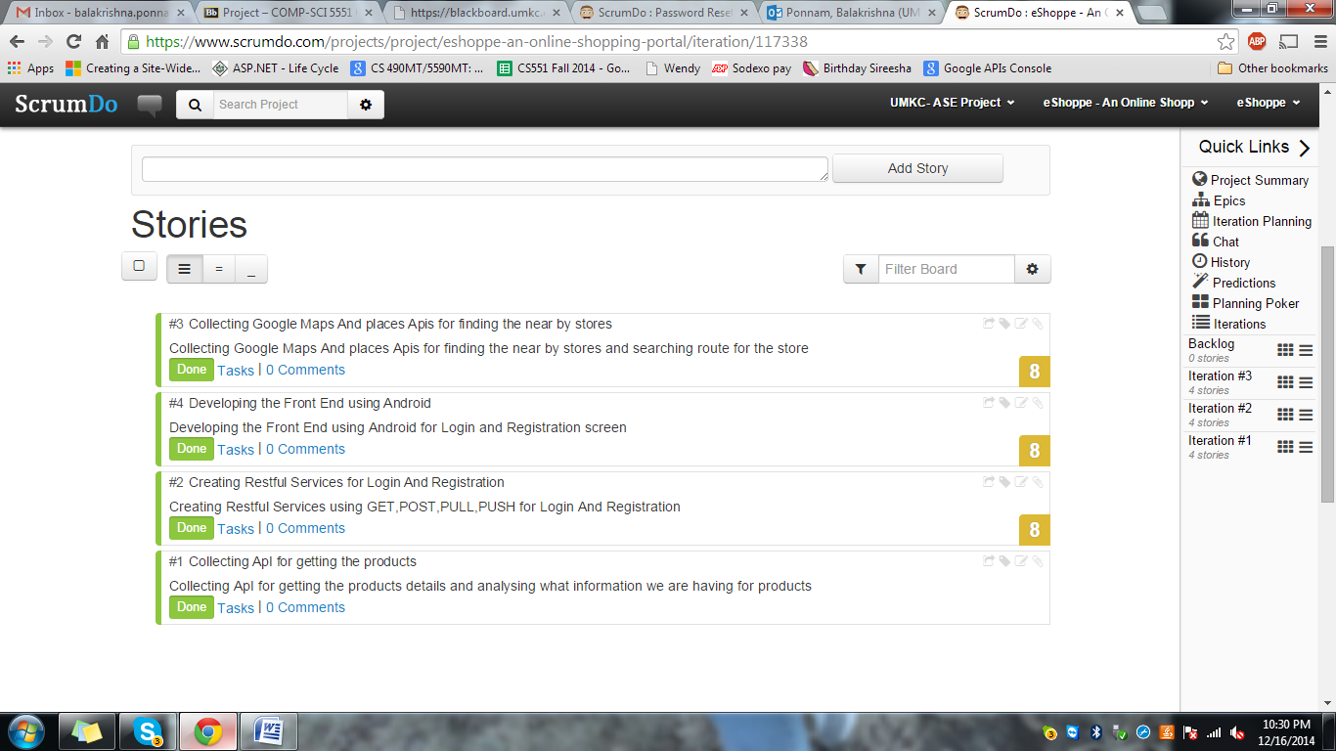

Figure 1.1 First Increment

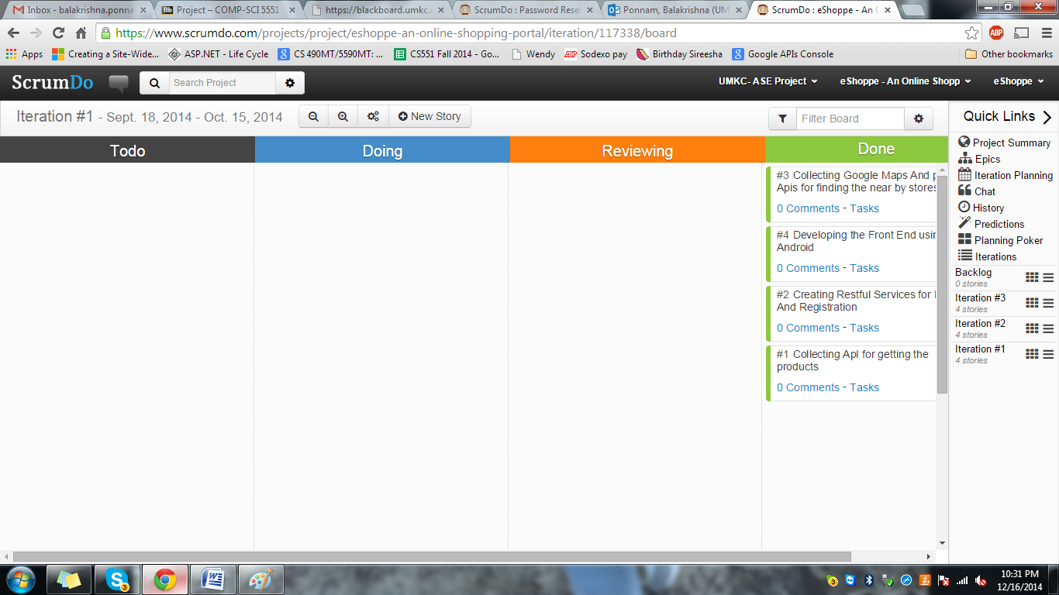

Figure .2 First Increment

**Second Increment:**

1. Develop Front End for shopping Online - Ramesh

2. Developing Front End for Google Maps - Balakrishna

3. Writing Parsers for Collected API - Sirisha

4. Integrating Rest Services to Android Application -Siva

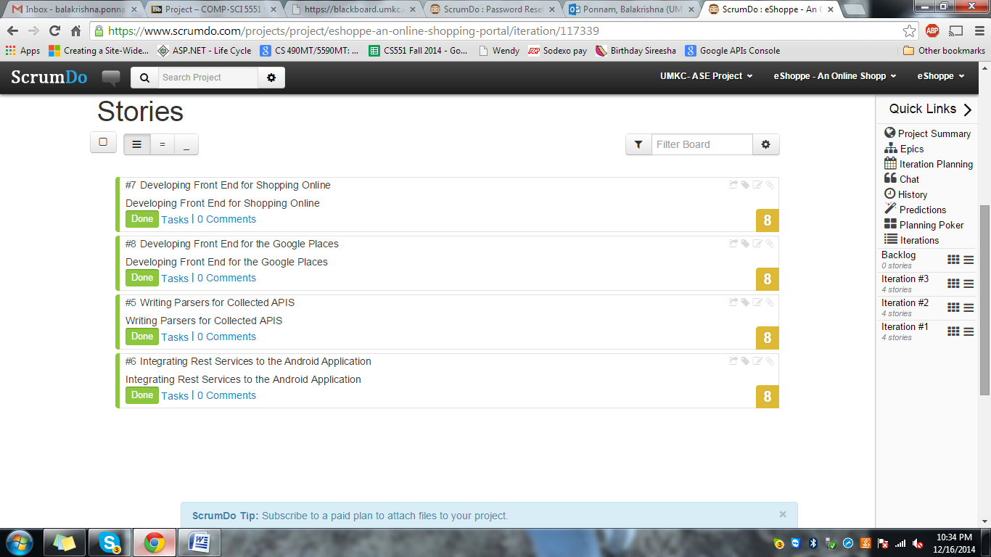

Figure 2.1 Second Increment

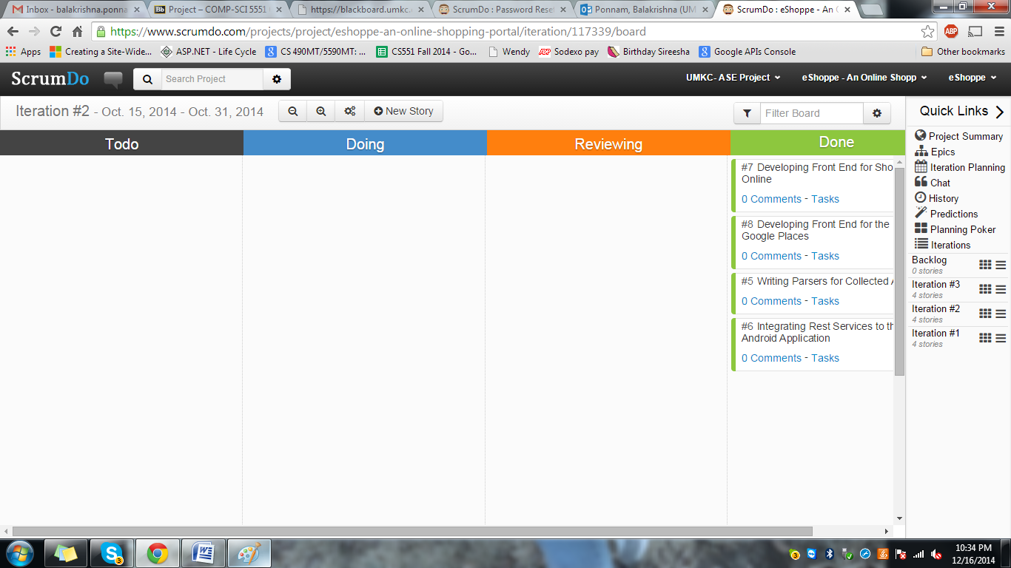

Figure 2.2 Second Increment

**Third Increment:**

1. Testing Entire Project - Sirisha
2. Integrating Wallmart API – Ramesh
3. Implementing Frond End shipping task and back end tasks. – BalaKrishna
4. Implementing directions to the store - Shiva

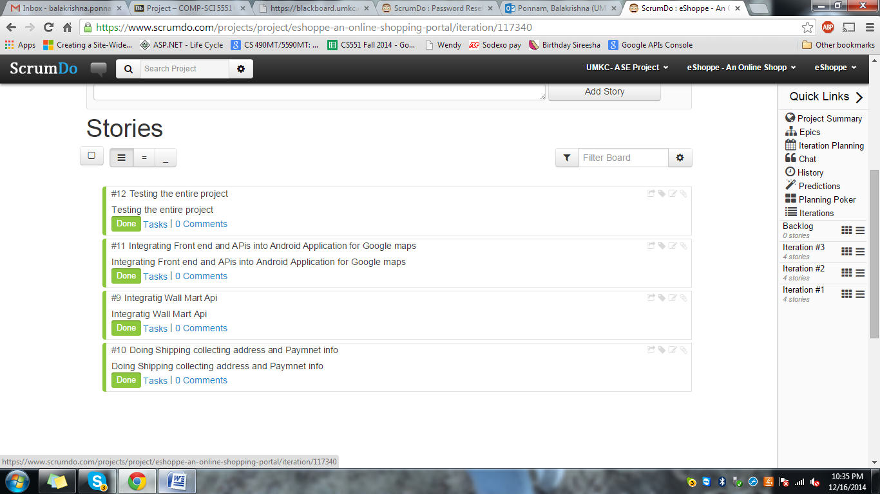

Figure 3.1 Third Increment

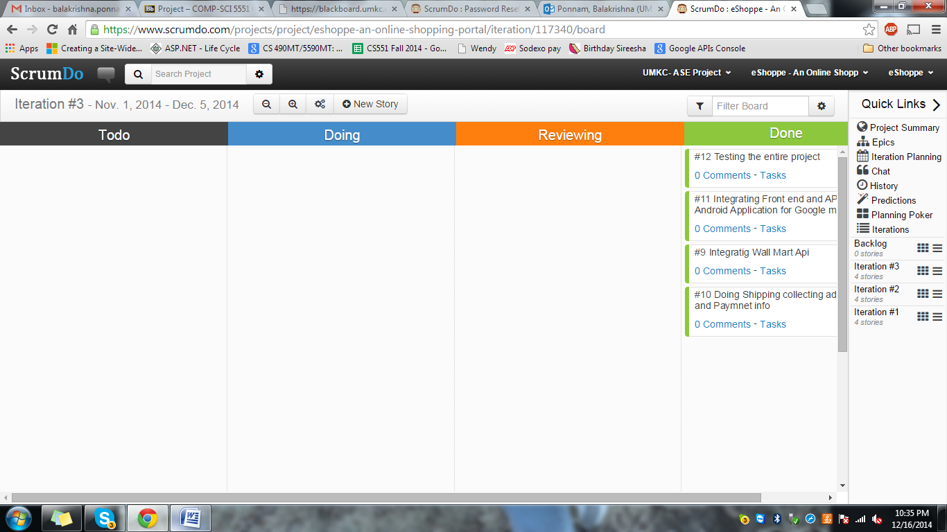

Figure3.2 Third Increment

**Project Summary:**

The entire project summary is shown below with a graph, which reflects the process in project development in each iteration:

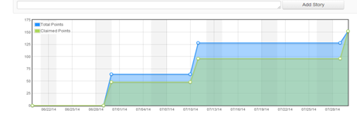

Figure 6 Project Graph

The entire project scrum work and tasks can be viewed in the following link:

* <https://www.scrumdo.com/projects/project/eshoppe-an-online-shopping-portal/summary>