**User Manual**

**System Requirements:**

Operating System: Android

Android Version Support: Froy to JellyBean

Memory required: 256MB

Internet Connection: Yes

**Devices: Android devices**

* Bluetooth 4.0 compatible android device
* Android 4.3 or above OS

**Goal:**

To provide to develop an online shopping application for the android users to make shopping easier and effective to the users.

To develop application which is more user friendly for product purchase and also for finding the nearest store in a particular city this is more helpful to the user is who is not that aware of the every nook and corner of the place.

**Guide Lines:**

1. Please download the eShoppe.apk file and install it onto your mobile device.
2. Once you have installed the application, Launch the application by clicking or tapping eShoppe icon which will be displayed on your screen.
3. Now you can see the buttons on the screen for login and for registration first.
4. Click on the login button to enter into the application.
5. You notice two buttons Find a store and Shop online
6. Find store will ask you for the location about the stores to be find.
7. Shop online will ask you to search a product.
8. Once we search a product it shows description of the product and asks for purchase.
9. On clicking the purchase button it asks for the shipping address and billing information.
10. On successful purchase it shows the shipping address and approximate time of delivery of the product.

**Sample Execution:**

On running the application, we will be getting the below screen which pops up for user login if the user is a registered user if not user needs to register first.

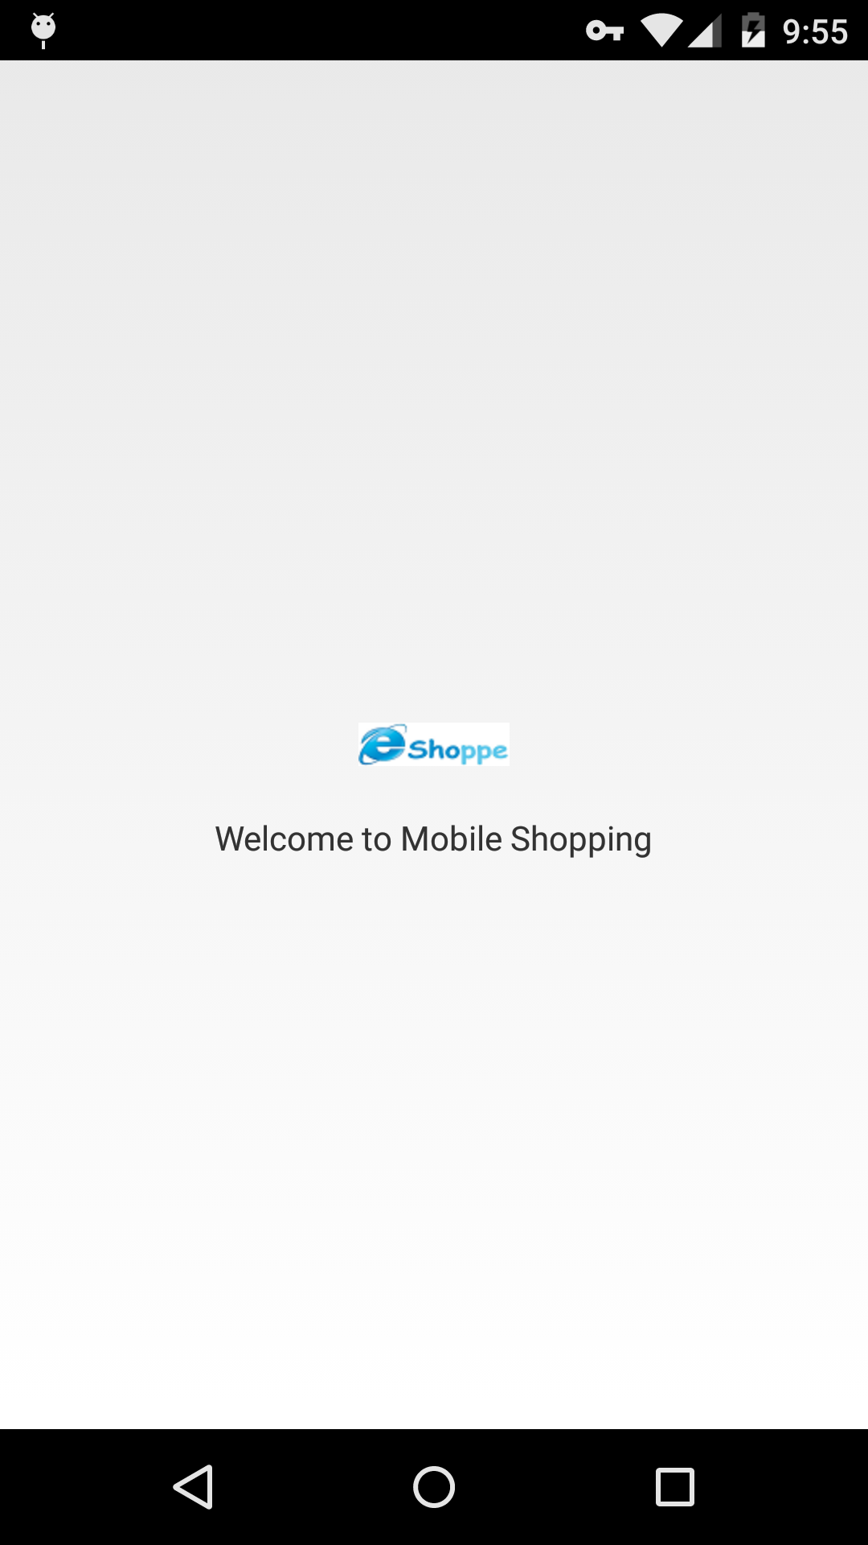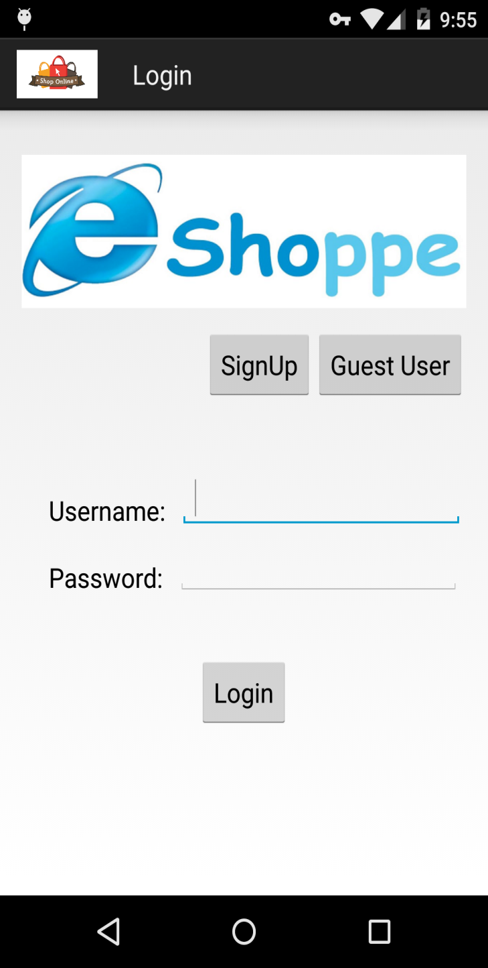

The below screen shows the Dashboard containing the main features in the application.

Shop online and Find a store. For finding nearest store and for Shopping online.

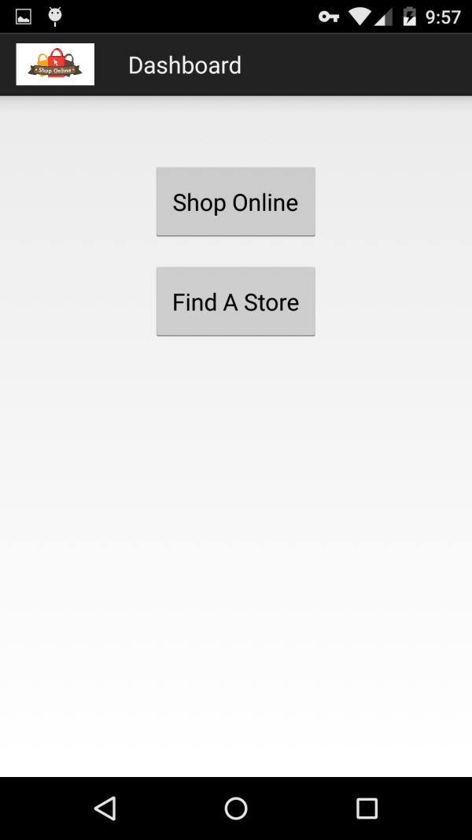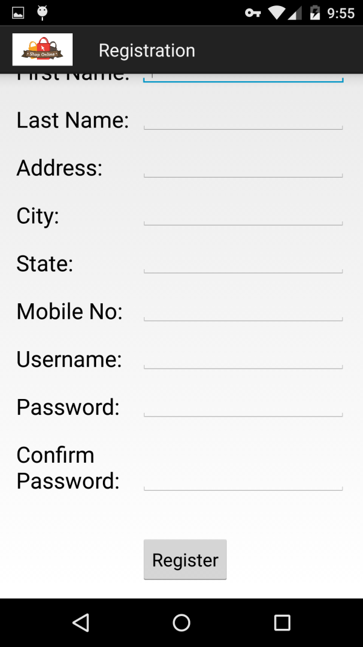

**Generating Charts for the Gestures:**

On getting logged in we get the Dash board saying to find the nearest stores or to do shopping online.

On selecting shopping online we can search the required product we required. Which displays all the available products with includes that search. So that we can select the required product and can also see the description. And can also convert text to speech which is very helpful to the persons who can’t see properly.

The below screen shots shows the searching and listing products and the other is description of the product.

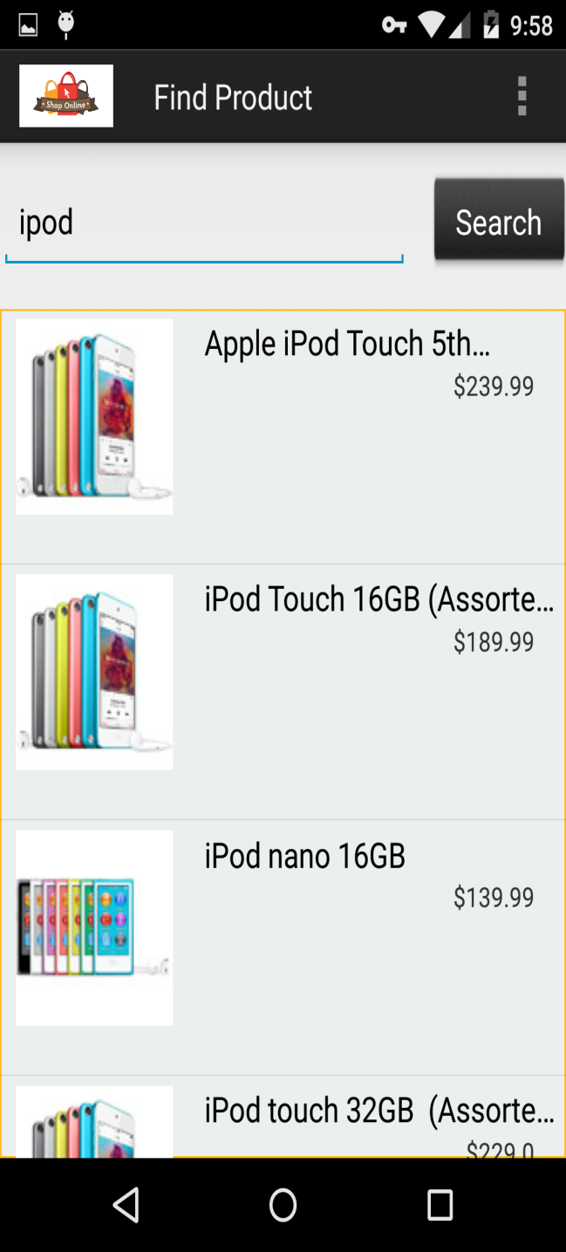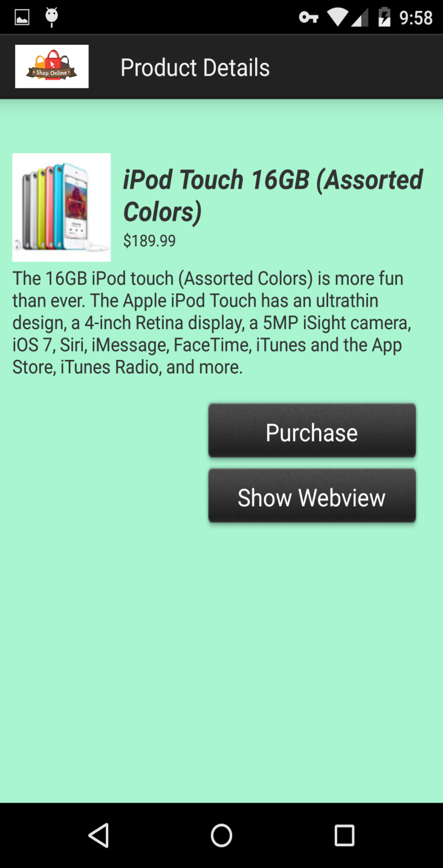

In this application we can also see the content of the product which is displayed on the actual web page. That content can be shown by clicking on the button Show Web view.

And the items or products can be added to the cart. Those products in the cart can delete or can be continued by placing the shipping address and doing the payment.

The below screen shows the web view data from actual website of product and the shopping cart information.

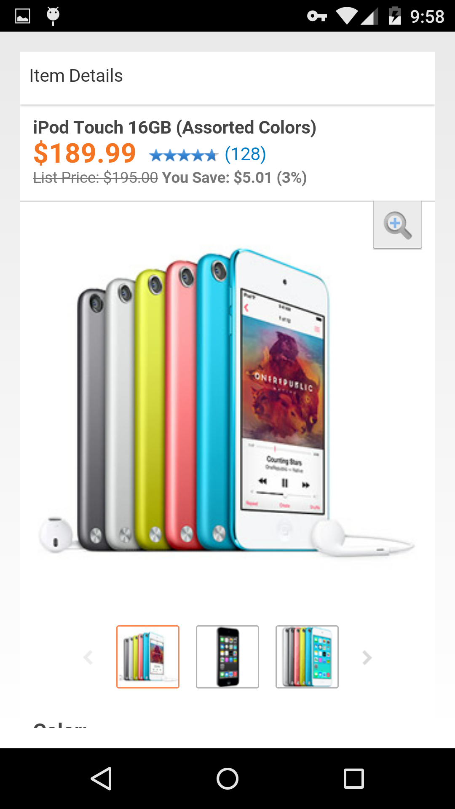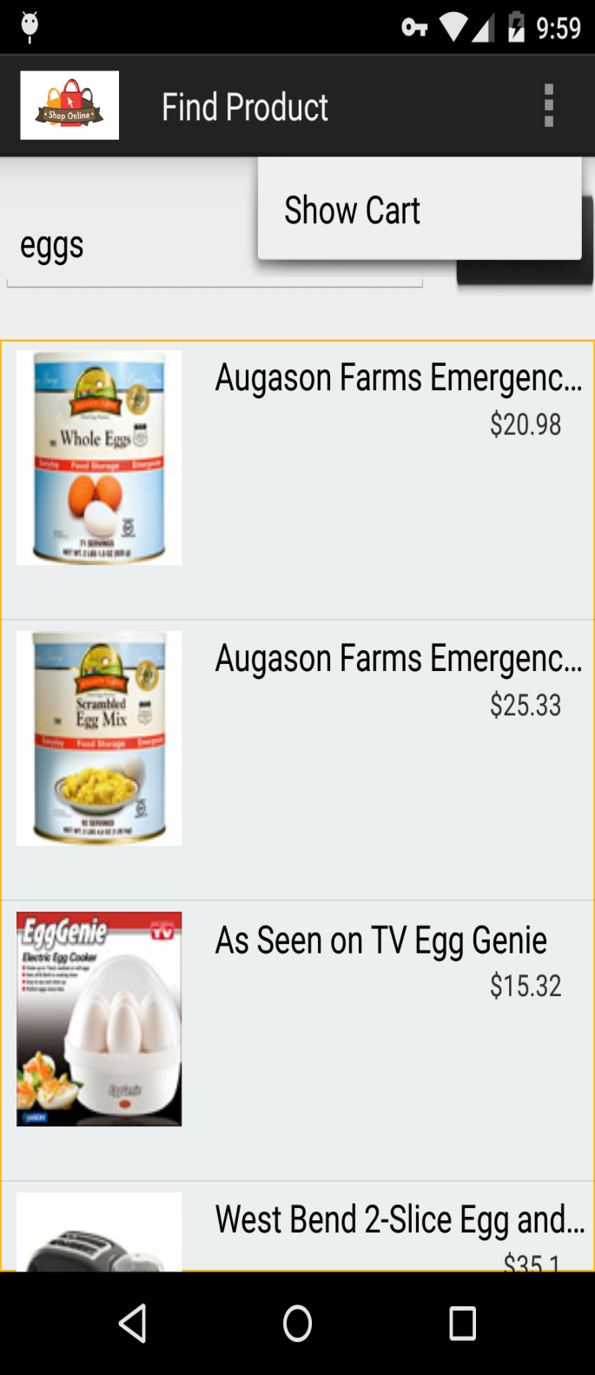

The below screen shot show the Information in the cart, and the product which is added to the cart can also be deleted.

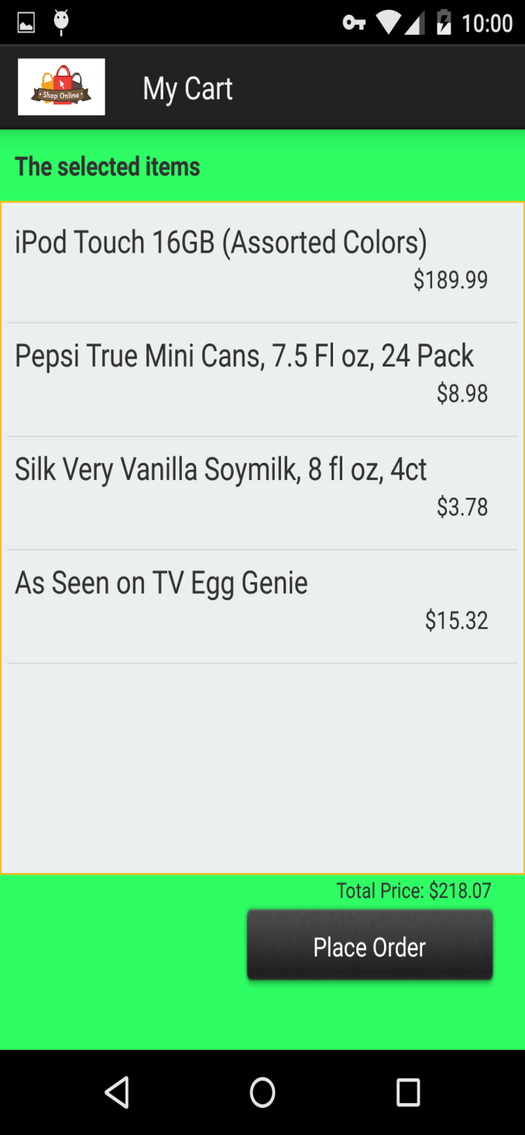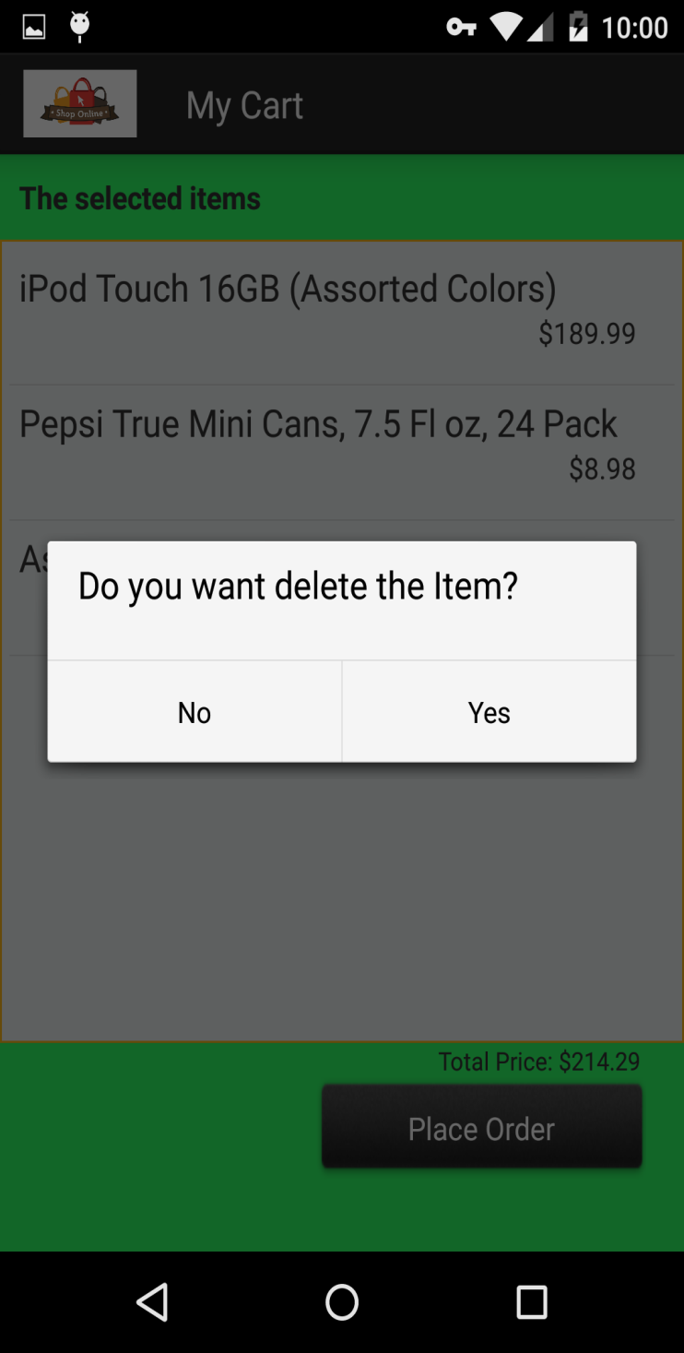

After the product is added to the cart by clicking place order you will be redirected to a page asking for the shipping address. And in the same page it also shows the store address. On the next page it asks for the payment details, on giving the payment details it shows the thank you screen and the approximate time showing to deliver the product.

The below screen shows the billing invoice and store address asking for the shipping address on the other page it takes the payment details.

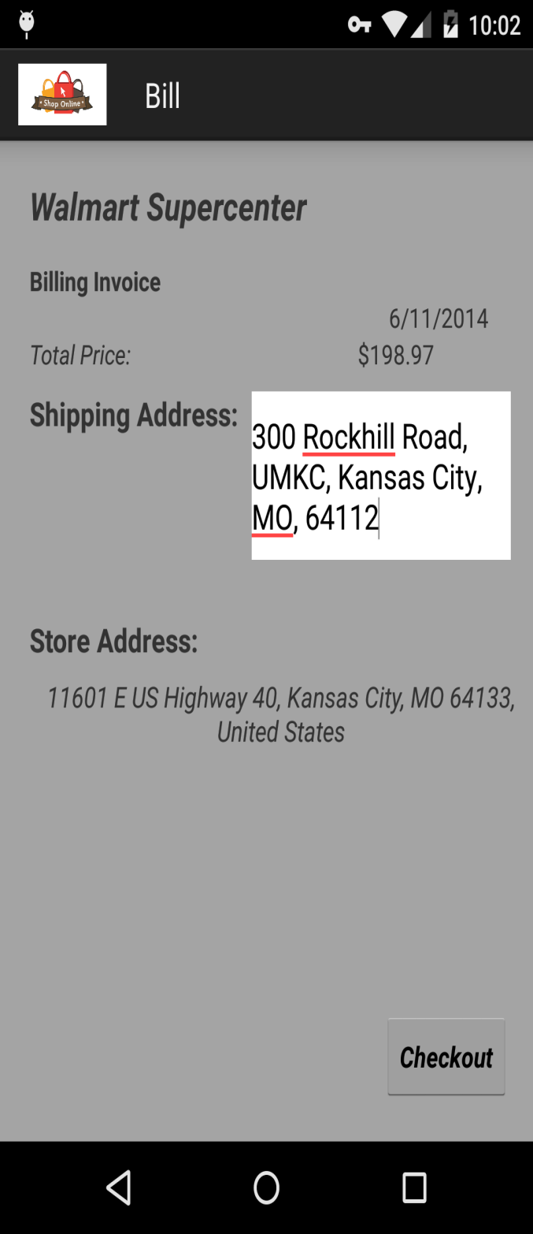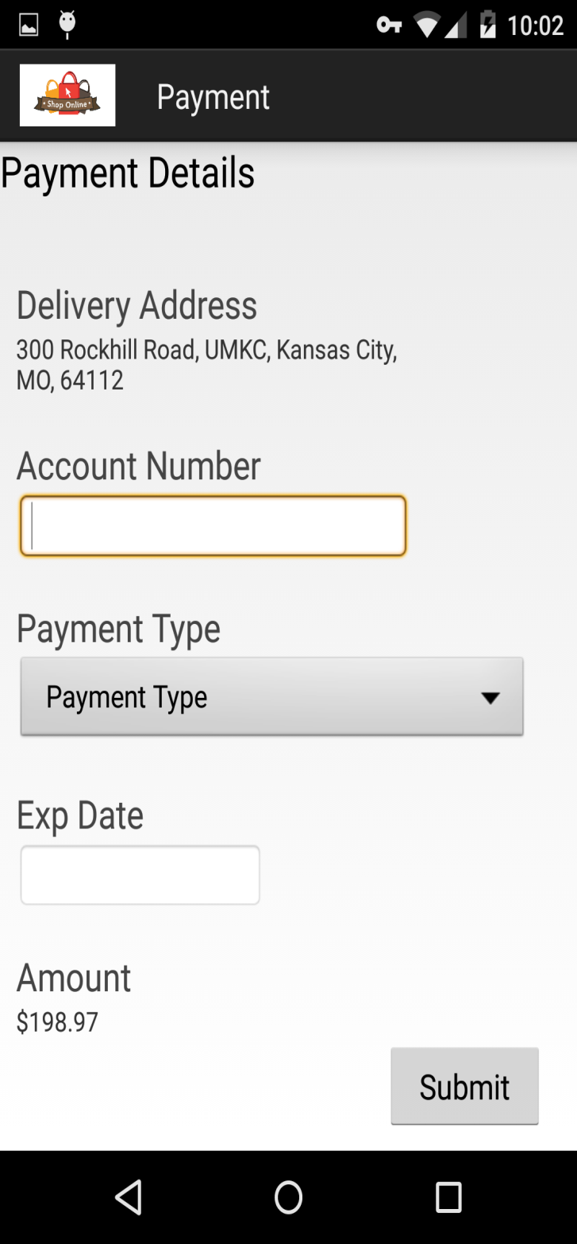

After the payment details are submitted then it says thank you and shows the shipping address to where it gets shipped.

The stores also can be found by using this app on entering the store to find with city name and searching then it shows the store location in the map

The below screen shot shows thank you screen and the finding the stores in map view:

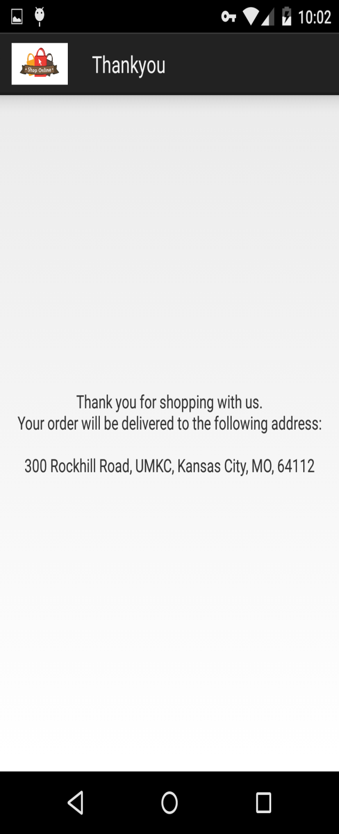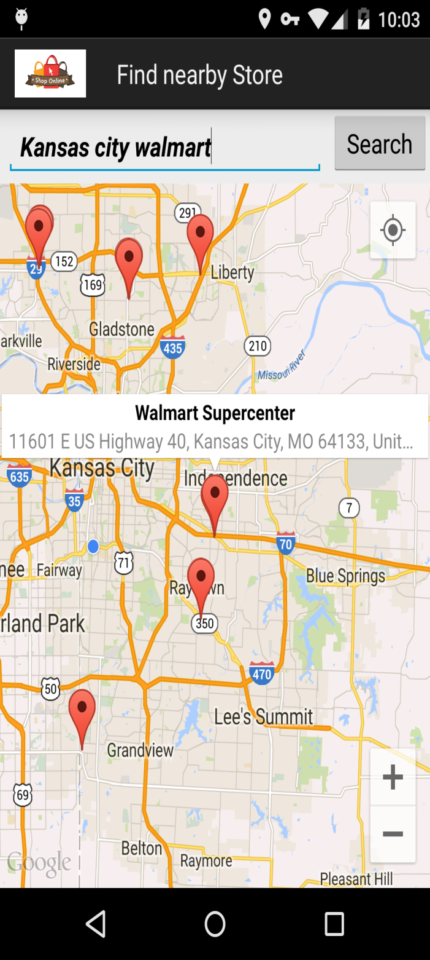

**Troubleshooting:**

* If you have any issues while installing, please remove the apk and reload it.