**Project Plan**

**Objective:**

e$hopee is a user friendly application developed for purchasing the products online. This makes the user feels comfortable to shop the goods required from home. With this application user can find the nearest stores and can also from the route and estimated time from user’s current location. When the user login for the second time we recommend the items to be purchased based on his previous search and purchase.

**Introduction:**

Now-a-days people are getting busier with their daily routines and their schedules. They want everything to be done over the network rather than spending their time by going to the store. This application is designed for users to shop online where user can search for products and view their specifications before purchasing. Products can be delivered to their place after payment is done through online.

**Proposed system:**

e$hopee is an application where user needs to register first in the sign up page if they want to purchase the products. Guest users can only view the products. Using Google API we will design the application in such way that user can find the nearest store details such as distance and route map from the user’s location. User can search the products based on various criteria like price, brand etc. Once the user triggers the search, we will get data based on the search criteria using rest or soap service from back end API’s and parses it using XML Parser or JSON Parser and display the required information.

On selecting the product user can view the complete product description. If user is interested in purchasing the product, can add it to the cart or to wish list for current or future purchase, user can also delete the product from the cart before purchase if he wants to do so. User can proceed to checkout and can pay online once the shopping is done, user will get a notification mail and message regarding the payment, product and its delivery details. If the user logins for next time, will be getting recommendations based on wish list and previous search history.

The implementation will help android version from froyo till the kitkat 4.4.4

The mentioned diagram portray the UML activity sketch

**Activity Diagram:**

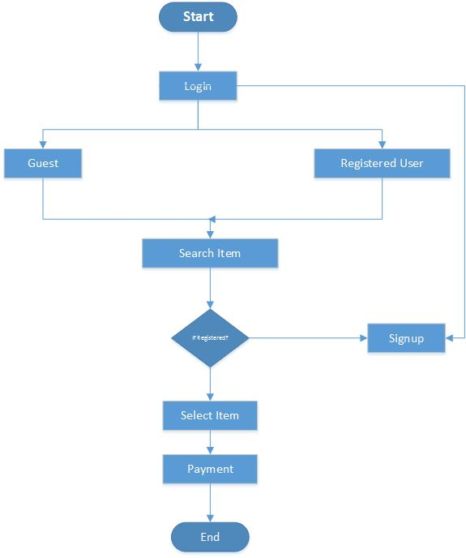

Figure 1.1 Activity Diagram

**System Architecture:**

The concise explanation of the application system architecture is reported below.



Figure 1.2 System Architecture

The Architecture diagram shows the basic representation of flow of the application. The developed all features are represented in nice GUI. The user access those developed features where they request by giving some input. On giving the input it gets connected to the database or the web services based on the feature the user has requested. Then he returns the required response data after the operations. Those returned data will be displayed to the GUI where the user can access.

**Class Diagram:**

The class diagram for the application:

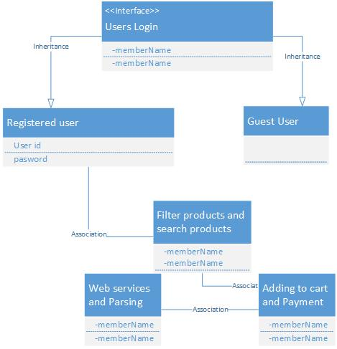

Figure 1.3 Class Diagram

The class diagram shows the main features in the project where divided into the classes. It also describes the relation between two classes. And in the classes it shows the features using and shown as the blueprint of an application for the developers.

**Sequence Diagram:**

The sequence diagram for the application:



Figure 1.4 Sequence Diagram

**Software Specifications:**

Tools: Visual Studio, Android Development Kit

Languages: Java, C#, ASP.Net, ADO.Net

Operating System: Android

Development Operating System: Windows 8

Database: SQL Server, SQLite

**Web Services:**

* eBay API - <http://developer.ebay.com/DevZne/Shopping/docs/CallRef/index.html>
* Super Market API - www.supermarketapi.com
* Amazon API - <https://developer.amazonservices.com/>

**Task Planning:**

The entire project is implementing by using latest technology tools and is done with four iterations.

In brief each iteration consists of following tasks:

1. Designing of graphical user interface.
2. Connecting to the database and implementing web services.
3. Making a payment and implementing recommendation tasks.
4. Testing the entire application and bug fixing.

The whole process of development and tasks division has been completely displayed in the scrum Do tool and below is the link for the Scrum DO action of our project.

<http://www.scrumdo.com/organization/umkc139/dashboard#>

**Team Members:**

* Ponnam Balakrishna ([BP8G6@mail.umkc.edu](mailto:BP8G6@mail.umkc.edu))
* Sirisha Valluri ([svb65@mail.umkc.edu](mailto:svb65@mail.umkc.edu))
* Shiva Shankar Kommineni ([skkw4@mail.umkc.edu](mailto:skkw4@mail.umkc.edu))
* Ramesh Kuthala ([rktg9@mail.umkc.edu](mailto:rktg9@mail.umkc.edu))

**References:**

* <https://www.google.com/>
* <http://developer.android.com/sdk/index.html>
* <http://msdn.microsoft.com/en-us/vstudio/aa718325.aspx>
* <http://www.w3schools.com/>
* <http://msdn.microsoft.com/en-us/library/vstudio/4w3ex9c2(v=vs.100).aspx>