CS560 Knowledge Discovery and Management

Feb. 4 (T), 2014

**LAB - 2**

**Report of Mobile Client Application Using Web Services**

**BY**

**Ponnam Balakrishna**

**16177831(BP8G6)**

This application describes the direction between two places. Google web service is used for this application. The JavaScript to show the distance between the source and destination is taken from Google maps web service. JavaScript URL from Google used for this application is [https://maps.googleapis.com/maps/api/js?v=3.exp&sensor=true](https://maps.googleapis.com/maps/api/js?v=3.exp&sensor=true%20)

The below screen shot shows the Initial page of this application

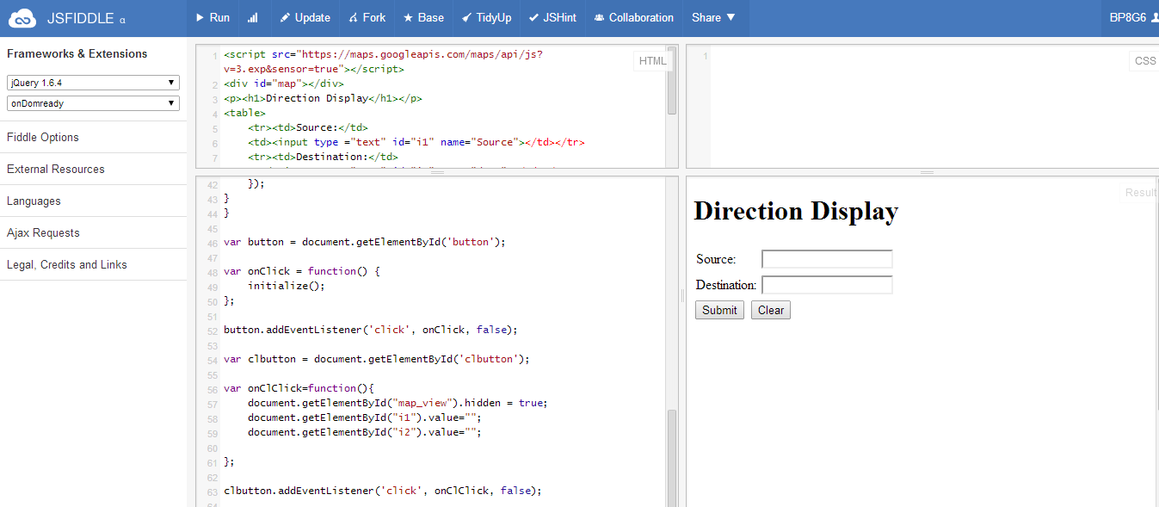

The above Screen shot has Source, Destination fields and submit and clear button.

**Source –** Need to mention From Place of the direction/distance.

**Destination –**Need to mention TO Place of the direction/distance.

**Submit –** By pressing this Button it gives the Direction in the Map between the Source and Destination.

**Clear** – By pressing this button it clears both the source, destination fields and the map. And can search for the direction between the other two places.

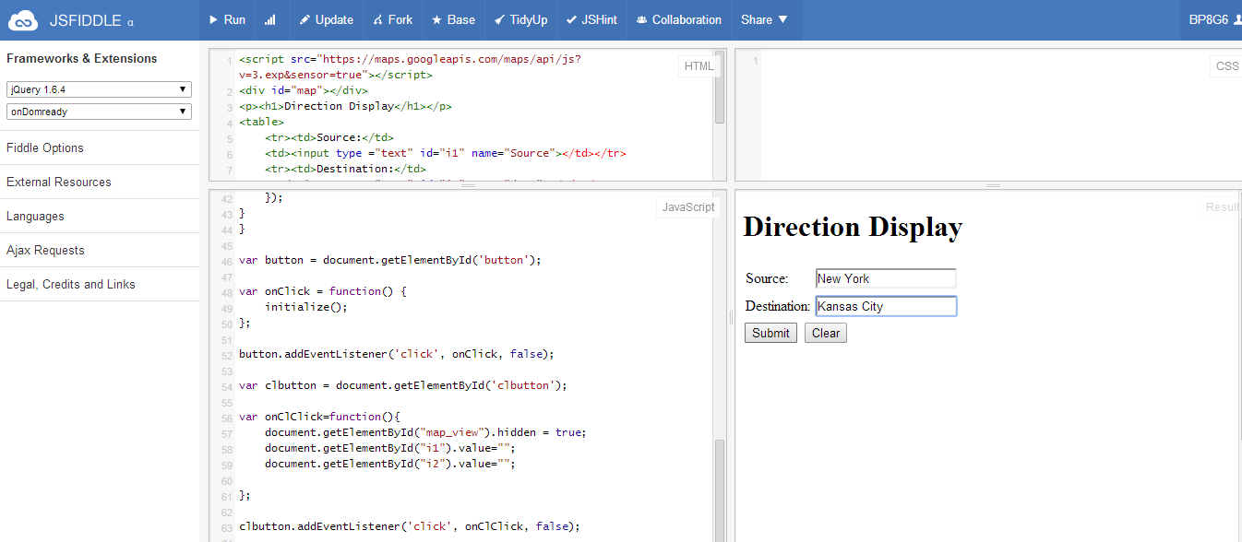

In the above screen shot the Source is mentioned as New York and the Destination as Kansas City. If we press the submit button we will get the direction from New York to Kansas City in the Map.Which can be seen in the below screen shot.

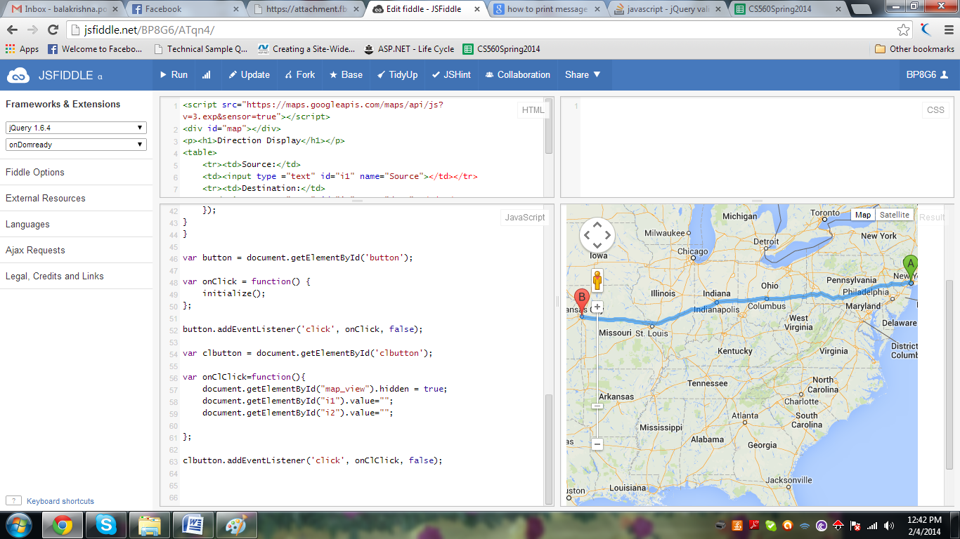

In the Above screen ‘A’ indicates the source and ‘B’ indicates the Destination. We can Zoom In /Zoom Out the map. Can also move the map in different directions and can see the Map/Satellite view to the see the direction between’ **A’** and **‘**B’.

If we press Clear button it clears the text fields of Source, Destination and the Map. Also shows the blank text fields to enter new Source and Destination.

Screenshot of after clicking the clear button

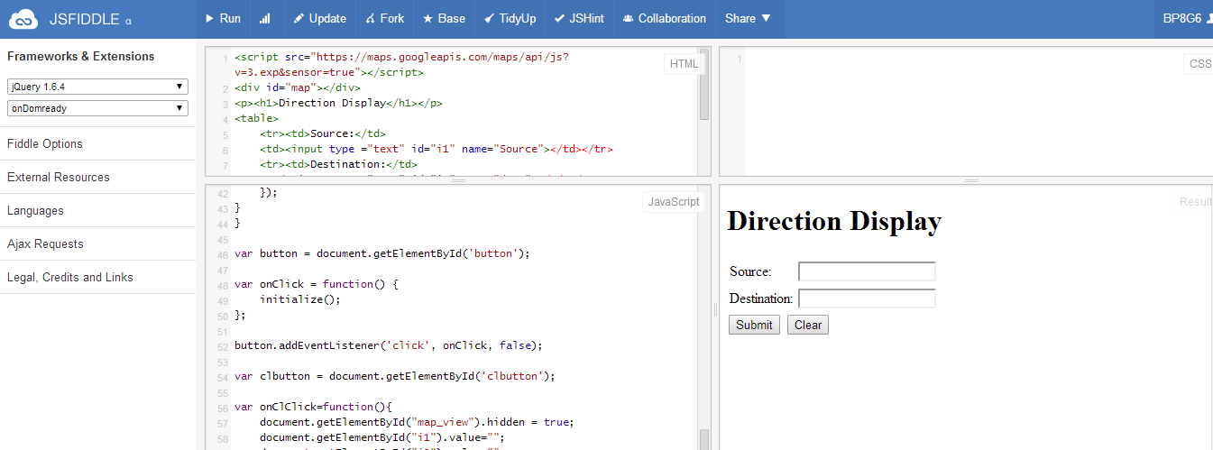

**URL of JSfiddle:**

<http://jsfiddle.net/BP8G6/ATqn4/>

**Source Code:**

**HTML:**

**<script src="https://maps.googleapis.com/maps/api/js?v=3.exp&sensor=true"></script>**

**<div id="map"></div>**

**<p><h1>Direction Display</h1></p>**

**<table>**

**<tr><td>Source:</td>**

**<td><input type ="text" id="i1" name="Source"></td></tr>**

**<tr><td>Destination:</td>**

**<td><input type="text" id="i2" name="dest"></td></tr>**

**</table>**

**<button id="button">Submit</button>**

**<button id="clbutton">Clear</button>**

**<div id="map_view" style="height: 500px; width: 500px"></div>**

**Java Script:**

**var directionDisplay;**

**var directionsService = new google.maps.DirectionsService();**

**var map2;**

**var Source;**

**var dest;**

**function initialize()**

**{**

**var Source = document.getElementById("i1").value;**

**var dest = document.getElementById("i2").value;**

**if(Source==""&& Destination=="")**

**{**

**}**

**else**

**{**

**document.getElementById("map_view").hidden = false;**

**directionsDisplay = new google.maps.DirectionsRenderer();**

**var center = new google.maps.LatLng(0, 0);**

**var myOptions =**

**{**

**zoom:7,**

**mapTypeId: google.maps.MapTypeId.ROADMAP,**

**center: center**

**}**

**map2 = new google.maps.Map(document.getElementById("map_view"), myOptions);**

**directionsDisplay.setMap(map2);**

**var request =**

**{**

**origin:Source,**

**destination:dest,**

**travelMode: google.maps.DirectionsTravelMode.DRIVING**

**};**

**directionsService.route(request, function(response, status)**

**{**

**if (status == google.maps.DirectionsStatus.OK)**

**{**

**directionsDisplay.setDirections(response);**

**}**

**});**

**}**

**}**

**var button = document.getElementById('button');**

**var onClick = function() {**

**initialize();**

**};**

**button.addEventListener('click', onClick, false);**

**var clbutton = document.getElementById('clbutton');**

**var onClClick=function(){**

**document.getElementById("map_view").hidden = true;**

**document.getElementById("i1").value="";**

**document.getElementById("i2").value="";**

**};**

**clbutton.addEventListener('click', onClClick, false);**