**SOLUTIONS**

**Q1. Display the states, gender affected and the confirmed cases in their respective states where confirmed cases are more than 100**

SELECT DISTINCT State, Gender, Confirmed

FROM death_and_recovery

INNER JOIN statewisedata

ON death_and_recovery.State = statewisedata.State_UT

WHERE Confirmed>100;

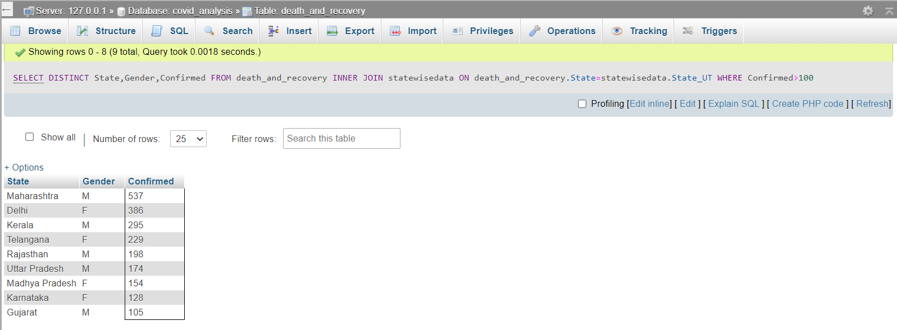

**Q2. Display the states which collected more than 1000 samples in day.**

SELECT statewisedata.sno as 'Serial No.', statewisedata.State_UT, icmrtestingdata.TotalSamplesTested

FROM icmrtestingdata

RIGHT join statewisedata

on statewisedata.sno = icmrtestingdata.sno

WHERE icmrtestingdata.TotalSamplesTested>1000;

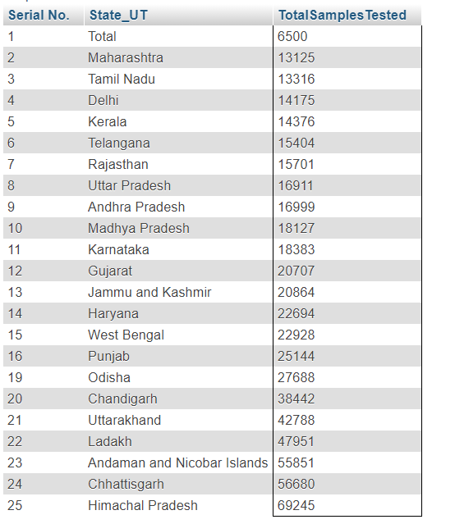

**Q3. Retrieve the state with maximum population, their density per sq km and group by descending order with respect to population**

SELECT Rank, State_UT, Population, Density_per_sqkm

FROM populationdistribution_2011census_

WHERE (State_UT, Population) IN

(SELECT State_UT, MAX(Population)

FROM populationdistribution_2011census_

GROUP BY Population);

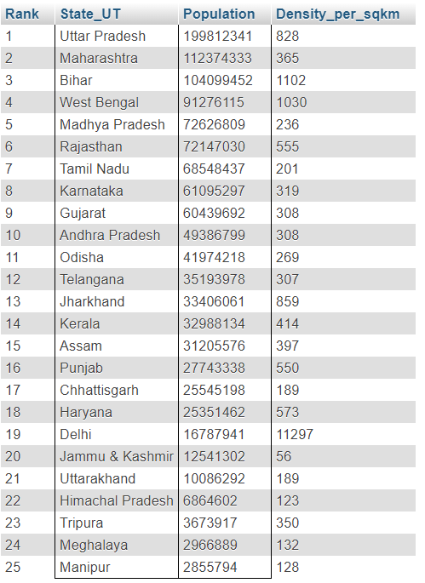

**Q4. Display the hospital beds along with their location where patients have recovered from covid-19 and those beds are made available to the needy patients waiting in the queue to get admitted.**

SELECT death_and_recovery.Patient_status as 'Patient Status', death_and_recovery.State, death_and_recovery.City, hospitalbeds.Beds_Available

FROM death_and_recovery

RIGHT join hospitalbeds

ON death_and_recovery.State = hospitalbeds.State_UT

WHERE death_and_recovery.Patient_status = 'Recovered';

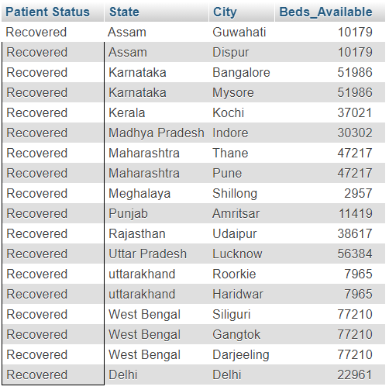

**Q5. Display the total number of people in assam who have recovered**

SELECT COUNT(Patient_status)

FROM death_and_recovery

WHERE Patient_status="Recovered" And State="Assam";

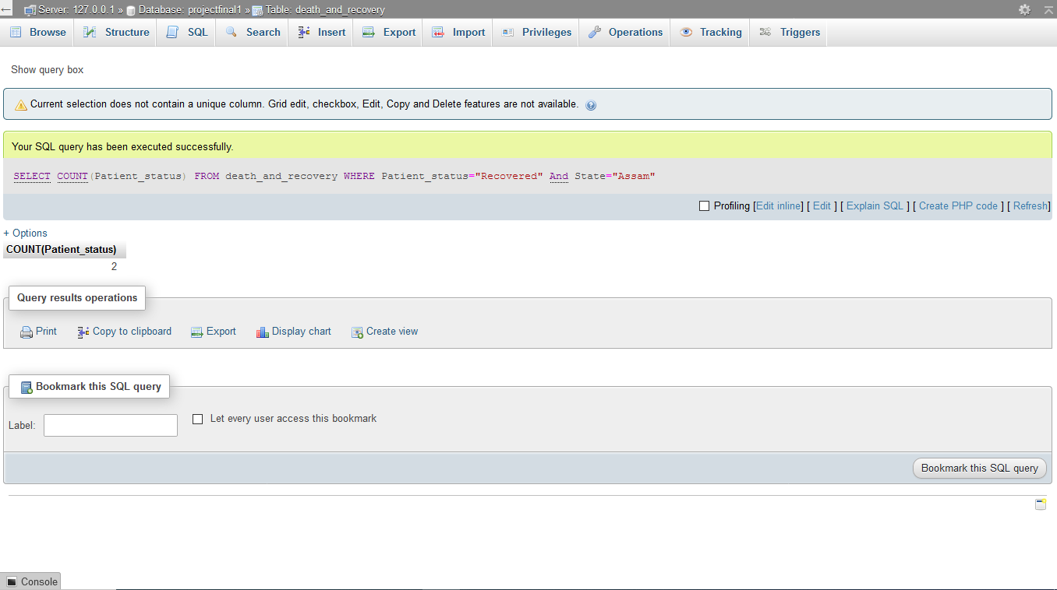

**Q6. Show the state, hospitals and beds available where beds and hospitals available are more than 1000.**

SELECT State_UT, Hospitals_Available, Beds_Available

FROM hospitalbeds WHERE Hospitals_Available>1000 AND Population_beds>1000;

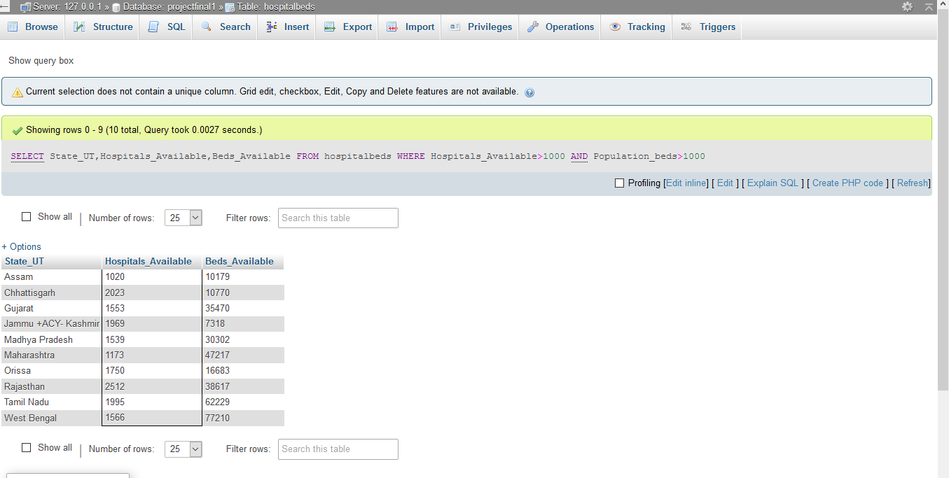

**Q7. Show states where active cases are less than 50**

SELECT State_UT FROM statewisedata WHERE Active<50;

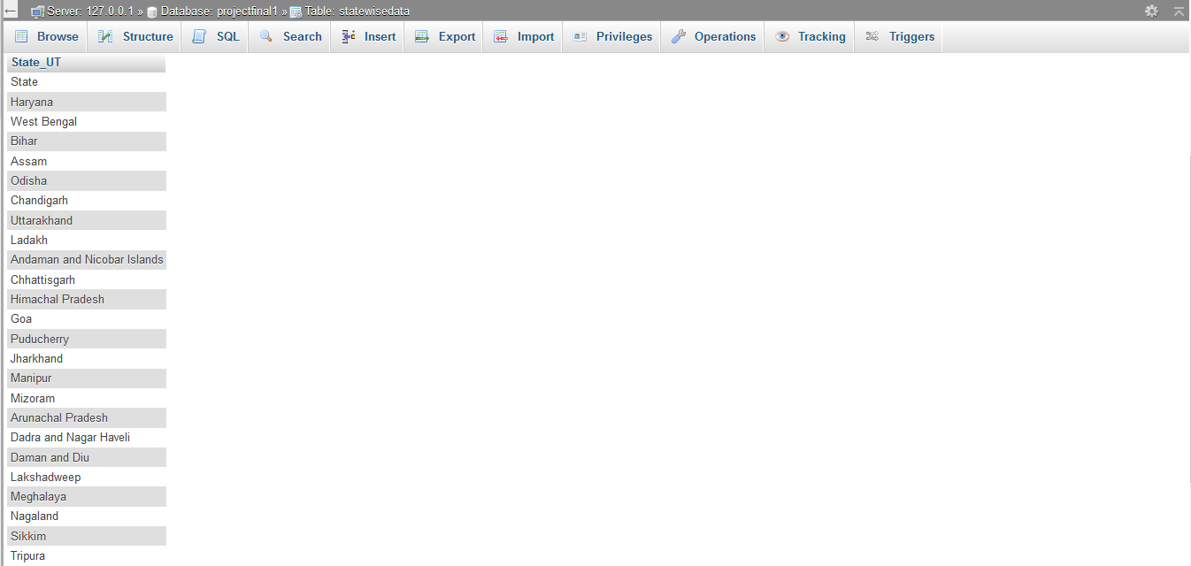

**Q8. Show the dates when the beds are available**

SELECT DISTINCT datewisepatients.Date, hospitalbeds.Beds_Available

FROM datewisepatients, hospitalbeds;

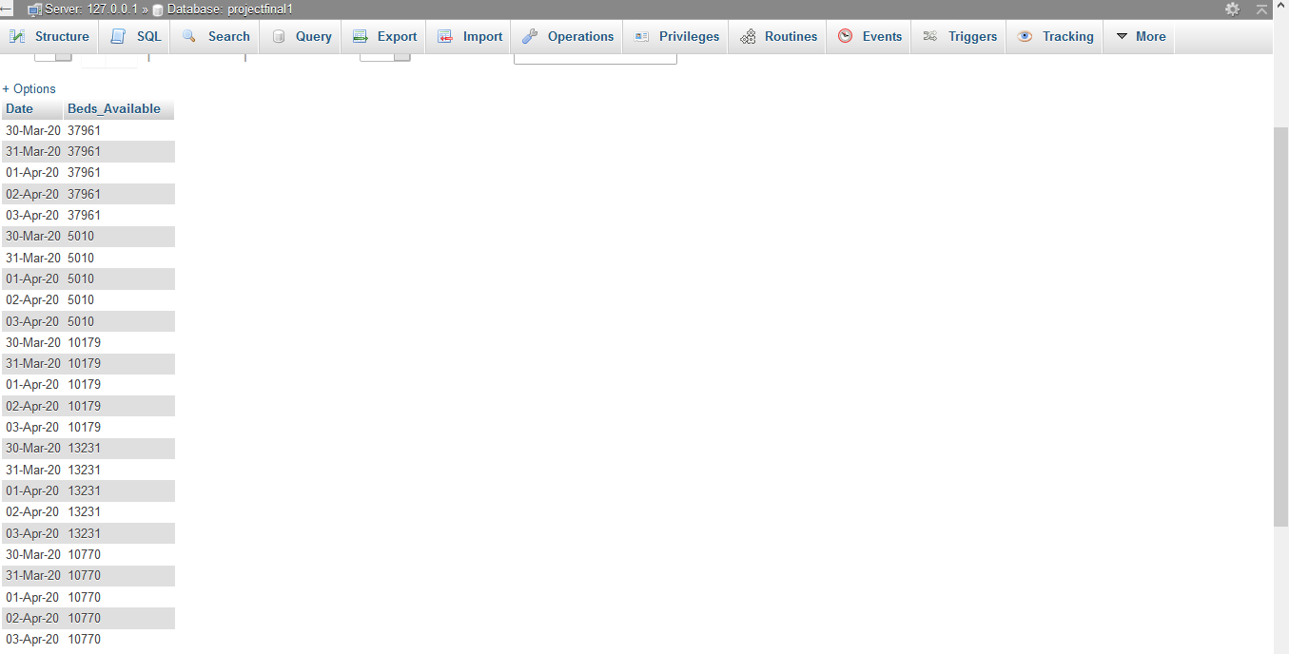

**Q9. Show the details of the number of samples tested across each timestamp**

SELECT distinct UpdatedTimeStamp, TotalSamplesTested

FROM icmrtestingdata where TotalSamplesTested<>"";

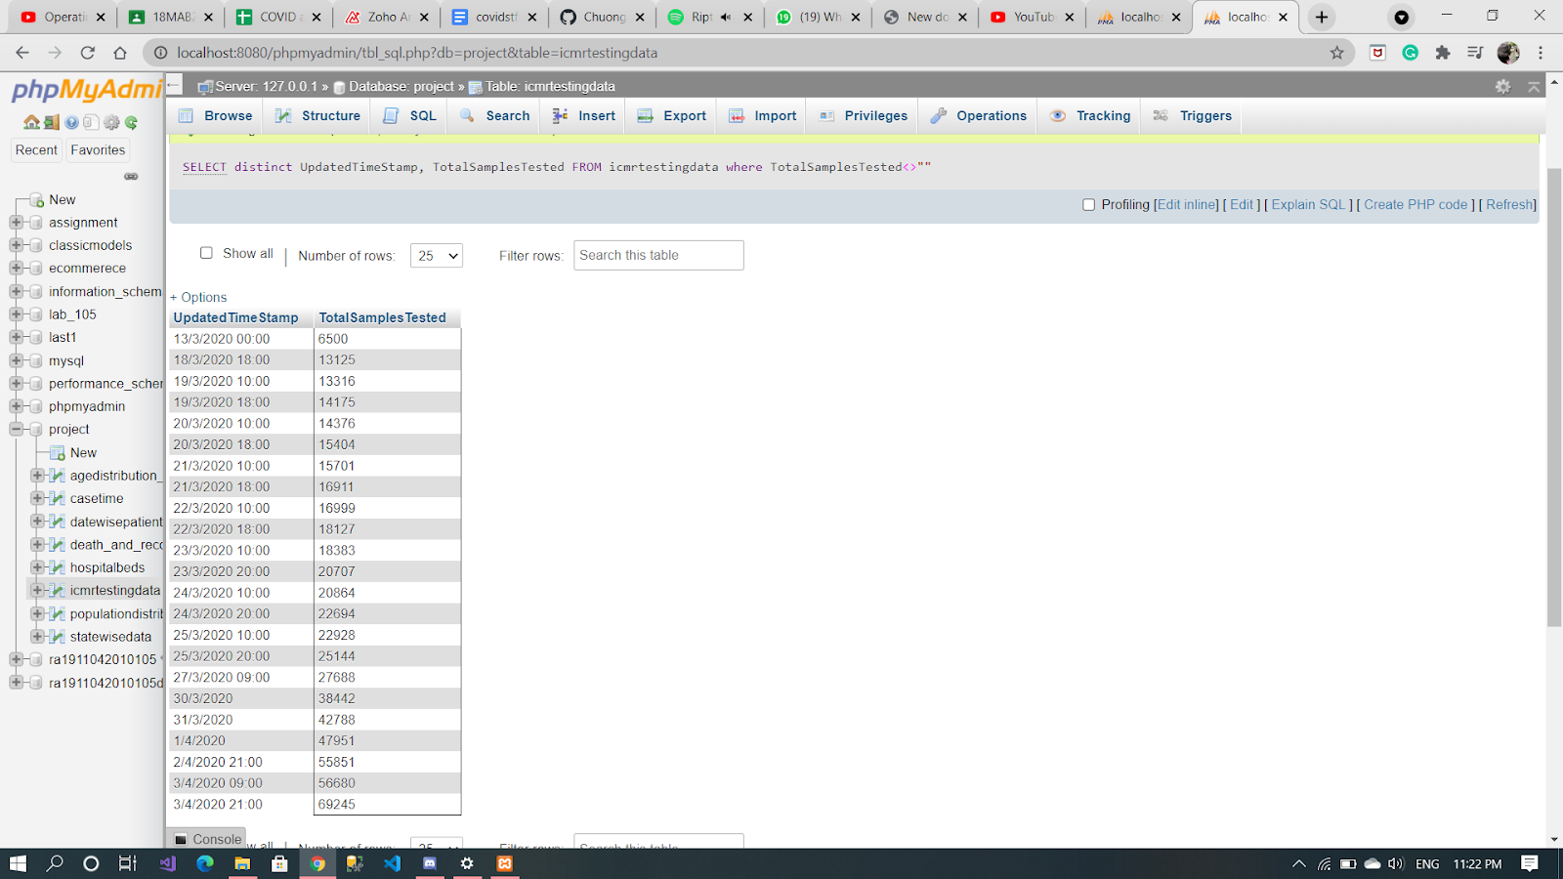

**Q10. Display the number of males and females who have recovered**

SELECT Gender, count(Gender) as 'Count'

FROM `death_and_recovery`

where Patient_status='Recovered' group by Gender;

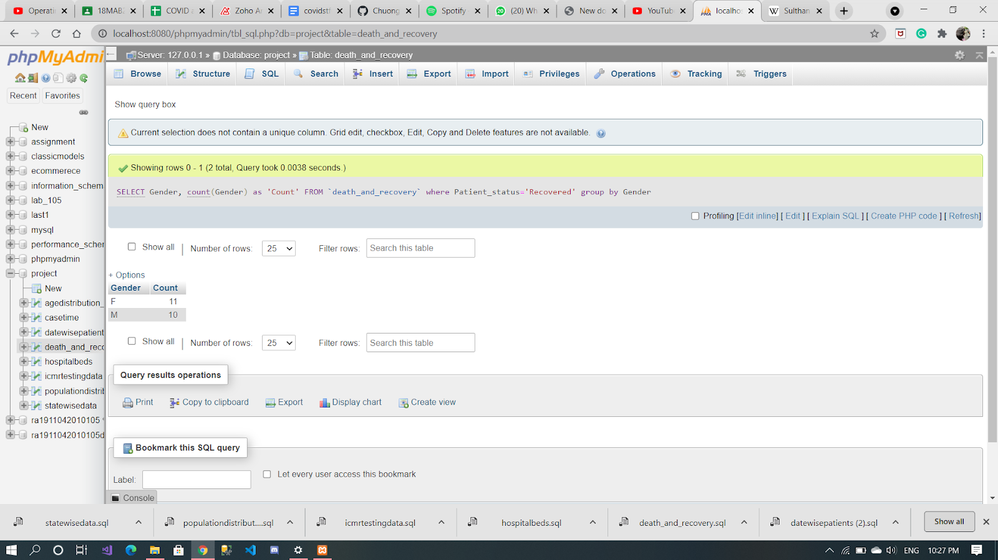

**Q11. List the states where the population is greater than the number of beds available in descending order of serial number**

SELECT State_UT, Beds_Available

FROM `hospitalbeds`

where Beds_Available<Population_beds order by sno desc ;

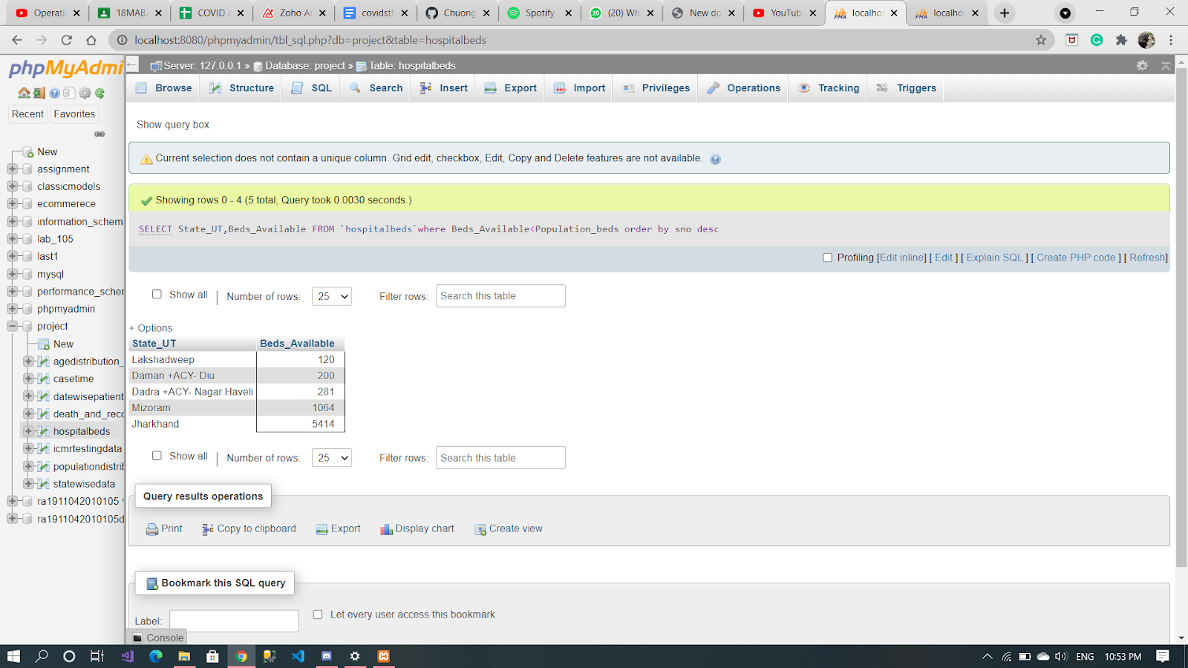

**Q12. Display the number of patients who have recovered along with their dates.**

SELECT Daily_confirmed as 'Dates', Total_recovered, status

from casetime join datewisepatients

on datewisepatients.Date = casetime.Daily_confirmed

where status='Recovered';

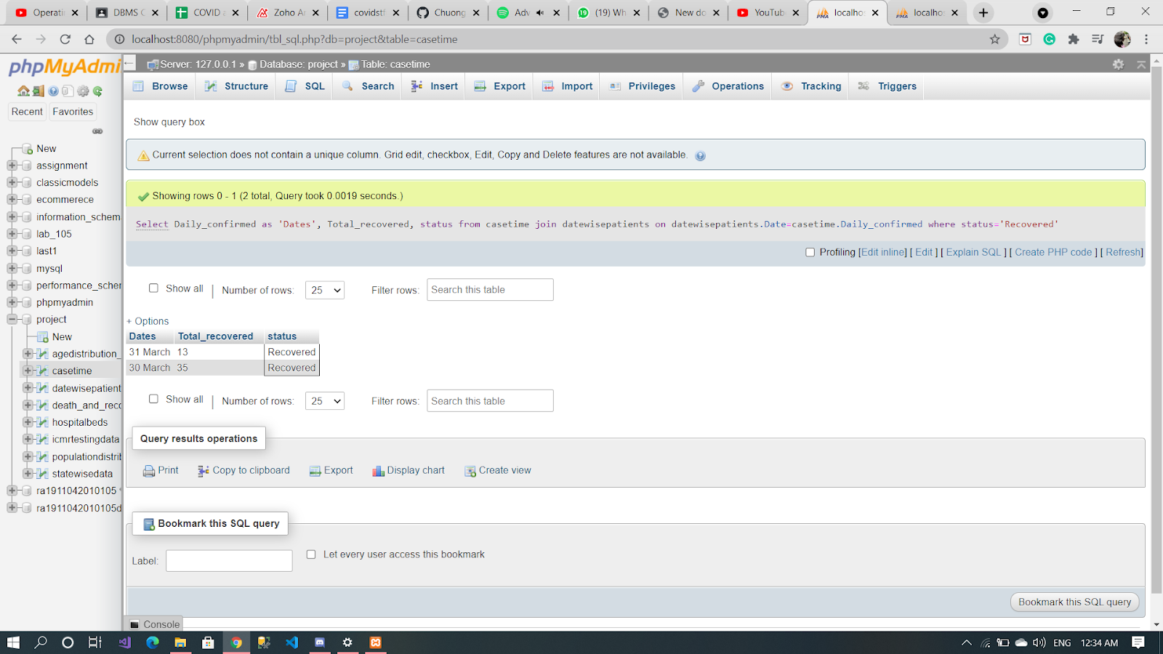

**Q13. Show the ratio of male and female to the whole population for all states**

SELECT sum(Male)/sum(population) as male_ratio,

sum(Female)/sum(population) as female_ratio

FROM populationdistribution_2011census_;

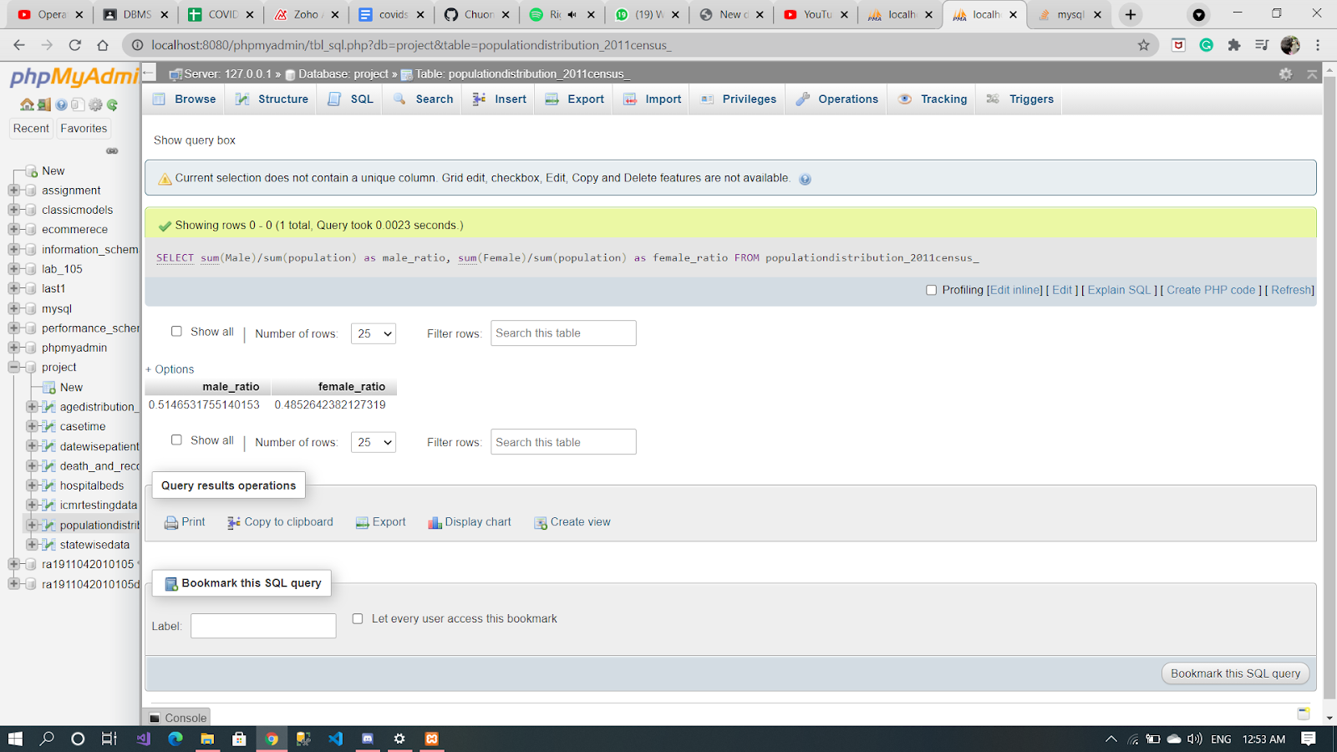

**Q14. Display the total number of beds available in Tamil Nadu**

SELECT Beds_Available FROM `hospitalbeds` WHERE State_UT=’Tamil Nadu’;

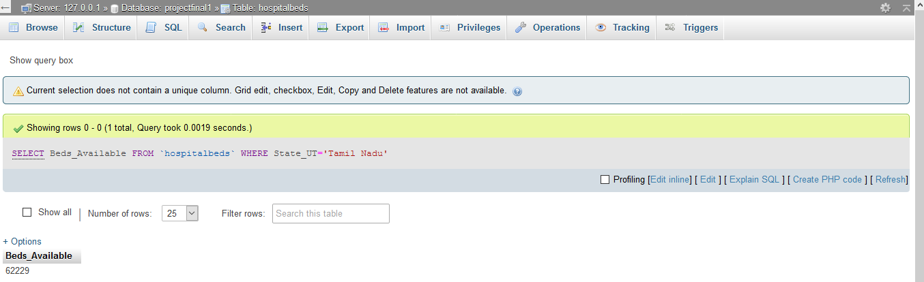

**Q15. Display the total number of beds available in India.**

SELECT SUM(Beds_Available) FROM `hospitalbeds`;

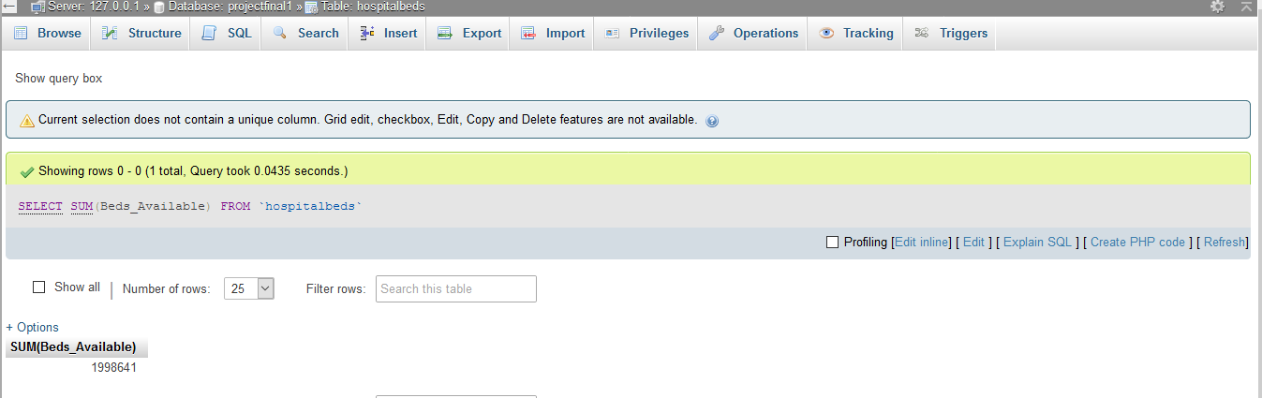

**Q16. Find out the Patients who tested negative after collection of samples.**

SELECT i.TotalSamplesTested , i.TotalPositiveCases, i.TotalSamplesTested- i.TotalPositiveCases AS Difference

FROM   icmrtestingdata as i

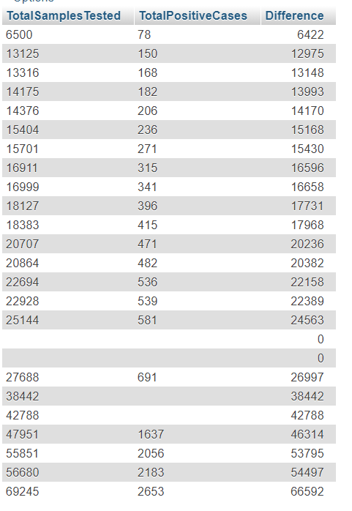

**Q17. Show TotalSamplesTested and TotalPositiveCases with date and time**

SELECT i.TotalSamplesTested , i.TotalPositiveCases, i.TotalSamplesTested- i.TotalPositiveCases AS Difference FROM icmrtestingdata as i;

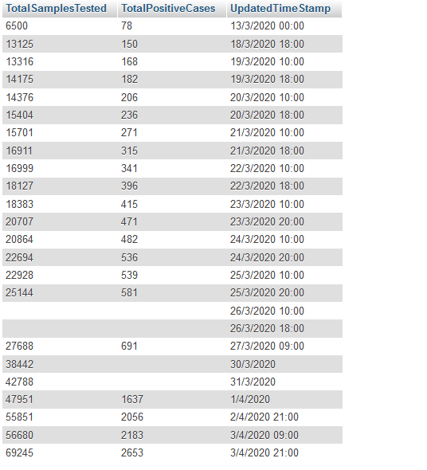

**Q18. Display the total number of hospitals available in India.**

SELECT DISTINCT TotalSamplesTested, TotalPositiveCases, UpdatedTimeStamp

FROM icmrtestingdata;

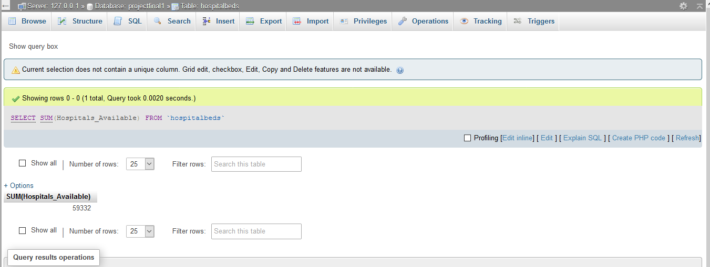

**Q19. Show the total population and active cases and the states.**

SELECT populationdistribution_2011census_.Population,statewisedata.Active,populationdistribution_2011census_.State_UT

FROM populationdistribution_2011census_

JOIN statewisedata

WHERE populationdistribution_2011census_.State_UT=statewisedata.State_UT;

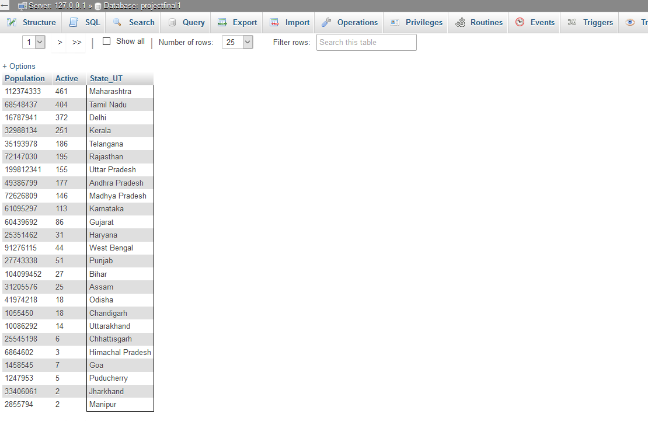

**Q20. Find the 3rd minimum population in the population_distribution table and also find out the State and area per sq km.**

SELECT populationdistribution_2011census_.Population, statewisedata.Active, populationdistribution_2011census_.State_UT FROM populationdistribution_2011census_

JOIN statewisedata WHERE populationdistribution_2011census_.State_UT=statewisedata.State_UT;

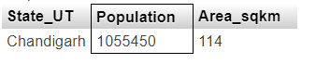

**Q21.Show the Active Cases that are falling under the even dates of march and April in their respective states**

SELECT DISTINCT State_UT, Population, Area_sqkm

from populationdistribution_2011census_ p1 where 3 = (select count (distinct Population) from populationdistribution_2011census_ p2 where p1.Population >= p2.Population);

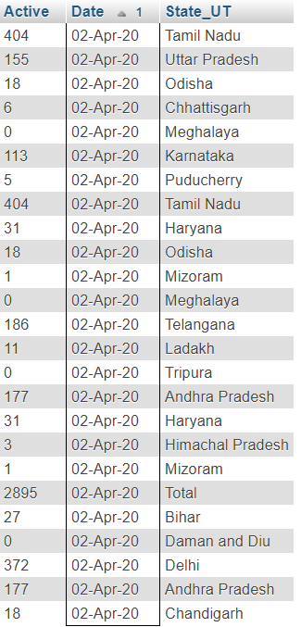

**Q22. Display the total confirmed cases till 31-March in Maharashtra**

SELECT statewisedata.Active, datewisepatients.Date, statewisedata.State_UT FROM statewisedata, datewisepatients WHERE MOD (datewisepatients.Date,2) =0 ORDER BY datewisepatients.Date;

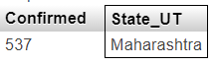

**Q23. Find the ratio of female to male between the age group of 50-54**

SELECT Confirmed,State_UT

FROM statewisedata

WHERE statewisedata.Last_updad_time <='31/03/2020 23:07:28' AND statewisedata.State_UT='Maharashtra';

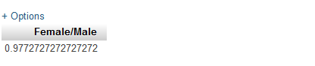

**Q24. Display the total percentage of male and female being affected by covid-19 ranging between ‘0-50’**

SELECT SUM(Female), SUM(Male)

FROM agedistribution_2016_estimates_

WHERE Age_group BETWEEN '0-4' AND '45-50';

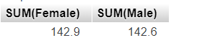

**Q 25. Display the States, recovered cases and their population living under where area is less than 4000 sq km.**

SELECT populationdistribution_2011census_.State_UT, statewisedata.Recovered, populationdistribution_2011census_.Population

FROM populationdistribution_2011census_ LEFT JOIN statewisedata ON populationdistribution_2011census_.State_UT=statewisedata.State_UT WHERE Area_sqkm< 4000;

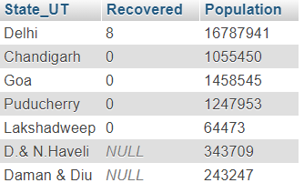

**Q 26. Find out the recovery rate among the states and display it along with the names of the states and the number of recovered & active cases.**

SELECT Recovered, Active, State_UT, (Recovered/Active) *100 FROM `statewisedata`;

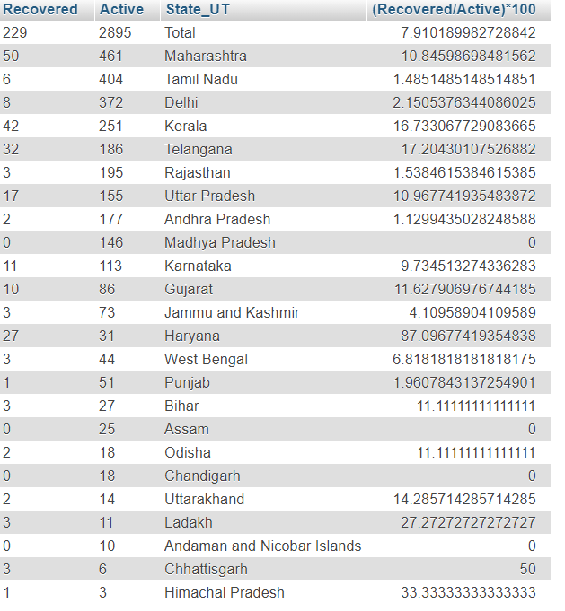

**Q 27. Display the age and the origin of those who recovered from covid-19 and is of masculine gender.**

SELECT death_and_recovery.Age, death_and_recovery.State FROM `death_and_recovery`

JOIN statewisedata ON death_and_recovery.State=statewisedata_.State_UT

WHERE Patient_status="Recovered" and death_and_recovery.Gender="M";

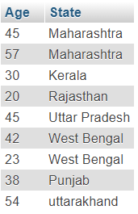

**Q 28. Display the states along with the ratio of Beds available against the total population beds**

SELECT State_UT, Beds_Available, Population_beds, Beds_Available/Population_beds FROM `hospitalbeds`;

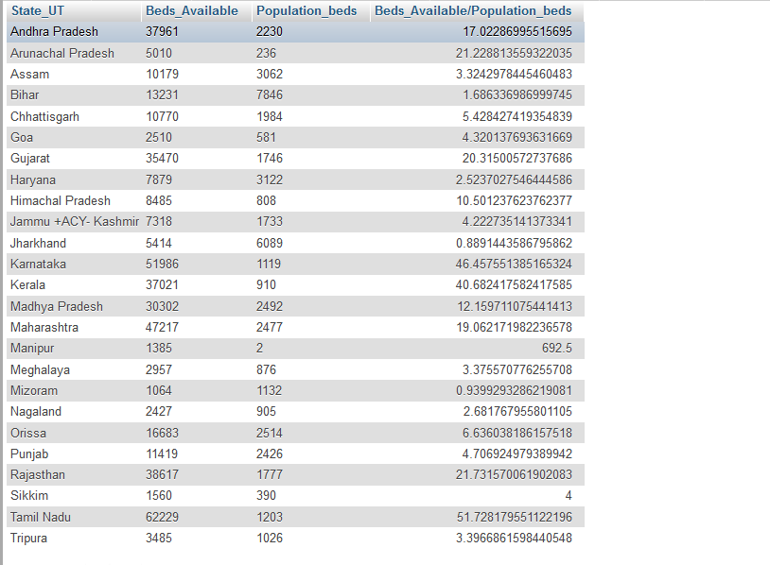

**Q29. Display the status of the patients in all the cities**

SELECT DISTINCT death_and_recovery.Patient_status,death_and_recovery.City

FROM death_and_recovery JOIN statewisedata ON statewisedata. State_UT=death_and_recovery.State

WHERE Age= ANY (SELECT Age FROM death_and_recovery);

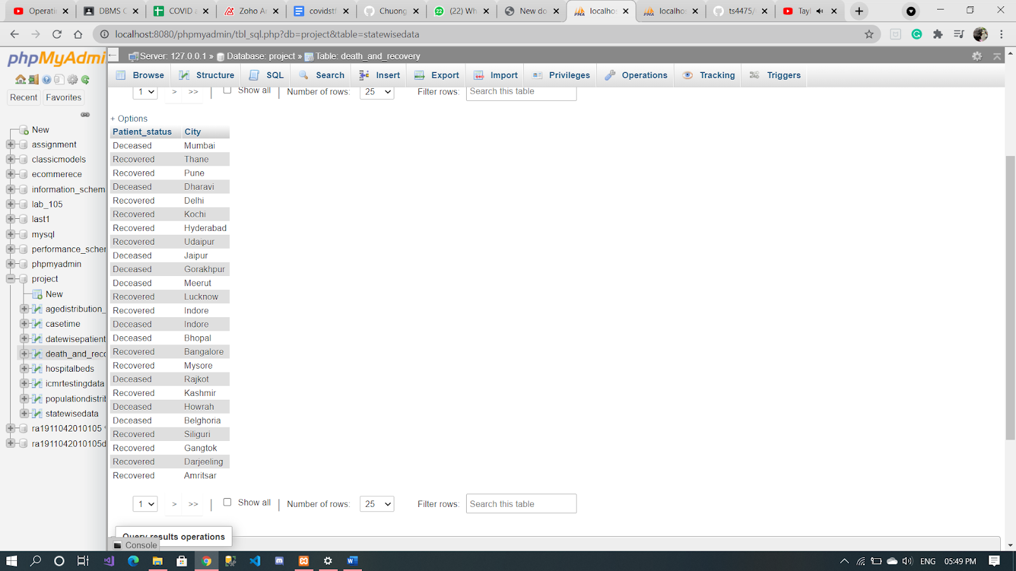

**Q30. Display the death ratio of each state**

SELECT State_UT, death/confirmed as 'Death ratio' from statewisedata;

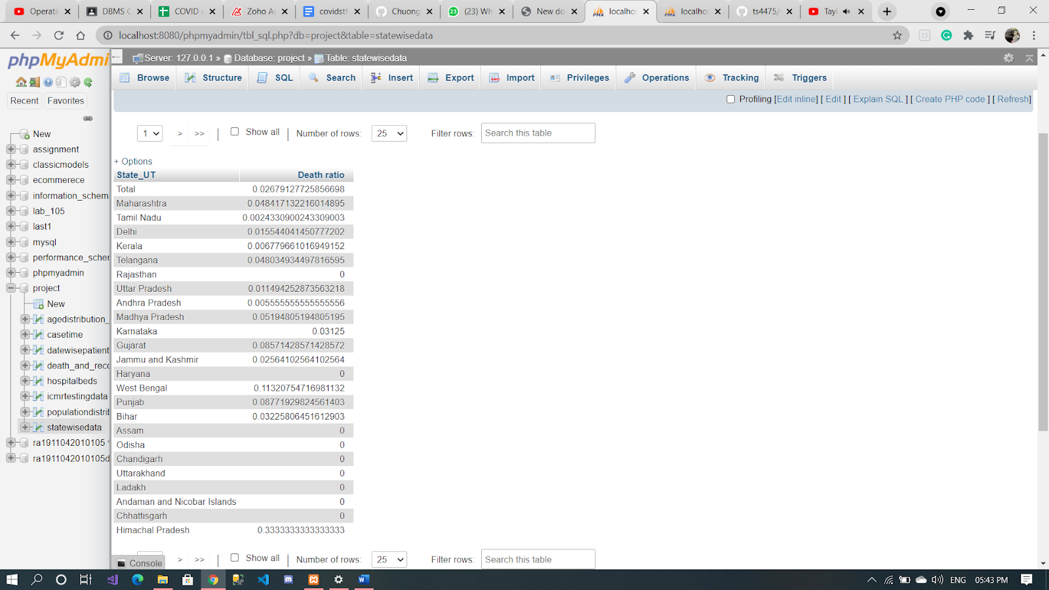

**Q31. Display the population, hospital beds, ratio of hospital beds to population in every state**

SELECT populationdistribution_2011census_.Population, hospitalbeds.Hospitals_Available, hospitalbeds.Hospitals_Available/populationdistribution_2011census_.Population

FROM populationdistribution_2011census_

JOIN hospitalbeds ON populationdistribution_2011census_.State_UT=hospitalbeds.State_UT;

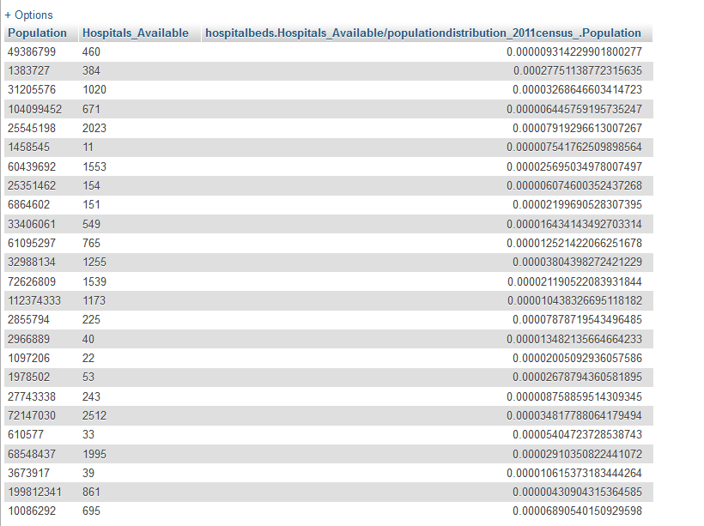

**Q32. Display the ratio of affected people in every state**

SELECT statewisedata.State_UT,confirmed/population as 'Ratio of affected people' from statewisedata join populationdistribution_2011census_ on populationdistribution_2011census_.State_UT=statewisedata.State_UT;

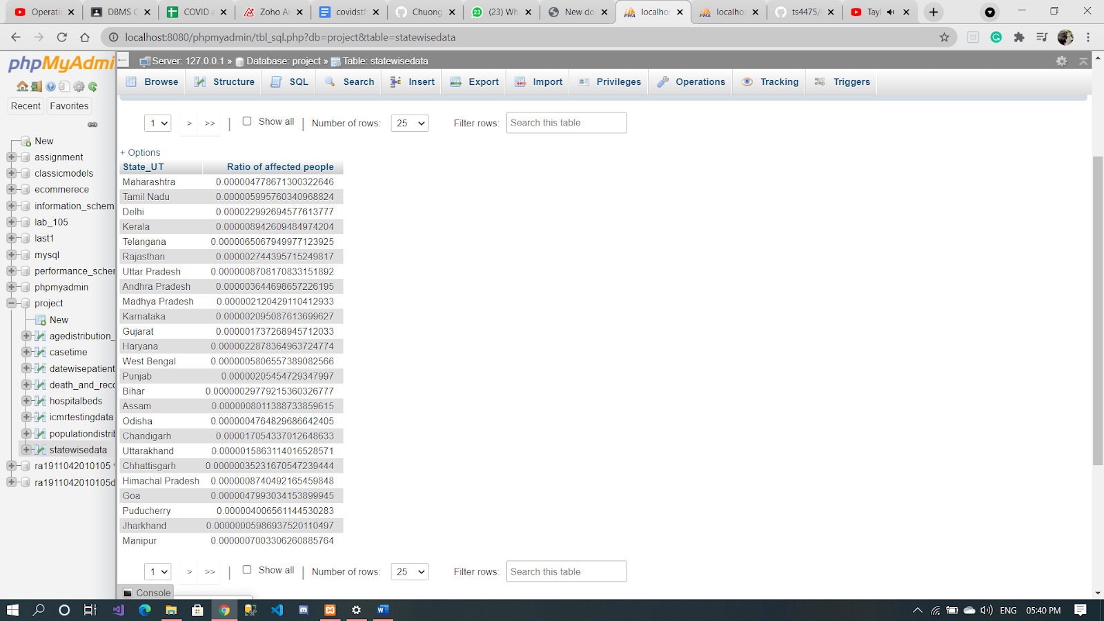

**Q33. Display the first five affected states along with their respective active cases using PL/SQL**

DECLARE

type states IS VARRAY(10) OF VARCHAR2(20);

type actives IS VARRAY(7) OF INTEGER;

state states;

active actives;

total integer;

BEGIN

state := states('Maharashtra','Tamil Nadu','Delhi','Kerala','Karnataka');

active:= actives(461, 404, 372,251,113);

total := state.count;

dbms_output.put_line('First '|| total || ' States with maximum covid cases are:-');

FOR i in 1 .. total LOOP

dbms_output.put_line('State'||i||':' || state(i) || '

Active Cases: ' || active(i));

END LOOP;

END;

/

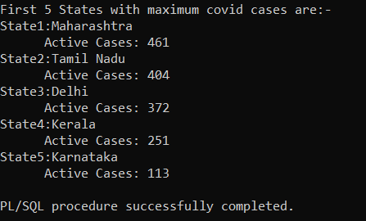

**Q34. Check whether one belongs between the age 20-24 and also display the total population affected within the given range using PL/SQL**

DECLARE

age number(10) := 0;

age1 number(10) := 24;

BEGIN

age:= 20;

age1:= 25;

-- check the boolean condition using if statement

IF( age < 25) THEN

-- if condition is true then print the following

dbms_output.put_line('Age is between 20-24' );

ELSE

dbms_output.put_line('Age is above 24' );

END IF;

dbms_output.put_line('Total Population affected within 20-24 is 35%') ;

END;

/

