Background

* Look at Olympic data gold medals and temperature data by country
  + City where Olympic was located - potentially

Data Sources:

* Olympic – Kaggle – <https://www.kaggle.com/heesoo37/120-years-of-olympic-history-athletes-and-results?select=athlete_events.csv>
  + This is a historical dataset on the modern Olympic Games, including all the Games from Athens 1896 to Rio 2016.
* Temperature – Kaggle – <https://www.kaggle.com/berkeleyearth/climate-change-earth-surface-temperature-data?select=GlobalLandTemperaturesByCountry.csv>
  + - Trim to Olympic years wanted

Visualizations

* Display Olympic data gold medals mapped against the average temperature by country
* Temperature of Cities where Olympics were held and look at temperature based on where gold medal winner was from

[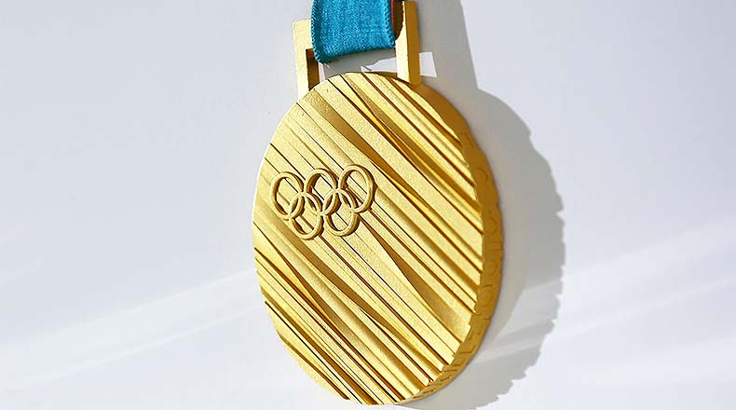](https://www.google.com/imgres?imgurl=https%3A%2F%2Fathlonsports.com%2Fsites%2Fathlonsports.com%2Ffiles%2Fgoldmedal_PyeongChang_Olympics_2018_0.jpg&imgrefurl=https%3A%2F%2Fathlonsports.com%2Folympics%2Folympic-gold-medal-actually-made-gold&tbnid=GNieMF_O-QohLM&vet=12ahUKEwirv7qH84rtAhXoT98KHYzjA_4QMygJegUIARCvAg..i&docid=GG1ZhTHkyue76M&w=790&h=440&q=gold%20medal&client=firefox-b-1-d&ved=2ahUKEwirv7qH84rtAhXoT98KHYzjA_4QMygJegUIARCvAg)

