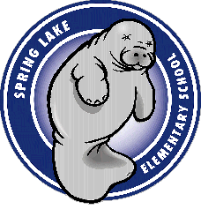

Seminole County Public Schools
Spring Lake Elementary School
2009-2010 Image Consent Form

PICTURES/VIDEOTAPING/TELEVISION BROADCASTS

The photographing, videotaping and broadcasting of class activities, school functions and events are common and customary practices on public school campuses and the images are used within the school campus. When student photos or videos are distributed to outside sources for publication to the general public, parent consent is requested.

Regarding distribution of student photos, video tapes, or broadcasts to the media or outside sources, including the school or county web page, parent consent must be maintained on file by the school. Please complete the following form as indicated below and return to the principal by August 28, 2009, or within 10 days of enrollment.

Student Name _________________________________________________________________

Grade ________________________________ Teacher _______________________________

My child’s image/photograph may be released to the media and/or outside sources as explained above.

Yes

No

Parent or Legal Guardian (please print) ______________________________________________

Parent or Legal Guardian Signature _________________________________________________

Date _______________________________

