**Star Wars: Return of the Jedi**

**Scene 28: Meeting Jabba**

**Greetings Exalted One**. Allow me to introduce myself. I am **Luke Skywalker**, *Jedi Knight* and friend to Captain Solo. I know that you are powerful, mighty Jabba, and that your anger with Solo must be equally powerful. Learn more about Luke’s Story (link to http://en.wikipedia.org/wiki/Luke_Skywalker)

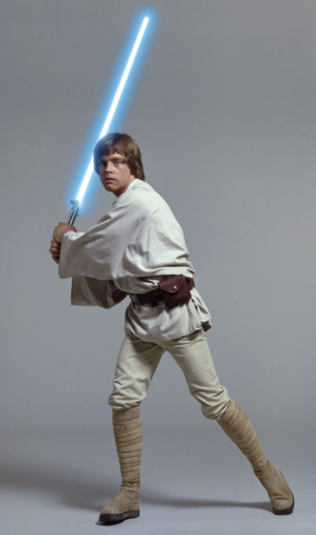  
  
I seek an audience with *Your Greatness* to bargain for Solo's life. With your wisdom, I'm sure that we can work out an arrangement, which will be mutually beneficial and enable us to avoid any unpleasant confrontation. As a token of my goodwill, I present to you a gift: these two droids. What did he say? Both are hardworking and will serve you well.

**Class One Droid Types**

* Mechanical
* Biological
* Physical
* Mathematics

Of course I'm worried. And you should be, too. Lando Calrissian and poor Chewbacca never returned from this awful place. Artoo whistles timidly. Don't be so sure. If I told you half the things I've heard about this **Jabba the Hutt**, you'd probably short-circuit. Artoo, are you sure this is the right place? I better knock, I suppose. There doesn't seem to be anyone there. Let's go back and tell Master Luke.

**Scene 45: Freed from the Carbonite**

You're free of the carbonite. Shhh. You have hibernation sickness. I can't see. Your eyesight will return in time. Where am I? Jabba's palace. Who are you? Someone who loves you. Leia! I gotta get you out of here. What's that? I know that laugh. Hey, Jabba. Look, Jabba, I was just on my way to pay you back, but I got a little sidetracked. It's not my fault. It's too late for that, Solo.

You may have been a good smuggler, but now you're Bantha fodder.  
 Look... Take him away! Jabba...  
I'll pay you triple!   
You're throwing away a fortune here.

**Classes of Droids**

There are **five classes** of droids that are used to classify droids. Droids were divided based upon *creativity, intelligence*, and *capacity for independent thought*. It also depended on the nature of work they were built for. Learn more about from the Star Wars Wikipedia Site (link to http://en.wikipedia.org/wiki/Star_Wars)

1. **Class One**droids were programmed to work in the fields of *mathematics, physics, physical sciences, and medicine*.
2. **Class Two** droids were programmed in *engineering and other technical sciences.*
3. **Class Three**droids are programmed to *interact with humans*. They were said to be the most ***advanced droids ever invented***.
4. **Class Four** droids were programmed to fight. Almost all class four droids carried weapons. Armed combat droids were among the first droids ever created.

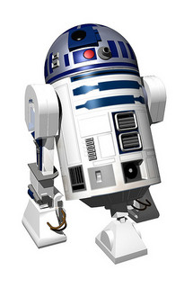

Where is that shuttle going? ***Shuttle Tydirium***, what is your cargo and destination? Parts and technical crew for the forest moon. Do they have a code clearance? It's an older code, sir, but it checks out. I was about to clear them. Shall I hold them? No. Leave them to me. I will deal with them myself. As you wish, my lord. Carry on. They're not goin' for it, Chewie.  
**Shuttle Tydirium**, deactivation of the shield will commence immediately.   
Follow your present course. Okay! I told you it was gonna work. *No problem*.

**RED Academy. Web Developer Essentials: Intro to HTML Lab Exercise.   
For Educational Purposes Only.**