* Requirements (2)
  + Use Case Model
  + Actor Details
  + Use Case Details
* Technology Plan (1)
* Risk Analysis (1)
* Effort Estimate (2)
  + Nominal Effort Calculation
  + Effort Estimate
* Initial Architecture

Requirements

Use Case Model

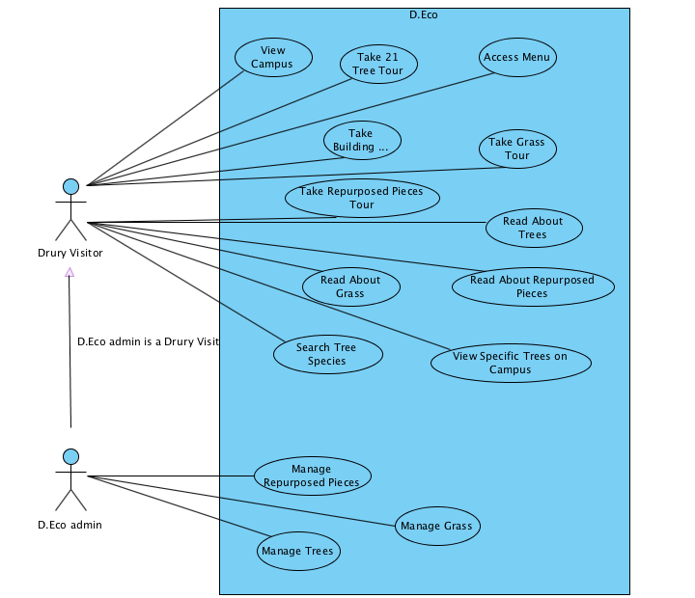

Actor Details

|  |  |
| --- | --- |
| Actor | Description |
| Drury Visitor | A Drury visitor is a person who uses the app to explore Drury’s buildings, grasses, and trees |
| D.Eco Admin | A D.Eco admin is a person who can manage (add, delete) the building, grass, and tree information |

Use Case Details

|  |  |
| --- | --- |
| Use Case | Description |
| View Campus | A *Drury Visitor* looks at the campus map, which contains options to look at trees, buildings, or repurposes pieces, or grass. In addition, they can see their current location. |
| Take 21 Tree Tour | A *Drury Visitor* views trees on map and is able to see their current location. In addition, they can click on specific trees. |
| Access Menu | A *Drury Visitor* can select which tour they want to take (tree, repurposed pieces, grass or building) |
| Take Building Tour | Drury Visitor views buildings on the campus map and is able to see their name and information about the building. |
| Take Grass Tour | A *Drury Visitor* looks at different species located on campus and is able to see information about the species. |
| Take Repurposed Pieces Tour | A *Drury Visitor* looks at the different pieces on campus and can click on more information about the pieces. |
| Read About Trees | A *Drury Visitor* reads detailed information (species, paragraph about, in honor of person, and pictures) about the specific tree clicked. |
| Read About Repurposed Pieces | A *Drury Visitor* reads detailed information about specific repurposed piece clicked. |
| Read About Grass | A *Drury Visitor* reads detailed information about specific grass clicked. |
| View Specific Trees on Campus | A *Drury Visitor* can see the unique species mapped on the campus. |
| Search Trees Species | A *Drury Visitor* uses a search bar to look for specific species on Drury’s campus |
| Manage Repurposed Pieces | A *D.Eco Admin* adds, deletes, or edit information about repurposed places. |
| Manage Grass | A *D.Eco Admin* adds, deletes, or edit information about grasses. |
| Manage Trees | A *D.Eco Admin* adds, deletes, or edit information about trees. |

Technology Plan

Risk Analysis

Effort Estimate

Initial Architecture