Chapter 01.01

Introduction to Numerical Methods

After reading this chapter, you should be able to:
- understand the need for numerical methods, and
- go through the stages (mathematical modeling, solving and implementation) of solving a particular physical problem.

Mathematical models are an integral part in solving engineering problems. Many times, these mathematical models are derived from engineering and science principles, while at other times the models may be obtained from experimental data.
Mathematical models generally result in need of using mathematical procedures that include but are not limited to
- differentiation,
- nonlinear equations,
- simultaneous linear equations,
- curve fitting by interpolation or regression,
- integration, and
- differential equations.
These mathematical procedures may be suitable to be solved exactly as you must have experienced in the series of calculus courses you have taken, but in most cases, the procedures need to be solved approximately using numerical methods. Let us see an example of such a need from a real-life physical problem.
To make the fulcrum (Figure 1) of a bascule bridge, a long hollow steel shaft called the trunnion is shrink fit into a steel hub. The resulting steel trunnion-hub assembly is then shrink fit into the girder of the bridge.
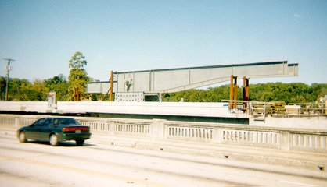 | 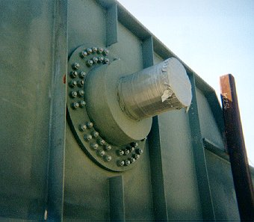  Trunnion  Hub  Girder
Figure 1 Trunnion-Hub-Girder (THG) assembly.

This is done by first immersing the trunnion in a cold medium such as a dry-ice/alcohol mixture. After the trunnion reaches the steady state temperature of the cold medium, the trunnion outer diameter contracts. The trunnion is taken out of the medium and slid through the hole of the hub (Figure 2).
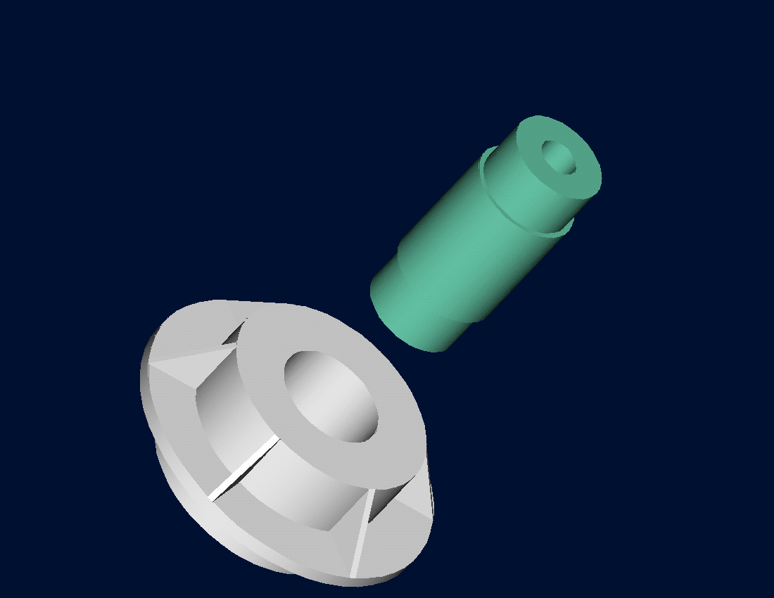
Figure 2 Trunnion slided through the hub after contracting

When the trunnion heats up, it expands and creates an interference fit with the hub. In 1995, on one of the bridges in Florida, this assembly procedure did not work as designed. Before the trunnion could be inserted fully into the hub, the trunnion got stuck. Luckily, the trunnion was taken out before it got stuck permanently. Otherwise, a new trunnion and hub would needed to be ordered at a cost of $50,000. Coupled with construction delays, the total loss could have been more than a hundred thousand dollars.
Why did the trunnion get stuck? This was because the trunnion had not contracted enough to slide through the hole. Can you find out why?
A hollow trunnion of outside diameter 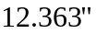 is to be fitted in a hub of inner diameter 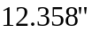. The trunnion was put in dry ice/alcohol mixture (temperature of the fluid - dry ice/alcohol mixture is 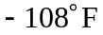) to contract the trunnion so that it can be slid through the hole of the hub. To slide the trunnion without sticking, a diametrical clearance of at least 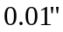 is required between the trunnion and the hub. Assuming the room temperature is 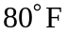, is immersing the trunnion in dry-ice/alcohol mixture a correct decision?
To calculate the contraction in the diameter of the trunnion, the thermal expansion coefficient at room temperature is used. In that case the reduction 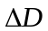 in the outer diameter of the trunnion is
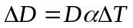 (1)
where
D = outer diameter of the trunnion,
coefficient of thermal expansion coefficient at room temperature, and
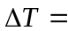change in temperature,
Given
D =
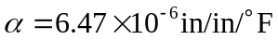 at
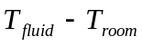
= 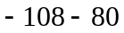
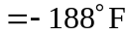
where
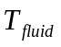= temperature of dry-ice/alcohol mixture
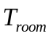= room temperature
the reduction in the outer diameter of the trunnion is given by
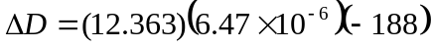
= 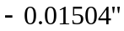
So the trunnion is predicted to reduce in diameter by 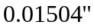. But, is this enough reduction in diameter? As per specifications, the trunnion needs to contract by
= trunnion outside diameter - hub inner diameter + diametric clearance
= 12.363 – 12.358 + 0.01
= 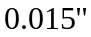
So according to his calculations, immersing the steel trunnion in dry-ice/alcohol mixture gives the desired contraction of greater than as the predicted contraction is . But, when the steel trunnion was put in the hub, it got stuck. Why did this happen? Was our mathematical model adequate for this problem or did we create a mathematical error?
As shown in Figure 3 and Table 1, the thermal expansion coefficient of steel decreases with temperature and is not constant over the range of temperature the trunnion goes through. Hence, Equation (1) would overestimate the thermal contraction.
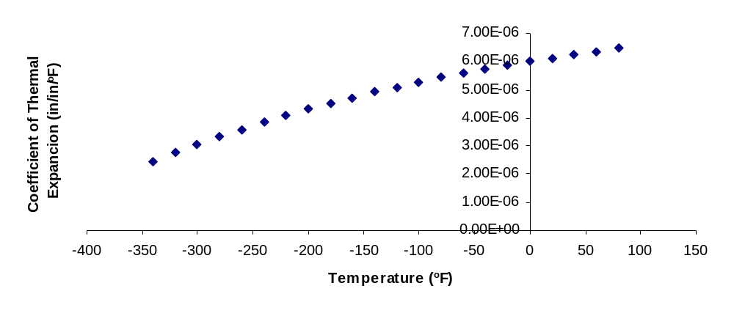
Figure 3 Varying thermal expansion coefficient as a function of temperature for cast steel.

The contraction in the diameter of the trunnion for which the thermal expansion coefficient varies as a function of temperature is given by
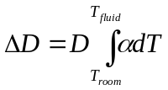 (2)
So one needs to curve fit the data to find the coefficient of thermal expansion as a function of temperature. This is done by regression where we best fit a curve through the data given in Table 1. In this case, we may fit a second order polynomial
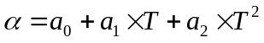 (3)

Table 1 Instantaneous thermal expansion coefficient as a function of temperature.
Temperature | Instantaneous  Thermal Expansion
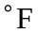 | 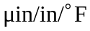
80 | 6.47
60 | 6.36
40 | 6.24
20 | 6.12
0 | 6.00
-20 | 5.86
-40 | 5.72
-60 | 5.58
-80 | 5.43
-100 | 5.28
-120 | 5.09
-140 | 4.91
-160 | 4.72
-180 | 4.52
-200 | 4.30
-220 | 4.08
-240 | 3.83
-260 | 3.58
-280 | 3.33
-300 | 3.07
-320 | 2.76
-340 | 2.45
The values of the coefficients in the above Equation (3) will be found by polynomial regression (we will learn how to do this later in Chapter 06.04). At this point we are just going to give you these values and they are
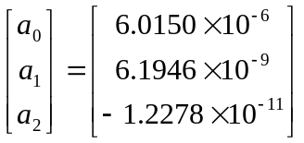
to give the polynomial regression model (Figure 4) as
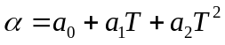
Knowing the values of 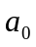,  and , we can then find the contraction in the trunnion diameter as
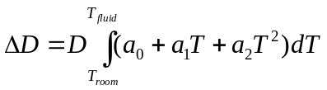
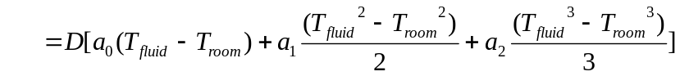 (4)
which gives
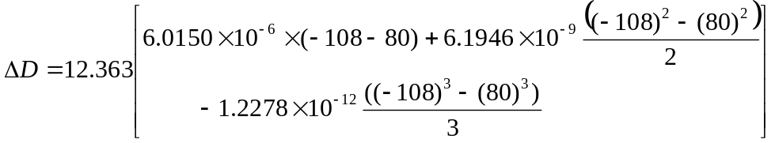
= 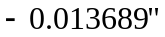
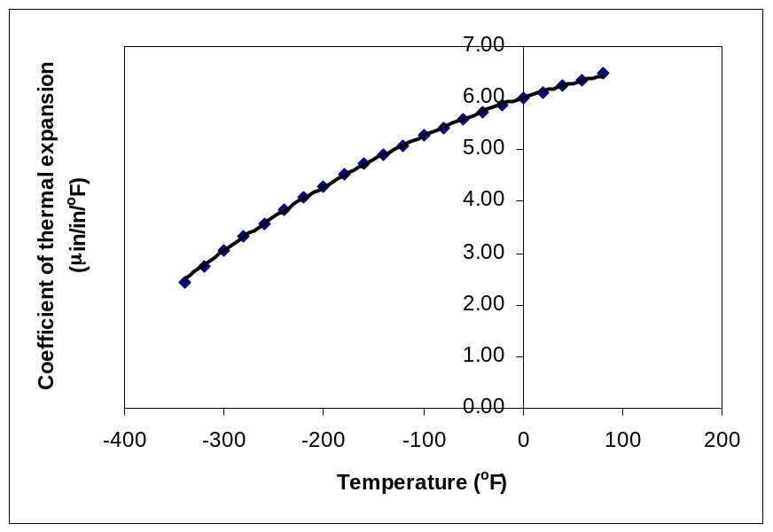
Figure 4 Second order polynomial regression model for coefficient of thermal expansion as a function of temperature.

What do we find here? The contraction in the trunnion is not enough to meet the required specification of .
So here are some questions that you may want to ask yourself?
- What if the trunnion were immersed in liquid nitrogen (boiling temperature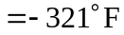)? Will that cause enough contraction in the trunnion?
- Rather than regressing the thermal expansion coefficient data to a second order polynomial so that one can find the contraction in the trunnion OD, how would you use Trapezoidal rule of integration for unequal segments? What is the relative difference between the two results?
- We chose a second order polynomial for regression. Would a different order polynomial be a better choice for regression? Is there an optimum order of polynomial you can find?
As mentioned at the beginning of this chapter, we generally see mathematical procedures that require the solution of nonlinear equations, differentiation, solution of simultaneous linear equations, interpolation, regression, integration, and differential equations. A physical example to illustrate the need for each of these mathematical procedures is given in the beginning of each chapter. You may want to look at them now to understand better why we need numerical methods in everyday life.

