Chapter 02.01

Bisection Method of Solving a Nonlinear Equation

After reading this chapter, you should be able to:

- follow the algorithm of the bisection method of solving a nonlinear equation,
- use the bisection method to solve examples of finding roots of a nonlinear equation, and
- enumerate the advantages and disadvantages of the bisection method.

What is the bisection method and what is it based on?
One of the first numerical methods developed to find the root of a nonlinear equation 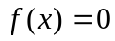 was the bisection method (also called binary-search method). The method is based on the following theorem.

Theorem
An equation, where  is a real continuous function, has at least one root between 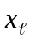 and 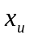 if 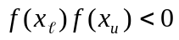 (See Figure 1).
Note that if 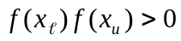, there may or may not be any root between and (Figures 2 and 3). If , then there may be more than one root between and (Figure 4). So the theorem only guarantees one root between and .

Bisection method
Since the method is based on finding the root between two points, the method falls under the category of bracketing methods.
Since the root is bracketed between two points, and , one can find the mid-point, 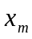 between and . This gives us two new intervals
- and , and
- and .

f (x)
x_{ℓ}
x_{u}

x

Figure 1 At least one root exists between the two points if the function is real, continuous, and changes sign.

f (x)
x_{ℓ}
x_{u}

x

Figure 2 If the function does not change sign between the two points, roots of the equation may still exist between the two points.
f (x)
x_{ℓ}
x_{u}
x
f (x)
x_{ℓ}
x_{u}
x

Figure 3 If the function does not change sign between two points, there may not be any roots for the equation between the two points.
f (x)
x_{ℓ}
x_{u}
x
Figure 4 If the function changes sign between the two points, more than one root for the equation may exist between the two points.

Is the root now between 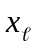 and or between and 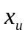? Well, one can find the sign of 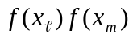, and if 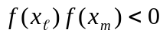 then the new bracket is between and , otherwise, it is between and . So, you can see that you are literally halving the interval. As one repeats this process, the width of the interval 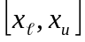 becomes smaller and smaller, and you can zero in to the root of the equation 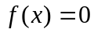. The algorithm for the bisection method is given as follows.

Algorithm for the bisection method
The steps to apply the bisection method to find the root of the equation are
- Choose and as two guesses for the root such that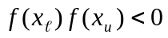, or in other words,  changes sign between and .
- Estimate the root, , of the equation as the mid-point between and as
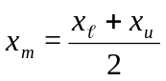
- Now check the following
- If , then the root lies between and ; then 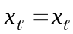 and 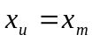.
- If 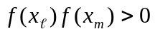, then the root lies between and ; then 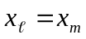 and 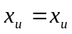.
- If 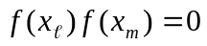; then the root is . Stop the algorithm if this is true.
- Find the new estimate of the root
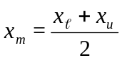
Find the absolute relative approximate error as
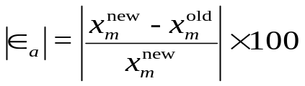
where
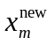 = estimated root from present iteration
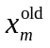= estimated root from previous iteration
- Compare the absolute relative approximate error 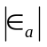 with the pre-specified relative error tolerance 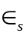. If 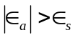, then go to Step 3, else stop the algorithm. Note one should also check whether the number of iterations is more than the maximum number of iterations allowed. If so, one needs to terminate the algorithm and notify the user about it.

Example 1
You are working for ‘DOWN THE TOILET COMPANY’ that makes floats for ABC commodes. The floating ball has a specific gravity of 0.6 and has a radius of 5.5 cm. You are asked to find the depth to which the ball is submerged when floating in water.
The equation that gives the depth to which the ball is submerged under water is given by
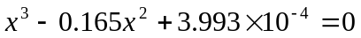
Use the bisection method of finding roots of equations to find the depth to which the ball is submerged under water. Conduct three iterations to estimate the root of the above equation. Find the absolute relative approximate error at the end of each iteration, and the number of significant digits at least correct at the end of each iteration.

Solution
From the physics of the problem, the ball would be submerged between  and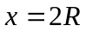,
where
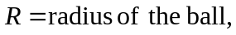
that is
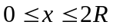
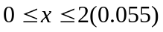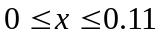

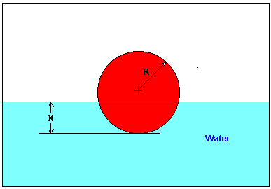
Figure 5 Floating ball problem.
Lets us assume
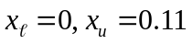
Check if the function changes sign between and .
Hence
So there is at least one root between and , that is between 0 and 0.11.

Iteration 1
The estimate of the root is
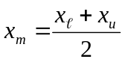
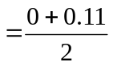
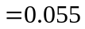
Hence the root is bracketed between and , that is, between 0.055 and 0.11. So, the lower and upper limit of the new bracket is
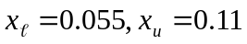
At this point, the absolute relative approximate error 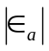 cannot be calculated as we do not have a previous approximation.

Iteration 2
The estimate of the root is
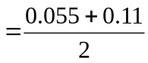
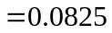
Hence, the root is bracketed between and , that is, between 0.055 and 0.0825. So the lower and upper limit of the new bracket is
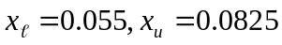
The absolute relative approximate error at the end of Iteration 2 is
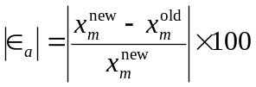
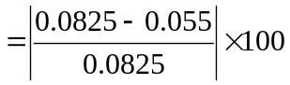
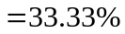
None of the significant digits are at least correct in the estimated root of 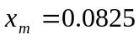 because the absolute relative approximate error is greater than 5%.

Iteration 3
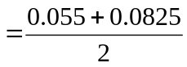
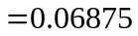
Hence, the root is bracketed between and , that is, between 0.055 and 0.06875. So the lower and upper limit of the new bracket is
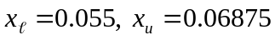
The absolute relative approximate error at the ends of Iteration 3 is
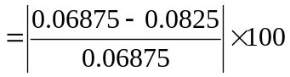
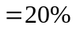
Still none of the significant digits are at least correct in the estimated root of the equation as the absolute relative approximate error is greater than 5%.
Seven more iterations were conducted and these iterations are shown in Table 1.

Table 1 Root of 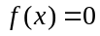 as function of number of iterations for bisection method.
Iteration |  | 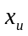 | 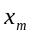 | 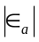% | 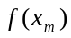
1 | 0.00000 | 0.11 | 0.055 | ---------- | 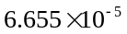
2 | 0.055 | 0.11 | 0.0825 | 33.33 | 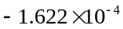
3 | 0.055 | 0.0825 | 0.06875 | 20.00 | 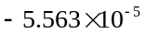
4 | 0.055 | 0.06875 | 0.06188 | 11.11 | 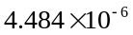
5 | 0.06188 | 0.06875 | 0.06531 | 5.263 | 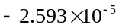
6 | 0.06188 | 0.06531 | 0.06359 | 2.702 | 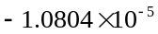
7 | 0.06188 | 0.06359 | 0.06273 | 1.370 | 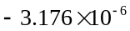
8 | 0.06188 | 0.06273 | 0.0623 | 0.6897 | 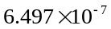
9 | 0.0623 | 0.06273 | 0.06252 | 0.3436 | 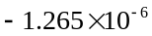
10 | 0.0623 | 0.06252 | 0.06241 | 0.1721 | 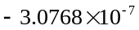

At the end of 10th iteration,
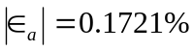
Hence the number of significant digits at least correct is given by the largest value of for which
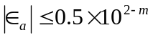
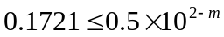
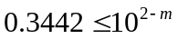
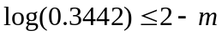
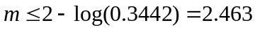
So
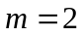
The number of significant digits at least correct in the estimated root of 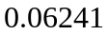 at the end of the 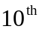 iteration is 2.

Advantages of bisection method
- The bisection method is always convergent. Since the method brackets the root, the method is guaranteed to converge.
- As iterations are conducted, the interval gets halved. So one can guarantee the error in the solution of the equation.

Drawbacks of bisection method
- The convergence of the bisection method is slow as it is simply based on halving the interval.
- If one of the initial guesses is closer to the root, it will take larger number of iterations to reach the root.
- If a function is such that it just touches the -axis (Figure 6) such as
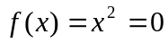
it will be unable to find the lower guess, , and upper guess, , such that
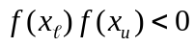
- For functions where there is a singularity and it reverses sign at the singularity, the bisection method may converge on the singularity (Figure 7). An example includes
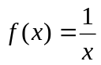
where 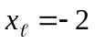, 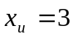 are valid initial guesses which satisfy
However, the function is not continuous and the theorem that a root exists is also not applicable.

f (x)
x
Figure 6 The equation has a single root at that cannot be bracketed.
A singularity in a function is defined as a point where the function becomes infinite. For example, for a function such as 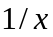, the point of singularity is 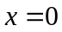 as it becomes infinite.

f (x)
x
Figure 7 The equation 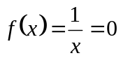 has no root but changes sign.

