Chapter 02.02

Newton-Raphson Method of Solving a Nonlinear Equation

After reading this chapter, you should be able to:

- derive the Newton-Raphson method formula,
- develop the algorithm of the Newton-Raphson method,
- use the Newton-Raphson method to solve a nonlinear equation, and
- discuss the drawbacks of the Newton-Raphson method.

Introduction
Methods such as the bisection method and the false position method of finding roots of a nonlinear equation 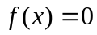 require bracketing of the root by two guesses. Such methods are called bracketing methods. These methods are always convergent since they are based on reducing the interval between the two guesses so as to zero in on the root of the equation.
In the Newton-Raphson method, the root is not bracketed. In fact, only one initial guess of the root is needed to get the iterative process started to find the root of an equation. The method hence falls in the category of open methods. Convergence in open methods is not guaranteed but if the method does converge, it does so much faster than the bracketing methods.

Derivation
The Newton-Raphson method is based on the principle that if the initial guess of the root of is at , then if one draws the tangent to the curve at 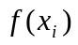, the point 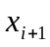 where the tangent crosses the -axis is an improved estimate of the root (Figure 1).
Using the definition of the slope of a function, at 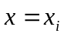
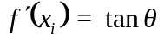
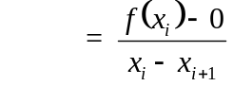,
which gives
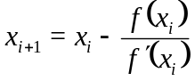 (1)
Equation (1) is called the Newton-Raphson formula for solving nonlinear equations of the form 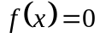. So starting with an initial guess, , one can find the next guess, , by using Equation (1). One can repeat this process until one finds the root within a desirable tolerance.

Algorithm
The steps of the Newton-Raphson method to find the root of an equation are
- Evaluate 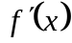 symbolically
- Use an initial guess of the root, , to estimate the new value of the root, , as
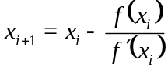
- Find the absolute relative approximate error 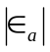 as
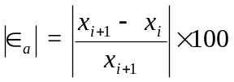
- Compare the absolute relative approximate error with the pre-specified relative error tolerance, 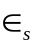. If >, then go to Step 2, else stop the algorithm. Also, check if the number of iterations has exceeded the maximum number of iterations allowed. If so, one needs to terminate the algorithm and notify the user.

f (x)
f (x_{i})
f (x_{i+1})
x_{i+2}
x_{i+1}
x_{i}
x
θ
[x_{i}, f (x_{i})]
Figure 1 Geometrical illustration of the Newton-Raphson method.

Example 1
You are working for ‘DOWN THE TOILET COMPANY’ that makes floats for ABC commodes. The floating ball has a specific gravity of 0.6 and has a radius of 5.5 cm. You are asked to find the depth to which the ball is submerged when floating in water.

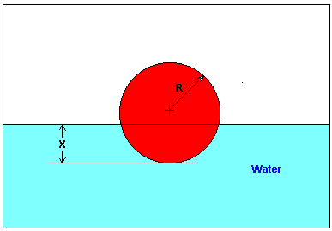
Figure 2 Floating ball problem.

The equation that gives the depth in meters to which the ball is submerged under water is given by
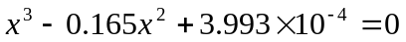
Use the Newton-Raphson method of finding roots of equations to find
- the depth to which the ball is submerged under water. Conduct three iterations to estimate the root of the above equation.
- the absolute relative approximate error at the end of each iteration, and
- the number of significant digits at least correct at the end of each iteration.

Solution
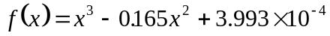
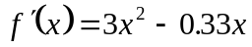
Let us assume the initial guess of the root of is 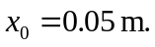 This is a reasonable guess (discuss why  and 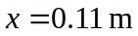 are not good choices) as the extreme values of the depth would be 0 and the diameter (0.11 m) of the ball.

Iteration 1
The estimate of the root is
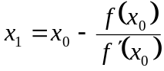
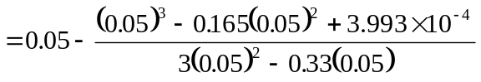
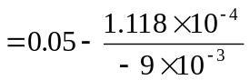
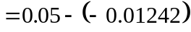
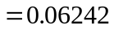
The absolute relative approximate error at the end of Iteration 1 is
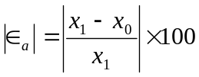
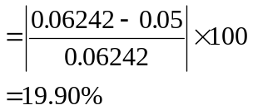

The number of significant digits at least correct is 0, as you need an absolute relative approximate error of 5% or less for at least one significant digit to be correct in your result.

Iteration 2
The estimate of the root is
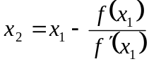
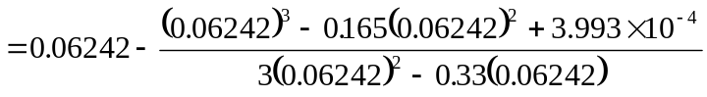
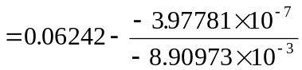
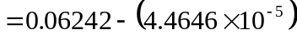
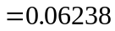
The absolute relative approximate error at the end of Iteration 2 is
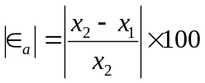
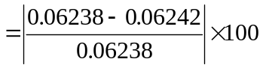
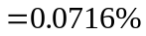
The maximum value of for which 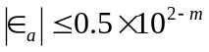 is 2.844. Hence, the number of significant digits at least correct in the answer is 2.

Iteration 3
The estimate of the root is
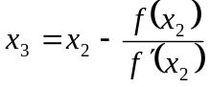
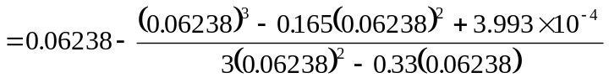
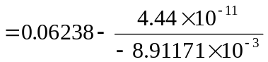
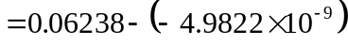
The absolute relative approximate error at the end of Iteration 3 is
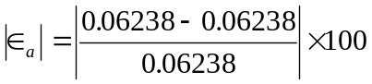
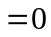
The number of significant digits at least correct is 4, as only 4 significant digits are carried through in all the calculations.

Drawbacks of the Newton-Raphson Method
1. Divergence at inflection points
If the selection of the initial guess or an iterated value of the root turns out to be close to the inflection point (see the definition in the appendix of this chapter) of the function  in the equation 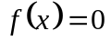, Newton-Raphson method may start diverging away from the root. It may then start converging back to the root. For example, to find the root of the equation
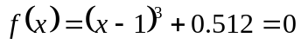
the Newton-Raphson method reduces to
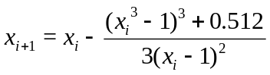
Starting with an initial guess of 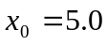, Table 1 shows the iterated values of the root of the equation. As you can observe, the root starts to diverge at Iteration 6 because the previous estimate of 0.92589 is close to the inflection point of 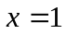 (the value of 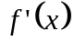 is zero at the inflection point). Eventually, after 12 more iterations the root converges to the exact value of 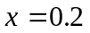.
Table 1 Divergence near inflection point.
Iteration  Number | 
0 | 5.0000
1 | 3.6560
2 | 2.7465
3 | 2.1084
4 | 1.6000
5 | 0.92589
6 | –30.119
7 | –19.746
8 | –12.831
9 | –8.2217
10 | –5.1498
11 | –3.1044
12 | –1.7464
13 | –0.85356
14 | –0.28538
15 | 0.039784
16 | 0.17475
17 | 0.19924
18 | 0.2

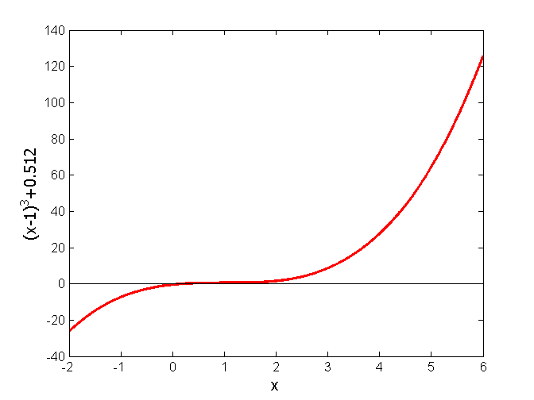
Figure 3 Divergence at inflection point for 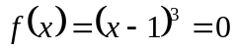.

2. Division by zero
For the equation
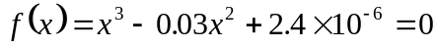
the Newton-Raphson method reduces to
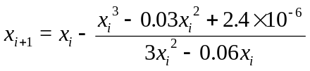
For 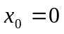 or 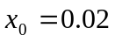, division by zero occurs (Figure 4). For an initial guess close to 0.02 such as 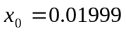, one may avoid division by zero, but then the denominator in the formula is a small number. For this case, as given in Table 2, even after 9 iterations, the Newton-Raphson method does not converge.

Table 2 Division by near zero in Newton-Raphson method.
Iteration  Number |  | 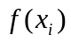 | 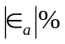
0  1  2  3  4  5  6  7  8  9 | 0.019990  –2.6480  –1.7620  –1.1714  –0.77765  –0.51518  –0.34025  –0.22369  –0.14608  –0.094490 | 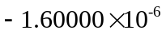  18.778  –5.5638  –1.6485  –0.48842  –0.14470  –0.042862  –0.012692  –0.0037553  –0.0011091 | 100.75  50.282  50.422  50.632  50.946  51.413  52.107  53.127  54.602

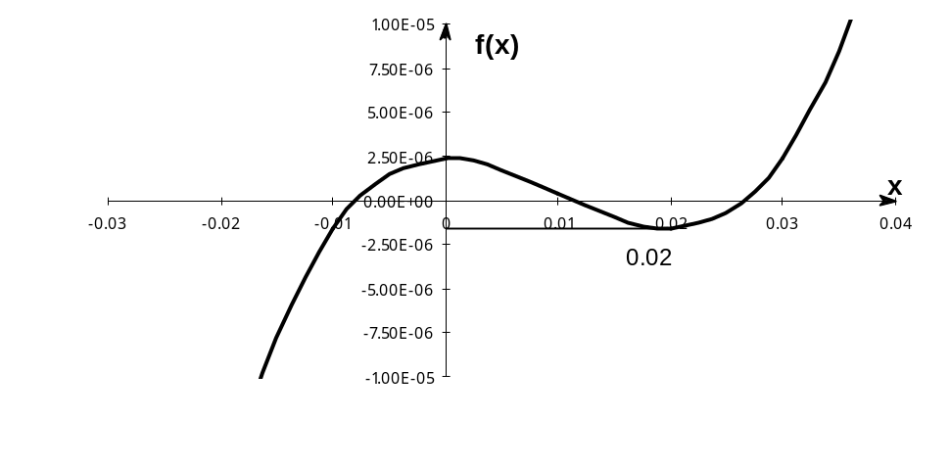
Figure 4 Pitfall of division by zero or a near zero number.

3. Oscillations near local maximum and minimum
Results obtained from the Newton-Raphson method may oscillate about the local maximum or minimum without converging on a root but converging on the local maximum or minimum. Eventually, it may lead to division by a number close to zero and may diverge.
For example, for
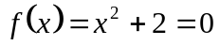
the equation has no real roots (Figure 5 and Table 3).
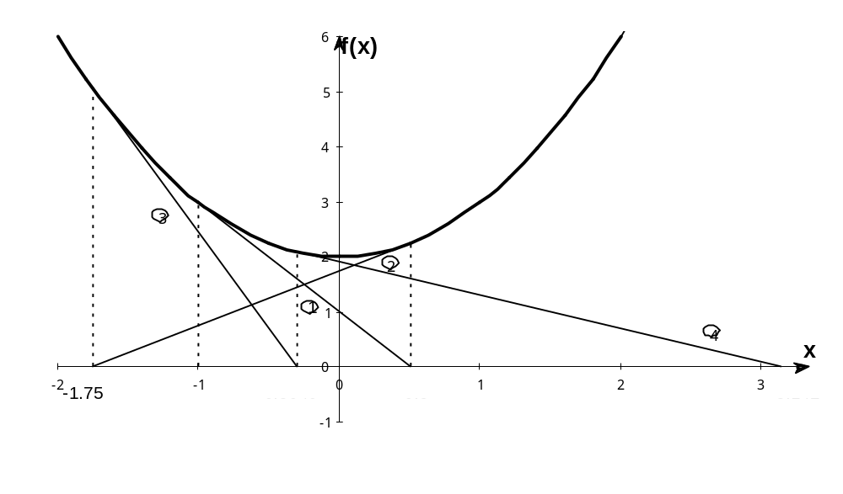
Figure 5 Oscillations around local minima for 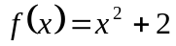.

Table 3 Oscillations near local maxima and minima in Newton-Raphson method.
Iteration
Number
0  1  2  3  4  5  6  7  8  9 | –1.0000  0.5  –1.75  –0.30357  3.1423  1.2529  –0.17166  5.7395  2.6955  0.97678 | 3.00  2.25  5.063  2.092  11.874  3.570  2.029  34.942  9.266  2.954 | 300.00  128.571  476.47  109.66  150.80  829.88  102.99  112.93  175.96

4. Root jumping
In some case where the function  is oscillating and has a number of roots, one may choose an initial guess close to a root. However, the guesses may jump and converge to some other root. For example for solving the equation 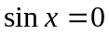 if you choose 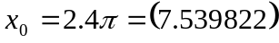 as an initial guess, it converges to the root of  as shown in Table 4 and Figure 6. However, one may have chosen this as an initial guess to converge to 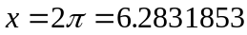.

Table 4 Root jumping in Newton-Raphson method.
Iteration
Number
0  1  2  3  4  5 | 7.539822  4.462  0.5499  –0.06307  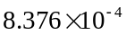  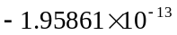 | 0.951  –0.969  0.5226  –0.06303  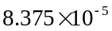  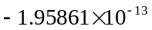 | 68.973  711.44  971.91  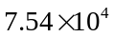  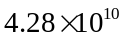

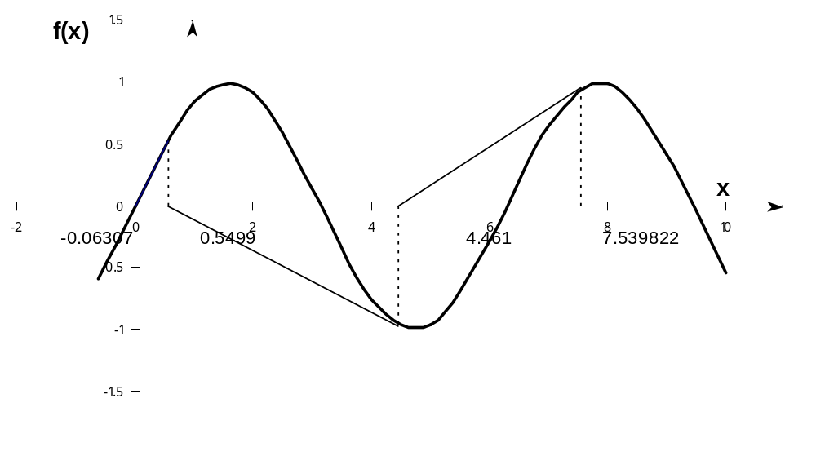
Figure 6 Root jumping from intended location of root for 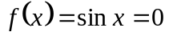.

Appendix A. What is an inflection point?
For a function , the point where the concavity changes from up-to-down or down-to-up is called its inflection point. For example, for the function 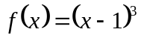, the concavity changes at  (see Figure 3), and hence (1,0) is an inflection point.
An inflection points MAY exist at a point where 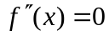 and where 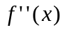 does not exist. The reason we say that it MAY exist is because if , it only makes it a possible inflection point. For example, for 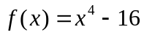, 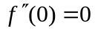, but the concavity does not change at 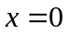. Hence the point (0, –16) is not an inflection point of .
For , 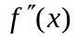changes sign at (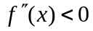 for 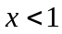, and 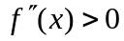 for 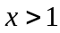), and thus brings up the Inflection Point Theorem for a function that states the following.
“If 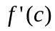 exists and 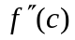 changes sign at , then the point 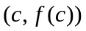 is an inflection point of the graph of .”

Appendix B. Derivation of Newton-Raphson method from Taylor series
Newton-Raphson method can also be derived from Taylor series. For a general function , the Taylor series is
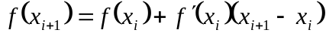+ 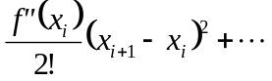
As an approximation, taking only the first two terms of the right hand side,
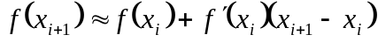
and we are seeking a point where 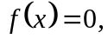 that is, if we assume
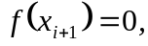
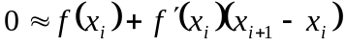
which gives
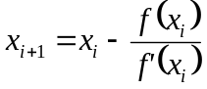
This is the same Newton-Raphson method formula series as derived previously using the geometric method.

