Chapter 04.01

Newton’s Divided Difference Interpolation

After reading this chapter, you should be able to:
- derive Newton’s divided difference method of interpolation,
- apply Newton’s divided difference method of interpolation, and
- apply Newton’s divided difference method interpolants to find derivatives and integrals.

What is interpolation?
Many times, data is given only at discrete points such as 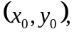 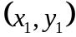, 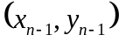, 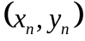. So, how then does one find the value of at any other value of ? Well, a continuous function  may be used to represent the 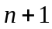 data values with passing through the points (Figure 1). Then one can find the value of at any other value of . This is called interpolation.
Of course, if falls outside the range of for which the data is given, it is no longer interpolation but instead is called extrapolation.
So what kind of function should one choose? A polynomial is a common choice for an interpolating function because polynomials are easy to
- evaluate,
- differentiate, and
- integrate,
relative to other choices such as a trigonometric and exponential series.
Polynomial interpolation involves finding a polynomial of order that passes through the points. One of the methods of interpolation is called Newton’s divided difference polynomial method. Other methods include the direct method and the Lagrangian interpolation method. We will discuss Newton’s divided difference polynomial method in this chapter.

Newton’s Divided Difference Polynomial Method
To illustrate this method, linear and quadratic interpolation is presented first. Then, the general form of Newton’s divided difference polynomial method is presented. To illustrate the general form, cubic interpolation is shown in Figure 1.
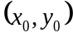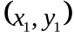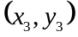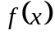

Figure 1 Interpolation of discrete data.

Linear Interpolation
Given 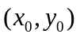 and 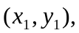 fit a linear interpolant through the data. Noting 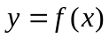 and 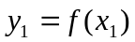, assume the linear interpolant 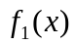 is given by (Figure 2)
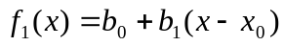
Since at 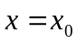,
and at 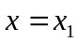,
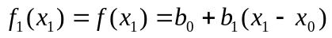
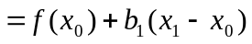
giving
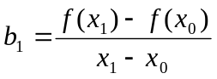
So
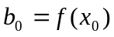
giving the linear interpolant as
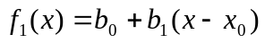
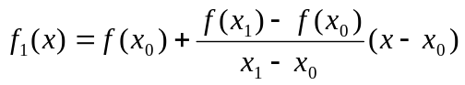

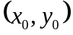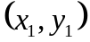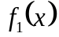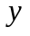
Figure 2 Linear interpolation.

Example 1
The upward velocity of a rocket is given as a function of time in Table 1 (Figure 3).

Table 1 Velocity as a function of time.
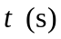 | 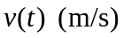
0 | 0
10 | 227.04
15 | 362.78
20 | 517.35
22.5 | 602.97
30 | 901.67
Determine the value of the velocity at 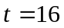 seconds using first order polynomial interpolation by Newton’s divided difference polynomial method.

Solution
For linear interpolation, the velocity is given by
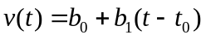
Since we want to find the velocity at , and we are using a first order polynomial, we need to choose the two data points that are closest to that also bracket to evaluate it. The two points are 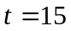 and 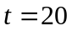.
Then
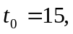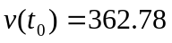
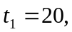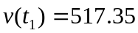
gives
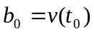
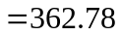
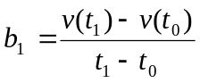
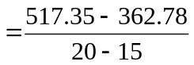
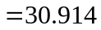

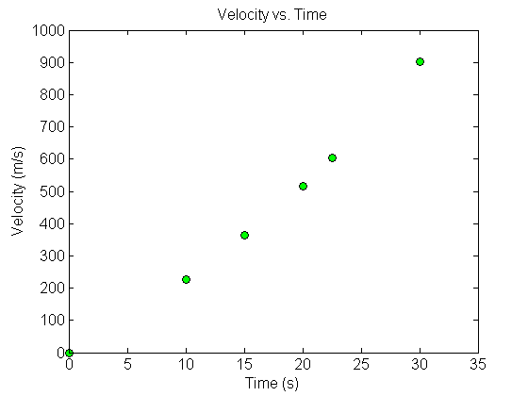
Figure 3 Graph of velocity vs. time data for the rocket example.
Hence
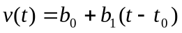
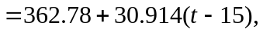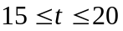
At 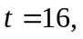
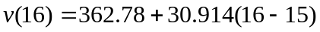
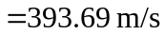
If we expand
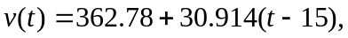
we get
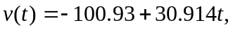
and this is the same expression as obtained in the direct method.

Quadratic Interpolation
Given 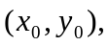 and 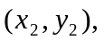 fit a quadratic interpolant through the data. Noting 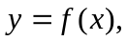 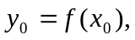 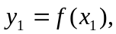 and 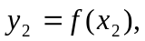assume the quadratic interpolant 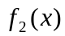 is given by
At ,
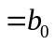
At 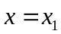
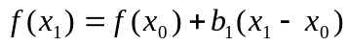
giving
At 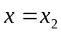
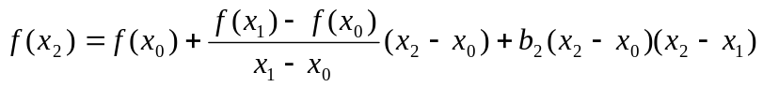
Giving
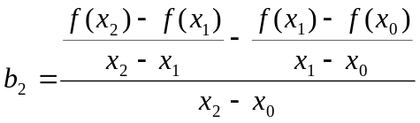
Hence the quadratic interpolant is given by
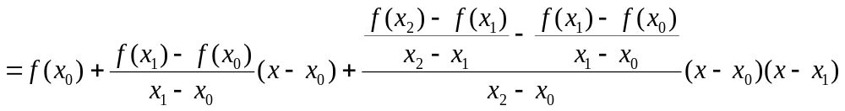

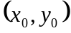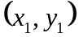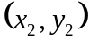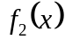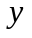
Figure 4 Quadratic interpolation.

Example 2
The upward velocity of a rocket is given as a function of time in Table 2.

Table 2 Velocity as a function of time.
 | 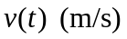
0 | 0
10 | 227.04
15 | 362.78
20 | 517.35
22.5 | 602.97
30 | 901.67

Determine the value of the velocity at 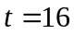 seconds using second order polynomial interpolation using Newton’s divided difference polynomial method.

Solution
For quadratic interpolation, the velocity is given by
Since we want to find the velocity at 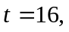 and we are using a second order polynomial, we need to choose the three data points that are closest to that also bracket to evaluate it. The three points are 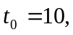 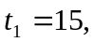 and 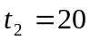.
Then
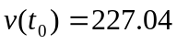
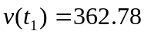
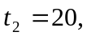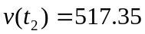
gives
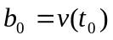
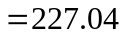
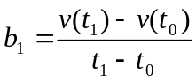
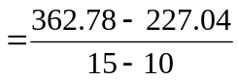
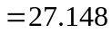
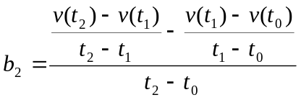
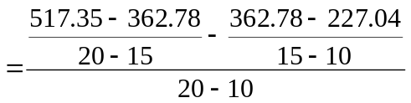
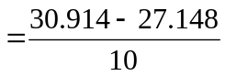
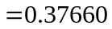
Hence
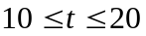
At
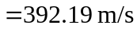
If we expand
we get
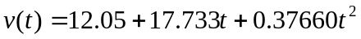,
This is the same expression obtained by the direct method.

General Form of Newton’s Divided Difference Polynomial
In the two previous cases, we found linear and quadratic interpolants for Newton’s divided difference method. Let us revisit the quadratic polynomial interpolant formula
where
Note that 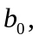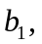 and 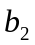 are finite divided differences. and are the first, second, and third finite divided differences, respectively. We denote the first divided difference by
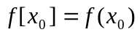
the second divided difference by
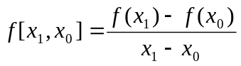
and the third divided difference by
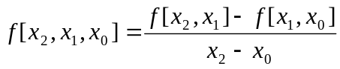
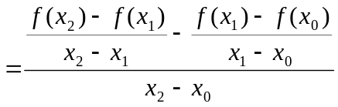
where 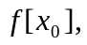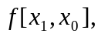 and 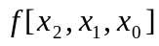 are called bracketed functions of their variables enclosed in square brackets.
Rewriting,
This leads us to writing the general form of the Newton’s divided difference polynomial for data points, , as
where
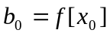
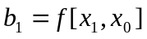
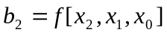
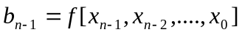
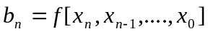
where the definition of the 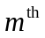 divided difference is
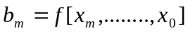
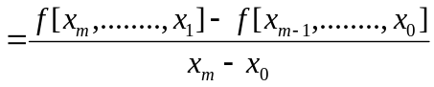
From the above definition, it can be seen that the divided differences are calculated recursively.
For an example of a third order polynomial, given and 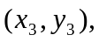
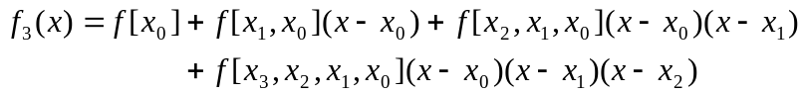
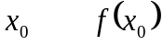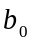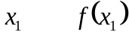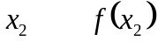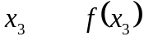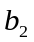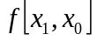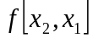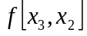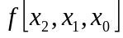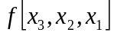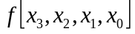
Figure 5 Table of divided differences for a cubic polynomial.

Example 3
The upward velocity of a rocket is given as a function of time in Table 3.

Table 3 Velocity as a function of time.
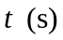
0 | 0
10 | 227.04
15 | 362.78
20 | 517.35
22.5 | 602.97
30 | 901.67

a) Determine the value of the velocity at seconds with third order polynomial interpolation using Newton’s divided difference polynomial method.
b) Using the third order polynomial interpolant for velocity, find the distance covered by the rocket from 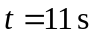 to 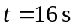.
c) Using the third order polynomial interpolant for velocity, find the acceleration of the rocket at 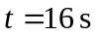.

Solution
a) For a third order polynomial, the velocity is given by
Since we want to find the velocity at and we are using a third order polynomial, we need to choose the four data points that are closest to that also bracket to evaluate it. The four data points are and 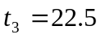.
Then
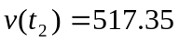
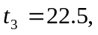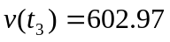
gives
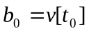
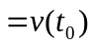
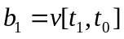
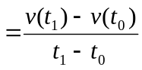
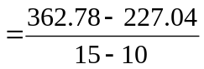
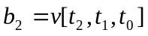
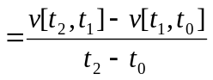
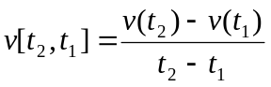
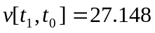
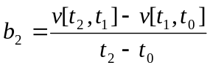
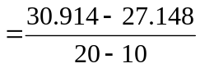
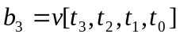
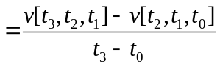
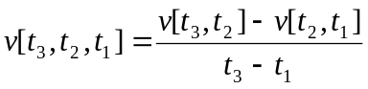
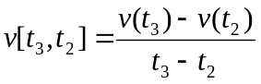
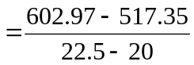
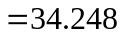
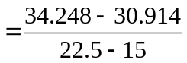
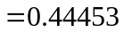
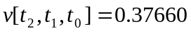
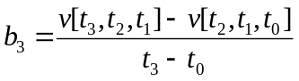
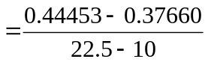
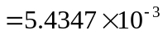
Hence
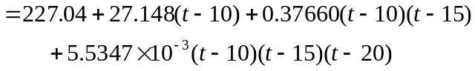
At
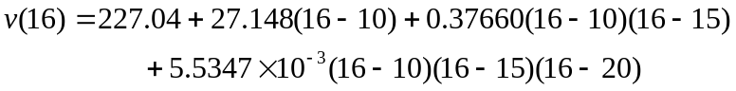
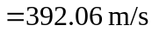
b) The distance covered by the rocket between and can be calculated from the interpolating polynomial
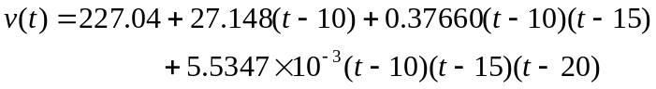
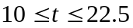
Note that the polynomial is valid between 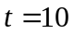 and 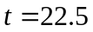 and hence includes the limits of 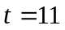 and .
So
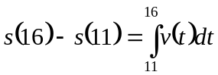
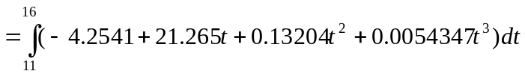
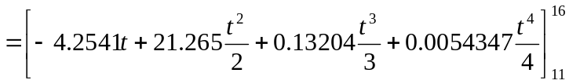
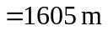
c) The acceleration at is given by
