Chapter 04.02

Lagrangian Interpolation

After reading this chapter, you should be able to:
- derive Lagrangian method of interpolation,
- solve problems using Lagrangian method of interpolation, and
- use Lagrangian interpolants to find derivatives and integrals of discrete functions.

What is interpolation?
Many times, data is given only at discrete points such as 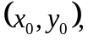 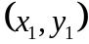, 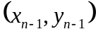, 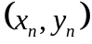. So, how then does one find the value of at any other value of ? Well, a continuous function  may be used to represent the 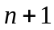 data values with passing through the points (Figure 1). Then one can find the value of at any other value of . This is called interpolation.
Of course, if falls outside the range of for which the data is given, it is no longer interpolation but instead is called extrapolation.
So what kind of function should one choose? A polynomial is a common choice for an interpolating function because polynomials are easy to
- evaluate,
- differentiate, and
- integrate,
relative to other choices such as a trigonometric and exponential series.
Polynomial interpolation involves finding a polynomial of order that passes through the 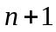 data points. One of the methods used to find this polynomial is called the Lagrangian method of interpolation. Other methods include Newton’s divided difference polynomial method and the direct method. We discuss the Lagrangian method in this chapter.

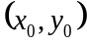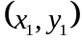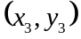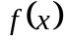

Figure 1 Interpolation of discrete data.

The Lagrangian interpolating polynomial is given by
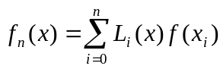
where in 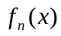 stands for the 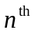 order polynomial that approximates the function  given at data points as , and
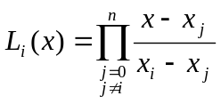
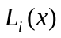 is a weighting function that includes a product of 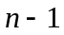 terms with terms of 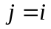 omitted. The application of Lagrangian interpolation will be clarified using an example.

Example 1
The upward velocity of a rocket is given as a function of time in Table 1.

Table 1 Velocity as a function of time.
(s) | 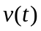 (m/s)
0 | 0
10 | 227.04
15 | 362.78
20 | 517.35
22.5 | 602.97
30 | 901.67

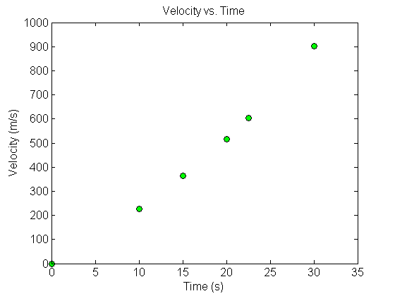
Figure 2 Graph of velocity vs. time data for the rocket example.

Determine the value of the velocity at 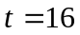 seconds using a first order Lagrange polynomial.

Solution
For first order polynomial interpolation (also called linear interpolation), the velocity is given by
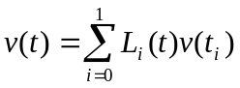
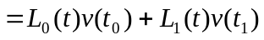

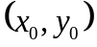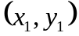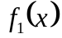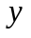
Figure 3 Linear interpolation.

Since we want to find the velocity at , and we are using a first order polynomial, we need to choose the two data points that are closest to that also bracket to evaluate it. The two points are 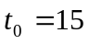 and 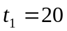.
Then
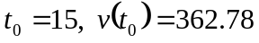
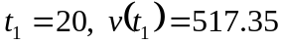
gives
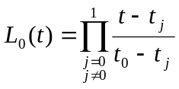
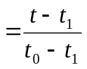
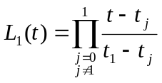
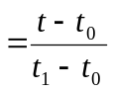
Hence
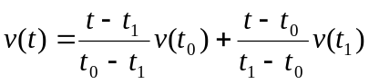
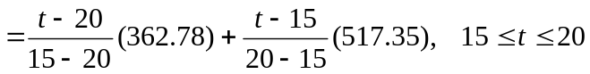
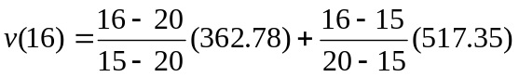
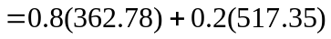
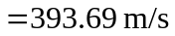
You can see that 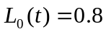 and 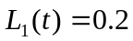 are like weightages given to the velocities at 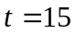 and 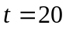 to calculate the velocity at 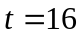.

Quadratic Interpolation

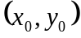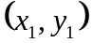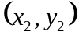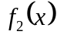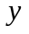
Figure 4 Quadratic interpolation.

Example 2
The upward velocity of a rocket is given as a function of time in Table 2.

Table 2 Velocity as a function of time.
(s) | (m/s)
0 | 0
10 | 227.04
15 | 362.78
20 | 517.35
22.5 | 602.97
30 | 901.67

a) Determine the value of the velocity at 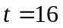 seconds with second order polynomial interpolation using Lagrangian polynomial interpolation.
b) Find the absolute relative approximate error for the second order polynomial approximation.

Solution
a) For second order polynomial interpolation (also called quadratic interpolation), the velocity is given by
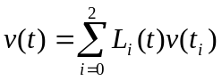
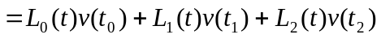
Since we want to find the velocity at , and we are using a second order polynomial, we need to choose the three data points that are closest to that also bracket to evaluate it. The three points are 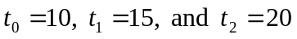.
Then
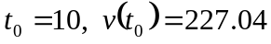
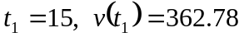
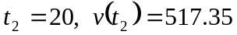
gives
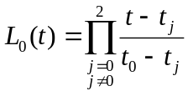
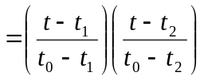
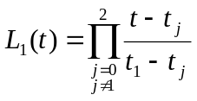
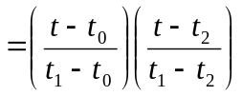
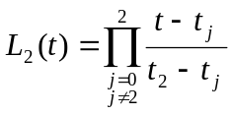
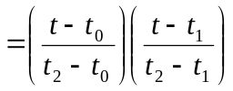
Hence
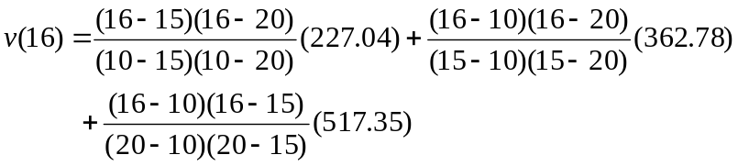
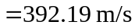
b) The absolute relative approximate error 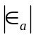 for the second order polynomial is calculated by considering the result of the first order polynomial (Example 1) as the previous approximation.
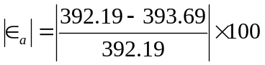
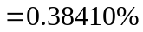

Example 3
The upward velocity of a rocket is given as a function of time in Table 3.

Table 3 Velocity as a function of time
(s) | (m/s)
0 | 0
10 | 227.04
15 | 362.78
20 | 517.35
22.5 | 602.97
30 | 901.67

a) Determine the value of the velocity at 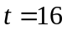 seconds using third order Lagrangian polynomial interpolation.
b) Find the absolute relative approximate error for the third order polynomial approximation.
c) Using the third order polynomial interpolant for velocity, find the distance covered by the rocket from 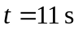 to 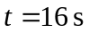.
d) Using the third order polynomial interpolant for velocity, find the acceleration of the rocket at .

Solution
a) For third order polynomial interpolation (also called cubic interpolation), the velocity is given by
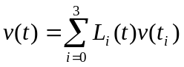

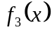

Figure 5 Cubic interpolation.

Since we want to find the velocity at , and we are using a third order polynomial, we need to choose the four data points closest to that also bracket to evaluate it. The four points are 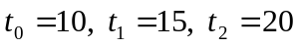 and 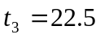.
Then
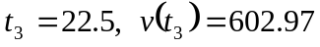
gives
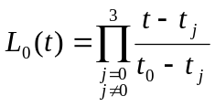
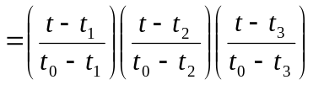
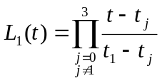
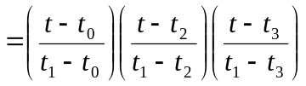
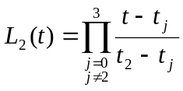
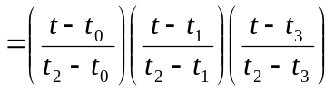
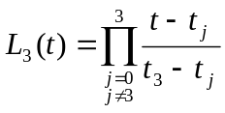
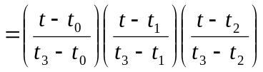
Hence
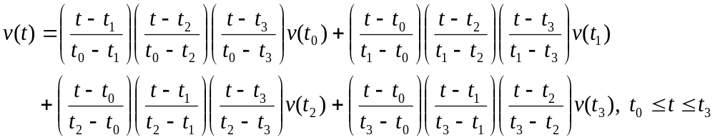
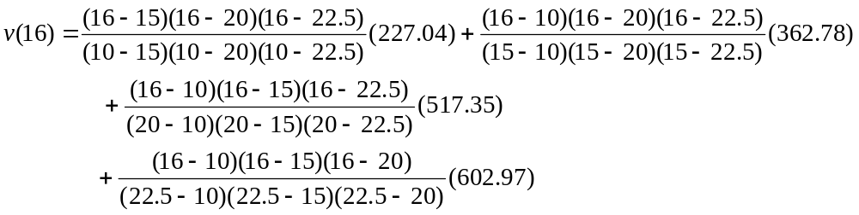
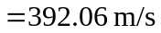
b) The absolute percentage relative approximate error, 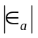 for the value obtained for 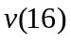 can be obtained by comparing the result with that obtained using the second order polynomial (Example 2)
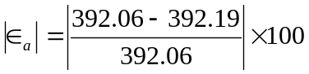
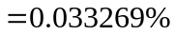
c) The distance covered by the rocket between 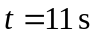 to can be calculated from the interpolating polynomial as
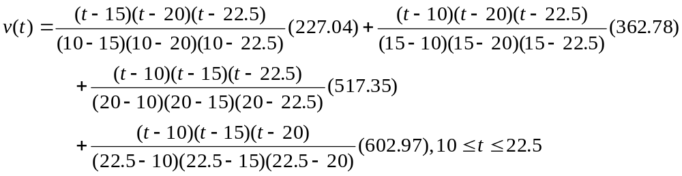
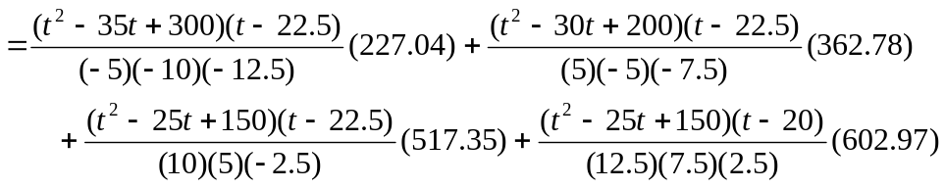
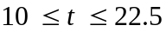
Note that the polynomial is valid between 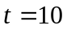 and 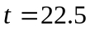 and hence includes the limits of 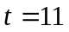 and .
So
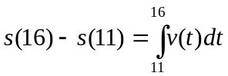
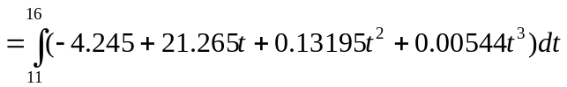
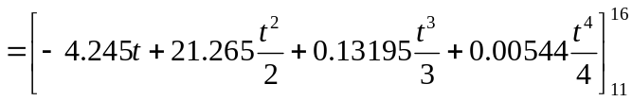
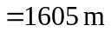
d) The acceleration at is given by
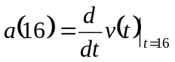
Given that
, 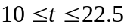
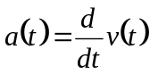
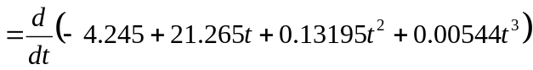
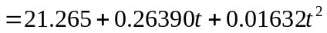,
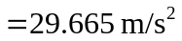
Note: There is no need to get the simplified third order polynomial expression to conduct the differentiation. An expression of the form
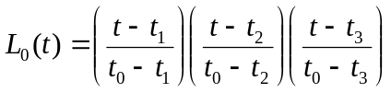
gives the derivative without expansion as

