Chapter 05.02

Simpson’s 1/3 Rule of Integration

After reading this chapter, you should be able to
- derive the formula for Simpson’s 1/3 rule of integration,
- use Simpson’s 1/3 rule it to solve integrals,
- develop the formula for multiple-segment Simpson’s 1/3 rule of integration,
- use multiple-segment Simpson’s 1/3 rule of integration to solve integrals, and
- derive the true error formula for multiple-segment Simpson’s 1/3 rule.

What is integration?
Integration is the process of measuring the area under a function plotted on a graph. Why would we want to integrate a function? Among the most common examples are finding the velocity of a body from an acceleration function, and displacement of a body from a velocity function. Throughout many engineering fields, there are (what sometimes seems like) countless applications for integral calculus. You can read about some of these applications in Chapters 07.00A-07.00G.
Sometimes, the evaluation of expressions involving these integrals can become daunting, if not indeterminate. For this reason, a wide variety of numerical methods has been developed to simplify the integral. Here, we will discuss Simpson’s 1/3 rule of integral approximation, which improves upon the accuracy of the trapezoidal rule.
Here, we will discuss the Simpson’s 1/3 rule of approximating integrals of the form
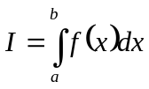
where
 is called the integrand,
lower limit of integration
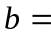 upper limit of integration

Simpson’s 1/3 Rule
The trapezoidal rule was based on approximating the integrand by a first order polynomial, and then integrating the polynomial over interval of integration. Simpson’s 1/3 rule is an extension of Trapezoidal rule where the integrand is approximated by a second order polynomial.

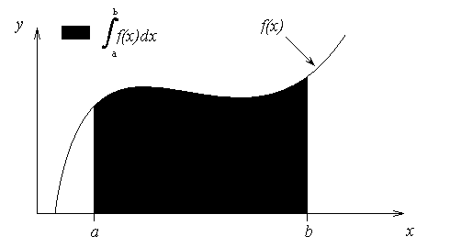
Figure 1 Integration of a function

Method 1:
Hence
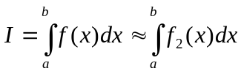
where 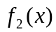 is a second order polynomial given by
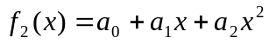.
Choose
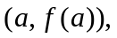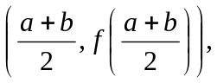 and 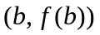
as the three points of the function to evaluate 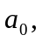 and .
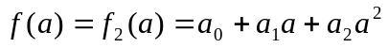
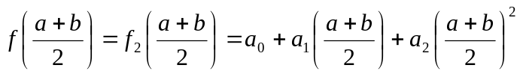
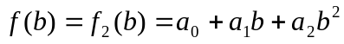
Solving the above three equations for unknowns, 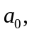 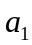 and 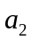 give
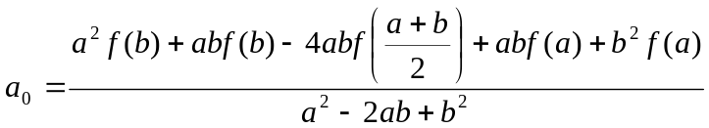
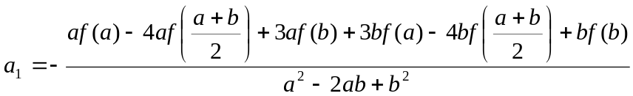
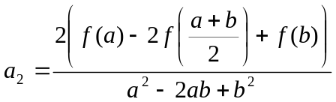
Then
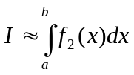
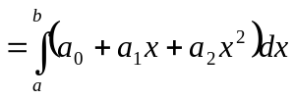
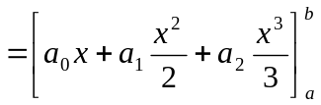
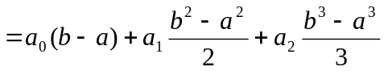
Substituting values of and give
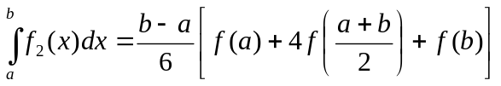
Since for Simpson 1/3 rule, the interval 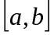 is broken into 2 segments, the segment width
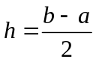
Hence the Simpson’s 1/3 rule is given by
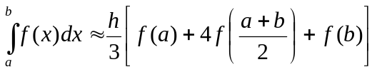
Since the above form has 1/3 in its formula, it is called Simpson’s 1/3 rule.

Method 2:
Simpson’s 1/3 rule can also be derived by approximating by a second order polynomial using Newton’s divided difference polynomial as
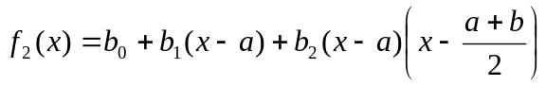
where
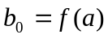
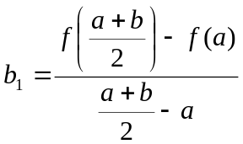
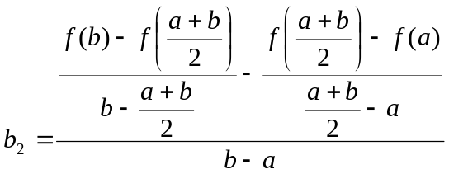
Integrating Newton’s divided difference polynomial gives us

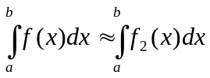
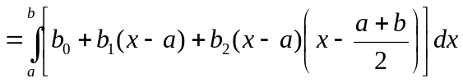
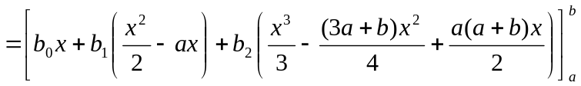
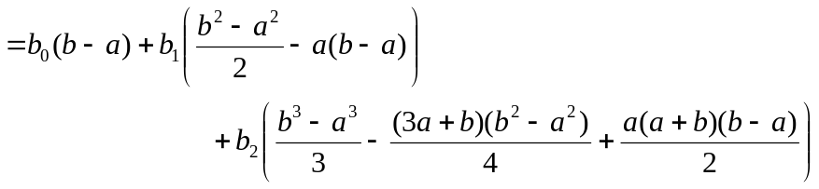

Substituting values of 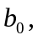 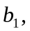 and 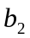 into this equation yields the same result as before
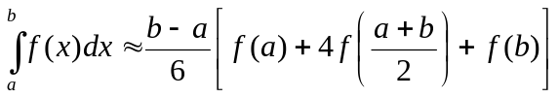

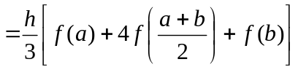

Method 3:
One could even use the Lagrange polynomial to derive Simpson’s formula. Notice any method of three-point quadratic interpolation can be used to accomplish this task. In this case, the interpolating function becomes
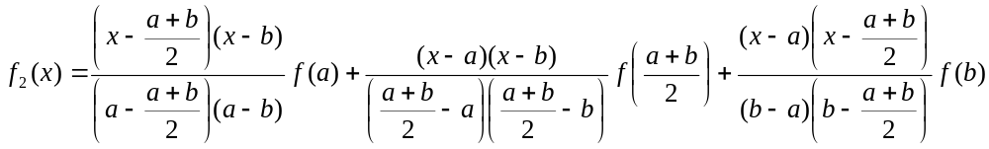
Integrating this function gets
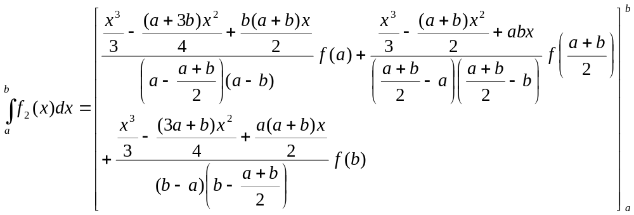
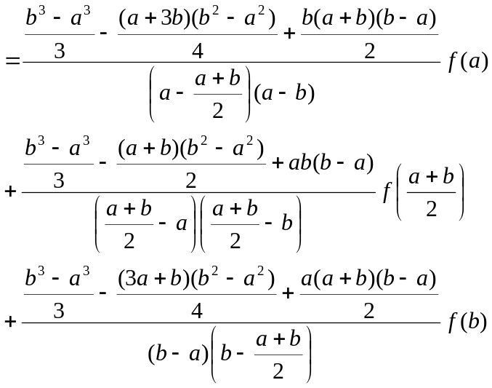
Believe it or not, simplifying and factoring this large expression yields you the same result as before
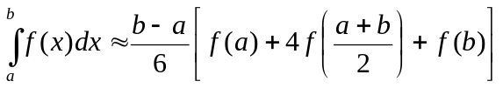

.

Method 4:
Simpson’s 1/3 rule can also be derived by the method of coefficients. Assume
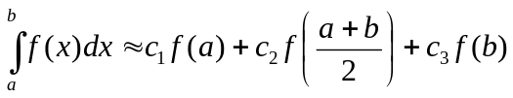
Let the right-hand side be an exact expression for the integrals 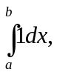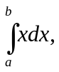 and 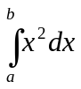. This implies that the right hand side will be exact expressions for integrals of any linear combination of the three integrals for a general second order polynomial. Now
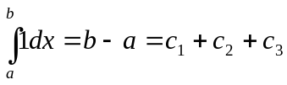
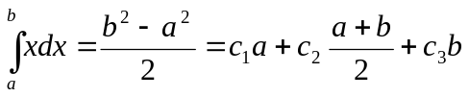
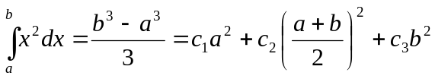
Solving the above three equations for 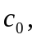 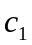 and 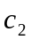 give
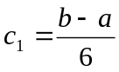
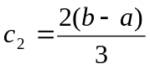
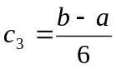
This gives
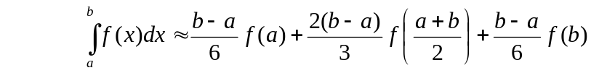
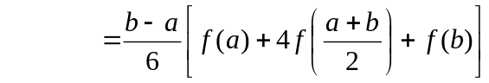

The integral from the first method
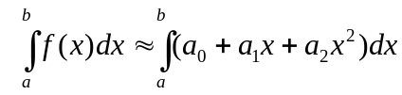
can be viewed as the area under the second order polynomial, while the equation from Method 4
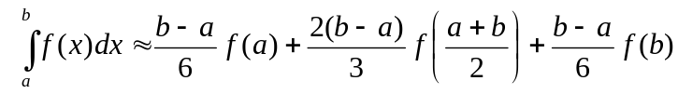
can be viewed as the sum of the areas of three rectangles.

Example 1
The distance covered by a rocket in meters from 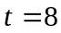s to 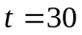s is given by
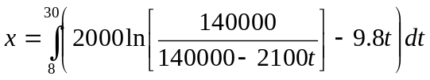
- Use Simpson’s 1/3 rule to find the approximate value of .
- Find the true error, 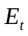.
- Find the absolute relative true error, 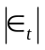.

Solution
a) 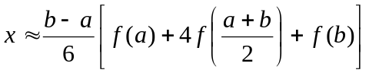
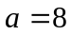
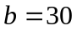
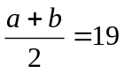
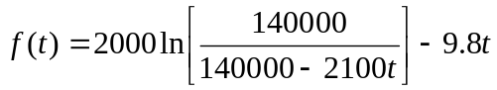
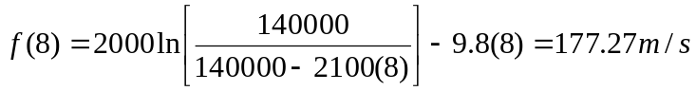

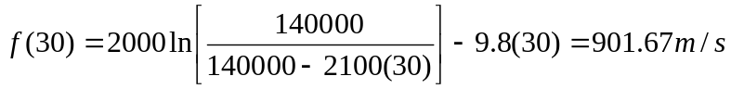

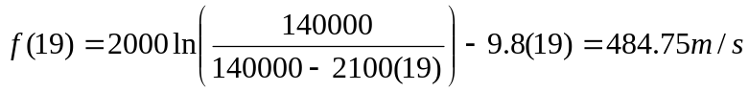

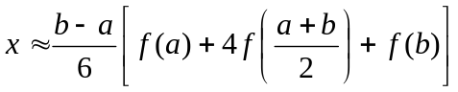
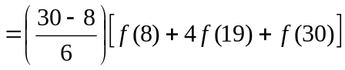
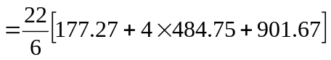
=11065.72 m
b) The exact value of the above integral is
=11061.34 m
So the true error is
=11061.34-11065.72
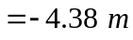
c) The absolute relative true error is
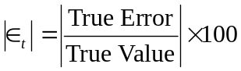
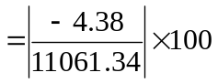
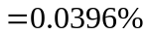

Multiple-segment Simpson’s 1/3 Rule
Just like in multiple-segment trapezoidal rule, one can subdivide the interval into segments and apply Simpson’s 1/3 rule repeatedly over every two segments. Note that needs to be even. Divide interval into equal segments, so that the segment width is given by
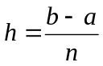.
Now
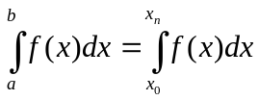
where
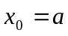
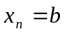
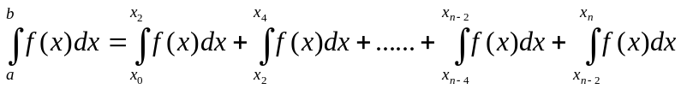
Apply Simpson’s 1/3rd Rule over each interval,
Since
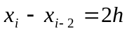
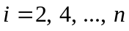
then
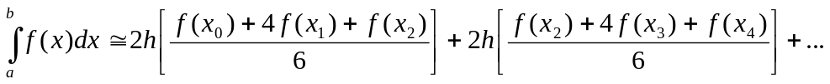
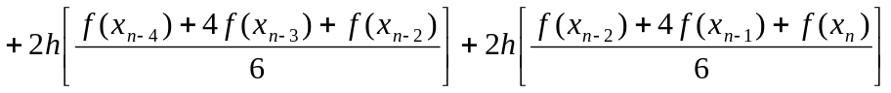
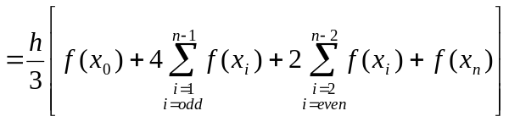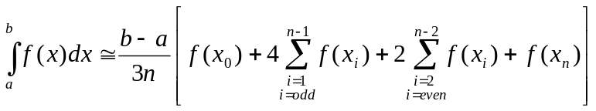

Example 2
Use 4-segment Simpson’s 1/3 rule to approximate the distance covered by a rocket in meters from 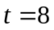s to s as given by
- Use four segment Simpson’s 1/3rd Rule to estimate x.
- Find the true error, 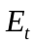 for part (a).
- Find the absolute relative true error, for part (a).

Solution:
a) Using segment Simpson’s 1/3 rule,
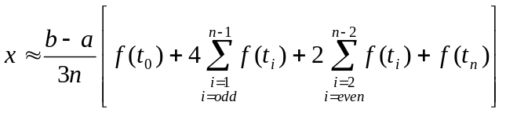
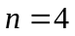
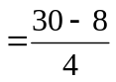
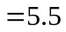

So
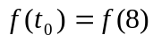

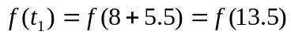

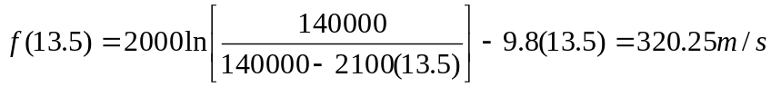

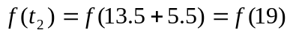

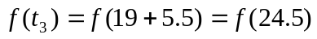

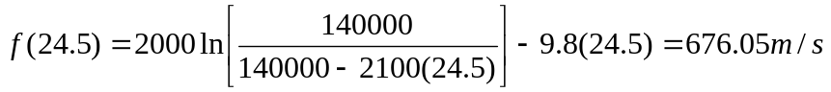

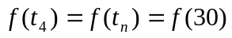

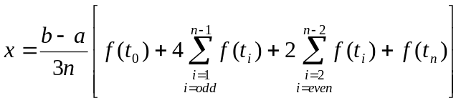
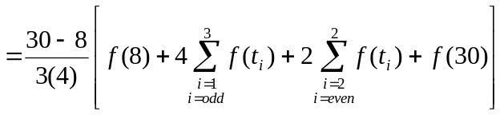
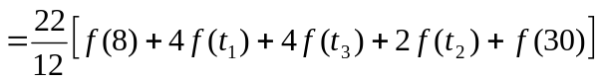
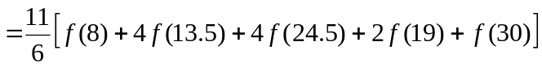
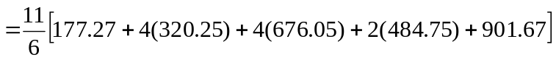
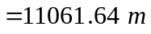
b) The exact value of the above integral is
=11061.34 m
So the true error is
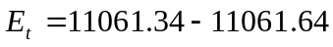
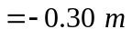
c) The absolute relative true error is
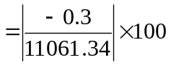
= 0.0027%

Table 1 Values of Simpson’s 1/3 rule for Example 2 with multiple-segments
 | Approximate Value |  | 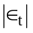
2  4  6  8  10 | 11065.72  11061.64  11061.40  11061.35  11061.34 | -4.38  -0.30  -0.06  -0.02  -0.01 | 0.0396%  0.0027%  0.0005%  0.0002%  0.0001%

Error in Multiple-segment Simpson’s 1/3 rule
The true error in a single application of Simpson’s 1/3rd Rule is given by
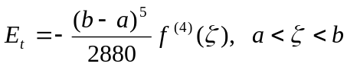
In multiple-segment Simpson’s 1/3 rule, the error is the sum of the errors in each application of Simpson’s 1/3 rule. The error in the n segments Simpson’s 1/3rd Rule is given by
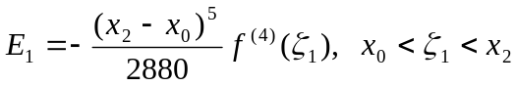
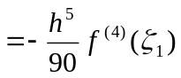
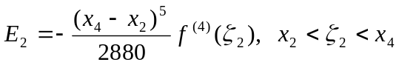
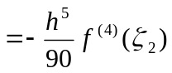
:
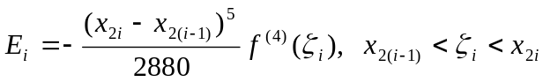
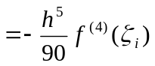
:
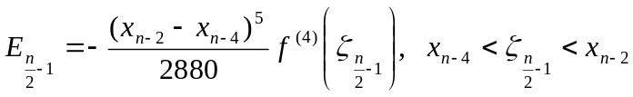
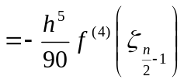
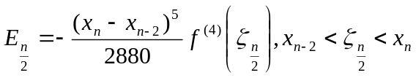
Hence, the total error in the multiple-segment Simpson’s 1/3 rule is
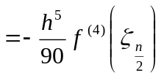
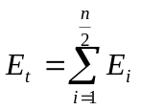
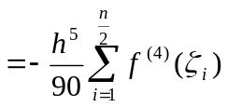
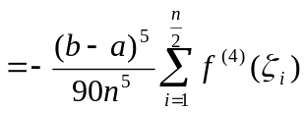
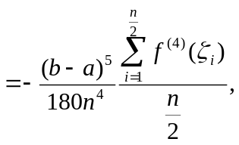
The term 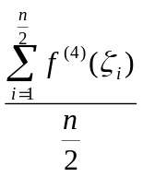 is an approximate average value of 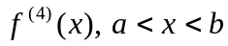. Hence
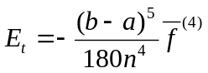
where
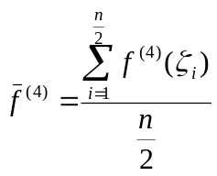

The 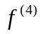in the true error expression stands for the fourth derivative of the function.

