DAY 08 / X01 • A17 LUNAR EXPLORER

A digital design.
A physical boundary.
A17 Lunar Explorer is a complete digital engineering package for its released scope.
The rocket has not been fabricated, physically validated, or flown.
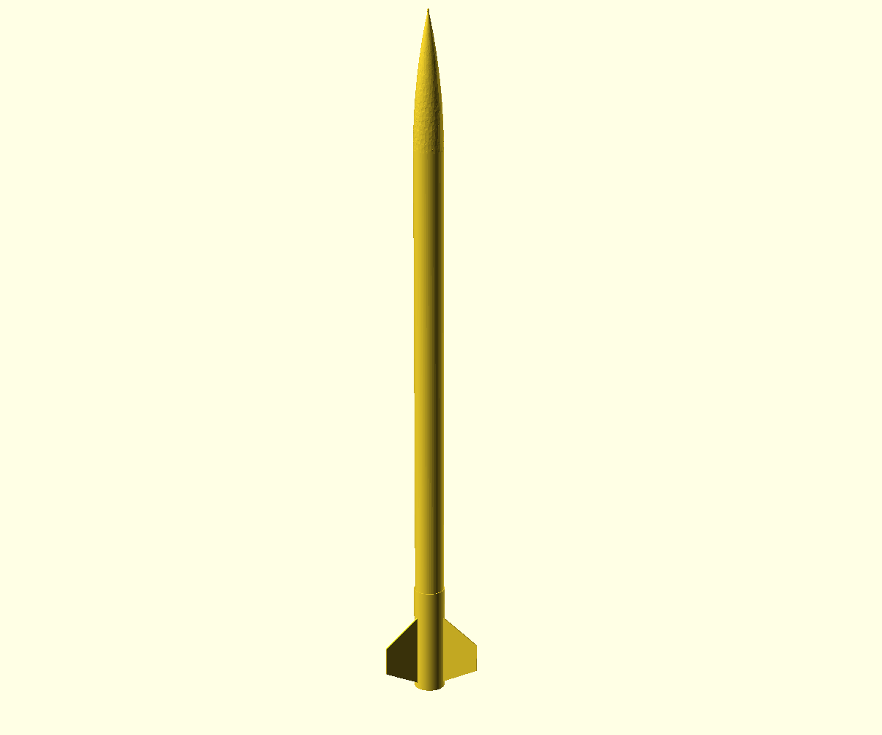

01 / THE FILE SET

What is inside
Design | CAD and printable files, drawings, renders, and original graphics

Build reference | Documentation, inspection and safety guidance, and a bill of materials

Models | OpenRocket artifacts and modeled trajectory outputs

Traceability | Public claims, rights, and provenance records

02 / MODELED VERSUS MEASURED

The assembly exists as files
The CAD and simulation can be inspected before a physical article exists.
Modeled | A predicted result from the digital design

Measured | A real-world result that this release does not provide

03 / CLAIM BOUNDARY

What is not claimed
Fabrication | Not performed

Ground testing | No physical validation established

Flight | Not performed

Performance | No measured or guaranteed result

No NASA affiliation, sponsorship, approval, endorsement, official status, or official-replica status.

04 / WHY IT MATTERS

Ask the evidence the right question

The files show what was designed.
They can be inspected for geometry, part relationships, modeled results, and documented assumptions.

Physical evidence shows what happened.
Fabrication quality, measured dimensions, ground tests, and flight behavior require separate work and separate proof.
This release keeps those states distinct.

05 / INSPECT THE RELEASE

Explore the package
Start with the scope and safety boundary. Then inspect the engineering download and its provenance records.

Repository
github.com/BRAIZ-Works/ubuildos-a17-lunar-explorer

Public site
braiz-works.github.io/ubuildos-a17-lunar-explorer/
A digital release is not authorization to build or launch. Check current rules and qualified supervision before physical use.

