# 

# 📦 Core Product Workbook

This workbook is designed to help you design, differentiate, and deepen your core product into an offer that's not just sellable—but scalable.  
  
A great product isn't built on one idea alone. It's a strategic system of layers—each one increasing value, defensibility, and demand. This tool helps you think through each of those layers deliberately and practically.  
  
The model below outlines eight strategic levers across two spectrums:  
1. From YOUR side: what makes your offer profitable, unique, and hard to replicate  
2. From the CUSTOMER side: what makes it desirable, valuable, and aligned  
  
For each lever, you’ll answer four simple but powerful questions:  
- What can I do to increase this?  
- What will I implement first?  
- Cost of implementation  
- Who is going to do it?  
  
Let’s break down each part of the core product system below.

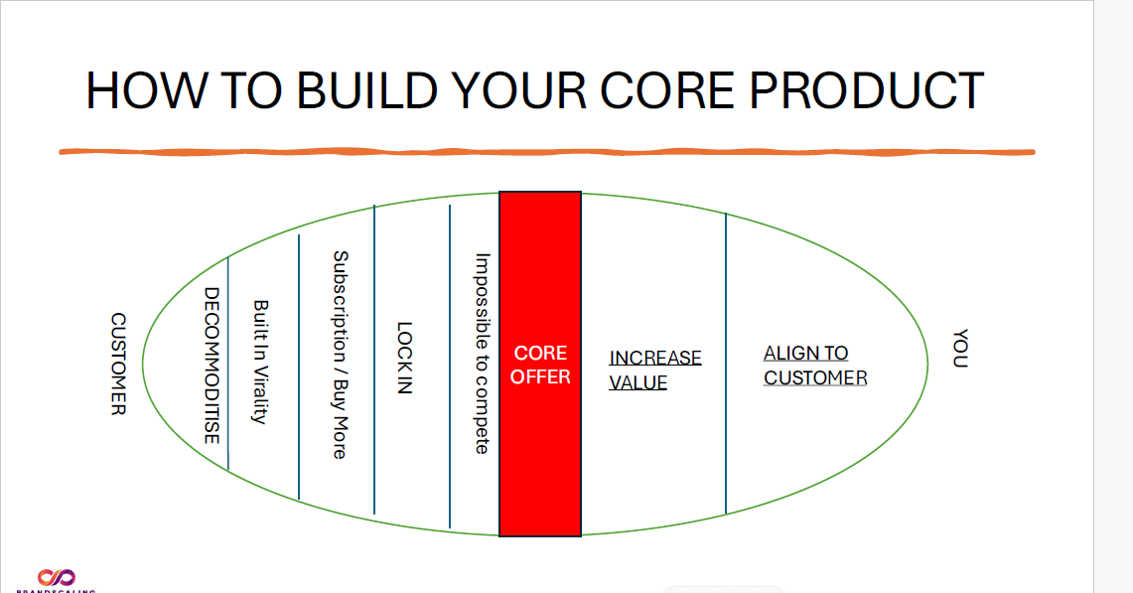

## Core Product 🎯 **Craft Your Core Offer**

**Instructions:**

Your Core Offer is not just what you sell. It's the transformation you deliver — the thing your customer truly wants, even if they don’t have the words for it yet.

Use this space to write your Core Offer Statement. It should be magnetic, specific, and centered around the outcome your perfect customer deeply desires.

**Prompt Box:**

“I help [who] get [transformation], without [pain or resistance], by [your unique mechanism or method].”

**Examples:**

* “I help burnt-out coaches create a product that sells itself — without needing a funnel or audience — using the Core Product Framework.”
* “We help e-comm founders scale profitably without paid ads, using a community-led launch system.”

## 🧲 **CUSTOMER-SIDE GROWTH LAYERS**

They help you reduce friction, increase repeat use, and create word-of-mouth potential.

The following five sections help you make your core product more desirable, sticky, and scalable from the *customer's perspective*.

## DECOMMODITISE

|  |  |
| --- | --- |
| Questions | Response |
| What can I do to increase this? |  |
| What will I implement first? |  |
| Cost of implementation |  |
| Who is going to do it? |  |

**Need help answering these? Use the following ChatGPT prompts to guide your thinking.**

## ChatGPT Prompts

**1. What can I do to increase this?**  
*Prompt:*

"Act as a product strategist. I want to make my offer feel unique and signature, not like a commodity. Here's what I currently offer: [insert product/offer]. What are powerful ways to decommoditise it and differentiate deeply?"

**2. What will I implement first?**  
*Prompt:*

"Based on these differentiation ideas: [insert ideas], help me identify which one I should implement first. Prioritize based on effort vs. impact and speed to execute."

**3. Cost of implementation**  
*Prompt:*

"Estimate the likely costs—money, time, and team energy—of implementing this idea: [insert idea]. I need a breakdown for realistic planning."

**4. Who is going to do it?**  
*Prompt:*

"Given this initiative: [insert what you plan to implement], who is the ideal person to own it? Should it be handled by a founder, product designer, marketer, or someone else?"

## Built-In Virality

|  |  |
| --- | --- |
| Questions | Response |
| What can I do to increase this? |  |
| What will I implement first? |  |
| Cost of implementation |  |
| Who is going to do it? |  |

**Need help answering these? Use the following ChatGPT prompts to guide your thinking.**

## ChatGPT Prompts

**1. What can I do to increase this?**  
*Prompt:*

"Act as a product-led growth expert. How can I design built-in virality into my product or offer? Here’s what I currently sell: [insert product]. Suggest specific viral loops, user triggers, or sharing mechanics that feel natural."

**2. What will I implement first?**  
*Prompt:*

"Here are some viral growth ideas I’m considering: [insert list]. Help me choose the one to implement first based on ease of execution, impact, and alignment with my audience behavior."

**3. Cost of implementation**  
*Prompt:*

"Estimate the cost—in money, time, and effort—of building this virality idea into my product: [insert idea]. I want a realistic view to plan resource allocation."

**4. Who is going to do it?**  
*Prompt:*

"For this viral growth initiative: [insert chosen idea], who should lead the execution? Should it be a product manager, marketing lead, developer, or a cross-functional role?"

## Subscription / Buy More

|  |  |
| --- | --- |
| Questions | Response |
| What can I do to increase this? |  |
| What will I implement first? |  |
| Cost of implementation |  |
| Who is going to do it? |  |

**Need help answering these? Use the following ChatGPT prompts to guide your thinking.**

## ChatGPT Prompts

**1. What can I do to increase this?**  
*Prompt:*

"Act as a recurring revenue strategist. I want to increase repeat purchases or introduce a subscription model for my offer: [insert product]. What are effective ways to structure this so it feels valuable and natural to my audience?"

**2. What will I implement first?**  
*Prompt:*

"I have a few ideas for recurring value (e.g., bonuses, bundles, tiers, access). Which of these should I implement first, considering simplicity, customer demand, and ROI?"

**3. Cost of implementation**  
*Prompt:*

"Break down the estimated costs—time, money, and team capacity—of setting up this subscription or repeat purchase mechanic: [insert idea]. I want to anticipate challenges before launch."

**4. Who is going to do it?**  
*Prompt:*

"For this subscription or recurring revenue idea: [insert detail], who is the best person to lead implementation—someone in marketing, product, ops, or elsewhere?"

## LOCK-IN

|  |  |
| --- | --- |
| Questions | Response |
| What can I do to increase this? |  |
| What will I implement first? |  |
| Cost of implementation |  |
| Who is going to do it? |  |

**Need help answering these? Use the following ChatGPT prompts to guide your thinking.**

## ChatGPT Prompts

**1. What can I do to increase this?**  
*Prompt:*

"Act as a customer retention strategist. How can I make my product harder to switch away from—in a way that feels valuable and convenient to the customer? Here's what I offer: [insert product]. Suggest mechanisms like habits, integrations, or ongoing value."

**2. What will I implement first?**  
*Prompt:*

"From these lock-in ideas: [insert list], help me prioritize which to implement first. Consider customer impact, ease of implementation, and potential for long-term retention."

**3. Cost of implementation**  
*Prompt:*

"Estimate the costs—financial, technical, and operational—of implementing this lock-in strategy: [insert chosen idea]. Give me a simple breakdown."

**4. Who is going to do it?**  
*Prompt:*

"Who on my team should own and lead this lock-in initiative: [insert chosen idea]? Should it be a product lead, customer success, or someone else?"

## Impossible to Compete

|  |  |
| --- | --- |
| Questions | Response |
| What can I do to increase this? |  |
| What will I implement first? |  |
| Cost of implementation |  |
| Who is going to do it? |  |

**Need help answering these? Use the following ChatGPT prompts to guide your thinking.**

## ChatGPT Prompts

**1. What can I do to increase this?**  
*Prompt:*

"Act as a competitive strategy consultant. How can I create something in my offer that no competitor can easily copy—whether it’s a system, experience, or proprietary method? Here’s what I currently offer: [insert details]. Suggest ideas to strengthen my unique edge."

**2. What will I implement first?**  
*Prompt:*

"From these defensibility ideas: [insert list], help me decide which to build or reinforce first. Prioritize based on strategic impact, feasibility, and long-term value."

**3. Cost of implementation**  
*Prompt:*

"Break down the estimated costs (team, time, and money) of developing this defensibility asset: [insert chosen idea]. I want to understand what it will take to build a moat."

**4. Who is going to do it?**  
*Prompt:*

"Who on my team—or externally—should lead this defensibility initiative: [insert idea]? Consider roles like strategy, ops, product, or partnerships."

## 💡 **BUSINESS-SIDE LEVERAGE LAYERS**

These next two sections help you boost profitability and long-term alignment from *your side of the business*. They’re about increasing margins and keeping your offer aligned to evolving customer needs.

## INCREASE VALUE

|  |  |
| --- | --- |
| Questions | Response |
| What can I do to increase this? |  |
| What will I implement first? |  |
| Cost of implementation |  |
| Who is going to do it? |  |

**Need help answering these? Use the following ChatGPT prompts to guide your thinking.**

## ChatGPT Prompts

**1. What can I do to increase this?**  
*Prompt:*

"Act as a product positioning expert. How can I increase the perceived value of my offer—through bonuses, packaging, naming, or presentation—without significantly raising cost? My product: [insert details]. Give me creative ways to elevate its value."

**2. What will I implement first?**  
*Prompt:*

"I’ve brainstormed some ways to increase value: [insert list]. Which one should I implement first for the highest perceived ROI and quickest impact?"

**3. Cost of implementation**  
*Prompt:*

"What will it cost—in terms of design, time, and team resources—to upgrade my offer’s value using this approach: [insert idea]? Help me map out realistic cost factors."

**4. Who is going to do it?**  
*Prompt:*

"Based on this value enhancement idea: [insert detail], who should take ownership of execution—brand, design, product, or someone else?"

## ALIGN TO CUSTOMER

|  |  |
| --- | --- |
| Questions | Response |
| What can I do to increase this? |  |
| What will I implement first? |  |
| Cost of implementation |  |
| Who is going to do it? |  |

**Need help answering these? Use the following ChatGPT prompts to guide your thinking.**

## ChatGPT Prompts

**1. What can I do to increase this?**  
*Prompt:*

"Act as a customer insight strategist. How can I evolve my offer to stay perfectly aligned with my ideal customer's shifting needs, language, and priorities? My offer is: [insert offer]. Give me ways to adapt without diluting our core."

**2. What will I implement first?**  
*Prompt:*

"From these alignment ideas: [insert list], help me choose one to implement immediately. Prioritize based on relevance to current customer desires and ease of execution."

**3. Cost of implementation**  
*Prompt:*

"Estimate the resources—time, money, team effort—required to make this adjustment to my offer: [insert idea]. I want to keep it agile and lean."

**4. Who is going to do it?**  
*Prompt:*

"Who should lead the customer-alignment effort for this initiative: [insert detail]? Should it be marketing, product, strategy, or direct customer interviews?"