Automated Parametric Optimization of a High-Purity Germanium Monte Carlo Neutral-Particle Model
Bryan V. Egner,* Robert S. Torzilli*

*Air Force Institute of Technology, 2950 Hobson Way, Wright-Patterson AFB, OH 45433, Bryan.Egner@afit.edu

INTRODUCTION

Gamma-ray spectroscopy using high-purity germanium (HPGe) detectors is a leading method for obtaining high-energy-resolution spectra in both the field and laboratory settings. These detectors have the ability to obtain energy resolutions as low as 0.15 keV for the Full-Width-Half-Maximum, at incident photons around 5.9 keV [1]. The tradeoff for high-energy resolution is an overall lower detection efficiency compared to other types of detectors. The advancement of radiation transport codes, such as Monte Carlo Neutral-Particle (MCNP), allows researchers to accurately model detection responses of HPGe detectors at various geometries, source energies, and environments.
Unfortunately, creating a MCNP detector model accurately representing reality can be difficult and time consuming, thus applying a systematic computational approach can streamline the process. Rather than manually carrying out trial-and-error adjustments to match experimental data, development of an automated parametric optimization code will simplify the enhancement of a rudimentary HPGe detector model.

Problem Description

Factors to consider when developing a MCNP detector model include the following: the type and position of the radiation source; the properties, both geometrical and compositional; and the characteristics of primary and secondary incident radiation. Published literature has stated relative differences between the experimental and Monte Carlo simulated full-energy peak absolute efficiencies for HPGe detectors have reached as low as 0.2% [2]. There have also been studies showing discrepancies between the detector specifications of internal components compared to measured values, such as the crystal length and dead layers [3].
Experimental measurements of gamma-ray emissions using a standard Canberra p-type HPGe detector were provided by Lieutenant Colonel Buckley O’Day, at the Air Force Institute of Technology, using a calibration multi-nuclide source manufactured by Eckert & Ziegler Isotope Products. The multi-nuclide source covered photon energies ranging from 59.9 to 1836 keV, allowing for a full representation of the absolute efficiency curve.
A labeled diagram of the various source positions with respect to the HPGe detector and base of the lead shield is shown in Figure 1. At each position, a 24-hour count was performed to minimize uncertainty. For position 1, the source was centered on the Al casing, position 2 was resting on the front face and flush with the edge of the casing, position 3 was centered 7 cm above the front face, position 4 was placed 3 cm down the side of the casing, and position 5 was offset 13 cm above the detector.
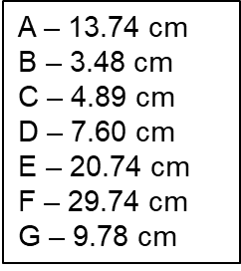
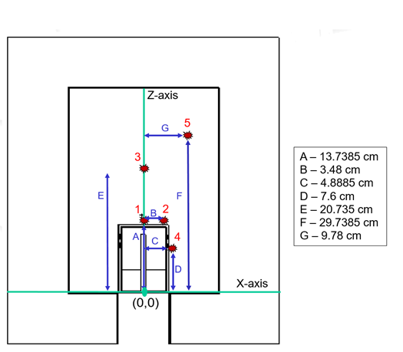
Fig. 1. Experimental setup diagram displaying each source position on a Cartesian coordinate system. The origin is centered at the base of the Al casing of the detector.

A plot of the spectra and the calculated absolute efficiencies as a function of energy were also provided by Lt Col O’Day for comparison with the simulated results. The absolute efficiency was calculated using Equation 1.
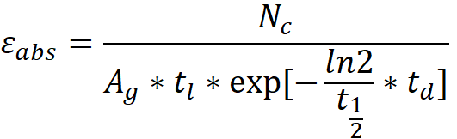

(1)

N_{c} is the total number of counts under the full-energy peak. A_{g} is the amount of gamma-rays emitted per second, multiplied by the live time, t_{l}, in seconds. The source decay is accounted for by multiplying the denominator by the decay exponential where t_{1/2} is the half-life and t_{d} is the age of the source, both in seconds.

Description of Work

First, a HPGe detector model was created using MCNP, and then an optimization code was produced in Python. After the model was optimized, efficiency curves were plotted for a quantitative analysis.

HPGe MCNP Model

The MCNP model was designed based off the manufacturer provided detector diagram labeled with various dimensions and materials. Unfortunately, some dimensions were not labeled, including information about the internal contact pin, gap widths between the Ge crystal and the inner Al holder, and the insulation materials. For higher energy photons, these features are not as important, but for the lower energies, attenuation is more probable to occur which might affect the efficiency calculations. The goal of the generic MCNP model was to have easily adjustable parameters, thus only right circular cylinders and planes were utilized in the model geometry. The only changes needed to be made would be raising or lowering the heights, and widening or compressing the widths to adjust detector parameters. The final design of the generic HPGe MCNP model outputted in VisEd and illustrated in Figure 2.

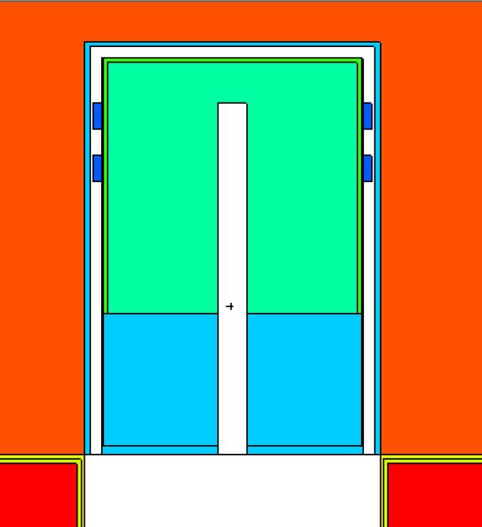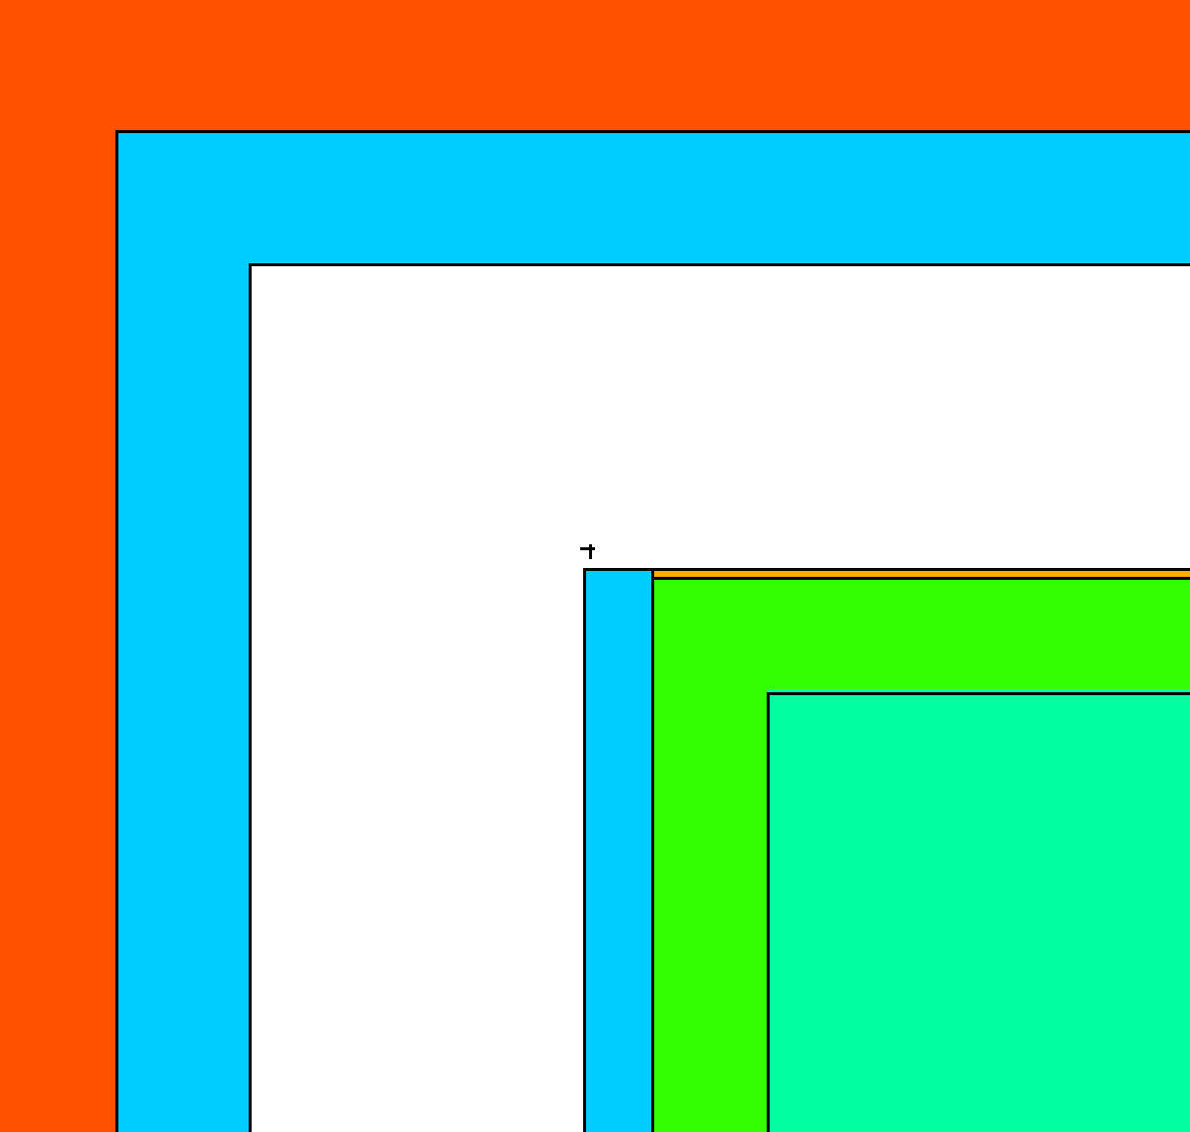
Air
Al Casing
Vacuum
IR Window
Ge Crystal
Outer Deadlayer
Al Holder
Air
Metal Clasps
Inner Deadlayer
Fig. 2. Generic HPGe Model displayed using VisEd. An enlarged view of the top edge of the Ge crystal is shown.

The infrared window placed directly above the top deadlayer is composed of a thin 0.010 cm kapton tape window and a 0.000847 cm Al Mylar layer. Both the HPGe crystal top edges and the top of the inner coaxial were assumed to be squared, rather than rounded, since the manufacturer did not specify these features. In the left image of Figure 2, the outer deadlayer can be seen and was assumed to be a lithium drifted surface. The inner deadlayer was assumed to be a boron implanted contact. Neither of these materials were explicitly stated in the detector schematic, and the compositional assumptions were based on common p-type HPGe detector fabrication techniques [1]. All material composition data were found in resources published by Los Alamos and Pacific Northwestern National Laboratories [4, 5]. The cross-sectional data library used was mcplib84 (.84p) for photon transport utilizing 278 energy groups.
Since only the absolute efficiency was desired, a full-energy spectrum accounting is unnecessary and Gaussian energy broadening was neglected. The default Physics Card settings were used, meaning Bremsstrahlung, coherent scattering, and photo-fission were ignored as well. The source card represented the multi-nuclide source as an isotropic point source emitting 12 discrete photon energies, each with the same probability distribution to avoid large statistical variations in each source from differing emission rates. The energy deposition, F8, tally was used to track particle interactions with the Ge crystal, and 10⁶ source particles were used to reduce uncertainties.
After the model was created, a review of previous research led to the conclusion that the deadlayers, entrance windows, HPGe crystal length, and radius had the largest effect on modeling HPGe detection efficiency [2, 3]. A full list of model parameters adjusted and the order of adjustments can be found in Table I of the results section.

Automated Parametric Optimization Code

The MCNP Automated Parameters, MAP, Python code developed uses user supplied data, points of interest, parameters of interest and their associated range, and a prepared MCNP input deck to create an experimentally observed detector. It accomplishes this task by iterating through all defined points for each parameter while keeping the values that minimize the chi squared value
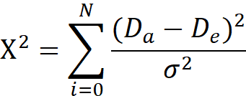
(2)

where D_{a} is the analytical derived efficiency created by MAP, D_{e} is the experimental efficiency that MAP is trying to match, and σ is the uncertainty of the experimental data. The closer chi squared is to one, the better fit the model is to the experimental data.

The process that MAP currently uses to determine which values are the best is a brute force method. By comparing the previous best chi squared value with the current one for every step in the user supplied range it can make a reasonable decision on what would be the best value to use for each parameter. Once it has determined the optimum result it can achieve from that parameter’s given range, it moves on to the next parameter and repeats this process.

MAP’s secondary purpose is to automate the collection of relevant data for the purpose of recording what other parameters could be of interest based on how it affects the overall data. This is accomplished by printing out the relative difference between the experimental and MCNP absolute efficiencies, the average relative difference, and plots of the data superimposed upon the experimental data in an easy to read format. From these outputs, the user can determine if an interested parameter is behaving as expected or if it even affects the model in a meaningful way. This makes it easier to determine what values need to be adjusted as well as what could be occurring to cause a difference in the model versus the experiment.

RESULTS

Five efficiency curves were produced from the output of the F8 tallies, and the results are shown in Figures 3 through 7. In the experimental data, a systematic jump in efficiency at 320 keV for each position was evident and so the Cr-51, 320 keV photopeak efficiency was neglected and only 11 energies were plotted. Figure 3 displays the experimental and MCNP absolute efficiencies for source position 1 where the average relative difference was 52%, and the minimum relative difference was 2%. The experimental and MCNP results match up fairly well for energies above 159 keV being less than 10%, but the lower energies have 100% or more, relative difference.
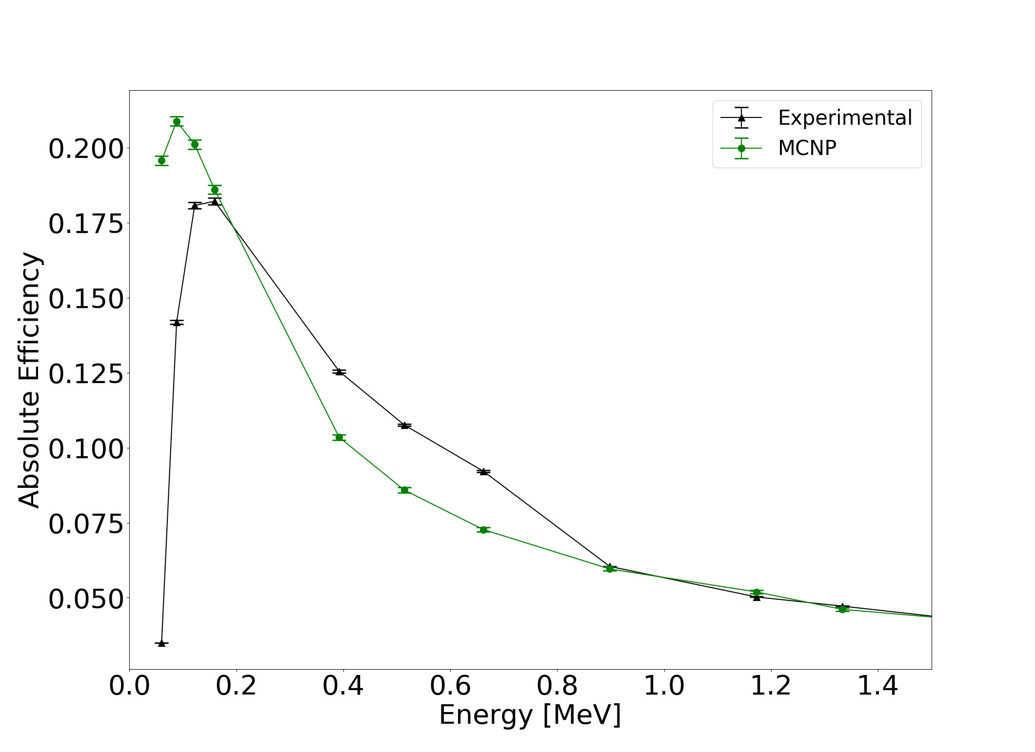

Fig. 3. Experimental and MCNP absolute efficiency as a function of photon energy at position 1.

The results for position 2 and 3, displayed in Figure 4 and Figure 5 respectively, showed a similar behavior as position 1; where the experimental efficiencies for lower energy photons varied drastically compared to the MCNP model.
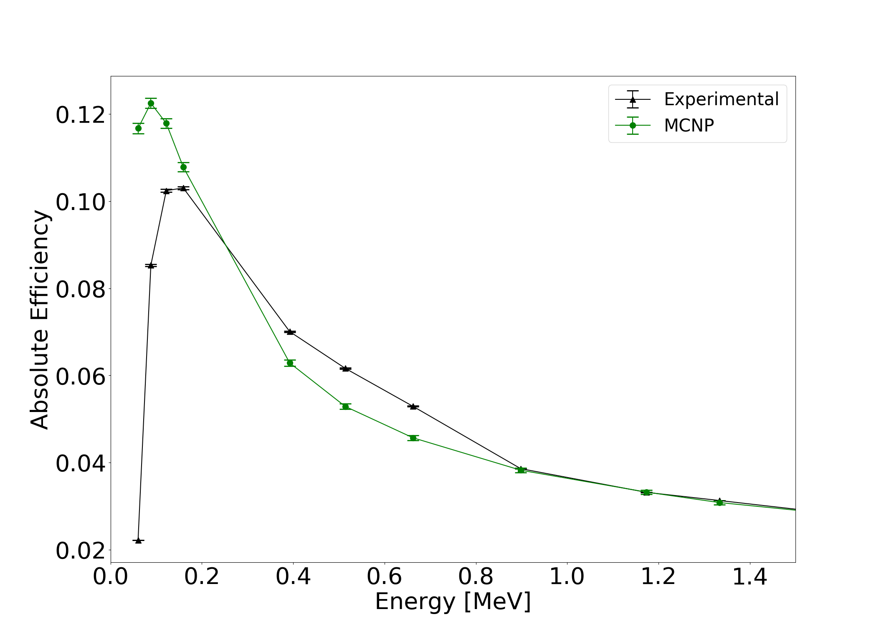
Fig. 4. Experimental and MCNP absolute efficiency as a function of photon energy at position 2.
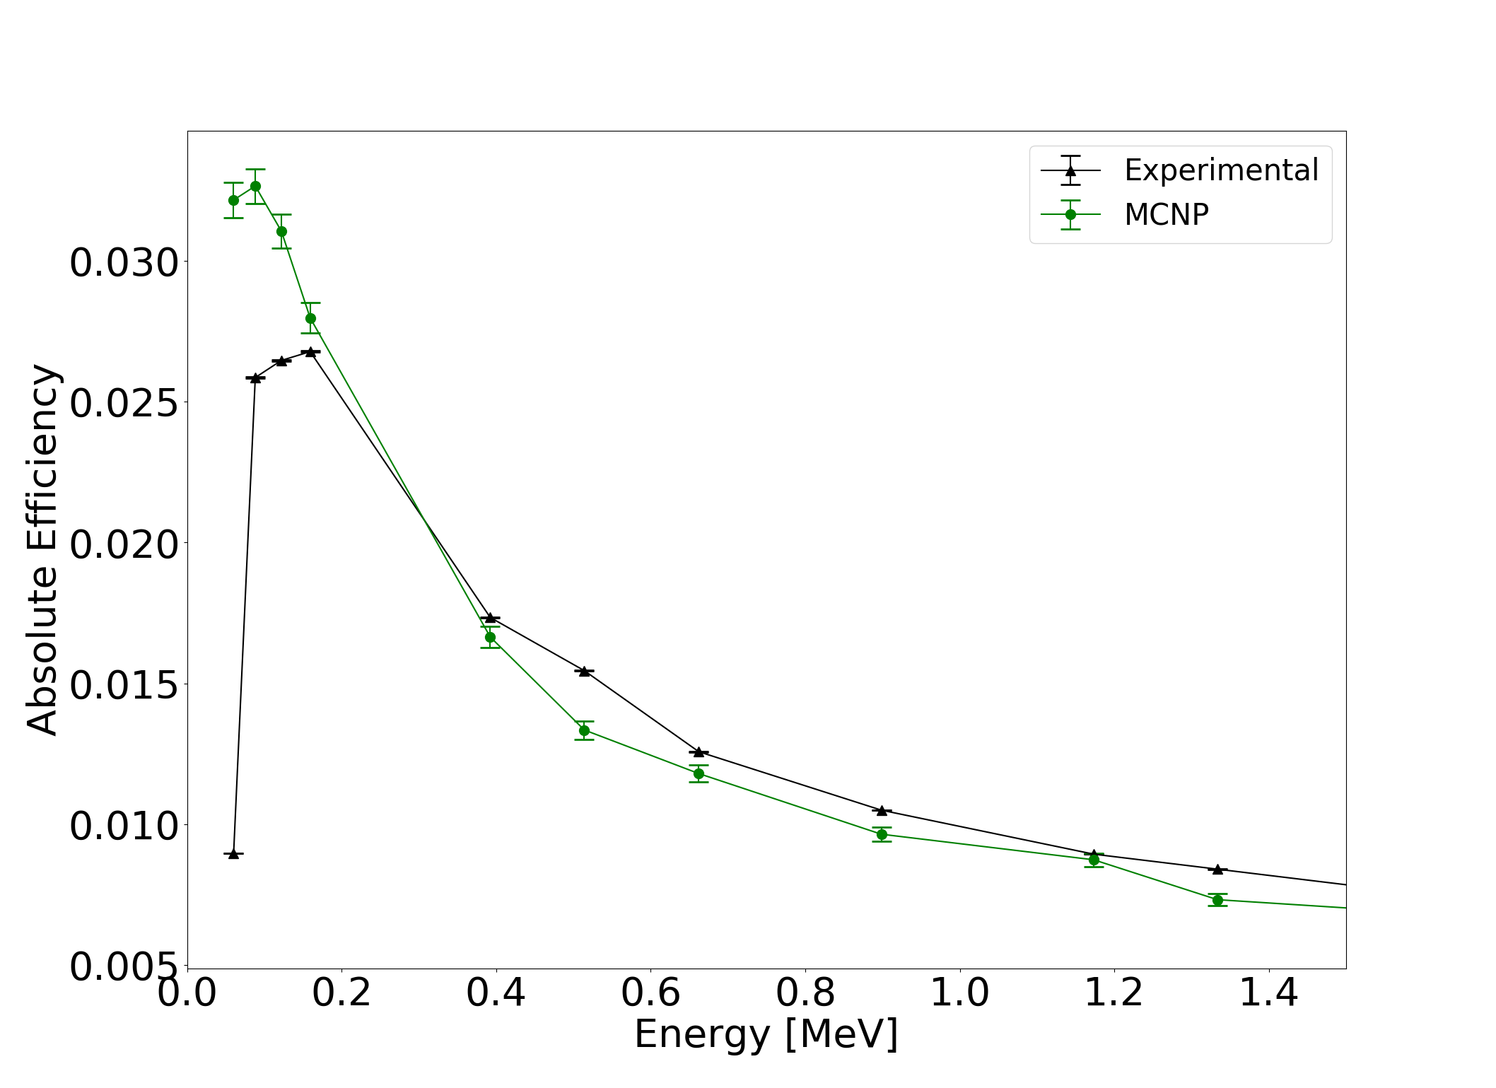
Fig. 5. Experimental and MCNP absolute efficiency as a function of photon energy at position 3.

When the source was placed on the side of the HPGe detector, the experimental and MCNP efficiencies were not in agreement, as shown in Figure 6. This may have occurred possibly due to the shorter active distance the photons have to travel through the Ge crystal compared to a source above the detector.
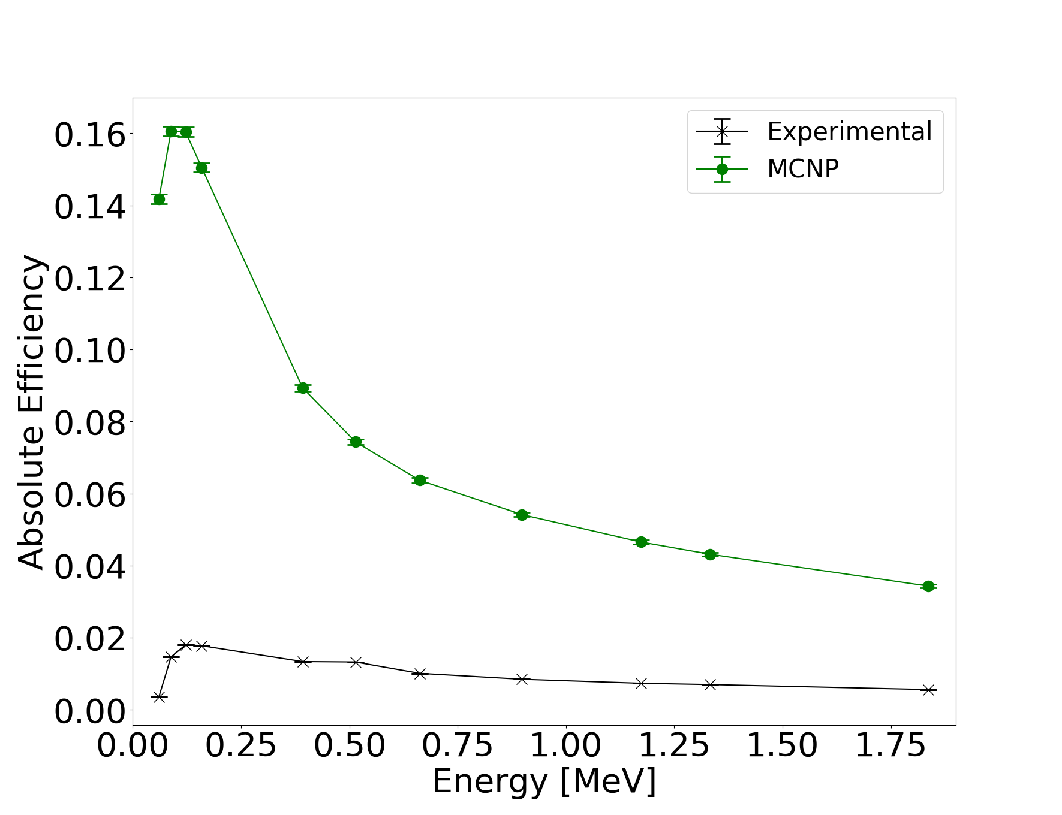
Fig. 6. Experimental and MCNP absolute efficiency as a function of photon energy at position 4.

The results for the final position for a source offset and 13 cm above the detector had a similar efficiency curve shape to positions 1, 2, and 3, as shown in Figure 7.
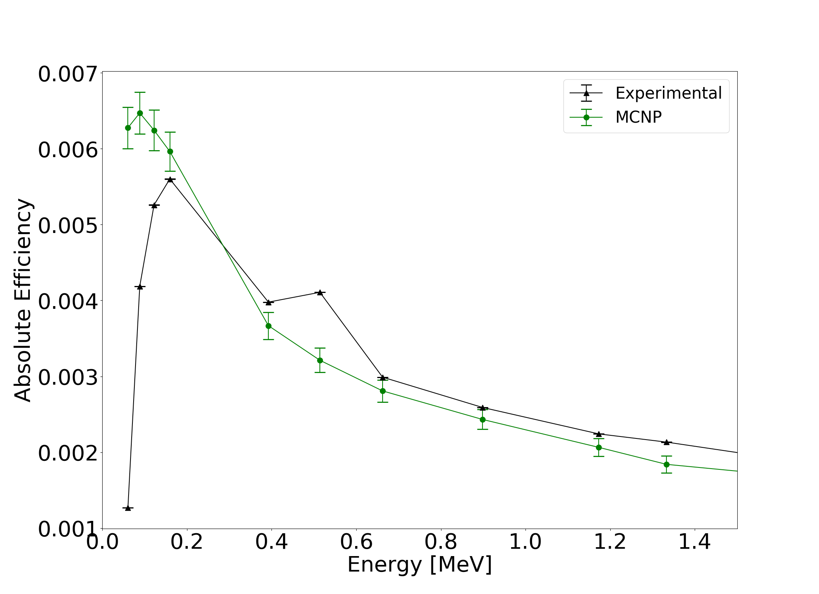
Fig. 7. Experimental and MCNP absolute efficiency as a function of photon energy at position 5, offset 13 cm above the detector.

The final parameters outputted by the automated optimization code are shown in Table 4. Most of the adjustments for each source position were similar, where the top deadlayer increased and the crystal length shortened to account for pileup, electric field, and other losses not captured in the MCNP model by pure photon transport.

TABLE I. Optimized Detector Parameters
Parameter | Initial Value | Position:
Parameter | Initial Value | 1 | 2 | 3 | 4 | 5
Outer Top Deadlayer [cm] | 0.13 | 0.738 | 0.739 | 0.739 | 0.739 | 0.739
Outer Sides Deadlayer [cm] | 0.13 | 0.23 | 0.23 | 0.23 | 1.35 | 0.23
Ge Crystal Length [cm] | 8.32 | 7.66 | 7.48 | 7.48 | 7.48 | 7.48
Kapton Window [cm] | 0.010 | 0.110 | 0.110 | 0.110 | 0.058 | 0.110
Inner Top Coaxial Deadlayer [cm] | 3E-05 | 1E-04 | 6E-05 | 6E-05 | 1E-04 | 6E-05
Inner Sides Coaxial Deadlayer [cm] | 3E-05 | 2E-05 | 6E-05 | 7E-05 | 1E-3 | 7E-05
Top Al Casing Thickness [cm] | 0.15 | 0.25 | 0.25 | 0.25 | 0.05 | 0.25
Sides Al Casing Thickness [cm] | 0.15 | 0.05 | 0.05 | 0.05 | 0.27 | 0.25
Ge Crystal Density [g/cm³] | 5.32 | 5.32 | 5.32 | 5.35 | 5.32 | 5.342
The efficiency curves matched well at higher energies but poorly at energies below 159 keV. Another optimization trial was performed at position 3 where only energies above 159 keV were used to observe the model performance and the results can be seen in Figure 8 and Table 5. There was a stronger agreement between experimental and MCNP efficiencies with an average relative difference of 2.4%.
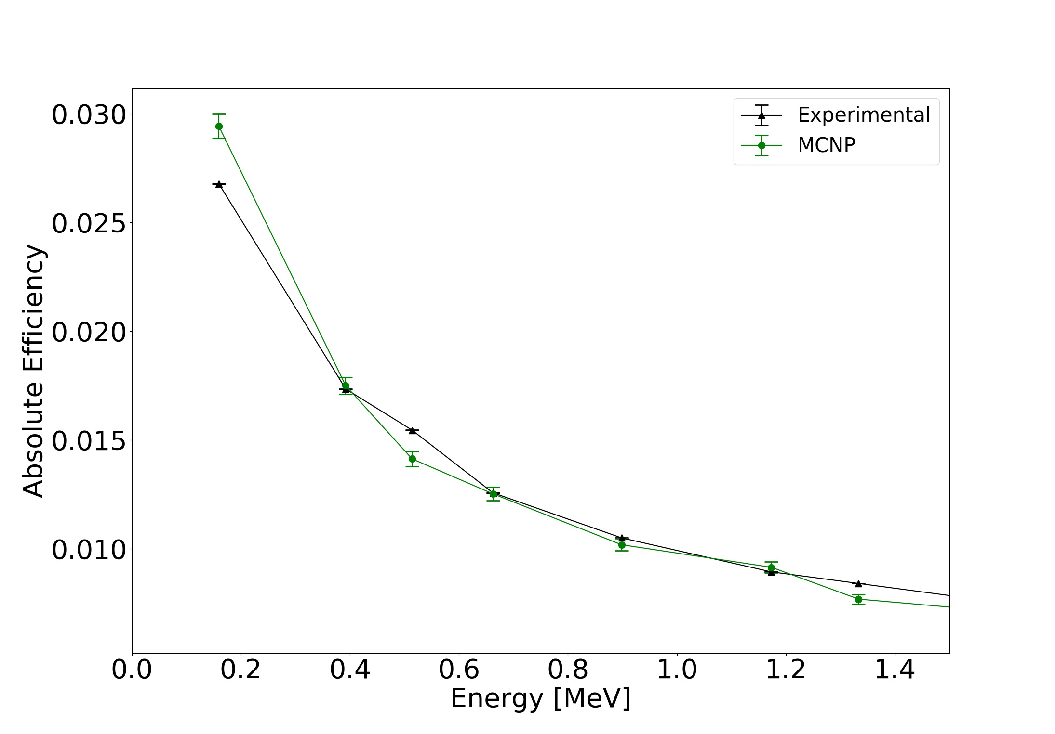

Fig. 8. Experimental and MCNP absolute efficiency as a function of photon energy at position 3 for energies 159 keV and higher.

TABLE II. Optimized Detector Parameters for Position 3
Parameter | Initial Value | Position
Parameter | Initial Value | 3 | 3 Adjusted
Outer Top Deadlayer [cm] | 0.13 | 0.739 | 0.975
Outer Sides Deadlayer [cm] | 0.13 | 0.23 | 0.13
Ge Crystal Length [cm] | 8.32 | 7.475 | 8.602
Kapton Window [cm] | 0.010 | 0.110 | 0.130
Inner Top Coaxial Deadlayer [cm] | 3E-05 | 6E-05 | 5E-05
Inner Sides Coaxial Deadlayer [cm] | 3E-05 | 7E-05 | 5E-05
Top Al Casing Thickness [cm] | 0.15 | 0.25 | 0.183
Sides Al Casing Thickness [cm] | 0.15 | 0.05 | 0.25
Ge Crystal Density [g/cm³] | 5.32 | 5.35 | 5.35

Conclusion

The brute-force automated parametric optimization method produced a HPGe MCNP model that represents the absolute efficiency between energies of 159 keV to 1836 keV, with a relative difference less than 5.9% for sources placed 7 cm above the detector. Areas where the method failed to resemble experimentally obtained efficiencies are at low photon energies and locations where there would be more internal components holding the Ge crystal in place, such as source positions 2 and 4. Regions that have more attenuation layers will have more secondary radiation produced by Compton events, potentially leading to the MCNP model overestimations in efficiency. A better understanding of how to model lower energy photons in MCNP is required along with a more detailed description of the internal components of the detector.
In the future, more adjustable parameters will be added to the optimization code along with more realistic radiation transport physics to reproduce experimental spectra. Efforts can be made to generalize the structure of the automation optimization code to be applicable for other detectors and experiments, as well as alternate means of optimization.

REFERENCES

1. G. F. Knoll, Radiation Detection and Measurement, Hoboken, NJ: John Wiley & Sons, Inc., (2010).
2. R. G. Helmer, R. G. Hardy, V. E. Iacob, M. Sanchez-Vega, R. G. Neilson and J. Nelson, "The use of Monte Carlo Calculations in the Determination of a Ge Detector Efficiency Curve," Nuclear Instruments and Methods in Physics Research, vol. 551, no. A, pp. 360-381 (2002).
3. R. M. Keyser, "Resolution and Sensitivity as a Function of Energy and incident Geometry for Germanium Detectors," Nuclear Instruments and Methods in Physics Research Section B: Beam Interactions with Materials and Atoms, vol. 213, pp. 236-240 (2004).
4. L. Conlin, "Listing of Available ACE Data Tables," Los Alamos National Laboratory, Los Alamos National Laboratory (2013).
5. R. McConn, "Compendium of Material Composition Data for Radiation Transport Modeling," Pacific North Western National Laboratory, Richland, WA (2011).
7. S. Guilherme and J. d. S. Corrêa, "Computational Modeling of a High Purity," in International Nuclear Atlantic Conference, Belo Horizonte, MG, Brazil, 2011.
8. D. B. Pelowitz, "MCNP6 User's Manual Version 1.0," Los Alamos National Laboratory, Los Alamos National Laboratory, 2013.

