CAS ETH in Computational Form-Finding
Programme concept and curriculum — Certificate of Advanced Studies (CAS), ≈ 10 ECTS
Status: working draft for discussion · Basis: shared Google Doc “CAS Computational Form-finding”, the Teaching repository (ReadMe files), and the MAS ETH CSD preparation dossier.
Field | Value
Working title | CAS ETH in Computational Form-Finding (CAS ETH CFF)
Host | Block Research Group (BRG), ITA, D-ARCH, ETH Zürich — with ETH School for Continuing Education (SCE)
Volume | 10 ECTS (300 h student workload; ≈ 100 contact hours)
Duration | 6 months (onsite-intensive semester) or 12 months (part-time online) — both within the 6–12 month limit
Format | Hybrid: on-campus intensive blocks in Zürich and/or live online evening sessions
Language | English
Indicative fee | CHF 7,000–8,000 (SCE CAS guideline CHF 700–800 per ECTS), plus ETH semester fee
Credential | CAS ETH confirmation / Certificate of Advanced Studies UZH-ETH format (10 ECTS)
Cohort | Min. 10, target 16, max. 24 participants

How to read this document
The document is layered — read top-down and stop when you know enough. The table of contents on the next page lists all levels; section numbers are stable and used for cross-referencing (e.g. §4.4.2 is the resource list of Chapter 4).
- Level 0 — §0 “Programme in one page”: the whole CAS as pure bullet points. Start here.
- Level 1 — the “In brief” blocks at the start of every section: two to four summary bullets.
- Level 2 — the sections themselves: background, audience, outcomes, delivery, assessment, resources, work to be done, timeline, budget.
- Level 3 — the teaching chapters (§4.1–4.6): content, resources and exercises chapter by chapter.
- Level 4 — chapter sub-sections (§4.x.1–4.x.3) and the appendices: full link inventory and sources.

Table of contents
0 Programme in one page (read first) 3
1 Background: from the MAS ETH CSD to a focused CAS 3
1.1 Why the MAS did not launch — lessons applied here 3
1.2 The CAS answer at a glance 4
2 Target audience and admission 4
2.1 Target audience 4
2.2 Admission requirements 4
3 Learning outcomes (competencies) 5
4 Curriculum: teaching chapters in detail 5
4.1 Chapter 1 — History and graphic-statics foundations (1 ECTS, 30 h) 6
4.1.1 Content 6
4.1.2 Resources 6
4.1.3 Exercises and deliverables 7
4.2 Chapter 2 — COMPAS and Python bootcamp (2 ECTS, 60 h) 7
4.2.1 Content 7
4.2.2 Resources 7
4.2.3 Exercises and deliverables 7
4.3 Chapter 3 — 2D graphic statics in code (1.5 ECTS, 45 h) 7
4.3.1 Content 7
4.3.2 Resources 8
4.3.3 Exercises and deliverables 8
4.4 Chapter 4 — Form-finding of tension systems (2 ECTS, 60 h) 8
4.4.1 Content 8
4.4.2 Resources 8
4.4.3 Exercises and deliverables 8
4.5 Chapter 5 — Thrust Network Analysis for compression shells (1.5 ECTS, 45 h) 8
4.5.1 Content 8
4.5.2 Resources 9
4.5.3 Exercises and deliverables 9
4.6 Chapter 6 — Individual project (2 ECTS, 60 h) 9
4.6.1 Content 9
4.6.2 Assessment weight 9
5 Delivery formats and schedule 10
6 Assessment and grading 11
7 Teaching resources and infrastructure 11
8 Work that needs to be done 12
9 Development and approval timeline 13
10 Budget sketch (indicative) 14
Appendix A — Link inventory 15
Appendix B — Source material in this repository 15

0 Programme in one page (read first)
- What: CAS ETH in Computational Form-Finding — a Certificate of Advanced Studies of ≈ 10 ECTS (300 h workload, ≈ 100 contact hours), taught with the open-source COMPAS ecosystem.
- Why: the prepared MAS ETH CSD (60 ECTS, 11 months full-time on campus, ≈ CHF 30k) did not launch — too expensive, too long, too narrow a market. The CAS keeps its strongest content and drops the barriers.
- Who: practising architects and structural/civil engineers (part-time compatible), advanced Master’s/PhD students, and AEC computational designers. Min. 10, target 16, max. 24 per cohort.
- Structure — six chapters from history to own project: Ch 1 history & graphic statics (1 ECTS) · Ch 2 COMPAS/Python bootcamp (2) · Ch 3 2D graphic statics in code, AGS/IGS (1.5) · Ch 4 tension form-finding, FD/DR/FoFin (2) · Ch 5 Thrust Network Analysis, RhinoVAULT (1.5) · Ch 6 individual project on GitHub (2).
- How: two equivalent tracks — Track A onsite-intensive semester (6 months, two Zürich block weeks) or Track B part-time online (12 months, weekly 3 h live sessions); flipped classroom, all submissions as code via GitHub.
- Assessment: chapter assignments 40 % + individual project 60 %; pass ≥ 4.0; CAS ETH certificate with 10 ECTS, stackable towards future CAS/DAS modules.
- Cost: ≈ CHF 7,000–8,000 per participant (SCE CAS band), break-even at ≈ 12 participants.
- When: content & approval Sep 2026 – mid 2027 (DK decision Nov 2026, fallback May 2027), marketing Feb – Sep 2027, cohort 1 starts October 2027.
- Critical work first: consolidate gitbooks, author solver-mathematics chapters and graded exercise sets, define project briefs, appoint the Programmkoordinator:in, file the SCE package (§8).

1 Background: from the MAS ETH CSD to a focused CAS
In brief — The 60-ECTS, 11-month, ≈ CHF 30k full-time MAS did not launch: price, format and a very narrow market were the blockers.
- The CAS keeps the strongest, most complete content (computational form-finding with COMPAS) at 10 ECTS, 6–12 months, ≈ CHF 7–8k, part-time compatible.
- It is self-contained and stackable: the first block of a future CAS → DAS → MAS pathway.
This concept expands the shared Google Doc “CAS Computational Form-finding”. It re-scopes the previously prepared, but never launched, MAS ETH in Computational Structural Design (MAS ETH CSD) into a shorter, cheaper, more flexible Certificate of Advanced Studies concentrated on the strongest and most complete body of teaching material: computational form-finding with graphic statics, the force density method, dynamic relaxation and Thrust Network Analysis, all taught through the open-source COMPAS ecosystem.

1.1 Why the MAS did not launch — lessons applied here
- Price: ≈ CHF 30,000 programme fee plus ~11 months of living costs in Zürich and lost salary — the dossier itself flagged cost as the number-one threat, with no scholarships available.
- Format: 60 ECTS, 11 months, full-time and in-person — professionals aged 25–35 had to quit their jobs.
- Market: 16 enrolments targeted from an estimated world-wide pool of ~2,500 qualified candidates, with a 48-application funnel in a shortened first recruitment cycle.
- Breadth: four foundation modules, three case studies, advanced topics, building workshops and a 15-ECTS thesis — effectively a second Master’s degree, with much content still to be authored.
- Finances: break-even only from the third run, dependent on CHF 120,000 departmental subsidy.
The CAS answers each point: ~10 ECTS instead of 60, 6–12 months part-time-compatible instead of 11 months full-time, ≈ CHF 7–8k instead of ≈ CHF 30k, a broader target audience (part-time professionals and advanced students, not only elite computational engineers), and a curriculum built on material that already exists (eQUILIBRIUM, the gitbooks, the COMPAS repositories and this Teaching repo).

1.2 The CAS answer at a glance
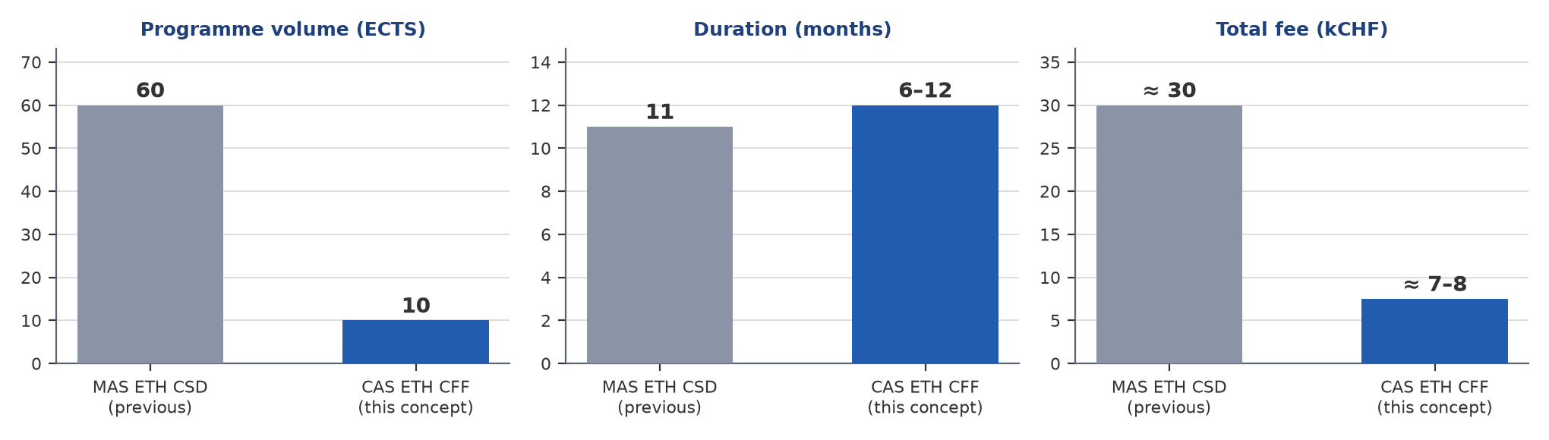
Figure 1 — The previous MAS ETH CSD versus the proposed CAS ETH CFF.
The CAS is designed as a self-contained certificate that can later be stacked: a successful CAS cohort is the natural recruiting pool for a future DAS/MAS built from further CAS blocks (advanced masonry analysis, computational BIM, AI-assisted structural design), matching SCE’s own modular model instead of a monolithic 60-ECTS programme.

2 Target audience and admission

2.1 Target audience
- Primary: practising architects and structural/civil engineers who want to add computational form-finding to their design toolkit while staying employed (part-time tracks).
- Secondary: advanced Master’s students and doctoral researchers in architecture, civil and structural engineering seeking a structured, code-based route into graphic statics and form-finding.
- Tertiary: computational designers in AEC industry R&D teams who need to customise COMPAS-based workflows rather than only use black-box software.

2.2 Admission requirements
- Master’s degree in architecture, civil/structural engineering or a related field; or Bachelor’s degree plus at least two years of relevant professional experience (SCE standard).
- Basic programming affinity; no prior Python knowledge is strictly required — Chapter 2 is a bootcamp, with a guided pre-course self-study package for beginners.
- English B2 or better (teaching and materials in English).
- Own laptop able to run Rhino 8 (evaluation licence acceptable) and a conda-based Python environment.

3 Learning outcomes (competencies)
Graduates of the CAS ETH CFF are able to:
- Explain the historical development of graphic statics and funicular design — from Hooke, Maxwell and Culmann (ETH Zürich, 1866) through Gaudí, Otto and Isler to today’s interactive methods — and relate form and force through reciprocal diagrams.
- Set up and programme the COMPAS ecosystem: core geometry and datastructures, compas_ags, compas_fd, compas_dr, compas_tna/compas_tno, and the Rhino 8 plugins compas-IGS, COMPAS FormFinder and RhinoVAULT.
- Construct and analyse 2D equilibrium solutions in code (form and force diagrams, algebraic graphic statics) and reproduce classic eQUILIBRIUM constructions programmatically.
- Form-find tension systems (cable nets, membranes, strut-and-tie models) with the force density method and dynamic relaxation, and judge the structural consequences of modelling choices.
- Form-find compression-only shells and masonry vaults with Thrust Network Analysis and assess their stability and construction feasibility (BRG demonstrators as references).
- Deliver an individual computational design project as a documented, reproducible open-source repository on GitHub, and present it to peers and reviewers.

4 Curriculum: teaching chapters in detail
In brief — Six chapters, 10 ECTS / 300 h in total: history → COMPAS code → graphic statics → tension form-finding → compression shells → individual project.
- Every chapter pairs existing public resources (gitbooks, GitHub repos, Rhino plugins) with graded, code-based deliverables.
- The individual project (Ch 6) is the core of the certificate: a documented, runnable repository worth 60 % of the grade.
The CAS is a single integrated module of 10 ECTS (300 h), structured in six teaching chapters that progress from history and theory to hands-on code and, finally, to the students’ individual projects. One ECTS corresponds to 30 h of student workload; roughly one third of each chapter is contact teaching, one third guided exercises and one third self-study.
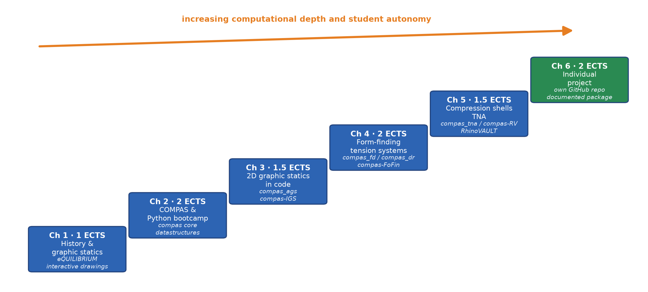
Figure 2 — Learning progression across the six teaching chapters.
Chapter | Content | ECTS | Workload (h) | Contact (h)
Ch 1 | History and graphic-statics foundations | 1.0 | 30 | 10
Ch 2 | COMPAS and Python bootcamp | 2.0 | 60 | 20
Ch 3 | 2D graphic statics in code (AGS / IGS) | 1.5 | 45 | 15
Ch 4 | Form-finding of tension systems (FD / DR, FoFin) | 2.0 | 60 | 20
Ch 5 | Thrust Network Analysis for compression shells (TNA / RhinoVAULT) | 1.5 | 45 | 15
Ch 6 | Individual project | 2.0 | 60 | 10 (supervision)
Total |  | 10.0 | 300 | ≈ 100 (≈ 16 teaching days of 6 h)

4.1 Chapter 1 — History and graphic-statics foundations (1 ECTS, 30 h)
Question: Why do structures stand? Form and force as one geometry.

4.1.1 Content
- From Hooke’s hanging chain (“as hangs the flexible line, so inverted stands the rigid arch”) to Maxwell’s reciprocal figures and Rankine’s theorems.
- Culmann and “Die graphische Statik” (ETH Zürich, 1866): the Zurich school of graphic statics, Eddy’s theorem, funicular polygons and their use in 19th-century engineering.
- Funicular masters of the 20th century: Gaudí’s hanging models, Frei Otto’s soap films and cable nets, Heinz Isler’s shells, Eladio Dieste’s masonry — and the digital turn to interactive graphic statics.
- Interactive exploration on the eQUILIBRIUM platform (drawings, case studies, courses, exams) and with this repository’s step-by-step reconstruction of the eQUILIBRIUM drawings (54 views, interactive three.js player with deep-linkable construction steps).

4.1.2 Resources
- eQUILIBRIUM — interactive environment for graphic statics: https://block.arch.ethz.ch/eq/
- Teaching repo, step-by-step drawings player: https://github.com/ — local: 2_computational_form_finding/Equilibrium/drawings/web (views 1–54)

4.1.3 Exercises and deliverables
- Reproduce three classic eQUILIBRIUM constructions by hand and in the interactive player; explain each construction step in a short annotated report.
- Mini-essay (2 pages): one funicular precedent from history and its relevance to a current design task.

4.2 Chapter 2 — COMPAS and Python bootcamp (2 ECTS, 60 h)
Question: How do we represent geometry and structure in code?

4.2.1 Content
- Environment setup before day one: Anaconda/miniconda, VS Code, Rhino 8, COMPAS installation and verification (guided by the repo’s Installation guide; installation support session in week 0).
- Python essentials for geometric computing: object-oriented programming, data structures, functions, notebooks; how COMPAS organises geometry (Point, Vector, Line, Polyline, …) and datastructures (Mesh, Network, Graph).
- Geometry processing and algorithms: topology, adjacency, queries; serialisation (JSON), the compas_viewer for interactive 3D, artists in Rhino.
- Good practice: structuring, documenting and testing small scientific tools; git and GitHub workflow used for all exercise submissions (in coordination with GKR and DBT teaching formats and the BRG-teaching workshop repositories).

4.2.2 Resources
- COMPAS getting started: https://compas.dev/#/gettingstarted
- BRG-teaching workshops: https://github.com/BRG-teaching
- Installation guide (Teaching repo): https://compas.dev/#/gettingstarted — local: 1_compas/Installation.md — conda env, VS Code, Rhino 8, verification

4.2.3 Exercises and deliverables
- Weekly notebook exercises (mesh from scratch, network traversal, custom artists).
- Graded mini-assignment: a documented Python module that builds and visualises a parametric truss geometry, submitted as a GitHub repository.

4.3 Chapter 3 — 2D graphic statics in code (1.5 ECTS, 45 h)
Question: How do form and force diagrams work — drawn, and computed?

4.3.1 Content
- Form and force diagrams, reciprocal diagrams, degrees of (in)determinacy, constraints and degrees of freedom in 2D equilibrium constructions.
- Algebraic graphic statics with compas_ags: setting up equilibrium from graph data, modifying forces and geometries, computing force diagrams.
- Interactive design in Rhino with compas-IGS; moving between drawing, plugin and script.
- Strut-and-tie thinking for load paths; from eQUILIBRIUM drawings to reproducible code.

4.3.2 Resources
- Gitbook — Computational Graphic Statics (preview): https://app.gitbook.com/o/-M57B1lKy7REE1wfeNSt/sites/site_hEawx/preview — ★★ — to be consolidated for the course
- Gitbook — Graphic Statics (preview): https://sites.gitbook.com/preview/site_gbuez — ★★
- Rhino plugin compas-IGS: https://github.com/BlockResearchGroup/compas-IGS
- compas_ags (algebraic graphic statics): https://github.com/BlockResearchGroup/compas_ags

4.3.3 Exercises and deliverables
- Re-implement three eQUILIBRIUM drawing views as compas_ags scripts (starter code exists in this repository under 2_computational_form_finding/Equilibrium).
- Design exercise: size and verify an arch or truss for given loads; submit form/force diagrams plus code.

4.4 Chapter 4 — Form-finding of tension systems (2 ECTS, 60 h)
Question: How do we compute the shape of nets, membranes and strut-and-tie models?

4.4.1 Content
- Force density method (Schek 1974): equilibrium of cable nets, force-length ratios, solving for geometry; boundary conditions and constraints.
- Dynamic relaxation with kinetic damping as an alternative solver; when to use which method (the mathematics of the solvers is taught explicitly — closing a documented gap of the current materials).
- Tensile surface structures, cable-net formworks (KnitCandela, HiLo precedent), 3D strut-and-tie models.
- Hands-on with compas_fd and compas_dr in scripts, and with the COMPAS FormFinder plugin in Rhino 8 for interactive exploration.

4.4.2 Resources
- Gitbook — COMPAS FormFinder: https://blockresearchgroup.gitbook.io/compas-fofin — ★★★ most mature teaching text
- Rhino plugin compas-FoFin: https://github.com/BlockResearchGroup/compas-FoFin
- compas_fd (force density): https://github.com/BlockResearchGroup/compas_fd
- compas_dr (dynamic relaxation): https://github.com/BlockResearchGroup/compas_dr

4.4.3 Exercises and deliverables
- Form-find a saddle net and a cable-net canopy; study the influence of boundary conditions and force densities; compare FD and DR solutions on the same problem.
- Graded mini-assignment: form-found design of a small tension structure with verification of equilibrium in code (notebook + short report).

4.5 Chapter 5 — Thrust Network Analysis for compression shells (1.5 ECTS, 45 h)
Question: How do we find funicular forms that stand in compression only?

4.5.1 Content
- Thrust Network Analysis (TNA): thrust networks, horizontal equilibrium of the form diagram, vertical equilibrium and force densities; relation to graphic statics (reciprocity).
- Funicular shells and masonry vaults: stability, envelope thinking, load cases; references to BRG demonstrators (Armadillo Vault, Striatus, Phoenix, tile vaults).
- Interactive funicular form-finding with RhinoVAULT (Rhino 8 plugin, compas-RV); scripted workflows with compas_tna; outlook to optimisation with compas_tno.
- From form-found geometry to fabrication-aware design: boundaries, openings, thickness, materialisation.

4.5.2 Resources
- Gitbook — RhinoVAULT: https://blockresearchgroup.gitbook.io/rhinovault — ★★★
- Rhino plugin compas-RV: https://github.com/BlockResearchGroup/compas-RV
- compas_tna: https://github.com/BlockResearchGroup/compas_tna
- compas_tno (optimisation): https://github.com/BlockResearchGroup/compas_tno

4.5.3 Exercises and deliverables
- Form-find a vault from a given plan; iteratively modify the form diagram to steer the solution; check reaction forces and thrust lines.
- Graded mini-assignment: compression-only pavilion design, verified with compas_tna, documented in a notebook with diagrams.

4.6 Chapter 6 — Individual project (2 ECTS, 60 h)
Question: Can you carry a form-found design from concept to reproducible code on your own?

4.6.1 Content
- Each participant (optionally pairs) selects a brief: a structural typology (arch, vault, shell, cable net, grid shell, strut-and-tie system) applied to an own design question — from practice, research, or seeded by a BRG demonstrator (HiLo, Striatus/Phoenix, KnitCandela, timber floor systems).
- The project must use at least two of the CAS toolchains (e.g. compas_ags + compas_fd, or FoFin + RhinoVAULT/TNA) and must run as code, not only as plugin interaction.
- Milestones: one-page proposal (project week 1), mid-term review with peers (half-time), final review with external critics; bi-weekly online supervision slots in between.
- Deliverables: a public GitHub repository with documented, runnable COMPAS-based code (README, environment file, notebooks), a 4–6 page design booklet, and a 15-minute final presentation.

4.6.2 Assessment weight
- The individual project counts 60 % of the CAS grade; the graded chapter assignments (Ch 2–5) count 40 %. Pass mark: 4.0 on the ETH 6-point scale.

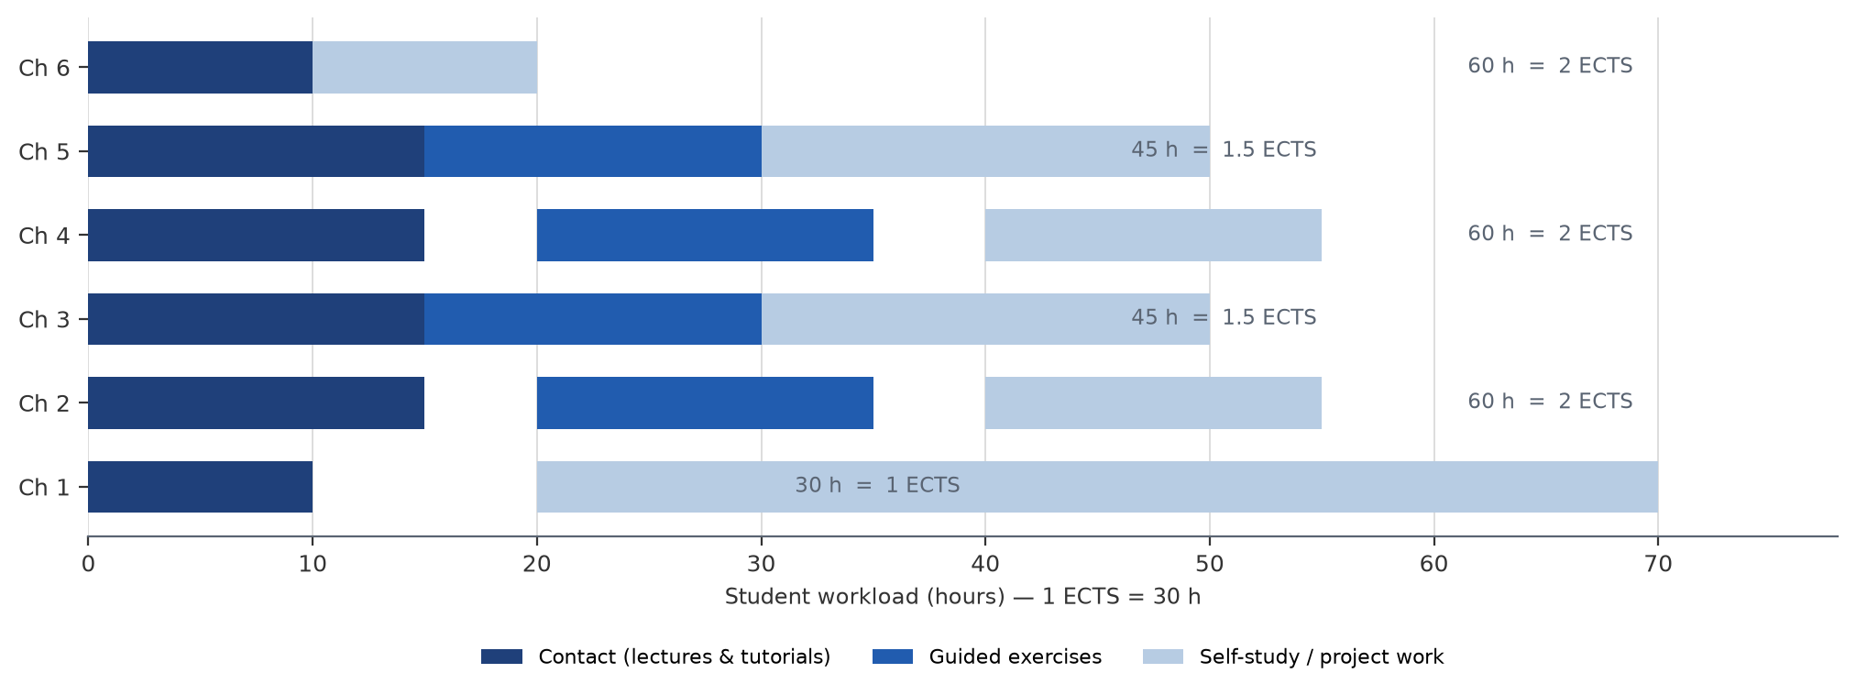
Figure 3 — Workload split per chapter (contact, guided exercises, self-study).

5 Delivery formats and schedule
In brief — Same six chapters, two tracks: a 6-month onsite-intensive semester (two Zürich block weeks) or a 12-month part-time online track (weekly 3 h live sessions).
- Flipped classroom: theory asynchronously via gitbooks and eQUILIBRIUM; live time for code-alongs, clinics and reviews; everything submitted on GitHub.
The same six chapters are offered in two equivalent tracks, so that both local and remote participants can complete the CAS within at most 12 months. Tracks may run in parallel (shared recordings, shared exercise infrastructure) or alternate per cohort.
Aspect | Track A — onsite-intensive semester | Track B — part-time online
Duration | 6 months (October – March, autumn semester) | 12 months (October – September)
Contact format | Two on-campus block weeks in Zürich (block 1: Ch 1–3 kick-off in October; block 2: Ch 4–5 in January) plus bi-weekly online tutorials and online project supervision | Weekly 3 h live online session (late afternoon/evening, CET), recorded; optional on-campus workshop day per chapter
Contact hours | ≈ 100 h (60 h blocks + 40 h online) | ≈ 100 h (33 weekly sessions)
Chapter pacing | ≈ one chapter per month | 4–8 weeks per chapter
Who it serves | Participants able to travel twice to Zürich; ETH-adjacent students | Working professionals worldwide; the primary growth market

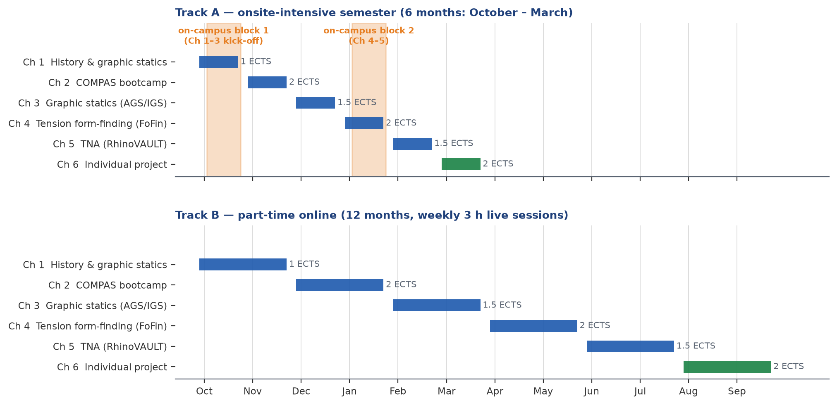
Figure 4 — Chapter placement across the two delivery tracks.
Blended-learning principle: theory is consumed asynchronously (gitbooks, recorded lectures, interactive eQUILIBRIUM drawings); live time is reserved for discussion, code-along tutorials, exercise clinics and reviews (flipped classroom). All exercise submissions and project repositories live on GitHub, making assessment location-independent.

6 Assessment and grading
Component | Weight | Evidence
Chapter assignments Ch 2–5 (4 × 10 %) | 40 % | Notebooks/scripts + short reports, submitted via GitHub; rubric: correctness, code quality, structural reasoning
Individual project (Ch 6) | 60 % | Public repository with runnable documented code (50 %), design booklet (20 %), final presentation and defence (30 %)
Pass requirement | — | Overall grade ≥ 4.0 (ETH 6-point scale); all components submitted; ≥ 80 % attendance in contact sessions
On passing, participants receive the CAS ETH CFF certificate with 10 ECTS. A verification option for the eQUILIBRIUM exam material can be reused for the Ch 1 and Ch 3 assessments.

7 Teaching resources and infrastructure
In brief — The course reuses the existing public ecosystem — eQUILIBRIUM, three gitbooks, nine COMPAS packages/plugins — instead of building a new platform.
- The readiness column in the table below is the gap list: what is ready, what needs consolidation or new exercises.
The curriculum deliberately reuses the existing, public COMPAS teaching ecosystem. The table maps every resource named in the Teaching repository’s ReadMe files to its chapter and readiness.
Resource | Type | Chapter | Readiness for teaching
eQUILIBRIUM platform (block.arch.ethz.ch/eq) | Web platform | Ch 1, Ch 3 | Ready — built for teaching; includes drawings, courses, exams
Equilibrium drawings player (this repo, 54 views + movies) | Web app + Python | Ch 1, Ch 3 | Ready — interactive step-by-step reconstructions
Gitbook: Computational Graphic Statics (2 previews) | Gitbook | Ch 3 | Needs consolidation into one public course gitbook
Gitbook: COMPAS FormFinder | Gitbook | Ch 4 | Good core (★★★); extend with solver mathematics
Gitbook: RhinoVAULT | Gitbook | Ch 5 | Good core (★★★); extend with theory chapter
compas / compas_viewer + installation guide | Framework + docs | Ch 2 | Ready — used in workshops; guide exists in repo
compas_ags / compas-IGS | Package + Rhino plugin | Ch 3 | Works; needs teaching exercises and notebooks
compas_fd / compas_dr / compas-FoFin | Packages + Rhino plugin | Ch 4 | Works; needs teaching exercises and notebooks
compas_tna / compas_tno / compas-RV (RhinoVAULT) | Packages + Rhino plugin | Ch 5 | Works; needs teaching exercises and notebooks
BRG demonstrator material (HiLo drive, Striatus, Phoenix, KnitCandela) | Case material | Ch 4–6 | Partly internal; needs packaging and licensing check

- Infrastructure to run: course Moodle/OLAT (or equivalent LMS), GitHub Classroom organisation for submissions, video conferencing for Track B, shared conda environment files per chapter (pattern already proven in 1_compas/Installation.md).
- Everything submitted by students is code: reproducibility (environment file + notebooks that run) is an explicit grading criterion.

8 Work that needs to be done
In brief — Twelve work items; the red ones are start blockers: gitbook consolidation, solver-mathematics chapters, graded exercise sets, project briefs, LMS/GitHub Classroom, the SCE package and the Programmkoordinator:in.
- Total content effort ≈ 20–30 person-weeks — mostly adapting existing research documentation, not writing from scratch.
- Masonry/FEA, BIM and AI content is explicitly out of scope and reserved for a future CAS 2.
The Teaching repository’s ReadMe names the gaps explicitly (“2D Graphic Statics is made for teaching — everything else is made for developers”; FEA resources minimal; AI material absent; solver mathematics unexplained). The table below turns those gaps into a prioritised work list. Highlighted rows are critical: without them the CAS cannot start.
# | Task | Type | Priority | Effort (est.) | Notes
1 | Consolidate the scattered graphic-statics gitbooks (2 preview links) into one public, course-structured gitbook | Content | Critical | 3–4 w | Preview links are not citable for students
2 | Author theory chapters on solver mathematics (force density, dynamic relaxation, TNA equilibrium) — currently the docs focus on user interfaces | Content | Critical | 4–6 w | Explicit gap in repo ReadMe
3 | Write graded exercise sets + notebooks for Ch 3–5 (compas_ags, compas_fd/dr, compas_tna/RV) with solution keys | Content | Critical | 6–8 w | Repos are developer-grade, not teaching-grade
4 | Define 6–8 individual-project briefs + grading rubrics (Ch 6) | Content | Critical | 2 w | Seed with BRG demonstrators
5 | Package BRG demonstrator material (HiLo, Striatus/Phoenix, KnitCandela) as teachable case data; check what may be public | Content | High | 2–3 w | HiLo currently only a Drive folder
6 | Set up LMS course space, GitHub Classroom, per-chapter conda environments, video recording pipeline | Infrastructure | Critical | 2–3 w | Reuse existing installation guide
7 | Record the gitbook-based asynchronous lectures for Track B | Content | High | 4 w | Can follow the first onsite run
8 | Reuse/extend eQUILIBRIUM exam material for Ch 1 and Ch 3 assessments | Content | Medium | 1–2 w | Platform already has an exams section
9 | SCE package: programme-development Canvas, Management Summary (1,000-character fields), budget in SCE template | Admin | Critical | 3–4 w | Templates exist in the MAS dossier
10 | Appoint the Programmkoordinator:in (SCE requirement, admin role FS 8–9) | Admin | Critical | — | Main SCE contact; runs admissions and budget
11 | Website + brochure + marketing campaign (reuse MAS drafts, re-scoped) | Marketing | High | 4–6 w | 6 drafts of the MAS brochure can be cannibalised
12 | Optional follow-ups OUT OF SCOPE for this CAS: masonry/FEA material (compas_dem, compas_cra, compas_fea2), BIM (compas_model, compas_ifc), AI module — reserve for a future CAS 2 | Content | Backlog | — | Explicitly deferred; noted for stackability

Legend: red = critical (start blocker), orange = high, yellow = medium. Total content effort ≈ 20–30 person-weeks, largely covered by adapting existing research documentation rather than writing from scratch.

9 Development and approval timeline
In brief — Start of work September 2026; department-conference (DK) decision November 2026, with the May 2027 DK session as built-in fallback; cohort 1 starts October 2027 on both tracks.
- First graduations: March 2028 (Track A) and September 2028 (Track B), then evaluation and the go/no-go for follow-up modules.
SCE approval runs through the department conference (DK), which sits only twice per semester; the DK needs the Canvas, the Management Summary (financing concept + rough curriculum) and the draft Studienreglement (produced with SCE). The plan below targets the autumn DK session; the spring session is the built-in fallback. Continuing-education programmes must be budgeted to cover costs.
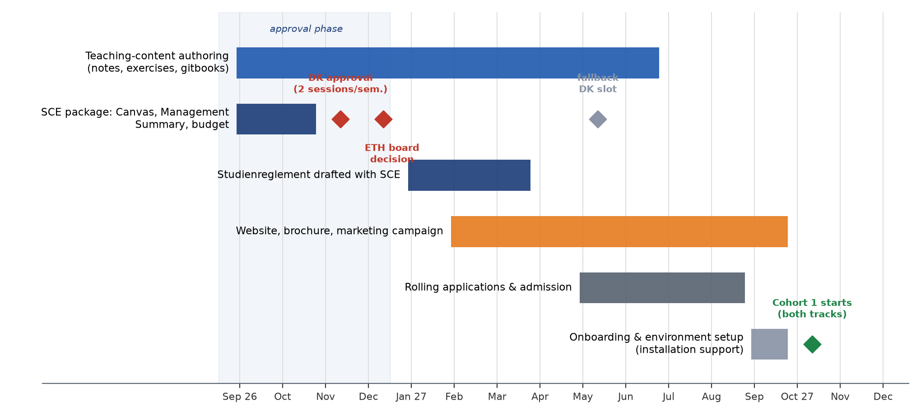
Figure 5 — Development, approval and launch plan (start of work: September 2026; cohort 1: October 2027).
- Sep – mid-Oct 2026: write the critical content (work items 1–4) and the SCE package (item 9) in parallel.
- Nov 2026: DK presentation and departmental approval; Dec 2026: ETH executive-board decision (fallback: May 2027 DK slot).
- Jan – Mar 2027: Studienreglement with SCE; LMS and GitHub Classroom setup (item 6); pricing finalised.
- Feb – Sep 2027: marketing campaign and rolling applications; admission decisions within 4 weeks of application.
- Sep 2027: onboarding, installation support (week 0); Oct 2027: cohort 1 starts on both tracks.
- Mar 2028: first Track A graduations; Sep 2028: first Track B graduations; evaluation and decision on CAS 2 modules.

10 Budget sketch (indicative)
Indicative figures only — the binding budget is produced in the SCE budget template (continuing-education programmes must cover their costs). The CAS price band of CHF 700–800 per ECTS is the SCE rule of thumb; at 10 ECTS this gives CHF 7,000–8,000 per participant.
Position | Basis | Indicative amount (CHF)
Revenue | 12–20 participants × CHF 7,500 | 90,000 – 150,000
Programme coordination | 30–40 % position (Programmkoordinator:in, SCE requirement) | 35,000 – 50,000
Teaching & development amortisation | ≈ 100 contact h + exercise clinics + supervision; content authoring amortised over runs | 40,000 – 60,000
Marketing & administration | campaign, LMS, SCE overhead | 10,000 – 20,000
Balance | break-even at ≈ 12 participants | positive from first run if cohort ≥ 12
Compared with the MAS (break-even only from run 3, CHF 120,000 subsidy), the CAS is designed to be cost-covering from its first run and to create the audience for follow-up modules.

Appendix A — Link inventory
- Shared Google Doc (basis of this concept): https://docs.google.com/document/d/17gDPkJS4DjB0FUJg9BehDfBTe4H2NIyb7-zygBppUCI/edit?tab=t.0
- ETH School for Continuing Education (SCE): https://sce.ethz.ch/
- eQUILIBRIUM — interactive graphic statics: https://block.arch.ethz.ch/eq/
- Gitbook — Computational Graphic Statics (preview 1): https://app.gitbook.com/o/-M57B1lKy7REE1wfeNSt/sites/site_hEawx/preview
- Gitbook — Graphic Statics (preview 2): https://sites.gitbook.com/preview/site_gbuez
- compas-IGS (Rhino plugin): https://github.com/BlockResearchGroup/compas-IGS
- compas_ags: https://github.com/BlockResearchGroup/compas_ags
- Gitbook — COMPAS FormFinder: https://blockresearchgroup.gitbook.io/compas-fofin
- compas-FoFin (Rhino plugin): https://github.com/BlockResearchGroup/compas-FoFin
- compas_fd: https://github.com/BlockResearchGroup/compas_fd
- compas_dr: https://github.com/BlockResearchGroup/compas_dr
- Gitbook — RhinoVAULT: https://blockresearchgroup.gitbook.io/rhinovault
- compas-RV (RhinoVAULT plugin): https://github.com/BlockResearchGroup/compas-RV
- compas_tna: https://github.com/BlockResearchGroup/compas_tna
- compas_tno: https://github.com/BlockResearchGroup/compas_tno
- COMPAS — getting started: https://compas.dev/#/gettingstarted
- BRG-teaching workshops: https://github.com/BRG-teaching
- HiLo case material (Drive): https://drive.google.com/drive/folders/1ak3IM7J1DWiUHm3ELGD6ENYNsw564hVr
- Deferred to a future CAS 2 — compas-Masonry: https://github.com/BlockResearchGroup/compas-Masonry
- Deferred — compas_dem: https://github.com/BlockResearchGroup/compas_dem
- Deferred — compas_cra: https://github.com/BlockResearchGroup/compas_cra
- Deferred — compas_fea2: https://github.com/compas-dev/compas_fea2
- Deferred — compas_model (BIM): https://github.com/BlockResearchGroup/compas_model
- Deferred — compas_ifc (BIM): https://github.com/compas-dev/compas_ifc
- Deferred — COMPAS skills / AI: https://compas.dev/compas_ifc/latest/skill.html

Appendix B — Source material in this repository
- ReadMe.md — module/ECTS schedule (1 ECTS = 30 h; teaching ≈ ⅓ of workload; 6 contact h per teaching day) and open questions.
- 1_compas/ — COMPAS introduction and installation guide (used for Ch 2 and week-0 onboarding).
- 2_computational_form_finding/ — resource map for graphic statics, form-finding and TNA; Equilibrium/drawings/ contains 54 step-by-step drawing reconstructions (Python + interactive web player + movies).
- 3_advanced_masonry_analysis/, 4_bim/, 5_ai/, 6_case_studies/ — module notes; content explicitly deferred to a future CAS 2 / DAS stack.
- MAS_Preparation-20260812T111231Z-1-001/ — previous MAS ETH CSD dossier (curriculum outline, programme development plan, SCE materials, budget, marketing drafts) used as the baseline and lessons-learned source.

