Treasure Pyland – A Pyrate Adventure!
Senior Project
Spring 2016
Sponsor: Branch Archer

Objective:
Create an adventure game which will help teach Python string manipulation techniques to students in an introductory Object-oriented programming class.

Motivation:
Young people today are very accustomed to spending many hours per day playing video games and/or interacting on social media. Creating a environment which has an interactive game-like feel could channel this energy into a learning experience.

Platform:
Although a tablet or smartphone device might be more popular, it is not practical to require that students own such devices for this purpose. Therefore, the game should be accessible through a standard web browser such as Firefox or Chrome.

Server-side development:
- Python: check submitted code for correctness
- HTTP service: Any scripting language with which the students are familiar.
Ideally, Ruby on Rails (RonR) or NodeJS (MongoDB database).

Database:
- A limited version of the project would not require a database
- RonR: sqlite3 or MySQL database
- NodeJS: MongoDB

Client-side development:
- HTML5 (or haml for RonR, jade for NodeJS)
- CSS (or scss for RonR, less for NodeJS)
- JavaScript
- jQuery framework

Development Environment:
- Operating system: Linux
- Version control: git
- Source code repository: github.com
- Graphic art: SVG files (e.g., created using Inkscape)

Deliverables:
- Story board
- Text narrative
- Graphics, preferably with some animations, to help convey and enliven the narrative
  - Sound effects would be an enhancement
- String manipulation problems to be solved
- Python code for evaluating the submitted solutions
  - The student code need to be tested to ensure that the solution is not embedded in the code
  - Run the student code in the Python interpreter, and determine whether the output is correct
  - The interpreter would have to be restricted to a sandbox so that the server file system is protected – I already have code for this purpose
- Finished product

Narrative outline:
You have just finished high school, and are preparing to go off to college. On the way home
from your summer job, you see a sign for a furniture auction, and you decide to check it out.
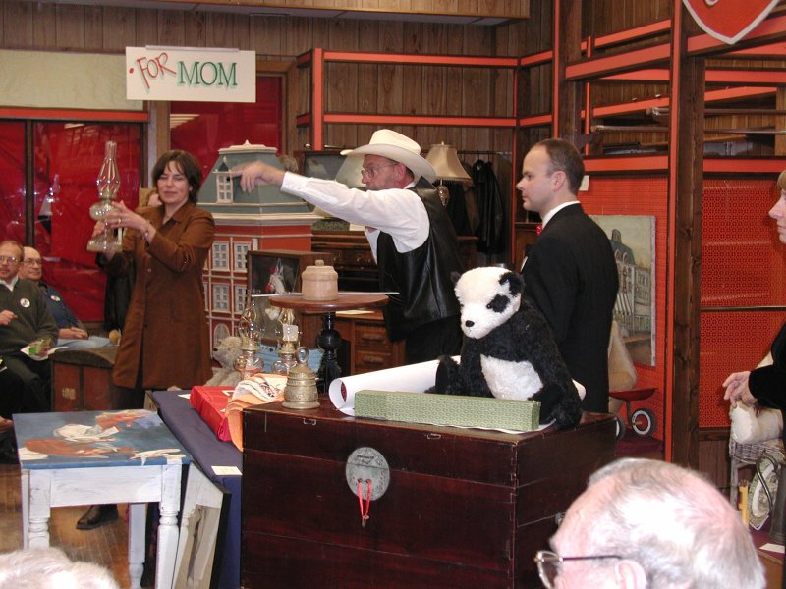

PROBLEM: What is the name of the furniture auction?
INPUT TEXT: pYLand FuRNIture AUCtIon
ALGORITHM: Capitalize all words in the input to generate the output
SAMPLE SOLUTION:
def outputText(inputText):
open('database.sqlite','w')
return ' '.join([word.capitalize() for word in inputText.split()])

OUTPUT TEXT: Pyland Furniture Auction
Note: This problem is just a sample … it is too hard for the first problem. The idea is that the problems would start simple and get progressively harder.

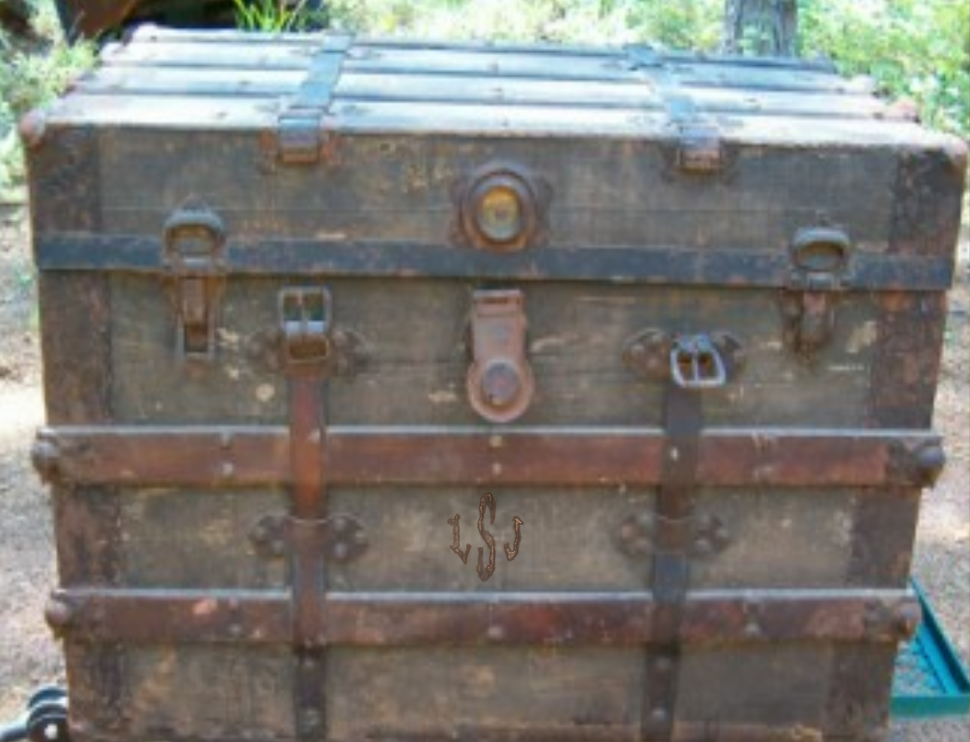
You decide to bid on an old chest, that looks like it might be good for taking to college in the Fall. You win the bid!

[Notice the monogram on the chest. Use Inkscape to add clues to photographs, such as the one I have added here]
PROBLEM: What was your winning bid?
INPUT TEXT: thgie fo seceip 83
ALGORITHM: Reverse the input text to generate the output
SAMPLE SOLUTION:
def outputText(inputText):
return inputText[::-1]

OUTPUT TEXT: 38 pieces of eight

And the story continues from here … a few ideas:
- After cleaning the chest, you notice a monogram below the lock … LSJ. Rearrange the monogram so that the large middle letter (the last name) comes last. ( LSJ → LJS )
- Talk to a friend about the discovery, who suggests LJS may be an abbreviation for Long John Silver.
- Find a secret compartment in the chest (add a map into secret compartment at left), which contains a map (add graphics to map).
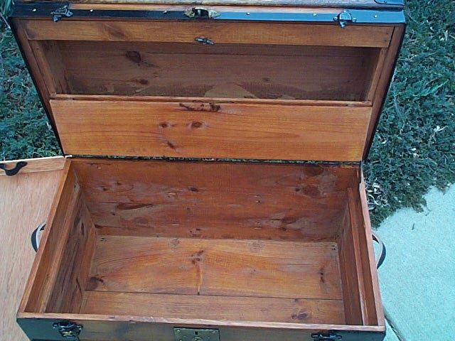

- Look up archaeologists in the area … get the University address (which must be unscrambled).
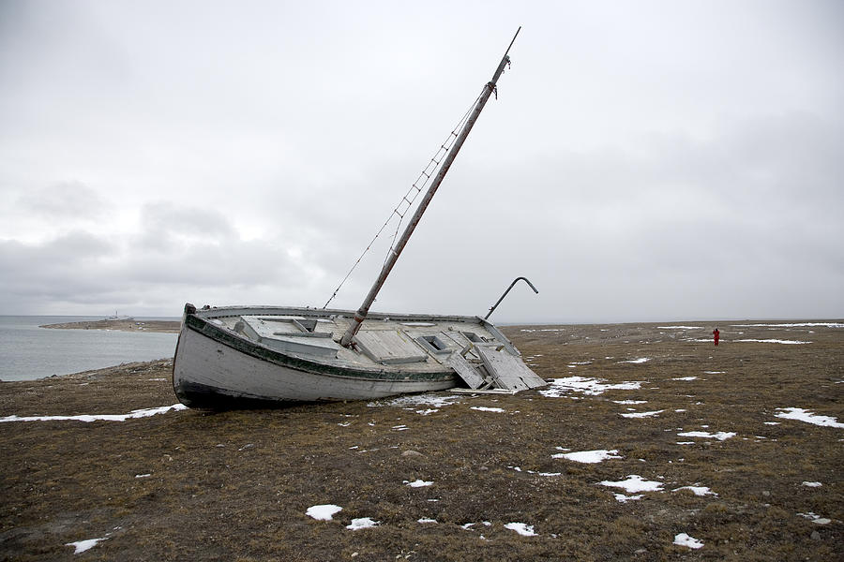
- The archaeologist realizes the significance of the map, and becomes very excited. She offers to take you on her fabulous yacht, the SS Minnow (see at right!) to follow the trail. Unscramble the name of her yacht.
- Go to Treasure Pyland and follow the clues on the map, solving puzzles as you go.

