- 1.WHAT IS PYTHON?
Python is general purpose interpreted languagewith easy syntax & dynamic semantics
Created by Guido Van Rossum in 1989.

FEATURES OF PYTHON
1. Simplicity: Python has made programming fun because it's simple
2. Open Source: It is free for anyone to use. Modification in python is also allowed
3. Portability: Write your code and you can share your anyone u want.
4. Extendible & Extensible: Python supports adding code of other languages.
5. Interpreted: Management of memory, CPU and debugging the code is simpler
6. Huge Libraries: python has a huge library support which helps you in problem
7. Object Orientation: Python supports oops

Begginers Python Basics: From installation to Programming...
INSTALLATION OF PYTHON:
Just follow the following things to install python on your computer right.
Step 1: Just go to the browser and type: https://www.python.org/downloads
Step 2: Click on download python 3.8.3 or any 3.x.x version you want
Step 3: Go to the download folder and double click on python file to install and follow the steps.
Step 4: Python 3 is installed on your computer. next step is we need to choose a text editor.
Step 5: To get the Text editor (Python IDE for developers) go to the https://www.jetbrains.com/pycharm
Step 6: There are two download versions professional and Community. just click on community version.
Step 7: Go to the download folder and double click on PyCharm file to install and follow the steps.
Step 8: This text editor help us while developing a code, it guide us the errors and all alright.
Step 9: Now python 3 and pycharm text editor both installed on computer and now we are ready to set up & Hello world Program.
How to create a First Python Program...
Step 1: First you have to open up the pycharm text editor.
Step 2: Just click on Create a New Project.
Step 3: In Location text box you have to specify the program name like FirstProg. [C:\Users\Admin\PycharmProjects\FirstProg]
Step 4: In Existing Interpreter you will see the our installed python3.8.3 interpreter is there. after that just click on Create button.
Step 5: Go to the FirstProg folder in right side right click on it and say New File ---> and select Python file.
Step 6: Give file name app so it will save the file in app.py format
Step 7: Start writing your first python program i:e Hello world using pycharmIDE.
Step 8: To run this program just click on Run option click on Run it will ask which file choose your file here the file is app so click on it and after that down below on python console you will see the output.
Step 9: That's all in this way you have to write your python code using PyCharm IDE.
Note: Still doing all of this if anyone is facing problem in installation of both Python and PyCharm they have to use this link for python coding but remember internet connection is must for this. i mean to say you have to use online Python Compiler(Interpreter) so without wasting a time just click on the link: https://www.programiz.com/python-programming/online-compiler/

How to create a Menu driven Program in Python
HOW TO CREATE A MENU DRIVEN PROGRAM IN PYTHON..
Step 1. Open your python command prompt.
Step 2. Write the following code into it.
Step 3. Execute it / Test the output for various inputs.
Step 4. Now move towards the study parts of python like how to declare and define function in python.
Step 5. To study function more in detail please click on the following link
Step 6. https://www.javatpoint.com/python-functions

The code to write in Step 2 are as follows:
(base) C:\Users\Admin>python
Python 3.7.6 (default, Jan 8 2020, 20:23:39) [MSC v.1916 64 bit (AMD64)] :: Ana
conda, Inc. on win32
Type "help", "copyright", "credits" or "license" for more information.
>>> def mainMenu():
... print("1. Adition")
... print("2. Substraction")
... print("3. Exit")
... choice=int(input("Enter u r choice"))
... if choice==1:
... add()
... elif choice==2:
File "<stdin>", line 8
elif choice==2:
^
SyntaxError: invalid syntax Note: indentation of code is too much important in python otherwise you will get error like this.
# Following is the code of main function in python.
>>> def mainMenu():
... print("1. Adition")
... print("2. Substraction")
... print("3. Exit")
... choice=int(input("Enter u r choice"))
... if choice==1:
... add() #when choice is equals to 1 we call add() function from mainMenu()
... elif choice==2:
... sub() #when choice is equals to 2 we call sub() function from mainMenu()
... elif choice==3:
... exit #when choice is equals to 3 we call exit function from mainMenu()
... else:
... print("Invalid choice, Enter valid choice1-3")
... mainMenu()
...# to come out from function press two times Enter key.
# To call mainMenu function for execution.
>>> mainMenu()
1. Adition
2. Substraction
3. Exit
Enter u r choice5 # here we are testing our code for invalid input.
Invalid choice, Enter valid choice1-3
1. Adition
2. Substraction
3. Exit
Enter u r choice3 # for valid inputs its works fine
# Definition of add() function that is actual logic of addition function how it behaves after calling.
>>> def add():
... print("Enter no1:")
... x=int(input())
... y=int(input("Enter no2:"))
... z=x+y
... print("The add is:",z)
... mainMenu()
...
>>> mainMenu() # space is not allowed while calling function
File "<stdin>", line 1
mainMenu()
^
IndentationError: unexpected indent
>>> mainMenu()
1. Adition
2. Substraction
3. Exit
Enter u r choice1 #Execution or calling of sub() function
Enter no1:
2
Enter no2:2
The add is: 4
1. Adition
2. Substraction
3. Exit
Enter u r choice4
Invalid choice, Enter valid choice1-3
1. Adition
2. Substraction
3. Exit
Enter u r choice3
# Definition of sub() function that is actual logic of substraction function how it behaves after calling.
>>> def sub():
... a=int(input("enter no1"))
... b=int(input("enter no2"))
... print("The sub is:",a-b)
... mainMenu()
...
>>> mainMenu()
1. Adition
2. Substraction
3. Exit
Enter u r choice2 #Execution or calling of sub() function
enter no120
enter no210
The sub is: 10
1. Adition
2. Substraction
3. Exit
Enter u r choice3
>>>

What is list in python?
Lists are just like dynamic sized arrays.
Why we require list in python?
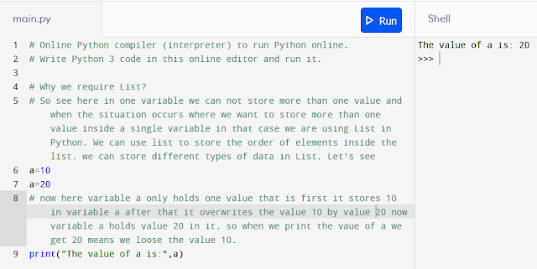

Lists need not be stored similar data types of elements always which makes it a most powerful tool in Python. A single list may contain different types of data like Float,Integers, Strings, as well as Objects.
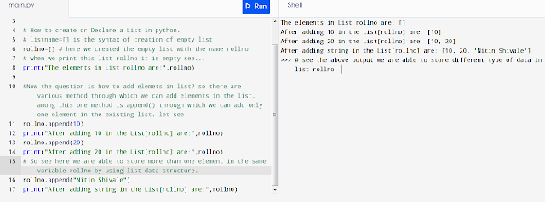

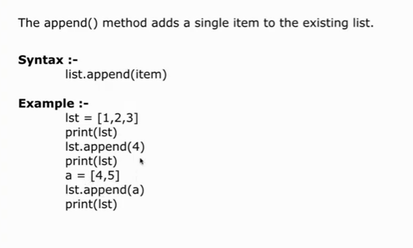

Lists are mutable, and hence, they can be altered even after their creation.

List in Python are ordered and have a definite count. The elements in a list are indexed according to a definite sequence and the indexing of a list is done with 0 being the first index. Each element in the list has its definite place in the list, which allows duplicating of elements in the list, with each element having its own distinct place and credibility.
Note- Lists are a useful tool for preserving a sequence of data and further iterating over it.

MORE FUNCTION IN LIST:
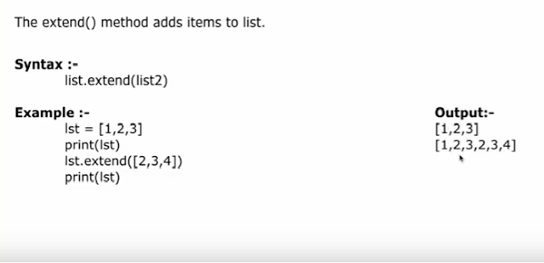Note: extend() simple adds the elements in existing list it doesn't make Nested list.

Next Function is insert( ) in Python

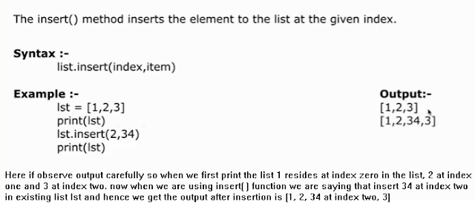
Problem Statement:
In second year computer engineering class, group A student’s play cricket, group B students play badminton and group C students play football. Write a Python program using functions to compute following: -
a) List of students who play both cricket and badminton
b) List of students who play either cricket or badminton but not both
c) Number of students who play neither cricket nor badminton
d) Number of students who play cricket and football but not badminton.
(Note- While realizing the group, duplicate entries should be avoided, Do not use SET built-in functions)

Source Program:
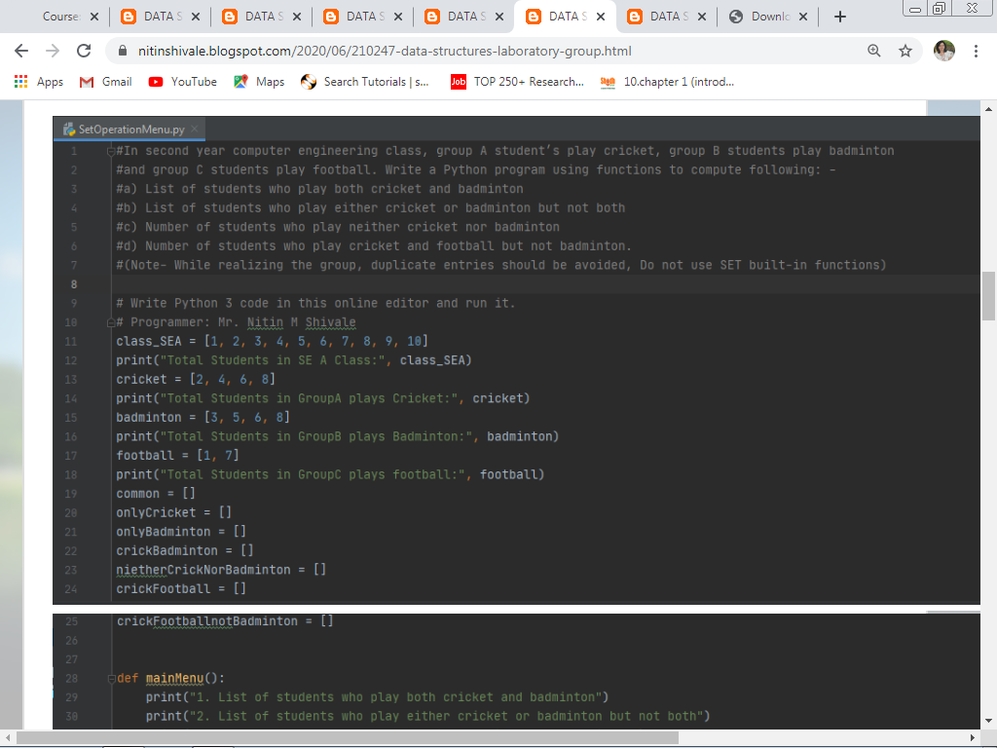
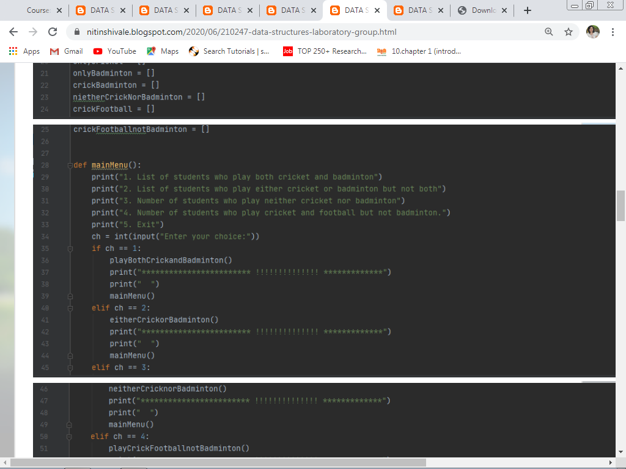
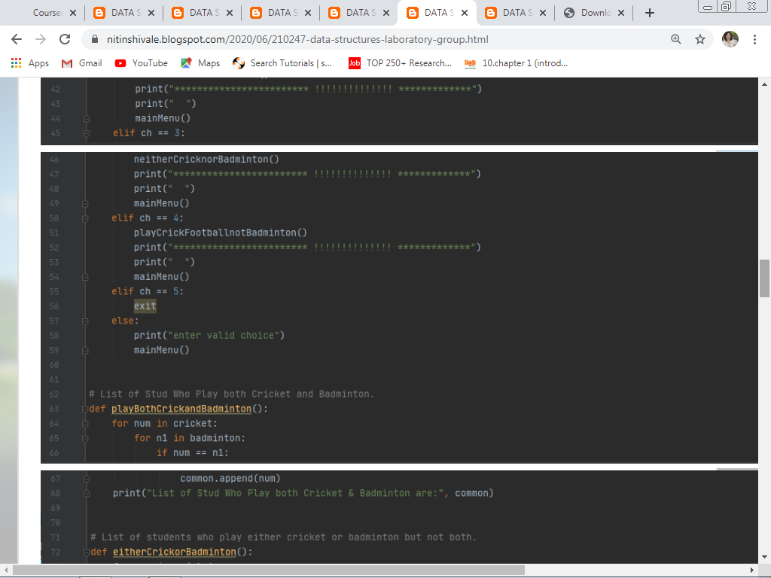
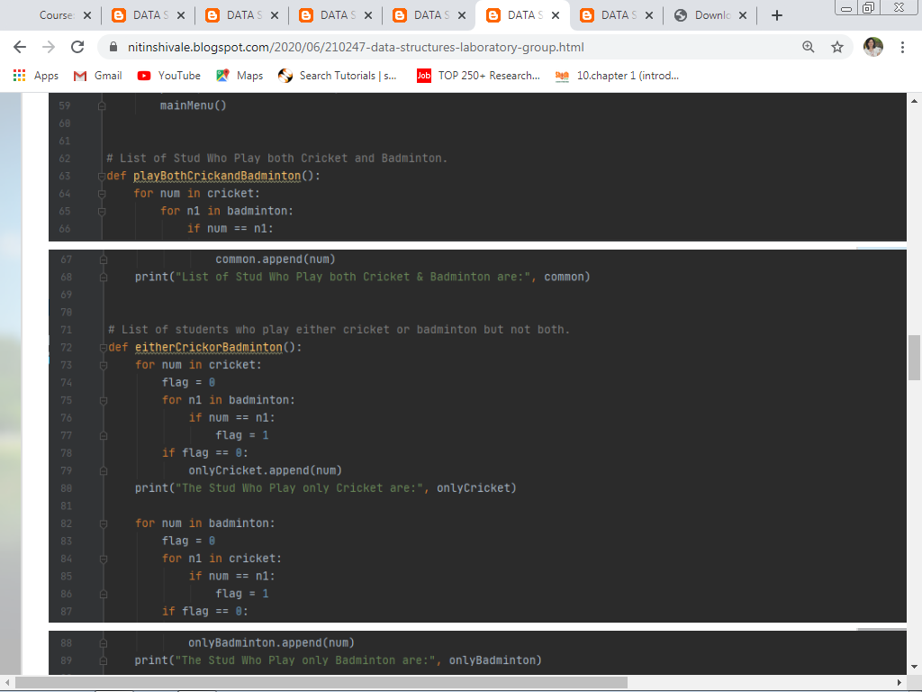
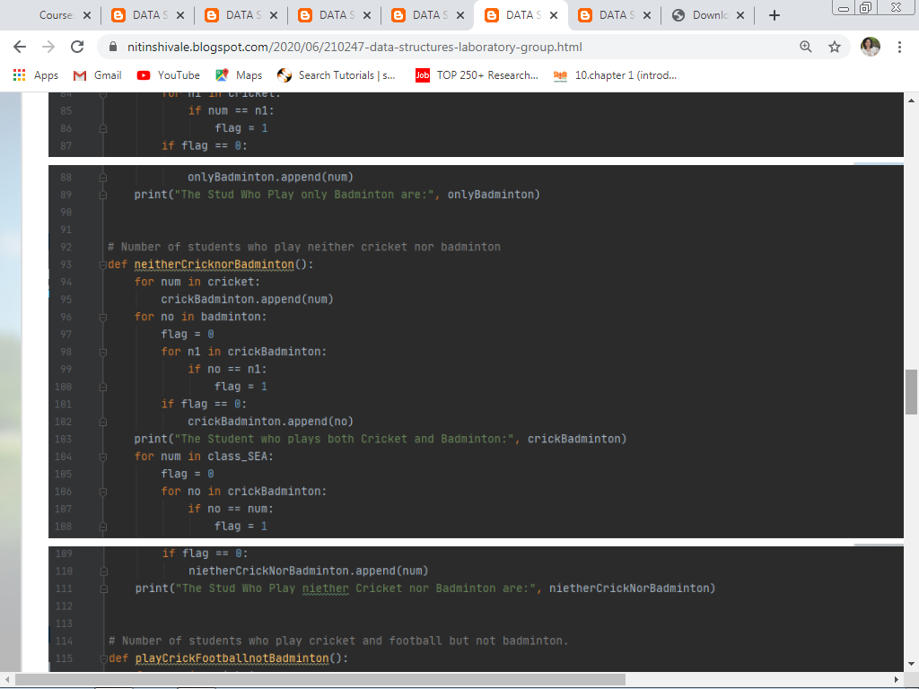
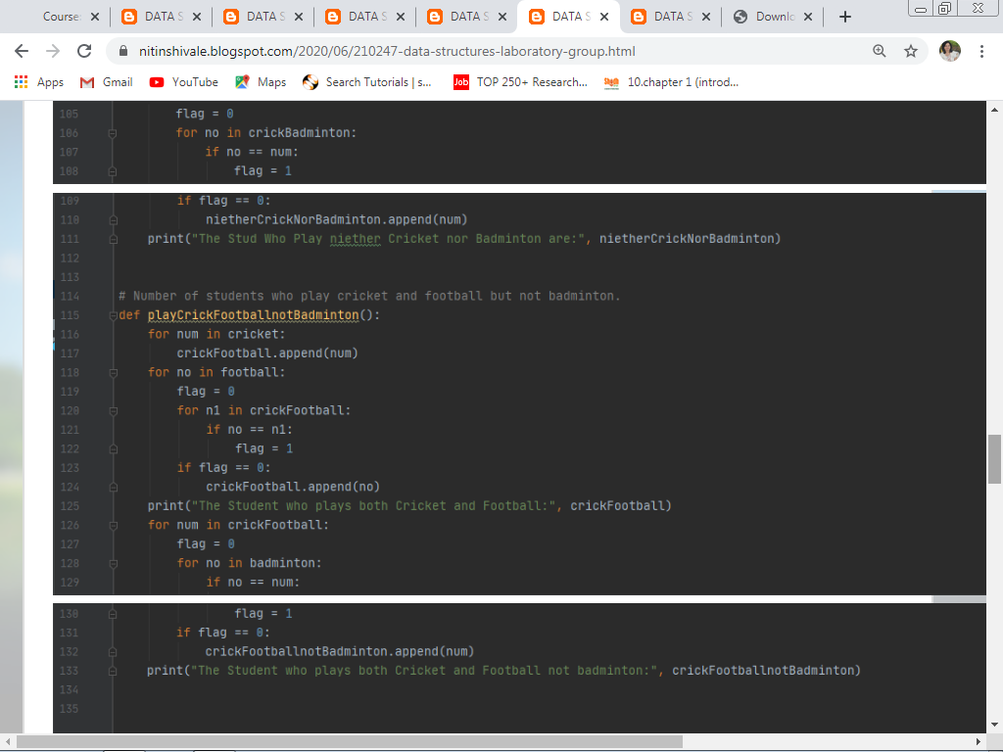

Output:
Total Students in SE A Class: [1, 2, 3, 4, 5, 6, 7, 8, 9, 10]
Total Students in GoupA plays Cricket: [2, 4, 6, 8]
Total Students in GoupB plays Badminton: [3, 5, 6, 8]
Total Students in GoupC plays football: [1, 7]
>>> mainMenu()
1. List of students who play both cricket and badminton
2. List of students who play either cricket or badminton but not both
3. Number of students who play neither cricket nor badminton
4. Number of students who play cricket and football but not badminton.
5. Exit
Enter your choice:1
List of Stud Who Play both Cricket & Badminton are: [6, 8]
************************ !!!!!!!!!!!!!! ***************************
1. List of students who play both cricket and badminton
2. List of students who play either cricket or badminton but not both
3. Number of students who play neither cricket nor badminton
4. Number of students who play cricket and football but not badminton.
5. Exit
Enter your choice:2
The Stud Who Play only Cricket are: [2, 4]
The Stud Who Play only Badminton are: [3, 5]
************************ !!!!!!!!!!!!!! ***************************
1. List of students who play both cricket and badminton
2. List of students who play either cricket or badminton but not both
3. Number of students who play neither cricket nor badminton
4. Number of students who play cricket and football but not badminton.
5. Exit
Enter your choice:3
The Student who plays both Cricket and Badminton: [2, 4, 6, 8, 3, 5]
The Stud Who Play neither Cricket nor Badminton are: [1, 7, 9, 10]
************************ !!!!!!!!!!!!!! ***************************
1. List of students who play both cricket and badminton
2. List of students who play either cricket or badminton but not both
3. Number of students who play neither cricket nor badminton
4. Number of students who play cricket and football but not badminton.
5. Exit
Enter your choice:4
The Student who plays both Cricket and Football: [2, 4, 6, 8, 1, 7]
The Student who plays both Cricket and Football not badminton: [2, 4, 1, 7]
************************ !!!!!!!!!!!!!! ***************************
1. List of students who play both cricket and badminton
2. List of students who play either cricket or badminton but not both
3. Number of students who play neither cricket nor badminton
4. Number of students who play cricket and football but not badminton.
5. Exit
Enter your choice:5

First of all we have to analyze the problem statement, we have to find out the following things from the Problem statement.
1. What is given in the Problem statement? [Given]

2. Identify the entity and it's attributes. [Entity]

3. Identify the users actual requirements and what are the inputs we are accepting from user.[Input]

4. Identify to store and process the data which data structure is required? [Data Structure]

5. How many functions are there in Problem statement? [Output]

Analysis of Problem Statement by referring above five points:

1. Given:
In the above Problem Statement Given/Assume things are:
a. Class SEA Student Roll numbers. that is whole class strength of SEA
b. Students Plays in Group_A Cricket: Group_B Badminton: and Group_C Football:

2. Entity:
Here the entity is Class_SE_A and the attribute is Rollno.

3. Input:
As a input we have to accept following things from the user:

3.1 Group_A Cricket: The Rollno of students who plays Cricket from Class_SE_A.
3.2 Group_B Badminton: The Rollno of students who plays Badminton from Class_SE_A.
3.3 Group_C Football: The Rollno of students who plays Football from Class_SE_A.
3.4 Class_SE_A: we have to assume the N number of students in class SE A.

4. Data Structure:
To Store and Process the data as per user requirement we are using LIST as a data Structure in Python Programming Language.

5. Output:
As per the user requirement user wants following things as an output when he is going to process the data.
5.1 List of students who play both cricket and badminton.
5.2 List of students who play either cricket or badminton but not both.
5.3 Number of students who play neither cricket nor badminton.
5.4 Number of students who play cricket and football but not badminton.

In this way we are going to analyze each and every problem statement before designing the algorithm that is called as "Requirement Analysis" in Software Development Life Cycle.

So by referring the above analysis,
we comes to know that we have to design Four algorithms for each and every Output.

