Compte rendu TP3 :
1) Configuration de la NAT Dynamique :

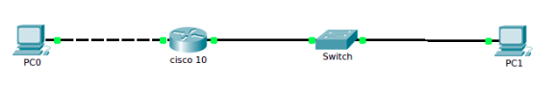

La configuration du routeur cisco 10 :

enable
conf t
ip nat pool NAT-POOL1 192.168.1.11 192.168.1.21 netmask 255.255.255.0
access-list 7 permit 10.1.1.0 0.0.0.255
ip nat inside source list 7 pool NAT-POOL1

interface g0/1
ip address 10.1.1.1 255.255.255.0
ip nat inside
no shut
exit

interface g0/0
ip address 192.168.1.20 255.255.255.0
ip nat outside
no shut
end

2) Configuration de la NAT Statique :
enable
conf t
ip nat inside source static 10.1.1.3 192.168.1.20

interface g0/1
ip address 10.1.1.1 255.255.255.0
ip nat inside
no shut
exit

interface g0/0
ip address 192.168.1.20 255.255.255.0
ip nat outside
no shut
end

