**Uses Cases of IoT Environment Monitoring:**

The three main types of environmental monitoring are soil, atmosphere and water. IoT environment monitoring is used in a wide range of industries, from agriculture and forestry to urban planning, energy generation and distribution. In the agricultural sector, IoT-based systems are used to monitor crops, soil health, water quality and weather conditions. This information can be used to inform decisions about pest control, fertilisation, irrigation and land management. IoT-based systems in the energy sector are used to monitor emissions, air quality and weather conditions. Below are six examples of use cases of IoT environmental monitoring:



Air-quality monitoring:

Industrial processes, like burning fuel, emit air pollutants and organic compounds that can negatively impact human health and the environment. Whether it’s from industrial processes, car exhausts or herds of cattle, the carbon monoxide, hydrocarbons and greenhouse gases emitted must be monitored to ensure good air quality and to protect the wider environment. Indoor spaces are also subject to pollutants.

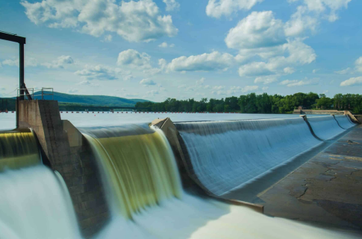

**2) Water-quality monitoring:**

Water quality is an important factor in determining the overall health of aquatic ecosystems and human health for those who inevitably come into contact. IoT-based water quality monitoring systems can be used to control the contamination levels of water sources and identify any potential pollutants that could be harmful to people or the environment. This data can then be used to help manage water resources more effectively, inform decisions around pollution mitigation and inform the development of sustainable strategies for water management

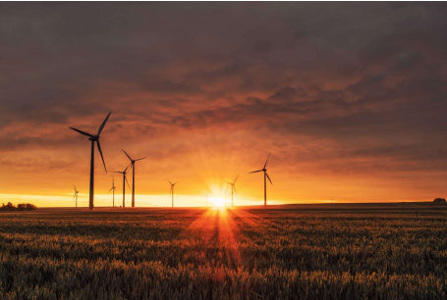

**3) Energy monitoring:**

Considering there is a limited amount of global energy resources, measures must be taken to ensure effective conservation. IoT-based energy monitoring systems can be used to track energy usage, detect any anomalies or changes that could indicate an issue and inform decisions around energy conservation. This is particularly prevalent within the energy distribution systems and through measurements at points of consumption, most notably through the use of smart meters.

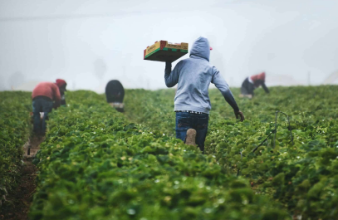

**4) Commercial farming:**

The agricultural sector is one of the most energy-intensive industries, with commercial farming operations requiring huge amounts of energy to power irrigation systems, lighting and cooling. IoT-based systems can be used to monitor soil health, crop conditions and water quality in order to inform decisions around pest control, fertilisation, irrigation and land management. This data can also be used to inform decisions around energy efficiency and help reduce the environmental impacts of agricultural operations

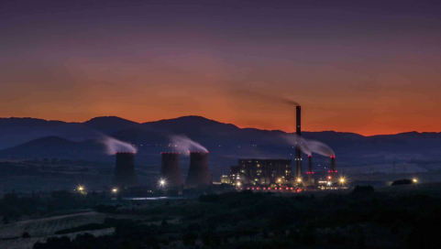

**How to work on wokwi for environmental monitoring project:**

**Example1:**

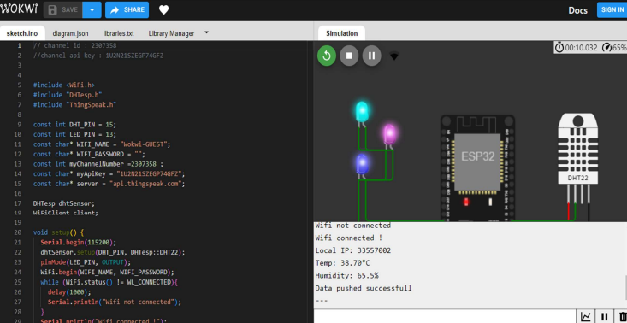

**Example2:**

