Automatic Weather Station (AWS)

**INTRODUCTION**

An **Automatic weather station** (AWS) is an automated type of traditional weather station, either to enable measurements from remote areas or to save human labor. The system may report in several different ways. It may be in real -time via a local link to a computer system or via telecommunications or satellite systems. GSM mobile phone technology has also been known to be used. An alternative is the storage of the information in local data storage such as flash memory for retrieval at a later stage.

Most automatic weather stations have the following setup for weather monitoring:

* Thermometer for measuring temperature
* Anemometer for measuring wind speed, Wind vane for wind direction,
* Hygrometer for measuring humidity,
* Barometer for measuring the atmospheric pressure,
* Rain gauge for measuring rainfall.

Additionally we can also find ceilometers for measuring cloud height, present weather sensor or visibility sensor.

**Typical AWS Configurations :**

The configuration of an AWS may vary due to the purpose of the system but typically consists of:

* A weather-proof enclosure containing the data logger, rechargeable battery and telemetry (optional)
* Meteorological sensors
* Solar panel or wind turbine
* Mast

Temperature sensors:

There are many temperature sensors available with various applications and additional features. Some of the examples that we might use in our project are:

1. Temperature Sensor TMP36:

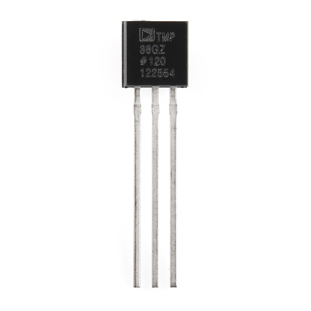

The sensors use a solid-state technique to determine the temperature. Because these sensors have no moving parts, they are precise, never wear out, don't need calibration, work under many environmental conditions, and are consistent between sensors and readings. Moreover they are very inexpensive and quite easy to use.

Features:

* TO-92 package (about 0.2" x 0.2" x 0.2") with three leads
* Temperature range: -40°C to 150°C / -40°F to 302°F
* Output range:0.1V (-40°C) to 2.0V (150°C) but accuracy decreases after 125°C
* Power supply: 2.7V to 5.5V only, 0.05 mA current draw.
* Temp in °C = [(Vout in mV) - 500] / 10

1. Analog Devices (AD7414/15):

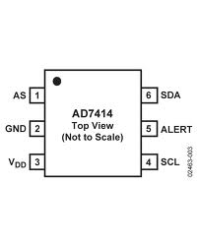 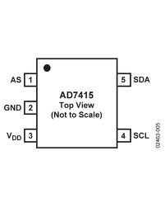

The AD7414/15 are complete temperature monitoring systems in 6-lead and 5-lead SOT-23 packages. They contain a band gap temperature sensor and a 10-bit ADC to monitor and digitize the temperature reading to a resolution of 0.25°C. In the AD7414, on-chip registers can be programmed with high and low temperature limits, and an open-drain over-temperature indicator output (ALERT) becomes active when a programmed limit is exceeded.

**Features :**

* 10-bit temperature-to-digital converter
* Temperature range: −40°C to +125°C
* Typical accuracy of ±0.5°C at +40°C
* SMBus/I2C®-compatible serial interface
* 3 μA power-down current
* Temperature conversion time: 29 μs
* Space-saving 6-lead (AD7414) and 5-lead (AD7415)
* Over-temperature indicator (AD7414 Only)
* 4 versions allow 8 I2C addresses (AD7414)
* 2 versions allow 6 I2C addresses (AD7415)

1. Texas Instruments (LM73):

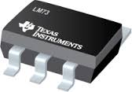

The LM73 is a digital temperature sensor that senses the temperature of its die using a sigma-delta analog-to digital converter and stores the temperature in the Temperature Register. The temperature resolution is programmable, allowing the host system to select the optimal configuration between sensitivity and conversion time. The LM73 can be placed in shutdown to minimize power consumption when temperature data is not required. The host can query the LM73 at any time to read temperature.

**Features:**

* Shutdown Mode with One-Shot Feature Available for Very Low Average Power Consumption.
* Programmable Digital Temperature Resolution from 11 Bits to 14 Bits.
* Conversion Time:

11-bit (0.25°C): 14 ms (max)

14-bit (0.03125°C): 112 ms (max)

* Supply Voltage: 2.7V to 5.5V

Humidity sensors:

Humidity is the presence of water in air. The amount of water vapor in air can affect human comfort as well as many manufacturing processes in industries and other purposes. The Relative Humidity is defined as Ratio of mass (vapor) to mass (saturated vapor) OR ratio of actual vapor pressure to saturation vapor pressure (given in %).

1. Humidity Sensor HIH-4030:

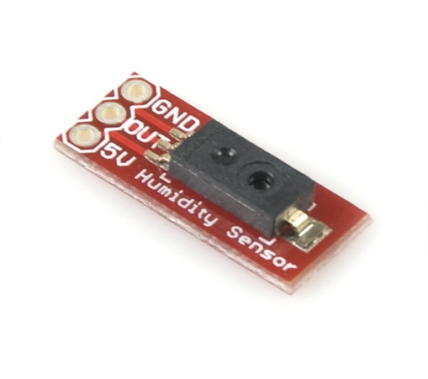

The HIH-4030 measures relative humidity (%RH) and delivers it as an analog output voltage. We can connect the output of the sensor directly to an ADC on a microcontroller.

**Features:**

* Near linear, analog output
* 4-5.8VDC voltage supply
* All pins broken out to a 0.1" pitch header
* Low power design, typical current draw of only 200μA
* Enhanced accuracy
* Fast response time
* Stable, low drift performance

2. Humidity sensor - HH10D:

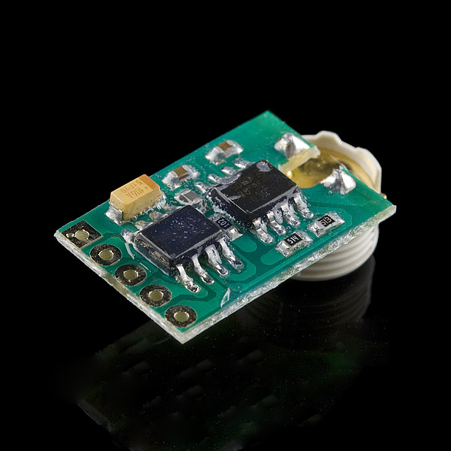

The HH10D relative humidity sensor module is comprised of a capacitive type humidity sensor, a CMOS capacitor to frequency converter and an EEPROM used to hold the calibration factors. Due to the characteristics of capacitor type humidity sensor, the system can respond to humidity change very quickly. Each sensor is calibrated twice at two different accurate humidity chambers and two unique sensor related coefficients are stored onto the EEPROM on the module.

**FEATURES :**

* + Relative humidity sensor
  + Two point calibrated with capacitor type sensor, excellent performance
  + Frequency output type, can be easily integrated with user application system
  + Very low power consumption
  + No extra components needed

3. Humidity Sensor HS1101LF:

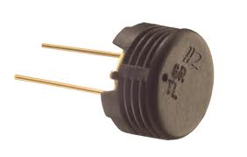

Based on a unique capacitive cell, this relative humidity sensors are designed for high volume, cost sensitive applications such as office automation, automotive cabin air control, home appliances, and industrial process control systems. They are also useful in all applications where humidity compensation is needed. These are Full interchangeable with no calibration required in standard conditions, Instantaneous de-saturation after long periods in saturation phase, Compatible with automated assembly processes, Individual marking for compliance to stringent traceability requirements, Part may be washed with distilled water.

Features:

Operating Temperature - 60 to 140 °C

Storage Temperature - 60 to 140 °C

Supply Voltage (Peak) - 10 V

Humidity Operating Range - 0 to 100 % RH

Barometric Pressure Sensors:

Barometric pressure (also known as atmospheric pressure) is the force exerted by the atmosphere at a given point.  It is known as the "weight of the air". A barometer measures barometric pressure. Measurement of barometric pressure can be expressed in millibars(mb) or in inches or millimeters of mercury (Hg).

1. Barometric Pressure Sensor Breakout - BMP180:

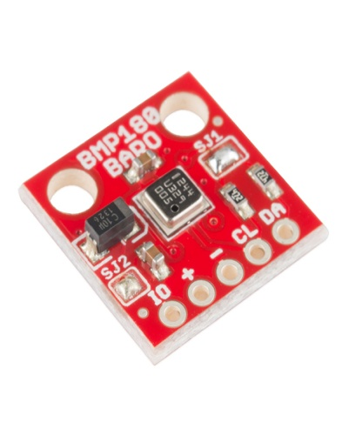

This is a breakout board for the Bosch BMP180 high-precision, low-power digital barometer. The BMP180 offers a pressure measuring range of 300 to 1100 hPa with accuracy down to 0.02 hPa in advanced resolution mode. It’s based on piezo-resistive technology for high accuracy, ruggedness and long term stability. These come factory-calibrated, with the calibration coefficients already stored in ROM.

Features:

* Digital two wire (I²C, TWI, “Wire”)interface, Wide barometric pressure range
* Flexible supply voltage range (1.8V to 3.6V), Ultra-low power consumption
* Factory-calibrated
* Includes temperature sensor

2. Barometric Pressure MPL15A2

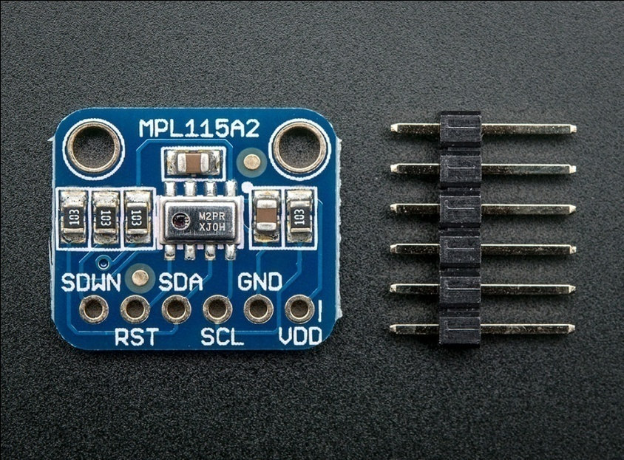

The MPL115A2 employs a MEMS pressure sensor with a conditioning IC to provide accurate pressure measurements from 50 to 115 kPa. An integrated ADC converts pressure and temperature sensor readings to digitized outputs via an I2C port. Factory calibration data is stored internally in an on-board ROM.

Features:

• Digitized pressure and temperature information together with programmed calibration coefficients for host micro use.

• Factory calibrated

• 50 kPa to 115 kPa absolute pressure and ±1 kPa accuracy

• 2.375V to 5.5V supply

• Integrated ADC

• I2C Interface (operates up to 400 kHz)

• Monotonic pressure and temperature data outputs.

**Wind Speed and Direction:**

Wind speed and direction are important for monitoring and predicting weather patterns and global climate. Wind speed and direction have numerous impacts on surface water. These parameters affect rates of evaporation, mixing of surface waters, etc.

1. Wind Vane:

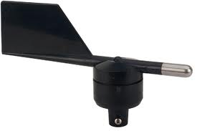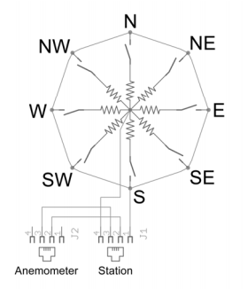

The wind vane is the most complicated of the three sensors. It has eight switches, each connected to a different resistor. The vane’s magnet may close two switches at once, allowing up to 16 different positions to be indicated. An external resistor can be used to form a voltage divider, producing a voltage output that can be measured with an analog to digital converter, as shown below.

2. Wind Speed:

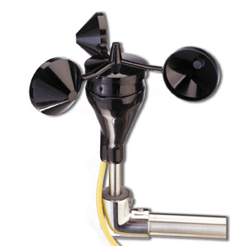

An anemometer or wind-meter is a device used for measuring wind speed, and is a common weather station instrument. It has three hemispherical cups, each mounted on one end of four horizontal arms, which in turn were mounted at equal angles to each other on a vertical shaft. The air flow past the cups in any horizontal direction turned the shaft in a manner that was proportional to the wind speed. Therefore, counting the turns of the shaft over a set time period produced the average wind speed for a wide range of speeds.

3. Wind Speed and Direction Sensor:

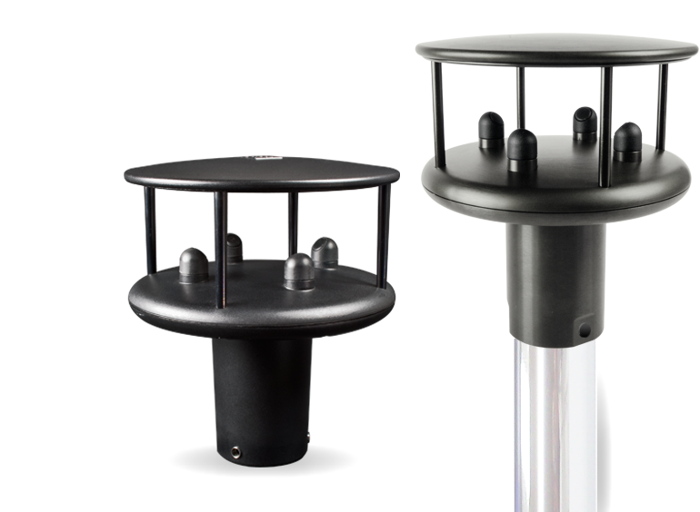

Sonic anemometers operate on the principle that the time required for a sound wave to travel from point A to point B is affected by the speed of the wind in a predictable and repeatable way. It is easy to install and maintain because of lightweight and compact, and has no moving parts. Sonic anemometers are provided with a built-in, flux-gate compass, which automatically references the wind direction output to magnetic north, regardless of the sensors orientation. This compass feature, combined with our sensors small size, low weight and low power requirements makes it very easy to transport and deploy for short-term studies.

Rain-Fall/Precipitation:

Rainfall is usually measured by first collecting it in a rain gauge. These special drums are then used to record the depth of the water inside. Rain water is collected by the funnel and is then is fed into measuring cylinder.

Tipping Bucket Rain Gauge:

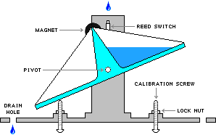

A tipping bucket rain gauge is a meteorological device that measures the amount of precipitation, or rain, which has fallen. A tipping bucket rain gauge has a receiving funnel leading to two small metal collectors (buckets). When a bucket accumulates 0.2 mm of rain water, the weight of the water causes it to tip and empty itself. Each time a bucket tips, an electrical contact is made, thereby enabling recording or rainfall amount and intensity with time.

BOARDS TO BE USED ☹

PRESENT EXISTING AWS IN INDIA:

1. instrumex Company:

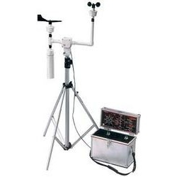

|  |
| --- |
| **Meterological Station** |

Wireless Weather Station with Rugged Construction for rough weather  
Measurement of following Parameters: **- Wind speed- Wind direction- Rain bucket- Solar radiation- Temperature- Humidity- Atmospheric pressure With - Wireless data logger**  
**- Solar panel- Mounting accessories**  
  
Data transfer over GSM/GPRS network on to a cental server. Historic Data available date wise from this server. Also saved in a Micro SD card placed inside the Base receiver.

2. India mart company:



The Wired Indradhanu™ Automatic Weather Station (AWS) offers multiple sensors including Wind Direction, Wind Speed, Rain, Atmospheric Temperature, Atmospheric Humidity, Atmospheric Pressure, Leaf Wetness, Solar Radiation, Soil Moisture, Soil Temperature & Canopy Temperature Sensors.   
  
The Basic Wired Indradhanu™ AWS of Neurosynaptic offers standard sensors that include Wind Direction, Wind Speed, Rain, Atmospheric Temperature, Atmospheric Humidity & Atmospheric Pressure along with Data Logger. The connectivity to an internet enabled Desktop PC/Laptop is provided either through a 15 meter cable or a Radio Frequency (RF) unit. The Indradhanu™ client application is installed on this Desktop PC/Laptop.   
  
Indradhanu™ AWS can either be deployed on the terrace of any building or Farm from where a Wired or RF Connectivity to a Client Desktop/Laptop/PDA, which can communicate through internet to a centrally located Server. Neurosynaptic thus can provide an array or network of AWS along with wired or RF connectivity and all of these can seamlessly collect various sensor data to one centrally located Indradhanu Server Application.

3. Sivara Enterprises(Bangalore):

Price : 65000

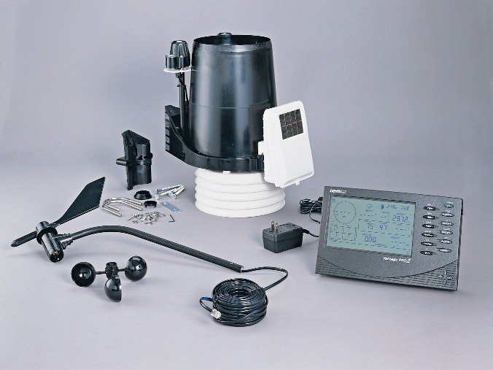

Most of the components are same as but this is battery powered and has nice GUI.

4. inGEN:

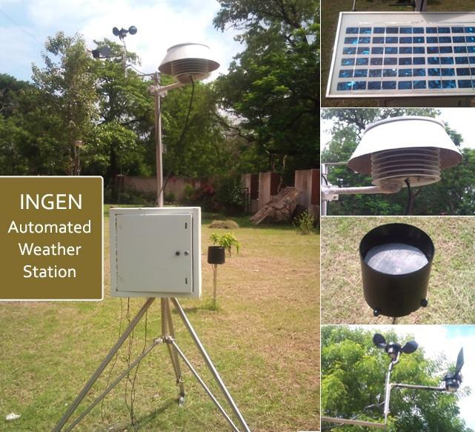

PRICE : 700 USD

* POWERING
  + Voltage 110.240 VAC or 12 .30 VDC
  + Internal battery 7 Ah/12V
  + Power consumption
  + Without sensor heating 4W
  + With wind sensor heating 24 W
* Materials: Stainless steel, Plastic, Anodized-aluminum
* Height: 4200 -4500 mm
* Weight enclosure: approx 5 kg

5. R.K. Engineering :

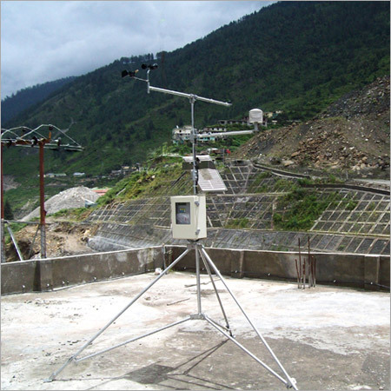

Our firm specializes in providing an extensive array of **Automatic Weather Station.** The offered weather station is extensively used in weather forecast department for saving human labor and enables measurements from remote areas. Manufactured using high grade raw material and latest technology, the offered weather station is extremely appreciated by our clients due to its high performance. Further, the offered weather station is the most dependable and accurate instrument to find out the exact weather condition

6. B.S.K. Technologies:

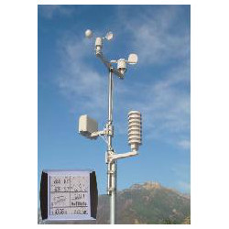

It consist a data shuttle, which is a pocket-sized device, allowing ease of download and transportation of data to a personal computer. When connected to a pc, it is used to view and read collected data with the help of turnkey windows based weather station software. The corresponding data file is saved in Microsoft’s excel format. Post processing of recorded information helps in understanding the various aspects of the atmosphere in relation to the specific application. The use of Automatic weather station is immense in such situations.