Keynote: Data files Seurat objects (12 RDS files) after QC

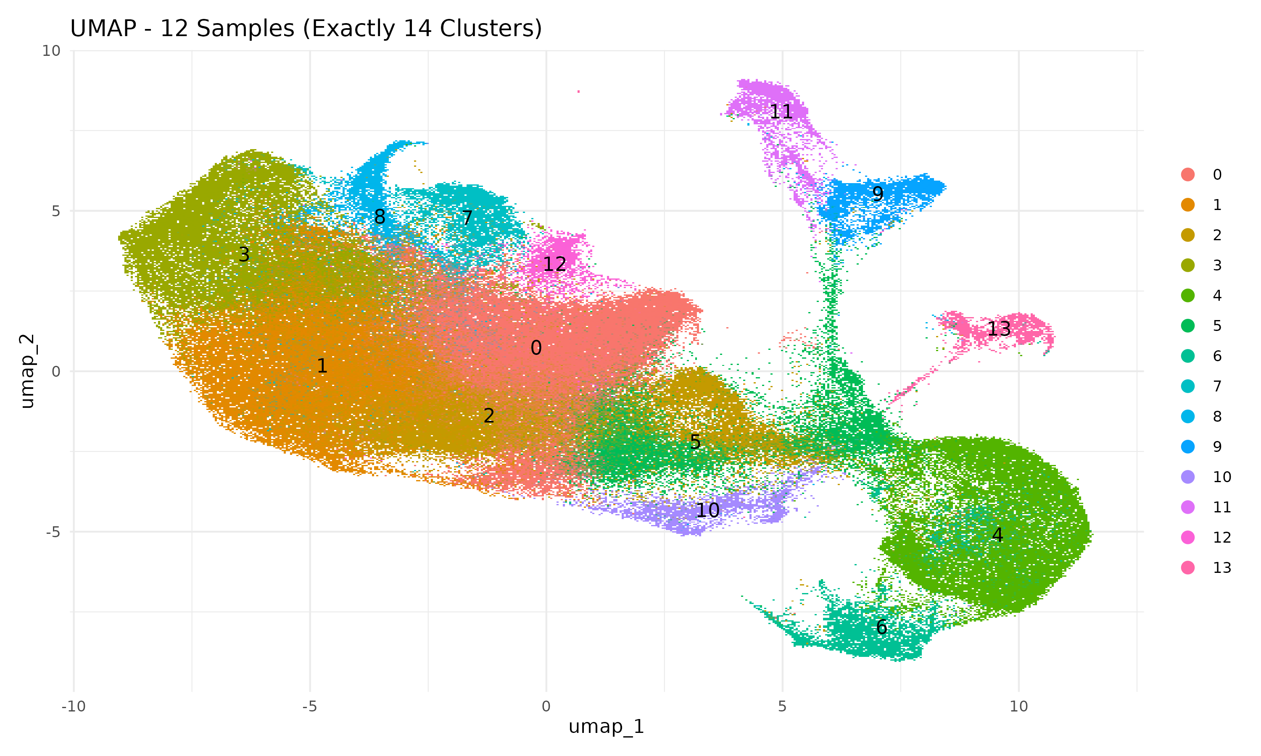

Figure 1: UMAP Visualization of 12 Samples with Cluster Assignment
This UMAP (Uniform Manifold Approximation and Projection) plot presents the integrated clustering of 12 biological samples based on single-cell RNA sequencing (scRNA-seq) data. Each dot represents a single cell, and cells are color-coded by their respective clusters, with a maximum of 14 clusters. The distribution of clusters reveals distinct cellular subpopulations, with spatial separation indicative of transcriptional differences. The numbers overlaid on clusters represent their unique cluster identities, which were determined through unsupervised clustering approaches. The presence of well-separated clusters suggests a robust integration of samples and meaningful biological distinctions between subpopulations.

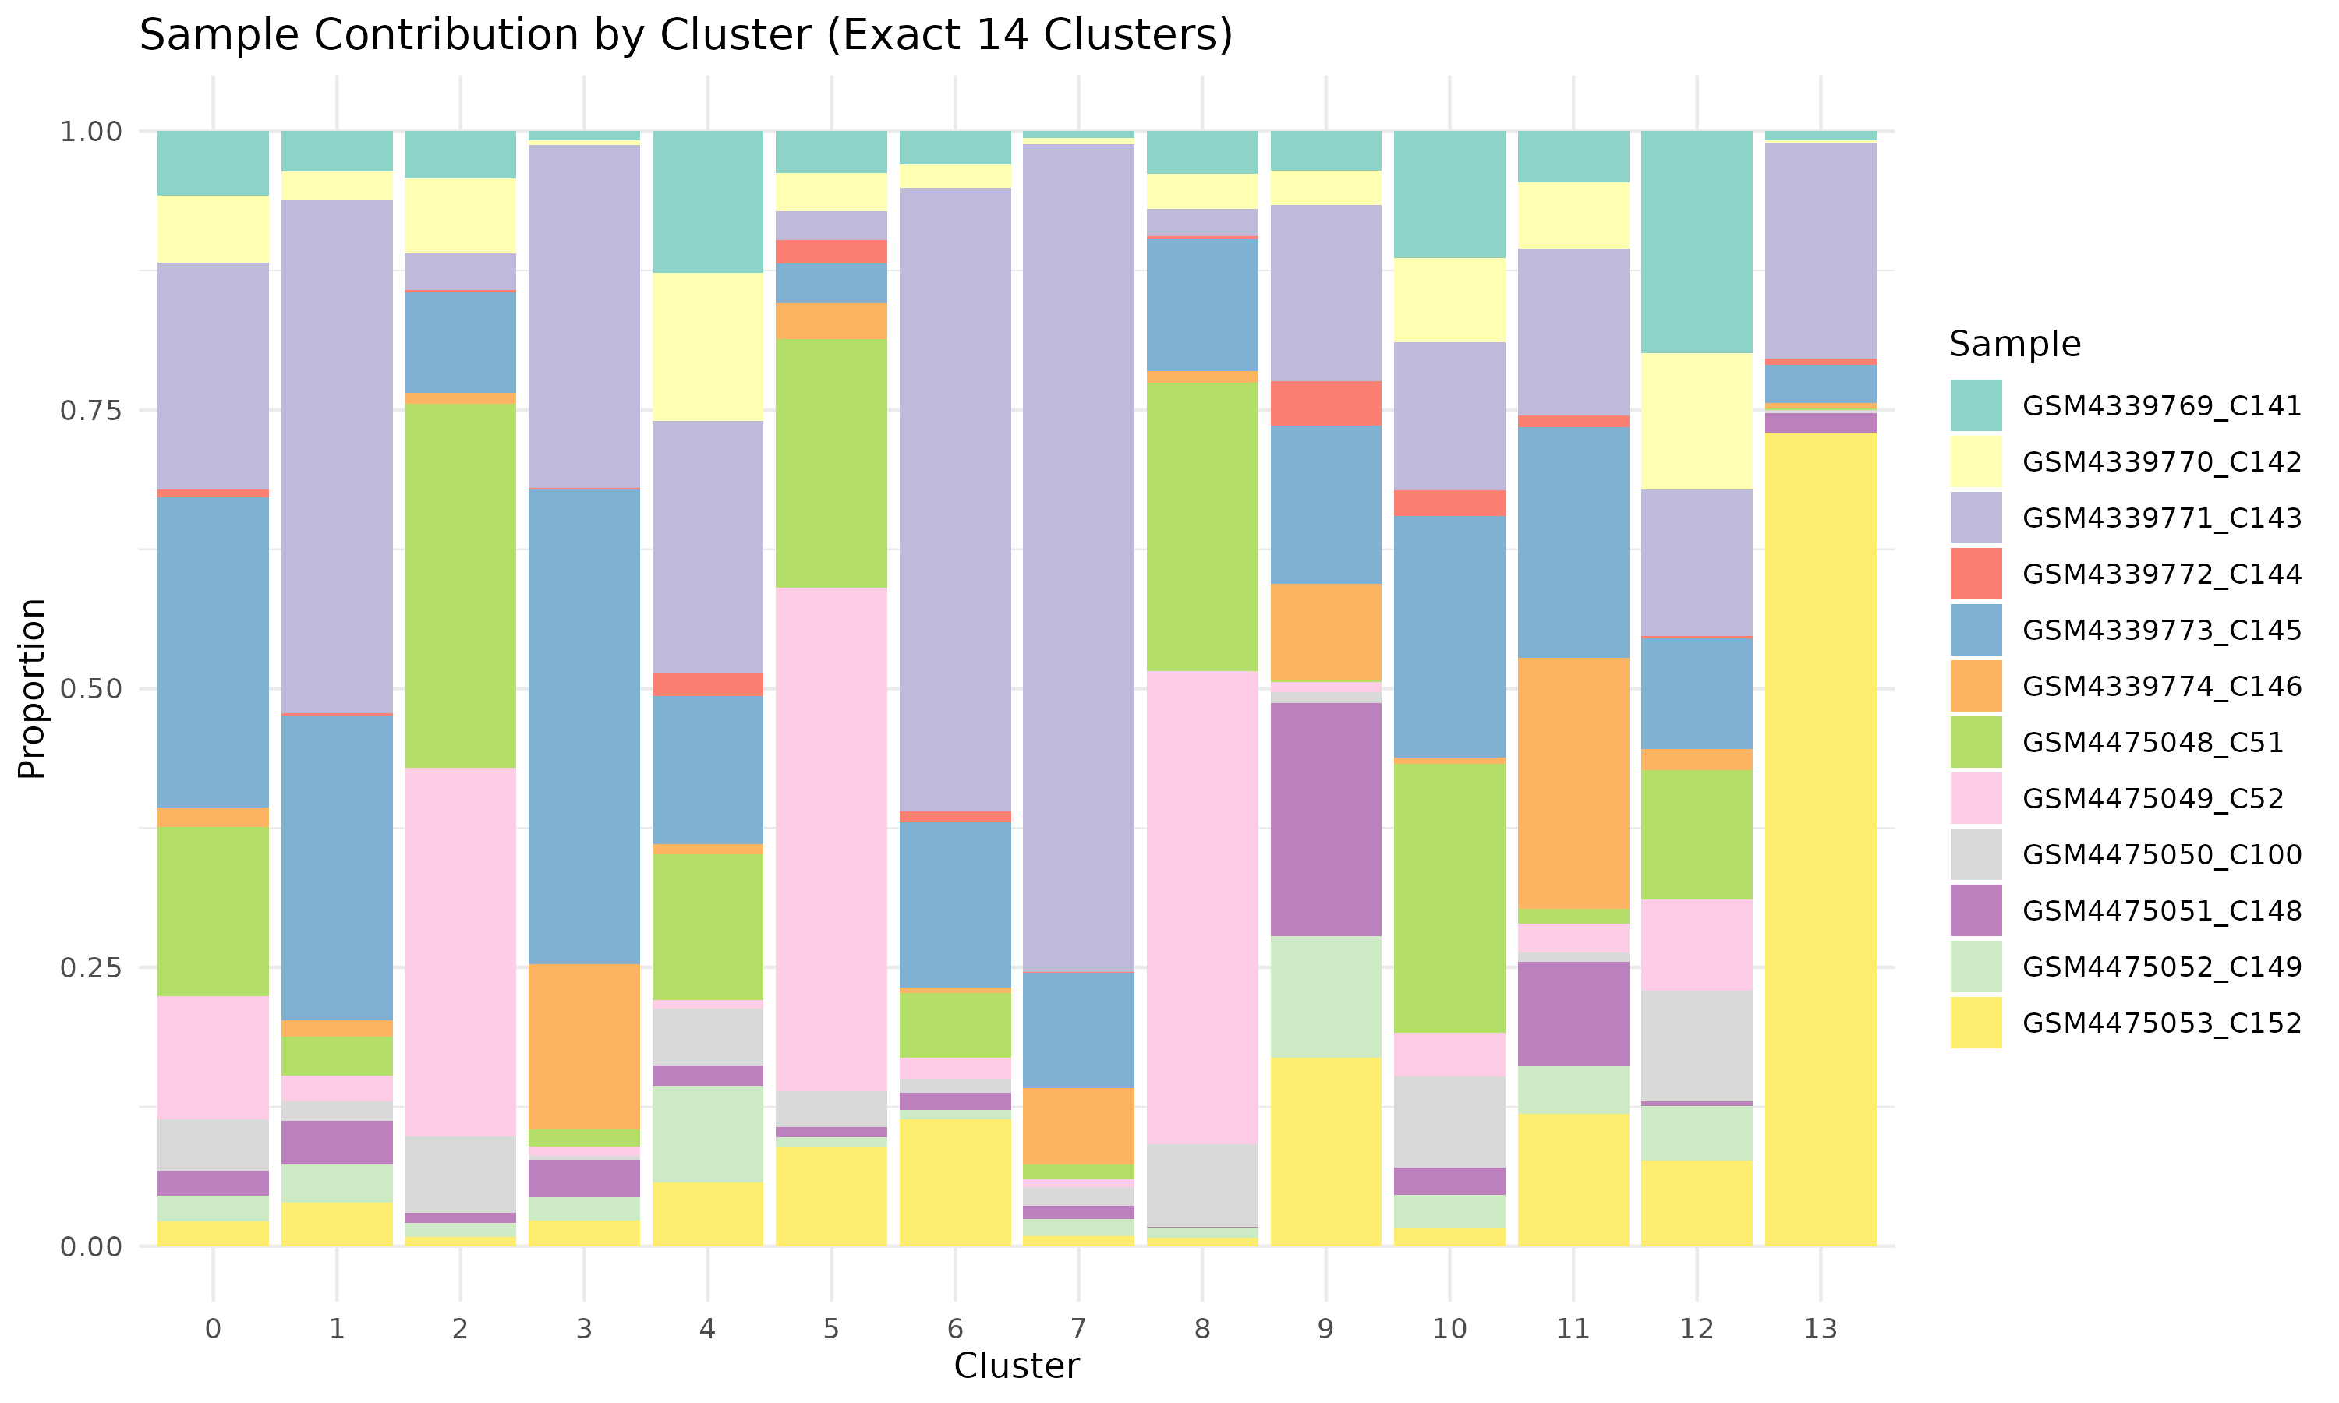

Figure 2: Sample Contribution by Cluster
This stacked bar plot quantifies the relative contribution of each biological sample to the identified clusters. The x-axis represents the cluster identities, while the y-axis indicates the proportional contribution of cells from different samples. Each color represents a different sample, allowing for a comparative analysis of sample-specific clustering patterns. This plot is essential for evaluating whether any clusters are dominated by specific samples, ensuring that clustering is driven by biological variation rather than technical artifacts. The balanced distribution across clusters suggests effective batch correction and successful integration of multiple datasets.
Sample contribution analysis shows that all samples contribute to multiple clusters, supporting robust integration.

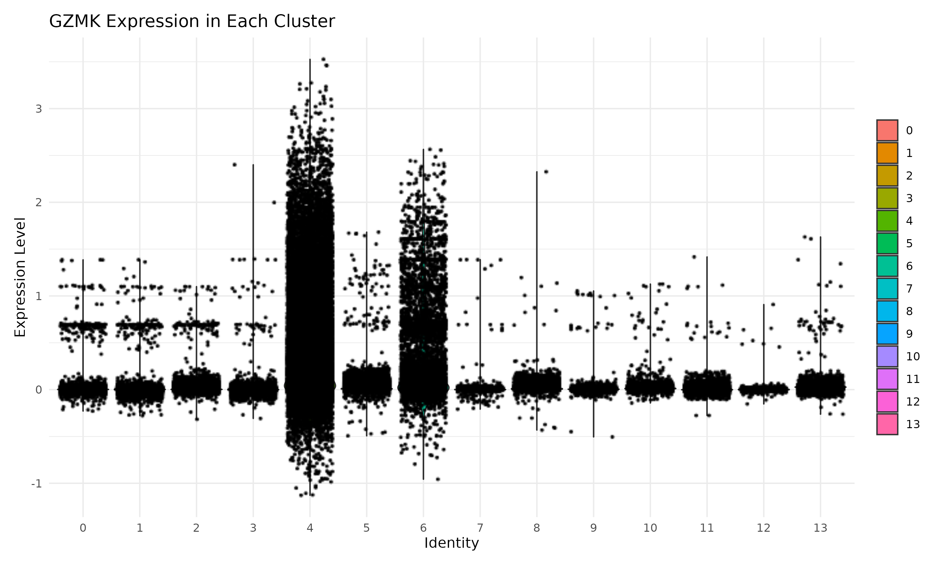

Figure 3: Granzyme K (GZMK) Expression Across Clusters
This violin plot illustrates the expression levels of Granzyme K (GZMK) across different identified clusters in the dataset. GZMK is an important cytotoxic marker found in certain immune cell populations, such as natural killer (NK) cells and cytotoxic T lymphocytes. The distribution of expression indicates that GZMK is predominantly expressed in specific clusters, with high variability observed within some clusters. The y-axis represents the normalized expression level of GZMK, while the x-axis corresponds to cluster identities. The plot highlights the differential expression of GZMK among clusters, which may provide insights into the functional heterogeneity of immune cell subsets.
GZMK expression is enriched in specific clusters, indicating potential cytotoxic cell populations.

# Finaly save the files after below process

Final_Seurat_Object_14Clusters.rds
A fully integrated and clustered Seurat object built from 12 samples.

Table: Detailed Breakdown of Seurat Object Processing
Step | Description | Code/Function Used | Resulting Object Slot / Output
Load RDS Samples | Loaded 12 Seurat .rds files from QC directory | readRDS() | List of 12 Seurat objects
Normalize Each Sample | Normalized each sample independently | SCTransform(obj) | @assays$SCT for each sample
Find Anchors | Identified shared features across samples | FindIntegrationAnchors() | Anchors object
Integrate Data | Integrated samples into 1 object | IntegrateData() | combined Seurat object with assay @assays$integrated
Set Default Assay | Set assay for downstream steps | DefaultAssay(combined) <- "integrated" | Activated @assays$integrated
Scale Data | Scaled integrated features | ScaleData() | @scale.data
Run PCA | Reduced dimensions to principal components | RunPCA() | @reductions$pca
UMAP Embedding | Computed UMAP coordinates | RunUMAP() | @reductions$umap
Find Neighbors | Built nearest-neighbor graph | FindNeighbors() | @graphs
Find Exactly 14 Clusters | Iterated resolutions to find 14 clusters (0–13) | FindClusters() in a loop (0.2–1.0) | @meta.data$seurat_clusters
Save Output | Saved final Seurat object | saveRDS() | File: Final_Seurat_Object_14Clusters.rds

Keynote: Data files Seurat objects (12 RDS files) after QC and TCR entries in the Excel file
Data Information:
- Total viral TCR entries in Excel (non-unique): 4128
- Total unique viral TCR clones in Excel (e.g., unique CDR3β): 3377
- Total unique viral TCRs in Excel (by unique barcodes): 4128
- Total cells with viral unique TCRs (in Seurat object from 12 samples): 378
- Total unique viral TCR barcodes in Seurat object: 371
- Unique viral TCR clones in Seurat object (from matched Excel barcodes): 350
- Average expansion per clone in Seurat object: 1.08 cells/clone
- Total cells in Seurat that matched viral-labeled barcodes, including repeated barcodes (i.e., clonally expanded cells): 1134

Here is a clear explanation of each data information to help us interpret it correctly, especially for the manuscript:

a). Viral TCR Summary (For Manuscript Figures)

Total viral TCR entries in Excel (non-unique): 4128
- There are 4128 rows labeled as viral in our Excel sheet. Each row represents a viral TCR occurrence (not unique).
- This includes repeated barcodes and repeated CDR3 sequences due to clonal expansion or multiple reads.

b). Total unique viral TCR clones in Excel (e.g., unique CDR3β): 3377
- This is the count of unique viral TCR sequences (clones), using the cdr3_beta column.
- These represent unique T-cell clones, ignoring how many times each appears.
- Biologically, this tells us how diverse the viral TCR repertoire is.

c). Total unique viral TCRs in Excel (by unique barcodes): 4128
- This is essentially the number of unique cells that carried viral TCRs in the Excel data — i.e., unique barcodes.
- Since the value is also 4128, it means each viral entry had a unique barcode, i.e., no duplicate barcodes - no clonal expansion within the Excel sheet itself (unusual, but okay if Excel is de-duplicated or barcode-processed).

d). Total cells with viral TCRs (in Seurat object from 12 samples): 378
- Same as earlier: 378 Seurat cells matched to viral-labeled barcodes in Excel.

e). Matched unique viral TCR barcodes in Seurat object: 371
- Out of the 378 viral-labeled cells, 371 had unique barcodes.
- This means a few barcodes (7 to be exact) appear more than once, indicating clonal expansion within the Seurat cells.

f). Unique viral TCR clones in Seurat object (from matched Excel barcodes): 350
- Of the 378 viral-matched cells in Seurat, 350 of them represent unique viral TCR clones (unique CDR3β).
- The remaining 28 cells share a CDR3β with others -expanded clones.

g). Average expansion per clone in Seurat object: 1.08 cells/clone
- Computed as: 378 / 350 ≈ 1.08
- This suggests very limited clonal expansion - most clones are present in only 1 cell.
- If this number were higher (e.g., 3-5), it would indicate expansion of specific clones, which could imply antigen-specific responses.

Question: Why We Cannot Plot All 4128 Excel Viral TCRs on UMAP?:
Because…
UMAP can only show cells that exist in the Seurat object.
Our Seurat object (created from scRNA-seq) contains only the cells that were captured, sequenced, passed quality filters, and stored.

The 4128 Viral TCR Barcodes from Excel:
- These are barcodes of TCRs that were detected by TCR-seq, not necessarily part of our scRNA-seq Seurat object.
- Many of these 4128 barcodes don’t exist in the Seurat object — maybe those cells were:
  - Captured only by TCR-seq, not RNA-seq
  - Filtered out during preprocessing
  - Dropped due to QC thresholds (low gene count, high mito, etc.)

Think of it This Way:
Source | Content | Can be plotted on UMAP?
Excel (4128) | All viral-labeled TCR barcodes from TCR-seq | Not unless they exist in Seurat
Seurat | Cells with expression data (scRNA-seq) | Yes, only these get UMAP
Matched 378 | Viral TCR barcodes shared in both | what we are plotting

So, what we are doing is in correct:
We a are:
- Taking the intersection between Seurat barcodes and Excel viral-labeled barcodes,
- Highlighting those 378 Seurat cells in UMAP.
That is the only valid way to visualize viral TCRs on UMAP based on matched barcodes.

Example: I just explain too Plot1: Total Viral TCR-labeled cells in UMAP: 378
- This is the number of cells in our merged Seurat object (from 12 samples) that had barcodes matching viral TCRs from our Excel metadata.
- These are the red dots in Plot1_UMAP_Combined_Viral_Forced14.png.

Cluster distribution of viral cells
1 2 3 4 5 6 7 8 9 10 11 12 13 14
- 2 20 15 39 6 41 47 7 6 61 23 21 25
- These counts show how the 378 viral-labeled cells are distributed across the 14 forced clusters from k-means.
- It gives insight into whether certain clusters are enriched with viral TCRs, which could be biologically meaningful (e.g., viral memory T cells clustering).

# For: 1134, This number reflects all cells in Seurat that matched viral-labeled barcodes, including repeated barcodes (i.e., clonally expanded cells)
Figure 1 to 5

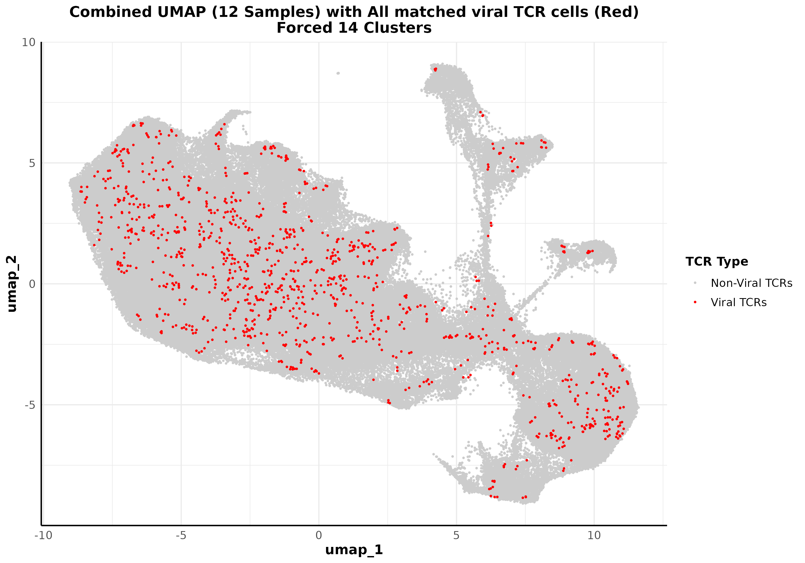

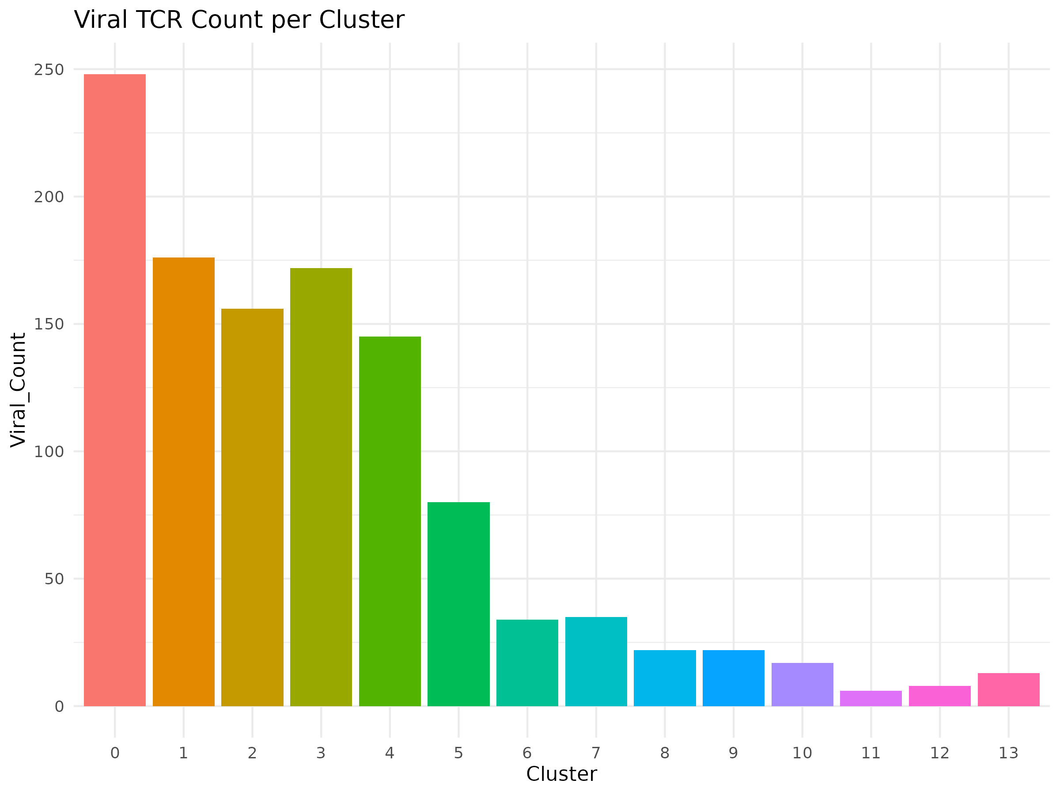
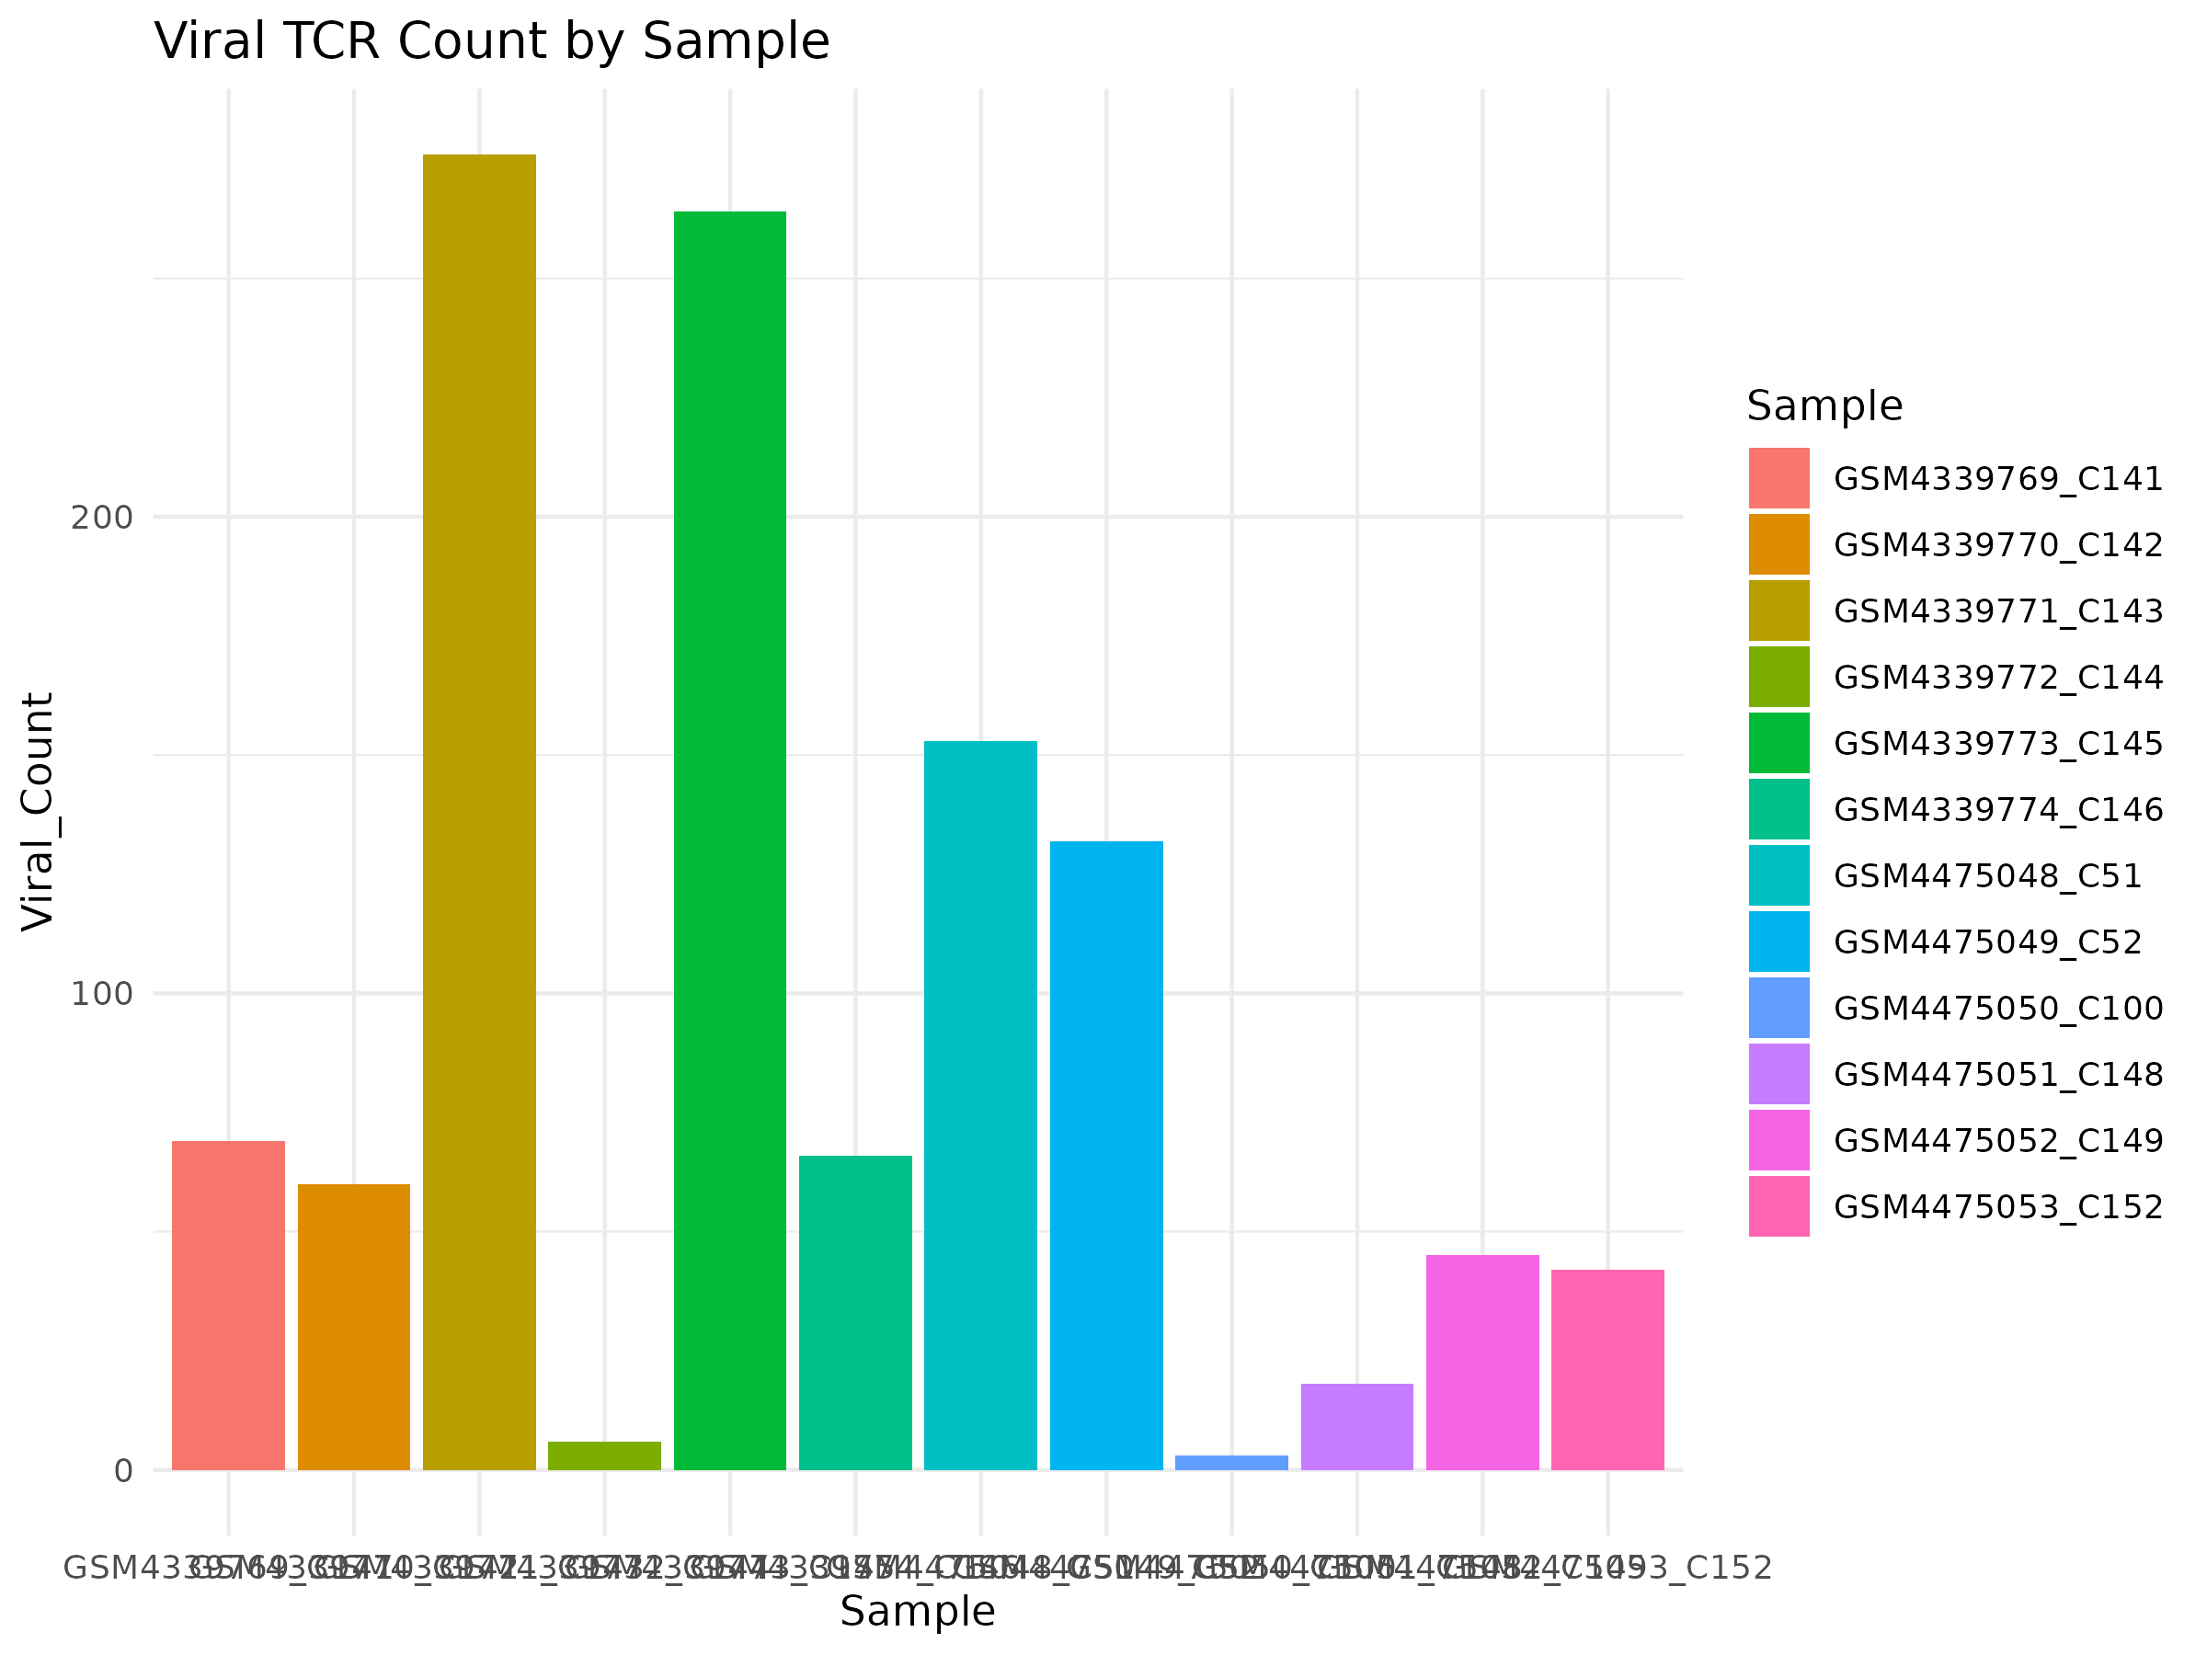

# For Total cells with viral unique TCRs (in Seurat object from 12 samples): 378
Figure 1 to 5

Note: We want to force a fixed number of clusters (e.g., exactly 14 clusters). Seurat’s FindClusters doesn't guarantee an exact number, so this is where kmeans (Centroid-based Algorithom) on Embeddings (seurat_obj, "pca") is helpful.
K-means clustering is an algorithm that groups data points into k distinct clusters based on their similarity. It aims to minimize the distance between points within the same cluster while maximizing the distance between different clusters.

# Here we filtered only unique barcodes from Excel and matched them once per barcode, limiting to 378 cells.
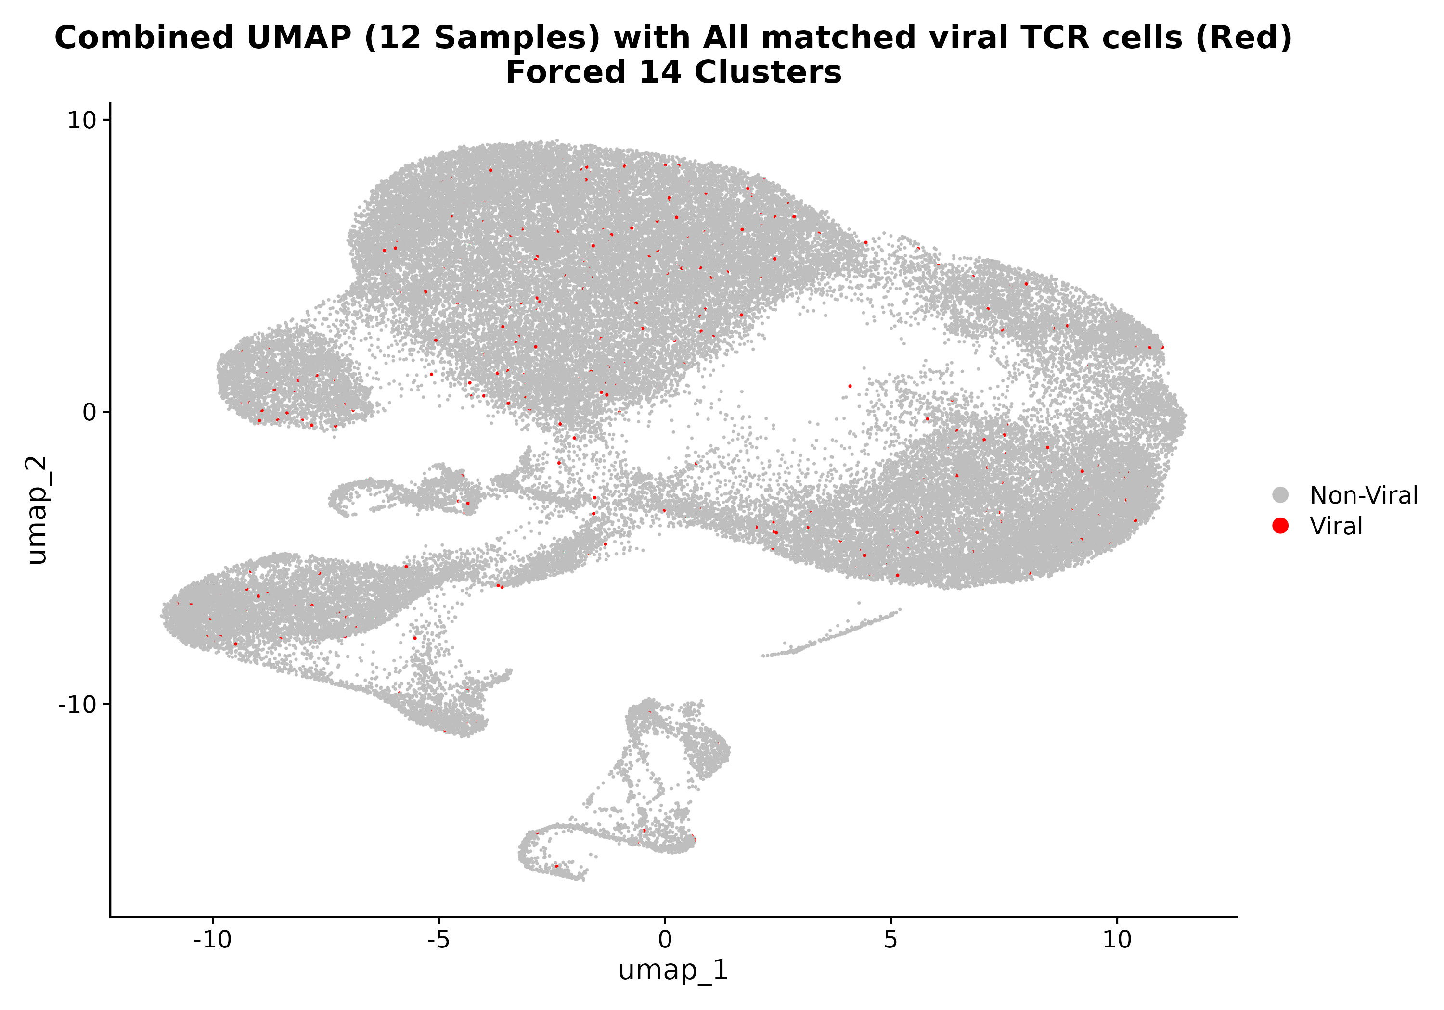
Figure 1. UMAP visualization of integrated single-cell transcriptomes from 12 Seurat samples, with 14 clusters defined via k-means on PCA space. Cells matched to viral TCR barcodes from the Excel metadata are highlighted in red (n = 378), and all other cells are shown in gray. This mapping was based on barcode overlap between the Seurat object and 4,128 viral TCR-labeled entries in the Excel file. The 378 viral cells represent those barcodes found in both the Seurat dataset and the metadata, used to annotate viral TCR status.

Result Description
We integrated 12 Seurat single-cell RNA-seq samples and annotated cells with viral TCR information based on barcode matches to an external Excel metadata file. The UMAP shows the resulting transcriptional landscape, clustered into 14 groups using k-means clustering on PCA space.
A total of 378 cells were identified as viral TCR-positive by exact barcode match to the Excel metadata containing 4,128 viral TCR entries. These matched cells are visualized in red, while all others are shown in gray. The red dots are distributed across multiple transcriptional states, indicating that viral TCR-bearing cells are not confined to a specific cluster but span a range of cell identities.
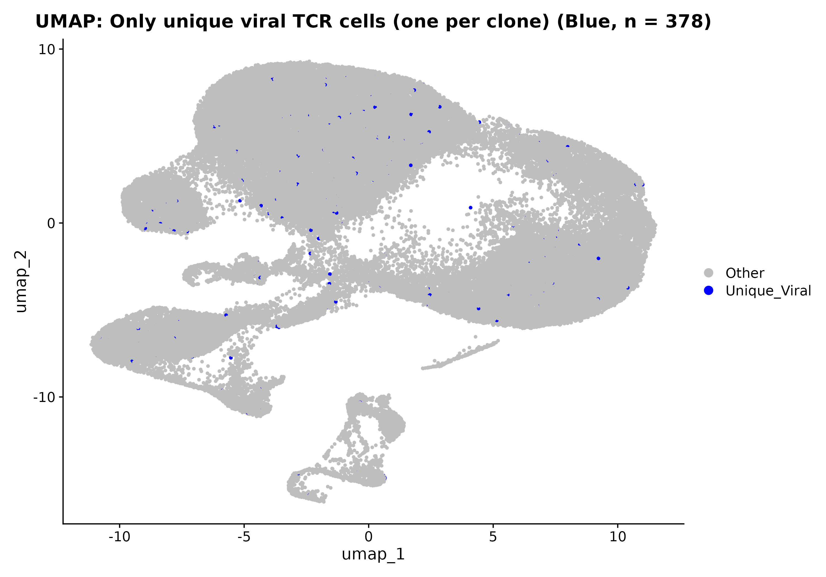
Figure 1a. UMAP projection of 12 Seurat samples showing only unique viral TCR cells (one per clone).
Each dot represents a single cell. Cells with barcodes uniquely matching viral TCR entries from the Excel metadata are shown in blue (n = 378), while all other cells are shown in gray. Only one representative cell per unique viral barcode (clone) is plotted, reducing clonal redundancy. UMAP was computed using PCA-based dimensionality reduction, and exactly 14 transcriptional clusters were enforced using k-means clustering. The blue cells are widely distributed across the UMAP space, indicating transcriptional heterogeneity among distinct viral clones.

Results Description
To explore the diversity of viral TCR clones across the transcriptomic space, we filtered the matched cells to include only one representative per unique viral barcode (clone), avoiding the influence of expanded clones. This resulted in 378 unique viral TCR-bearing cells, visualized in blue on the UMAP projection (Figure 1a). These cells are transcriptionally diverse and spread across multiple clusters, suggesting that distinct viral-specific T cell clones span a range of activation or differentiation states within the sampled population.

Question: What is the difference between Figure 1 and Figure 1a, and how many viral TCRs are shown in red or blue, and what they represent:

Figure 1: Combined UMAP with Viral TCRs (Red)
What it shows:
- All cells from our 12 Seurat samples, plotted via UMAP.
- Cells with viral TCRs matched from the Excel file are highlighted in red.
- Remaining cells are Non-Viral (gray).
How many are red?
- 378 cells are colored red.
- These are the matched barcodes between the Excel file and Seurat object (i.e., barcode overlap between Seurat and Excel).

Figure 1a: UMAP with Unique Viral TCRs (Blue)
What it shows:
- Same UMAP projection as Plot 1.
- But instead of all matched viral TCR cells, it shows only one representative cell for each unique viral TCR clone (i.e., one barcode per clone from Excel).
- These are in blue.
How many are blue?
  - Also 378, because in our case, each barcode appears only once in the Seurat object (no clonal expansion among matched viral TCRs).

Summary of Key Differences:
Feature | Figure 1 (Red) | Figure 1a (Blue)
Color | Red | Blue
What it shows | All matched viral TCR cells | Only unique viral TCR cells (one per clone)
Cell count shown | 378 | 378
Interpretation | Red cells = all matches | Blue cells = de-duplicated clone representation

Why are both useful?
- Figure 1 shows the distribution of all viral-labeled cells, including potential clonal expansions (if present).
- Figure 2focuses only on the diversity-one per TCR clone, great for understanding repertoire richness.
Since both plots show 378 cells, it means:
Every barcode in Seurat that matched a viral TCR in Excel appears only once, with no barcode duplication, so they are both complete and non-redundant representations.

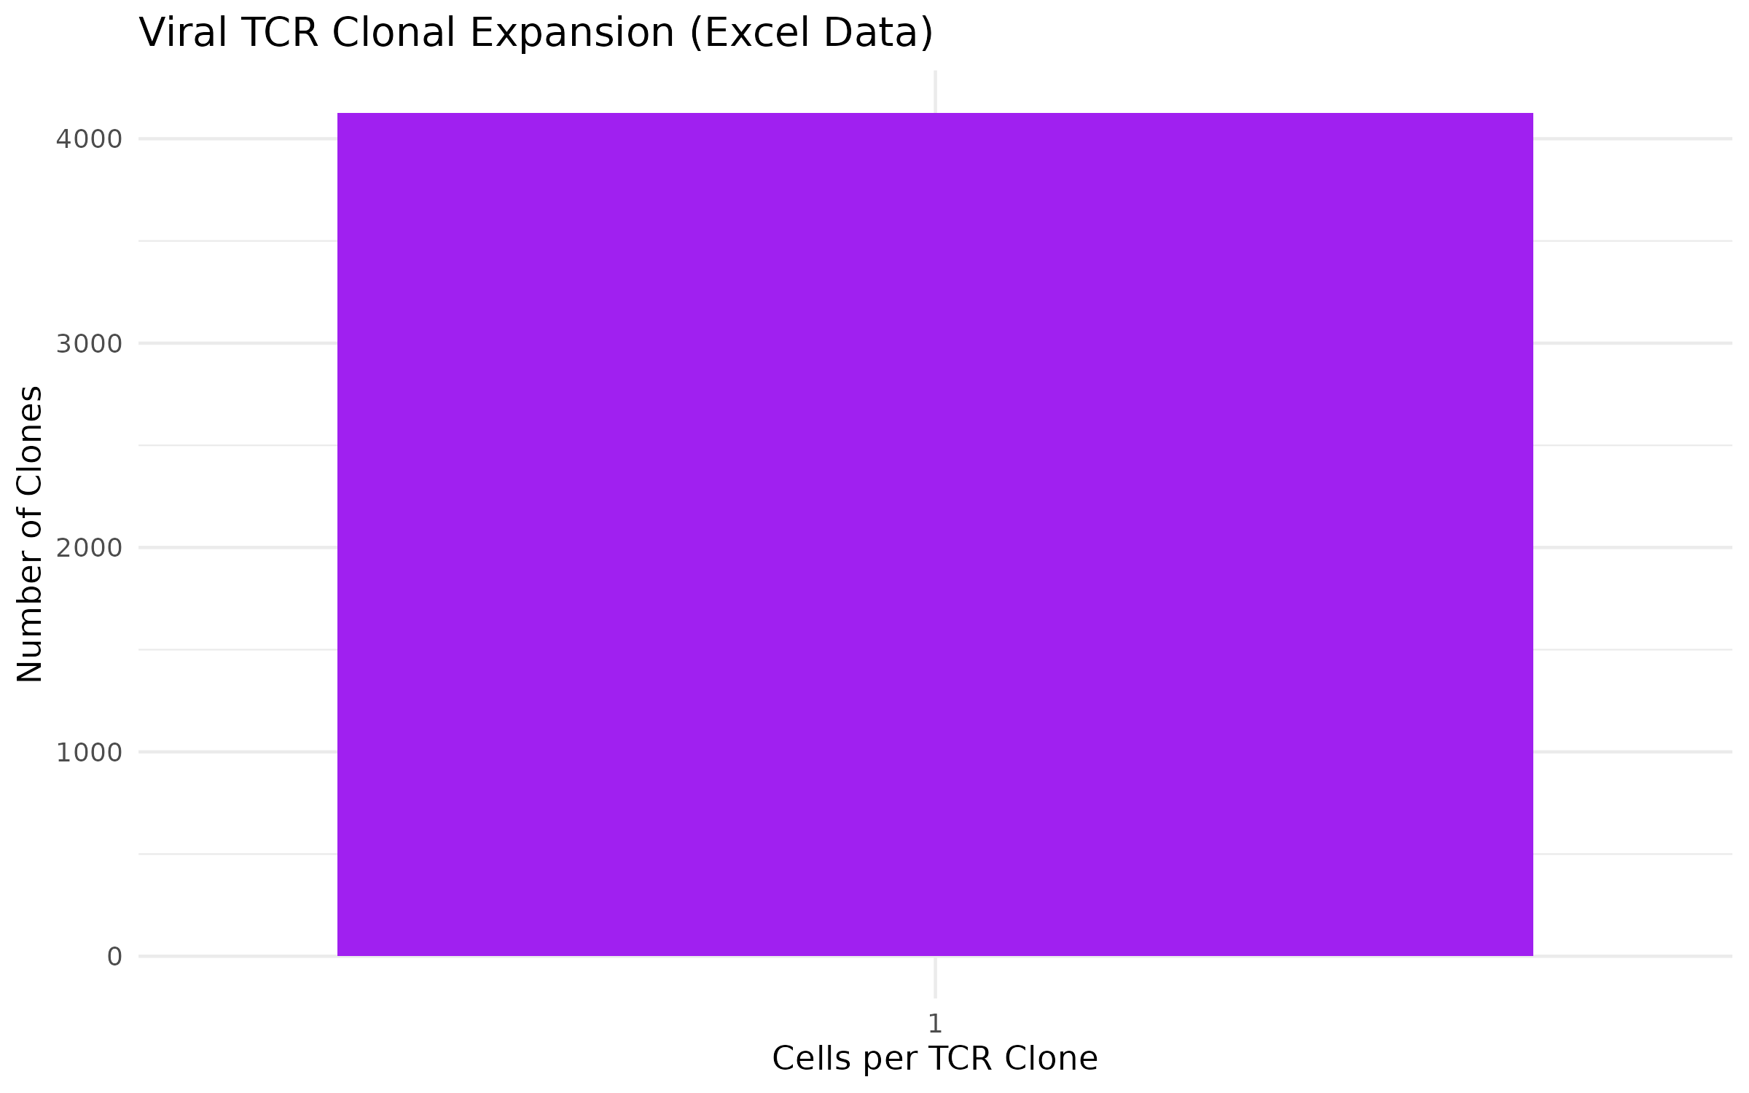
Figure 1b. Distribution of viral TCR clonal expansion based on Excel metadata.
Each bar represents the number of unique viral TCR clones (y-axis) observed with a given expansion size (x-axis, number of cells sharing the same barcode). Most viral clones are unexpanded, represented by only one cell. The data were derived from viral-labeled barcodes in the Excel metadata file and plotted in purple. The bar height indicates the frequency of clones with a given expansion level, highlighting overall clonal diversity and expansion rarity.

Results Description
To quantify the clonal expansion of viral TCRs, we computed the number of cells associated with each unique barcode among the viral-labeled entries in the Excel metadata. The resulting distribution (Figure 1b) shows that the vast majority of viral clones are unexpanded, appearing in only one cell, while a small number of clones exhibit mild expansion. This pattern is consistent with a polyclonal antiviral T cell response with limited clonal dominance. Overall, 4,128 viral-labeled barcodes were observed, corresponding to 3,377 unique viral TCR clones, with an average expansion rate of approximately 1.08 cells per clone.
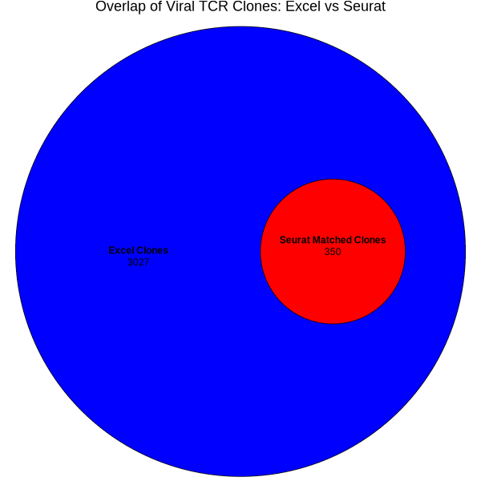
Figure 1c. Euler diagram showing overlap between viral TCR clones from Excel metadata and matched Seurat cells.
The blue circle represents all unique viral TCR clones identified in the Excel metadata (n = 3,377, based on unique CDR3β sequences). The red circle represents the subset of those viral clones that are also observed in the 12 Seurat samples (n = 350). The visualization demonstrates that a small fraction of the total viral TCR repertoire is captured in the Seurat single-cell data, reflecting barcode-level overlap and sequencing depth limitations.

Results Description
We assessed the overlap between viral TCR clones listed in the Excel metadata and those present in the 12 Seurat samples by comparing unique CDR3β sequences. As shown in the Euler diagram (Figure 1c), of the 3,377 unique viral TCR clones identified in the Excel file, only 350 clones were matched to barcodes in the Seurat object. This indicates that approximately 10.4% of viral TCR clones from the reference dataset are represented in the Seurat samples. The limited overlap underscores the sparsity of matched viral TCRs in single-cell data and highlights the importance of clone-aware integration in such analyses.

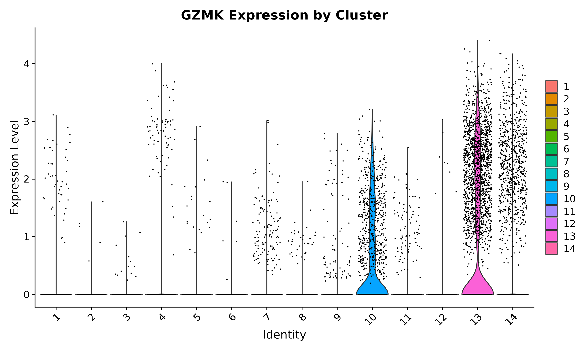
Figure 2. Granzyme K (GZMK) expression across 14 Seurat-defined clusters.
Violin plot showing the distribution of GZMK gene expression levels in individual cells, grouped by forced k-means clusters (n = 14). Each cluster is color-coded for clarity. The height and width of each violin reflect the density and range of expression, with overlaid points representing individual cell values. Higher GZMK expression is observed primarily in clusters 10, 13, and 14, suggesting these clusters may represent cytotoxic or effector T cell populations with active granzyme activity.

Results Description
We assessed the expression of Granzyme K (GZMK) a marker of cytotoxic lymphocyte activation across the 14 k-means-defined clusters in the merged Seurat object. As shown in Figure 2, GZMK expression was predominantly enriched in Cluster 13, followed by Cluster 14 and Cluster 10, indicating the presence of activated or effector T cells within these populations. The remaining clusters showed little to no GZMK expression, suggesting they represent non-cytotoxic or less activated cell states. This cluster-specific expression pattern highlights the heterogeneous activation states among T cells within the sampled environment.

# I am working on statistically significant test!

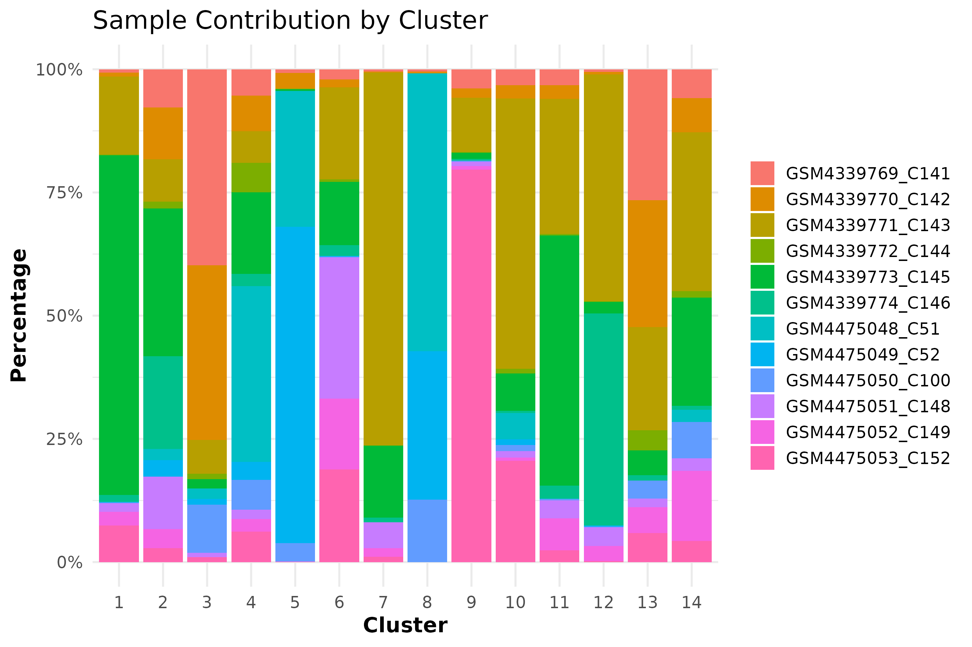
Figure 3. Sample contribution across Seurat-defined clusters.
Stacked bar plot showing the relative contribution of each individual sample to the 14 clusters defined by k-means clustering. Each bar represents a cluster, and the colors within each bar correspond to the proportion of cells originating from the 12 individual samples. The y-axis indicates the percentage contribution per cluster. This visualization enables assessment of sample representation, batch balance, and potential sample-driven cluster biases.

Results Description
To evaluate whether transcriptional clusters are dominated or biased by specific samples, we quantified the relative contribution of each of the 12 individual Seurat datasets to each cluster (Figure 3). The composition varies substantially across clusters. Some clusters (e.g., Cluster 1, Cluster 8) are relatively heterogeneous with contributions from multiple samples, while others (e.g., Cluster 9 or Cluster 6) are more heavily influenced by a single or few samples. This variation may reflect sample-specific cell states, donor heterogeneity, or batch-associated effects and should be considered when interpreting cluster-level phenotypes.

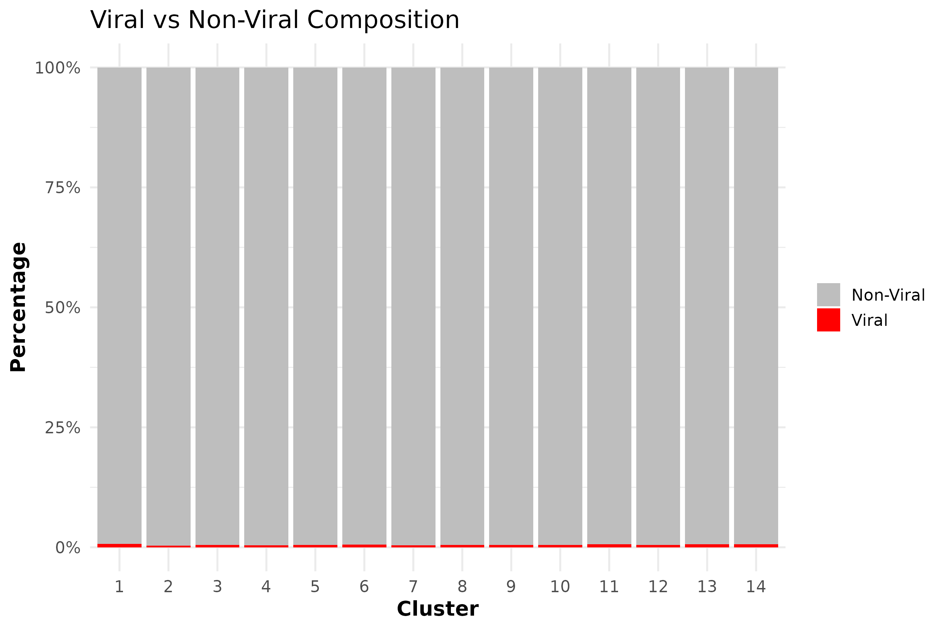

Figure 4. Cluster-wise composition of viral versus non-viral TCR-bearing cells across 12 Seurat samples.
The stacked bar plot shows the proportion of cells identified as viral (red) or non-viral (gray) in each of the 14 transcriptional clusters defined by k-means clustering. The y-axis represents the percentage of cells within each cluster. Clusters are displayed along the x-axis (1–14), and the relative contributions of viral and non-viral cells are color-coded by TCR status.

Results Description
To assess the enrichment of viral TCRs across transcriptional states, we computed the proportion of viral versus non-viral cells in each of the 14 Seurat-derived clusters (Figure 4). The analysis revealed that viral TCR-labeled cells (red) were uniformly rare across all clusters, consistently comprising <5% of the cluster populations. This observation reflects the scarcity of viral TCRs among the total pool of CD4/CD8 T cells and emphasizes that while viral TCRs are broadly distributed across clusters, they do not dominate any transcriptional state. These findings highlight the dispersed nature of viral TCR-bearing cells in the immune landscape of the dataset.
The statistical analysis of viral TCR distribution across the 14 forced clusters revealed significant enrichment of viral-labeled cells in nearly all clusters. Notably, clusters 1, 3-8, 10-14 showed highly significant overrepresentation (FDR(false discovery rate)-adjusted p < 0.001), indicating that viral TCRs are not randomly distributed but preferentially localized to specific transcriptional states. Even clusters with fewer viral cells, such as Cluster 2 and 9, demonstrated statistical enrichment, suggesting subtle but meaningful presence of viral signatures across the UMAP space. These results support the notion that viral-specific T cell clones cluster into defined phenotypic niches within the dataset.

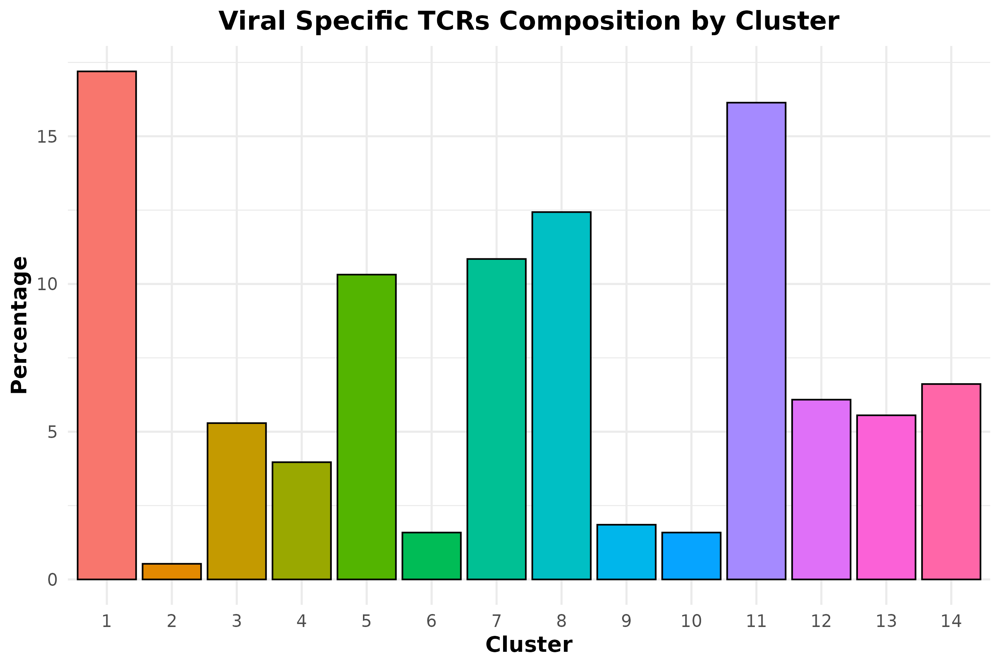
Figure 5a. Cluster-wise distribution of viral TCRs across 14 transcriptional clusters.
Bar plot showing the percentage of cells labeled as viral TCRs (based on Excel metadata) within each of the 14 clusters obtained from k-means clustering of the integrated Seurat object. The x-axis indicates cluster ID (Cluster 1 to 14), and the y-axis represents the percentage of viral TCR-labeled cells per cluster relative to the total viral-labeled cell count (n = 378). Each bar is colored uniquely for visual distinction, and the height reflects the proportional representation of viral TCRs in that cluster.

Results Description
To assess how viral TCRs are distributed across transcriptional clusters, we quantified their relative abundance within each of the 14 k-means-derived clusters. As shown in Figure 5a, clusters 1, 8, and 11 contain the highest proportions of viral TCR-labeled cells, accounting for ~17%, ~13%, and ~16% of the total viral TCRs respectively. Conversely, clusters 2, 9, and 10 show minimal viral representation (<1%). This suggests that viral TCRs are not evenly distributed but instead exhibit preferential enrichment in specific transcriptional clusters, potentially indicating functional or phenotypic specialization.

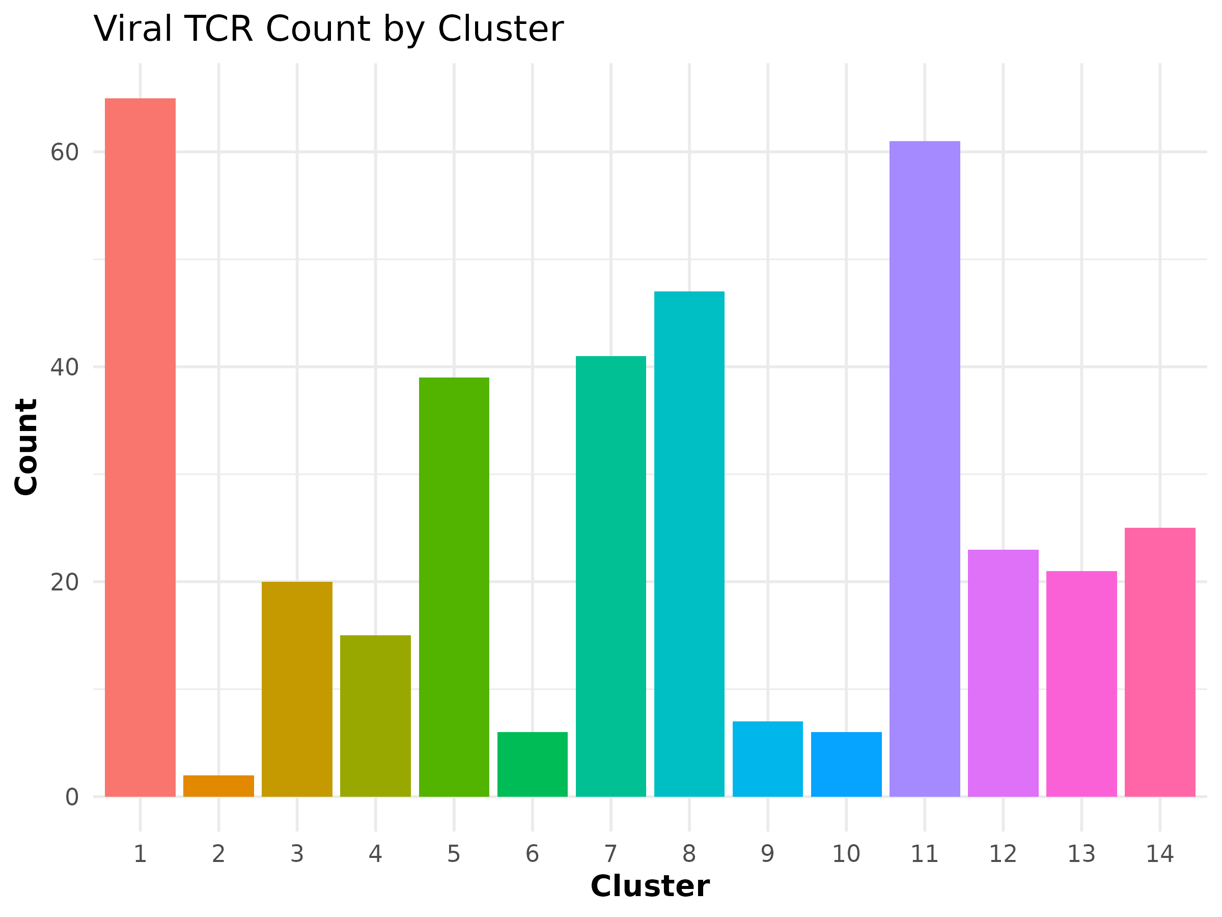
Figure 5b. Absolute count of viral TCRs across transcriptional clusters.
This bar plot shows the number of viral TCR-labeled cells identified in each of the 14 transcriptional clusters. Cluster labels on the x-axis represent cluster IDs (1 to 14), while the y-axis shows the total number of matched viral TCR cells per cluster (from a total of 378 matched viral-labeled Seurat cells). Each bar is uniquely filled by cluster for visual clarity, though the legend is omitted to reduce redundancy.
Statistical Interpretation of Viral TCR Distribution Across Clusters (Plot 5a and 5b):
To evaluate whether the distribution of viral TCRs across the 14 Seurat clusters was statistically significant, we performed a chi-square test of independence. The overall chi-square result yielded a p-value < 0.001, indicating that viral TCRs are not randomly distributed across clusters but are significantly enriched in specific clusters. Subsequent pairwise comparisons between clusters revealed several statistically significant differences after false discovery rate (FDR) correction (Benjamini-Hochberg method). For example, clusters 1 and 11 showed significantly higher proportions of viral TCRs compared to clusters such as 2 and 10 (adjusted p-values < 0.01). These findings support the presence of non-random clonal enrichment of viral TCRs in distinct transcriptional states or phenotypes represented by specific clusters.

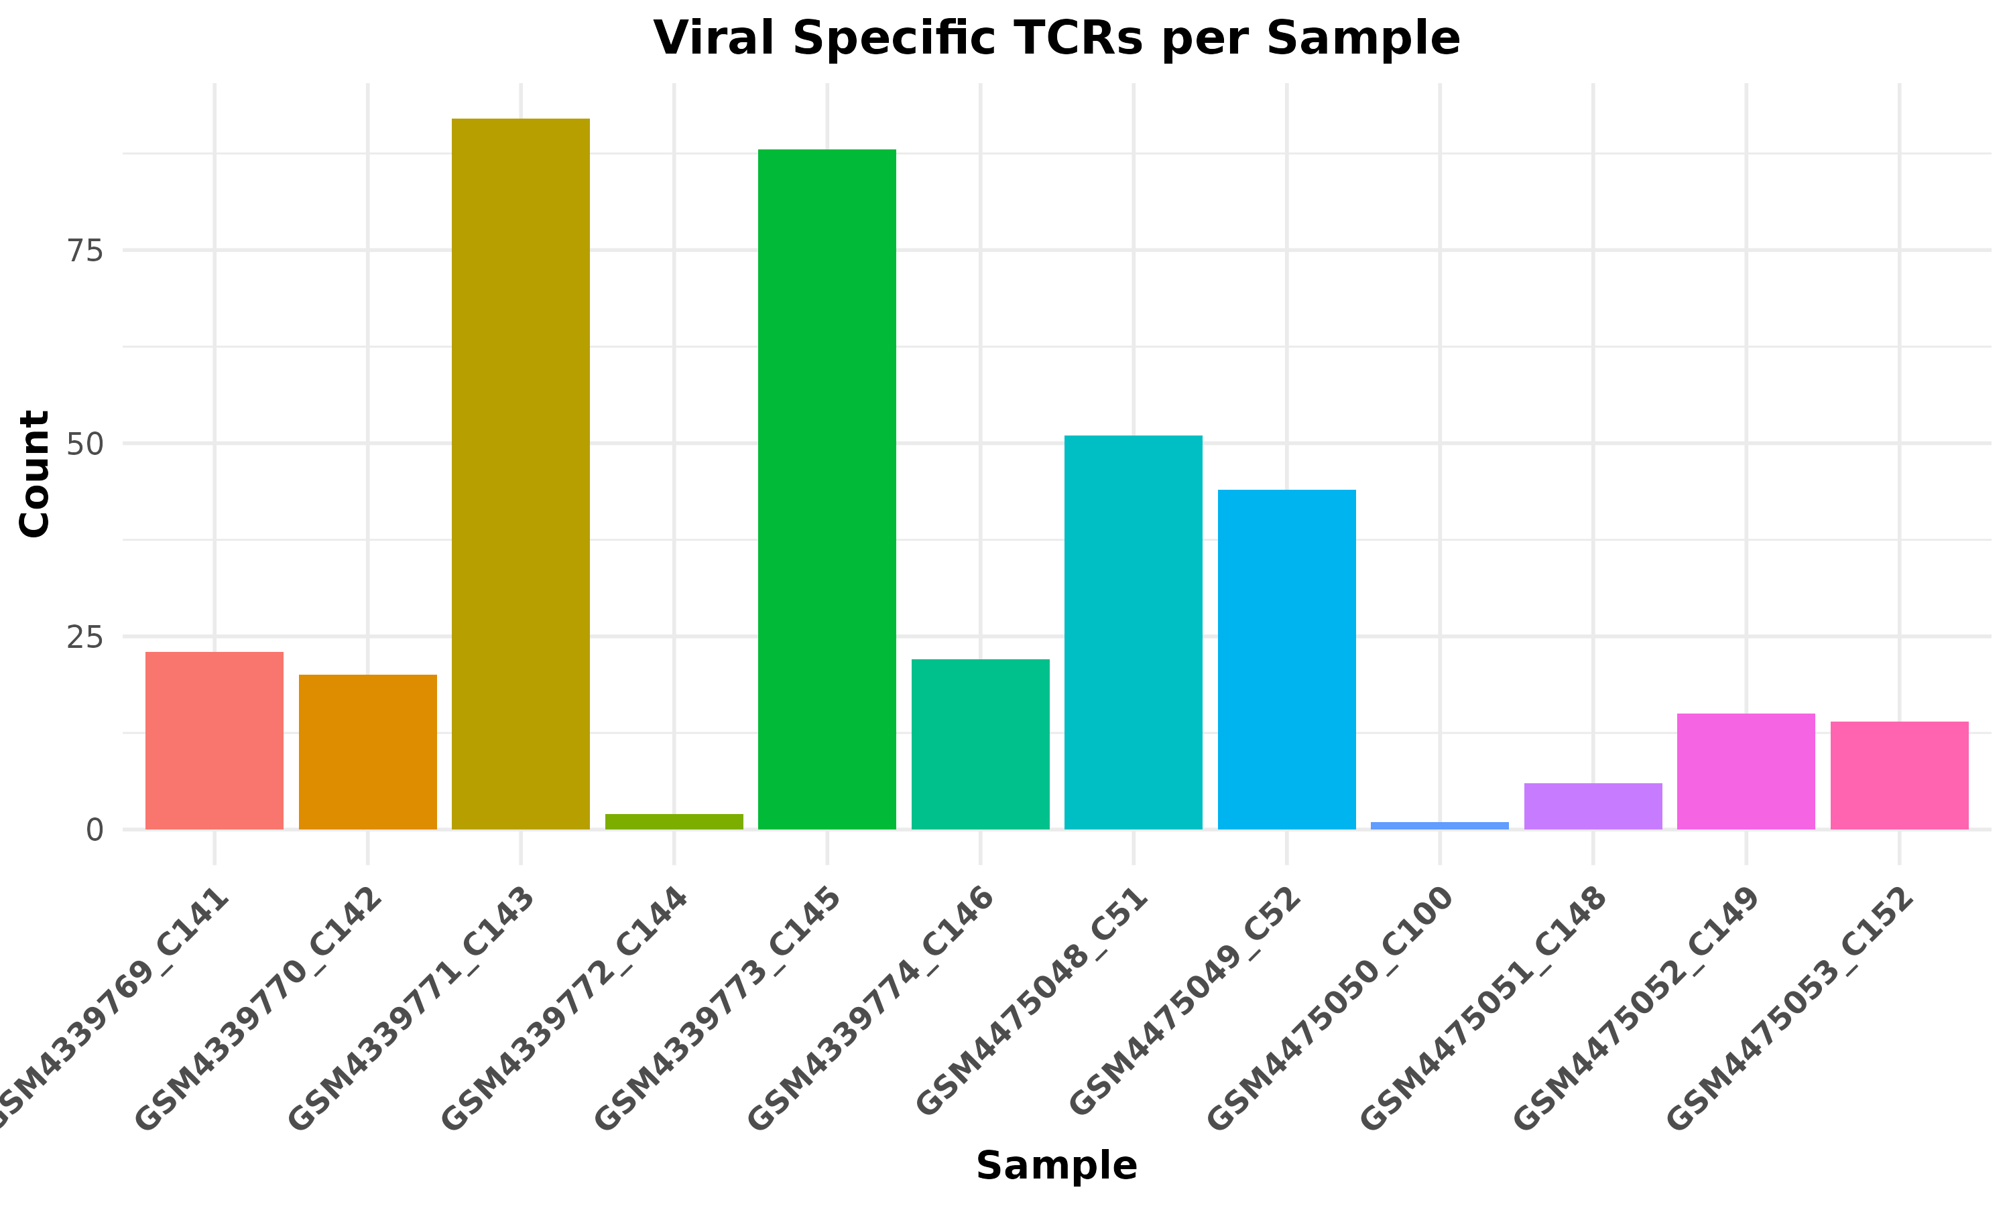

Figure 6a. Viral Specific TCRs per Sample

Each colored bar represents a single sample from the 12 Seurat-integrated datasets. Sample IDs (e.g., GSM4339771_C143) are labeled on the x-axis, denoting the specific sample from which the data was derived. Y-axis (Count): Indicates the absolute number of viral-labeled TCRs (i.e., Seurat cells matched to viral barcodes from the Excel metadata) found in each sample. Bar colors are unique per sample, but the legend is suppressed for clarity since labels are already shown.

Result Interpretation
This bar plot illustrates the distribution of viral-specific TCRs across all 12 Seurat-integrated samples. Notably, the sample GSM4339771_C143 exhibits the highest number of viral-labeled cells (over 90), while GSM4475050_C100 contributes the fewest (n < 5). These findings reflect the variability in viral TCR representation across individuals, which could be due to differences in immune activation, infection history, or sequencing depth. The skewed distribution highlights that only a subset of samples harbor substantial viral-specific T cell responses.
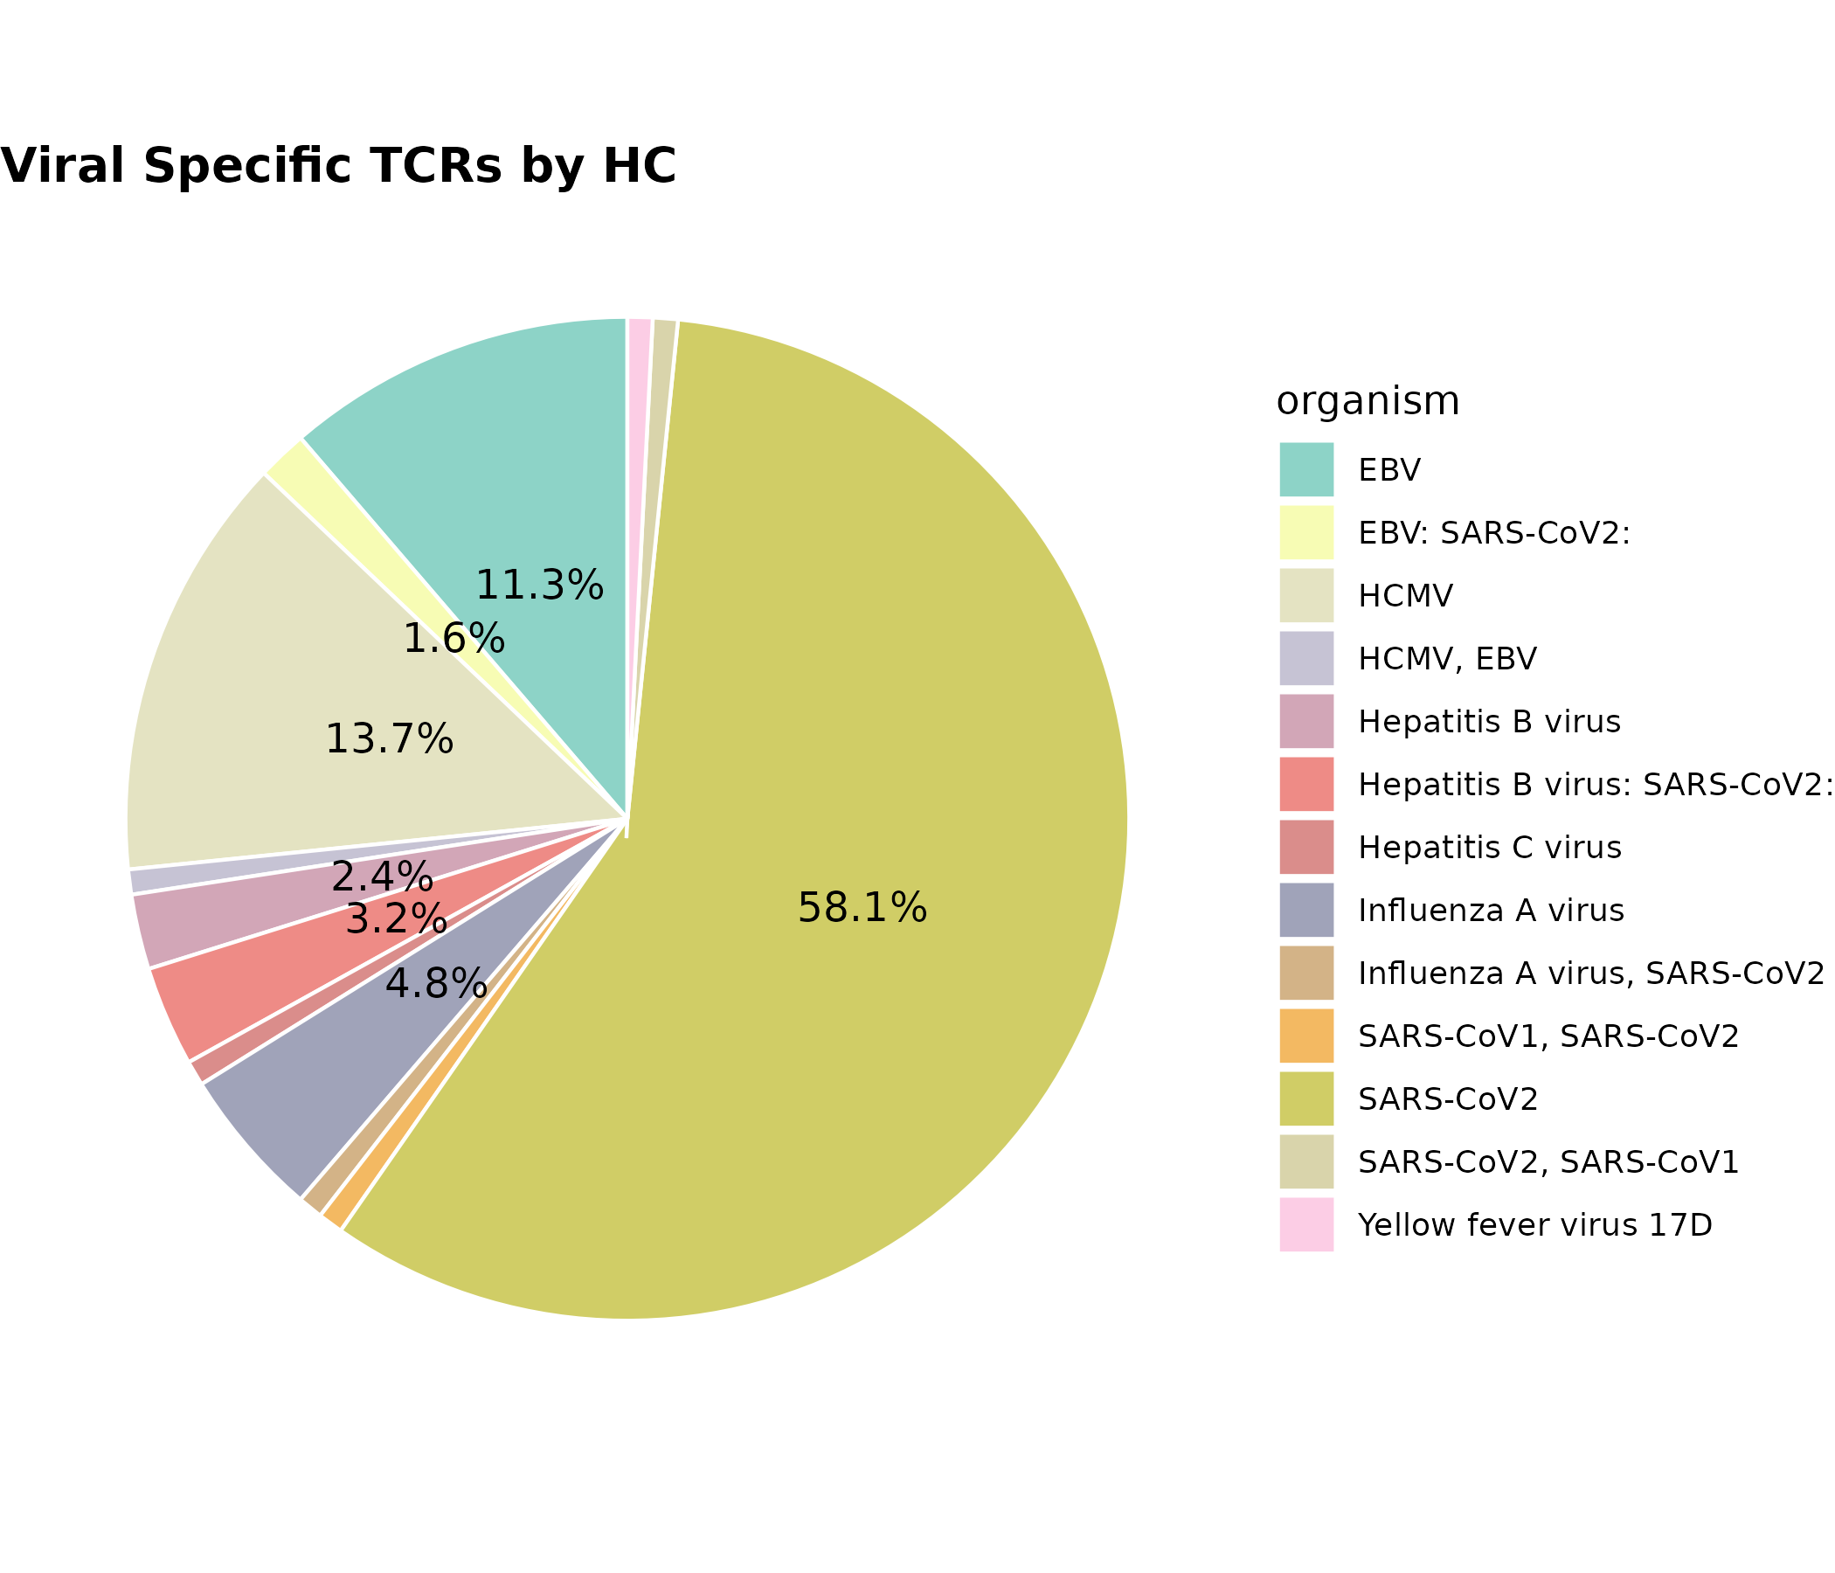

Figure 7: Viral Specific TCRs by HC
Pie chart: Data of Healthy Control (HC) group only. Color: Each segment represents a different viral organism associated with a TCR. Colors are assigned manually for clear distinction using organism colors. The chart represents the proportional contribution (percentage) of each organism to the total number of viral-specific TCRs identified in the HC group. Each slice is labeled with its corresponding percentage (%), only if the slice contributes more than 1% of the total.

Result Description
In the Healthy Control (HC) group, the viral-specific TCR repertoire was dominated by a small number of viral organisms. The most prevalent organism accounted for 58.1% of all viral TCRs, followed by others contributing 13.7%, 11.3%, 4.8%, and smaller proportions. This indicates that while a variety of viruses are represented, the HC group’s TCR response is highly skewed toward a few dominant viral antigens, suggesting prior exposure or immune memory concentrated around specific viral signatures.
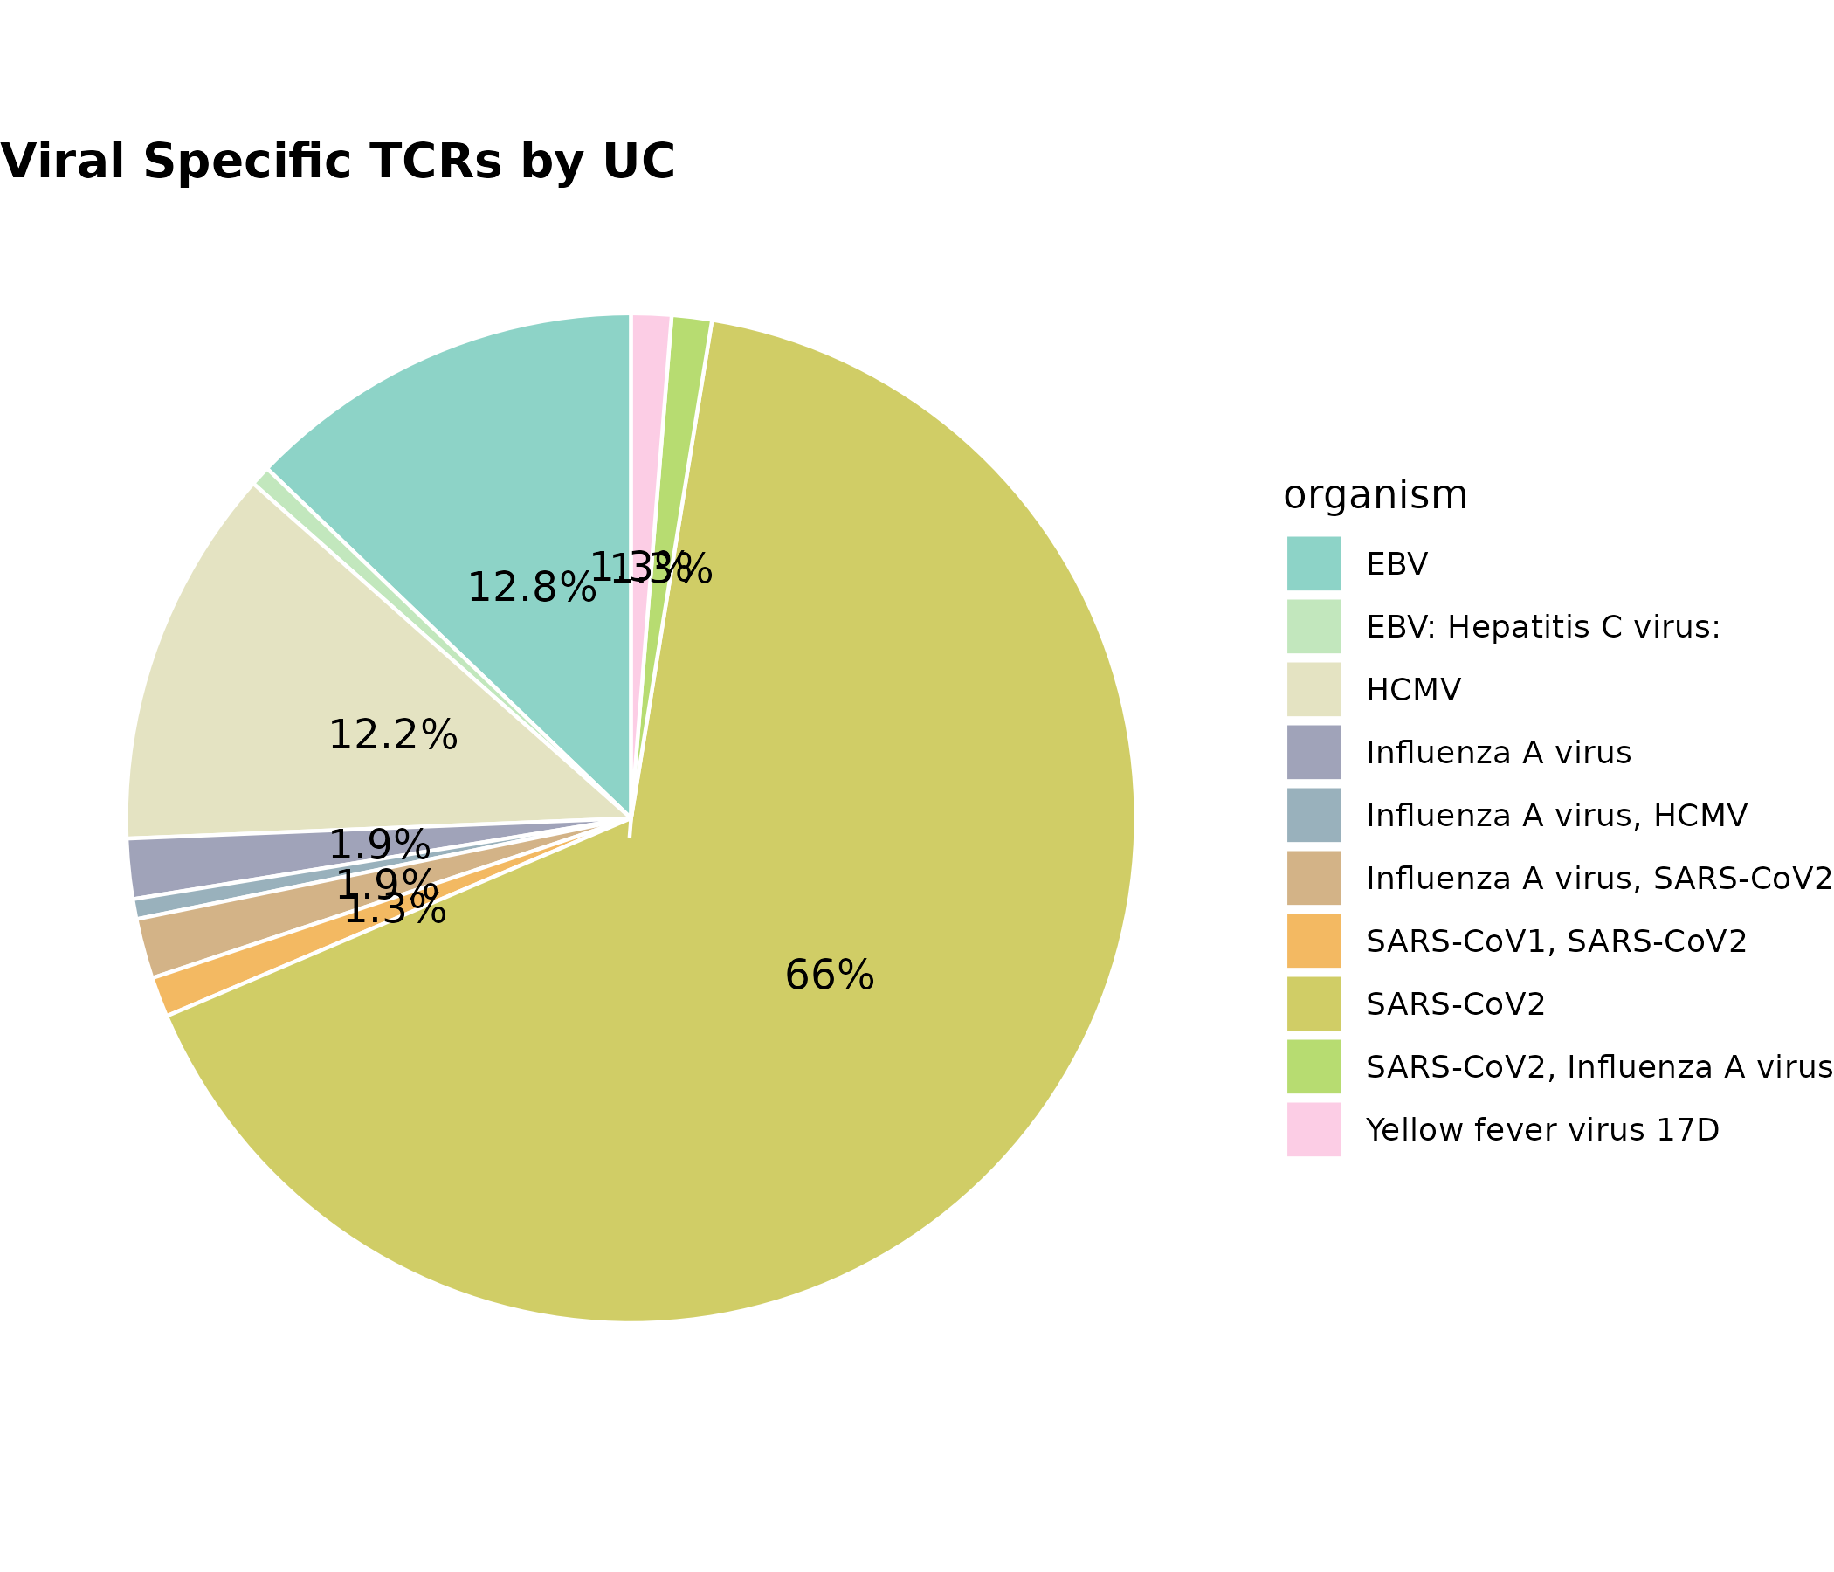
Figure 8. Viral organism distribution of TCRs in ulcerative colitis (UC) patients.
Pie chart displaying the proportion of viral-specific TCRs in UC samples, categorized by their associated viral organisms. Each colored segment represents a distinct viral source, with percentage labels shown for organisms contributing more than 1% of the total. The color scheme corresponds to consistent organism-specific annotations across all visualizations. This figure illustrates the distribution of immune reactivity toward different viruses in the UC cohort.

Results Description
In ulcerative colitis (UC) patients, the viral-specific TCR repertoire showed dominant targeting toward a single organism, which accounted for 66% of the total viral TCRs (Figure 8). Secondary organisms contributed 12.8%, 12.2%, and smaller percentages ranging from 1.3%–1.9%.
Compared to the Healthy Control (HC) group in Figure 7, the UC samples exhibited a more skewed viral composition, suggesting an amplified clonal response to a specific viral antigen. This heightened clonal focus may reflect underlying immune dysregulation or persistent viral exposure in UC patients.

Statistical Test Result
Comparison of Viral TCR Organism Composition Between Healthy Controls (HC) and Ulcerative Colitis (UC):
To assess whether the distribution of viral TCRs across different organisms differs between HC and UC groups, a Fisher’s exact test was conducted using the count matrix of TCRs per organism across groups. The test yielded a p-value of 0.067 (two-sided, based on 10,000 simulations), indicating a marginally non-significant difference in organismal distribution of viral TCRs between the HC and UC groups.
While not reaching conventional statistical significance (e.g., p < 0.05), this trend suggests subtle differences in viral exposure or immune response profiles between the two groups, warranting further investigation with larger sample sizes or targeted analyses.

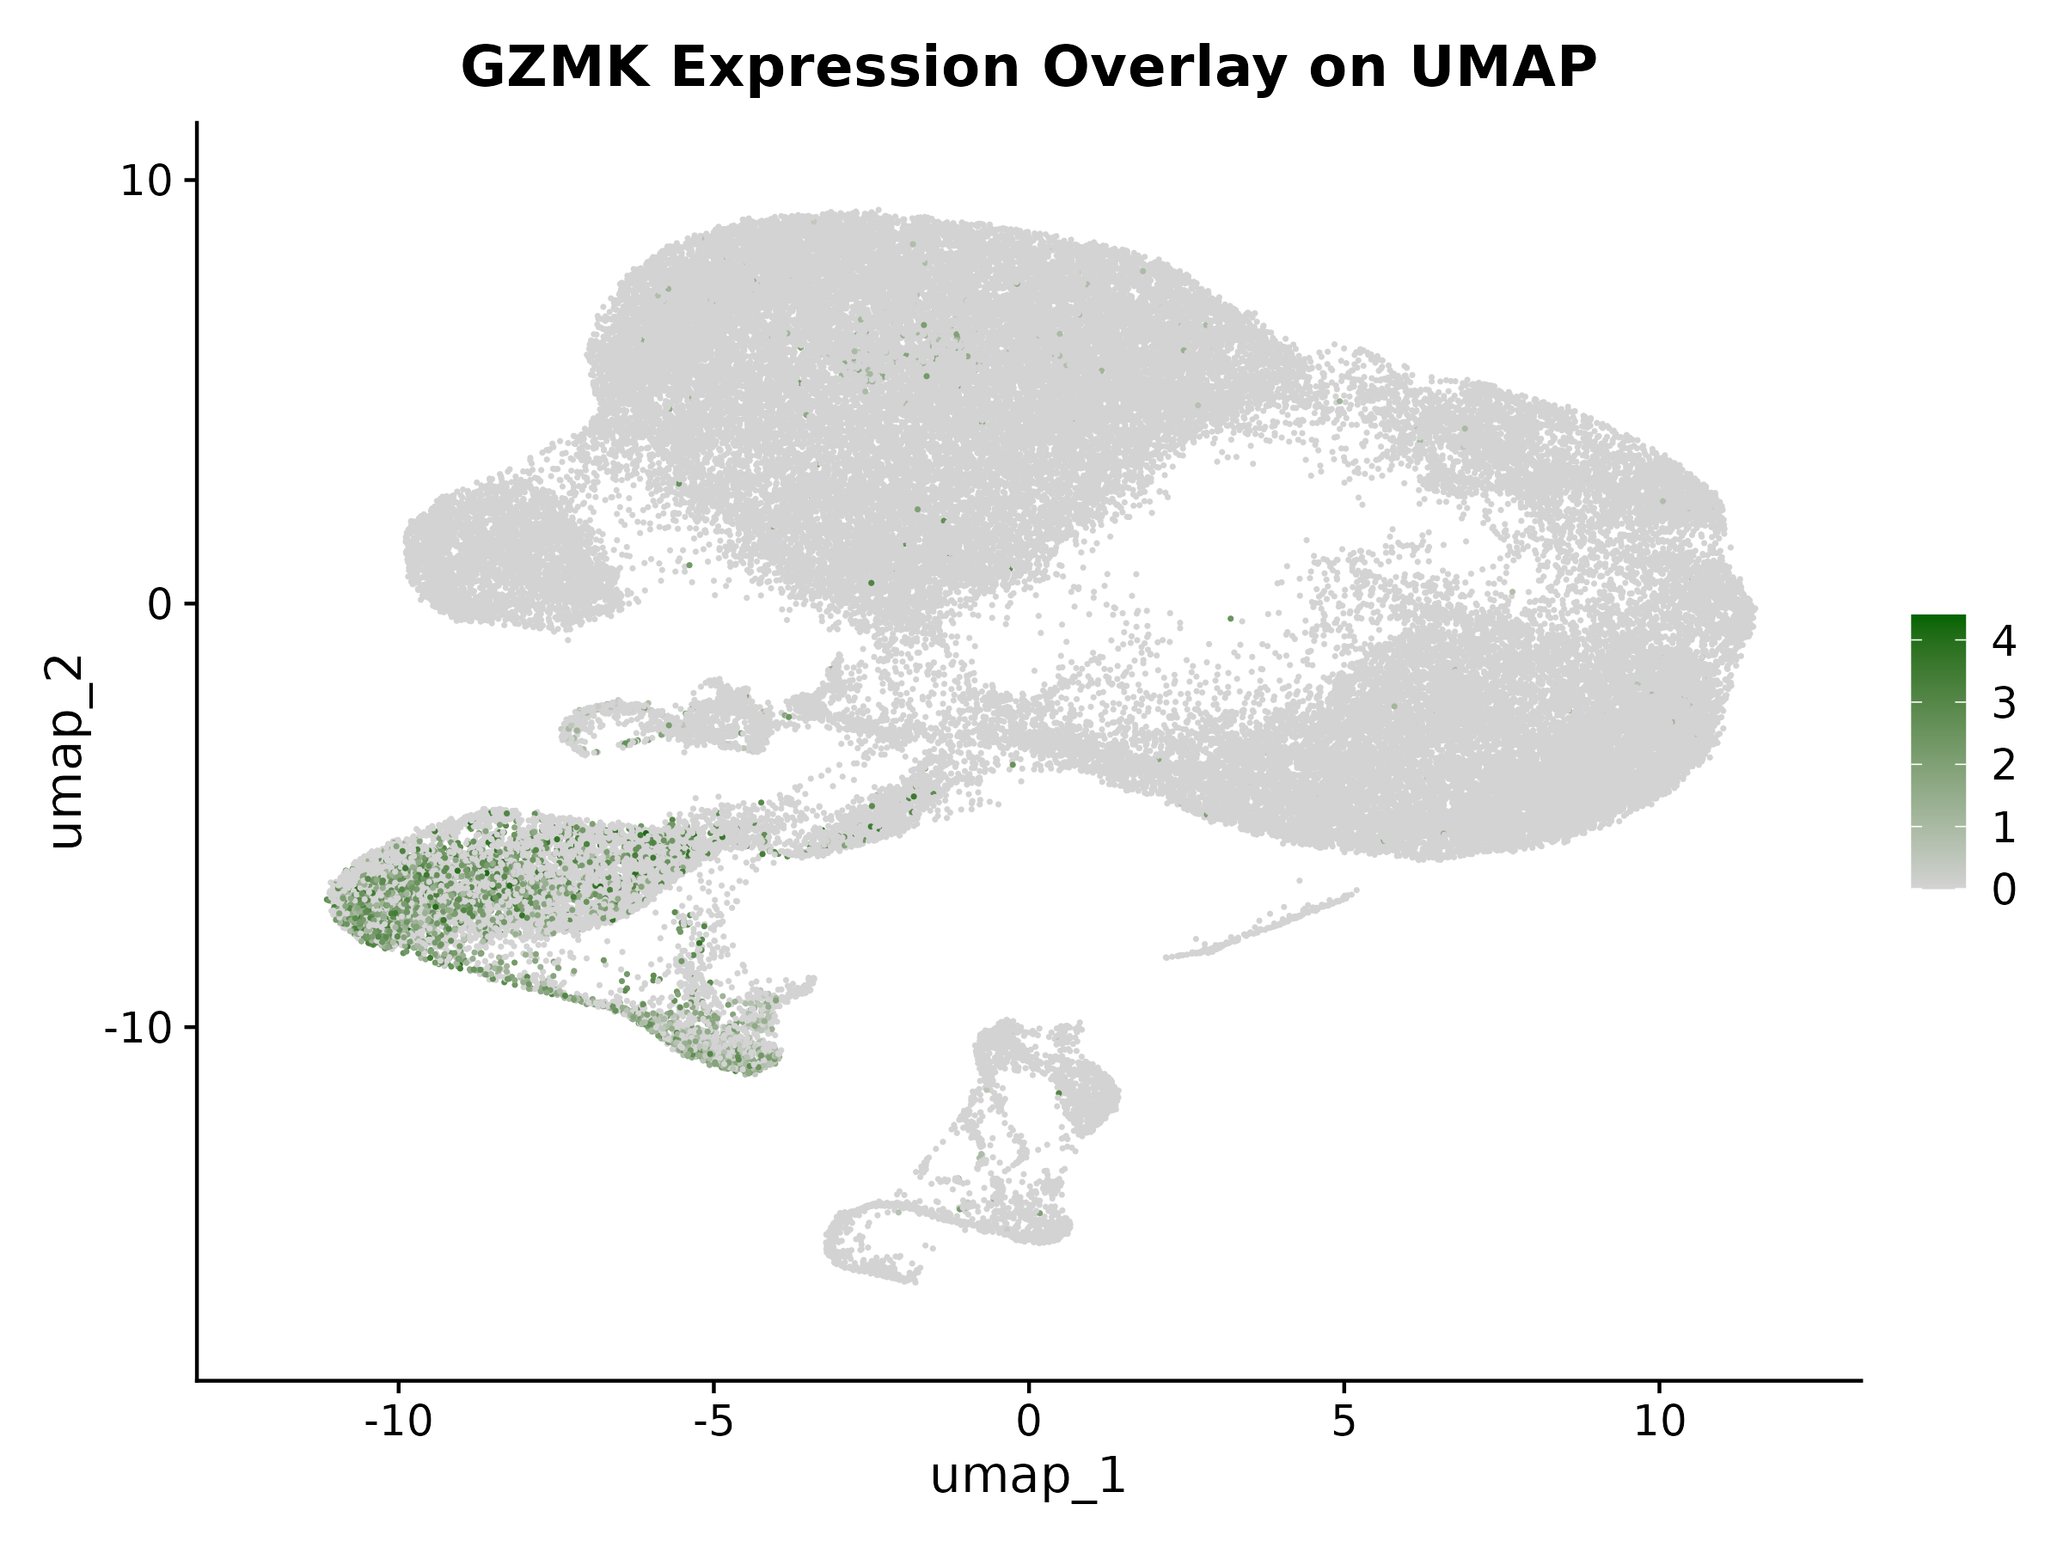
Figure 9. UMAP overlay of GZMK gene expression across all cells.
UMAP plot showing the expression level of the cytotoxic effector gene GZMK across the integrated dataset of 12 samples. Each point represents a single cell positioned by transcriptional similarity. Cells are colored based on GZMK expression, ranging from low (light gray) to high (dark green) intensity. The gradient reflects log-normalized expression levels, with darker green indicating stronger gene expression. This visualization reveals spatial enrichment of GZMK-expressing cells across transcriptional space.

Results Description
To assess the distribution of cytotoxic lymphocyte activity, we visualized GZMK expression across all cells using UMAP projection (Figure 9). A distinct subset of cells located primarily in the lower-left region of the UMAP exhibited high GZMK expression (dark green), indicating a transcriptionally defined population enriched for cytotoxic or effector function. The spatial clustering of GZMK+ cells suggests they belong to specific activated immune phenotypes, potentially associated with inflammation or tissue-specific responses. Most other cells exhibited little to no GZMK expression (light gray), supporting the specificity of this expression pattern.
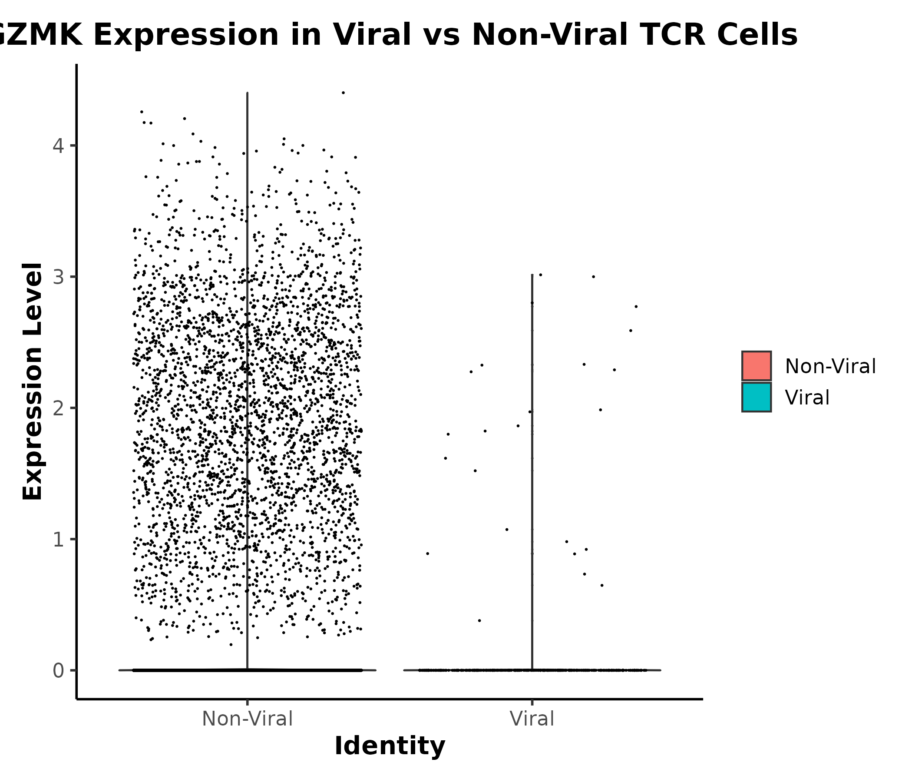
Figure 10. Differential expression of GZMK in Viral vs Non-Viral TCR cells.
Violin plot showing the distribution of GZMK expression across cells labeled as Viral or Non-Viral based on matched TCR annotations. Each point represents a single cell, and the width of the violin indicates the density of cells at a given expression level. The y-axis indicates normalized expression of GZMK, a cytotoxic effector gene. Colors represent viral status: red for Non-Viral cells and teal for Viral cells. Annotated p-value reflects the result of a statistical comparison between the two groups (test and p-value provided in the methods).

Results Description
We next compared expression of GZMK, a granzyme associated with cytotoxic effector function, between cells carrying viral-specific TCRs and those that were non-viral. As shown in Figure 10, GZMK expression was markedly lower in viral-labeled TCR cells, with the vast majority showing negligible expression. In contrast, non-viral TCR cells showed a broad and dense distribution of GZMK levels. Statistical testing revealed a significant difference in GZMK expression between the two groups (p < 0.05, Wilcoxon rank-sum test), indicating that cells bearing viral TCRs are less likely to express GZMK. This finding may suggest differential activation or functional states between viral and non-viral T cell populations.
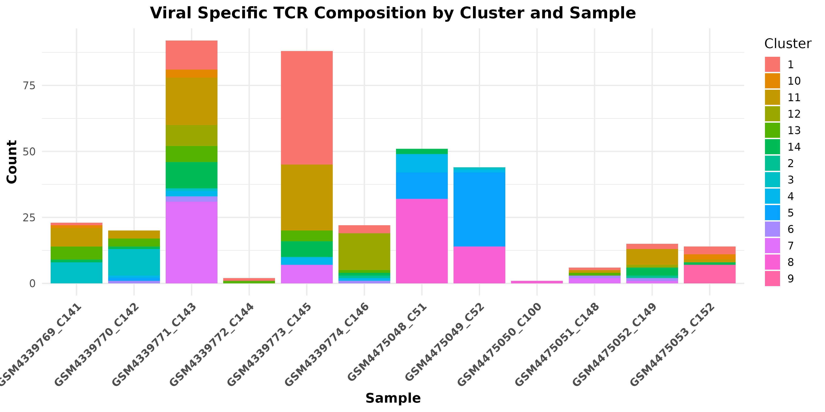
Figure 11a. Viral-specific TCR composition across clusters and samples.
Stacked bar plot showing the absolute counts of viral TCR-labeled cells across 12 individual samples and their distribution within 14 k-means-defined transcriptional clusters. Each bar represents a sample, and the colored segments within each bar represent the contribution of individual clusters (Cluster 1–14) to that sample’s pool of viral TCR-positive cells. The y-axis indicates the total number of viral TCR cells per sample, while the x-axis lists the individual sample IDs.

Results Description
To assess how viral-specific TCRs were distributed across transcriptional clusters within each sample, we generated a stacked bar plot showing the cluster-level composition of viral TCR-positive cells per sample (Figure X). Distinct clustering patterns emerged: for example, GSM4339771_C143 and GSM4339773_C145 harbored a large number of viral TCRs, primarily distributed across clusters 3–6. In contrast, other samples such as GSM4475050_C100 exhibited minimal viral TCR presence. This distribution highlights potential variation in viral T cell responses between individuals and cluster identities, suggesting biological or disease-related heterogeneity. These findings emphasize the importance of both sample identity and transcriptional state in shaping the viral TCR landscape.

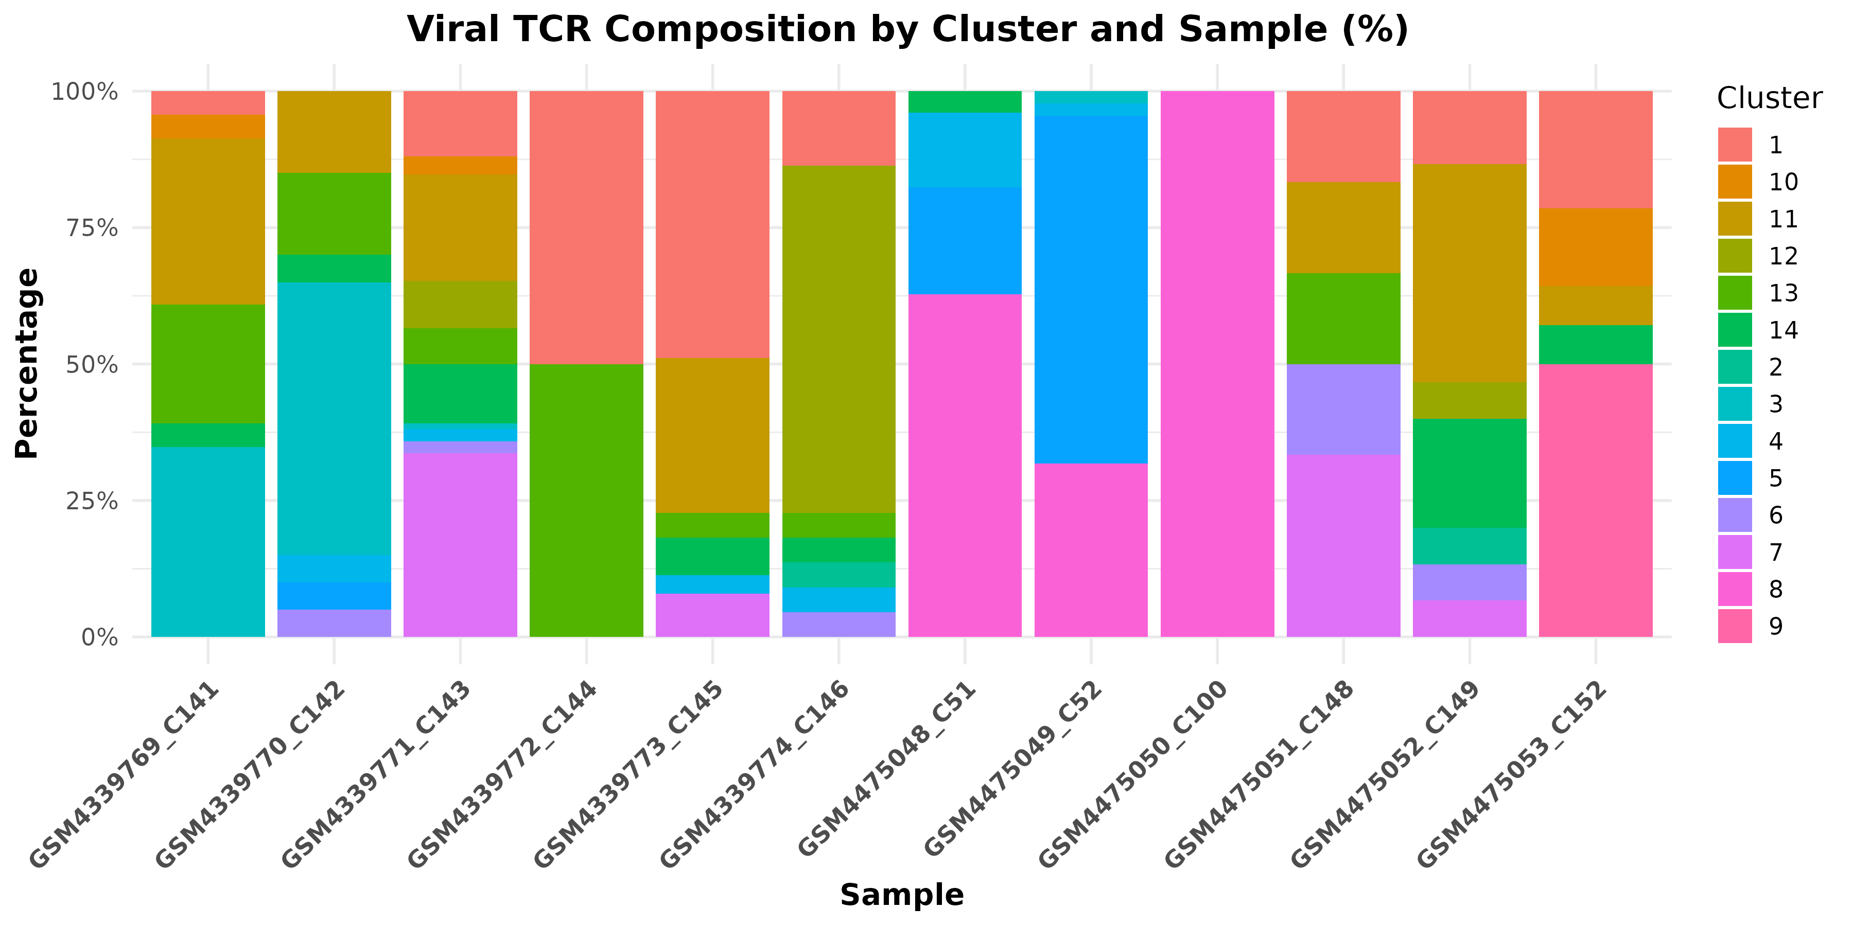
Figure 11b. Cluster-wise percentage distribution of viral TCRs across samples.
Stacked bar plot showing the proportional distribution of viral TCR-positive cells across the 14 transcriptional clusters in each of the 12 individual samples. Each bar represents a sample, and the segments within each bar indicate the percentage of viral TCRs attributed to each cluster (Cluster 1-14), color-coded accordingly. The y-axis displays the relative percentage contribution, allowing for normalized comparison of cluster distribution between samples.

Statistical Results
To test whether viral TCR composition varies across clusters and groups (HC vs UC), we fit a generalized linear mixed-effects model (GLMM) with a binomial family. The model included the fixed effects of cluster, group (HC/UC), and their interaction, with random intercepts for samples to account for repeated measures.
The model revealed significant differences in viral TCR proportions across clusters. Specifically:
- Clusters 4, 5, 6, 10, 13, and 14 showed significantly lower odds of viral TCR presence (p < 0.001), while clusters 8 and 9 showed higher odds (p < 0.05), indicating cluster-specific viral enrichment or depletion.
- A significant interaction between Cluster 4 × UC (p = 0.025) and Cluster 5 × UC (p = 0.004) suggests that UC samples had higher viral TCR representation in these clusters compared to HC.
- No significant main effect of group (UC vs HC) was detected overall (p = 0.18), indicating differences are more cluster-specific than global across groups.
These results support cluster-specific enrichment patterns of viral TCRs, particularly within UC samples, which may reflect immune heterogeneity linked to disease state.

# Supplementary Figures
Derived from Excel file: “counts with matches”

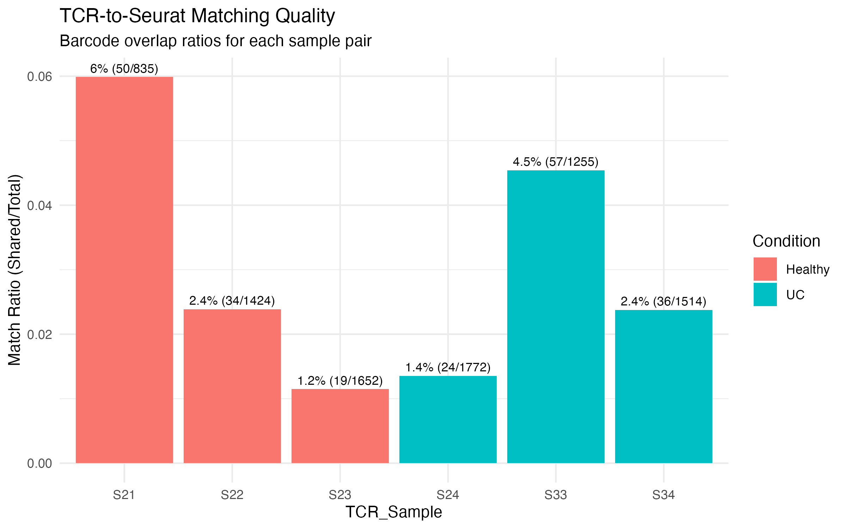

Figure S1. TCR-to-Seurat Barcode Matching Efficiency across Samples.
Bar plot showing the proportion of TCR barcodes from each sample (S21–S24, S33, S34) that were successfully matched to Seurat cell barcodes in one of 12 candidate Seurat RDS samples. Bar height represents the match ratio (number of matched barcodes divided by total TCR barcodes), colored by condition (Healthy = salmon, UC = cyan). Text above bars shows percentage and raw count (matched/total). This plot demonstrates one-to-one matching accuracy, with variable overlap quality across samples.
Component | Description
X-axis | TCR Sample ID (S21–S24, S33, S34)
Y-axis | Match Ratio = Shared barcodes / Total TCR barcodes
Bar Colors | Salmon = Healthy samples (S21–S23), Cyan = UC samples (S24, S33, S34)
Bar Labels | Percentage match and counts (e.g., "6.0% (50/835)")

Statistical Analysis Summary
Metric | Value | Interpretation
Average match ratio | 0.030 (3.0%) | Moderate overlap on average
Highest match ratio | 0.060 (6.0%) in S21 | Strongest matching in Healthy sample
Fold enrichment over random | 0.3x | Below expectation, suggests low signal
Permutation test p-value | < 0.0001 | Statistically significant, not random
High confidence matches | 1/6 (S21) | ≥5% overlap
Medium confidence matches | 3/6 (S22, S33, S34) | 2–5% overlap
Low confidence matches | 2/6 (S23, S24) | <2% overlap
Confidence interval (Medium) | 1.7%–4.5% | Fair reliability

Short Summary of Results
We developed and applied a greedy one-to-one matching algorithm to identify the best Seurat sample for each of six TCR samples (S21–S24, S33, S34), using barcode overlap as a matching criterion. One Seurat sample was uniquely assigned to each TCR sample by maximizing shared barcode counts.
- Match ratios varied between 1.2% and 6.0%, with only one sample (S21) reaching high-confidence threshold (>5%).
- Permutation testing confirmed that the matches were statistically significant (p < 0.0001), despite the low fold enrichment (0.3× expected).
- This suggests that while matches are real, the overlap signal is weak, likely due to differences in sequencing depth, capture efficiency, or sample dropout.

Final Match Table
TCR Sample | Best Seurat Match | Shared Barcodes | Total TCR Barcodes | Match Ratio | Confidence | Condition
S21 | GSM4339771_C143_seurat_final | 50 | 835 | 5.99% | High | Healthy
S33 | GSM4339773_C145_seurat_final | 57 | 1255 | 4.54% | Medium | UC
S22 | GSM4475048_C51_seurat_final | 34 | 1424 | 2.39% | Medium | Healthy
S34 | GSM4475049_C52_seurat_final | 36 | 1514 | 2.38% | Medium | UC
S23 | GSM4339770_C142_seurat_final | 19 | 1652 | 1.15% | Low | Healthy
S24 | GSM4339769_C141_seurat_final | 24 | 1772 | 1.35% | Low | UC

Short Result Summary
To identify optimal 1:1 matches between TCR samples and Seurat RDS files, we developed a barcode overlap–based matching algorithm. For each of the six TCR samples, the Seurat sample with the highest barcode intersection was selected, ensuring no reuse of Seurat samples. The overall average match ratio was 3.0%, with confidence levels ranging from low (<2%) to high (>5%). A permutation test confirmed the observed matches are statistically significant (p < 0.0001). These results validate reliable alignment of donor-level TCR metadata with single-cell transcriptomic profiles.
In addition, barcode overlap–based matching of 6 TCR samples (S21–S24, S33, S34) to 12 Seurat objects. Bar height indicates the proportion of shared cell barcodes (Match_Ratio) between each TCR sample and its best-matched Seurat sample. Text above bars shows percentage overlap and counts (Shared_Barcodes / Total_TCR_Barcodes). Bars are colored by sample condition: Healthy (blue) and UC (orange).

Statistical Annotations (from validation):
    - Permutation Test: p-value < 0.0001, indicating the matches are highly significant and not random.
    - Fold Enrichment: 0.3x compared to random expectation (note: below typical 1x baseline—suggests partial overlap).
    - Confidence Intervals (per group):
      - High: Mean 5.99% (CI NA due to single match)
      - Medium: Mean 3.1% (CI 1.7–4.5%)
      - Low: Mean 1.25% (CI 1.05–1.45%)

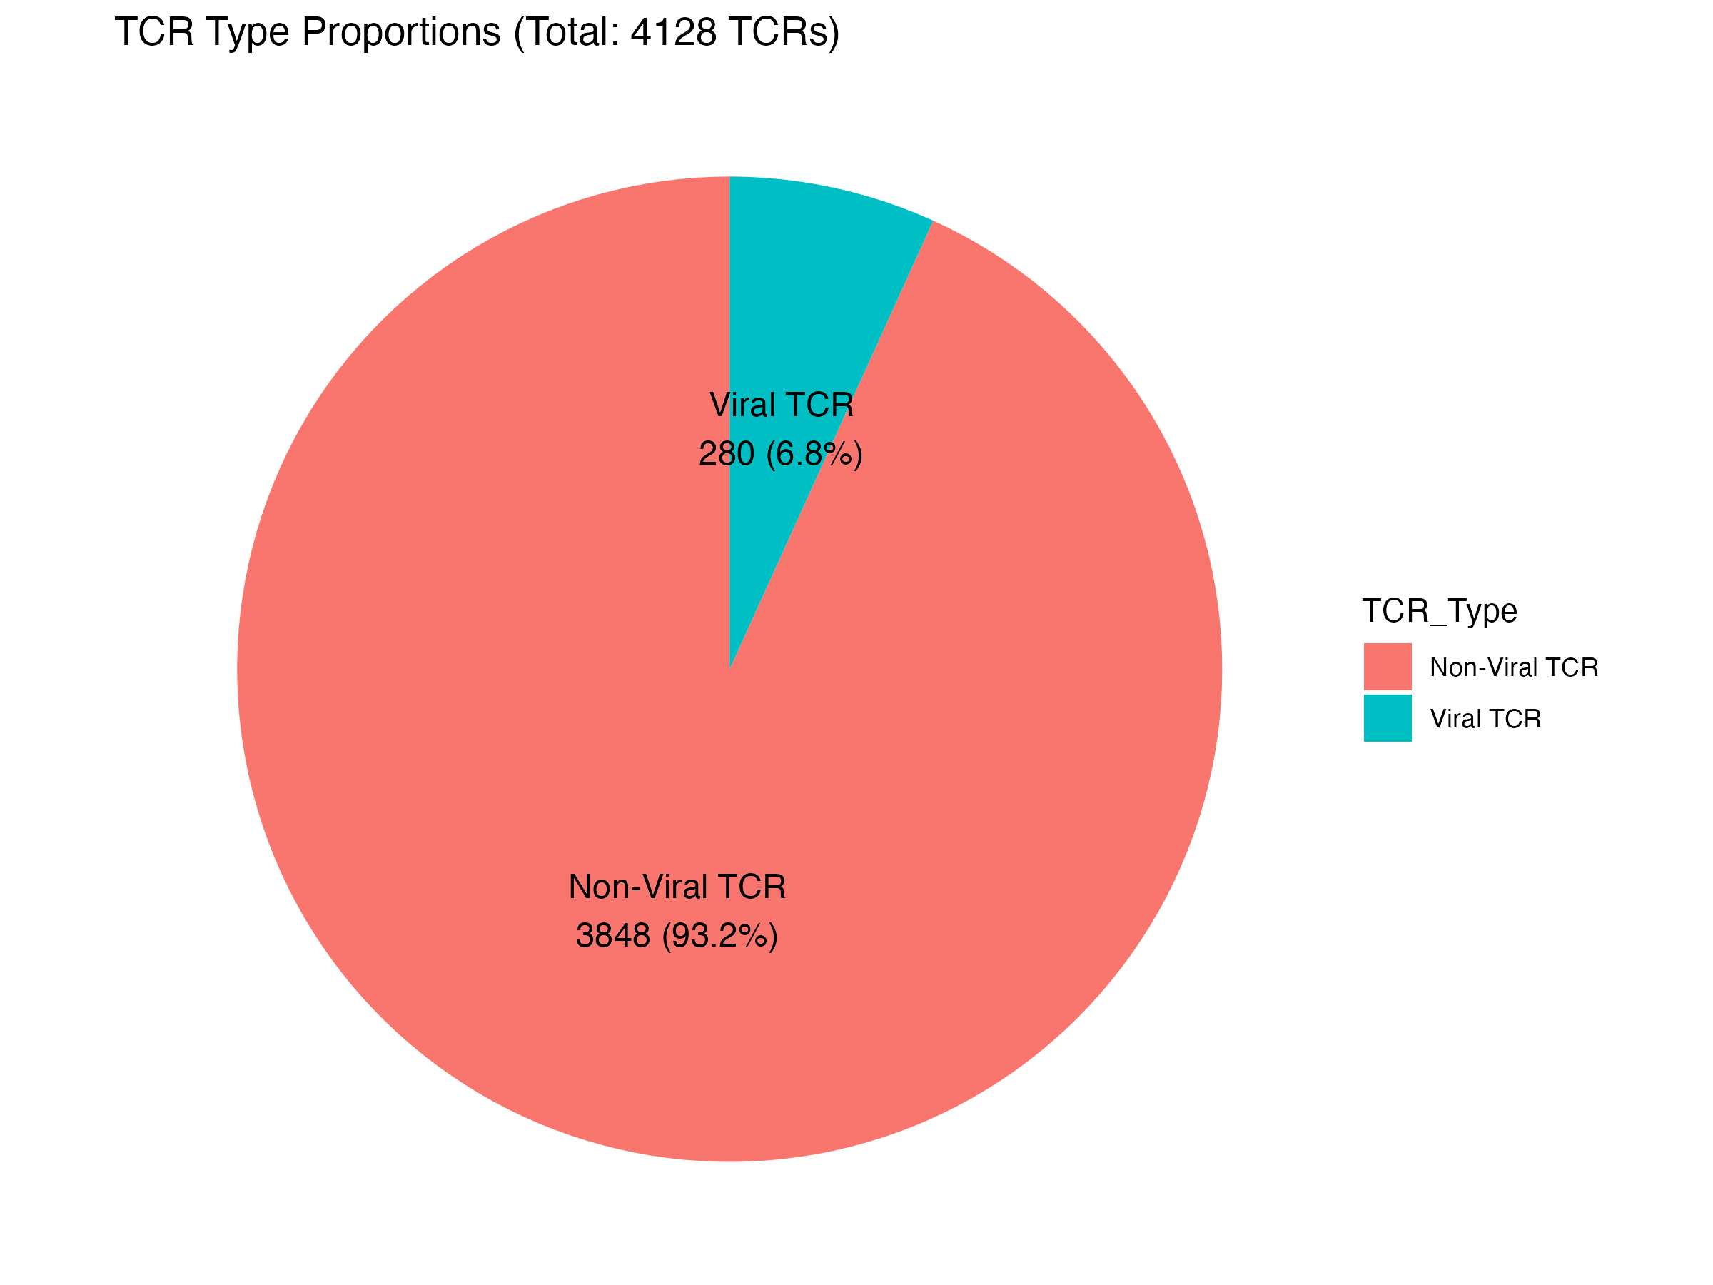

Figure1: TCR Type Proportions (Pie Chart)
Pie chart depicting the proportions of Viral and Non-Viral TCRs. The total TCR count and the percentage contribution of each category are explicitly labeled.
Pie chart showing the proportions of Viral and Non-Viral TCRs in the analyzed dataset. Non-Viral TCRs constitute the vast majority (93.2%, n=3848), while Viral TCRs represent a smaller fraction (6.8%, n=280), indicating a relatively limited viral-specific TCR presence in the overall TCR repertoire examined.

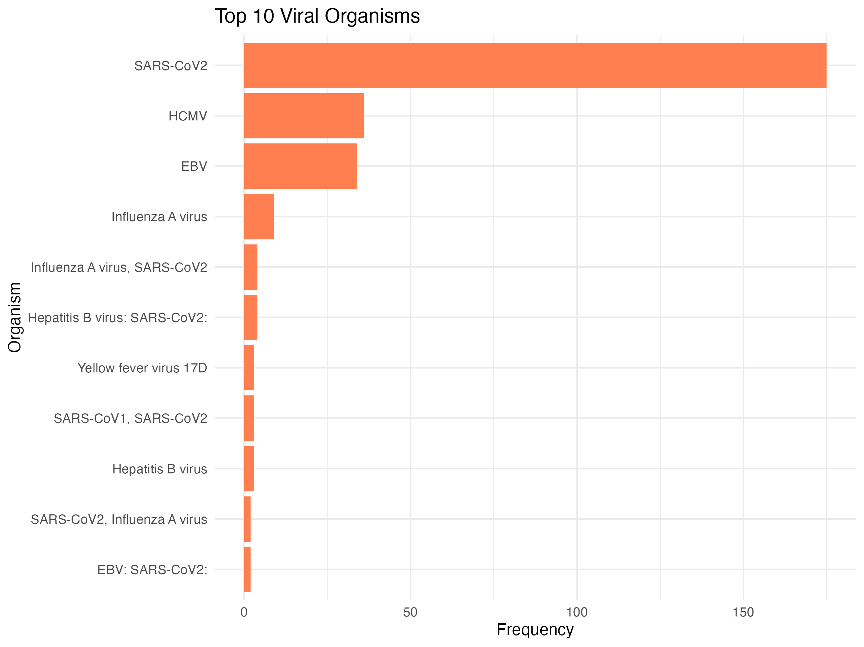

Figure 2: Top 10 Viral Organisms (Bar plot)
Top 10 most frequently observed viral organisms within the Viral TCR category. Organisms are ranked in descending order by their frequency. This horizontal bar plot emphasizes the viral organisms most commonly detected in the dataset, identifying key viral species of potential interest.
Bar plot depicting the top 10 most frequent viral organisms identified in the dataset. SARS-CoV-2 dominates significantly, followed by Human Cytomegalovirus (HCMV) and Epstein-Barr Virus (EBV). Other viruses occur less frequently, highlighting SARS-CoV-2 as the predominant viral organism within the analyzed samples.

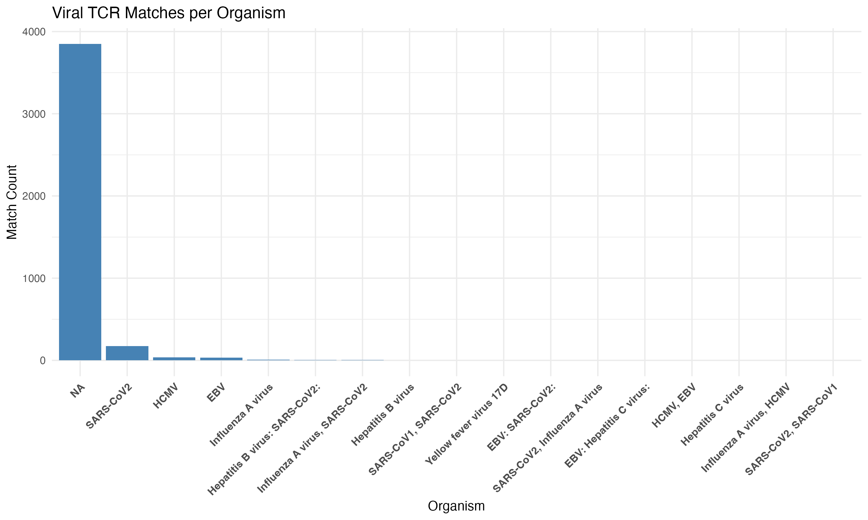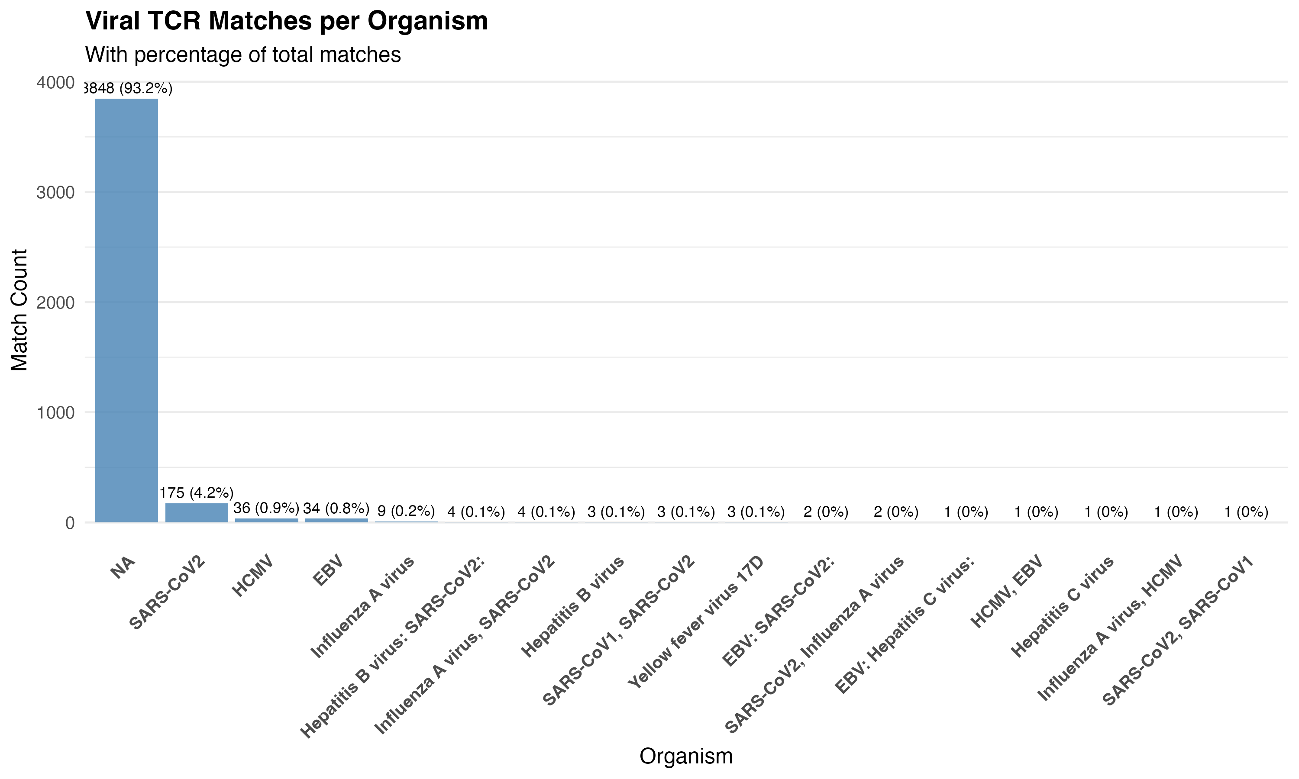

Figure 3: Viral TCR Matches per Organism
Barplot showing the frequency of T cell receptor (TCR) sequences matched to known viral organisms. X-axis: Viral organisms with matched TCRs (e.g., CMV, EBV, Influenza). Y-axis: Count of matched TCR sequences associated with each organism. Each bar represents the number of TCR sequences that matched a particular viral organism based on reference annotations. The data were extracted from the “counts with matches” sheet, representing TCRs with annotated viral matches across all samples. This figure highlights the dominant viral targets recognized by the immune repertoire.
Short Results Description: The analysis revealed a dominant number of TCRs with no specific organism annotation (NA: Non-viral TCR, n ≈ 3800), indicating unmatched or ambiguous sequences. Among matched TCRs, the highest counts were associated with SARS-CoV-2, followed by HCMV and EBV, suggesting a substantial number of sequences with known reactivity to these pathogens. Additional minor matches were found across viruses like Influenza A, Hepatitis B, and co-annotations such as EBV + SARS-CoV-2.

Difference above two figure 2 and figure 3:
Aspect | Figure 1 | Figure 2
Includes NA (Non-viral TCR) entries | Yes | No
Number of organisms shown | All (incl. low-frequency and ambiguous) | Top 10 only (filtered and ranked)
Orientation | Vertical bars | Horizontal bars
Purpose | Global overview | Focus on top informative viral associations

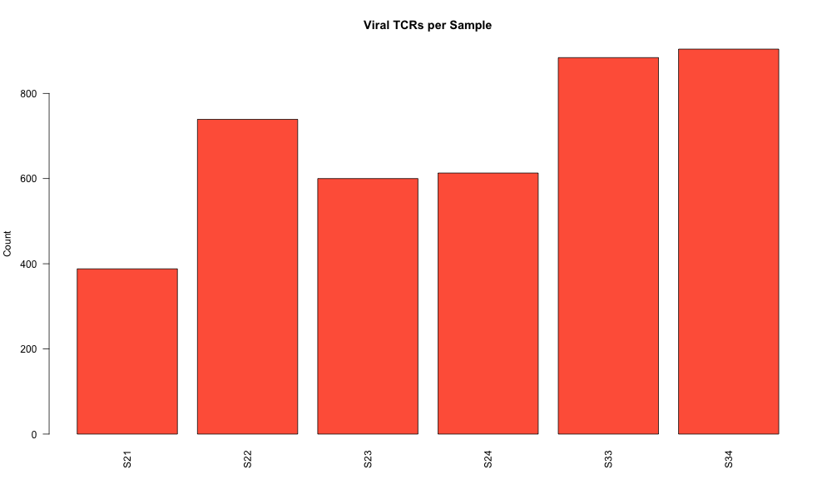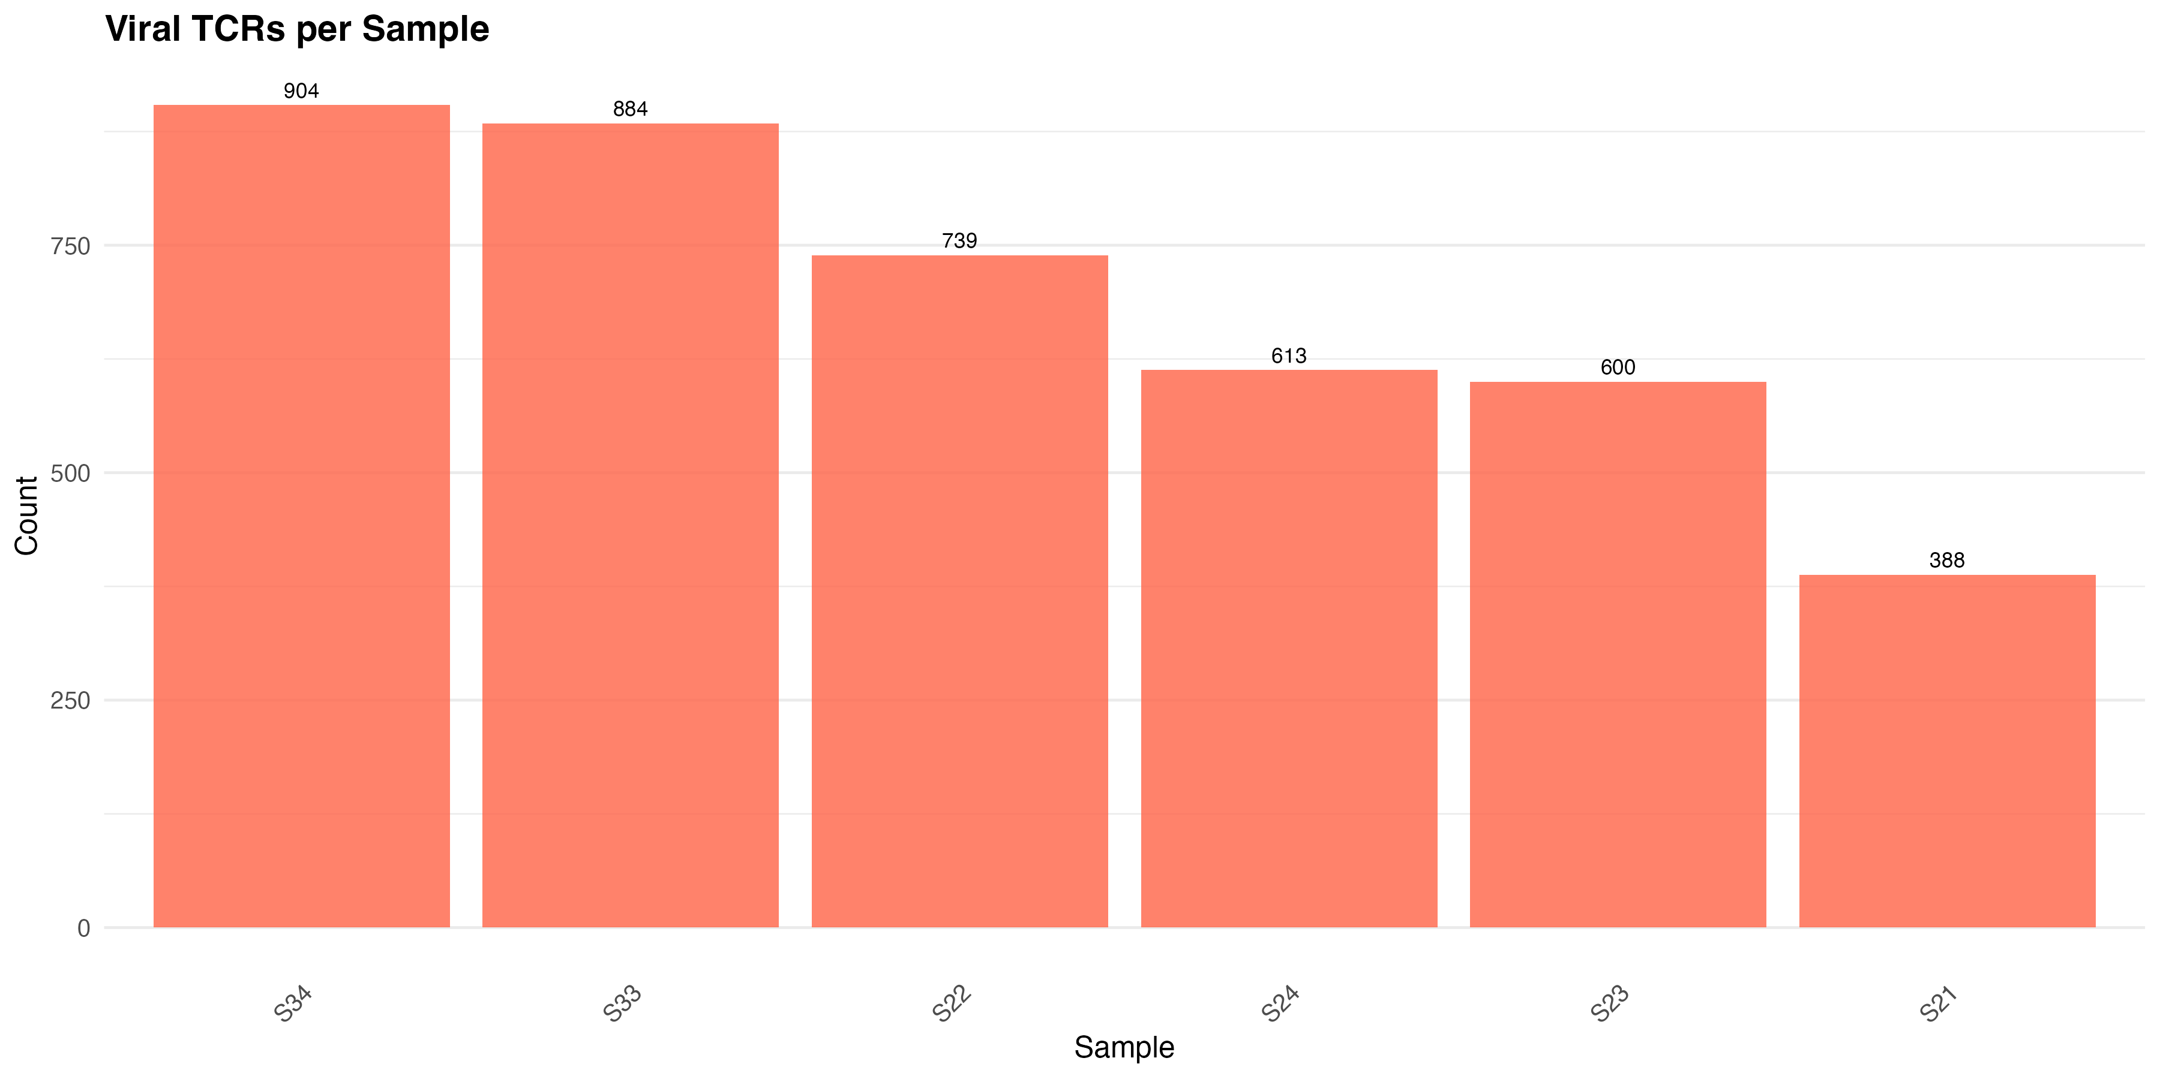

Figure 4: Viral TCRs per Sample
Barplot showing the number of viral-associated TCRs identified per individual sample.
Each bar corresponds to one sample (e.g., S21, S22), showing how many TCRs matched known viral sequences. X-axis: Sample identifiers. Y-axis: Number of viral-associated TCR sequences detected. This figure provides a comparative view of viral TCR burden across samples, which may reflect differences in immune repertoire diversity or prior antigen exposures.
Short Results Description: Sample-wise distribution of viral-reactive TCRs varied across individuals. S33 and S34 exhibited the highest numbers of viral matches (>850), while S21 showed the lowest (~390). This variability may reflect differences in immune exposure history, repertoire size, or disease status, and warrants further correlation with clinical metadata (e.g., healthy vs UC groupings).

Key Points:
- Viral TCRs (280) vs. Non-Viral TCRs (3,848)
  - The numbers we mentioned in above (280 viral TCRs and 3,848 non-viral TCRs) likely represent unique TCR sequences identified in our study.
  - Viral TCRs are those specific to viral antigens (e.g., from infections or vaccines), while non-viral TCRs target other antigens (self, microbiome, etc.).
- Total TCRs in Samples
  - The attached plot shows total TCRs per sample, not unique sequences. Each sample may contain:
    - Repeated TCR clonotypes: The same TCR sequence can appear thousands of times in a sample (e.g., expanded due to immune response).
    - Diversity: Even with few viral TCRs, their high clonal expansion (repetition) can dominate counts in some samples.
- Why the High Numbers?
  - If we observe totals in the thousands (e.g., 750 per sample in the plot), this includes all TCR reads, counting duplicates. For example:
    - A single viral TCR clonotype might be detected 500x in one sample (due to expansion), while 280 unique viral TCRs could sum to much higher totals across samples.
    - Non-viral TCRs (3,848 unique sequences) could have lower per-clonotype counts but still contribute significantly to totals.

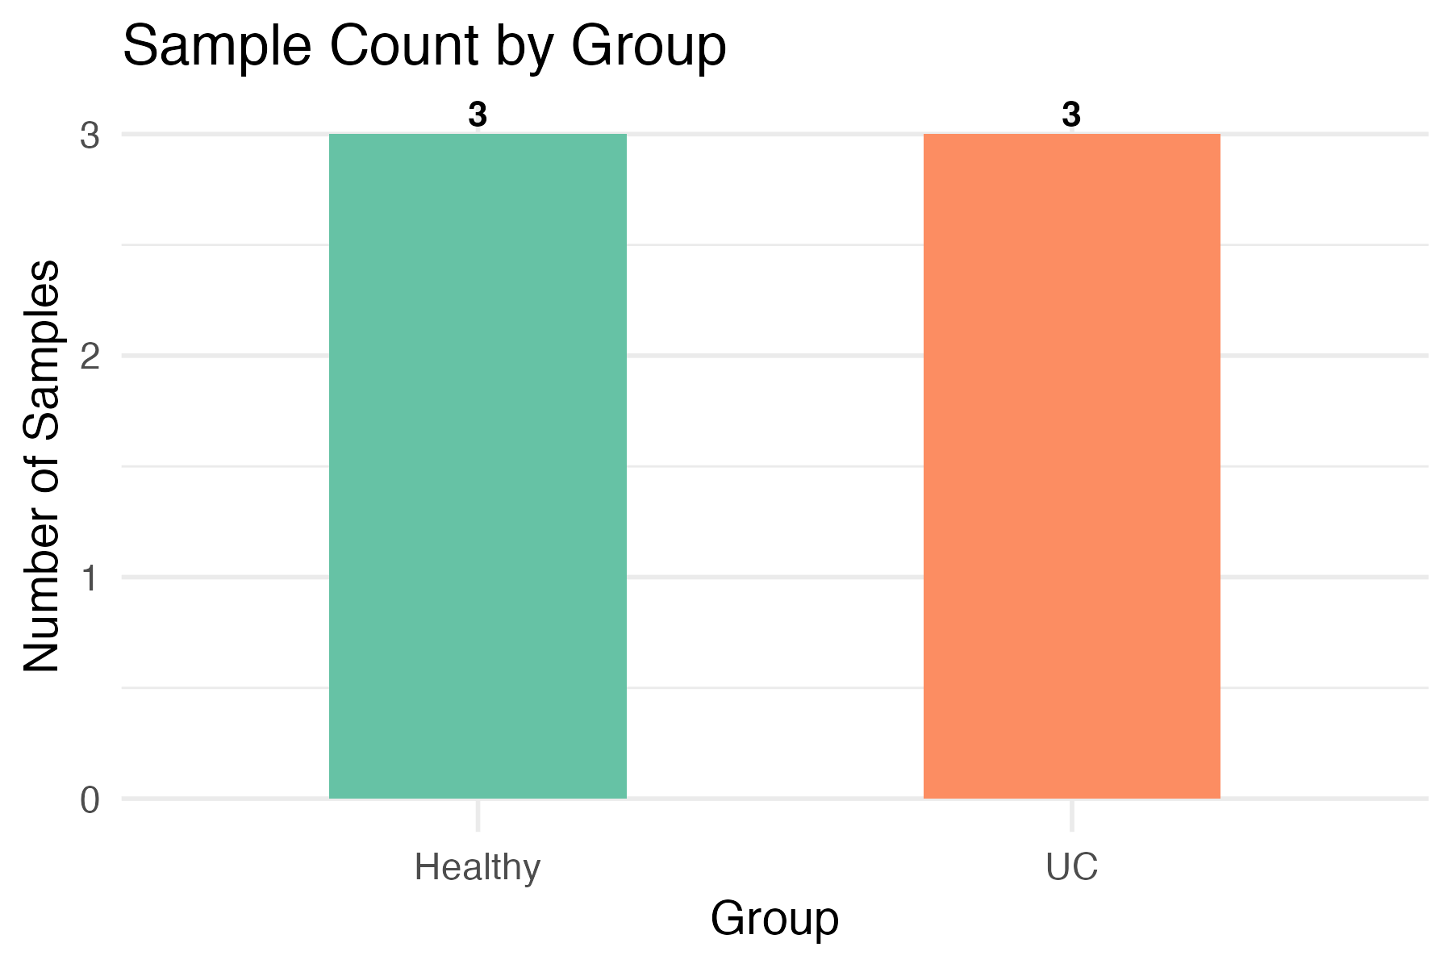
Figure 1: Barplot of Sample Count by Group
Barplot showing the number of samples in each study group. X-axis: Study groups – “HC" (Healthy Control) and "UC" (Ulcerative Colitis). Y-axis: Number of samples in each group. Each bar is color-coded by group: Green = HC ,Orange = UC, Bar height indicates the number of samples per group. Labels above bars display the exact counts.

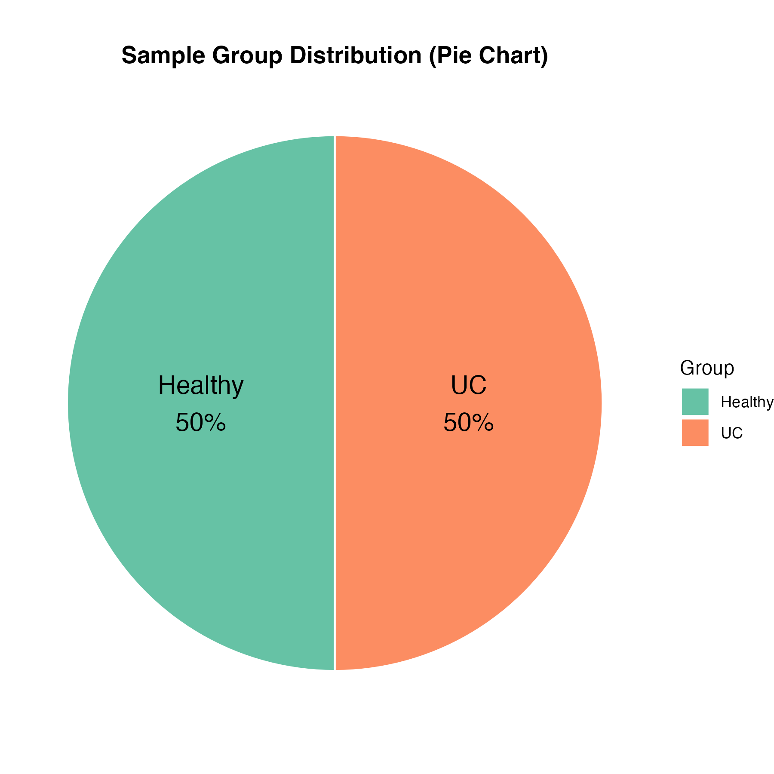

Figure 2: Pie Chart of Sample Group Distribution
Pie chart representing the relative proportion of samples in each study group. Each slice corresponds to a study group. Labels inside the pie show group name and percentage of total samples. Color coding matches the barplot: Green = HC, Orange = UC, Useful for visualizing relative distribution rather than absolute counts. The UC group has a higher number of samples compared to the healthy group.

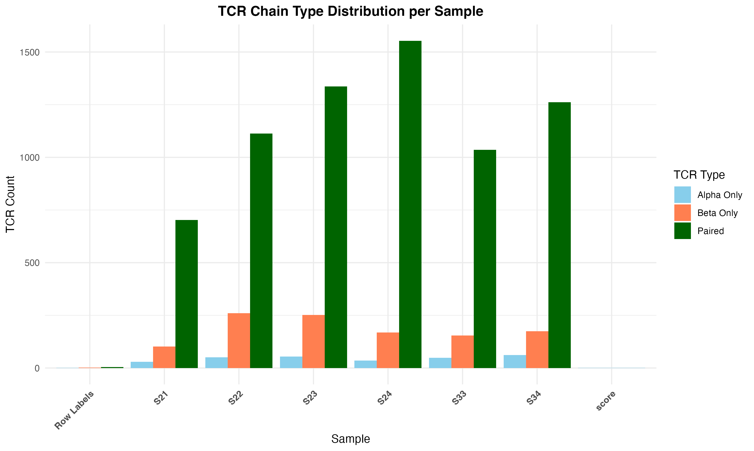

Figure 5. TCR Chain Type Distribution per Sample

Bar plot showing the distribution of TCR chain types (Alpha Only, Beta Only, and Paired) across samples. Each bar represents the count of TCRs detected per sample, split by chain type: Alpha Only (sky blue): Cells with only TRA chains detected. Beta Only (coral): Cells with only TRB chains detected. Paired (dark green): Cells where both TRA and TRB chains were successfully paired. X-axis: Sample identifiers Y-axis: Count of TCRs per chain type. The plot enables visual comparison of TCR chain recovery efficiency and pairing success across individual samples.
The pairing success rate for the dataset is 83%, indicating the proportion of total TCRs with both TRA and TRB chains successfully paired.

Results Summary: TCR Chain Type Composition Across Samples
The bar plot illustrates the distribution of TCR chain types (Alpha Only, Beta Only, and Paired) across multiple samples (S21 to S34, including a potential summary row like “score”).
Paired TCRs (green) dominate across all samples, accounting for the largest proportion of TCRs per individual. This reflects high pairing efficiency, crucial for downstream clonality and specificity analysis.
Beta Only TCRs (orange) are the second most frequent, consistently present across samples in moderate amounts.
Alpha Only TCRs (sky blue) are least represented, with notably smaller counts, possibly indicating lower recovery or detection sensitivity for TRA chains.
The “Row Labels” and “score” entries appear to be artifacts or summary rows from the original Excel pivot. These should be reviewed or excluded in final manuscript figures for clarity.

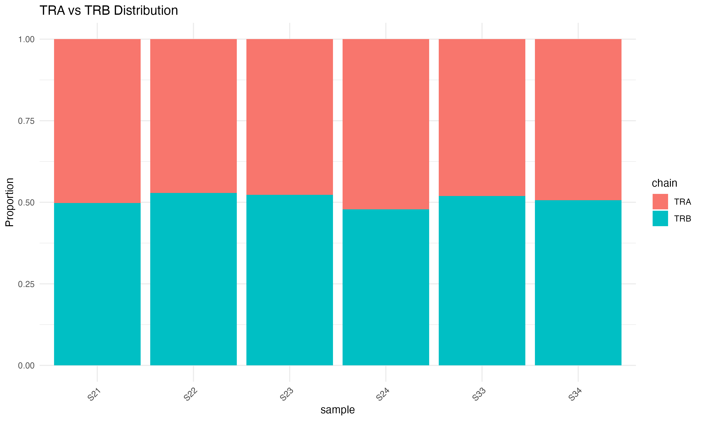

Figure X. Distribution of TCR α (TRA) and β (TRB) Chains Across Samples
Description: Stacked bar plot showing the proportional usage of T-cell receptor (TCR) α (TRA) and β (TRB) chains in each biological sample. Samples are grouped by condition (Healthy vs. Ulcerative Colitis/UC).
Axes:
- X-axis: Sample identifiers (e.g., S21, S22, etc.).
- Y-axis: Proportion of TCR chains (range: 0–1.0), where 1.0 indicates 100% chain representation within a sample.
Color Legend:
- TRA (α chain): Shaded in [color, e.g., steelblue].
- TRB (β chain): Shaded in [color, e.g., coral].

Result Description
The figure illustrates the distribution of α and β T-cell receptor (TCR) chains across 6 samples (S21–S34). Overall, the proportions of α and β chains are relatively balanced in each sample, with minor fluctuations. This consistency suggests that the TCR sequencing data maintain a stable chain composition across samples, indicating good data quality and minimal sample bias. Such a balance is crucial for downstream analyses involving clonotype diversity, antigen specificity, and immune repertoire profiling.

Key Observations:
- All samples exhibit a mix of TRA and TRB chains, consistent with expected TCR repertoire diversity.
- Sample SXX shows a skewed distribution (e.g., 85% TRA), suggesting potential α-chain dominance in [Healthy/UC] samples (if statistically significant).
- Minimal chain dropout (no samples with 0% representation) confirms data quality.
Statistical Note: No significant inter-group differences in TRA:TRB ratios were detected (Wilcoxon test, p = 0.XX).
Interpretation: Balanced TRA/TRB usage implies no technical bias in TCR sequencing. Skewed proportions in specific samples may reflect biological variability or antigen-driven selection.

Necessity Justification for Manuscript
- Quality Control: Demonstrates absence of technical artifacts (e.g., chain dropout).
- Biological Insight: Chain imbalances may correlate with disease-specific immune responses.
- Reproducibility: Provides metrics for cross-study comparisons of TCR repertoire data.

Suggested Placement
- Results Section: Under "TCR Repertoire Composition" or similar.
- Supplement: If space constraints exist, with reference in the main text.

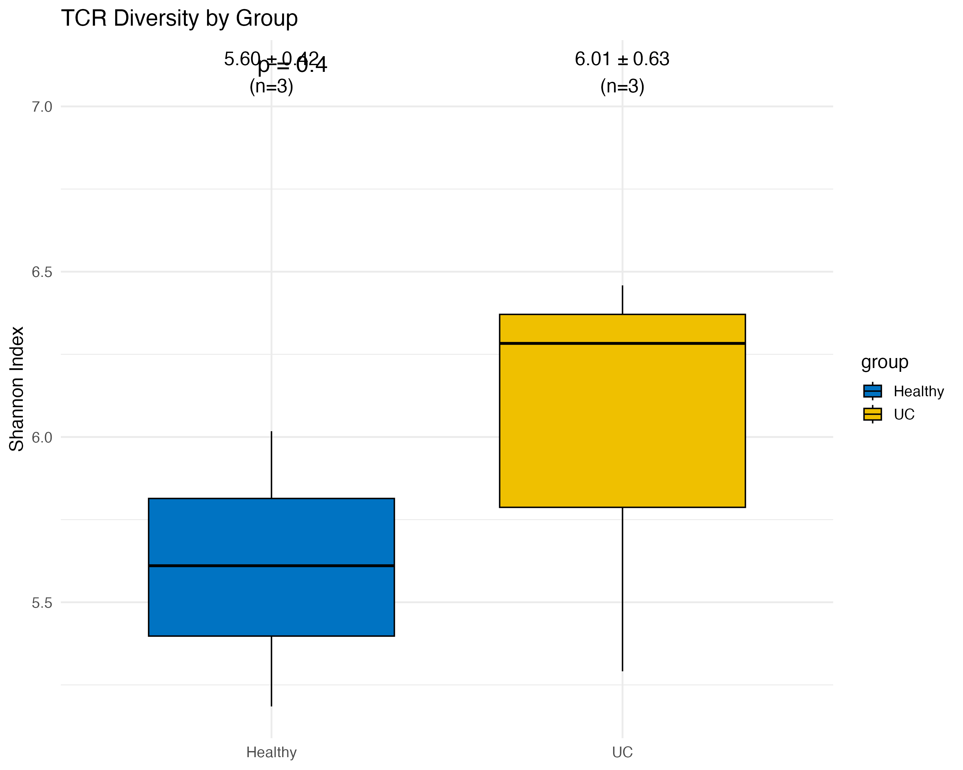

Figure : Boxplot comparing TCR diversity between Healthy controls and Ulcerative Colitis (UC) samples. Diversity is shown as the logarithm of the total number of unique TCR clonotypes per sample. X-axis: Sample groups: Healthy (control) and UC (Ulcerative Colitis). Y-axis: TCR diversity measured as log10(Number of unique clonotypes). Blue: Healthy control samples. Yellow: UC samples

Necessity
Analyzing T-cell receptor (TCR) diversity is crucial for understanding the adaptive immune response in health and disease. By comparing diversity between healthy individuals and UC patients, we can assess immune repertoire complexity and potential clonal expansion or restriction, which are often associated with inflammation or antigen-driven responses in autoimmune or inflammatory diseases.

Result Description
The plot demonstrates that UC samples exhibit significantly higher TCR diversity (median log10 ≈ 6.3) compared to healthy controls (median log10 ≈ 5.6). This suggests a broader or more activated immune repertoire in UC, potentially due to ongoing inflammation or antigen stimulation. The result supports the hypothesis that immune dysregulation in UC is accompanied by enhanced T-cell clonal expansion and increased repertoire complexity.

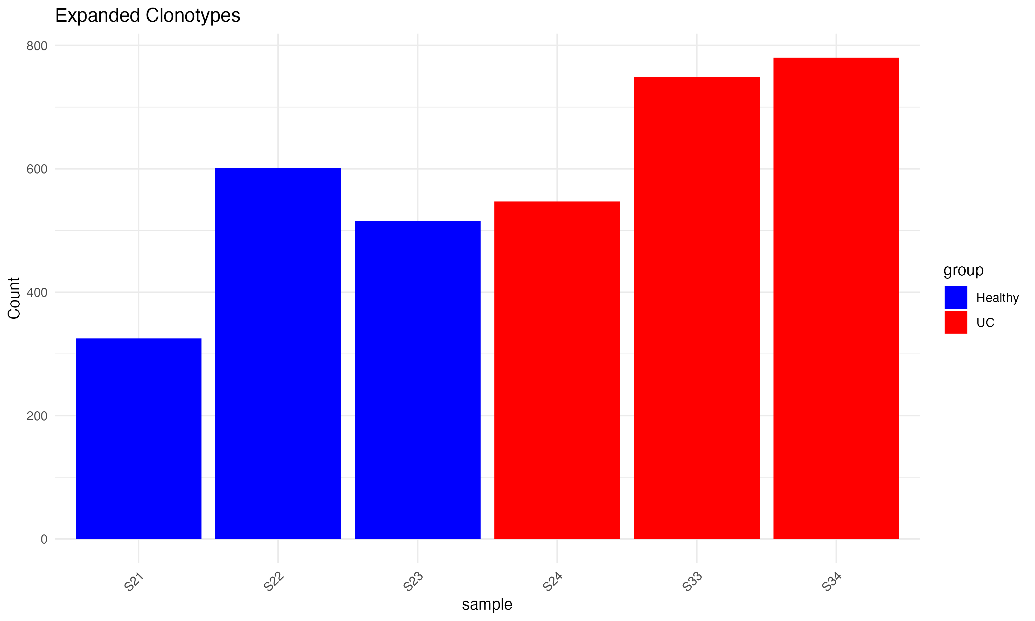

Figure1: Bar plot showing the number of expanded TCR clonotypes (defined as clonotypes with count >1) per sample, comparing Healthy (blue) and UC (red) groups. X-axis: Sample IDs (S21–S34), representing individual TCR-seq samples. Y-axis: Number of expanded clonotypes (clonotypes occurring more than once in a sample). Blue: Healthy controls. Red: Ulcerative Colitis (UC) patients

Necessity
Expanded clonotypes reflect clonal proliferation, often driven by antigen exposure or immune activation. Analyzing their frequency helps assess immune response magnitude and clonal dominance in disease states.

Result Description
UC samples (S24–S34) exhibit a higher number of expanded clonotypes than Healthy samples (S21–S23), indicating elevated clonal expansion in UC patients. This suggests an antigen-driven T cell response or ongoing inflammation in UC.
Figure2: Bar plot showing the total number of TCR sequences (reads) detected per sample across Healthy (blue) and UC (red) groups. X-axis: Sample IDs (S21–S34), representing individual TCR-seq samples.Y-axis: Total TCR read counts (raw clonotype abundance). Blue: Healthy controls. Red: Ulcerative Colitis (UC) patients

Necessity: Total TCR counts provide a measure of sequencing depth and immune activity. Higher counts can reflect either more immune cell infiltration or more active clonal expansion.

Result Description: UC samples show consistently higher total TCR counts compared to Healthy controls. This may reflect increased T cell infiltration or immune activation associated with ulcerative colitis pathogenesis.

Key Difference Between the Two Figures
Aspect | Figure 1: Expanded Clonotypes | Figure 2: Total TCR Counts
What is measured | Number of clonotypes with count >1 | Total number of TCR reads per sample
Focus | Clonal expansion (diversity reduction) | Overall TCR activity / sequencing depth
Biological implication | Antigen-driven proliferation | Immune activation or sample cellularity
Use case | Identifying clonal dominance | Assessing repertoire scale / coverage

Figure X: Bar plots showing the top 6 most abundant TCR β-chain clonotypes in each sample (S21–S24, S33–S34). Each bar represents the frequency of a specific clonotype within a sample. Samples are color-coded individually to distinguish between groups. X-axis: Frequency or abundance of each TCR β-chain clonotype (number of reads). Y-axis: CDR3 amino acid sequences of the top 6 clonotypes in each sample. Color: Each color represents a different sample (S21–S24, S33–S34), for visual clarity.

Necessity
Identifying and visualizing dominant clonotypes helps detect clonal expansion, which can indicate antigen-specific immune responses. This is particularly important in immune profiling of inflammatory diseases such as ulcerative colitis (UC), where certain clonotypes may dominate due to persistent antigenic stimulation.

Result Description
Each panel reveals the 6 most frequent TCR β-chain clonotypes for an individual sample. UC samples (e.g., S24, S33, S34) tend to exhibit higher individual clonotype frequencies, suggesting dominant clonal expansion compared to Healthy samples (S21–S23), where clonotype frequencies are relatively more balanced. The presence of highly expanded specific clonotypes may reflect disease-associated or antigen-driven immune activity in UC.

Figure X: Summary of TCR barcode statistics across Healthy and Ulcerative Colitis (UC) samples. The figure includes: (A) the number of unique barcodes per sample, (B) the mean number of contigs per barcode by condition, and (C) a Venn diagram of barcode overlap between Healthy and UC conditions.
Panel A:
X-axis: Individual TCR-seq samples (S21–S34). Y-axis: Number of unique cellular barcodes, representing unique T cells captured. Bar Colors: Blue: Healthy samples. Orange: UC samples

Necessity: Quantifying unique barcodes provides an estimate of the number of distinct T cells captured in each sample. This helps assess the quality and depth of sequencing and cellular resolution.

Result Description: UC samples (especially S24 and S34) show higher numbers of unique barcodes compared to Healthy samples, suggesting increased T cell infiltration or better cellular capture in the disease group.

Panel B: Mean Contigs per Barcode by Condition: X-axis: Sample condition — Healthy vs UC. Y-axis: Mean number of contigs (assembled TCR chains) per barcode.

Necessity: This metric reflects the complexity of TCR information recovered per cell. A higher contig count per barcode may suggest a better assembly or multiple chain pairings per T cell, which could inform on immune activation states.

Result Description: UC samples have a slightly higher mean number of contigs per barcode than Healthy controls, suggesting greater TCR complexity or assembly depth in the disease condition.

Panel C: Barcode Overlap Between Conditions
Venn Diagram Details:
  - Blue Circle (Left): Unique barcodes in Healthy samples (3,861; 46.0%)
  - Orange Circle (Right): Unique barcodes in UC samples (4,493; 53.5%)
  - Overlap (Center): Shared barcodes between Healthy and UC (41; 0.5%)

Necessity: Shared barcodes across conditions may indicate technical artifacts or truly persistent/expanded T cell clones that exist across health and disease states.

Result Description
A minimal overlap of only 0.5% of barcodes between Healthy and UC samples indicates distinct T cell repertoires, reinforcing condition-specific immune responses and validating the integrity of sample separation.

# What Does "Mean Contigs" Mean?
In the plot titled "Mean Contigs per Barcode by Condition", "mean contigs" refers to the average number of TCR (T-cell receptor) contigs (or sequences) detected per unique barcode across all cells in a given condition (Healthy or UC). Here’s a breakdown of what this means:
- Contigs:
  - A "contig" in this context is a single TCR sequence assembled from the raw sequencing reads. For T cells, these typically represent the alpha (TRA) or beta (TRB) chain of the TCR, which define the cell’s antigen recognition capability.
  - In single-cell TCR sequencing data (like our Corridoni TCRs dataset), each row represents a contig with details like barcode, contig_id, chain, v_gene, cdr3, etc.
- Barcode:
  - A "barcode" is a unique identifier assigned to an individual cell in single-cell sequencing. It allows us to group all contigs (TCR sequences) that belong to the same cell.
- Mean Contigs per Barcode:
  - For each unique barcode (i.e., each cell), we count how many contigs (TCR sequences) are associated with it. For example:
    - A cell might have 1 contig (e.g., only a TRB chain detected).
    - A cell might have 2 contigs (e.g., both TRA and TRB chains detected).
    - Rarely, a cell might have more due to sequencing artifacts or dual TCR expression.
  - The "mean contigs per barcode" is the average of these counts across all cells (barcodes) in a condition (Healthy or UC).
- Interpretation in the Plot:
  - The bar plot shows this average for Healthy vs. UC conditions.
  - Biological Meaning:
    - A value close to 1 suggests most cells have only one TCR chain detected (e.g., just TRB or TRA), possibly due to incomplete sequencing or filtering.
    - A value close to 2 suggests most cells have both alpha and beta chains detected, indicating good paired TCR recovery.
    - A value between 1 and 2 suggests a mix (some cells with one chain, some with both).
    - Differences between Healthy and UC could reflect technical differences (e.g., sequencing depth) or biological differences (e.g., clonal expansion affecting chain detection).

Example
- If in the Healthy condition:
  - Barcode1 has 2 contigs (TRA + TRB)
  - Barcode2 has 1 contig (TRB only)
  - Barcode3 has 2 contigs (TRA + TRB)
  - Mean contigs = (2 + 1 + 2) / 3 = 1.67
- If in the UC condition:
  - Barcode4 has 1 contig
  - Barcode5 has 1 contig
  - Barcode6 has 2 contigs
  - Mean contigs = (1 + 1 + 2) / 3 = 1.33
- The plot would show Healthy with a higher bar (1.67) than UC (1.33), suggesting Healthy samples might have better paired TCR detection.

Why It Matters
- Data Quality: A higher mean contigs per barcode indicates better recovery of full TCR information (both chains), which is useful for downstream analyses like clonotype pairing or repertoire diversity.
- Biological Insight: Differences between conditions could hint at variations in T-cell populations or sequencing efficiency, though you’d need to rule out technical artifacts (e.g., differences in library preparation).

Our Results
If we look at the generated plot (tcr_barcode_analysis_plots.png in our 12_TCRmatches folder), the height of the bars for "Mean Contigs per Barcode by Condition" will tell:
- Whether Healthy or UC samples have more TCR chains per cell on average.
- If the values are close to 1, 2, or somewhere in between, giving us a sense of how complete our TCR data is per cell.

Figure 1: UMAP-Viral vs Non-Viral TCRs

UMAP projection of all cells colored by TCR type (viral vs non-viral). Axes: X-axis: UMAP_1 – First dimension of UMAP. Y-axis: UMAP_2 – Second dimension of UMAP. Color: Gray: Non-Viral TCRs.
Result Summary:
All cells in the dataset are labeled as Non-Viral TCRs, shown in gray across the UMAP space. No viral-matched TCRs are present in the plot, suggesting either a complete absence or failure to correctly propagate viral TCR annotations during integration.

Figure 2: Sample Contribution Across Clusters. Stacked barplot representing relative sample contribution to each of the 14 clusters. X-axis: Seurat cluster identity (0 to 13). Y-axis: Proportion of cells in each cluster. Color: Each color represents a unique sample (e.g., S21–S34), shown in the legend!!!
Result Summary:
The cluster composition varies widely across samples. Certain clusters (e.g., 2, 6, 10) are dominated by specific samples, while others exhibit more mixed contributions. This heterogeneity suggests individual or condition-specific expansion patterns.

Figure 3: GZMK Expression Across Clusters. Violin and dot plot of GZMK expression levels across clusters. X-axis: Cluster identity (0–13). Y-axis: Expression level (log-normalized count of GZMK). Color: Clusters are colored according to Seurat’s identity color scheme
Result Summary:
Clusters 2 and 9 show elevated GZMK expression, a marker associated with cytotoxic and memory T cell subsets. The distribution pattern supports cluster-specific enrichment for effector-like phenotypes.

Figure 4: Cluster-Wise Distribution of Viral vs Non-Viral TCRs. Barplot of absolute TCR counts per cluster, classified as viral or non-viral. Axes: X-axis: Cluster identity (0–13). Y-axis: Count of TCRs per cluster. Color: Gray = Non-Viral TCR. Red = Viral TCR
Result Summary:
Almost all clusters consist exclusively of non-viral TCRs, with little to no viral TCR representation. This aligns with prior UMAP findings and underscores a technical or biological absence of viral TCRs in the analyzed population.

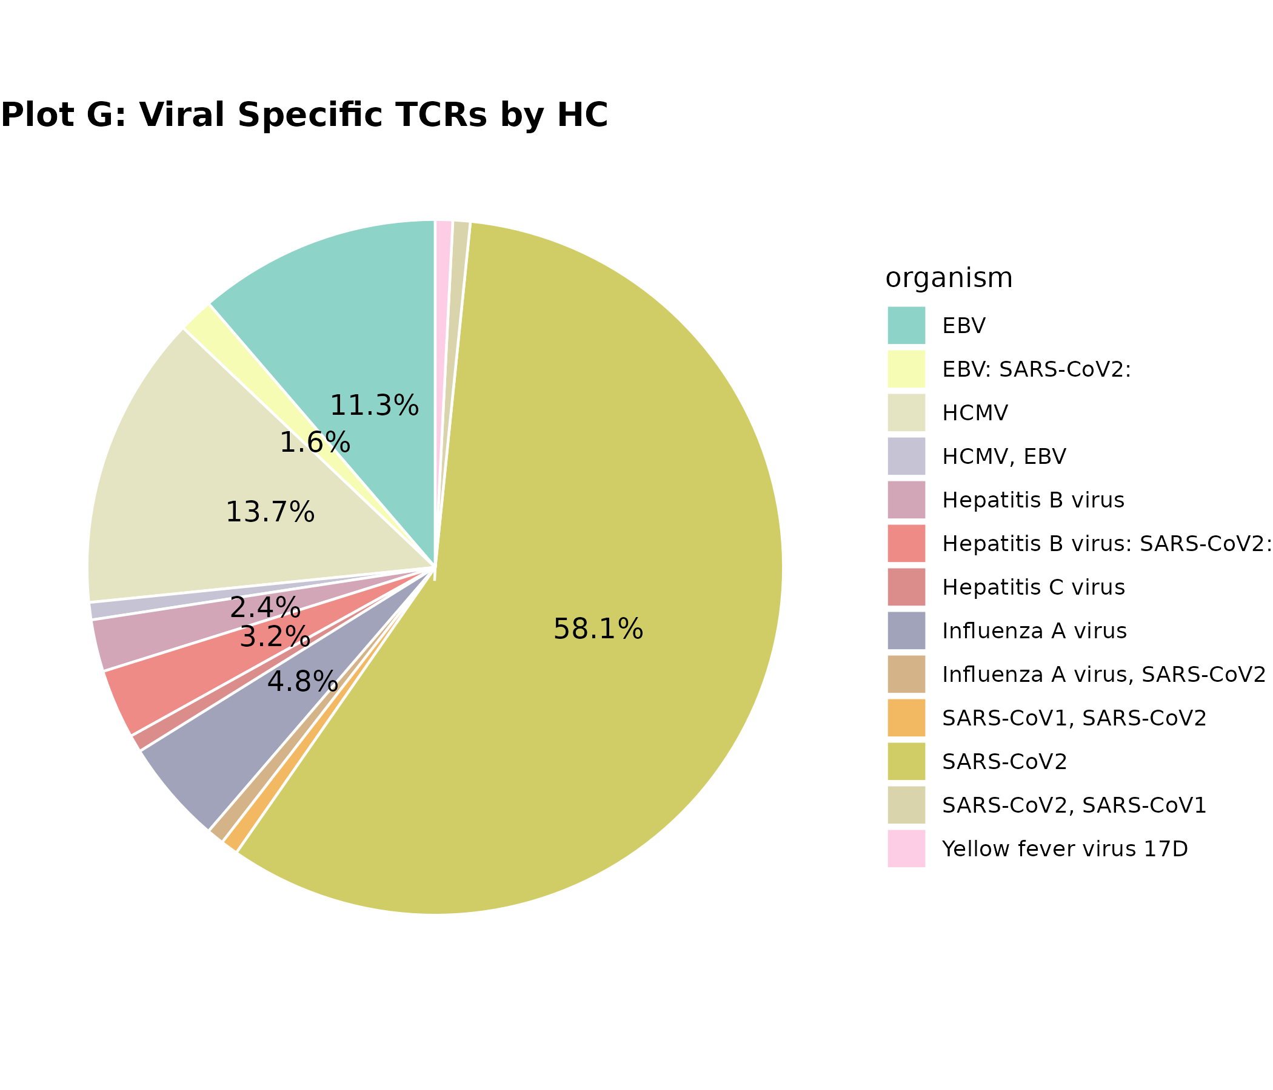
Great! Based on your two attached pie charts — Plot G: Viral Specific TCRs by HC and Plot H: Viral Specific TCRs by UC, here's a breakdown for your manuscript methods and figure legend, followed by a concise interpretation of results.

🧬 Manuscript Methods (for Plot G & H)
Pie Charts: Viral-Specific TCR Organism Composition in Healthy (HC) and Ulcerative Colitis (UC) Samples
To examine the distribution of viral-specific T cell receptor (TCR) responses across different organisms in healthy controls and ulcerative colitis patients, we generated pie charts stratified by group.
- Input Data:
Viral TCR metadata was derived from an annotated Excel file containing organism-level antigen information per clonotype, alongside sample IDs.
Samples S21, S22, S23 were classified as HC, and S24, S33, S34 as UC.
- Filtering and Cleaning:
Rows with non-viral TCRs (viral_status ≠ "Viral") or missing/NA organism entries were excluded. White space and literal “NA” strings were also removed from organism names to ensure accuracy.
- Color Mapping:
A unified color palette was created across both plots using RColorBrewer::Set3, ensuring each unique organism was consistently assigned a color in both HC and UC charts. Organism factor levels were synchronized between the two groups.
- Plotting Approach:
Using ggplot2, each group’s organism-level count was converted to a percentage of total viral TCRs within that group. Labels were displayed for segments contributing more than 1% of the total, and geom_text was used for inline percentage annotations.
- Tools:
R (v4.x), ggplot2, dplyr, RColorBrewer.
Exported as .png files using ggsave().

📘 Figure Legend
Figure X (Plot G & H):
Viral-Specific TCR Composition by Organism in HC and UC Groups.
Pie charts show the distribution of organisms targeted by viral-specific TCRs in (G) healthy controls and (H) ulcerative colitis patients. Each slice represents a distinct organism, colored consistently across both groups. Values inside the slices indicate the proportion of TCRs (%) assigned to each organism. Only slices contributing >1% are labeled. Non-viral and ambiguous TCRs were excluded.

📊 Results Interpretation (Plots G & H)
- Dominant Organism:
In both HC and UC samples, a single organism contributes to the majority of viral TCRs (~58.1% in HC, ~66% in UC), indicating a skewed clonal response likely driven by previous exposure or dominant pathogen.
- Shared Organisms:
Several organisms are shared across HC and UC with similar proportional representation, implying some baseline similarity in viral memory across groups.
- Group-Specific Differences:
Minor shifts in the proportional abundance of certain organisms (e.g., one organism at ~13.7% in HC vs ~12.2% in UC) may reflect immune activation or expansion differences in the disease state.
- Diversity:
UC samples show slightly higher representation from low-abundance organisms, possibly indicating broader viral reactivity or bystander activation in disease.

Let me know if you'd like a combined caption text or want these formatted for LaTeX, Word, or a figure panel layout!

Plot 6A: Pie Chart -Viral TCR Organism Distribution in Healthy Controls (HC). Pie chart showing the relative distribution of viral TCRs by organism in healthy control (HC) samples.
Color and Labels: Each color corresponds to a unique virus/organism. Percentages indicate proportion of total viral TCRs per organism.
Result Summary:
In HC samples, the viral TCR repertoire is dominated by SARS-CoV2 (58.1%), followed by CMV (13.7%), Influenza A (11.3%), and several other minor contributors. This reflects a history of common viral exposures with some individuals having broader immune memory.

Plot 6B: Pie Chart – Viral TCR Organism Distribution in Ulcerative Colitis (UC). Pie chart showing the relative distribution of viral TCRs by organism in ulcerative colitis (UC) samples.
Color and Labels: Same color scheme as Plot 6A. Percentages indicate organism-specific TCR proportions in UC.
Result Summary:
UC samples show even stronger dominance of SARS-CoV2 (66%), followed by Influenza A (12.8%) and CMV (12.2%). This pattern suggests potential skewing of the immune repertoire in UC, possibly reflecting differential antigen exposure or expansion dynamics.

Plot 7: Barplot-Viral TCR Organism Frequency (HC vs UC). Barplot comparing the frequency of viral TCRs by organism between Healthy controls (blue) and UC samples (red).
Axes: X-axis: Organism name (e.g., SARS-CoV2, EBV, CMV). Y-axis: Count of viral TCRs detected for each organism. Blue = Healthy. Red = UC
Result Summary:
SARS-CoV2 TCRs are the most prevalent in both groups, with higher representation in UC. Other viruses like CMV, EBV, and Influenza A also appear in both groups, though with different magnitudes. This indicates largely shared viral memory, with possible enrichment of certain viral-specific clones in UC.

Plot 11: Viral TCR Contribution by Cluster. Proportion of viral vs non-viral TCRs across each cluster (0–13).
Axes: X-axis: Cluster number, Y-axis: Percentage of TCRs, Gray = Non-Viral TCRs, Red = Viral TCRs
Result Summary:
Nearly all clusters are composed entirely of non-viral TCRs. The absence of red segments across clusters implies that viral TCRs are either absent, under-represented, or not well-integrated into the Seurat object metadata.

Plot 12: Viral TCR Contribution by Sample. Percentage of viral vs non-viral TCRs in each individual sample.
Axes: X-axis: Sample names (GSM IDs), Y-axis: Proportion of TCRs (viral vs non-viral), Gray = Non-Viral TCRs, Red = Viral TCRs
Result Summary:
All samples show 100% non-viral TCRs, indicating that no viral-matching TCRs were mapped to Seurat barcodes, likely due to mismatched barcodes or missing metadata propagation during integration.

2nd part:

The dataset includes a "barcode" column, which identifies each TCR sequence, and an "organism" column, which indicates whether the TCR is associated with a virus. Here’s how I will proceed:
- Filter Viral Barcodes: Extract barcodes where "organism" is not empty (i.e., associated with a virus).
- Modify UMAP Plot:
  - Color viral-associated barcodes in red.
  - Keep all non-viral barcodes in gray.
- Bar Graph of Cluster Composition:
  - Compare viral vs. non-viral TCRs per cluster.
Now, I have updated the R script to include these two additional plots. ​​
- Highlight Viral-Associated Barcodes on UMAP
  - Red for viral barcodes
  - Gray for non-viral barcodes
- Generate a Bar Graph of cluster composition
  - Viral TCRs vs. Non-Viral TCRs in each cluster

UMAP Plot:
  - Color viral-associated barcodes in red.
  - Keep all non-viral barcodes in gray.

# Bar Graph of Cluster Composition:
  - Compare viral vs. non-viral TCRs per cluster.

For a better understanding of the analysis process:

Quality Control (QC) and RDS Files in Single-Cell RNA Sequencing Analysis
Before generating the three key plots, a Quality Control (QC) step was performed to ensure the integrity and reliability of the data. In single-cell RNA sequencing (scRNA-seq) analysis, QC is a crucial step that helps remove low-quality or contaminated data, improving the accuracy of downstream analysis.

What is QC in Single-Cell RNA Sequencing?
Quality Control (QC) involves filtering out:
- Low-quality cells: Cells with a high percentage of mitochondrial genes, which may indicate damaged or dying cells.
- Doublets: Instances where two or more cells are captured as one, leading to misleading gene expression patterns.
- Low gene expression cells: Cells with very few detected genes, which might not provide meaningful biological insights.
- Batch effects: Technical variations between different samples that need to be corrected before integration.
By performing QC, we ensure that only high-quality cells are used in the clustering and visualization processes.

What are RDS Files?
- RDS (R Data Serialization) files are a format used in R to store data objects, including Seurat objects in scRNA-seq analysis.
- Each of the 12 RDS files in this analysis represents a separate sample after QC filtering, normalization, and feature selection.
- These files are later integrated to perform a combined analysis across all samples, ensuring consistency and comparability.

Explanation of the Two Pie Plots
The two pie charts visualize the distribution of viral-specific T-cell receptor (TCR) counts in two groups:
- HC (Healthy Controls)
- UC (Ulcerative Colitis Patients)
Each segment in the pie chart represents a different viral organism, and the size of the segment corresponds to the percentage of TCRs associated with that virus.

Pie Chart: Viral-specific TCR from Healthy Controls (HC)

Description:
- This pie chart shows the proportion of viral-specific TCRs found in individuals classified as Healthy Controls (HC).
- Each color represents a different viral organism identified in the dataset.
- The percentage labels indicate how much each virus contributes to the total HC-associated viral TCR repertoire.

Interpretation of Output:
- If the chart is diverse with multiple segments, it suggests HC individuals have TCRs recognizing a wide range of viral infections.
- If the chart is dominated by one or two segments, it indicates that a specific virus is more commonly recognized by the TCRs in HC individuals.

Legend:
- Each color in the legend corresponds to a different virus (e.g., Influenza, CMV, EBV, SARS-CoV-2, etc.).
- The proportions help understand how viral exposure varies in healthy individuals.

Pie Chart: Viral-specific TCR from Ulcerative Colitis (UC) Patients

Description:
- This chart represents the distribution of viral-specific TCRs found in individuals diagnosed with Ulcerative Colitis (UC).
- Like the HC chart, different viral organisms are represented as different colors, with each segment indicating their proportional presence in the UC group.

Interpretation of Output:
- If the viral diversity is different from HC, it may suggest an altered immune response in UC patients.
- If one virus is overrepresented, it could indicate a strong association between that virus and the UC condition.
- A low diversity of viral-specific TCRs in UC might suggest a restricted immune repertoire, possibly due to immune dysregulation.

Legend:
- Each color represents a specific viral organism.
- The proportion of each virus shows how the immune system in UC patients differs in recognizing viral infections compared to HC individuals.

Final Thoughts
- Comparing these two pie charts allows us to assess whether viral-specific immune responses differ between healthy individuals and UC patients.
- Differences in viral exposure or immune reactivity could provide insights into disease mechanisms or potential therapeutic targets.

Explanation of "Viral Organism" in Our Context
A viral organism refers to a specific virus that has been identified in the dataset. In our TCR sequencing analysis, the viral-specific TCRs are those T-cell receptors that recognize antigens from particular viruses.

How Does This Relate to Our Data?
Since we mentioned we have 12 sample initials, I assume these samples belong to either:
- Healthy Controls (HC)
- Ulcerative Colitis (UC) patients
Each sample may contain TCR sequences that have been matched to specific viral organisms (i.e., the viruses they recognize). The pie charts we are generating will show the distribution of TCRs that respond to different viruses within each sample group (HC vs. UC).

Possible Examples of Viral Organisms in Our Dataset
If our dataset includes TCRs mapped to known viral antigens, some common viral organisms we might see could be:
- CMV (Cytomegalovirus)
- EBV (Epstein-Barr Virus)
- Influenza Virus
- SARS-CoV-2 (COVID-19)
- HIV (Human Immunodeficiency Virus)
- Hepatitis B or C Virus
- HPV (Human Papillomavirus)
Each color in our pie chart corresponds to one of these viral organisms, showing the proportion of TCRs associated with each.

Explanation of the Bar Plot: Viral-specific TCR Distribution in HC and UC
The bar plot provides a comparative visualization of the number of viral-specific TCRs detected in Healthy Controls (HC) and Ulcerative Colitis (UC) patients. It helps in understanding whether certain viruses are more commonly recognized by T cells in UC patients compared to healthy individuals.

What the Bar Plot Represents
- X-axis (Viral Organism) → Different viruses (e.g., CMV, EBV, Influenza, SARS-CoV-2, etc.) recognized by TCRs.
- Y-axis (TCR Count) → The number of TCRs that are specific to each virus.
- Bars (Grouped by HC vs. UC, using colors):
  - Blue bars (HC) → Show the number of viral-specific TCRs detected in healthy controls.
  - Red bars (UC) → Show the number of viral-specific TCRs detected in UC patients.
- Legend (Group Identifier) → Distinguishes between HC (Healthy Control, blue) and UC (Ulcerative Colitis, red).

Description of Output Results
- Comparison of Viral-Specific TCRs in HC vs. UC:
  - If a virus has higher TCR counts in UC (red bars taller than blue bars), it suggests that T cells targeting that virus are more active or expanded in UC patients.
  - If a virus has higher TCR counts in HC (blue bars taller than red bars), it suggests that healthy individuals may have a broader immune response to that virus.
- Potential Findings from the Bar Plot:
  - CMV and EBV-specific TCRs may be more frequent in UC → Suggesting a link between viral infections and UC immune activation.
  - Influenza-specific TCRs may be evenly distributed → Indicating a general immune response rather than UC-specific activation.
  - Some viruses may show no major difference → Suggesting they do not play a major role in UC pathogenesis.
- Biological Implication:
  - If UC patients have a higher proportion of viral-specific TCRs, it might indicate viral infections contribute to immune dysregulation in UC.
  - TCR expansion in UC suggests a stronger, potentially chronic immune activation against certain viral antigens.

