Tasks:
Task 1: SQL-Based Traffic Analysis
Using the Metro Interstate Traffic Volume dataset:
1.1 Load the dataset
- Load the comma-delimited traffic CSV file into SQLite.
- Verify that the data has been loaded correctly.
Loaded Metro_Interstate_Traffic_Volume.csv into a SQLite table traffic_volume (schema in 01_schema.sql) using DB Browser for SQLite's CSV import feature. Verified the load with the following checks, all matching the source CSV
Row count: 48,204 (via SELECT COUNT(*) FROM traffic_volume;)
Column count: 9, with correct data types (temp/rain_1h/snow_1h as REAL, clouds_all/traffic_volume as INTEGER)
Min/max traffic_volume: 0 and 7,280, matching the source data
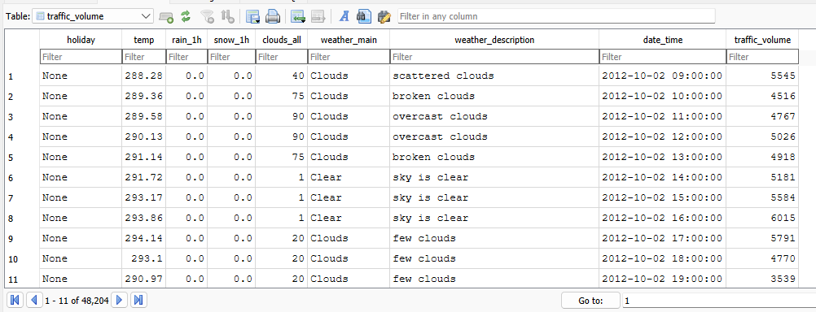
1.2 Analyse annual traffic trends
Compare the total yearly traffic volume for:
- 2012
- 2013
- 2014
- 2015
- 2016
- 2017
Total traffic volume by year (after removing duplicate-timestamp rows, explained below):
2012: 6,785,754
2013: 24,139,878
2014: 14,718,915
2015: 11,706,145
2016: 25,032,183
2017: 29,420,221
Note: I found that 5,445 timestamps in this dataset appear 2–3 times each, because the weather feed sometimes logs more than one observation within the same hour. I confirmed traffic_volume is identical across these duplicate rows, so I removed duplicates (keeping one row per unique hour, via the hourly_traffic view in 02_annual_trends.sql) before summing. Without this step, the totals above would be inflated.

Then:
- Identify years with increases or decreases.
2013: increase vs. 2012
2014: decrease vs. 2013
2015: decrease vs. 2014
2016: increase vs. 2015
2017: increase vs. 2016
- Calculate the change between years where appropriate.
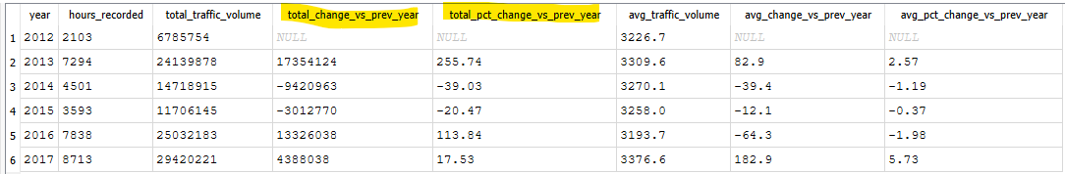
- Explain at least two meaningful observations about traffic volume trends.
  - The totals above are heavily shaped by how much data exists for each year, not just real traffic demand. The percentage of the year actually covered by hourly records ranges from 23.9% (2012) to 99.5% (2017). This is why 2013 looks like a 255% jump over 2012, as the year 2012 only has data from October 2 onward (~ 2 mths). Thus, not a genuine traffic surge.
  - A fairer comparison is average traffic volume per recorded hour, since its agnostic to how much data exists for each year. From that perspective, 2012–2015 stayed in a narrow band (about 3,227 to 3,310 vehicles/hour). However, 2016 was the lowest of all six years (3,193.7/hour) despite having good coverage (89.2%). 2017 then reached the highest average of any year (3,376.6/hour, +5.73% over 2016), and since 2017 also has the most complete coverage (99.5%), this looks like a genuine increase in traffic demand rather than a data artifact.
1.3 Analyse temperature around holidays
Compare temperature patterns for 2015, 2016 and 2017 during:
- New Year's Day
- Labor Day

Holiday | Year | Avg Temp (°C) | Avg Temp (K) | Hours Recorded | Avg Traffic Volume
New Year's Day | 2015 | No data* | No data* | 0 | No data*
New Year's Day | 2016 | -6.06 | 267.09 | 18 | 1832.00
New Year's Day | 2017 | -3.06 | 270.09 | 24 | 2127.60
Labor Day | 2015 | 22.17 | 295.32 | 24 | 2430.30
Labor Day | 2016 | 21.86 | 295.01 | 24 | 2151.50
Labor Day | 2017 | 18.14 | 291.29 | 24 | 2395.20

* Note: New Year's Day 2015 could not be included in this comparison as there are zero hourly records for that date due to large gap between 2014-08-08 and 2015-06-11 (~10mths). As a result, I have marked 2015 New Years day as ‘No data’.
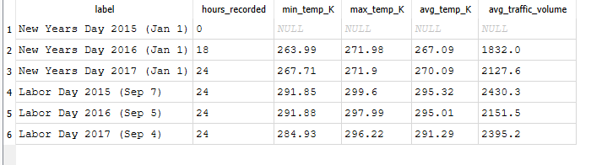
Identify notable year-on-year changes and discuss whether these changes appear relevant to traffic conditions.
Notable YoY Changes:
New Year's Day: 2016 - 2017 warmed by +3.00 degrees C (only one year-on-year comparison is possible, since 2015 has no data).
Labor Day: 2015 - 2016 was essentially flat (−0.31 degrees C). 2016 - 2017 noted a drop of −3.72 degrees C, the largest change observed in this analysis.
“Whether these changes appear relevant to traffic conditions”:
- For New Year's Day, average traffic volume also rose alongside the temperature increase (2016: 1,832.0 to 2017: 2,127.6, +16.1%), which is directionally consistent with warmer weather coinciding with more traffic. As indicated in the previous task 2017 had the highest overall traffic of any year in the given dataset and the temperature change can be considered as one of the factors rather than the only factor contributing to a YoY growth.
- For Labor Day, the relationship breaks down, as the average temperature changed only marginally (a decrease of -0.31 degrees C) between 2015 and 2016. However, traffic fell by 11.5% (2,430.3 – 2,151.5). Thereafter between 2016 and 2017 temperature dropped sharply by ~ - 3.72 degrees C (i.e. relatively cooler) but traffic registered an increase of 11.3% (2,151.5 to 2,395.2) which is contrary to what one might expect if cooler weather suppressed travel. So, this mismatch indicates that temperature is not a strong driver of changes in traffic for Labor Day.

Task 2: Descriptive Statistics and Correlation
Using the traffic dataset, calculate:
2.1 Traffic volume statistics
- Mean
- Median
- Standard deviation
- Variance
- Range
Mean | 3,290.65
Median | 3,427.00
Std Dev | 1,984.77
Variance | 3,939,323.50
Minimum | -
Maximum | 7,280.00
Range | 7,280.00

Interpret what these statistics tell you about traffic volume and its variability.
Mean vs Median: The mean (3,290.65) is noticeably lower than the median (3,427.00), a gap of about 136 vehicles. Since the mean is below the median, the distribution of traffic volume leans toward lower values. There is a cluster of low traffic hours, mainly overnight and early morning when volume drops close to zero, pulling the average down, while most hours sit at moderate to high volumes clustered nearer the median.
Std Deviation & Variance: The standard deviation (1,984.77) is large relative to the mean, and looking at the coefficient of variation at ~60.3% of the mean value (1,984.77 / 3,290.65 is ~ 60.3%) indicates substantial variability i.e. traffic volume swings widely rather than staying close to its average. The variance (3,939,323.50) conveys the same spread in squared units, so it is mainly useful as an input to other calculations rather than something to interpret directly on its own.
Range: The range (7,280, from a minimum of 0 to a maximum of 7,280 vehicles per hour) confirms this. The corridor goes from essentially empty at its quietest to fully saturated at its busiest within the same dataset.
Looking at the above statistics as a cohort the trend seems consistent. Traffic volume is not stable throughout the day. It depends heavily on the time of day, with a wide range between quiet overnight hours and peak commuting hours. A single average figure hides most of what is actually happening, and any predictive model needs to account for this time driven swing rather than treating traffic volume as roughly constant.

2.2 Correlation analysis
Calculate the correlation coefficient between:
- Temperature
- Traffic volume
Pearson correlation coefficient (temperature vs. traffic volume), calculated across all 40,575 unique hourly records in the dataset r = 0.14 (unrounded: 0.1369). Because a Pearson correlation is unaffected by a linear rescaling of either variable, this value is identical whether temperature is expressed in Kelvin (as available in the file) or converted to Celsius.
Note: 10 rows record temperature as exactly 0 K (absolute zero), and a further 78 rows record exactly 276.793 K — both look like placeholder/default values rather than real sensor readings (0 K is physically impossible for Minneapolis–St Paul (unless it is created in a lab), and 276.793 K recurs suspiciously often, always on the "extra" row of an hour that already has a duplicate weather entry). Recomputing the coefficient with these 88 rows (0.22% of the data) excluded gives r = 0.1391, which still rounds to 0.14, so this data-quality issue does not change the result.
Interpret the direction of the relationship.
Direction: The coefficient is positive (r = 0.14 > 0), so temperature and traffic volume move in the same direction on average: hours with higher temperatures tend to have slightly higher traffic volume, and hours with lower temperatures tend to have slightly lower traffic volume. The relationship is not negative, so there is no evidence here that heat suppresses driving.
Interpret the strength of the relationship.
Strength: By conventional benchmarks for correlation strength (roughly: <0.20 very weak, 0.20–0.39 weak, 0.40–0.59 moderate, 0.60–0.79 strong, ≥0.80 very strong), r = 0.14 falls in the very weak range that indicates close to no linear relationship at all. Squaring the coefficient gives R^2 ≈ 0.019, meaning temperature alone statistically accounts for under 2% of the hour-to-hour variation in traffic volume. This lines up with the sql task finding that traffic volume is dominated by time-of-day/commuting patterns rather than a single continuous driver such as temperature.
Explain why correlation does not necessarily imply causation.
Correlation vs. causation: A correlation coefficient only measures how closely two variables move together; it cannot by itself show that one causes the other. Two variables can be correlated because a third, unmeasured variable drives them both (a confounder), because the relationship actually runs in the opposite direction, or simply by chance. In this dataset, a plausible confounder is time (hour of day and season): traffic volume follows a strong commuting-driven daily cycle that has nothing to do with the outdoor temperature at that moment, while temperature follows its own daily and seasonal cycle. The two series can drift together somewhat simply because both are shaped by the calendar, without temperature having any direct influence on how many vehicles are on the road. For example, a warm summer rush hour and a cold winter rush hour can both be "high traffic" for scheduling reasons alone. Given how weak this correlation already is (R^2 < 2%), it would be a mistake to conclude from it that warmer weather causes more people to drive; the data only supports saying the two are weakly, positively associated.
Overall, temperature has only a marginal linear association with traffic volume in this dataset. It is directionally positive but too weak to treat as a meaningful driver of traffic on its own, reinforcing that time-based factors (hour, day of week, holiday status) are far more important explanatory variables than weather.

Task 3: Probability and Congestion Analysis
Congestion is defined for this task as an hour where traffic_volume > 5,500 vehicles.
3.1 Basic probability
Calculate:
- P(Congestion)
- P(Clear Weather)
- P(Congestion AND Clear Weather)
Method: All three probabilities are empirical relative frequencies computed over the same 40,575-row deduplicated, one-row-per-hour dataset used throughout Tasks 1.2, 2.1 and 2.2 (so an hour with multiple weather log entries is not double-counted). "Clear Weather" uses the weather_main column’s exact category "Clear" (one of 10 categories in the data: Clouds, Clear, Rain, Drizzle, Mist, Fog, Thunderstorm, Haze, Snow, Squall, Smoke) rather than the free-text weather_description field, since weather_main gives a single unambiguous label per hour.
P(Congestion): 6,107 of 40,575 hours have traffic_volume > 5,500, so P(Congestion) = 6,107 / 40,575 ≈ 0.1505 (15.05%).
P(Clear Weather): 13,366 of 40,575 hours are logged with weather_main = "Clear", so P(Clear Weather) = 13,366 / 40,575 ≈ 0.3294 (32.94%).
P(Congestion AND Clear Weather): 1,762 of 40,575 hours are both congested and clear, so P(Congestion AND Clear Weather) = 1,762 / 40,575 ≈ 0.0434 (4.34%).

3.2 Conditional probability
Calculate:
- P(Clear Weather | Congestion)
- P(High Temperature | Congestion), where high temperature > 292K
- Determine whether weather conditions and congestion can be considered independent using P(A ∩ B) = P(A) × P(B)
- Calculate the odds ratio of congestion in clear versus cloudy weather.

Conclude with a short explanation of what the probability analysis suggests about the relationship between weather and congestion.
P(Clear Weather | Congestion): 1,762 of the 6,107 congested hours were logged as Clear, so P(Clear Weather | Congestion) = 1,762 / 6,107 ≈ 0.2885 (28.85%).
P(High Temperature | Congestion): 1,699 of the 6,107 congested hours have temperature above 292K, so P(High Temperature | Congestion) = 1,699 / 6,107 ≈ 0.2782 (27.82%).
Independence check: if Congestion and Clear Weather were independent, P(Congestion) x P(Clear Weather) would equal P(Congestion AND Clear Weather). Here P(Congestion) x P(Clear Weather) = 0.1505 x 0.3294 ≈ 0.0496 (4.96%), while the actual joint probability is 0.0434 (4.34%). These two values are not equal, so Congestion and Clear Weather cannot be considered independent.
Odds ratio: among clear hours, 1,762 were congested and 11,604 were not, giving odds of 1,762 / 11,604 ≈ 0.1518. Among cloudy hours, 2,587 were congested and 12,536 were not, giving odds of 2,587 / 12,536 ≈ 0.2064. The odds ratio of congestion in clear weather versus cloudy weather is 0.1518 / 0.2064 ≈ 0.7358.
Conclusion: Overall the probability analysis suggests that weather has only a mild relationship with congestion. Congestion is somewhat less likely during clear conditions than the independence assumption would predict, and the odds of congestion in clear weather are about 26 percent lower than in cloudy weather, since the odds ratio is below 1. This points in the same direction as the weak positive correlation found between temperature and traffic volume in Task 2.2, but the effect size is small in both cases. Weather appears to shift the likelihood of congestion only slightly rather than acting as a major driver of it, so factors such as time of day and day of week are still likely to matter more than weather conditions alone.

Task 4: Power BI Traffic Intelligence Dashboard
Import the traffic CSV file into Power BI Desktop and use Power Query Editor to prepare the data.
4.1 Data quality and preparation
Perform the following:
- Determine the number of rows and columns.
- Identify null/missing values and the columns affected.
- Check whether the data types are appropriate.
- Extract Hour from DateTime.
- Create Temperature in Celsius.
- Create a Traffic Category:
Traffic Volume | Category
< 4,500 | Low
4,500–5,500 | Medium
> 5,500 | High

Steps Followed as below:
- Row and column count: the imported CSV has 48,204 rows and 9 columns (holiday, temp, rain_1h, snow_1h, clouds_all, weather_main, weather_description, date_time, traffic_volume).
- Null and missing values: Power Query's Column quality view initially reported 0% Empty for every column, which looks like no missing data at all. However holiday stores the literal text None for non holiday hours rather than a true blank, in 48,143 of 48,204 rows (99.87%). This is not detected as missing until the text is explicitly replaced. Applying Replace Values (None to blank) on holiday raised its reported Empty percentage to 99%, correctly reflecting that almost every hour has no holiday.
- Data type check: date_time, clouds_all and traffic_volume were auto detected with appropriate types (Date/Time and Whole Number). However temp, rain_1h and snow_1h were auto detected as Text rather than a numeric type, which would have prevented correct aggregation and charting. These three were changed to Decimal Number. As a side effect, rain_1h's reported distinct value count dropped from 372 to 30, since several text representations of the same number (such as 0 and 0.0) had been counted as different values before the fix, a further sign the original type was wrong.
- Hour: extracted from date_time using Time.Hour([date_time]), producing a Whole Number column ranging 0 to 23.
- Temperature in Celsius: created as a Custom Column named Temperature_C using the formula [temp] minus 273.15. Power Query initially left this column as the generic Any type, so it was explicitly changed to Decimal Number.
- Traffic Category: created as a Custom Column named Traffic_Category using nested if logic so every row falls into exactly one non overlapping band: Low below 4,500, Medium from 4,500 up to and including 5,500, and High above 5,500, the same threshold used to define Congestion in Task 3. Spot checking against known traffic_volume values confirmed correct results, for example 5,545 correctly categorised as High and 4,516 as Medium.
