Tasks:
Task 1: SQL-Based Traffic Analysis
Using the Metro Interstate Traffic Volume dataset:
1.1 Load the dataset
- Load the comma-delimited traffic CSV file into SQLite.
- Verify that the data has been loaded correctly.
Loaded Metro_Interstate_Traffic_Volume.csv into a SQLite table traffic_volume (schema in 01_schema.sql) using DB Browser for SQLite's CSV import feature. Verified the load with the following checks, all matching the source CSV
Row count: 48,204 (via SELECT COUNT(*) FROM traffic_volume;)
Column count: 9, with correct data types (temp/rain_1h/snow_1h as REAL, clouds_all/traffic_volume as INTEGER)
Min/max traffic_volume: 0 and 7,280, matching the source data
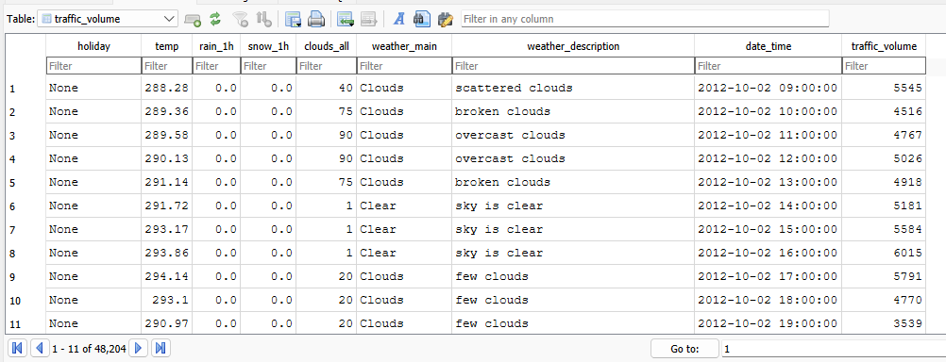
1.2 Analyse annual traffic trends
Compare the total yearly traffic volume for:
- 2012
- 2013
- 2014
- 2015
- 2016
- 2017
Total traffic volume by year (after removing duplicate-timestamp rows, explained below):
2012: 6,785,754
2013: 24,139,878
2014: 14,718,915
2015: 11,706,145
2016: 25,032,183
2017: 29,420,221
Note: I found that 5,445 timestamps in this dataset appear 2–3 times each, because the weather feed sometimes logs more than one observation within the same hour. I confirmed traffic_volume is identical across these duplicate rows, so I removed duplicates (keeping one row per unique hour, via the hourly_traffic view in 02_annual_trends.sql) before summing. Without this step, the totals above would be inflated.

Then:
- Identify years with increases or decreases.
2013: increase vs. 2012
2014: decrease vs. 2013
2015: decrease vs. 2014
2016: increase vs. 2015
2017: increase vs. 2016
- Calculate the change between years where appropriate.
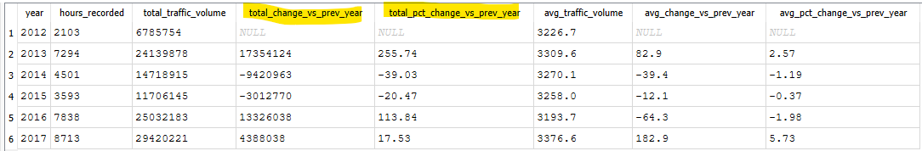
- Explain at least two meaningful observations about traffic volume trends.
  - The totals above are heavily shaped by how much data exists for each year, not just real traffic demand. The percentage of the year actually covered by hourly records ranges from 23.9% (2012) to 99.5% (2017). This is why 2013 looks like a 255% jump over 2012, as the year 2012 only has data from October 2 onward (~ 2 mths). Thus, not a genuine traffic surge.
  - A fairer comparison is average traffic volume per recorded hour, since its agnostic to how much data exists for each year. From that perspective, 2012–2015 stayed in a narrow band (about 3,227 to 3,310 vehicles/hour). However, 2016 was the lowest of all six years (3,193.7/hour) despite having good coverage (89.2%). 2017 then reached the highest average of any year (3,376.6/hour, +5.73% over 2016), and since 2017 also has the most complete coverage (99.5%), this looks like a genuine increase in traffic demand rather than a data artifact.
1.3 Analyse temperature around holidays
Compare temperature patterns for 2015, 2016 and 2017 during:
- New Year's Day
- Labor Day

Holiday | Year | Avg Temp (°C) | Avg Temp (K) | Hours Recorded | Avg Traffic Volume
New Year's Day | 2015 | No data* | No data* | 0 | No data*
New Year's Day | 2016 | -6.06 | 267.09 | 18 | 1832.00
New Year's Day | 2017 | -3.06 | 270.09 | 24 | 2127.60
Labor Day | 2015 | 22.17 | 295.32 | 24 | 2430.30
Labor Day | 2016 | 21.86 | 295.01 | 24 | 2151.50
Labor Day | 2017 | 18.14 | 291.29 | 24 | 2395.20

* Note: New Year's Day 2015 could not be included in this comparison as there are zero hourly records for that date due to large gap between 2014-08-08 and 2015-06-11 (~10mths). As a result, I have marked 2015 New Years day as ‘No data’.
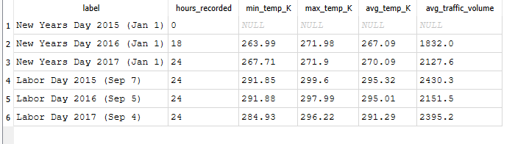
Identify notable year-on-year changes and discuss whether these changes appear relevant to traffic conditions.
Notable YoY Changes:
New Year's Day: 2016 - 2017 warmed by +3.00 degrees C (only one year-on-year comparison is possible, since 2015 has no data).
Labor Day: 2015 - 2016 was essentially flat (−0.31 degrees C). 2016 - 2017 noted a drop of −3.72 degrees C, the largest change observed in this analysis.
“Whether these changes appear relevant to traffic conditions”:
- For New Year's Day, average traffic volume also rose alongside the temperature increase (2016: 1,832.0 to 2017: 2,127.6, +16.1%), which is directionally consistent with warmer weather coinciding with more traffic. As indicated in the previous task 2017 had the highest overall traffic of any year in the given dataset and the temperature change can be considered as one of the factors rather than the only factor contributing to a YoY growth.
- For Labor Day, the relationship breaks down, as the average temperature changed only marginally (a decrease of -0.31 degrees C) between 2015 and 2016. However, traffic fell by 11.5% (2,430.3 – 2,151.5). Thereafter between 2016 and 2017 temperature dropped sharply by ~ - 3.72 degrees C (i.e. relatively cooler) but traffic registered an increase of 11.3% (2,151.5 to 2,395.2) which is contrary to what one might expect if cooler weather suppressed travel. So, this mismatch indicates that temperature is not a strong driver of changes in traffic for Labor Day.

