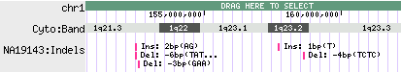
SNPs uploaded into track named “NA19143:Indels”
Individual indels, indicating type, size, and sequence.

