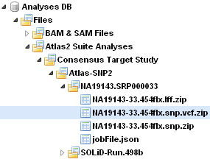
Your study
Your job
Result files
Another job

