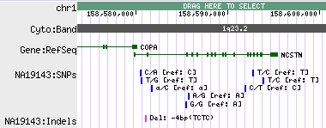
SNPs uploaded into track named “NA19143:SNPs”
Individual SNPs, indicating the Ref and Alt alleles

