1. Задание 1

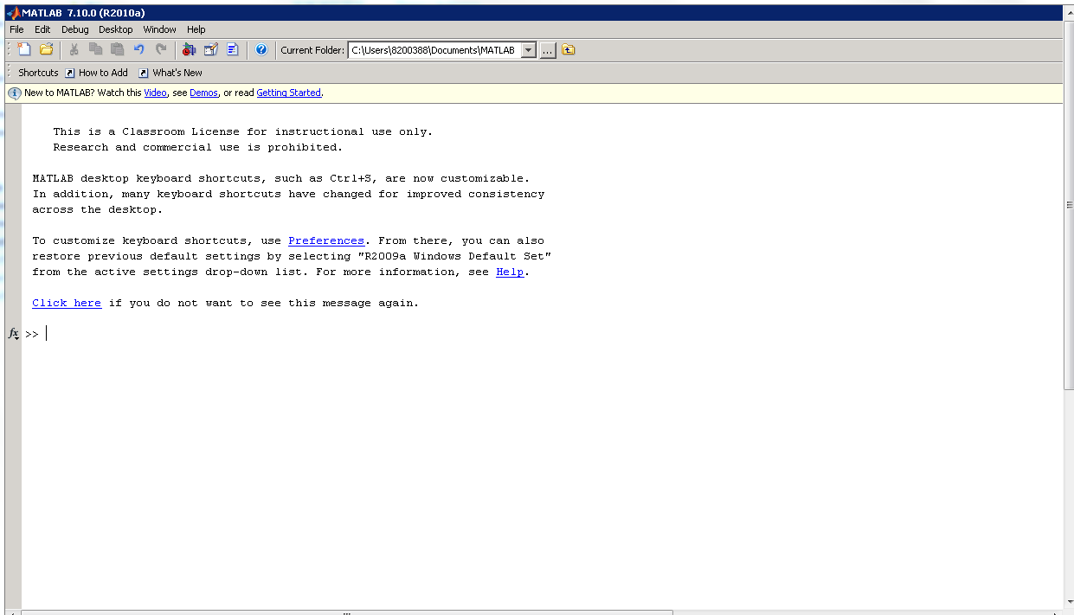

1. Задание 2

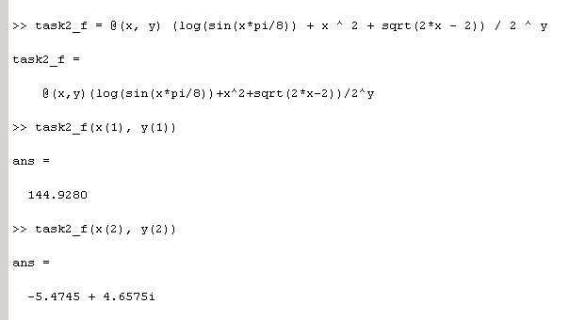

1. 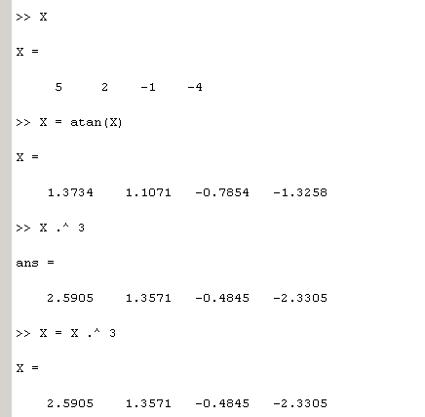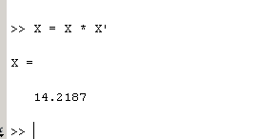
2. 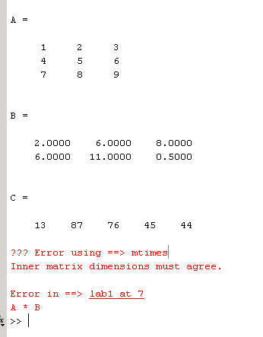

Умножение не было выполнено, тк у матриц не совпадают измерения.

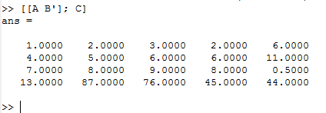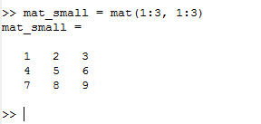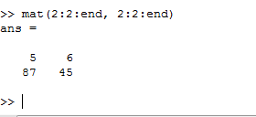

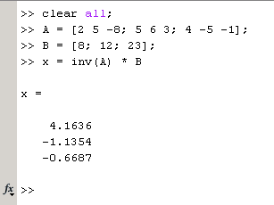

1. Задание 5

clc; clear all; clf; close all;

func1 = @(x) x - sin(3 * x);

func2 = @(x) x / sin(x);

% START func1

subplot(2, 2, 1)

hold on, grid on, axis equal

x_lim = [-10 10];

ezplot('x - sin(3 * x)', x_lim)

title('ezplot, func1')

xlim(x_lim)

ylim(x_lim)

subplot(2, 2, 3)

hold on, grid on, axis equal

fplot(func1, x_lim)

title('fplot, func1')

xlim(x_lim)

ylim(x_lim)

% END func1

% START func2

subplot(2, 2, 2)

hold on, grid on, axis equal

ezplot('x / sin(x)', x_lim)

title('ezplot, func2')

xlim(x_lim)

ylim(x_lim)

subplot(2, 2, 4)

hold on, grid on, axis equal

fplot(func2, x_lim)

xlim(x_lim)

ylim(x_lim)

title('fplot, func2')

% END func2



% START func3

figure

subplot(1, 2, 1)

hold on, grid on, axis equal

func3 = 'x * sin(5*x)';

x_lim1 = [0, 2 * pi];

x_lim2 = [-2 * pi, 2 * pi];

ezpolar(func3, x_lim1)

title('0 : 2pi')

subplot(1, 2, 2)

ezpolar(func3, x_lim2)

title('-2pi : 2pi')

% END func3



% Ellipse

figure

hold on, grid on, axis equal

a = 5;

b = 4;

x1 = -3; y1 = 2;

t = -pi:0.01:pi;

x = x1 + (a * cos(t));

y = y1 + (b * sin(t));

plot(x, y);



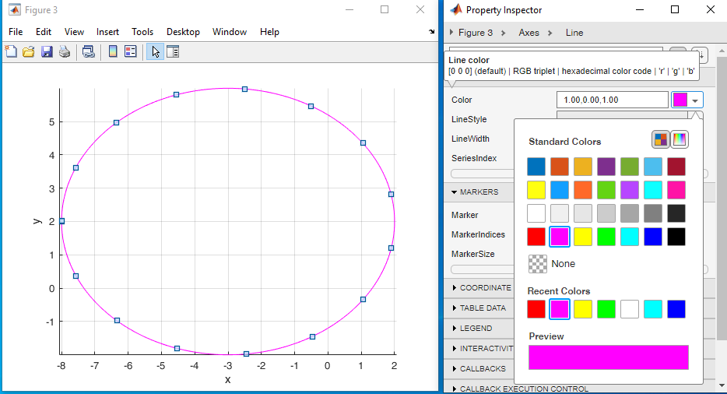

1. Задание 6.

clc; clear all; clf; close all;

t = -4.9:0.01:4.9;

x = sin(t);

y = 2 * cos(2 * t);

plot3(x, y, t)

title('plot3')

xlabel('x')

ylabel('y')

zlabel('t')

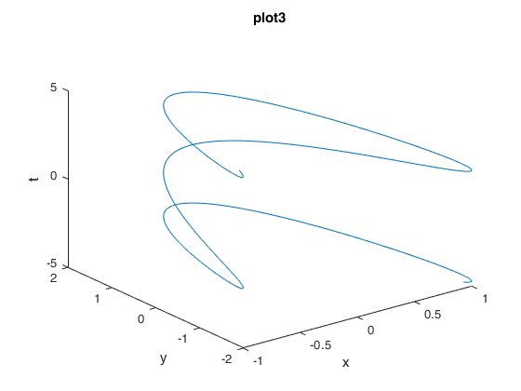

func = '(x ^ 2 + y ^ 2) / (5 * x * y) + log(x + y)';

ezsurf(func, [0 3 0 3])

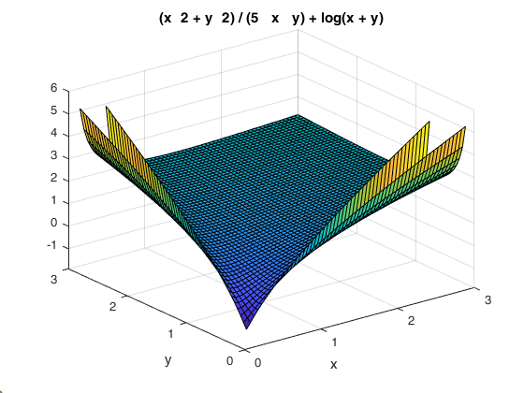

1. Задание 7

clc; clear all; clf; close all;

for i = 1:3

fprintf('for hello %d\n', i)

end

i = 0;

display("")

while i < 3

i = i + 1;

fprintf('while hello %d\n', i)

end

if i == 3

display("if hello")

end

switch i

case 3

display("switch hello")

otherwise

display("switch otherwise hello")

% factorial(-1)

assert(factorial(0) == 1, "Error")

assert(factorial(1) == 1, "Error")

assert(factorial(2) == 2, "Error")

assert(factorial(3) == 6, "Error")

assert(factorial(4) == 24, "Error")

display("factorial check is passed")