Bryce Moore

* Research using at least two credible sources, and then develop an outline for at least three advantages and disadvantages of features of five mobile app development solutions (i.e. Android Studio).
* *The Best Android Developer Tools for getting started*. Android Authority. (2021, April 9). Retrieved January 28, 2022, from https://www.androidauthority.com/best-android-developer-tools-671650/
* Demchenko, M. (2021, December 15). *Android IDES for developers*. NCube. Retrieved January 28, 2022, from https://ncube.com/blog/android-ides-for-developers

Android Studio is the most standard one so I feel that it doesn’t have any huge advantages or disadvantages, just mainly that it’s the most standardized one. I feel this because it is one of the most approachable while also allowing complexity if wanted. The main disadvantage I would say is that it doesn’t specialize in certain audiences, rather just pleases everyone. B4X is a lesser known option, I’d say mainly due to its target audience. This solution decides to prioritize people new to coding making it good for first projects, yet most people will move on from it to the more expansive other options. Xamarin’s approach to standing out is through sheer compatibility. It allows you to use Visual Studio to make apps, allowing accessibility to people who know C#, and the biggest thing it has going for it is the fact that it can build for any operating system which includes iOS and Windows. Android SDK stands for Software Development Kit, and it has a focus on libraries and features tools that can debug and compile. ADB shell is a big part of this as it serves as a small command line that can monitor a device while running apps. This promises to save time once you learn to use it more. Unity is a very popular and strong cross-platform engine that can be used for both 2D and 3D development. A big advantage of this is how it is a way more visual experience to learn, as you can drag around props and actively see what you are coding in. This makes it the most ideal along with Unreal for game development with the main difference between the two being that Unity is better for 2D development, while Unreal focuses more on 3D development.

* Research using at least two credible sources, and then in your own words define an AVD and how it is used in Android Studio?
* *Create and manage virtual devices  :   android developers*. Android Developers. (n.d.). Retrieved January 28, 2022, from https://developer.android.com/studio/run/managing-avds
* *How to create new AVD (virtual device) in Emulator in Android Studio*. Abhi Android. (n.d.). Retrieved January 28, 2022, from https://abhiandroid.com/androidstudio/create-avd-virtual-device-emulator-android-studio
* Appraise, and then recommend at least two alternative emulators used to emulate Android Apps.
* *15 best android emulators for PC and Mac of 2022*. Android Authority. (2022, January 5). Retrieved January 28, 2022, from https://www.androidauthority.com/best-android-emulators-for-pc-655308/

Blue stacks is the most commonly used android emulator that I know about, it is mainly used for playing games, and very quick to setup. Its downside however is that it is not made for app development, so you will have to find something else for that purpose.

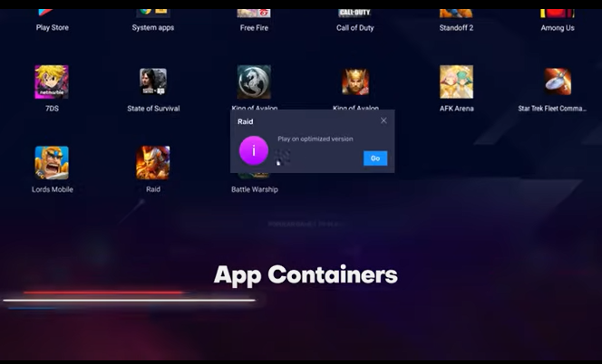

If you are looking for an alternative to Android Studio however, Genymotion fills the same purpose as a development focused emulator. It provides a lot of freedom for devices to test, and can even be used on the cloud as well as natively on your desktop, which is very useful for those with weak computers. The main downside however is that in order to use it for sale you do have to pay for it, but the services are entirely free for personal uses.

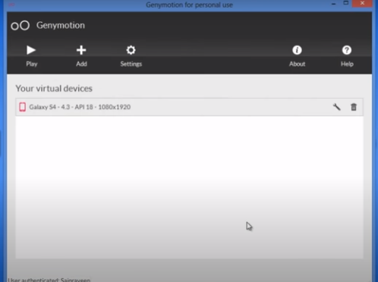

* Evaluate a mobile app that is used by an organization (university, business, charity, etc.) currently. Categorize the functionality of the mobile app in terms of how it has changed over time in the daily operations of the organization. Include a screen capture of the app.

Microsoft teams is a very commonly used app focused around communication. It is actively used by tons of universities, businesses, and more due to it’s simple interface and ease of use to set up meetings.

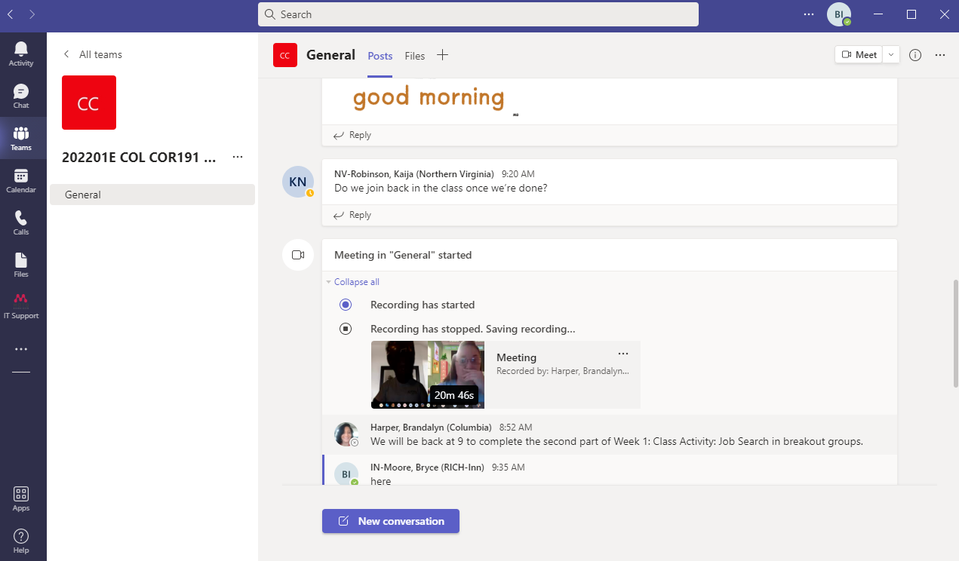

* Research, an everyday process in today’s society that may be improved by developing a mobile application, and then develop and defend your hypothesis.

I feel that a process that I could help minimize is scams and phishing successes. By helping people better actually understand the logic and such of them, I think that could help them stop being so successful. I specifically said actually understand, because most people understand that scams and phishing attempts are bad and to avoid clicking links if possible, but they do not understand how they work which restricts their understanding of why not to click minus their info gets stolen. I feel that if I spread awareness of how they work from a social engineering level and a coding/logic level, that could do a lot to combat their schemes.