# Part 1: The CNOSSOS-EU Model

The CNOSSOS-EU (Common Noise Assessment Methods in Europe) model has been developed by the EU JRC-IHCP (Joint Research Centre - Institute for Health and Consumer Protection) with the goal of providing a common noise modelling framework for Europe. Currently, individual organisations or countries apply their own models to noise pollution mapping. Although these models are often similar, they do not always give directly comparable results. The CNOSSOS-EU approach will allow harmonised modelled road, rail, industrial and aircraft noise to be compared for different regions across Europe.

For full details of the model, see the following publications:

Kephalopoulos, S., Paviotti, M. & Anfosso‐Lédée, F. (2012). Common Noise Assessment Methods in Europe (CNOSSOS‐EU) EUR 25379 EN. Publications Office of the European Union, Luxembourg.

Kephalopoulos, S., Paviotti, M., Anfosso-Lédée, F., van Maercke, D., Shilton, S., & Jones, N. (2014). Advances in the development of common noise assessment methods in Europe: The CNOSSOS-EU framework for strategic environmental noise mapping. Science of the Total Environment. 482-483, 400-410.

The version of the noise model uses an implementation of the road traffic noise part of this framework, but adjusted to handle low resolution data sets that are widely available with European-wide coverage

Morley, D.W., de Hoogh, K., Fecht, D., Fabbri, F, Bell, M. , Goodman, P.S., Elliott, P., Hodgson, S., Hansell, A., and Gulliver, J. (2015). International scale implementation of the CNOSSOS-EU road traffic noise prediction model for epidemiological studies. Environmental Pollution

## Application of the CNOSSOS-EU model

The accuracy and precision of a noise model output depends on the input data supplied to it. The CNOSSOS-EU method can handle extremely detailed inputs concerning multiple reflections and diffractions from individual buildings and barriers, meteorology (air temperature and wind direction) variability in ground terrain (both land cover and surface heights), specifics of the road network (junction type, road gradient, traffic flows) and characteristics of the traffic fleet (vehicle types).

Detailed input data are ideal for modelling at a high spatial resolution, for example, at a city-wide scale. For a national level application, input data may not be available to this degree of detail or would be too computationally intensive to process. The solution to this, within the BioSHaRE project, is to adopt a national level version of the CNOSSOS-EU model based on less-detailed inputs, but with the ability to quickly produce accurate noise level estimates at receptor sites. The resultant input data are a low-resolution representation of the true environment.

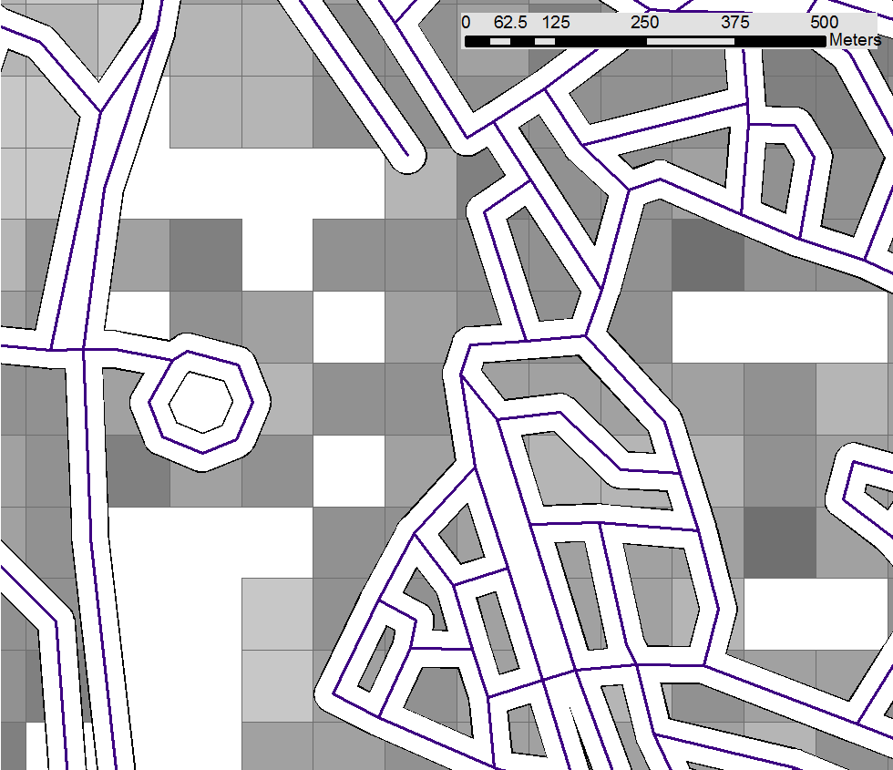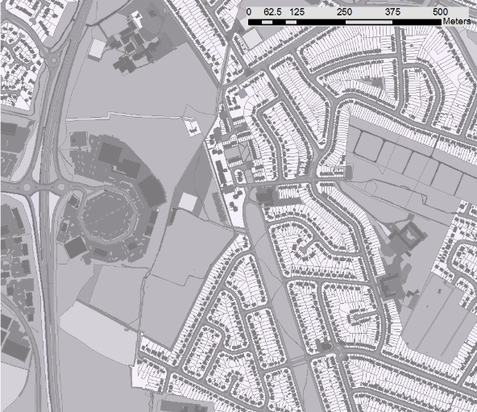

*The ‘true’ high resolution geographical representation from Ordnance Survey Master Map data (left) and the low resolution representation as used in the noise model here (right). The low resolution image shows the road network with 25m buffer and the 100m building height grid derived from landmap data. White areas indicate no buildings present while darker greys indicates taller buildings.*

## Model Inputs

The table below shows the required inputs of the CNOSSOS-EU road traffic noise model. The simplified version used here does not include the data sets that are marked with an ‘x’. This is because such data are either too difficult to acquire (road junction and surface type) or too intensive to process (topography and gradient).

|  |  |  |  |
| --- | --- | --- | --- |
|  | Data set | Description | Use |
|  | Traffic flow | Number of vehicles per hour on a road segment | On a particular road segment, the number of vehicles defines the total noise source |
|  | Vehicle type | Relative proportion of light vehicles (e.g. passenger cars) and heavy vehicles (e.g. lorries, buses) | A heavy vehicles contributes more noise than a light vehicle |
|  | Speed limits | Maximum legal limit or average speed (if available) according to road class and vehicle type | The speed of a vehicle effects the associated sound power output |
|  | Road network | Spatial layout of the road network | Sound propagation and contribution at a receptor site is based on the distance to, and the number of, nearby roads and associated traffic flow |
| X | Road junction type | Presence of roundabouts or crossings on a road segment | Influence on acceleration and deceleration and vehicle engine noise |
|  | Land cover | Mapped land cover types over the study area (buildings, grassland, woodland, water bodies etc.) | Distinction between sound absorbent (e.g. vegetation) and sound reflective surfaces (e.g. concrete) |
|  | Building heights | Height and location of buildings | Buildings act as a barrier to sound propagation |
|  | Air temperature | Annual average air temperature | As air temperature increases, traffic noise will decrease |
|  | Prevailing wind direction | Expected proportion of time wind can be expected from a certain direction (by quadrant) | A favourable (following) wind direction can aid sound propagation |
| X | Road surface type and age | Road surface material (e.g. concrete, asphalt) and age (condition) | Older roads and specific surface types lead to higher rolling noise levels |
| X | Studded tyre usage | Relative proportion of vehicles using studded (snow) tyres | Studded tyre use contributes to higher rolling noise levels |
| X | Road gradient | Slope of each road segment | Influence on acceleration and deceleration and vehicle engine noise |
| X | Topography | Elevation model of the study area | Line-of-sight between noise sources and receivers for sound propagation |

*Input data required by the CNOSSOS-EU road traffic noise model. The simplified version used in EnviroSHaPER does not include the datasets marked with an x.*

## Model output

Noise estimates are given as the A-weighted sound pressure level (LAeq) for a specified time interval. The A-weighting correction adjusts the relative importance of the predicted octave bands with respect to their relative perception by human hearing. Further to this, and from an epidemiological viewpoint, it has been recognised that noise exposure during different periods of the day are important. (European Directive on the Assessment and Management of Environmental Noise (2002/49/EC))

LDEN which gives an average noise exposure over 24 hours weighted (i.e. a penalty added) for the evening and night periods. Specific daily average noise metrics can also be calculated from hourly modelled estimates produced by CNOSSOS-EU such as LEVE (19.00 – 23.00), LNIGHT (23.00 – 07.00), LDAY (07.00 – 19.00) and LAEQ16 (07.00 – 23.00).

## Model functioning

### Spatial operations

The noise model functions on the principle of first locating all roads within 500m of a specific receptor point. These roads are then broken into segments of 20m (this distance can be user defined) length and propagation paths are projected to the receptor from the centre of each segment. Firstly, noise levels are estimated at the beginning (source) of each of these paths. Secondly, how this sound translates to the receptor along the propagation path is calculated.

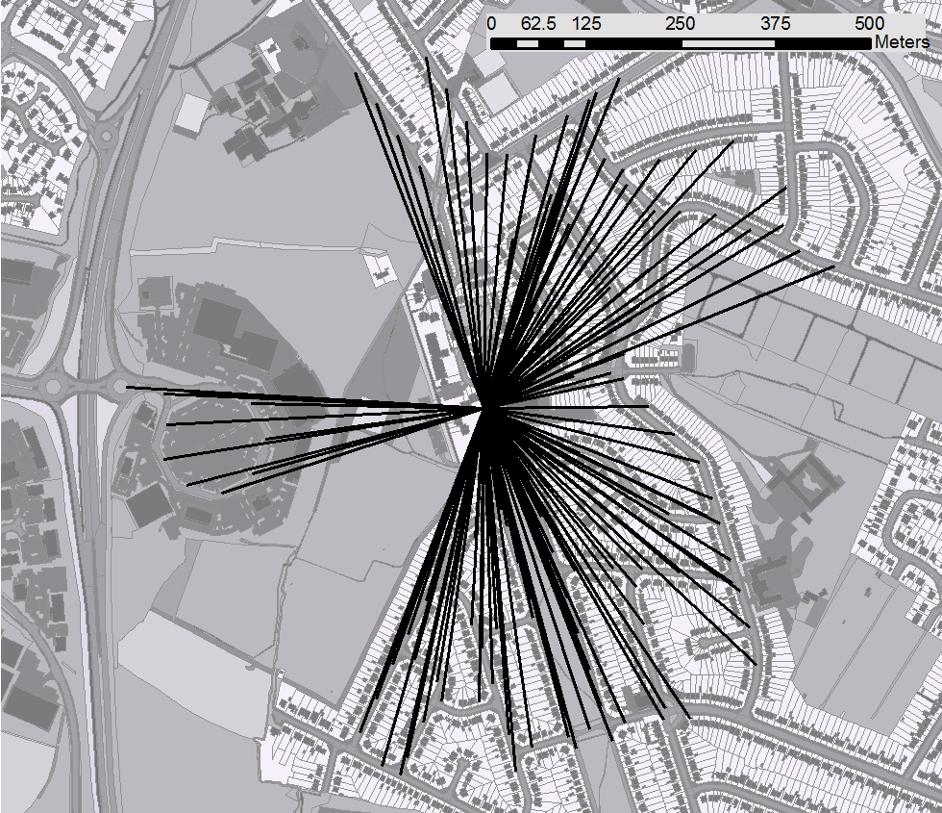

*An example of propagation paths radiating from a single receptor point. All roads within 500m of the receptor are divided into 20m segments and the centre point of each is joined directly to the receptor.*

### Road Traffic Noise

For each source point on the road network the noise emission is estimated as a combined contribution from rolling (tyre on road) and propulsion (engine) noise. Initially, this is calculated for an individual vehicle then scaled up according to traffic volume per road segment. Noise levels are estimated for each vehicle type (here, light and heavy) and for eight octave bands (between 63Hz to 8000Hz). These individual values are combined to a final total emission value using incoherent (logarithmic) summation.

Propulsion and rolling noise equations have been empirically derived for a set of reference conditions within the CNOSSOS-EU project. As such, it is possible to estimate these for an octave band and vehicle type by applying a set of coefficients and correcting the output according to the local traffic speed as defined by the road network data. The final total noise emission from a source point per octave is defined as the incoherent sum of rolling and propulsion noise. How this source sound then translates to what is heard at the receptor is dealt with by the sound propagation model.

### Sound Propagation

As sound travels from a source (road) to a receptor, it suffers from attenuation due to various factors. The most obvious of these is the distance over which the sound must travel and is accounted for by a correction based on the spherical spreading of energy, the angle of view of each road segment from the receptor is accounted for in this calculation. A more acute angle of view equates to a lower received sound level form a source. The land cover type of which the sound is travelling is important, soft ground such as vegetation and un-compacted soil will absorb sound while dense surfaces such as concrete and asphalt will lead to reflection. Atmospheric absorption is accounted for in a separate correction as it is wavelength as well as distance dependant.

The role of buildings obstructing a propagation path is dealt with by calculation of the attenuation due diffraction. This is primarily based on calculating the additional distance a sound ray must travel to be diffracted over a building (or buildings) of a given height.

The CNOSSOS-EU model makes the distinction between homogenous and favourable meteorological conditions for sound propagation. Favourable conditions occur when a following wind direction allows sound rays to curve over obstacles. This is accounted for in the model by finding the prevailing wind direction for a source site from meteorological data. Attenuation is therefore calculated under both homogenous and favourable conditions and weighted according to the probability of favourable conditions being found.

After all possible contributions to attenuation are calculated for a path, they are subtracted from the initial total noise level calculated at the source. To arrive at a final noise level at a single receptor, the contributions of all propagation paths are combined.

### Summary

The model proceeds as follows:

1. Find all roads intersecting a 500m buffer around a receptor point. If no roads found, take the first within a 2000m buffer
2. Buffer all roads within the search radius to 25m
3. Break each road source line into a series of source points at 20m intervals.
4. Project rays from each road point source to the receptor. Then for each ray:

* Find the intersection of each ray with the land cover to calculate the absorption coefficient
* Find intersection of each ray with the building height layer to find the position along the ray at which the first building is encountered and the position at which the final building is encountered. A 25m (corresponding to the road buffer) buffer around the receptor point is also needed in case the receptor point is ‘walled in’ by the representation of buildings in the model
* Calculate average building height along the ray path

1. Values for each ray path can then be inputted into the CNOSSOS-EU mathematical model
2. CNOSSOS-EU noise estimates for ray paths from the receptor are summed together logarithmically to give the final noise estimate.

For a detailed description of how the model works, see Kephalopoulos et al. (2012).



# Part 2: Running the Model

See the appendix below for a description of the datafiles needed.

These parameters need to be set in sql script

**Road buffer (**road_buf**)**: Apply a buffer around the road network (default 25m). This essentially creates a new land cover class for roads which is compatible with the coarse CORINE land cover data used in the model.

**Receptor buffer (**pnt_buf**)**: Apply a buffer around the receptor points (default 25m). This again ensures that the CORINE land cover is compatible and ensures that a point is not ‘walled-in’ by the representation of the urban extent.

**Road search radius (**radius**)**: Limit in which to search from the receptor point for road segments to contribute to the noise estimate (default 500m)

**Road segmentation (**seg_dst**)**: Step size by which to divide up the road segments for the creation of ray paths (default 20m).

These lines of code run the model in Postgres:

drop table if exists output;

select csharp_loop_mimic();

select * from output limit 100;

copy output to 'C:/Program Files/PostgreSQL/9.2/data/output.csv' delimiter ',' csv header;

# Appendix 1: Input data descriptions

**Receptors**

|  |  |  |
| --- | --- | --- |
| Field | Type | Definition |
| Geom | Geometry (Point) | Location of receptor |
| GID | Integer | Unique ID of receptor |
| … | … | Descriptor columns (optional) |

**Land cover**

|  |  |  |
| --- | --- | --- |
| Field | Type | Definition |
| Geom | Geometry (Polygon) | CORINE Land cover polygon |
| Code_06 | Text | CORINE Land cover code. 3 characters, e.g. 111 is continuous urban fabric |

**Building heights**

|  |  |  |
| --- | --- | --- |
| Field | Type | Definition |
| Geom | Geometry (Polygon) | Building or urban area polygon |
| Height | numeric | Building height in metres |

**Temperature**

|  |  |  |
| --- | --- | --- |
| Field | Type | Definition |
| Geom | Geometry (Point) | Location of met station |
| Air_temp | numeric | Annual average temperature in degrees Celsius |
| src_id | numeric | Unique ID of met station |

**Wind direction**

|  |  |  |
| --- | --- | --- |
| Field | Type | Definition |
| Geom | Geometry (Point) | Location of met station |
| NE | numeric | Proportion of time annually wind is from NE |
| SE | numeric | Proportion of time annually wind is from SE |
| SW | numeric | Proportion of time annually wind is from SW |
| NW | numeric | Proportion of time annually wind is from NW |
| src_id | numeric | Unique ID of met station |

**Road network and Traffic Flow**

|  |  |  |
| --- | --- | --- |
| Field | Type | Definition |
| Geom | Geometry (Line) | Road segment |
| qh_0 | numeric | Heavy vehicles per hour at 0.00 (midnight) – 1.00 |
| ql_0 | numeric | Light vehicles per hour at 0.00 (midnight) – 1.00 |
| qh_1 | numeric | Heavy vehicles per hour at 1.00 – 2.00 |
| ql_1 | numeric | Light vehicles per hour at 1.00 – 2.00 |
| qh_2 | numeric | Heavy vehicles per hour at 2.00 – 3.00 |
| ql_2 | numeric | Light vehicles per hour at 2.00 – 3.00 |
| qh_3 | numeric | Heavy vehicles per hour at 3.00 – 4.00 |
| ql_3 | numeric | Light vehicles per hour at 3.00 – 4.00 |
| qh_4 | numeric | Heavy vehicles per hour at 4.00 – 5.00 |
| ql_4 | numeric | Light vehicles per hour at 4.00 – 5.00 |
| qh_5 | numeric | Heavy vehicles per hour at 5.00 – 6.00 |
| ql_5 | numeric | Light vehicles per hour at 5.00 – 6.00 |
| qh_6 | numeric | Heavy vehicles per hour at 6.00 – 7.00 |
| ql_6 | numeric | Light vehicles per hour at 6.00 – 7.00 |
| qh_7 | numeric | Heavy vehicles per hour at 7.00 – 8.00 |
| ql_7 | numeric | Light vehicles per hour at 7.00 – 8.00 |
| qh_8 | numeric | Heavy vehicles per hour at 8.00 – 9.00 |
| ql_8 | numeric | Light vehicles per hour at 8.00 – 9.00 |
| qh_9 | numeric | Heavy vehicles per hour at 9.00 – 10.00 |
| ql_9 | numeric | Light vehicles per hour at 9.00 – 10.00 |
| qh_10 | numeric | Heavy vehicles per hour at 10.00 – 11.00 |
| ql_10 | numeric | Light vehicles per hour at 10.00 – 11.00 |
| qh_11 | numeric | Heavy vehicles per hour at 11.00 – 12.00 |
| ql_11 | numeric | Light vehicles per hour at 11.00 – 12.00 |
| qh_12 | numeric | Heavy vehicles per hour at 12.00 – 13.00 |
| ql_12 | numeric | Light vehicles per hour at 12.00 – 13.00 |
| qh_13 | numeric | Heavy vehicles per hour at 13.00 – 14.00 |
| ql_13 | numeric | Light vehicles per hour at 13.00 – 14.00 |
| qh_14 | numeric | Heavy vehicles per hour at 14.00 – 15.00 |
| ql_14 | numeric | Light vehicles per hour at 14.00 – 15.00 |
| qh_15 | numeric | Heavy vehicles per hour at 15.00 – 16.00 |
| ql_15 | numeric | Light vehicles per hour at 15.00 – 16.00 |
| qh_16 | numeric | Heavy vehicles per hour at 16.00 – 17.00 |
| ql_16 | numeric | Light vehicles per hour at 16.00 – 17.00 |
| qh_17 | numeric | Heavy vehicles per hour at 17.00 – 18.00 |
| ql_17 | numeric | Light vehicles per hour at 17.00 – 18.00 |
| qh_18 | numeric | Heavy vehicles per hour at 18.00 – 19.00 |
| ql_18 | numeric | Light vehicles per hour at 18.00 – 19.00 |
| qh_19 | numeric | Heavy vehicles per hour at 19.00 – 20.00 |
| ql_19 | numeric | Light vehicles per hour at 19.00 – 20.00 |
| qh_20 | numeric | Heavy vehicles per hour at 20.00 – 21.00 |
| ql_20 | numeric | Light vehicles per hour at 20.00 – 21.00 |
| qh_21 | numeric | Heavy vehicles per hour at 21.00 – 22.00 |
| ql_21 | numeric | Light vehicles per hour at 21.00 – 22.00 |
| qh_22 | numeric | Heavy vehicles per hour at 22.00 – 23.00 |
| ql_22 | numeric | Light vehicles per hour at 22.00 – 23.00 |
| qh_23 | numeric | Heavy vehicles per hour at 23.00 – 0.00 (midnight) |
| ql_23 | numeric | Light vehicles per hour at 23.00 – 0.00 (midnight) |
| speed1 | numeric | Maximum legal speed of light vehicles on segment |
| speed3 | numeric | Maximum legal speed of heavy vehicles on segment |