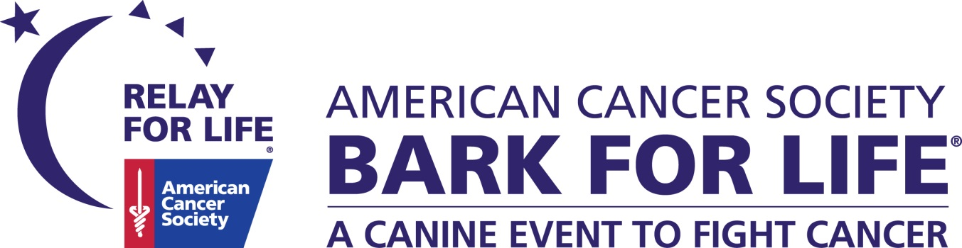

Dear Friend,

**We would like to invite you and your company to be a sponsor for the 2016 American Cancer Society Bark For Life of Oklahoma City’s premiere events: The Strollin’ Colon 5k Run and Night to Remember Walk.**

Bark For Life is an American Cancer Society Relay For Life community fundraising event that honors the caregiving qualities of our canine companions. Dogs are “Best Friends” and caregivers to their owners and families – now we are proud to say they are contributing to all of our cancer free futures. These events **CELEBRATE** the unconditional love that we receive from our pets, **REMEMBER** those that we have lost to cancer, and give us the opportunity to **FIGHT BACK** and find a cure for cancer.

March is Colon Cancer Awareness month and we will be hosting our second annual Strollin’ Colon 5k run on Saturday, April 2, 2016 at Wheeler Park. Last year, we had nearly 500 runners and educated over 600 attendees on colon cancer prevention.

“A Night to Remember” is scheduled for August 26, 2016 at Hafer Park in Edmond. By supporting our community fundraiser, you will help the American Cancer Society **SAVE LIVES**, and that helps us move closer to our ultimate goal of a world with less cancer and more birthdays. The American Cancer Society fights for every life threatened by every type of cancer in every community. The work we do impacts everyone and by sponsoring Bark For Life, your business will also have the opportunity to promote at many events year round.

We thank you in advance for becoming a supporter of our four-legged friends. Your tax deductible donation will help our community **FIGHT BACK** and win the battle against this disease that has taken so many loved ones from us.

Thank you!

Trisha Clark Lauren Polchisnki

Bark For Life Event Chair American Cancer Society Staff Partner

[trisha@a1petemporium.com](mailto:trisha@a1petemporium.com) [lauren.polchinski@cancer.org](mailto:lauren.polchinski@cancer.org) or 405-841-5819

**ORGANIZATION DESCRIPTION:**

The American Cancer Society combines an unyielding passion with nearly a century of experience to save lives and end cancer for good. As a global grassroots force of three million volunteers, we fight for every birthday threatened by every cancer in every community. We save lives by helping you stay well by preventing cancer or detecting it early, helping you get well by being there for you during and after a diagnosis, by finding cures through groundbreaking discovery and fighting back through public policy.

As the nation’s largest non-governmental investor in cancer research, contributing more than $3.8 billion, we turn what we know about cancer into what we do. As a result, an estimated 13.7 million people in America who have had cancer and countless more who have avoided it will be celebrating birthdays this year. To learn more about us or to get help, call us anytime, day or night, at [1-800-227-2345](tel:1-800-227-2345) or visit [cancer.org](http://cancer.org/).

**HOW DOES YOUR DONATION DIRECTLY CREATE A WORLD WITH LESS CANCER AND MORE BIRTHDAYS?**

The American Cancer Society offers numerous programs and services at *no cost to patients.*

* Free wigs for those undergoing treatment
* Road to Recovery provides free rides to life-saving treatment
* Guest Room helps locate free or reduced-rate hotel rooms for commuting patients.
* The American Cancer Society is the largest funder of cancer research besides the U.S. Government and has funded 46 Nobel Prize laureates for their life-saving research.
* 1-800-227-2345, a 24/7 phone line with patient navigators to help answer patients’ questions and locate resources to make their cancer journey easier.

**2015 BARK FOR LIFE EVENT SPONSORS**

|  |  |
| --- | --- |
| VCA Kickingbird Animal Hospital | Integris Health * Strollin Colon Run Presenting Sponsor* |
| Jam Events and Productions | Raising Canes |
| A1 Pet Emporium | Full Circle Obedience |
| Dog Talk with Pat Becker | Jersey Mikes |
| Mercury Network | TLC Chiropractic |
| Logan County Asphalt Co. | McClains RV |
| Triangle Industries | John Vance Autogroup |
| Humana | Nestle Purina |
| Valir Hospice | Red Coyote |
| Rib Crib | All About Pets |
| Kind Bars | Oklahoma Senior Journal |
| Gentle Care Animal Hospital | Best Feet Forward |

2016 Bark For Life of Oklahoma City Sponsorship Opportunities

|  |  |  |  |  |  |  |
| --- | --- | --- | --- | --- | --- | --- |
| **Sponsorship**  **Opportunities** | **Presenting**  **Best In Show**  **$2500** | **Top**  **Dog**  **$1000** | **Leader of the**  **Pack**  **$750** | **Tail-Wagger**  **$500** | **Bow-Wow**  **$250** | **Best**  **Friend**  **(Vendor Space)**  **$50 per event**  **$125 for ALL** |
| Vendor space  All 2016 events* |  |  |  |  |  |  |
| Company’s business card/ promotional item in participant bags |  |  |  |  |  |  |
| Recognition at opening ceremony of event |  |  |  |  |  |  |
| Included in pre- and  post-event publicity  Radio, TV, Print and Social Media |  |  | Social Media Only | Social Media Only | Social Media Only | Social Media Only |
| Company name or logo  displayed on  Bark for Life OKC website | (Logo) | (Logo) | (Logo) | (Name) | (Name) |  |
| Company name or logo included on back of event t-shirt  & on posters | (Logo) | (Logo) | (Name) | (Name) |  |  |
| Bring your company banner  to be displayed at event |  |  |  |  |  |  |
| Number of complimentary event  t-Shirt(s)  NIGHT TO REMEMBER WALK | 5 | 2 | 1 |  |  |  |
| Number of complimentary registrations for each event  Plus $5 off additional employee registrations (Pre- Registration Only) | 5 runners at each run plus 10 Dog entries for Bark for Life | 2 runners at each run plus 5 Dog entries for Bark for Life |  |  |  |  |
| **At your request, we'll provide a free table** |  |  |  |  |  |  |
| Signage along route for Strollin’ Colon and Night To Remember |  |  |  |  |  |  |

Please indicate sponsorship level and information below. Return completed form to: The American Cancer Society,

Attn: Bark for Life OKC 6525 N. Meridian #110 Oklahoma City, OK 73116. You may also fax your form to: 405.848.0795

Please direct questions to Lauren Polchinski at [lauren.polchinski@cancer.org](mailto:lauren.polchinski@cancer.org) or 405-841-5819

_____ $2500 _____ $1000 _____ $750 _____ $500 _____ $250 _____ $50 _____ $125

Company Name:______________________________________________________________________

Address:_____________________________________________________________________________

City, State, Zip:________________________________________________________________________

Contact Name:_____________________________________Phone:_____________________________

For Best in Show, Top Dog and Leader of the Pack sponsorship levels, please indicate the size(s) of t-shirt(s) you would like. T-shirts are available in S, M, L, XL and 2XL. ________________________________________

**2016 Bark For Life Events:** * Strollin Colon Run- April 2 at Wheeler Park * Bark in the Park- June 11 at Duffner Park

* A Night to Remember Walk- Aug. 26 at Hafer Park