UNIVERSITY OF TRENTO

**Department of Information Engineering and Computer Science**

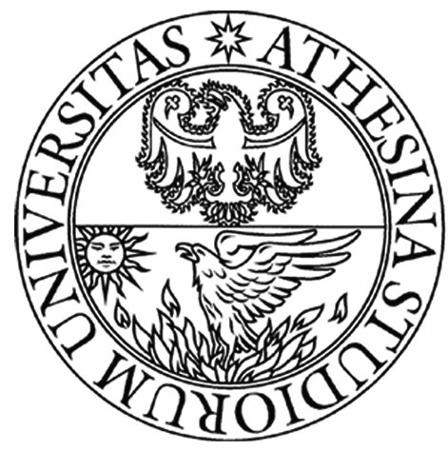

**Bachelor’s Degree in Computer Science**

**final dissertation**

**Evaluating MongoDb Performance:**

***How and where NoSQL databases are getting over Relational Databases***

|  |  |
| --- | --- |
| **Supervisor**  **Alberto Montresor** | **Student**  **Michele Romani** |

**Academic year 2015/2016**