**Integrating Machine Learning With DevOps**

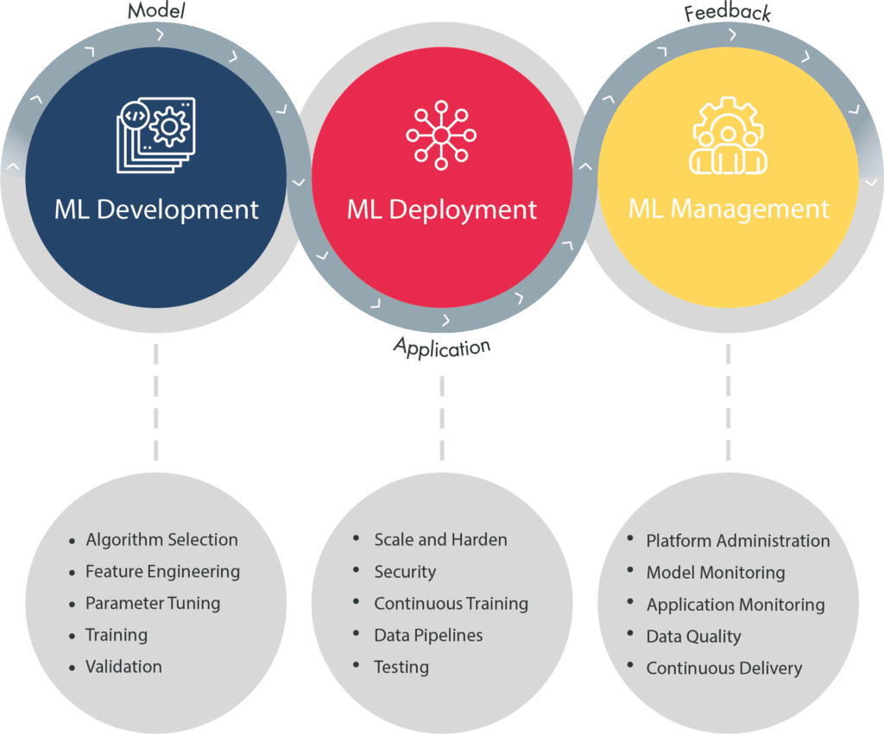

**TASK** **OBJECTIVE:**

1. Create container image that’s has Python3 and Keras or numpy installed using dockerfile

2. When we launch this image, it should automatically starts train the model in the container.

3. Create a job chain of job1, job2, job3, job4 and job5 using build pipeline plugin in Jenkins

4. Job1 : Pull the Github repo automatically when some developers push repo to Github.

5. Job2 : By looking at the code or program file, Jenkins should automatically start the respective machine learning software installed interpreter install image container to deploy code and start training( eg. If code uses CNN, then Jenkins should start the container that has already installed all the softwares required for the cnn processing).

6. Job3 : Train your model and predict accuracy or metrics.

7. Job4 : if metrics accuracy is less than 80% , then tweak the machine learning model architecture.

8. Job5: Retrain the model or notify that the best model is being created

9. Create One extra job job6 for monitor : If container where app is running. fails due to any reason then this job should automatically start the container again from where the last trained model left.

**WORKFLOW:**

## Creating Dockerfile:

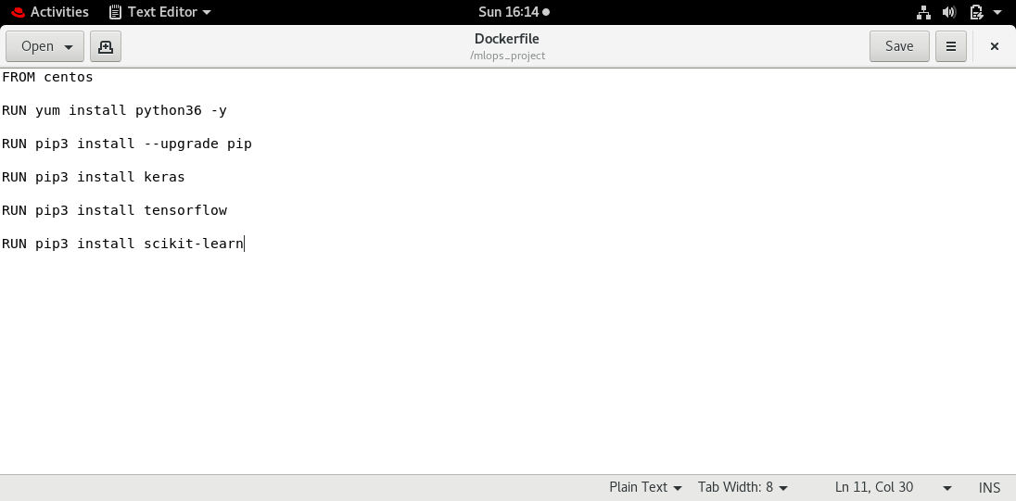

After this use this command to build the image using Dockerfile.

Syntax-

docker build -t dlos:v1 /mlops/

2. We will write a code, save it as .py extension and push the code to the github.

3.  Job_1- This job will automatically copy the files from my github repository to my workspace in redhat.

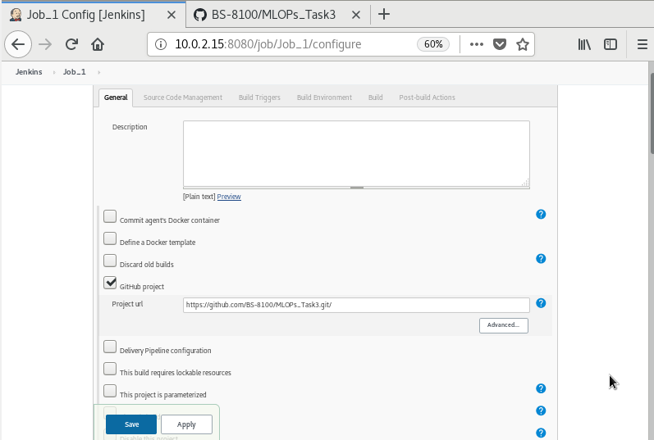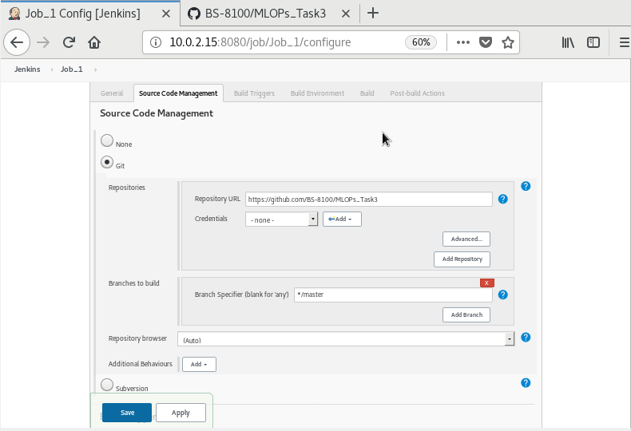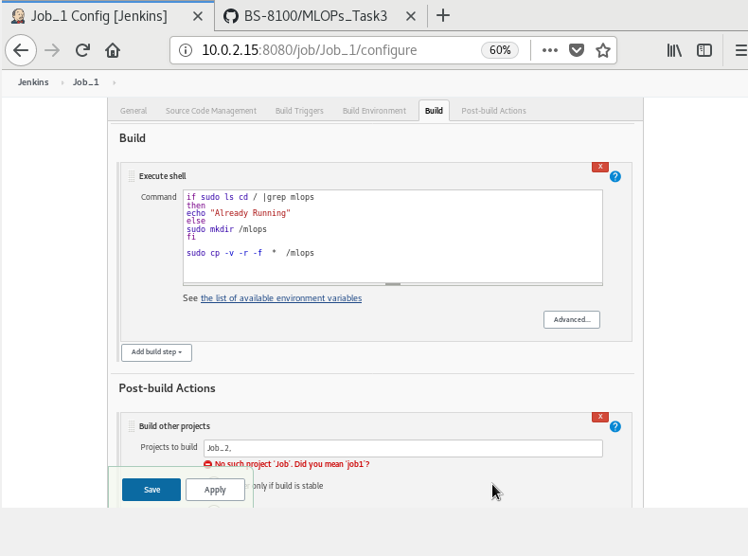

Job_2:Respective containers will be started and code will be deployed in for ML or DL.

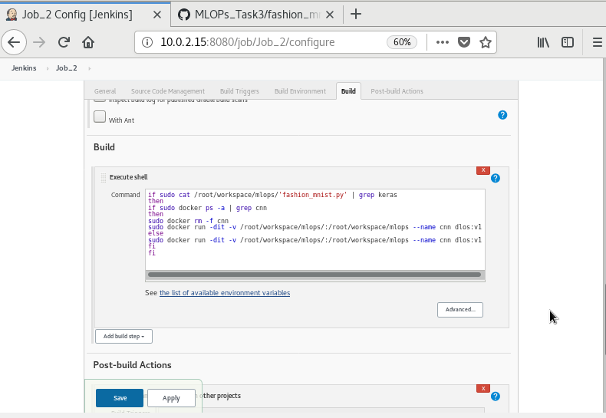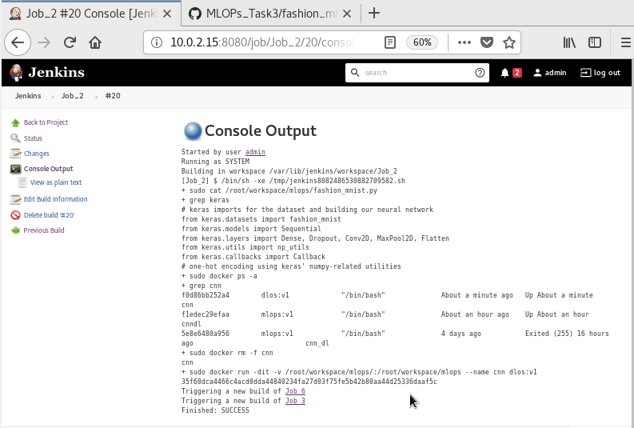

### Job_3: Model Training

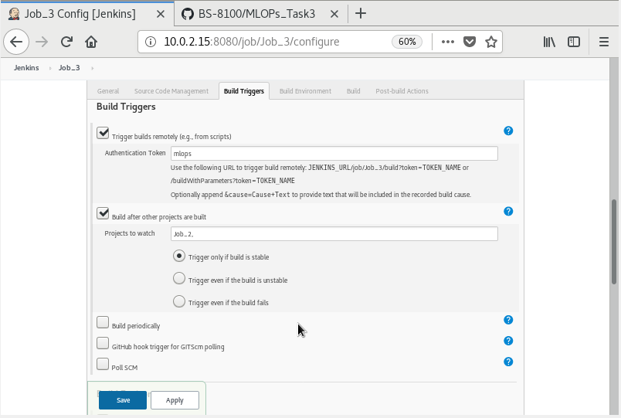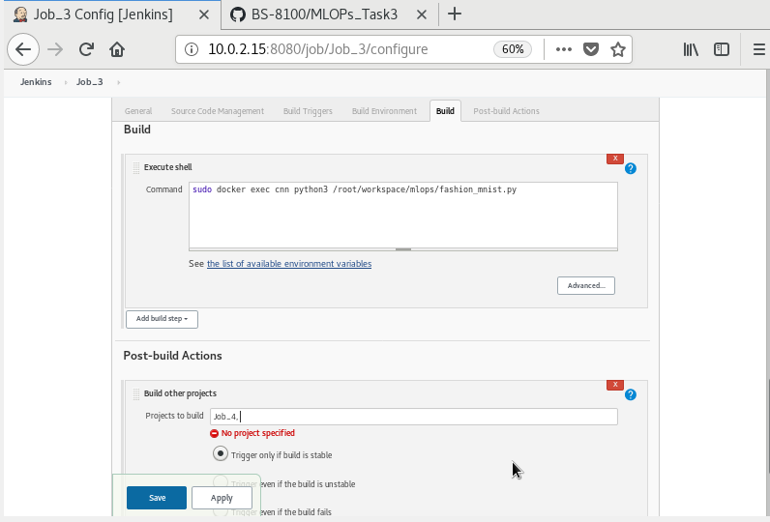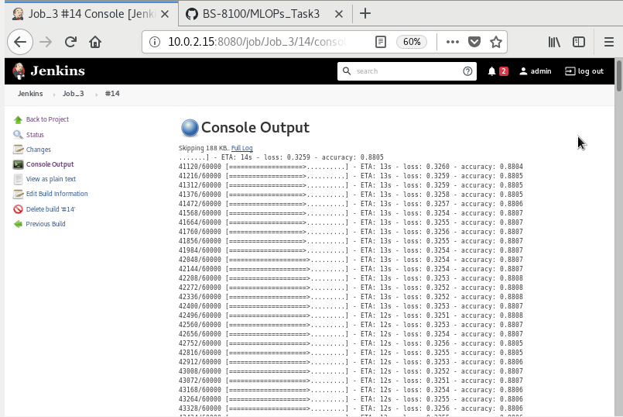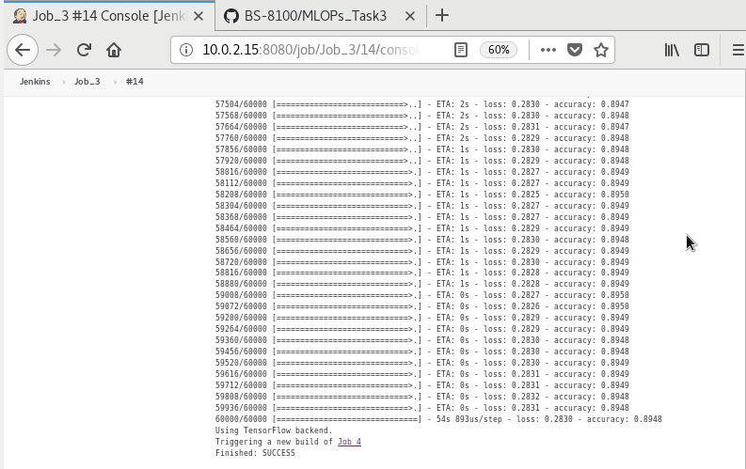

The accuracy achieved was 89%

### Job 4 : Retraining model

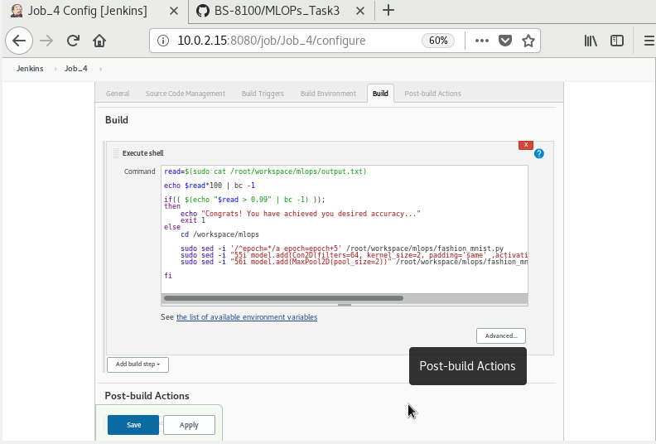

Job_5:Sending Email

Email will be sent if particular accuracy isn't achieved.

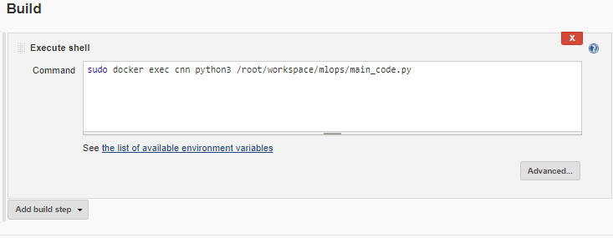

This command will run the container using Python3 to execute our main_code.py file.

Job_6:Monitoring

If container stops by any error this will automatically start the container from same state

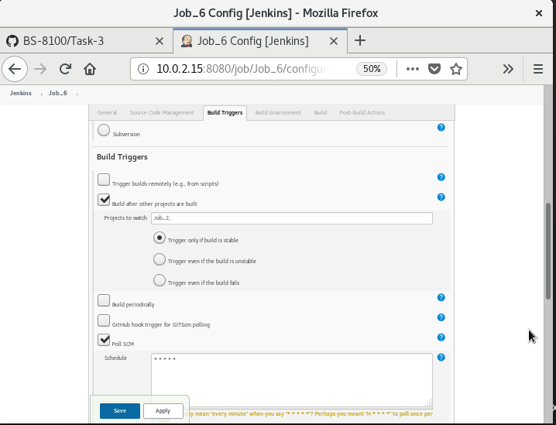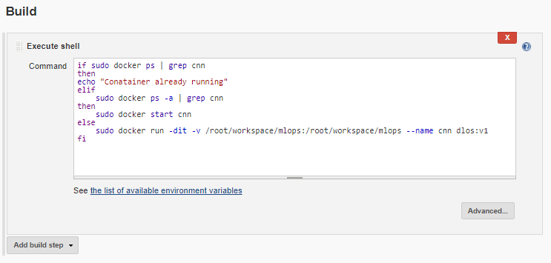

If the container has stopped it will automatically start the container by visiting Job3 and start the process again.

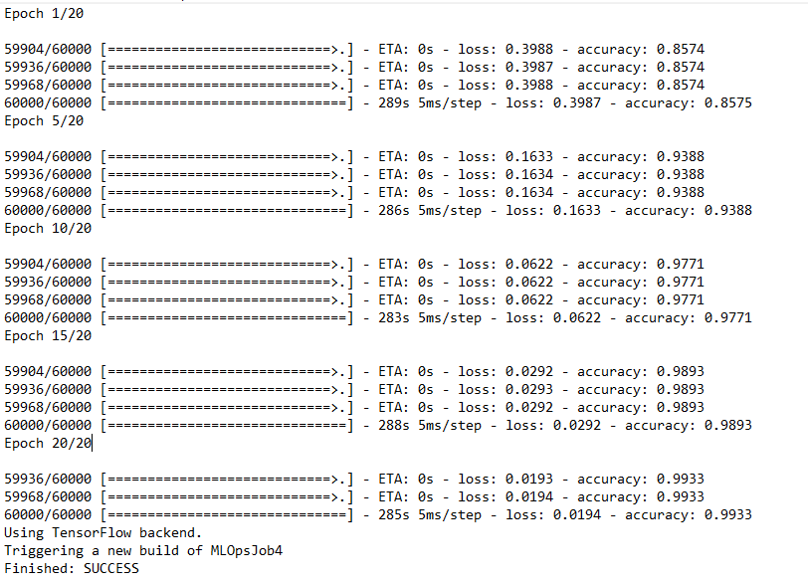

**Note:**Still I am trying to improve the project, so keep checking the article for updates.