Martel Steenblik
Professor Rabih Dimachki
OSC 2030-002
29 July 2026
Deloitte's Use of Business Statistics
INTRODUCTION
Deloitte provides; audit, tax, consulting, advisory, and technology services to major corporations and firms. It takes its name from William Welch Deloitte, who opened the original firm in London (“Our Heritage”). In fiscal year 2025, Deloitte reported $70.5 billion in global revenue and had more than 470,000 employees worldwide (“Deloitte Reports FY2025 Revenue”). Because Deloitte provides audits to large firms statistics help turn raw data into useful descriptive evidence.
BUSINESS PROBLEMS
Deloitte’s business problem is proving technology can create value. Many firms are adopting AI because they expect higher efficiency. However, Deloitte’s GenAI survey found that 54% of firms wanted efficiency and productivity improvements, but only 38% tracked employee productivity (“Despite Increased Investment”). This creates a problem because companies may be spending heavily on technology without collecting data to see if productivity is improving.
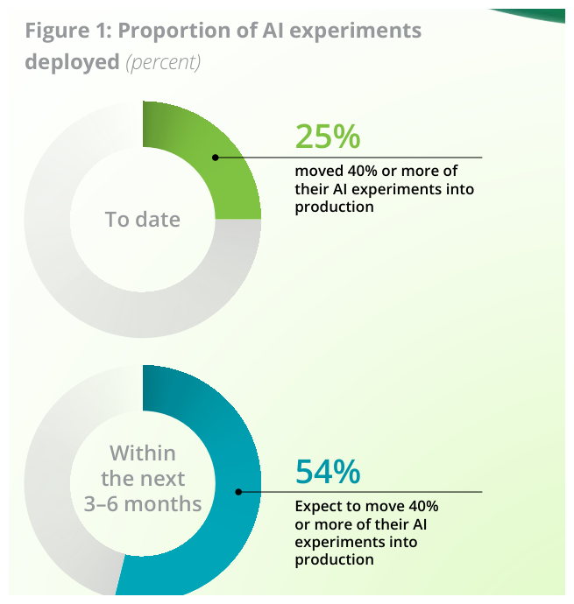
Deloitte source chart showing the share of AI experiments moved into production. Source: Deloitte, State of AI in the Enterprise, p. 8.
Another problem is workforce readiness. When companies adopt AI, employees need the skills to use it. Deloitte’s 2026 State of AI report shows that AI adoption changes workforce strategy in several ways, including hiring, and worker trust (“State of AI” 14). This creates a problem because a company may invest in new technology but fail to get full value from it if employees are not prepared to use it. The source chart below shows AI adoption changes.
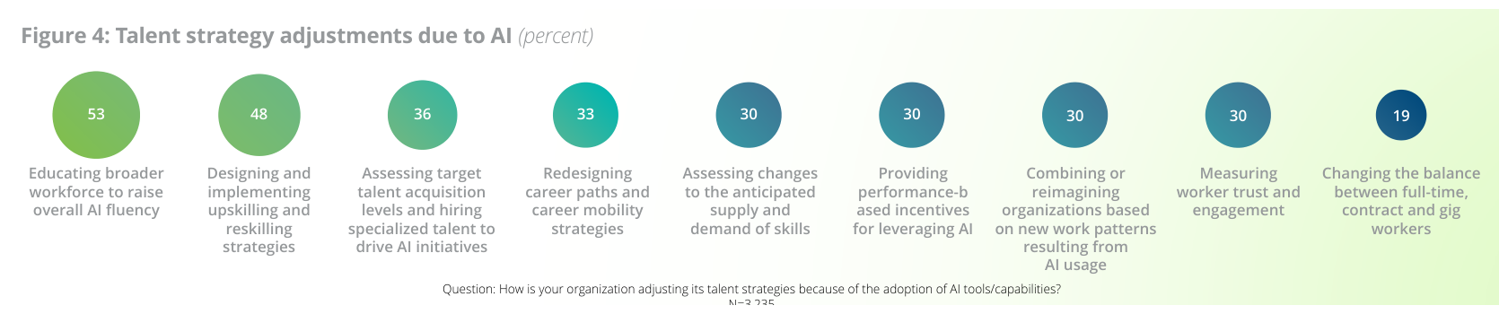
Deloitte source chart showing talent strategy adjustments related to AI adoption. Source: Deloitte, State of AI in the Enterprise, p. 14.
The final problem is data credibility. As an accounting firm, Deloitte helps clients make large financial datasets. A company’s records may include unusual transactions, duplicate entries, and incorrect classifications. This creates a serious problem because audit depends on whether the data being tested is reliable enough to support conclusions. Statistical methods help Deloitte address this problem by highlighting records that deserve closer review. For example, Deloitte’s DataDoc identifies irregularities in large datasets (“Finding Irregularities”). However, DataDoc is not the solution itself and may require human review.
DATA COLLECTION METHODS
Deloitte uses quantitative and qualitative data. Quantitative data includes survey percentages, productivity measures, cost savings, employee counts, audit records, and transaction values. Qualitative data includes performance reviews, employee comments, and meeting notes. All cohorts using GenAI would be the population, while Deloitte’s 2,770 survey respondents would be the sample.
Deloitte also works with cross sectional and time series data. cross sectional example would be comparing companies at one point in time based on whether they track GenAI productivity. A time series example would be tracking productivity, cost savings, or audit exceptions before and after a technology investment.
CHARTS AND NUMERICAL MEASURES
Deloitte’s statistical work also depends on charts, tables, and numerical measures. The source chart below compares benefits firms already achieve with AI. In OSC chapter 2 we focus on graphs and tables, which is important when Deloitte presents findings to clients. A bar chart can compare companies increasing GenAI investment, and tracking productivity. A line chart could show productivity or audit exceptions over time.
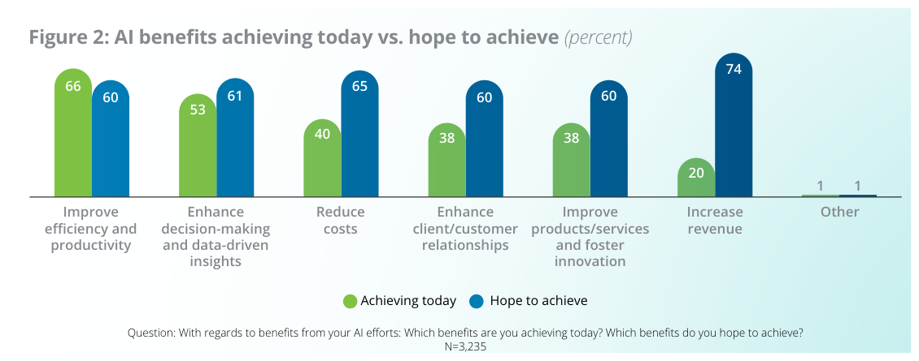
Deloitte source chart comparing AI benefits achieved today with benefits organizations still hope to achieve. Source: Deloitte, State of AI in the Enterprise, p. 10. Steenblik 3
OSC chapter 3 focuses on numerical measures such as proportions, means, and variation. In this project, the key numerical measure is a sample proportion. Deloitte reported that 38% of surveyed firms track employee productivity from GenAI (“Despite Increased Investment”). Deloitte can use the mean to compare average productivity before and after a technology is introduced. And then compare it using standard deviation to show whether results are consistent.
ASSUMPTIONS AND LIMITATIONS
For the confidence interval and hypothesis test, the sample should be large enough, and the responses should not depend on each other. Deloitte’s GenAI survey had 2,770 respondents, which is large enough to use the population proportion formula. However, the results can still have sampling error because the survey is only a sample, not the entire population.
There are also other limits. The survey only included leaders who were already involved with GenAI, so it may not represent every company. The answers were also self reported, which means people may not always give perfect or complete information.
ESTIMATION
Estimation is used when a business wants to use sample data to understand a larger group. Deloitte’s survey included 2,770 leaders, but the goal is to understand similar firms beyond just the people who answered the survey. Deloitte found that 38% of the sample tracked employee productivity when using GenAI. This means the sample proportion is 0.38. Using a 95% confidence level:



The confidence interval is about 0.362 to 0.398, or 36.2% to 39.8%. This means Deloitte can be 95% confident that the true proportion of similar firms tracking productivity is somewhere in that range.
HYPOTHESIS TEST
A hypothesis test can also be performed using Deloitte’s GenAI survey data. The business question is; Are fewer than half of firms tracking employee productivity when using GenAI? This tests whether firms use measurable evidence to evaluate technology return on investment
The null hypothesis is H0: p = 0.50, meaning 50% of firms track productivity. The alternative hypothesis is Ha: p < 0.50, meaning fewer than 50% track productivity. Deloitte’s survey found that the sample proportion was 0.38, and the sample size was 2,770. Using the one-proportion z-test:


The z-score is -12.63. At the 0.05 significance level, the critical value is -1.645. Since -12.63 is less than -1.645, the null hypothesis is rejected. This means there is enough statistical evidence to say that fewer than half of similar firms track employee productivity when using GenAI. For Deloitte, this shows a real measurement problem.
REGRESSION AND CORRELATION ANALYSIS
Regression and correlation analysis from OSC chapter 14 would also be valuable. Correlation could show whether two things are related, such as whether more employee training is connected to higher productivity after a company starts using new technology. Regression goes a step further by estimating how many changes are caused by training hours, technology spending, workflow changes, and KPI tracking change. In this example, productivity improvement would be the dependent variable, while training hours, technology spending, and KPI tracking would be the independent variables.
This matters because Deloitte should not assume that spending more money on technology automatically improves performance. Some companies may only buy new tools without changing how employees work. Other companies may redesign their processes, train employees, and track results. The source chart below shows these different levels of business transformation. McKinsey also found that tracking clear KPIs for GenAI had one of the strongest connections to bottom-line impact (“State of AI”). Regression would not prove that one factor causes success by itself, but it could help Deloitte see which factors are most connected to better results.
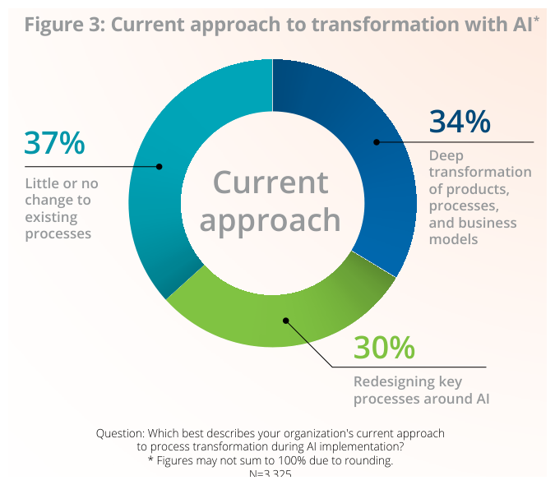
Deloitte source chart showing different levels of business transformation with AI. Source: Deloitte, State of AI in the Enterprise, p. 11.
CHALLENGES
One challenge Deloitte faces is that ROI is hard to measure. A company may use AI in many different parts of the business, so it can be difficult to tell exactly what caused the improvement. Deloitte explains that AI ROI can be hard to prove because some benefits are not easy to measure, and employees may not fully adopt the tools (“AI ROI”). Data quality is another challenge. Deloitte’s State of AI report shows that firms feel less prepared in areas like data management, risk, governance, and talent than they do in overall strategy (“State of AI” 28).
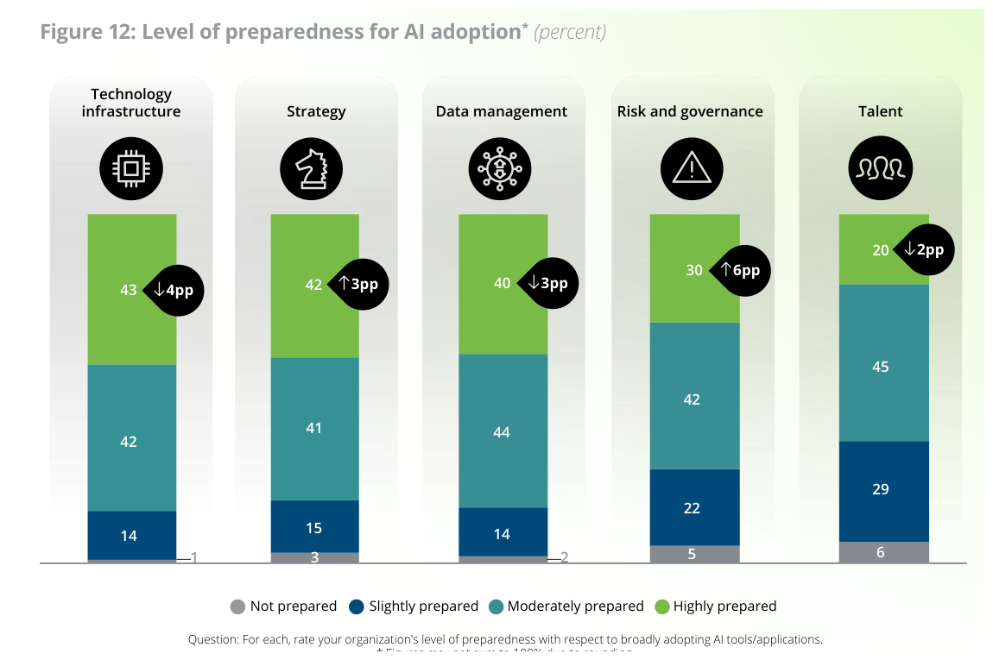
Deloitte source chart showing organizational preparedness for AI adoption across infrastructure, strategy, data, risk, and talent. Source: Deloitte, State of AI in the Enterprise, p. 28.
IMPACT
Statistics helps Deloitte make recommendations based on evidence. The confidence interval and hypothesis test show that the productivity measurement gap is real. If a client is spending a lot of money on AI but is not tracking productivity, Deloitte could recommend waiting before expanding. The client should first create KPI dashboards, measure productivity before the rollout, and collect data after the rollout.
CONCLUSION
This project showed me how statistics can be used to solve business problems connected to; technology, and data credibility. More importantly, overall this class has helped prepare me for future work in business related fields by showing me how data can support stronger decision making. Concepts such as data collection, charts, numerical measures, confidence intervals, hypothesis testing, and regression analysis are tools that can help business professionals provide statistical insight and make evidence based recommendations.

Works Cited
Deloitte. “AI ROI: The Paradox of Rising Investment and Elusive Returns.” Deloitte, 22 Oct. 2025, www.deloitte.com/ca/en/services/consulting/perspectives/ai-investment-where-the-real-roi-lies.html. Accessed 15 July 2026.
Deloitte. “Deloitte Reports FY2025 Revenue.” Deloitte, 30 Sept. 2025, www.deloitte.com/global/en/about/press-room/global-revenue-announcement.html. Accessed 15 July 2026.
Deloitte. “Despite Increased Investment and Early Enthusiasm, Data and Risk Remain Key Challenges to Scaling Generative AI, Reveals New Deloitte Survey.” Deloitte, 20 Aug. 2024, www.deloitte.com/us/en/about/press-room/state-of-generative-ai-Q3.html. Accessed 15 July 2026.
Deloitte. “Finding Irregularities Fast with the Anomaly Detector.” Deloitte, www.deloitte.com/de/de/products/aistudio/anomaly-detector-consistency.html. Accessed 15 July 2026.
Deloitte. “Our Heritage.” Deloitte, www.deloitte.com/global/en/about/story/purpose-values/our-history.html. Accessed 15 July 2026.
Deloitte. “Problem Solving with Workforce Data.” Deloitte Insights, 9 Oct. 2023, www.deloitte.com/us/en/insights/topics/talent/using-workforce-data-for-organizational-problem-solving.html. Accessed 15 July 2026.
Deloitte. “State of AI in the Enterprise: The Untapped Edge.” Deloitte, Jan. 2026, www.deloitte.com/content/dam/assets-zone3/us/en/docs/services/consulting/2026/state-of-ai-2026.pdf. Accessed 15 July 2026.
McKinsey & Company. “The State of AI: How Organizations Are Rewiring to Capture Value.” McKinsey & Company, 12 Mar. 2025, www.mckinsey.com/capabilities/quantumblack/our-insights/the-state-of-ai-how-organizations-are-rewiring-to-capture-value. Accessed 15 July 2026.
Stanford Institute for Human-Centered Artificial Intelligence. “The 2025 AI Index Report.” Stanford HAI, 2025, hai.stanford.edu/ai-index/2025-ai-index-report. Accessed 15 July 2026.

