Short films

[Coronavirus Is Killing Brazil and Bolsonaro Still Doesn't Think There's a Problem](https://www.youtube.com/watch?v=vqZyC3krvkY)

[](https://www.youtube.com/watch?v=vqZyC3krvkY)

[Climate Change Is Making it Even Harder to Escape Poverty](https://www.youtube.com/watch?v=VhEoMV3kPTE)

[](https://www.youtube.com/watch?v=VhEoMV3kPTE)

[The Super Users of America's Health Care System](https://www.youtube.com/watch?v=1lO6guLDlHk)

[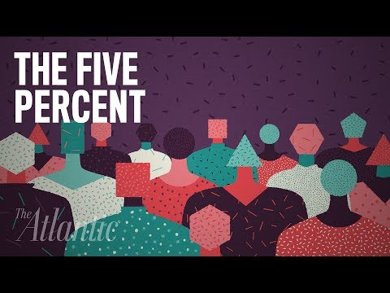](https://www.youtube.com/watch?v=1lO6guLDlHk)

[How Germany's Universal Health-Care System Works](https://www.youtube.com/watch?v=1d3QLPdHysc&t=525s)

[](https://www.youtube.com/watch?v=1d3QLPdHysc&t=525s)

[Indomitable Sentinels](https://www.youtube.com/watch?v=h5hl3l2nU1g&t=1s)

[](https://www.youtube.com/watch?v=h5hl3l2nU1g&t=1s)

[India's Growing Health Care Crisis | Mashable Explains](https://www.youtube.com/watch?v=RC9JRAqWZus)

[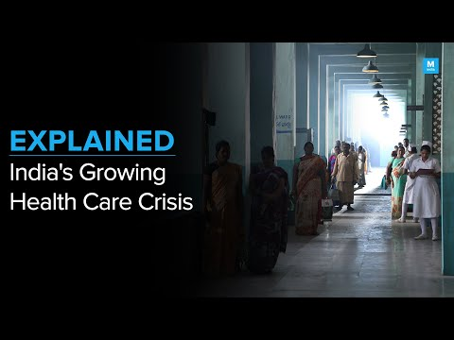](https://www.youtube.com/watch?v=RC9JRAqWZus)

[Too Many Patients, Not Enough Doctors : India’s Public Health Crisis | DataBaaz](https://www.youtube.com/watch?v=pVNJMyyQ7EM)

[](https://www.youtube.com/watch?v=pVNJMyyQ7EM)

[The Rural India Healthcare Crisis - Shortage Of Doctors](https://www.youtube.com/watch?v=bkYeh8yBsdo)

[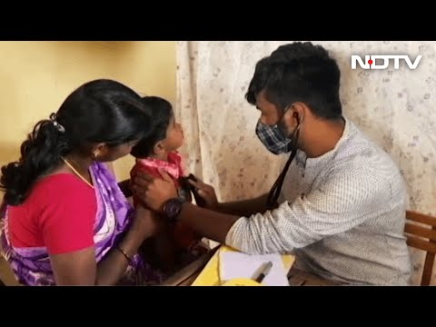](https://www.youtube.com/watch?v=bkYeh8yBsdo)

[Malady Nation: Remedying India's public healthcare](https://www.youtube.com/watch?v=k2MsonWXJ1c)

[](https://www.youtube.com/watch?v=k2MsonWXJ1c)