

Course Title

ELECTRONICS WORKBENCH

( Semester -1 )

Final Project Title

LINE-FOLLOWING AND OBSTACLE-AVOIDING ROBOT

Presented By:

1. Muhammad Moiz Ahmad (BSCE22029)
2. Alishba Zahid (BSCE22035)

Presented To:

Sir Junaid Ashraf

Date of submission:

December 12, 2022

COMPONENT TABLE:

|  |  |  |
| --- | --- | --- |
| NAME OF COMPONENTS:       1. ARDUINO UNO-R3 2. USB CABLE | PICTURE OF COMPONENT | NUMBER OF  COMPONENTS        1 |
| 3. ROBOT CAR CHASSIS |  | 1 |
| 4.L298 MOTOR DRIVER |  | 1 |
| 4. PIN-TO-HOLE JUMPER WIRE SET |  | 1 |
| 6. JUMPER WIRE SET |  | 1 |
| NAME OF COMPONENTS:    7. 3 X 18650 CELL HOLDER | PICTURE OF COMPONENT | NUMBER OF  COMPONENTS    1 |
| 8. SPST On-Off Switch |  | 2 |
| 9. Ultrasonic Sensor Module |  | 1 |
| 10. LINE FOLLOWING  MODULE |  | 2 |

WORKING OF COMPONENT:

1. Arduino Uno:

Arduino Uno controls the whole car. All the components are directly or indirectly connected and controlled by it.

1. Robot Car Chassis:

All the components i.e. Arduino, DC motors, ultrasonic sensor, line following module, cell holder, and L298 are fixed on the car chassis.

1. L298 Motor driver:

L298 motor driver is used to provide the necessary voltage required to run a DC motor. As the Arduino cannot supply more voltage than 5V, L298 is used to provide up to 12 volts to the DC motors. L298 can control 2 motors at a time.

1. Ultrasonic Sensor Module:

The ultrasonic sensor module consists of a receiver, a transmitter, and a control circuit. The ultrasonic sensor uses sonar to determine the distance to an object like bats or dolphins do. The sensor. The transmitter sends a sonar signal which is received by the receiver. Its ranging accuracy is about 400cm.

1. Line Following Module:

The line following module consists of a transmitter and receiver. The transmitter sends an infrared light which is reflected back from a surface and received by the transmitter. If the surface is black the light is absorbed by it and nothing is received by the receiver of the module in this way the module detects whether the surface is black or not.

SCHEMATIC DIAGRAM:

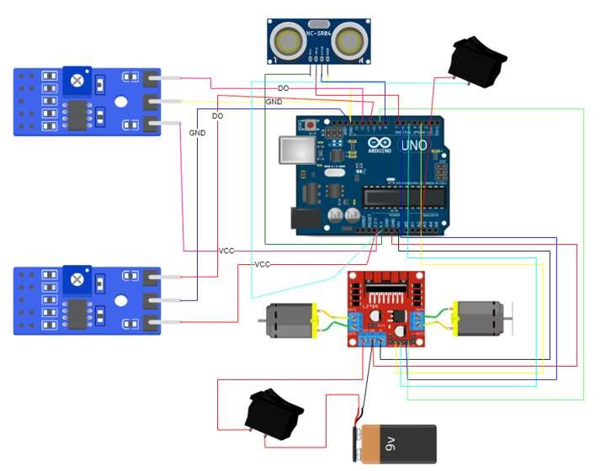

CODE EXPLANATION:

|  |
| --- |
| #define csL 11 //pin of left line sensor #define csR 12 //pin of right line sensor int mode = A2; //pin of mode changing button int in1 = 3; //motor 1 terminal 1 int in2 = 5; //motor 1 terminal 2 int in3 = 6; //motor 2 terminal 1 int in4 = 9; //motor 2 terminal 2 long distance; //initializing variable to store distance of ultrasonic sensor from obstacle int pingPin = 7; //trigpin of ultrasonic sensor int echoPin = 8; //echopin of ultrasonic sensor int state; //variable to store value of current state of button  long measure(){ //function to measure distance between obstacle and ultrasonic sensor digitalWrite(pingPin, LOW); //trigpin has no power i.e. no signal is send delayMicroseconds(2); //2 microsecond delay digitalWrite(pingPin, HIGH);//trigpin has full power i.e. a signal is send delayMicroseconds(5); //5 microsecond delay digitalWrite(pingPin, LOW); //trigpin has no power i.e. no signal is send long duration = pulseIn(echoPin, HIGH);//function to measure the length of pulse on echopin and store in variable return duration / 29 / 2; // return value in centimeters  } void motor_fwd(int fwd_speed){ //function to move car forward analogWrite(in1 ,fwd_speed); //move motor 1 in forward analogWrite(in2 ,0);  analogWrite(in3 ,fwd_speed); //move motor 2 in forward analogWrite(in4 ,0);  // delay(500);  }  void motor_back(int back_speed){ //function to move car backward analogWrite(in2 ,back_speed); //move motor 1 in backward analogWrite(in1 ,0);  analogWrite(in4 ,back_speed); //move motor 2 in backward analogWrite(in3 ,0);  // delay(500);  } void turn_right(int right_speed){ //function to turn car right |

|  |
| --- |
| analogWrite(in1 ,right_speed); //move motor 1 in forward analogWrite(in2 ,0); analogWrite(in4 ,right_speed); //move motor 2 in backward analogWrite(in3 ,0);  // delay(300);  } void turn_left(int left_speed){ //function to turn car left analogWrite(in2 ,left_speed); //move motor 1 in backward analogWrite(in1 ,0); analogWrite(in3 ,left_speed); //move motor 2 in forward analogWrite(in4 ,0);  // delay(300);  } void stop(){ //function to stop the car analogWrite(in2 ,0); //stop motor 1 analogWrite(in1 ,0); analogWrite(in3 ,0); //stop motor 2 analogWrite(in4 ,0);  // delay(500);  } void obstacle_avoiding(int speed){ //function for obstacle avoiding mode distance = measure(); //calling function to find the distance between car and obstacle  Serial.println(distance); //printing the distance if ( distance <= 30 ){ //if distance is less than 30 stop(); //stop the car delay (2000); //delay of 2 sec motor_back(speed); //move the car back delay(1000); //delay for 1 sec stop(); //stop the car delay(500); //delay for 0.5 sec turn_left(speed); //turn the car left delay(1000); //delay for 1 sec  }  else{ //if distance is greater than 30 motor_fwd(speed); //move the car forward }  } void line_follow(int speed){ //function for line following mode |
| if (!digitalRead(csL) && !digitalRead(csR)){ //if both sensor detect colour other tha black motor_fwd(speed); //move the car forward  } else if (!digitalRead(csL) && digitalRead(csR)){ //if right sensor detects black colour turn_right(speed); //turn the car right  } else if (digitalRead(csL) && !digitalRead(csR)){ //if left sensor detects black colour turn_left(speed); //turn the car left  }  else if (digitalRead(csL) && digitalRead(csR)){ //if both sensors detect black colour  stop(); //stop the car }  } void setup() { //function to set pins and Arduino setting pinMode(pingPin, OUTPUT); //set pingpin to output pinMode(csL, INPUT); //set csL pin to input pinMode(csR, INPUT); //set csR pin to input pinMode(mode, INPUT); //set mode pin to input  Serial.begin(9600); //serial.begin to write analog functions  }  void loop() { //loop to follow  Serial.println(analogRead(mode)); //printing button state  // delay(1000); state = analogRead(mode); //storing value of mode in state if (state > 1000){ //if state is greater than 1000 i.e. button is ON  obstacle_avoiding(127); //Makes the car obstacle avoiding  Serial.println("1"); //print 1  }  else{ //if state is less than 1000 i.e. button is OFF  line_follow(127); //Makes the car line following  Serial.println("0"); //print 0  }  } |

WORKING OF THE PROJECT:

When the main switch button is turned on the whole car comes to life. The second switch determines the mode of the car i.e. whether it is in line following mode or obstacle-avoiding mode. If the second switch is ‘ON’ the car is in obstacle-avoiding mode and if the button is ‘OFF’ the car is in line following mode.

1. Obstacle Avoiding:

In this mode, the ultrasonic sensor sends a sonar signal. This signal bounces off a surface and returns to the receiver of the ultrasonic sensor after some interval of time. Depending upon this interval of time the distance between the sensor and the object, from which the sonar signal bounced back, is determined. If this distance is less than 30 cm the car stops, moves backward, turns left, and again checks the distance between the sensor and the object it is facing. This process is repeated continuously until the distance between the sensor and the object it is facing becomes greater than 30 cm. Once the distance becomes greater than 30 cm the car starts moving forward.

1. Line Following:

In this mode, line-following modules are used to make the car follow a specific black line. The line following module consists of a transmitter and receiver. The transmitter sends an infrared light which is reflected from a surface and received by the transmitter. If the surface is black the light is absorbed by it and nothing is received by the receiver of the module in this way the module detects whether the surface is black or not. The car consists of a left and right module. If the left module detects black color the cars turn left, if the right module detects black color the car turns right, if both modules detect black color the car stops and if none of the modules detect black color the car moves forward.

WORKING ON PROJECT:

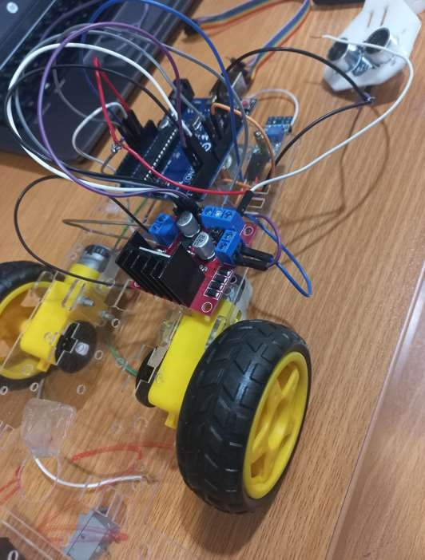

FINAL PRODUCT:

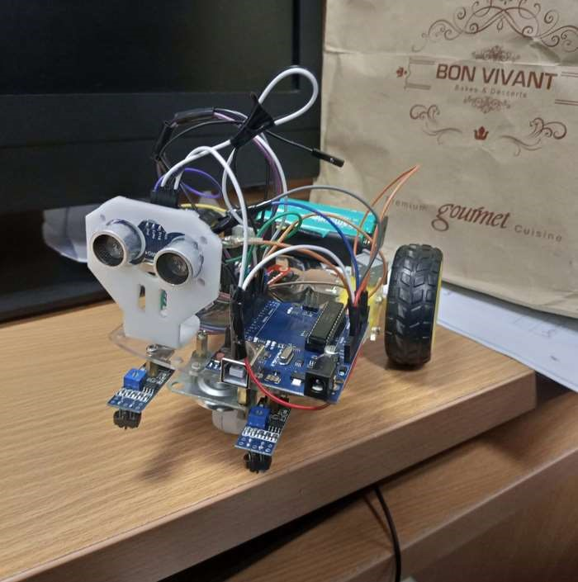

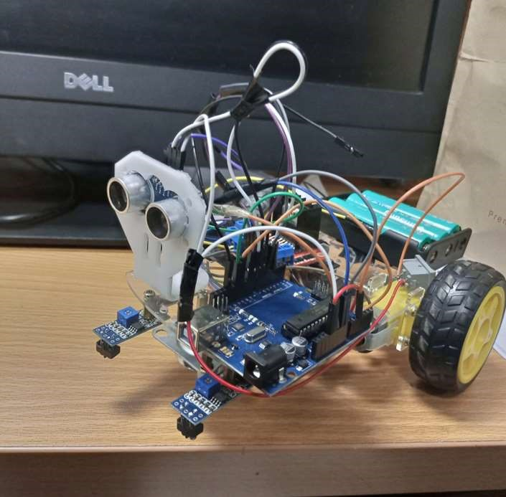

RESULT:

The car is working perfectly. It changes its mode from obstacle avoiding to the line following when the second button is turned ‘OFF’. In obstacle-avoiding mode, the car is able to avoid all the obstacles perfectly while in line-following mode the car is able to follow the black line perfectly.